**TOPICS: COUNT(*), GROUP BY**

**First it only looks for custid = 71, then it groups empid and YEAR(orderdate)**

**HAVING COUNT(*)>1 shows only the output based on the GROUP BY that have more then 1 row**

USE TSQLV4;

SELECT empid, YEAR(orderdate) AS orderyear, COUNT(*) AS numorders

FROM Sales.Orders

WHERE custid = 71

GROUP BY empid, YEAR(orderdate)

HAVING COUNT(*) > 1

ORDER BY empid, orderyear;

----------------------------------

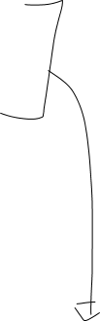

USE TSQLV4

SELECT empid, YEAR(orderdate) AS orderyear

FROM Sales.Orders

WHERE custid = 71

ORDER BY empid



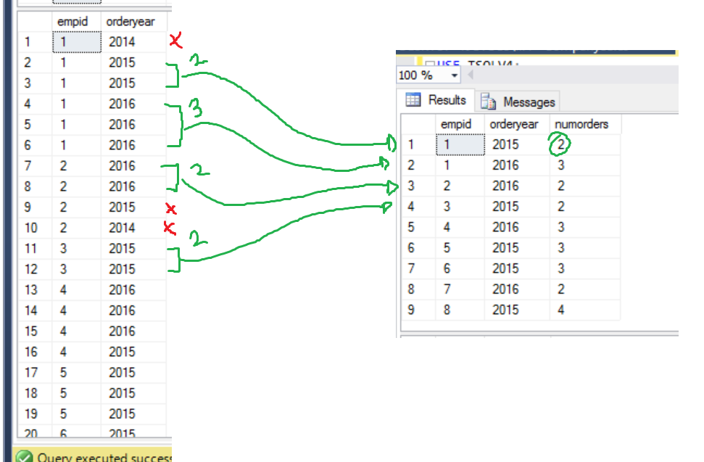

In GROUP BY order does not matter