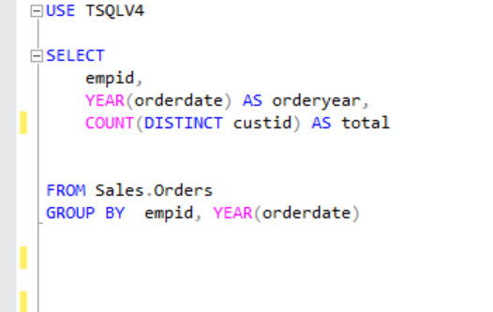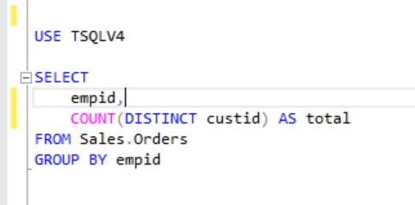



 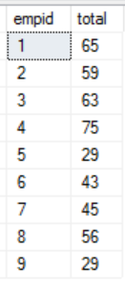



This doesn’t add up because even though distinct gets rid of duplicates, GROUP BY has a higher logical order, so it is executed first. Meaning that DISTINCT is only applies inside the group. Example Group 1 can only have a unique customerID lets say custid =10, This does not mean that another group cannot have custid = 10. So in Table 1 all the custid in(empid 1, 2014) is unique and all the custid in (empid1,2015) is unique, but between (empid 1, 2014) and (empid 1, 2015) there can be values that are repeated

EX:

