Learning outcomes covered in this assessment:
LO1: Examine and discuss the TCP/IP Internet Layer protocols
LO2: Examine and discuss the TCP/IP Host-to-Host Layer protocols
LO3: Examine and discuss the TCP/IP Application layer protocols and TCP/IP utilities
LO4: Examine and discuss the basics of Voice over IP

Critical questions: Q16 and Q19. All critical questions must be answered correctly.
Q1 | - What is the purpose of an IP address?  - IP addresses were initially issued in terms of classes. Why was this practice eventually abolished? |  |  | (4 marks)
A1 | Student answer  - An IP address serves the function of enabling communication between hosts on LAN networks and the internet. Determines which devices are the initiating and destination devices [1].  - b) Because so many assigned addresses were not being used, classful IP addressing was finally eliminated due to its high wastefulness [1].
F1 | Assessor feedback:  The purpose of an IP address and why the IP address was eventually abolished from issuing in terms of classes are correctly explained. |  |  | (4)
Q2 | - What is the HostID for the following IP address: 192.100.100.5/24? (1 mark)  - Write the following IP address in binary:192.100.100.1 (1 mark)  - Using dotted-decimal notation, write the default subnet mask for a Class A network. (1 mark)  - What are the drawbacks of using subnetting? (3 marks) | (6 marks)
A2 | Student answer  - 5  - 11000000 01100100 01100100 00000001  - 255.0.0.0  - The potential for confusion due to the network and subnet sharing the same address [1]. Each subnet uses more IP addresses, thus subnets are more difficult to set up. Additionally, router communication efficiency is decreased [1].
F2 | Assessor feedback:  The HostID, IP address in binary, default subnet mask and drawbacks of using subnetting are mentioned correctly. |  |  | (6)
Q3 | What is the purpose of using classless interdomain routing (CIDR)? |  |  |  | (3 marks)
A3 | Student answer  By removing the imposition of the class A, B, and C address masks, the CIDR enables a network owner to "supernet" several addresses together [1]. These several continuous network addresses can then be combined by the concentrating router to create a single network route advertisement [1].
F3 | Assessor feedback:  Answer effectively cover the purpose of using classless interdomain routing (CIDR) |  |  | (3)
Q4 | - What are the ranges for private IP addresses?  - How will you connect a private network to the Internet? |  | (4 marks)
A4 | Student answer  - Class A: from 10.0.0.0 to 10.255.255.255  Class B: from 172.16.0.0 to 172.31.255.255  Class C: from 192.168.0.0 to 192.168.255.255  - An existing network with both the internet access and RAS to be connected to the router [1]. Then the VPN tunnel server is connected via the router firewall [1].
F4 | Assessor feedback:  The ranges provided match the reserved ranges for private addresses, and connecting a private network to the internet is incorrect. The private network is connected to the internet through Network Address Translation. Please refer Routing Concepts in PR1_v1.pdf / PR1_v1.pptx. |  |  | (2)
Q5 | When your IP address is 105.23.1.1, what shouldyour default subnet mask be? |  |  |  | (2 marks)
A5 | Student answer  255.0.0.0
F5 | Assessor feedback:  The default subnet mask 255.0.0.0 is correct. |  |  | (2)
Q6 | Give one example each of the following IPv6 addresses:  - IPv4 mapped  - Unique Local  - Link-Local |  |  |  | (5 marks)
A6 | Student answer  - ::192.100.100.7  - FD11:2111:3222::/48  - fe77::212:6aee:ffbb:22b3
F6 | Assessor feedback:  The given examples of IPv4 mapped, Unique Local and Link Local of IPv6 addresses are correct. |  |  | (5)
Q7 | What are the four fields in the ARP cache? |  |  |  | (2 marks)
A7 | Student answer  - IF index  - Physical address  - Internet protocol (IP) address  - Type
F7 | Assessor feedback:  Four fields in the ARP cache are mentioned correctly. |  |  | (2)
Q8 | Name one of the tasks performed by ICMP. |  | (1 marks)
A8 | Student answer  Determining whether a node is reachable.
F8 | Assessor feedback:  The mentioned task of diagnosing whether a node is reachable is performed by ICMP. |  |  | (1)
Q9 | Name three protocols/technologies involved in the delivery of ‘ping’ messages on an Ethernet LAN, and describe the function of each. |  |  |  | (3 marks)
A9 | Student answer  DOS utilities  Window utilities  Software protocol analyzers
F9 | Assessor feedback:  The mentioned three protocols / technologies are incorrect. ICMP, IP and ARP or Ethernet are the correct answers. Please refer the corresponding topics in PR1_v1.pdf. |  |  | (0)
Q10 | - What is the role of Address Resolution Protocol?  - On which layer of the OSI model does ARP operate? |  |  |  | (2 marks)
A10 | Student answer  - It determines IP to MAC address translation.  - Layer 2, the data link layer.
F10 | Assessor feedback:  The role of ARP and which layer of the OSI model ARP operates on are correctly mentioned. |  |  | (2)
Q11 | - What is the purpose of TCP?  - Name two things that make TCP reliable. |  |  |  | (3 marks)
A11 | Student answer  - A connection is made between two machines via TCP prior to data transmission [1].  TCP reconstructs the data stream from received packets; if required, it breaks up big data chunks into smaller segments;  provides socket services for several connections to ports on distant hosts; handles packet verification, error control, and flow control; and indicates receipt of received data [1].  - TCP arranges for retransmission in the event that any packets are lost and confirms that all packets have been received [1].
F11 | Assessor feedback:  The purpose and reliability features of TCP are correctly explained. |  |  | (3)
Q12 | What is the purpose of a TCP port? |  |  |  | (1 mark)
A12 | Student answer  Recognizing each host process on both ends of the connection [1].
F12 | Assessor feedback:  The answer clearly explains the purpose of a TCP port. |  |  | (1)
Q13 | What are the potential drawbacks in implementing VoIP, in comparison with a normal landline service? |  |  |  | (2 marks)
A13 | Student answer  VOIP can suffer from packet jitter, which is brought on by varying packet queuing times as well as delays experienced by packets traveling diverse paths from their source to their destination [2].  Due to its reliance on switched network architecture, voice over IP is susceptible to packet loss, which causes delays because of packet retransmission [2].
F13 | Assessor feedback:  Packet Jitter, Delay and Packet Loss are potential drawbacks in implementing VoIP. |  |  | (2)
Q14 | What are the functions of a VoIP codec ? |  |  |  | (3 marks)
A14 | Student answer  A continuous analogue waveform is converted into discrete digital form by a VoIP codec [2]. The waveform is periodically sampled by the codec, which produces a value for each sample [2].  A frame of data is created by adding up these distinct values over a predetermined amount of time [2].
F14 | Assessor feedback:  The functions of a VoIP codec are properly explained. |  |  | (3)
Q15 | Specify the port numbers and purpose of the following TCP/IP Application Layer protocols:  - FTP  - HTTP  - BootP  - DHCP  - Telnet  - SSH | (12 marks)
A15 | Student answer  - FTP: Port 21, and is used for file transfer control [1].  - HTTP: Port 80 , Defines how messages are formatted and transmitted, and what actions Web servers and browsers should take in response to various commands [1].  - BootP: Port 67 for server and port 68 for client. The purpose is communication between server and client [1].  - DHCP: UDP port 67 for server and UDP Port 68 for client. Purpose is to centralize and streamline the allocation of IP addresses [1].  - Telnet: Port 23, and is used to enable virtual terminal capability across a network [1].  - SSH: Port 22, the purpose is to facilitate secure remote access, administration, and file transfer between network devices [1].
F15 | Assessor feedback:  The port numbers and purpose of the mentioned TCP/IP application layer protocols are correctly explained. |  |  | (12)
Q16 | Explain the usage of the Time to Live field in the IPv4 header.  Note – This question is mandatory. It should be answered completely right to be assessed as competent with a score for this module. |  | (3 marks)
A16 | Student answer  It guarantees that datagrams that cannot be sent eventually get rid of [1]. The Time to Live is reduced by one for each router processing a datagram; if this field is empty, the datagram needs to be eliminated [1].
F16 | Assessor feedback:  The core purpose and mechanisms of the usage of the Time to Live (TTL) field in the IPv4 header are explained correctly. |  |  | (3)
Q17 | What are the three common fields of an ICMP message, and their respective lengths? |  | (3 marks)
A17 | Student answer  - ICMP message type: 4 bits length  - A code of which the interpretation depends on the type of ICMP message: 4 bits length.  - A checksum calculated on the entire ICMP datagram: 16 bits length.
F17 | Assessor feedback:  The ICMP, Code and Checksum are the three common fields of an ICMP message and the specified length for ICMP and code are 8 bits. Please refer Internet Control Message Protocol (ICMP) topic in PR1_v1.pdf. |  |  | (1)
Q18 | Make a hand-drawn sketch of a TCP header. |  |  |  | (5 marks)
A18 | Student answer  The sketch below represents the TCP header [1].  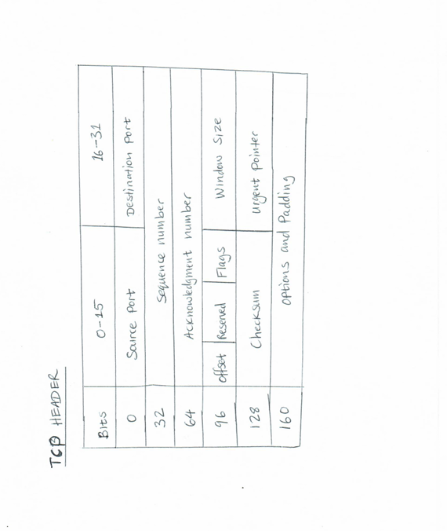
F18 | Assessor feedback:  The hand-drawn sketch of a TCP header is correct. |  |  | (5)
Q19 | A browser makes a TCP connection to a web server:  - Which port number will be used on the server side?  - The Initial Sequence Number from the client is 6456 and the Initial Sequence Number from the server is 11402. Make a sketch of the triple handshake with the SYN and ACK numbers clearly shown.  Note – This question is mandatory. It should be answered completely right to be assessed as competent with a score for this module. |  | (4 marks)
A19 | Student answer  - The server side will assign an ephemeral port.  - The sketch below represents TCP triple handshake [1].  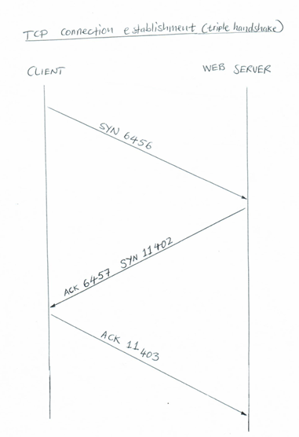
F19 | Assessor feedback:  The port number and the sketch represent TCP triple handshake. |  |  | (4)
Q20 | Explain the concepts around sending a UDP datagram. |  | (5 marks)
A20 | Student answer  Due to the lack of synchronization parameters, priority settings, sequence numbers, retransmission clocks, delayed acknowledgement timers, and packet retransmission, sending a UDP datagram entails very little overhead [1]. The protocol is quick and functionally simplified, and the header is compact [1]. The only negative aspect is that there is no assurance of delivery [1]. Therefore, broadcast communications, general network announcements, and real-time data are all handled via UDP [1].
F20 | Assessor feedback:  The concepts around sending a UDP datagram is explained correctly. |  |  | (5)
Q21 | Name one tool that could be used to determine the location and/or the routing path from your computer to any given website URL. |  |  |  | (2 marks)
A21 | Student answer  Traceroute for UNIX, and Tracert for windows
F21 | Assessor feedback:  Traceroute is the one tool that could be used to determine the location and routing path from your computer to any given website URL. |  |  | (2)
Q22 | Name four TCP/IP command-line (DOS) utilities used for networtk troubleshooting. |  |  |  | (4 marks)
A22 | Student answer  - NETSTAT – displays the TCP/IP protocol sessions, connections and open port connection information [1].  - NBTSTAT – displays a list of NetBIOS computer names that have been resolved to IP addresses [1].  - ROUTE – displays or modifies the local routing table [1].  - ARP – displays the cache of locally resolved IP addresses to MAC addresses [1].
F22 | Assessor feedback:  The mentioned four TCP/IP command-line (DOS) utilities used for network troubleshooting are correct. |  |  | (4)
Q23 | Name the best codec (in terms of saving bandwidth) for VoIP. |  |  |  | (1 mark)
A23 | Student answer  G. 729 codec
F23 | Assessor feedback:  Yes, G. 729 – Bandwidth saver is the best codec for VoIP. |  |  | (1)
Q24 | Describe the role of RTP and RTCP in VoIP. |  | (3 marks)
A24 | Student answer  Receivers can make up for the jitter and de-sequencing that IP networks create by using RTP and RTCP [2]. Voice and video packets must be carried and transported using RTP [2].  . Regular control information interchange between VoIP session participants is made possible by RTCP, which also provides feedback relating to quality [2].
F24 | Assessor feedback:  The role of RTP and RTCP are described correctly. |  |  | (3)
Q25 | Make a hand-drawn sketch of the H.323 architecture, showing the various components. |  |  |  | (4 marks)
A25 | Student answer  The sketch below represents the H.323 architecture [1]  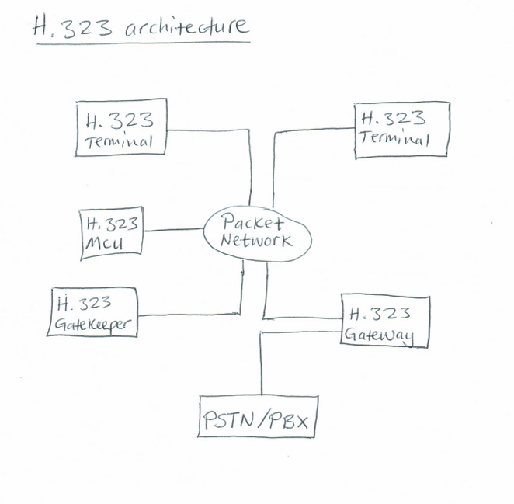
F25 | Assessor feedback:  The hand drawn sketch of H.323 architecture is correct. |  |  | (4)
Q26 | Give two examples of user agents in SIP. |  | (2 marks)
A26 | Student answer  LAN telephones and PSTN interfacing gateways.
F26 | Assessor feedback:  Yes, LAN telephones and PSTN interfacing gateways are two examples of user agents in SIP. |  |  | (2)
Q27 | Explain the three services involved in QoS. |  |  |  | (5 marks)
A27 | Student answer  - Best effort service: There is no assurance that a packet will reach its destination in this paradigm, even when the network makes every effort to carry it there [1]. Any amount of data can be sent by an application without asking the network for permission or alerting it [1].  - Integrated service: This architecture negotiates network parameters end-to-end to give apps a guaranteed quality of service [1].  - Differentiated service: Every packet is categorized when it enters the network, according to the differentiated service architecture [1].
F27 | Assessor feedback:  The three services involved in QoS – Best effort service, Integrated service and Differentiated service are explained correctly. |  |  | (5)
Q28 | Discuss (not list) any two VoIP applications in mining. |  |  |  | (4 marks)
A28 | Student answer  IPT (IP Telephony): An IP communications system that offers a phone system with high availability and scalability [2]. Industry standards like H.323, MGCP, SIP, JTAPI, TAPI, and others are supported by it [2].  Instead of using the conventional analogue land line service, VoIP enables customers to make phone calls using their current data networks [2].
F28 | Assessor feedback:  The answer missed to specify the VoIP applications in mining. Please refer Use of VOIP in Mining Applications in PR4_v1.pptx. |  |  | (0)
Q29 | What is the role of a proxy server? |  |  |  | (2 marks)
A29 | Student answer  After receiving requests from clients, a proxy server can either process them or send them to other servers for additional processing [1]. A message sent to other servers appears to be coming from a proxy instead of the network component that is behind it [1].
F29 | Assessor feedback:  The role of a proxy server is explained correctly. |  |  | (2)

References

[1] | IDC Technologies, Practical Fundamentals of Voice over IP (VoIP) for Engineers and Technicians, 5th ed., West Perth: IDC Technologies Pty Ltd, 2012.
[2] | IDC Technologies, TCP/IP and Ethernet Networking for Industry, 6th ed., West Perth: IDC Technologies Pty Ltd, 2013.

END OF ASSESSMENT
89/100

