

**School of Computer Science & Software Engineering**

Bachelor of Computer Science (Digital Systems Security)

CSCI321- Project DeepPurple

Project Proposal

22 October 2024

|  |  |  |
| --- | --- | --- |
|  | **Group** | **FYP-24-S4-15P** |
| **Name** | **UOW Student Number** | **Email** |
| Amanda | 1238912321 | Amanda@mail.com |
| Lim Zhi Yew | 7538984 | zyl712@uowmail.edu.au |
| Hau Bin Hui | 7900715 | bhh021@uowmail.edu.au |
| Lim Wei Hao | 7894326 | whlim025@mymail.sim.edu.sg |
| Ong Yu Yang | 8245873 | yyong019@mymail.sim.edu.sg |
|  |  |  |
|  | Supervisor | Mr Tian Sion Hui |
|  | Assessor | Mr Japit Sionggo |

# Document Control

**Title: Project Proposal**

**Document Name: ProjectProposal V1.docx**

|  |  |  |  |  |
| --- | --- | --- | --- | --- |
| **Owner** | **Current Version** | **Last Change on** | | **Approved by** |
| **Date** | **Time** |
| FYP-24-S4-15P | **1.0** | **22 Oct 2024** | **-** | Ong Yu Yang |

**Record of Revision**

|  |  |  |  |  |
| --- | --- | --- | --- | --- |
| **Revision Date** | **Description** | **Section Affected** | **Changes Made by** | **Version after Revision** |
| **22 Oct 2024** | **Initial Version for Submission** | **All** | **All** | **1.0** |
|  |  |  |  |  |
|  |  |  |  |  |
|  |  |  |  |  |
|  |  |  |  |  |
|  |  |  |  |  |
|  |  |  |  |  |
|  |  |  |  |  |
|  |  |  |  |  |
|  |  |  |  |  |
|  |  |  |  |  |
|  |  |  |  |  |
|  |  |  |  |  |
|  |  |  |  |  |
|  |  |  |  |  |

### Contents

Document Control 2

1. Executive Summary 4

2. Introduction 4

3. Project Description 4

3.1 Background 4

3.2 The Problem 4

4. Research 4

4.1 Emotional Intelligence in Text Analysis 4

4.2 Characteristics and Key Usage 4

4.3 Why Emotional Intelligence in Text Analysis 4

4.4 History and Timeline of Emotional Text Analysis 4

4.5 Components of Emotional Text Analysis 4

4.6 Usage of Sentiment Analysis with AI in Singapore 4

4.7 Summary 4

5. Objectives 5

5.1 What needs to be done to solve the problem 5

5.2 Algorithm and Technology to Use 5

5.3 Minimum Requirements 5

5.4 Criteria for Best Solution 5

6. Scope and Problems of Limitation 5

6.1 Scope 5

6.2 Problems of Limitation 5

6.3 Exclusions 5

7. Development Method 5

8. Roles and Responsibilities 5

9. Timetable 5

10. References 5

11. Appendix 7

## Executive Summary

DeepPurple is a cutting-edge text analysis software that leverages AI to detect emotions in client communications, providing businesses with insights into what their customers feel. This is done by transforming raw text data like emails, messages, comments into emotional insights. This helps to enable companies to better understand and engage based on the detected emotion. This helps to improve customer experiences and make informed decision based on emotional trends.

## Introduction

DeepPurple is an advanced text analysis tool that incorporates emotional intelligence by leveraging Natural Language processing. It stems from the increasing need for businesses to not only analyse the explicit content of customer communications but also the underlying emotions.

The modern business environment lacks the tools to capture subtle emotional cues behind customer communications. As a result, business struggle to personalise customer interactions and identify underlying customer sentiment. DeepPurple can provide sentiment analysis to improve customer service, identify pain points early, improve customer engagement and forecast market trends.

This proposal highlights how DeepPurple aims to bridge the gap between a basic text analysis tool and a more sophisticated emotional analysis AI-driven tool to address specific business challenges. It consists of several chapters:

1. **Project Description** provides context and defines the problem at hand.
2. **Research** includes current literature and research backing the importance of emotional intelligence in text analysis and how it may assist companies.
3. **Objective** defines the goals and expected outcomes of the project.
4. **Scope and Limitations** outlines the project’s scope and potential challenges.
5. **Development Method** discusses the technical approach chosen.
6. **Roles and Responsibilities** details team roles.
7. **Timetable** provides a timeline for the project’s completion.

## Project Description

## Background

In the modern business landscape, effective communication between companies and their clients is not merely about the exchange of information but also about understanding the emotions and intentions behind those communications. Traditional text analysis tools predominantly focus on the explicit content of messages, often overlooking the subtle emotional cues that significantly influence customer behavior and decision-making and are unable to pick up the sentiments behind such messages. This gap results in superficial insights, limiting businesses' ability to fully comprehend and respond to their clients' needs and sentiments.

Companies struggle to obtain meaningful insights that drive personalized and effective business strategies, hence effectively hindering their ability to tailor customer interactions, proactively address concerns, and anticipate market trends based on emotional feedback.

Moreover, existing text analysis tools frequently encounter challenges related to scalability, integration, and real-time processing. Companies are unable to find a solution that is able to handle large volumes of data in diverse formats requires robust and flexible systems that can seamlessly integrate with existing business infrastructures. Many current solutions lack the sophistication to relate emotions to specific aspects of communications, resulting in fragmented and incomplete understandings of customer needs and preferences.

The absence of comprehensive emotional analysis impairs businesses' ability to:

1. **Personalize Customer Interactions:** Without insight into customer emotions, companies cannot effectively tailor their communications to enhance user experiences.
2. **Identify and Address Pain Points:** Emotional cues often indicate underlying issues that, if unaddressed, can lead to decreased customer satisfaction and loyalty.
3. **Forecast Trends and Adapt Strategies:** Understanding emotional trends over time enables businesses to anticipate shifts in customer behavior and adjust their strategies accordingly.
4. **Improve Overall Customer Satisfaction and Loyalty:** A lack of emotional intelligence in customer interactions can result in missed opportunities to build stronger, more meaningful relationships.

These shortcomings can lead to misaligned strategies, reduced customer engagement, and missed opportunities for growth. As customer expectations continue to evolve, the need for advanced text analysis solution becomes more essential. Hence this is why we are proposing our solution, DeepPurple, a tool that will provide deep emotional insights for businesses aiming to thrive in a competitive market.

## The Problem

In response to the business need for deeper emotional insights in customer communications, we developed DeepPurple—an advanced text analysis software designed to overcome shortcomings stemmed from traditional generally available tools. DeepPurple was created to enable businesses to not only understand the explicit content of client interactions but also to accurately decipher the underlying emotions and intentions that drive customer behavior. By addressing the limitations of existing solutions, DeepPurple empowers companies to gain comprehensive and actionable insights from millions of communications, thereby enhancing their ability to personalize interactions, identify pain points, and anticipate market trends.

### 3.3 The Challenge

Developing DeepPurple to accurately analyze and interpret emotions from vast and diverse customer communications presents significant challenges.

The primary difficulty lies in designing a system robust enough to detect a wide range of emotional cues. Achieving high accuracy requires sophisticated algorithms and continuous refinement to adapt to evolving language patterns. Certain languages may present unique formats which traditional NLP may not be able to pick up, hence requiring the need to deploy a custom trained model rather than a pre-trained one. Additionally, ensuring scalability and real-time processing is critical, as DeepPurple must handle multiple communications simultaneously without compromising performance while also minimizing latency and reducing overhead costs.

Balancing the depth of emotional insights with user-friendly usability is another major challenge. DeepPurple must present complex emotional data in an accessible and actionable manner through its interactive and adaptive user interface, enabling businesses to easily interpret and leverage these insights without requiring specialized training.

Overcoming these challenges is essential to delivering a reliable, scalable, and insightful solution that empowers companies to seamlessly integrate the full potential of emotional intelligence in their customer communications.

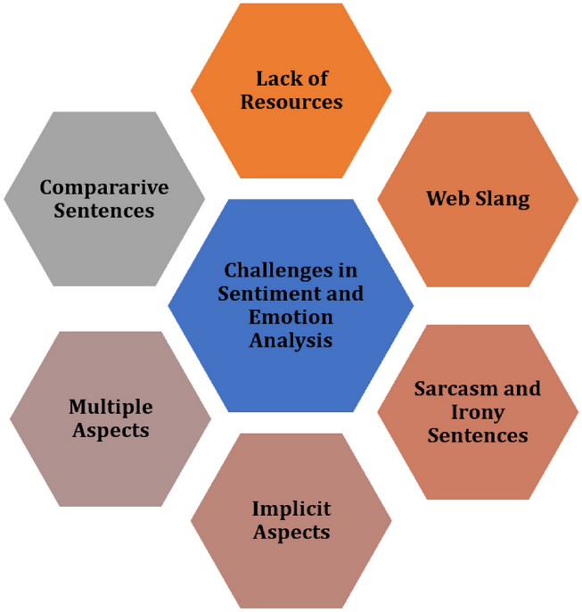

Alvi, A., & Qureshi, M. R. N. (2021). *Information diffusion analysis in complex networks: a study of influencer and viral marketing on social media*. Social Network Analysis and Mining, 11(1), 1-12. https://doi.org/10.1007/s13278-021-00776-6. Figure 5.

## Research

## Emotional Intelligence in Text Analysis

Emotional intelligence in text analysis refers to the capability of software to not only comprehend the explicit content of written communications but also to interpret the underlying emotions and intentions conveyed by the text. This advanced level of analysis goes beyond traditional sentiment analysis, which typically categorizes text as positive, negative, or neutral, by identifying a broader range of emotional states and their contextual significance.

## Characteristics and Key Usage

### Characteristics:

* **Comprehensive Emotion Detection**: Emotional text analysis is designed to identify a wide range of emotions within textual data. This granular detection allows for more understanding of sentiments expressed by individuals, providing deeper insights into their experiences and reactions.
* **Contextual Understanding**: Advanced emotional analysis tools possess the ability to discern the context in which emotions are expressed. This includes differentiating between genuine sentiments and rhetorical devices like sarcasm or irony. Contextual understanding ensures higher accuracy in emotion recognition, reducing the likelihood of misinterpretation compared to traditional methods where the context of the text is often ignored and words are analyzed individually.
* **Actionable Insights:** The primary goal of emotional text analysis is to translate complex emotional data into clear, actionable insights. These insights enable businesses to make informed decisions, tailor their strategies, and enhance their interactions with customers based on a deep understanding of their emotional states.

### Key Usage:

|  |  |  |  |
| --- | --- | --- | --- |
| Emotion Detection Level | Max Emotion Categories | Example Emotions | Key Usage |
| Basic Sentiment | 3 | Positive, Negative, Neutral | Ideal for generating high-level reports and dashboards to monitor overall customer satisfaction and general trends. |
| Intermediate Sentiment | 6 | Happiness, Sadness, Anger, Fear, Surprise, Disgust | Ideal for gaining deeper insights into specific emotional responses to enhance quality and experience. |
| Advanced Sentiment | 10 | Happiness, Sadness, Anger, Fear, Surprise, Disgust, Trust, Anticipation, Contempt, Shame | Ideal to fulfil the need to inform strategic initiatives done by a emotional analysis. Aids marketing strategies, product development and personalized customer interactions. |

## Why Emotional Intelligence in Text Analysis

Integrating emotional intelligence into text analysis addresses several critical needs for modern businesses:

* **Enhancing Customer Experience:**

By understanding and addressing customer emotions, companies can personalize interactions, leading to improved satisfaction and loyalty.

* **Identifying and Resolving Issues:**

Emotional cues can highlight underlying problems that may not be explicitly stated, enabling proactive resolution before issues escalate.

* **Optimizing Marketing Strategies:**

Insights into customer emotions can inform the creation of more effective and emotionally resonant marketing campaigns.

* **Predicting Market Trends:**

Analyzing emotional trends over time helps businesses anticipate changes in customer behavior and adapt their strategies accordingly.

* **Improving Product Development:**

Emotional feedback provides valuable information for refining existing products and developing new offerings that better meet customer needs.

## History and Timeline of Emotional Text Analysis

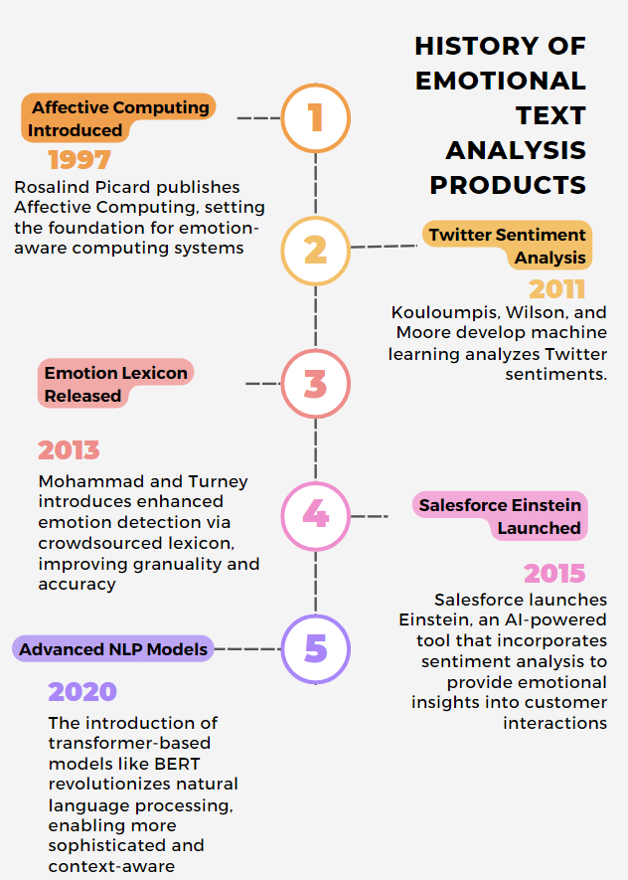

## Components of Emotional Text Analysis

1. **Input (Collection of Dataset)**:
   1. Start by gathering text data that the user want to analyze for sentiment/emotion.
2. **Preprocessing**:
   1. **Tokenization**: Break down the text into smaller pieces, usually words or tokens.
   2. **Normalization**: Convert text to a standard form, including lowercasing or removing punctuation.
   3. **Removing Stopwords**: Remove common words that do not contribute significantly to the sentiment (e.g., "the," "and").
   4. **POS Tagging**: Identify the part of speech of each word (e.g., noun, verb).
   5. **Stemming/Lemmatization**: Reduce words to their root form to unify different grammatical forms.
3. **Feature Extraction**:
   1. **Bag of Words (BoW)**: Create a frequency-based representation of words in the text.
   2. **N-gram**: Extract sequences of words or tokens to capture context (e.g., pairs of words).
   3. **TF-IDF**: Term Frequency-Inverse Document Frequency, which highlights important words in a document relative to a corpus.
   4. **Word Embedding**: Use vectorized representations of words, capturing semantic meanings, for more complex relationships.
4. **Model Development**:
   1. **Machine Learning/Deep Learning Models**: Train models (e.g., SVM, Random Forest, CNN, RNN, BERT) to classify text based on emotional sentiment, using the extracted features.
5. **Model Assessment**:
   1. Evaluate the performance of the sentiment analysis model using metrics such as accuracy, precision, recall, and F1-score. Compare it against baseline or existing models.

## Usage of Sentiment Analysis with AI in Singapore

Sentiment analysis powered by AI has become integral to various sectors in Singapore, enhancing decision-making processes and improving customer experiences.

In the **digital marketing and public engagement** arena, businesses leverage sentiment analysis to navigate Singapore’s vibrant digital dialogue. By analyzing social media interactions, customer reviews, and online conversations, companies can gauge public sentiment towards their brands, products, and services. This real-time sentiment monitoring enables organizations to tailor their marketing campaigns, address customer concerns proactively, and engage more effectively with their target audiences. For example, companies can identify trending topics and consumer preferences, informing more strategic and responsive marketing initiatives (Jodie Shaw, 2024).

In the **retail sector**, companies employ sentiment analysis to understand consumer preferences and optimize their marketing strategies. E-commerce platforms like **Lazada** and **Shopee** analyze customer sentiments from product reviews and social media interactions to refine their product offerings and enhance user engagement. This real-time feedback mechanism allows retailers to swiftly address negative sentiments, thereby improving overall customer satisfaction (sitiatarfa8, 2024).

Overall, the adoption of sentiment analysis with AI in Singapore spans multiple industries, driving innovation and fostering a data-driven approach to understanding and addressing the sentiments of consumers and citizens alike.

## Summary

The adoption of AI-driven sentiment analysis in Singapore is rapidly expanding, driven by robust technological infrastructure and proactive government support such as the IMDA initiative in conjunction with Google. With the global emotional AI market projected to reach USD 7 billion by 2025, Singaporean businesses are at the forefront, integrating these tools to enhance customer satisfaction and brand loyalty. Surveys indicate that a significant majority of businesses, especially in financial services and retail, are experiencing substantial improvements in customer engagement and loyalty metrics, underscoring the critical role of sentiment analysis in driving business success and competitive advantage in the Singaporean market.

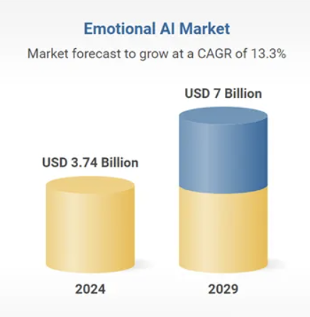

https://www.researchandmarkets.com/reports/5794050

## Objectives

DeepPurple aims to develop an AI-driven text analysis software that accurately deciphers emotions within client communications which can be used by businesses. By Natural Language Processing (NLP) and machine learning, DeepPurple seeks to provide businesses with actionable insights that enhance customer engagement, improve service quality, and inform strategic decision-making.

The following objectives outline the project's goals, methodologies, technologies, minimum requirements, and criteria for achieving the best solution.

Firstly, the primary objective of DeepPurple is to develop and provide an AI-driven text analysis software solution that is capable of decoding emotions expressed within client communications. By leveraging NLP (Natural Language Processing) techniques, the system will provide organisations with deep insights into customer sentiment, enabling them to customise strategies and enhance their business outcomes. The solution will offer comprehensive analysis at both individual and macro levels, with detailed reports available via an interactive and adaptive user interface.

Some approach to use could include the Lexicon-Based Approach. This strategy relies on meticulously constructed emotion lexicons or dictionaries. These lexicons houses an array of words and phrases that are associated with emotions. NLP algorithms can cross reference text with this lexicon and calculate the overall emotion for the text.

## What needs to be done to solve the problem

To address the challenge of understanding emotions and intentions behind client communications, DeepPurple will automate the text analysis process using NLP techniques.

This involves several key tasks:

1. **Comprehensive Data Collection and Preprocessing:**

Gather diverse textual data from sources such as emails, social media, customer reviews, and support tickets. Implement preprocessing steps including tokenization, normalization, stopword removal, and lemmatization to prepare the data for analysis. This allows our model to be trained on a wide array of emotions and sentiments so that it can better process user submitted inputs.

1. **Development of Robust Emotion Detection Algorithms:**

Design and train machine learning models capable of identifying a wide spectrum of emotions, including subtle cues like sarcasm and irony. In addition to emotions, the model will look up the semantics to deduce to the context rather than processing information based on keywords. Both transformer-based models and lexicon-based will be implemented to enhance accuracy and reliability.

1. **Integration with Existing Business Systems:**

Develop APIs and connectors to seamlessly integrate DeepPurple with popular Customer Relationship Management (CRM) platforms and other business tools, ensuring that emotional insights can be incorporated into existing workflows right away without integration issues.

1. **User-Friendly Interface Design:**

Create an intuitive and interactive dashboard that visualizes emotional insights and trends, allowing businesses to easily interpret and act upon the data without requiring specialized training.

1. **Ensuring Scalability and Real-Time Processing:**

Architect the system to handle large volumes of data with minimal latency, enabling real-time analysis and insights that support timely decision-making creating a highly available solution for businesses to self-manage after the warranty period.

## Algorithm and Technology to Use

DeepPurple will utilize the following technologies to meet the listed objectives:

1. **Transformer-Based models**

Transformer-based models such as OpenAI GPT-4 will allow DeepPurple to achieve contextual understanding of text, enable the accurate detection of a wide range of emotions, including understanding the context

1. **Lexicon-Based Approaches**

Integrate lexicon-based methods to enhance emotion categorization by referencing curated emotion dictionaries, providing an additional layer of accuracy in emotion detection

1. **Hybrid Models**

Combine machine learning and lexicon-based approaches to improve the overall accuracy and reliability of emotion detection, especially for detecting nuanced emotions.

1. **Technology Stack**
   1. **Frontend**

Develop a responsive and interactive frontend using React

* 1. **Backend**

Develop a scalable and secure backend using SpringBoot

* 1. **Cloud Services**

Use the AWS ecosystem to host our solutions

## Minimum Requirements

To ensure the project's success, the following minimum requirements must be met:

* **Accuracy in Emotion Detection:**

Achieve at least 85% accuracy in identifying core emotions across diverse datasets to ensure reliable insights. The solution must also be able to detect different nuances and must offer granularity in its responses.

* **Real-Time Processing Capability:**

Ensure the system can process and analyze incoming text data with a latency of under 10 seconds per message to facilitate timely decision-making.

* **User-Friendly Dashboard:**

Develop an intuitive dashboard that allows businesses to visualize emotional trends and generate customizable reports without requiring specialized training.

## Criteria for Best Solution

The best solution for DeepPurple will be characterized by several key factors:

* **High Accuracy and Reliability:**

The system must consistently deliver precise emotion detection across various textual inputs and contexts, minimizing false positives and negatives.

* **Scalability and Performance:**

Capable of handling large-scale data processing without performance degradation, ensuring that the system remains efficient as data volumes grow. Allows for multiple concurrent users to use that system at once.

* **User Experience:**

Provide a seamless and intuitive user interface that facilitates easy access to emotional insights through interactive visualizations and customizable reports.

* **Continuous Improvement and Adaptation:**

Incorporate mechanisms for continuous learning and model updates to adapt to evolving language patterns and emotional expressions, ensuring the tool remains effective and relevant over time reducing the maintenance required.

## Scope and Problems of Limitation

## Scope

DeepPurple aims to develop an AI-powered text analysis software that provides businesses with deep emotional insights from client communications. The project focuses on the following key areas:

1. **Emotion and Sentiment Detection**:
   * Identify emotions (e.g., happiness, anger, frustration) beyond traditional positive/negative sentiment classification.
2. **Real-Time and Scalable Processing**:
   * Enable the system to handle large volumes of text data from multiple sources with minimal latency.
3. **Interactive and Adaptive User Interface**:
   * Provide business users with an easy-to-navigate dashboard displaying actionable insights and trends.
4. **Cloud Deployment on AWS**:
   * Use AWS services (Lambda, Elastic Beanstalk, RDS) for scalability, reliability, and cost management.

## Problems of Limitation

1. **Access to Proprietary Datasets for Fine-Tuning**
   * **Problem**: Pre-trained models like GPT-4 require fine-tuning with domain-specific datasets for high accuracy. Obtaining proprietary datasets may be challenging.
   * **Proposed Solution**: Collaborate with industry partners or collect publicly available datasets to improve the model's performance.
2. **Handling Sarcasm, Irony, and Subtle Emotional Cues**
   * **Problem**: Recognizing complex emotional cues (e.g., sarcasm) is difficult for generic NLP models.
   * **Proposed Solution**: Implement a hybrid approach by combining GPT-3 with lexicon-based sentiment analysis to improve the detection of subtle emotions.
3. **Data Privacy and Regulatory Compliance**
   * **Problem**: Handling sensitive client communications may expose the system to regulatory risks (e.g., GDPR, CCPA).
   * **Proposed Solution**: Ensure compliance by encrypting data, implementing access controls, and anonymizing customer information where possible.
4. **Cloud Resource Costs and Management**
   * **Problem**: Extensive use of cloud services (e.g., Lambda, RDS) can lead to high operational costs.
   * **Proposed Solution**: Optimize workloads by leveraging serverless architecture and configuring auto-scaling options. Use monitoring tools to manage and reduce cloud costs.
5. **Maintaining Model Accuracy Over Time**
   * **Problem**: Language patterns and customer behaviours evolve, which could degrade the model's performance over time.
   * **Proposed Solution**: Implement continuous learning pipelines to regularly update models with fresh data and retrain them as needed.

## Exclusions

* The project will not provide detailed customization for every industry domain.
* Audio or voice-based emotional analysis is out of scope and will not be included.
* A mobile version of the platform is not planned for this phase of development.

## Development Method

[This section outlines the development methodology you will be using to develop, manage and implement your project. Specify your development methodology used (e.g., RUP, XP, Agile, CRUM, etc.) What tasks and activities that you will be doing to meet the objectives of your project, etc. **(Note project supervisor and assessor are not looking for the definition of what the development methodology that you are using.)**]

## Roles and Responsibilities

|  |  |  |
| --- | --- | --- |
| **Name** | **Role** | **Responsibility** |
| Ong Yu Yang | Project Manager/Lead | Oversees project management, timelines, risk, stakeholder communication, and team coordination. |
| Amanda | Pingie | Designs and develops the user interface using React, ensuring a responsive and user-friendly experience. |
| Hau Bin Hui | Backend Developer | Develops the server-side logic and APIs using Spring Boot, ensuring communication with AI and frontend. |
| Lim Wei Hao | AI/NLP Specialist | Integrates and configures the GPT-4 AI model for emotion detection and ensures accuracy in text analysis. |
| Lim Zhi Yew | Cloud Engineer | Manages the cloud infrastructure (AWS Lambda, RDS, Amplify, Elastic Beanstalk), ensuring scalability and security. |

**1. Project Manager/Lead**

* Role: Oversees the entire project, coordinates tasks among the team, ensures milestones and deadlines are met, and manages communication with stakeholders.
* Responsibilities:
  + Define project goals, timelines, and deliverables.
  + Monitor progress and ensure smooth collaboration between team members.
  + Handle risk management and ensure that any issues or challenges are addressed quickly.
  + Serve as the primary point of contact for stakeholders (e.g., faculty, external advisors).
  + Ensure the project stays within scope and align team efforts to the project’s vision.

**2. Frontend Developer (UI/UX Designer & Developer)**

* Role: Responsible for designing and developing the user interface of DeepPurple, ensuring it's interactive, user-friendly, and visually appealing.
* Responsibilities:
  + Design the user interface, including the dashboard for displaying emotional insights and trends.
  + Implement the frontend using React and integrate it with backend APIs.
  + Ensure that the UI is responsive and works across different devices and screen sizes.
  + Optimize the performance of the frontend for a smooth user experience.
  + Collaborate with the backend developer to handle data presentation (e.g., real-time charts/graphs for emotions).
  + Work closely with the team to incorporate user feedback into UI improvements.

**3. Backend Developer (API Developer)**

* Role: Develops and maintains the server-side logic and APIs, ensuring that the system can process and manage large volumes of data.
* Responsibilities:
  + Design and implement the backend using Spring Boot, creating RESTful APIs that serve data to the frontend.
  + Ensure proper communication between the GPT-3 AI engine and the frontend through API endpoints.
  + Handle data flow and storage by interacting with AWS services (RDS for the database, Lambda for serverless computing).
  + Optimize the backend for performance and scalability, ensuring it can handle large amounts of communication data.
  + Implement security features for the backend, such as authentication and data protection.

**4. AI/NLP Specialist (Machine Learning Engineer)**

* Role: Focuses on integrating the AI engine (GPT-4) and configuring the emotion detection system. Ensures the accuracy and efficiency of the emotional analysis.
* Responsibilities:
  + Develop and configure the AI model (using GPT-4) to detect emotions in text data.
  + Fine-tune the model based on specific communication datasets to improve accuracy.
  + Build and integrate the emotional analysis module into the backend using appropriate APIs.
  + Research and implement ways to improve the AI's ability to understand emotions and context from text.
  + Work with the backend developer to ensure the seamless integration of AI outputs into the system.
  + Continuously test and validate the accuracy of emotional analysis on various datasets.

**5. Cloud Engineer (AWS Specialist)**

* Role: Manages cloud infrastructure and ensures all cloud services, including AWS Lambda, Elastic Beanstalk, RDS, and Amplify, are properly configured and optimized.
* Responsibilities:
  + Set up and configure AWS Lambda for serverless processing, ensuring efficient data handling and real-time processing of communications.
  + Deploy and manage the backend using AWS Elastic Beanstalk, ensuring that it scales automatically based on demand.
  + Set up and configure AWS RDS (Relational Database Service) for secure data storage and manage backups, scaling, and optimization.
  + Deploy the frontend using AWS Amplify and ensure proper connection to the backend and AI engine.
  + Monitor the performance of AWS services and ensure cost-effective usage of cloud resources.
  + Ensure proper security measures are in place across all AWS services (e.g., setting up IAM roles, managing API keys, encrypting data).

## Timetable

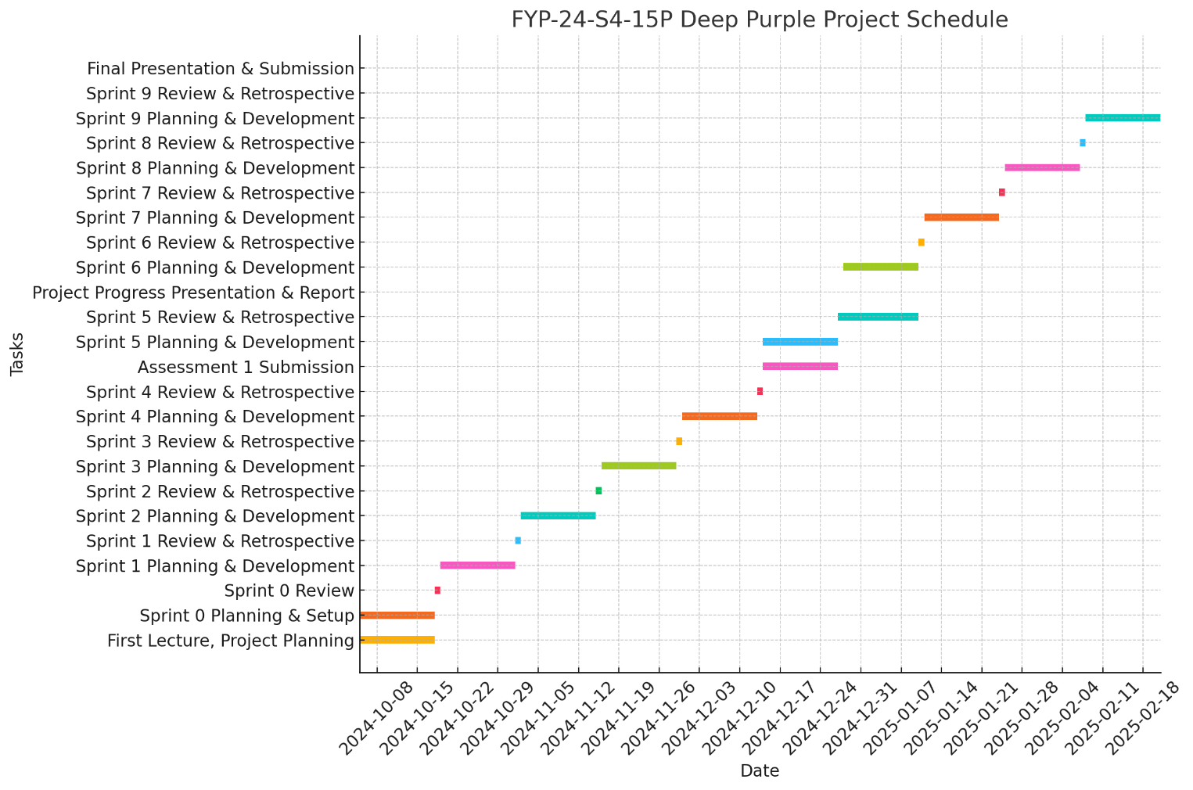

## References

Alvi, A., & Qureshi, M. R. N. (2021). *Information diffusion analysis in complex networks: a study of influencer and viral marketing on social media*. Social Network Analysis and Mining, 11(1), 1-12. https://link.springer.com/article/10.1007/s13278-021-00776-6. (Accessed: 20 October 2024).

*Jodie Shaw (2024) Leveraging Sentiment Analysis to Navigate Singapore’s Digital Dialogue. Available at: https://kadence.com/leveraging-sentiment-analysis-to-navigate-singapores-digital-dialogue/ (Accessed: 20 October 2024).*

*sitiatarfa8 (2024) Ai personalization: How ecommerce transform their business, Kitameraki. Available at: https://www.kitameraki.com/post/how-shopee-and-others-transforming-ecommerce-with-ai-personalization-strategies (Accessed: 20 October 2024).*

## Appendix

[This section contains all appendices that you have references somewhere in the body of your proposal.

This may include facilities as well as supporting material.]