Bahria University,

Karachi Campus



COURSE: SEN -448 SOFTWARE APPLICATION FOR MOBILE DEVICES

TERM: SPRING 2019, CLASS: BSE- 6 (B)

Submitted By:

Tandulkar 46150

(Name) (Reg. No.)

Submitted To:

Engr. Adnan ur Rehman/ Engr. Zohaib Shahzad

Signed Remarks: Score:

INDEX

|  |  |  |  |  |
| --- | --- | --- | --- | --- |
| SNO | DATE | LAB NO | LAB OBJECTIVE | SIGN |
| 1. | 5-2-19 | 1. | Introduction to Android Studio |  |
| 2. | 12-2-19 | 2. | Log and toast |  |
| 3. | 19-2-19 | 3. | Linear Layout View Group |  |
| 4. | 26-2-19 | 4. | Relative Layout View Group |  |
| 5. | 5-3-19 | 5. | Working with java |  |
| 6. | 12-3-19 | 6. | Intents |  |
| 7. | 19-3-19 | 7. | Custom objects |  |
| 8. | 2-4-19 | 8. | Start services |  |
| 9. | 9-4-19 | 9. | Services bound |  |
| 10. | 16-4-19 | 10. | Broadcast Receiver |  |
| 11. | 30-4-19 | 11. | Handler |  |
| 12. | 14-5-19 | 12. | Shared Preference |  |
|  |  |  |  |  |

**LAB1 – INTRODUCTION TO ANDROID STUDIO**

**TASK 1: Create Simple Hello World! App Run on android virtual device and on your android phone.**

**CODE:**

*<?***xml version="1.0" encoding="utf-8"***?>*<**android.support.constraint.ConstraintLayout xmlns:android="http://schemas.android.com/apk/res/android"  
 xmlns:app="http://schemas.android.com/apk/res-auto"  
 xmlns:tools="http://schemas.android.com/tools"  
 android:layout_width="match_parent"  
 android:layout_height="match_parent"  
 tools:context=".MainActivity"**>  
  
 <**TextView  
 android:layout_width="wrap_content"  
 android:layout_height="wrap_content"  
 android:text="Hello World!"  
 app:layout_constraintBottom_toBottomOf="parent"  
 app:layout_constraintLeft_toLeftOf="parent"  
 app:layout_constraintRight_toRightOf="parent"  
 app:layout_constraintTop_toTopOf="parent"** />  
  
</**android.support.constraint.ConstraintLayout**>

**OUTPUT:**

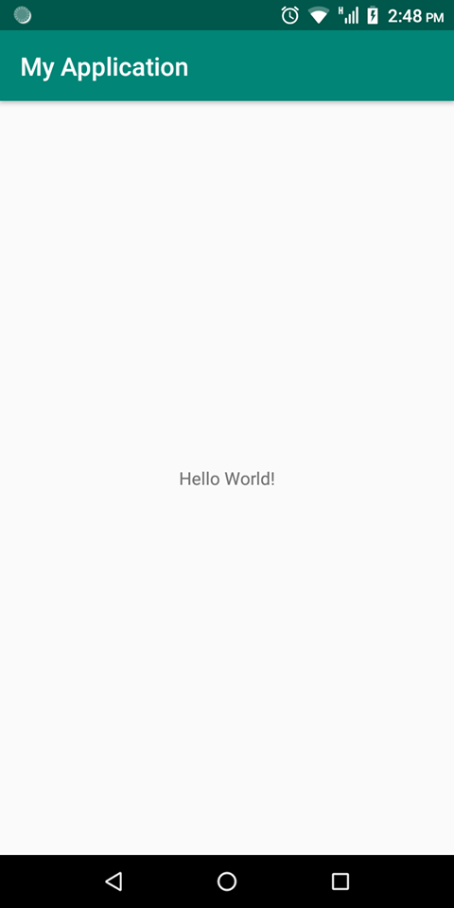

**On BlueStack:**

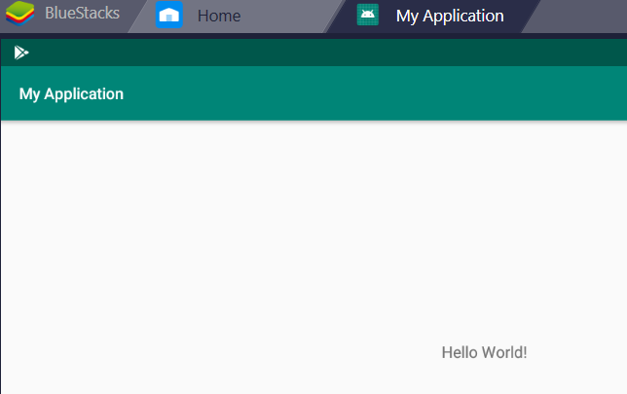

**TASK 2: Why we need separate folder for Assets and Resources if both folder are for same purpose?**

The real main difference between the two is that in the res directory each file is given a pre-compiled ID which can be accessed easily through R.id.[res id].

The assets directory is more like a file system and provides more freedom to put any file you would like in there.

**TASK 3: Explain the directory structure of simple Hello World app created in task 1.**

The first step is to create a simple Android Application using Android studio.

At the final stage it going to be open development tool to write the application code.

The main activity code is a Java file **MainActivity.java**. This is the actual application file which ultimately gets converted to a Dalvik executable and runs your application. Following is the default code generated by the application wizard for *Hello World!* Application

**public class** MainActivity **extends** AppCompatActivity {  
  
 @Override  
 **protected void** onCreate(Bundle savedInstanceState) {  
 **super**.onCreate(savedInstanceState);  
 setContentView(R.layout.***activity_main***);  
 }  
}

The **activity_main.xml** is a layout file available in *res/layout* directory, that is referenced by your application when building its interface. You will modify this file very frequently to change the layout of your application. For your "Hello World!" application, this file will have following content related to default layout

*<?***xml version="1.0" encoding="utf-8"***?>*<**android.support.constraint.ConstraintLayout  
 xmlns:android="http://schemas.android.com/apk/res/android"  
 xmlns:tools="http://schemas.android.com/tools"  
 xmlns:app="http://schemas.android.com/apk/res-auto"  
 android:layout_width="match_parent"  
 android:layout_height="match_parent"  
 tools:context=".MainActivity"**>  
  
 <**TextView  
 android:layout_width="wrap_content"  
 android:layout_height="wrap_content"  
 android:text="Hello World!"  
 app:layout_constraintBottom_toBottomOf="parent"  
 app:layout_constraintLeft_toLeftOf="parent"  
 app:layout_constraintRight_toRightOf="parent"  
 app:layout_constraintTop_toTopOf="parent"** />  
  
</**android.support.constraint.ConstraintLayout**>

**LAB2- LOG AND TOAST**

**TASK 1: Create a program which contains a textfield and a button and on click of the button method is called in which the number entered in textfield is multiplied by ‘3’ and the result generated is displayed using toast message.**

**CODE:**

**public class** MainActivity **extends** AppCompatActivity {  
 EditText **output**;  
 Button **toast**;  
 @Override  
 **protected void** onCreate(Bundle savedInstanceState) {  
 **super**.onCreate(savedInstanceState);  
 setContentView(R.layout.***activity_main***);  
 **toast**= (Button) findViewById(R.id.***button***);  
 }  
 **public void** increaseClicked(View v) {  
 **toast** = (Button) findViewById(R.id.***button***);  
 **output** = (EditText) findViewById(R.id.***output***);  
  
 **int** number = Integer.*parseInt*(**output**.getText().toString());  
 **int** product = number * 3;  
 Toast.*makeText*(MainActivity.**this**, Integer.*toString*(product), Toast.***LENGTH_LONG***).show();  
 }}

**OUTPUT:**

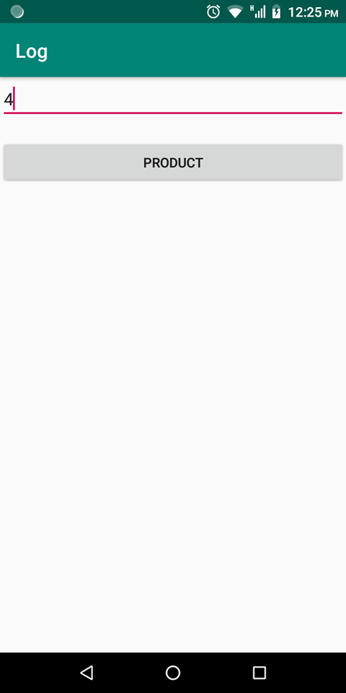

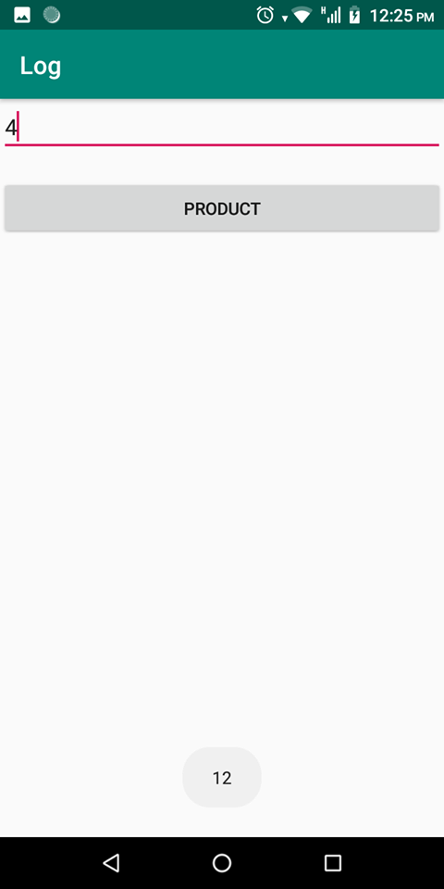

**TASK 2: Also call a function that will divide the number entered in textfield by 0. If successfully executed , the log should show info(log.i) else should show the exception (log.e).[use try catch]**

**CODE:**

**public void** something(View v) {

**try** {

**toast** = (Button) findViewById(R.id.***button***);

**output** = (EditText) findViewById(R.id.***output***);

**int** number = Integer.*parseInt*(**output**.getText().toString());

**int** product = number / 0;

Toast.*makeText*(MainActivity.**this**, Integer.*toString*(product), Toast.***LENGTH_LONG***).show();

Log.*i*(**"Info log"**, **"Button Clicked"**);

}

**catch** (Exception e) {

Log.*e*(***TAG***, **"Received an exception "** + e.getMessage());

Toast.*makeText*(**this**,e.getMessage(), Toast.***LENGTH_LONG***).show();

}

**OUTPUT:**

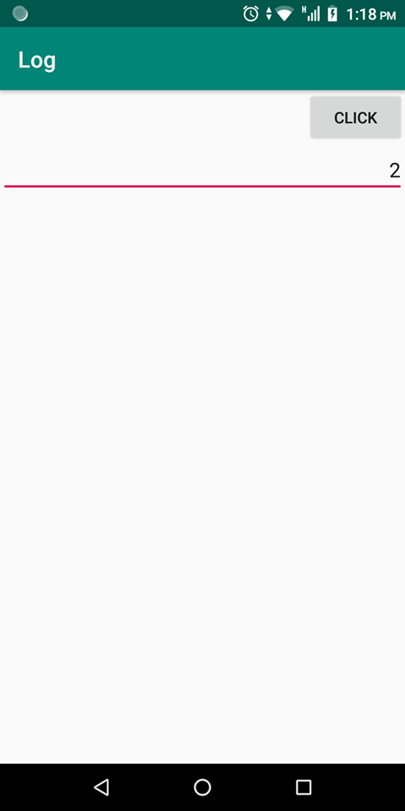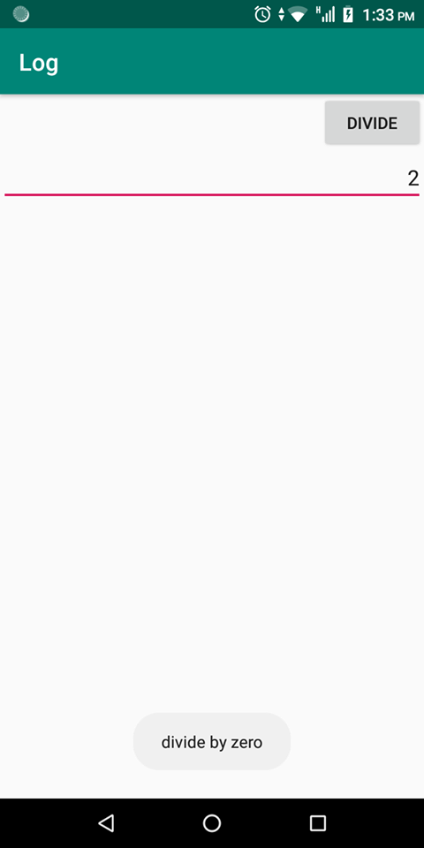

**LAB3 -** Linear Layout View Group

**TASK-01: Create vertical linear layout also apply weights.**

**Code:**

*<?***xml version="1.0" encoding="utf-8"***?>*<**LinearLayout xmlns:android="http://schemas.android.com/apk/res/android"  
 xmlns:app="http://schemas.android.com/apk/res-auto"  
 xmlns:tools="http://schemas.android.com/tools"  
 android:layout_width="match_parent"  
 android:layout_height="match_parent"  
 android:paddingLeft="16dp"  
 android:paddingRight="16dp"  
 android:orientation="vertical"** >  
 <**TextView  
  
 android:layout_width="match_parent"  
 android:layout_height="0dp"  
 android:layout_weight="2"  
 android:text="This is layout first with 50% width and height"  
 android:textColor="@android:color/black"  
 android:textSize="25dp"  
 android:background="#FFFF00"** />  
 <**TextView  
  
 android:layout_width="match_parent"  
 android:layout_height="0dp"  
 android:layout_weight="1"  
 android:text="This is layout second with 25% width and height"  
 android:textColor="@android:color/white"  
 android:textSize="25dp"  
 android:background="#0000FF"** />  
 <**TextView  
  
 android:layout_width="match_parent"  
 android:layout_height="0dp"  
 android:layout_weight="1"  
 android:text="This is layout third with 25% width and height"  
 android:textColor="@android:color/black"  
 android:textSize="25dp"  
 android:background="#008000"** />  
  
  
  
</**LinearLayout**>

**OUTPUT:**

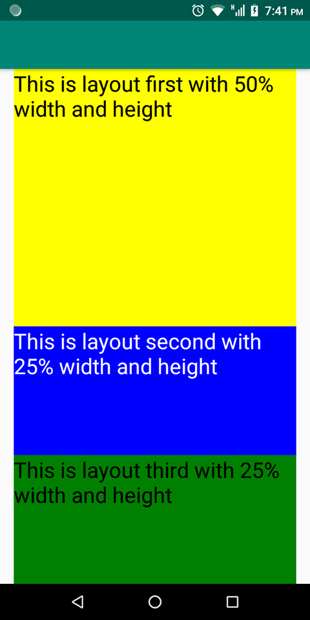

**TASK-02: Implement the design given below by using LinearLayout.**

**CODE:**

<?xml version="1.0" encoding="utf-8"?>  
<LinearLayout xmlns:android="http://schemas.android.com/apk/res/android"  
 xmlns:app="http://schemas.android.com/apk/res-auto"  
 xmlns:tools="http://schemas.android.com/tools"  
 android:layout_width="match_parent"  
 android:layout_height="wrap_content"  
 tools:context=".MainActivity"  
 android:orientation="vertical" >  
  
 <LinearLayout xmlns:android="http://schemas.android.com/apk/res/android"  
 xmlns:app="http://schemas.android.com/apk/res-auto"  
 xmlns:tools="http://schemas.android.com/tools"  
 android:layout_width="match_parent"  
 android:layout_height="wrap_content"  
 android:paddingTop="20dp"  
 android:orientation="horizontal" >  
  
  
 <TextView  
 android:layout_width="wrap_content"  
 android:layout_height="match_parent"  
 android:hint="0"  
 android:layout_weight="6" />  
  
  
  
  
  
 <ImageView  
 android:layout_width="wrap_content"  
 android:layout_height="wrap_content"  
 android:src="@drawable/cancel"  
 android:layout_weight="1"  
 />  
  
  
  
 </LinearLayout>  
  
 <LinearLayout xmlns:android="http://schemas.android.com/apk/res/android"  
 xmlns:app="http://schemas.android.com/apk/res-auto"  
 xmlns:tools="http://schemas.android.com/tools"  
 android:layout_width="match_parent"  
 android:layout_height="wrap_content"  
 android:orientation="horizontal" >  
  
 <ImageView  
 android:layout_width="wrap_content"  
 android:layout_height="wrap_content"  
 android:src="@drawable/a7"  
 android:layout_weight="2"  
 />  
  
  
 <ImageView  
 android:layout_width="wrap_content"  
 android:layout_height="wrap_content"  
 android:src="@drawable/a8"  
 android:layout_weight="2"  
 />  
  
  
 <ImageView  
 android:layout_width="wrap_content"  
 android:layout_height="wrap_content"  
 android:src="@drawable/a9"  
 android:layout_weight="2"  
 />  
  
  
 <ImageView  
 android:layout_width="wrap_content"  
 android:layout_height="wrap_content"  
 android:src="@drawable/aplus"  
 android:layout_weight="2"  
 />  
  
  
 </LinearLayout>  
 <LinearLayout xmlns:android="http://schemas.android.com/apk/res/android"  
 xmlns:app="http://schemas.android.com/apk/res-auto"  
 xmlns:tools="http://schemas.android.com/tools"  
 android:layout_width="match_parent"  
 android:layout_height="wrap_content"  
 android:orientation="horizontal" >  
  
 <ImageView  
 android:layout_width="wrap_content"  
 android:layout_height="wrap_content"  
 android:src="@drawable/a4"  
 android:layout_weight="2"  
 />  
  
  
 <ImageView  
 android:layout_width="wrap_content"  
 android:layout_height="wrap_content"  
 android:src="@drawable/a5"  
 android:layout_weight="2"  
 />  
  
  
 <ImageView  
 android:layout_width="wrap_content"  
 android:layout_height="wrap_content"  
 android:src="@drawable/a6"  
 android:layout_weight="2"  
 />  
  
  
 <ImageView  
 android:layout_width="wrap_content"  
 android:layout_height="wrap_content"  
 android:src="@drawable/aminus"  
 android:layout_weight="2"  
 />  
  
  
 </LinearLayout>  
 <LinearLayout xmlns:android="http://schemas.android.com/apk/res/android"  
 xmlns:app="http://schemas.android.com/apk/res-auto"  
 xmlns:tools="http://schemas.android.com/tools"  
 android:layout_width="match_parent"  
 android:layout_height="wrap_content"  
 android:orientation="horizontal" >  
  
 <ImageView  
 android:layout_width="wrap_content"  
 android:layout_height="wrap_content"  
 android:src="@drawable/a1"  
 android:layout_weight="2"  
 />  
  
  
 <ImageView  
 android:layout_width="wrap_content"  
 android:layout_height="wrap_content"  
 android:src="@drawable/a2"  
 android:layout_weight="2"  
 />  
  
  
 <ImageView  
 android:layout_width="wrap_content"  
 android:layout_height="wrap_content"  
 android:src="@drawable/a3"  
 android:layout_weight="2"  
 />  
  
  
 <ImageView  
 android:layout_width="wrap_content"  
 android:layout_height="wrap_content"  
 android:src="@drawable/astar"  
 android:layout_weight="2"  
 />  
  
  
  
 </LinearLayout>  
 <LinearLayout xmlns:android="http://schemas.android.com/apk/res/android"  
 xmlns:app="http://schemas.android.com/apk/res-auto"  
 xmlns:tools="http://schemas.android.com/tools"  
 android:layout_width="match_parent"  
 android:layout_height="wrap_content"  
 android:orientation="horizontal" >  
  
  
 <ImageView  
 android:layout_width="wrap_content"  
 android:layout_height="wrap_content"  
 android:src="@drawable/adot"  
 android:layout_weight="2"  
 />  
  
  
 <ImageView  
 android:layout_width="wrap_content"  
 android:layout_height="wrap_content"  
 android:src="@drawable/a0"  
 android:layout_weight="2"  
 />  
  
  
 <ImageView  
 android:layout_width="wrap_content"  
 android:layout_height="wrap_content"  
 android:src="@drawable/aequal"  
 android:layout_weight="2"  
 />  
  
  
 <ImageView  
 android:layout_width="wrap_content"  
 android:layout_height="wrap_content"  
 android:src="@drawable/adivide"  
 android:layout_weight="2"  
 />  
  
  
 </LinearLayout>

</LinearLayout>

**OUTPUT:**

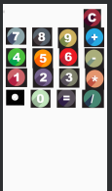

**LAB4 -** Relative Layout View Group

**TASK 1: Create Birthday Card Application.**

**CODE:**

*<?***xml version="1.0" encoding="utf-8"***?>*<**RelativeLayout xmlns:android="http://schemas.android.com/apk/res/android"  
 xmlns:app="http://schemas.android.com/apk/res-auto"  
 xmlns:tools="http://schemas.android.com/tools"  
 android:layout_width="match_parent"  
 android:layout_height="match_parent"  
 android:orientation="vertical"** >  
  
  
 <**ImageView  
 android:layout_width="match_parent"  
 android:layout_height="match_parent"  
 android:layout_weight="1"  
 android:src="@drawable/birthday"  
 android:layout_gravity="center"** />  
 <**TextView  
 android:layout_width="wrap_content"  
 android:layout_height="wrap_content"  
 android:text="Happy Birthday Alex !"  
 android:gravity="center"  
 android:textSize="30dp"** />  
 <**TextView  
 android:layout_width="wrap_content"  
 android:layout_height="wrap_content"  
 android:layout_alignParentRight="true"  
 android:layout_alignParentBottom="true"  
 android:text="From Robert"  
 android:textSize="30dp"** />  
  
  
 </**RelativeLayout**>

**OUTPUT:**

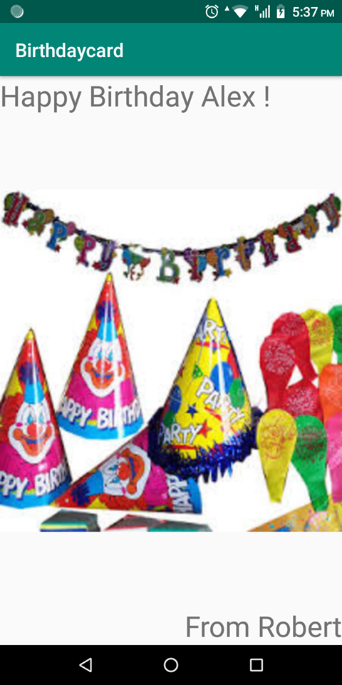

**TASK 2: Create Login Page.**

**CODE:**

<?xml version="1.0" encoding="utf-8"?>  
  
 <RelativeLayout xmlns:android="http://schemas.android.com/apk/res/android"  
 xmlns:app="http://schemas.android.com/apk/res-auto"  
 xmlns:tools="http://schemas.android.com/tools"  
 android:layout_width="match_parent"  
 android:layout_height="match_parent"  
 tools:layout_editor_absoluteX="167dp"  
 tools:layout_editor_absoluteY="355dp"  
 tools:context=".MainActivity"  
 >  
  
 <TextView  
 android:id="@+id/label"  
 android:layout_width="wrap_content"  
 android:layout_height="wrap_content"  
 android:layout_alignParentTop = "true"  
 android:layout_centerHorizontal = "true"  
 android:textSize = "49dp"  
 android:text="Sign In"  
 android:textColor = "#ff7aff24"  
 android:layout_marginTop = "80dp" />  
  
 <EditText  
 android:id="@+id/edituser"  
 android:layout_width="wrap_content"  
 android:layout_height="wrap_content"  
 android:layout_centerInParent="true"  
 android:inputType="textPassword"  
 android:layout_alignParentLeft = "true"  
 android:layout_alignParentStart = "true"  
 android:layout_alignParentRight = "true"  
 android:layout_alignParentEnd = "true"  
 android:hint = "Enter Name"  
 android:textColorHint = "#ffff25e6"  
 android:textSizeHint = "30dp"  
 android:focusable = "true"  
 android:layout_below = "@+id/label"  
 />  
  
 <EditText  
 android:id="@+id/editpass"  
 android:layout_width="wrap_content"  
 android:layout_height="wrap_content"  
 android:layout_alignParentLeft = "true"  
 android:layout_alignParentStart = "true"  
 android:layout_alignParentRight = "true"  
 android:layout_alignParentEnd = "true"  
 android:hint = "Enter password"  
 android:textColorHint = "#ffff25e6"  
 android:textSizeHint = "30dp"  
 android:focusable = "true"  
 android:layout_pading="70pd"  
  
 android:layout_below = "@+id/edituser" />  
  
 <Button  
 android:id="@+id/btnSignIn"  
 android:layout_width="wrap_content"  
 android:layout_height="wrap_content"  
 android:layout_centerInParent="true"  
 android:text="Login"  
 android:textSize = "30dp"  
  
 android:textColor = "#ff7aff24"  
 android:layout_below = "@+id/editpass"/>  
  
 </RelativeLayout>

**OUTPUT:**

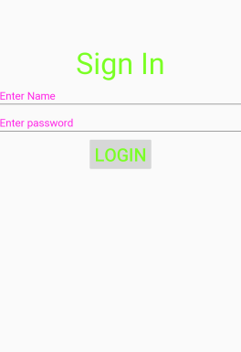

**LAB5 – WORKING WITH JAVA**

**TASK 1: Create a new design of calculator**

**CODE:**

<RelativeLayout xmlns:android="http://schemas.android.com/apk/res/android"  
 xmlns:tools="http://schemas.android.com/tools"  
 android:layout_width="match_parent"  
 android:layout_height="match_parent"  
 tools:context=".MainActivity">  
  
 <TextView  
 android:id="@+id/txtScreen"  
 android:layout_width="match_parent"  
 android:layout_height="wrap_content"  
 android:gravity="right"  
 android:textAppearance="?android:attr/textAppearanceLarge"  
  
 android:textSize="30dp"  
 android:background="#0000FF"  
 />  
 <TextView  
 android:id="@+id/txtInfo"  
 android:layout_width="match_parent"  
 android:layout_height="wrap_content"  
 android:gravity="right"  
 android:textAppearance="?android:attr/textAppearanceLarge"  
 android:textSize="30dp"  
  
 />  
  
 <LinearLayout  
 android:layout_width="match_parent"  
 android:layout_height="match_parent"  
 android:layout_below="@+id/txtScreen"  
 android:orientation="vertical">  
  
 <LinearLayout  
 android:layout_width="match_parent"  
 android:layout_height="0dp"  
 android:layout_weight="1">  
 <Button  
 android:id="@+id/btnSeven"  
 android:layout_width="wrap_content"  
 android:layout_height="wrap_content"  
 android:text="7" />  
 <Button  
 android:id="@+id/btnEight"  
 android:layout_width="wrap_content"  
 android:layout_height="wrap_content"  
 android:text="8" />  
 <Button  
 android:id="@+id/btnNine"  
 android:layout_width="wrap_content"  
 android:layout_height="wrap_content"  
 android:text="9"/>  
 <Button  
 android:id="@+id/btnDivide"  
 android:layout_width="wrap_content"  
 android:layout_height="wrap_content"  
 android:text="/"/>  
 </LinearLayout>  
  
 <LinearLayout  
 android:layout_width="match_parent"  
 android:layout_height="0dp"  
 android:layout_weight="1">  
 <Button  
 android:id="@+id/btnFour"  
 android:layout_width="wrap_content"  
 android:layout_height="wrap_content"  
 android:text="4"/>  
 <Button  
 android:id="@+id/btnFive"  
 android:layout_width="wrap_content"  
 android:layout_height="wrap_content"  
 android:text="5" />  
 <Button  
 android:id="@+id/btnSix"  
 android:layout_width="wrap_content"  
 android:layout_height="wrap_content"  
 android:text="6" />  
 <Button  
 android:id="@+id/btnMultiply"  
 android:layout_width="wrap_content"  
 android:layout_height="wrap_content"  
 android:text="*" />  
 </LinearLayout>  
  
 <LinearLayout  
 android:layout_width="match_parent"  
 android:layout_height="0dp"  
 android:layout_weight="1">  
 <Button  
 android:id="@+id/btnOne"  
 android:layout_width="wrap_content"  
 android:layout_height="wrap_content"  
 android:text="1" />  
 <Button  
 android:id="@+id/btnTwo"  
 android:layout_width="wrap_content"  
 android:layout_height="wrap_content"  
 android:text="2" />  
 <Button  
 android:id="@+id/btnThree"  
 android:layout_width="wrap_content"  
 android:layout_height="wrap_content"  
 android:text="3" />  
 <Button  
 android:id="@+id/btnSubtract"  
 android:layout_width="wrap_content"  
 android:layout_height="wrap_content"  
 android:text="-" />  
 </LinearLayout>  
  
 <LinearLayout  
 android:layout_width="match_parent"  
 android:layout_height="0dp"  
 android:layout_weight="1">  
 <Button  
 android:id="@+id/btnClear"  
 android:layout_width="wrap_content"  
 android:layout_height="wrap_content"  
 android:text="C" />  
 <Button  
 android:id="@+id/btnZero"  
 android:layout_width="wrap_content"  
 android:layout_height="wrap_content"  
 android:text="0" />  
 <Button  
 android:id="@+id/btnEquals"  
 android:layout_width="wrap_content"  
 android:layout_height="wrap_content"  
 android:text="=" />  
 <Button  
 android:id="@+id/btnAdd"  
 android:layout_width="wrap_content"  
 android:layout_height="wrap_content"  
 android:text="+"  
 android:onClick="add"  
 />  
 </LinearLayout>  
  
 </LinearLayout>  
</RelativeLayout>

**OUTPUT:**

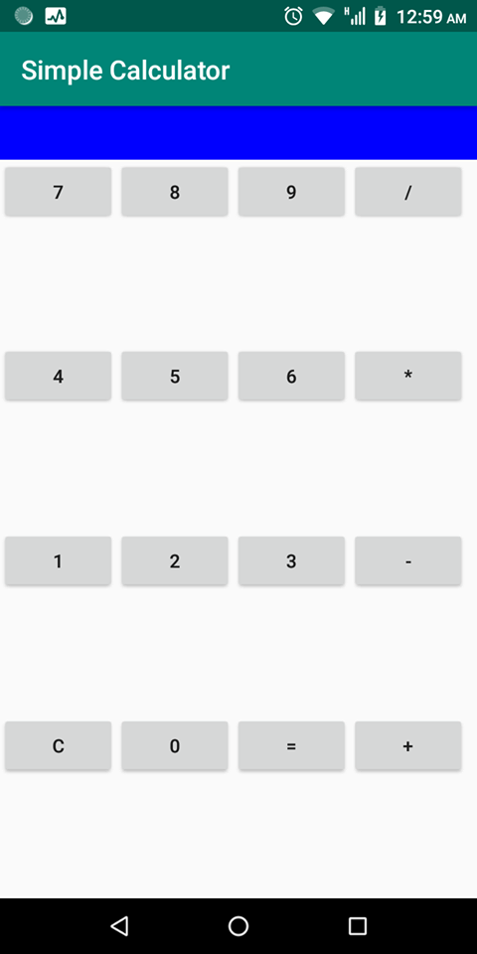

**TASK 2: Implement the complete functionality of Calculator designed in task one.**

**CODE:**

**package** com.example.calculator;

**import** android.support.v7.app.AppCompatActivity;  
**import** android.os.Bundle;  
**import** android.view.View;  
**import** android.widget.Button;  
**import** android.widget.TextView;  
  
**public class** MainActivity **extends** AppCompatActivity {  
 **private** Button **zero**;  
**private** Button **one**;  
**private** Button **two**;  
**private** Button **three**;  
 **private** Button **four**;  
 **private** Button **five**;  
 **private** Button **six**;  
 **private** Button **seven**;  
 **private** Button **eight**;  
 **private** Button **nine**;  
 **private** Button **add**;  
 **private** Button **sub**;  
 **private** Button **mul**;  
 **private** Button **div**;  
 **private** Button **equalsto**;  
 **private** Button **clear**;  
 **private** TextView **result**;  
 **private** TextView **info**;  
 **private final char ADDITION**= **'+'**;  
 **private final char SUBTRACTION**= **'-'**;  
 **private final char DIVISION**= **'/'**;  
 **private final char EQU**= 0;  
 **private final char MULTIPLICATION**= **'*'**;  
 **private double val1**=Double.***NaN***;  
 **private double val2**;  
 **private char ACTION**;  
  
@Override  
 **protected void** onCreate(Bundle savedInstanceState) {  
 **super**.onCreate(savedInstanceState);  
 setContentView(R.layout.***activity_main***);  
 **zero**=(Button)findViewById(R.id.***btnZero***);  
 **one**=(Button)findViewById(R.id.***btnOne***);  
 **two**=(Button)findViewById(R.id.***btnTwo***);  
 **three**=(Button)findViewById(R.id.***btnThree***);  
 **four**=(Button)findViewById(R.id.***btnFour***);  
 **five**=(Button)findViewById(R.id.***btnFive***);  
 **six**=(Button)findViewById(R.id.***btnSix***);  
 **seven**=(Button)findViewById(R.id.***btnSeven***);  
 **eight**=(Button)findViewById(R.id.***btnEight***);  
 **nine**=(Button)findViewById(R.id.***btnNine***);  
 **equalsto**=(Button) findViewById(R.id.***btnEquals***);  
 **clear**=(Button) findViewById(R.id.***btnClear***);  
 **result**=(TextView) findViewById(R.id.***txtScreen***);  
 **info**=(TextView) findViewById(R.id.***txtInfo***);  
  
 **zero**.setOnClickListener(**new** View.OnClickListener()  
 {  
 **public void** onClick(View v){  
 **info**.setText(**info**.getText().toString() + **"0"**);  
 }  
 });  
 **one**.setOnClickListener(**new** View.OnClickListener()  
 {  
 **public void** onClick(View v){  
 **info**.setText(**info**.getText().toString() + **"1"**);  
 }  
 });  
 **two**.setOnClickListener(**new** View.OnClickListener()  
 {  
 **public void** onClick(View v){  
 **info**.setText(**info**.getText().toString() + **"2"**);  
 }  
 });  
 **three**.setOnClickListener(**new** View.OnClickListener()  
 {  
 **public void** onClick(View v){  
 **info**.setText(**info**.getText().toString() + **"3"**);  
 }  
 });  
 **four**.setOnClickListener(**new** View.OnClickListener()  
 {  
 **public void** onClick(View v){  
 **info**.setText(**info**.getText().toString() + **"4"**);  
 }  
 });  
 **five**.setOnClickListener(**new** View.OnClickListener()  
 {  
 **public void** onClick(View v){  
 **info**.setText(**info**.getText().toString() + **"5"**);  
 }  
 });  
 **six**.setOnClickListener(**new** View.OnClickListener()  
 {  
 **public void** onClick(View v){  
 **info**.setText(**info**.getText().toString() + **"6"**);  
 }  
 });  
 **seven**.setOnClickListener(**new** View.OnClickListener()  
 {  
 **public void** onClick(View v){  
 **info**.setText(**info**.getText().toString() + **"7"**);  
 }  
 });  
 **eight**.setOnClickListener(**new** View.OnClickListener()  
 {  
 **public void** onClick(View v){  
 **info**.setText(**info**.getText().toString() + **"8"**);  
 }  
 });  
 **nine**.setOnClickListener(**new** View.OnClickListener()  
 {  
 **public void** onClick(View v){  
 **info**.setText(**info**.getText().toString() + **"9"**);  
 }  
 });  
 **add**.setOnClickListener(**new** View.OnClickListener()  
 {  
 **public void** onClick(View v){  
 compute();  
 **ACTION**=**ADDITION**;  
 **result**.setText(String.*valueOf*(**val1**) + **"+"**);  
 **info**.setText(**null**);  
 }  
 });  
 **sub**.setOnClickListener(**new** View.OnClickListener()  
 {  
 **public void** onClick(View v){  
 compute();  
 **ACTION**=**SUBTRACTION**;  
 **result**.setText(String.*valueOf*(**val1**) + **"-"**);  
 **info**.setText(**null**);  
 }  
 });  
 **mul**.setOnClickListener(**new** View.OnClickListener()  
 {  
 **public void** onClick(View v){  
 compute();  
 **ACTION**=**MULTIPLICATION**;  
 **result**.setText(String.*valueOf*(**val1**) + **"*"**);  
 **info**.setText(**null**);  
 }  
 });  
 **div**.setOnClickListener(**new** View.OnClickListener()  
 {  
 **public void** onClick(View v){  
 compute();  
 **ACTION**=**DIVISION**;  
 **result**.setText(String.*valueOf*(**val1**) + **"/"**);  
 **info**.setText(**null**);  
 }  
 });  
 **equalsto**.setOnClickListener(**new** View.OnClickListener()  
 {  
 **public void** onClick(View v){  
 compute();  
 **ACTION**=**EQU**;  
 **result**.setText(**result**.getText().toString() + String.*valueOf*(**val2**) + **"="** + String.*valueOf*(**val1**));  
 **info**.setText(**null**);  
 }  
 });  
 }  
 **private void** compute(){  
 **if**(!Double.*isNaN*(**val1**)){  
 **val2**=Double.*parseDouble*(**info**.getText().toString());  
 **switch**(**ACTION**){  
 **case ADDITION**:  
 **val1**=**val1**+**val2**;  
 **break**;  
 **case SUBTRACTION**:  
 **val1**=**val1**-**val2**;  
 **break**;  
 **case MULTIPLICATION**:  
 **val1**=**val1**\***val2**;  
 **break**;  
 **case DIVISION**:  
 **val1**=**val1**/**val2**;  
 **break**;  
 **case EQU**:  
 **break**;  
  
 }  
 }  
 **else**{  
 **val1**=Double.*parseDouble*(**info**.getText().toString());  
 }  
 }  
}

**OUTPUT:**

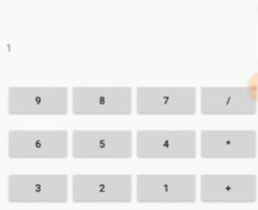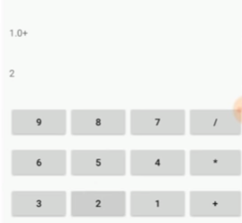

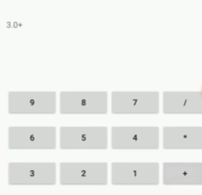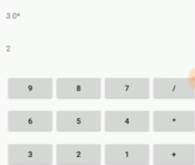

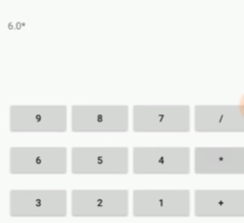

**LAB6 – INTENTS**

**TASK: Create an application which can take user-id and password from user, and if the credentials are valid then it shows “Login successful”, otherwise it shows “login failure” message.**

**Depending upon the user input, Login button must be enabled/disabled. You may use TextWatcher interface with addTextChangedListener() . When user pressed Login button user id and password must be passed to the SummaryActivity for authentication.**

**CODE:**

**package** com.example.loginintent;  
  
**import** android.content.Intent;  
**import** android.support.v7.app.AppCompatActivity;  
**import** android.os.Bundle;  
**import** android.text.Editable;  
**import** android.text.TextWatcher;  
**import** android.view.View;  
**import** android.widget.Button;  
**import** android.widget.EditText;  
**import** android.widget.TextView;  
  
**public class** MainActivity **extends** AppCompatActivity {  
 EditText **a**,**b**;  
 TextView **t**;  
Button **button**;  
  
 @Override  
 **protected void** onCreate(Bundle savedInstanceState) {  
 **super**.onCreate(savedInstanceState);  
 setContentView(R.layout.***activity_main***);  
 **a**=(EditText) findViewById(R.id.***username***);  
 **b**=(EditText) findViewById(R.id.***password***);  
 **t**=(TextView) findViewById(R.id.***tv***);  
 **button**=(Button) findViewById(R.id.***btn***);  
 **a**.addTextChangedListener(**loginTextWatcher**);  
 **b**.addTextChangedListener(**loginTextWatcher**);  
 }  
 **private** TextWatcher **loginTextWatcher** = **new** TextWatcher() {  
 @Override  
 **public void** beforeTextChanged(CharSequence s, **int** start, **int** count, **int** after) {  
  
 }  
  
 @Override  
 **public void** onTextChanged(CharSequence s, **int** start, **int** before, **int** count) {  
 String x= **a**.getText().toString().trim();  
 String y=**b**.getText().toString().trim();  
 **button**.setEnabled(!x.isEmpty() && !y.isEmpty());  
 }  
  
 @Override  
 **public void** afterTextChanged(Editable s) {  
  
 }  
 };  
 **public void** Check(View v){  
 String x= **a**.getText().toString();  
 String y=**b**.getText().toString();  
 **if**((x.equals(**"abc"**)) && (y.equals(**"xyz"**))){  
 Intent i=**new** Intent(**this**,login2.**class**);  
 startActivity(i);  
 }  
 **else**{  
 **t**.setText(**"Try Again"**);  
 }}}

**XML:**

*<?***xml version="1.0" encoding="utf-8"***?>*

<**LinearLayout**

**xmlns:android="http://schemas.android.com/apk/res/android"**

**xmlns:app="http://schemas.android.com/apk/res-auto"**

**xmlns:tools="http://schemas.android.com/tools"**

**android:layout_width="match_parent"**

**android:layout_height="match_parent"**

**tools:context=".MainActivity"**

**android:orientation="vertical"**

>

<**LinearLayout**

**xmlns:android="http://schemas.android.com/apk/res/android"**

**xmlns:app="http://schemas.android.com/apk/res-auto"**

**xmlns:tools="http://schemas.android.com/tools"**

**android:layout_width="match_parent"**

**android:layout_height="wrap_content"**

**android:orientation="horizontal"**

>

<**TextView**

**android:layout_height="wrap_content"**

**android:layout_width="wrap_content"**

**android:paddingTop="16dp"**

**android:paddingLeft="16dp"**

**android:text="Name:"**

/>

<**EditText**

**android:id="@+id/username"**

**android:layout_width="match_parent"**

**android:layout_height="wrap_content"**

**android:hint="Enter user name here"**

**android:paddingTop="16dp"**

**android:paddingLeft="16dp"**/>

</**LinearLayout**>

<**LinearLayout**

**xmlns:android="http://schemas.android.com/apk/res/android"**

**xmlns:app="http://schemas.android.com/apk/res-auto"**

**xmlns:tools="http://schemas.android.com/tools"**

**android:layout_width="match_parent"**

**android:layout_height="wrap_content"**

**android:orientation="horizontal"**

>

<**TextView**

**android:layout_height="wrap_content"**

**android:layout_width="wrap_content"**

**android:paddingTop="16dp"**

**android:paddingLeft="16dp"**

**android:text="Password:"**

/>

<**EditText**

**android:id="@+id/password"**

**android:layout_width="match_parent"**

**android:layout_height="wrap_content"**

**android:paddingTop="16dp"**

**android:hint="Enter password here"**

**android:paddingLeft="16dp"**/>

</**LinearLayout**>

<**Button**

**android:id="@+id/btn"**

**android:layout_width="wrap_content"**

**android:layout_height="wrap_content"**

**android:text="Login"**

**android:layout_marginTop="50dp"**

**android:layout_gravity="center"**

**android:onClick="Check"**

/>

<**TextView**

**android:id="@+id/tv"**

**android:layout_height="76dp"**

**android:layout_width="297dp"**

**android:paddingTop="16dp"**

**android:paddingLeft="16dp"**

**android:textSize="25sp"**

/>

</**LinearLayout**>

**OUTPUT:**

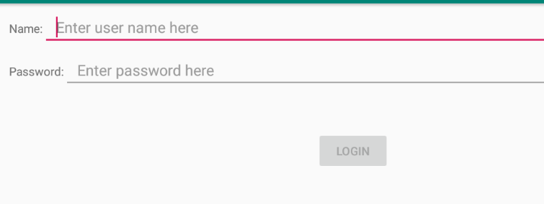

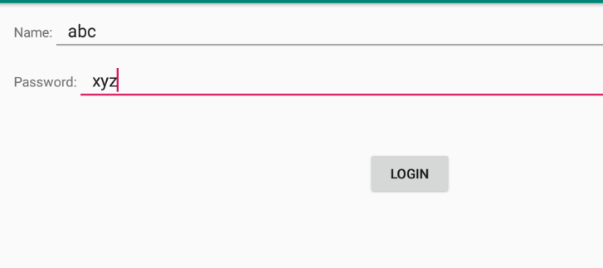

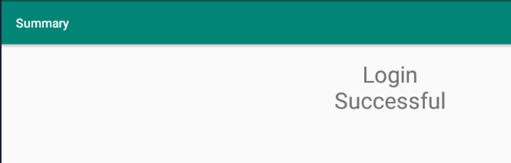

**LAB7-CUSTOM OBJECTS**

**Question#01**

Create an application which can manipulate a Clock object having hours, minutes and seconds as integer attributes..

**Activity_main.xml:**

<?xml version="1.0" encoding="utf-8"?>

<LinearLayout xmlns:android="http://schemas.android.com/apk/res/android"

xmlns:app="http://schemas.android.com/apk/res-auto"

xmlns:tools="http://schemas.android.com/tools"

android:layout_width="match_parent"

android:layout_height="match_parent"

android:orientation="vertical"

tools:context=".MainActivity">

<TextView

android:id="@+id/time"

android:layout_width="match_parent"

android:layout_height="wrap_content"

android:gravity="center"

android:layout_marginTop="20dp"

android:textSize="30dp"

android:text="00:00:00"/>

<RadioGroup

android:layout_width="match_parent"

android:layout_height="wrap_content">

<RadioButton

android:id="@+id/hr"

android:layout_width="wrap_content"

android:layout_height="wrap_content"

android:text="Hours"/>

<RadioButton

android:id="@+id/min"

android:layout_width="wrap_content"

android:layout_height="wrap_content"

android:text="Minutes"/>

<RadioButton

android:id="@+id/sec"

android:layout_width="wrap_content"

android:layout_height="wrap_content"

android:text="Seconds"/>

<Button

android:layout_width="wrap_content"

android:layout_height="wrap_content"

android:text="Update"

android:layout_gravity="center"

android:onClick="UpdateTime" />

</RadioGroup></LinearLayout>

**Activity_Update.xml:**

<LinearLayout xmlns:android="http://schemas.android.com/apk/res/android"

android:layout_height="match_parent"

tools:context=".UpdateActivity"

android:padding="20dp"

android:orientation="vertical">

<TextView

android:layout_width="match_parent"

android:layout_height="50dp" />

<Button

android:layout_marginTop="20dp"

android:layout_width="wrap_content"

android:layout_height="wrap_content"

android:onClick="updateBtn"

/>

</LinearLayout>

**MainActivity.java:**package com.example.myapplication;

import android.app.Instrumentation;

import android.content.Intent;

import android.support.annotation.Nullable;

import android.support.v7.app.AppCompatActivity;

import android.os.Bundle;

import android.view.View;

import android.widget.RadioButton;

import android.widget.TextView;

import java.io.Serializable;

public class MainActivity extends AppCompatActivity {

RadioButton radId[];

TextView txt;

Intent i;

Time t;

@Override

protected void onCreate(Bundle savedInstanceState) {

super.onCreate(savedInstanceState);

setContentView(R.layout.activity_main);

i = new Intent(getApplicationContext(),UpdateActivity.class);

txt = (TextView)findViewById(R.id.time);

radId = new RadioButton[] {

(RadioButton)findViewById(R.id.hr),

(RadioButton)findViewById(R.id.min),

(RadioButton)findViewById(R.id.sec)

};

t = new Time();

}

public void UpdateTime(View v){

Integer code = 0;

if (radId[0].isChecked()){

code = 1;

}

else if (radId[1].isChecked()){

code = 2;

}

else if (radId[2].isChecked()){

code = 3;

}

Bundle b = new Bundle();

b.putSerializable("time", (Serializable) t);

startActivityForResult(i,code);

}

public void onActivityResult(int requestCode, int resultCode, Intent data){

}

}

class Time{

private Integer hr;

private Integer min;

private Integer sec;

public void setHr(Integer hr){

this.hr = hr;

}

public void setMin(Integer min){

this.min = min;

}

public void setSec(Integer sec){

this.sec = sec;

}

public String getTime(){

return hr.toString() + ":" + min.toString() + ":" + sec.toString();

}

}

**UpdateActivity.java**

package com.example.myapplication;

import android.content.Intent;

import android.support.v7.app.AppCompatActivity;

import android.os.Bundle;

import android.view.View;

public class UpdateActivity extends AppCompatActivity {

Time t;

Intent i;

@Override

protected void onCreate(Bundle savedInstanceState) {

super.onCreate(savedInstanceState);

setContentView(R.layout.activity_update);

i = getIntent();

t = (Time) i.getSerializableExtra("time");

}

public void updateBtn(View v){

}

}

**Output:**

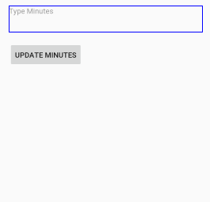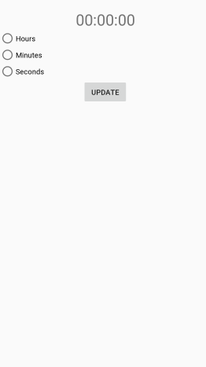

**LAB8- START SERVICES**

**Question#01**

Create an application which can demonstrate all callbacks of a started service.

**Activity_main.xml:**

*<?*xml version="1.0" encoding="utf-8"*?>*<RelativeLayout xmlns:android="http://schemas.android.com/apk/res/android"  
 xmlns:app="http://schemas.android.com/apk/res-auto"  
 xmlns:tools="http://schemas.android.com/tools"  
 android:layout_width="match_parent"  
 android:background="@drawable/background"  
 android:layout_height="match_parent"  
 tools:context=".MainActivity">  
 <LinearLayout  
 android:layout_width="match_parent"  
 android:layout_height="match_parent"  
 android:orientation="vertical">  
 <Button  
 android:id="@+id/button"  
 android:layout_width="280dp"  
 android:layout_height="wrap_content"  
 android:layout_alignParentTop="true"  
 android:layout_gravity="center"  
 android:layout_marginTop="239dp"  
 android:onClick="startService"  
 android:text="Start Service" />  
 <Button  
 android:id="@+id/button2"  
 android:layout_width="280dp"  
 android:layout_height="wrap_content"  
 android:layout_alignParentTop="true"  
 android:layout_gravity="center"  
 android:gravity="center"  
 android:layout_marginTop="20dp"  
 android:onClick="stopService"  
 android:text="Stop Service" />  
 </LinearLayout>  
</RelativeLayout>

**MainActivity.java:**package com.example.lab07_task01;  
import android.content.Intent;  
import android.support.v7.app.AppCompatActivity;  
import android.os.Bundle;  
import android.view.View;  
import android.view.View.OnClickListener;  
import android.widget.Button;  
public class MainActivity extends AppCompatActivity implements View.OnClickListener {  
 private Button start,stop;  
 protected void onCreate(Bundle savedInstanceState){  
 super.onCreate(savedInstanceState);  
 setContentView(R.layout.*activity_main*);  
 start=(Button)findViewById(R.id.*button*);  
 stop=(Button)findViewById(R.id.*button2*);  
 start.setOnClickListener(this);  
 }  
public void onClick(View v) {  
 if(v == start){  
 startService(new Intent(this,MyService.class));  
 }  
 else if(v==stop){  
 stopService(new Intent(this,MyService.class));  
 } }  
}

**MyService.java**

package com.example.lab07_task01;  
  
import android.app.Service;  
import android.content.Intent;  
import android.media.MediaPlayer;  
import android.os.IBinder;  
import android.provider.Settings;  
  
public class MyService extends Service {  
  
 MediaPlayer player;  
 public IBinder onBind(Intent intent) {  
 return null;  
 }  
  
 @Override  
 public int onStartCommand(Intent intent, int flags, int startId) {  
 player=MediaPlayer.*create*(this, Settings.System.*DEFAULT_RINGTONE_URI*);  
 player.setLooping(true);  
 player.start();  
 return *START_STICKY*;  
 }  
public void onDestroy() {  
 super.onDestroy();  
 player.stop();  
 }  
}

**Output:**

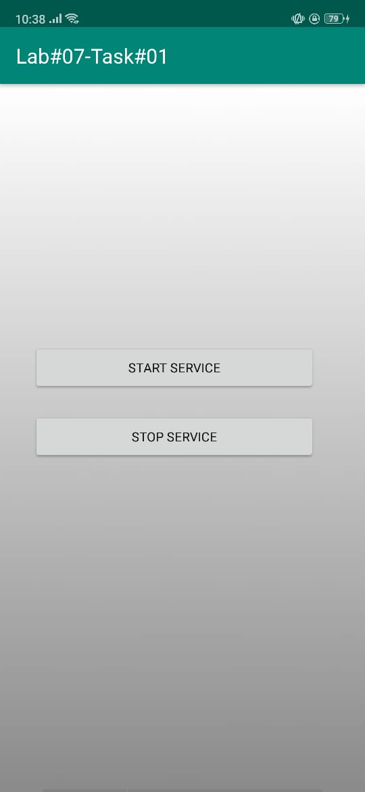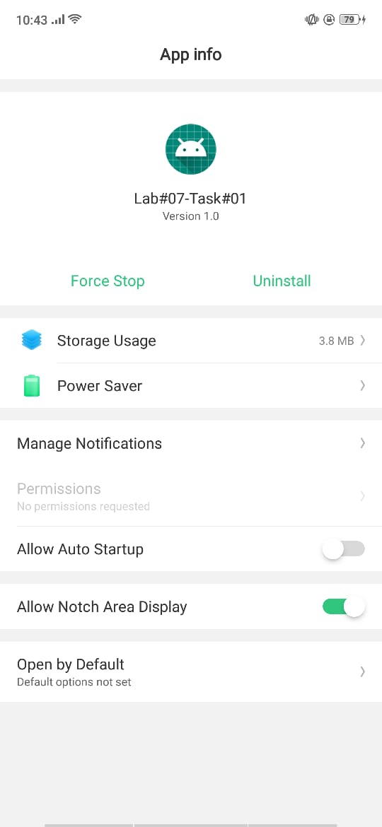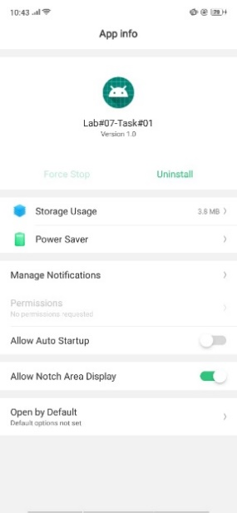

**Question#02**

Create Started service that use android MediaPlayer class with default Settings of device.

**Activity_main.xml:**

*<?*xml version="1.0" encoding="utf-8"*?>*<RelativeLayout xmlns:android="http://schemas.android.com/apk/res/android"  
 xmlns:app="http://schemas.android.com/apk/res-auto"  
 xmlns:tools="http://schemas.android.com/tools"  
 android:layout_width="match_parent"  
 android:background="@drawable/background"  
 android:layout_height="match_parent"  
 tools:context=".MainActivity">  
 <LinearLayout  
 android:layout_width="match_parent"  
 android:layout_height="match_parent"  
 android:orientation="vertical">  
 <Button  
 android:id="@+id/button"  
 android:layout_width="280dp"  
 android:layout_height="wrap_content"  
 android:layout_alignParentTop="true"  
 android:layout_gravity="center"  
 android:layout_marginTop="239dp"  
 android:onClick="startService"  
 android:text="Start Service" />  
 <Button  
 android:id="@+id/button2"  
 android:layout_width="280dp"  
 android:layout_height="wrap_content"  
 android:layout_alignParentTop="true"  
 android:layout_gravity="center"  
 android:gravity="center"  
 android:layout_marginTop="20dp"  
 android:onClick="stopService"  
 android:text="Stop Service" />  
 </LinearLayout>  
</RelativeLayout>

**MainActivity.java:**package com.example.lab07_task01;  
import android.content.Intent;  
import android.support.v7.app.AppCompatActivity;  
import android.os.Bundle;  
import android.view.View;  
import android.view.View.OnClickListener;  
import android.widget.Button;  
public class MainActivity extends AppCompatActivity implements View.OnClickListener {  
 private Button start,stop;  
 protected void onCreate(Bundle savedInstanceState){  
 super.onCreate(savedInstanceState);  
 setContentView(R.layout.*activity_main*);  
 start=(Button)findViewById(R.id.*button*);  
 stop=(Button)findViewById(R.id.*button2*);  
 start.setOnClickListener(this);  
 }  
public void onClick(View v) {  
 if(v == start){  
 startService(new Intent(this,MyService.class));  
 }  
 else if(v==stop){  
 stopService(new Intent(this,MyService.class));  
 } }  
}

**MyService.java**

package com.example.lab07_task01;  
  
import android.app.Service;  
import android.content.Intent;  
import android.media.MediaPlayer;  
import android.os.IBinder;  
import android.provider.Settings;  
public class MyService extends Service {  
 MediaPlayer player;  
 public IBinder onBind(Intent intent) {  
 return null;  
 }  
  
 @Override  
 public int onStartCommand(Intent intent, int flags, int startId) {  
 player=MediaPlayer.*create*(this, Settings.System.*DEFAULT_RINGTONE_URI*);  
 player.setLooping(true);  
 player.start();  
 return *START_STICKY*;  
 }  
public void onDestroy() {  
 super.onDestroy();  
 player.stop();  
 }  
}

**Output:**



**LAB9- SERVICE BOUND**

**Question#01**

Create an application which can demonstrate all callbacks of a started service.

**Activity_main.xml:**

*<?*xml version="1.0" encoding="utf-8"*?>*<LinearLayout  
 xmlns:android="http://schemas.android.com/apk/res/android"  
 xmlns:tools="http://schemas.android.com/tools"  
 xmlns:app="http://schemas.android.com/apk/res-auto"  
 android:layout_width="match_parent"  
 android:orientation="vertical"  
 android:layout_height="match_parent"  
 tools:context=".MainActivity">  
  
 <LinearLayout  
 android:layout_width="wrap_content"  
 android:layout_height="wrap_content"  
 android:textAlignment="center"  
 android:paddingTop="200dp"  
 android:layout_gravity="center|center_horizontal"  
 >  
 <EditText  
 android:id="@+id/editText2"  
 android:layout_margin="5px"  
 android:layout_width="150dp"  
 android:layout_height="wrap_content"  
 android:ems="10"  
 android:inputType="textPersonName" />  
  
   
 <TextView  
 android:layout_width="wrap_content"  
 android:layout_height="wrap_content"  
 android:text="+"  
 android:padding="10dp"  
 app:layout_constraintBottom_toBottomOf="parent"  
 app:layout_constraintLeft_toLeftOf="parent"  
 app:layout_constraintRight_toRightOf="parent"  
 app:layout_constraintTop_toTopOf="parent" />  
  
 <EditText  
 android:id="@+id/editText1"  
 android:layout_margin="5px"  
 android:layout_width="150dp"  
 android:layout_height="wrap_content"  
 android:ems="10"  
 android:inputType="textPersonName" />  
 </LinearLayout>  
   
 <Button  
 android:id="@+id/button3"  
 android:layout_width="match_parent"  
 android:layout_height="wrap_content"  
 android:text="Answer "  
   
 />  
  
 <LinearLayout  
 android:layout_width="wrap_content"  
 android:layout_height="wrap_content"  
 android:textAlignment="center"  
 android:paddingTop="200dp"  
 android:layout_gravity="center|center_horizontal"  
 >  
 <EditText  
 android:id="@+id/editText5"  
 android:layout_margin="5px"  
 android:layout_width="150dp"  
 android:layout_height="wrap_content"  
 android:ems="10"  
 android:text="5"  
 android:textAlignment="center"  
 android:inputType="textPersonName" />  
  
 </LinearLayout>  
  
</LinearLayout>

**MainActivity.java:**package com.example.lab9;  
  
import android.content.ComponentName;  
import android.content.Context;  
import android.content.Intent;  
import android.content.ServiceConnection;  
import android.os.IBinder;  
import android.support.v7.app.AppCompatActivity;  
import android.os.Bundle;  
import android.view.View;  
import android.widget.EditText;  
import android.widget.TextView;  
import android.widget.Toast;  
  
import com.example.myapplication.R;  
  
public class MainActivity extends AppCompatActivity {  
  
 MyService myservice;  
 boolean bound=false;  
  
 @Override  
 protected void onCreate(Bundle savedInstanceState) {  
 super.onCreate(savedInstanceState);  
 setContentView(R.layout.*activity_main*);  
 }  
  
 @Override  
 protected void onStart()  
 {  
 super.onStart();  
 Intent i=new Intent(getApplicationContext(),MyService.class);  
 bindService(i,connection, Context.*BIND_AUTO_CREATE*);  
 }  
  
 @Override  
 protected void onStop()  
 {  
 super.onStop();  
 if(bound)  
 {  
 unbindService(connection);  
 bound=false;  
 }  
 }  
  
 private ServiceConnection connection=new ServiceConnection()  
 {  
 @Override  
 public void onServiceConnected(ComponentName name, IBinder service) {  
 MyService.LocalBinder binder=(MyService.LocalBinder) service;  
 myservice=binder.getService();  
 bound=true;  
 }  
  
 @Override  
 public void onServiceDisconnected(ComponentName name) {  
 bound=false;  
 }  
 };  
  
 public void calculate(View view)  
 {  
 if(bound)  
 {  
 EditText a=findViewById(R.id.a);  
 EditText b=findViewById(R.id.b);  
 TextView ans=findViewById(R.id.answer);  
 int aa=Integer.*parseInt*(a.getText().toString());  
 int bb=Integer.*parseInt*(b.getText().toString());  
 int num=myservice.calculate(aa,bb);  
 ans.setText(num);  
 Toast.*makeText*(this,num,Toast.*LENGTH_LONG*).show();  
 }  
 }  
}

**Output:**

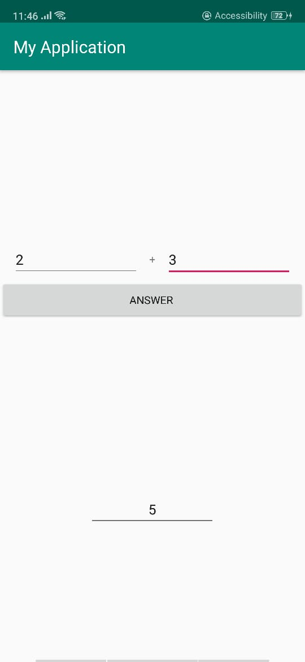

**LAB10- BROADCAST RECEIVER**

**Question#01**

Create an application which can send broadcast to the DebugConsole (above application).

**Activity_main.xml:**

*<?*xml version="1.0" encoding="utf-8"*?>*

<RelativeLayout xmlns:android="http://schemas.android.com/apk/res/android"  
 xmlns:app="http://schemas.android.com/apk/res-auto"  
 xmlns:tools="http://schemas.android.com/tools"  
 android:layout_width="match_parent"  
 android:paddingRight="16dp"  
 android:paddingTop="16dp"  
 android:paddingBottom="16dp"  
 android:background="@drawable/background"  
 android:layout_height="match_parent"  
 tools:context=".MainActivity">

<LinearLayout  
 android:layout_margin="30dp"  
 android:layout_width="match_parent"  
 android:layout_height="match_parent"  
 android:orientation="vertical">

<EditText  
 android:id="@+id/debugMessage"  
 android:layout_width="match_parent"  
 android:layout_height="wrap_content"  
 android:inputType="textPersonName"  
 android:layout_gravity="center"  
 android:hint="Debug message goes here “ />

<Button  
 android:layout_width="match_parent"  
 android:layout_height="wrap_content"  
 android:layout_gravity="center"  
 android:onClick="onBtnSend"  
 android:text="Send"  
 tools:layout_editor_absoluteX="16dp"  
 tools:layout_editor_absoluteY="73dp" />

</LinearLayout>

</RelativeLayout>

**MainActivity.java:**

package com.example.lab07_task02;

import android.content.BroadcastReceiver;  
import android.content.ComponentName;  
import android.content.Context;  
import android.content.Intent;  
import android.content.IntentFilter;  
import android.content.ServiceConnection;  
import android.os.IBinder;  
import android.support.v7.app.AppCompatActivity;  
import android.os.Bundle;  
import android.view.View;  
import android.widget.EditText;  
import android.widget.TextView;  
import android.widget.Toast;

public class MainActivity extends AppCompatActivity {  
 EditText msg;  
 protected void onCreate(Bundle savedInstanceState) {  
 super.onCreate(savedInstanceState);  
 setContentView(R.layout.*activity_main*);  
 msg=(EditText) findViewById(R.id.*debugMessage*);  
 BroadcastReceiver br=new BroadcastReceiver() {  
 public void onReceive(Context context, Intent intent) {  
 String s=intent.getStringExtra("info");  
 Toast.*makeText*(getApplicationContext(), s, Toast.*LENGTH_SHORT*).show();  
 }  
 };  
 IntentFilter filter =new IntentFilter("DEBUG_INFO");  
 registerReceiver(br,filter);  
 }  
 public void onBtnSend(View v) {  
 Intent intent = new Intent();  
 intent.putExtra("info", msg.getText().toString());  
 intent.setAction("DEBUG_INFO");  
 sendBroadcast(intent);  
 }}

**Output:**

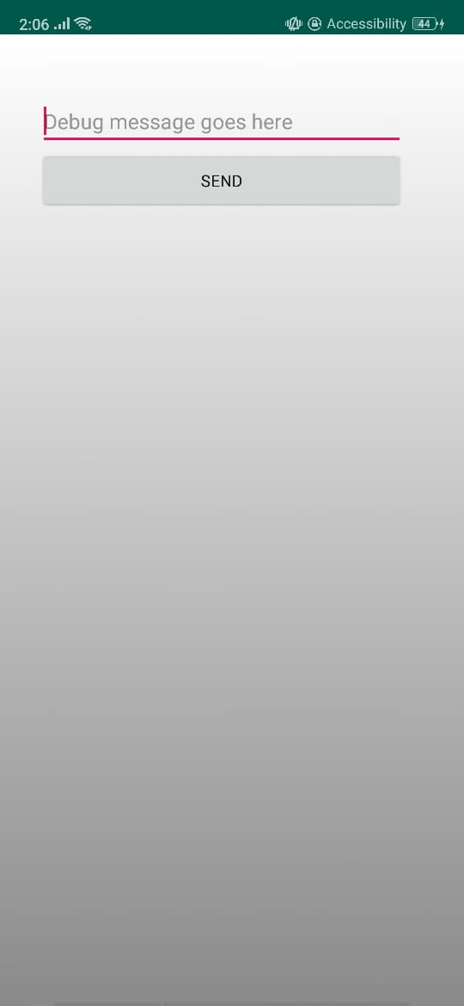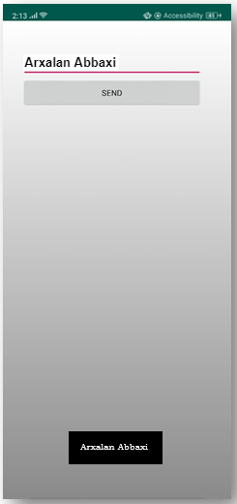

**LAB11- HANDLER**

**Creating Splash Screen & LogIn of Our Project “GupShup” using Android Handler:**

**Step#01:** GitHub Commits and Push of Splash Screen & LogIn of Our Project “GupShup”:

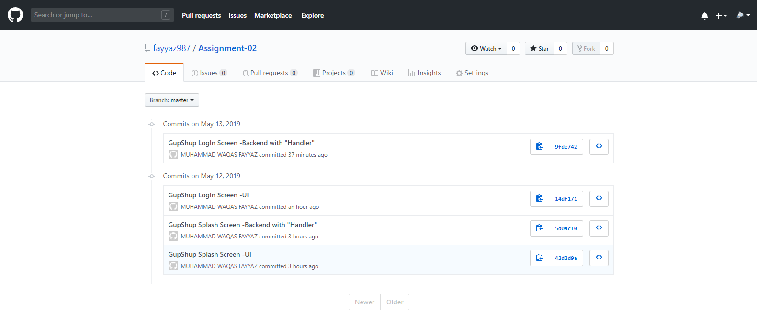

**Step#02:** .xml code of Splash Screen of “GupShup”:

*<?*xml version="1.0" encoding="utf-8"*?>*<RelativeLayout xmlns:android="http://schemas.android.com/apk/res/android"  
 xmlns:app="http://schemas.android.com/apk/res-auto"  
 xmlns:tools="http://schemas.android.com/tools"  
 android:layout_width="match_parent"  
 android:layout_height="match_parent"  
 android:background="#fff"  
 tools:context=".MainActivity">  
  
 <ImageView  
 android:layout_width="381dp"  
 android:layout_height="317dp"  
 android:src="@drawable/messenger"  
 android:layout_centerHorizontal="true"  
 />  
 <TextView  
 android:layout_width="wrap_content"  
 android:layout_height="wrap_content"  
 android:text="GupShup"  
 android:textSize="90px"  
 android:textColor="#594BC0"  
 app:layout_constraintBottom_toBottomOf="parent"  
 app:layout_constraintLeft_toLeftOf="parent"  
 app:layout_constraintRight_toRightOf="parent"  
 app:layout_constraintTop_toTopOf="parent"  
 android:fontFamily="sans-serif-smallcaps"  
 android:layout_centerHorizontal="true"  
 android:layout_centerVertical="true"  
 android:textStyle="bold"  
 />  
 <TextView  
 android:id="@+id/text"  
 android:paddingTop="1000px"  
 android:layout_width="wrap_content"  
 android:layout_height="wrap_content"  
 android:text="Bring Strong Connection!"  
 android:textSize="50px"  
 android:textColor="#73CADE"  
 app:layout_constraintBottom_toBottomOf="parent"  
 app:layout_constraintLeft_toLeftOf="parent"  
 app:layout_constraintRight_toRightOf="parent"  
 app:layout_constraintTop_toTopOf="parent"  
 android:fontFamily="cursive"  
 android:layout_centerHorizontal="true"  
 android:textStyle="bold"  
 />  
 <pl.droidsonroids.gif.GifImageView  
 android:layout_width="wrap_content"  
 android:layout_height="wrap_content"  
 android:layout_alignParentEnd="true"  
 android:layout_alignParentRight="true"  
 android:layout_marginEnd="0dp"  
 android:layout_marginRight="0dp"  
 android:paddingTop="390dp"  
 android:src="@drawable/source" />  
  
</RelativeLayout>

**Step#03:** .xml code of LogIn of “GupShup”:

*<?*xml version="1.0" encoding="utf-8"*?>*<RelativeLayout xmlns:android="http://schemas.android.com/apk/res/android"  
 xmlns:app="http://schemas.android.com/apk/res-auto"  
 xmlns:tools="http://schemas.android.com/tools"  
 android:layout_width="match_parent"  
 android:layout_height="match_parent"  
 android:background="#fff"  
 tools:context=".HomeActivity">

<RelativeLayout  
 android:layout_width="match_parent"  
 android:layout_height="wrap_content">  
  
 <ImageView  
 android:id="@+id/login_image"  
 android:layout_width="match_parent"  
 android:layout_height="250dp"  
 android:src="@drawable/messenger1"  
 android:layout_alignParentStart="true"  
 android:layout_alignParentTop="true"  
 android:scaleType="fitCenter"  
 android:layout_alignParentLeft="true" />  
 <TextView  
 android:id="@+id/t1"  
 android:layout_width="wrap_content"  
 android:layout_height="wrap_content"  
 android:text="GupShup"  
 android:textSize="90px"  
 android:textColor="#594BC0"  
 android:fontFamily="sans-serif-smallcaps"  
 android:layout_below="@+id/login_image"  
 android:layout_centerHorizontal="true"  
 android:textStyle="bold"  
 />  
 <TextView  
 android:id="@+id/text"  
 android:layout_below="@+id/t1"  
 android:layout_width="wrap_content"  
 android:layout_height="wrap_content"  
 android:text="Bring Strong Connection!"  
 android:textSize="50px"  
 android:textColor="#73CADE"  
 android:fontFamily="cursive"  
 android:layout_centerHorizontal="true"  
 android:textStyle="bold"  
 />  
 <EditText  
 android:layout_below="@+id/text"  
 android:id="@+id/login_email"  
 android:layout_width="match_parent"  
 android:layout_height="wrap_content"  
 android:layout_alignParentStart="true"  
 android:hint="samiwaqas123@gmail.com"  
 android:textColorHint="#594BC0"  
 android:inputType="text"  
 android:background="#fff"  
 android:textColor="#594BC0"  
 android:padding="4dp"  
 android:drawableStart="@drawable/email"  
 android:layout_marginTop="30dp"  
 android:layout_marginLeft="17dp"  
 android:layout_marginRight="17dp"  
 android:drawableLeft="@drawable/email"  
 android:layout_alignParentLeft="true" />

<EditText  
 android:id="@+id/login_password"  
 android:layout_width="match_parent"  
 android:layout_height="wrap_content"  
 android:layout_alignParentStart="true"  
 android:layout_below="@+id/login_email"  
 android:hint=" Password..."  
 android:textColorHint="#594BC0"  
 android:inputType="textPassword"  
 android:background="#fff"  
 android:textColor="#594BC0"  
 android:padding="4dp"  
 android:drawableStart="@drawable/password"  
 android:layout_marginTop="30dp"  
 android:layout_marginLeft="17dp"  
 android:layout_marginRight="17dp"  
 android:drawableLeft="@drawable/password"  
 android:layout_alignParentLeft="true" />  
  
 <TextView  
 android:id="@+id/forget_password_link"  
 android:layout_width="match_parent"  
 android:layout_height="wrap_content"  
 android:layout_centerHorizontal="true"  
 android:layout_below="@+id/login_password"  
 android:text="Forget Password ?"  
 android:layout_marginTop="2dp"  
 android:layout_marginLeft="15dp"  
 android:layout_marginRight="23dp"  
 android:textAlignment="textEnd"  
 android:textSize="17sp"  
 android:textStyle="bold"  
 android:textColor="@color/colorPrimaryDark"  
 android:gravity="end" />  
  
 <Button  
 android:id="@+id/button4"  
 android:layout_width="match_parent"  
 android:layout_height="wrap_content"  
 android:layout_below="@+id/forget_password_link"  
 android:padding="20dp"  
 android:layout_marginTop="60dp"  
 android:layout_marginLeft="19dp"  
 android:layout_marginRight="19dp"  
 android:text="Login"  
 android:textAllCaps="false"  
 android:textSize="24sp"  
 android:textColor="@android:color/background_light"  
 />  
  
 </RelativeLayout>  
  
  
  
  
</RelativeLayout>

**Step#05:** .java code of Splash Screen of “GupShup”:

package com.example.handler_assignment02;  
  
import android.content.Intent;  
import android.os.Handler;  
import android.support.v7.app.AppCompatActivity;  
import android.os.Bundle;  
  
public class MainActivity extends AppCompatActivity {  
 private static int *SPLASH_TIME_OUT*=4000;  
 @Override  
 protected void onCreate(Bundle savedInstanceState) {  
 super.onCreate(savedInstanceState);  
 setContentView(R.layout.*activity_main*);  
 new Handler().postDelayed(new Runnable() {  
 @Override  
 public void run() {  
 Intent intent=new Intent(MainActivity.this,HomeActivity.class);  
 startActivity(intent);  
 }  
 },*SPLASH_TIME_OUT*);  
  
  
 }  
}

**Step#06:** .java code of Log In of “GupShup”:

package com.example.handler_assignment02;  
  
import android.os.Build;  
import android.os.Handler;  
import android.support.annotation.RequiresApi;  
import android.support.v7.app.AppCompatActivity;  
import android.os.Bundle;  
import android.view.View;  
import android.widget.Toast;  
import android.widget.Toolbar;  
  
  
public class HomeActivity extends AppCompatActivity {  
  
 @RequiresApi(api = Build.VERSION_CODES.*LOLLIPOP*)  
 @Override  
 protected void onCreate(Bundle savedInstanceState) {  
 super.onCreate(savedInstanceState);  
 setContentView(R.layout.*activity_home*);  
  
 findViewById(R.id.*button4*).setOnClickListener(new View.OnClickListener() {  
 @Override  
 public void onClick(View v) {  
 new Handler().postDelayed(new Runnable() {  
 @Override  
 public void run() {  
 Toast.*makeText*(HomeActivity.this, "Authenticated Successfully", Toast.*LENGTH_LONG*).show();  
 }  
 },4000);  
 }  
 });}}

**Step#07:** Output of Splash Screen & Log In of “GupShup”:

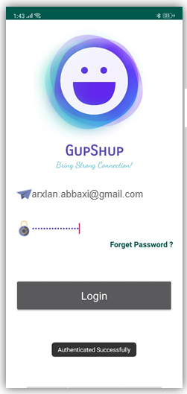

**LAB12 – SHARED PREFERENCE**

**Question#01**

Create Calculator application and persist result in shared preferences .

**Activity_main.xml:**

*<?*xml version="1.0" encoding="utf-8"*?>*<LinearLayout  
 xmlns:android="http://schemas.android.com/apk/res/android"  
 xmlns:tools="http://schemas.android.com/tools"  
 android:layout_width="match_parent"  
 android:layout_height="match_parent"  
 tools:context=".MainActivity"  
 android:orientation="vertical">  
  
 <LinearLayout  
 android:layout_width="match_parent"  
 android:layout_height="0dp"  
 android:layout_weight="2"  
 android:orientation="horizontal"  
 android:background="#3183C9">  
  
 <TextView  
 android:id="@+id/result_text_view"  
 android:layout_width="match_parent"  
 android:layout_height="match_parent"  
 android:text="0"  
 android:gravity="center_vertical"  
 android:paddingRight="30dp"  
 android:textAlignment="viewEnd"  
 android:textColor="#FFF"  
 android:textSize="40sp"  
 />  
  
 </LinearLayout>  
 <LinearLayout  
 android:layout_width="match_parent"  
 android:layout_height="0dp"  
 android:layout_weight="1"  
 android:orientation="horizontal">  
  
 <Button  
 android:layout_width="0dp"  
 android:layout_height="match_parent"  
 android:layout_weight="1"  
 android:text="@string/_7"  
 android:onClick="addValueInView"/>  
 <Button  
 android:layout_width="0dp"  
 android:layout_height="match_parent"  
 android:layout_weight="1"  
 android:text="@string/_8"  
 android:onClick="addValueInView"/>  
 <Button  
 android:layout_width="0dp"  
 android:layout_height="match_parent"  
 android:layout_weight="1"  
 android:text="@string/_9"  
 android:onClick="addValueInView"/>  
 <ImageButton  
 android:layout_width="0dp"  
 android:layout_height="match_parent"  
 android:layout_weight="1"  
 android:src="@drawable/division"  
 android:onClick="buttonDivide"/>  
  
 </LinearLayout>  
 <LinearLayout  
 android:layout_width="match_parent"  
 android:layout_height="0dp"  
 android:layout_weight="1"  
 android:orientation="horizontal">  
  
 <Button  
 android:layout_width="0dp"  
 android:layout_height="match_parent"  
 android:layout_weight="1"  
 android:text="@string/_6"  
 android:onClick="addValueInView"/>  
 <Button  
 android:layout_width="0dp"  
 android:layout_height="match_parent"  
 android:layout_weight="1"  
 android:text="@string/_5"  
 android:onClick="addValueInView"/>  
 <Button  
 android:layout_width="0dp"  
 android:layout_height="match_parent"  
 android:layout_weight="1"  
 android:text="@string/_4"  
 android:onClick="addValueInView"/>  
 <ImageButton  
 android:layout_width="0dp"  
 android:layout_height="match_parent"  
 android:layout_weight="1"  
 android:src="@drawable/multiply"  
 android:onClick="buttonMultiply"/>  
  
 </LinearLayout>  
 <LinearLayout  
 android:layout_width="match_parent"  
 android:layout_height="0dp"  
 android:layout_weight="1"  
 android:orientation="horizontal">  
  
 <Button  
 android:layout_width="0dp"  
 android:layout_height="match_parent"  
 android:layout_weight="1"  
 android:text="@string/_3"  
 android:onClick="addValueInView"/>  
 <Button  
 android:layout_width="0dp"  
 android:layout_height="match_parent"  
 android:layout_weight="1"  
 android:text="@string/_2"  
 android:onClick="addValueInView"/>  
 <Button  
 android:layout_width="0dp"  
 android:layout_height="match_parent"  
 android:layout_weight="1"  
 android:text="@string/_1"  
 android:onClick="addValueInView"/>  
 <ImageButton  
 android:layout_width="0dp"  
 android:layout_height="match_parent"  
 android:layout_weight="1"  
 android:src="@drawable/minus"  
 android:onClick="buttonSubtract"/>  
  
 </LinearLayout>  
 <LinearLayout  
 android:layout_width="match_parent"  
 android:layout_height="0dp"  
 android:layout_weight="1"  
 android:orientation="horizontal">  
  
 <Button  
 android:layout_width="0dp"  
 android:layout_height="match_parent"  
 android:layout_weight="1"  
 android:text="@string/c"  
 android:onClick="buttonClear"/>  
 <Button  
 android:layout_width="0dp"  
 android:layout_height="match_parent"  
 android:layout_weight="1"  
 android:text="@string/_0"  
 android:onClick="addValueInView"/>  
 <ImageButton  
 android:layout_width="0dp"  
 android:layout_height="match_parent"  
 android:layout_weight="1"  
 android:src="@drawable/equal"  
 android:onClick="buttonEqual"/>  
 <ImageButton  
 android:layout_width="0dp"  
 android:layout_height="match_parent"  
 android:layout_weight="1"  
 android:src="@drawable/plus"  
 android:onClick="buttonAdd"/>  
  
 </LinearLayout>  
  
</LinearLayout>

**MainActivity.java:**

package com.example.lab12;  
  
import android.support.v7.app.AppCompatActivity;  
import android.os.Bundle;  
import android.util.Log;  
import android.view.Gravity;  
import android.view.View;  
import android.widget.Button;  
import android.widget.TextView;  
import android.widget.Toast;  
import android.content.SharedPreferences;  
  
public class MainActivity extends AppCompatActivity {  
  
 public static final String *SHARED_PREFS* = "sharedPrefs";  
 public static final String *TEXT* = "text";  
  
 TextView textView;  
  
 private String text;  
  
 @Override  
 protected void onCreate(Bundle savedInstanceState) {  
 super.onCreate(savedInstanceState);  
 setContentView(R.layout.*activity_main*);  
 textView = (TextView)findViewById(R.id.*result_text_view*);  
  
 loadData();  
 updateViews();  
 }  
 public void applyToast(View v){  
 Toast t = Toast.*makeText*(this,"this is text",Toast.*LENGTH_SHORT*);  
 t.setGravity(Gravity.*CENTER_HORIZONTAL*,0,0);  
 t.show();  
 }  
  
 public void buttonClear(View v){  
 TextView text = (TextView)findViewById(R.id.*result_text_view*);  
  
 text.setText("0");  
 }  
  
 public void addValueInView(View v){  
 Button btn = (Button) v;  
 String text = btn.getText().toString();  
  
 TextView view = (TextView)findViewById(R.id.*result_text_view*);  
 if(view.getText().toString().equals("0")){  
 view.setText("");  
 view.append(text);  
 }  
 else{  
 view.append(text);  
 }  
 }  
  
 public void buttonDivide(View v){  
 v = (TextView)findViewById(R.id.*result_text_view*);  
  
 ((TextView)v).append("/");  
  
  
  
 }  
  
 public void buttonMultiply(View v){  
 v = (TextView)findViewById(R.id.*result_text_view*);  
  
 ((TextView)v).append("*");  
 }  
  
 public void buttonSubtract(View v){  
 v = (TextView)findViewById(R.id.*result_text_view*);  
  
 ((TextView)v).append("-");  
 }  
  
 public void buttonAdd(View v){  
 v = (TextView)findViewById(R.id.*result_text_view*);  
  
 ((TextView)v).append("+");  
 }  
  
 public void buttonEqual(View v){  
 v = (TextView)findViewById(R.id.*result_text_view*);  
 try {  
 if (((TextView) v).getText().toString().contains("/")) {  
 int index = ((TextView) v).getText().toString().indexOf('/');  
  
 String stringNum1 = ((TextView) v).getText().toString().substring(0, index);  
 String stringNum2 = ((TextView) v).getText().toString().substring(index+1);  
  
 double num1 = Double.*valueOf*(stringNum1);  
 double num2 = Double.*valueOf*(stringNum2);  
  
 double ans = num1 / num2;  
  
 ((TextView) v).setText(String.*valueOf*(ans));  
 }  
 else if (((TextView) v).getText().toString().contains("+")) {  
 int index = ((TextView) v).getText().toString().indexOf('+');  
  
 String stringNum1 = ((TextView) v).getText().toString().substring(0, index);  
 String stringNum2 = ((TextView) v).getText().toString().substring(index+1);  
  
 double num1 = Double.*valueOf*(stringNum1);  
 double num2 = Double.*valueOf*(stringNum2);  
  
 double ans = num1 + num2;  
  
 ((TextView) v).setText(String.*valueOf*(ans));  
 }  
 else if (((TextView) v).getText().toString().contains("*")) {  
 int index = ((TextView) v).getText().toString().indexOf('*');  
  
 String stringNum1 = ((TextView) v).getText().toString().substring(0, index);  
 String stringNum2 = ((TextView) v).getText().toString().substring(index+1);  
  
 double num1 = Double.*valueOf*(stringNum1);  
 double num2 = Double.*valueOf*(stringNum2);  
  
 double ans = num1*num2;  
  
 ((TextView) v).setText(String.*valueOf*(ans));  
 }  
 else if (((TextView) v).getText().toString().contains("-")) {  
 int index = ((TextView) v).getText().toString().indexOf('-');  
  
 String stringNum1 = ((TextView) v).getText().toString().substring(0, index);  
 String stringNum2 = ((TextView) v).getText().toString().substring(index+1);  
  
 double num1 = Double.*valueOf*(stringNum1);  
 double num2 = Double.*valueOf*(stringNum2);  
  
 double ans = num1-num2;  
  
 ((TextView) v).setText(String.*valueOf*(ans));  
 }  
 }catch (Exception e){  
 Log.*e*("error","Exception: "+e);  
 }  
 finally {  
 saveData();  
 }  
  
 Toast t = Toast.*makeText*(this,"this is text",Toast.*LENGTH_SHORT*);  
 t.setGravity(Gravity.*CENTER_HORIZONTAL*,0,0);  
 t.show();  
 }  
  
 public void saveData() {  
 SharedPreferences sharedPreferences = getSharedPreferences(*SHARED_PREFS*, *MODE_PRIVATE*);  
 SharedPreferences.Editor editor = sharedPreferences.edit();  
  
 editor.putString(*TEXT*, textView.getText().toString());  
  
 editor.apply();  
  
 Toast.*makeText*(this, "Data saved", Toast.*LENGTH_SHORT*).show();  
 }  
  
 public void loadData() {  
 SharedPreferences sharedPreferences = getSharedPreferences(*SHARED_PREFS*, *MODE_PRIVATE*);  
 text = sharedPreferences.getString(*TEXT*, "");  
 }  
  
 public void updateViews() {  
 textView.setText(text);  
 }  
}

**Output:**

