# What WHS principles were followed while working on this project

All my working hours are healthy, and it won’t later than 10 o’clock

# Describe how these images best suit the message

All the chosen images are directly relevant to the text on homepage. On about me page, the picture I choose is a man who is adjecting glasses, this is because I want to show the concept of profession by this image.

# What alternative file formats could these images have been saved

The common file formats to safe images are jpg, png and svg. All of them have different advantages and disadvantages such as jpg is smaller than png, but its quality will be reduced when every time it is saved.

I choose png for all my images because of its high quality.

# Secure original images

Most of my images are from pxhere.com and pixabay.com, both of them are images copyright free website.

Here is the URL list of these images:

<https://pxhere.com/en/photo/1554927>

<https://pxhere.com/en/photo/809387>

<https://pxhere.com/en/photo/1524555>

<https://pxhere.com/en/photo/810274>

<https://pxhere.com/en/photo/681268>

<https://pixabay.com/illustrations/facebook-icon-symbol-media-3383596/>

<https://pixabay.com/illustrations/instagram-icon-button-symbol-logo-3383597/>

<https://www.sciencephoto.com/media/728168/view/colour-blindness-test>

<http://pinclipart.com/pindetail/iwwmTi_copyright=>

# tools that were used to make alterations to these images

Most of them are barely resized, but the background of header is spelled by two images with Microsoft Paint and lower the contract by CSS filter.

# Screenshot of W3C Validation of HTML/CSS

index

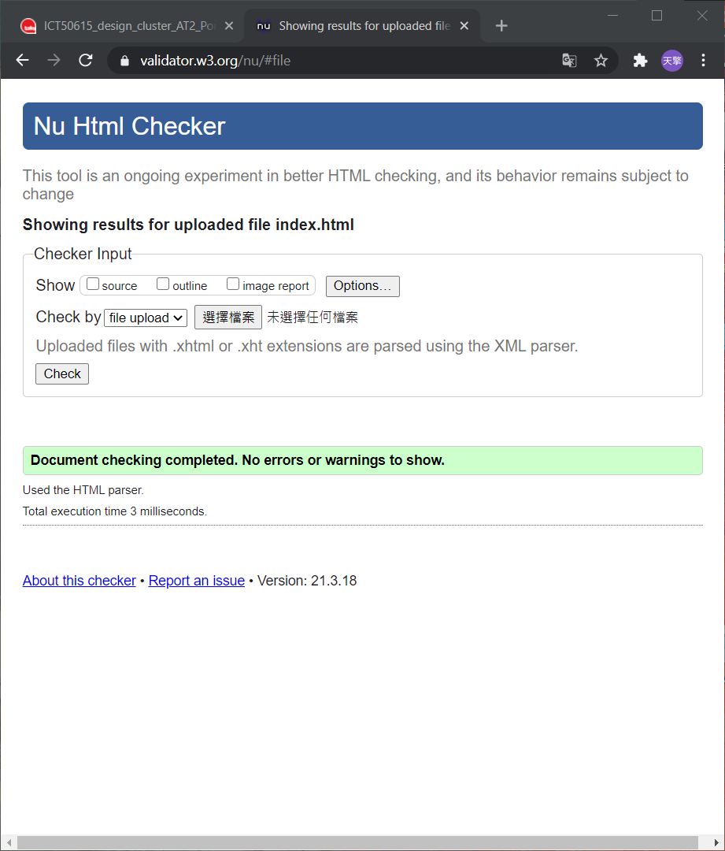

blogpage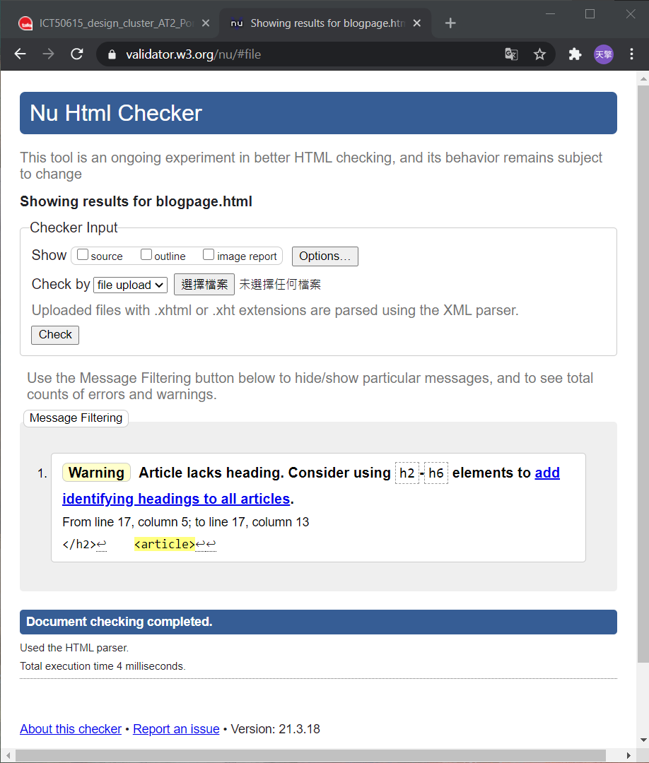

tableofdata

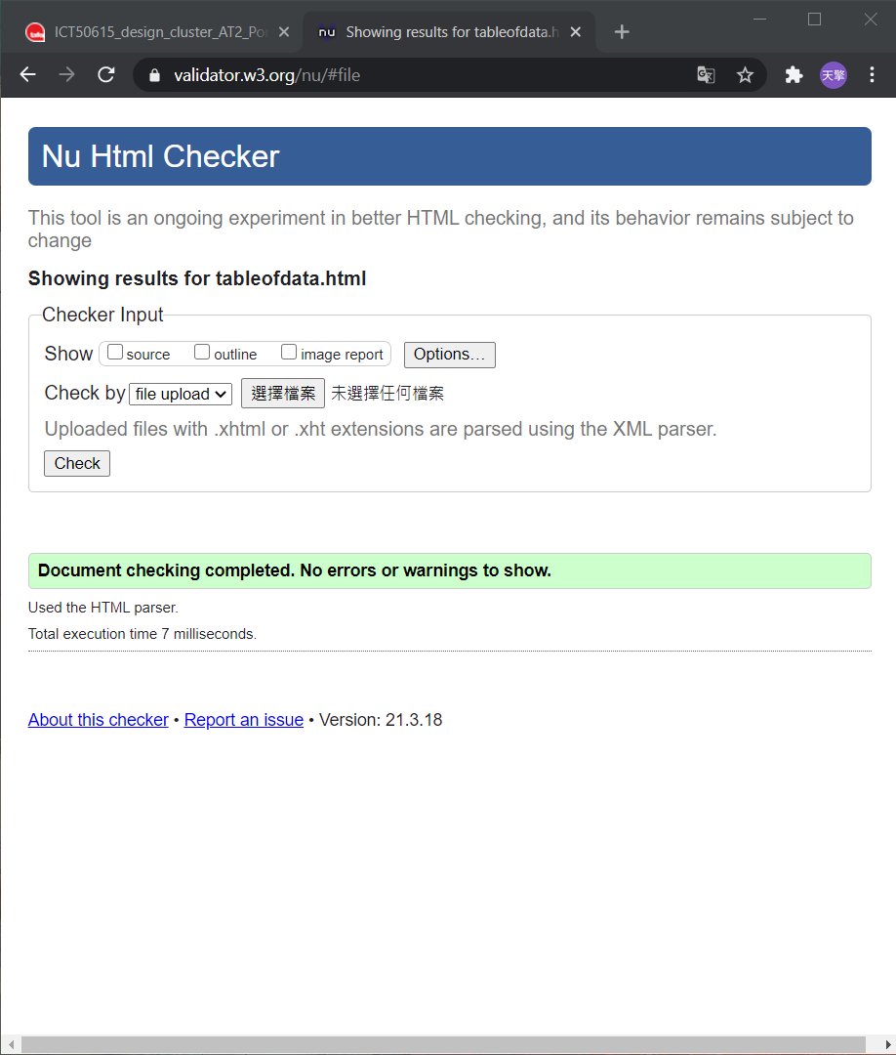

webform

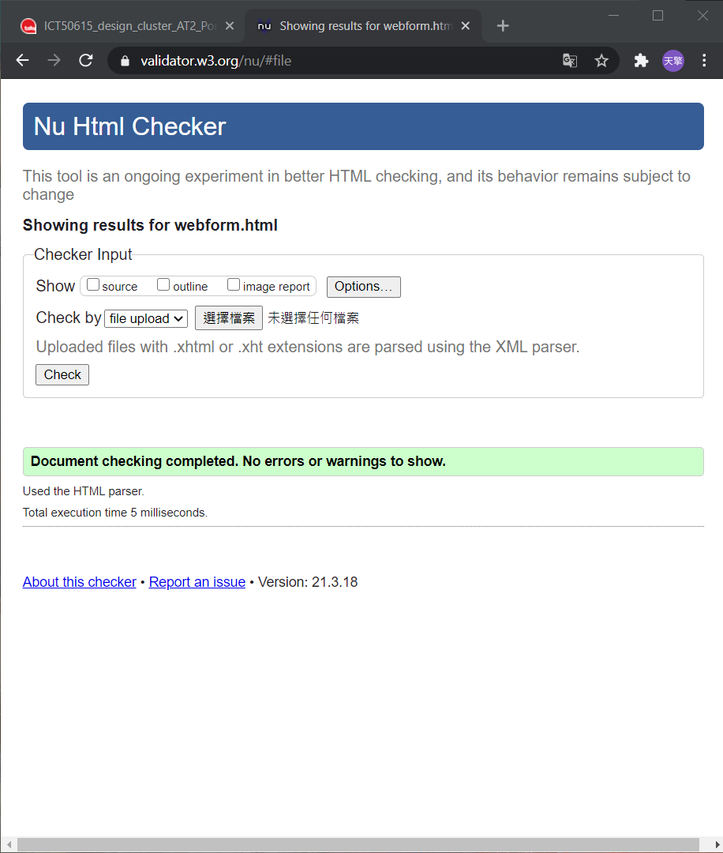

css

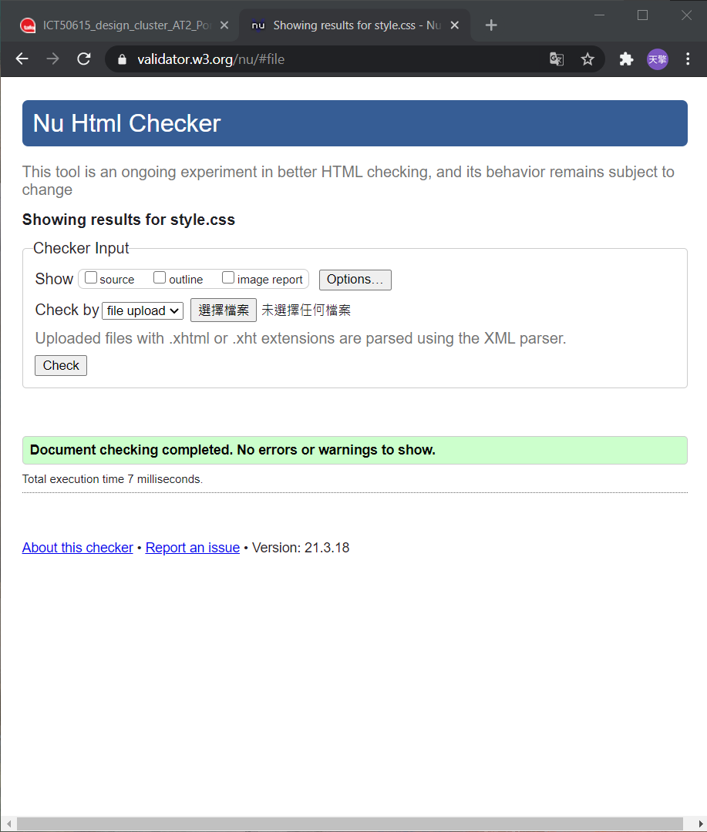

# Cross-Browser test three examples including mobile phone

On firefox

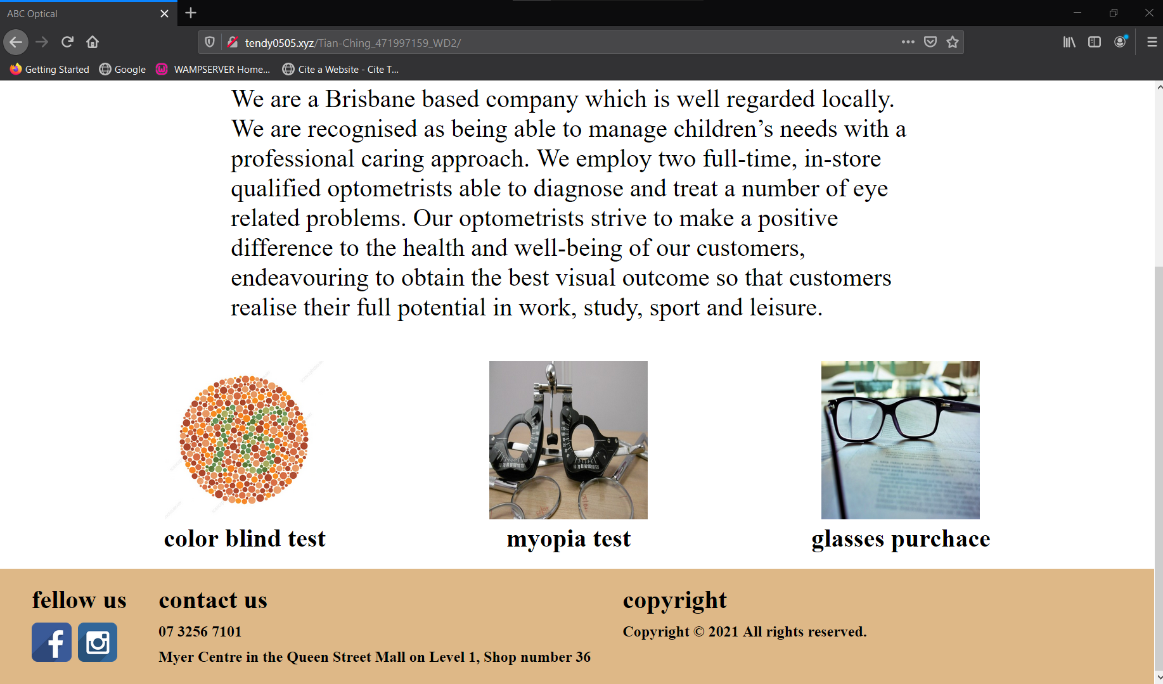

On chrome

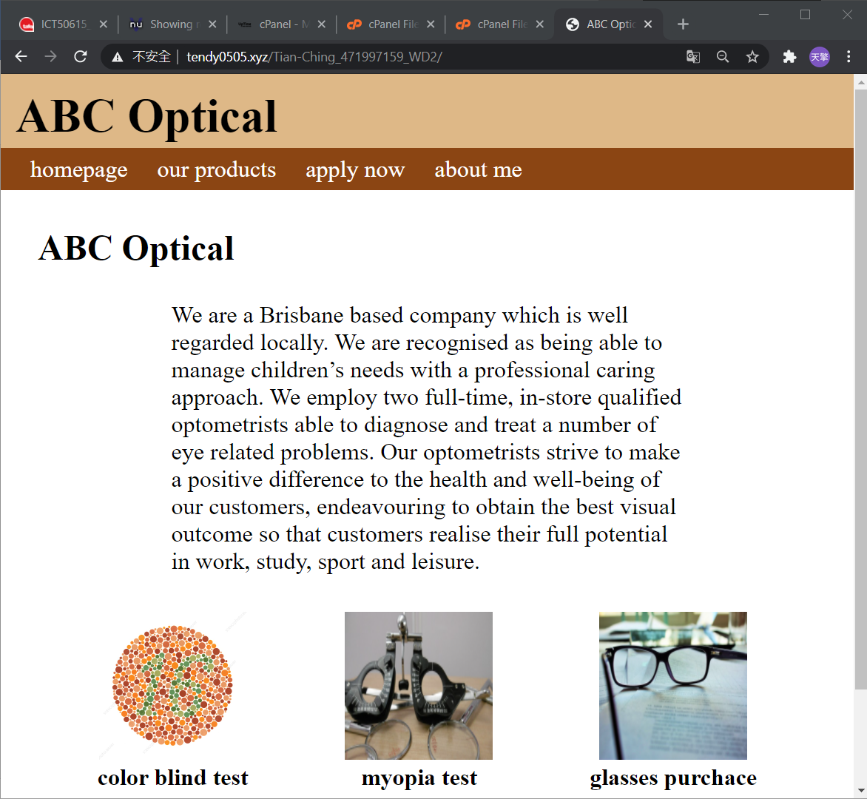

On my cellophane

