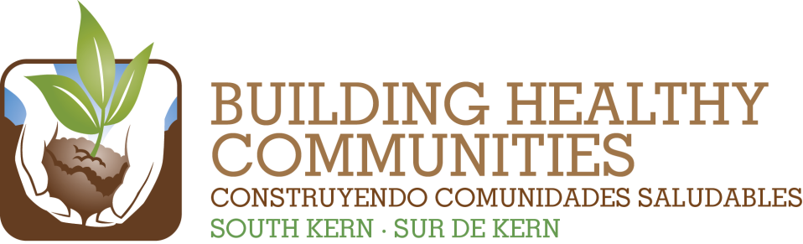

|  |  |  |  |
| --- | --- | --- | --- |
| We |  | | |
|  |  |  |  |
| Bu |  |  | In This Issue |



**In South Kern we will Improve Pre-K to Adult Education with Preparation and Local Access to College/University Programs**

***We Promise:*** *By July 1, 2015, we will ensure students in South Kern are healthier by supporting parent-school partnerships to improve school culture and environments to make them safer, healthier, and more supportive of the success of all students.*

|  |  |
| --- | --- |
| **Result to Achieve by 7/1/2015** | **Goals for 2020** |
| Fifteen South Kern parents are continuing and expanding their role as leaders and advocates for student health by participating in District Wellness Committees. | * Parents and youth partner with teachers and educational Institutions to promote children’s success. * Child development programs will help parents and children be prepared to enter kindergarten. * Student academic success in local schools will increase. |
| Twenty South Kern parents are actively and meaningfully engaged in creating a school culture of authentic and meaningful parent involvement and leadership, and school funding policies that support student success for all students. |
| Twenty South Kern Parents are engaged, in partnership with school district, are creating safer and more supportive school environments through individual advocacy and broad-level engagement. | * Youth have positive and supportive environments and are learning and exhibiting positive behavior. |
| Ten Schools in South Kern have established alternative positive discipline models in partnership with parents. |
| Through a partnership with local colleges and high schools, student pathways to higher education will be strengthened and South Kern youth participation in college will increase by 10%. | * South Kern has a college-bound culture. |