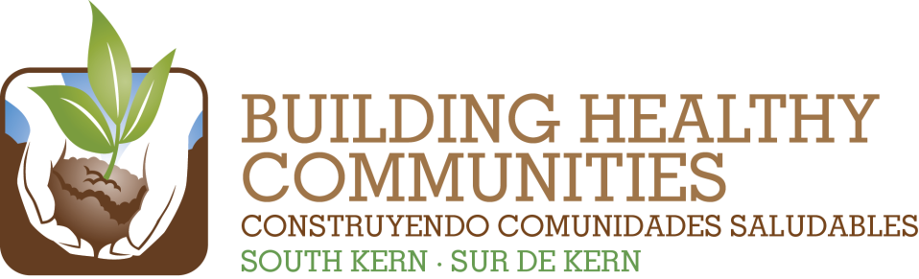

|  |  |  |  |
| --- | --- | --- | --- |
| We |  | | |
|  |  |  |  |
| Bu |  |  | In This Issue |

**In South Kern we will Create a Healthy Environment with Clean Air and Water**

***We Promise:*** *By July 1, 2015, we will provide a safer and healthier environment in South Kern by supporting residents in monitoring and advocating for improved environmental conditions and accountability in their community and enforcing and strengthening environmental laws and policies that impact South Kern.*

|  |  |
| --- | --- |
| **Result to Achieve by 7/1/2015** | **Goals for 2020** |
| Support twenty South Kern residents in monitoring local environment conditions and reporting on environmental hazards, i.e. KEEN, Bucket Brigade. | * *Goal 1: Reduce the use of Pesticides.* * *Goal 4: Establish and enforce local, regional, and state methods and policies to improve air quality.* * *And Goals 2, 3, and 5 listed below.* |
| Support twenty South Kern residents and partners in advocating for improved policies and enforcement at the county, regional, and state level that will create a healthy environment. |
| Advocate at the local, County and State level for funding and implementation of at least 3 major water/sewer infrastructure improvements in South Kern. | * *Goal 2: Improve infrastructure related to water drainage and sewage systems as well as improved streets.* |
| Support residents and community partners in advocating for and implementing immediate drinking water solutions in at least 25 community settings such as schools or parks. | * *Goal 3: Improve drinking water quality by removing contaminants* |
| Support residents and decision-makers in local communities in implementing health-promoting land-use policies that have been created, i.e. general and regional land-use plans. | * *Goal 5: Improve local and regional land-use planning to develop more walkable communities as well as to create and design future development that promotes health, clean air, and water.* |