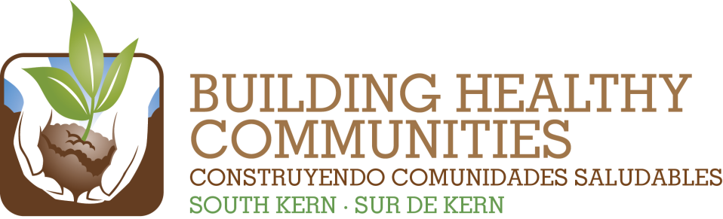

|  |  |  |  |
| --- | --- | --- | --- |
| We |  | | |
|  |  |  |  |
| Bu |  |  | In This Issue |



**In South Kern we will Improve Access to Recreation Activities, Facilities, and Parks**

***We Promise:*** *By July 1, 2015, we will support residents of South Kern in living healthier, active lifestyles by increasing transparency and coordination of recreation opportunities, advocating for improvements to local parks, and supporting efforts to make local parks safer and cleaner.*

|  |  |
| --- | --- |
| **Result to Achieve by 7/1/2015** | **Goals for 2020** |
| Increase awareness of and coordination among local recreation programs through completion, promotion, and institutionalization of a catalog of recreation opportunities. | * *Local recreation opportunities in South Kern will provide adequate, coordinated, and culturally appropriate recreation opportunities for residents and youth to be active.* |
| Increase long-term sustainability of recreation opportunities through identification of potential revenue or funding models for South Kern recreation. |
| Support residents, including youth, in partnering with local recreation systems and advocating for continued improvements to local parks through implementation of Park Master Plans and/or Skate Parks in four local parks. | * *Local recreation facilities, as well as shared and multi-purpose spaces in South Kern will provide adequate, safe and affordable access for residents and promote active, healthy lifestyles.* |
| Continue to support residents and community partners in increasing awareness of and advocating for policies that make local parks safer and cleaner. | * *Recreation spaces, neighborhoods, and streets in South Kern will be clean and safe for residents and youth to increase walkability.* |