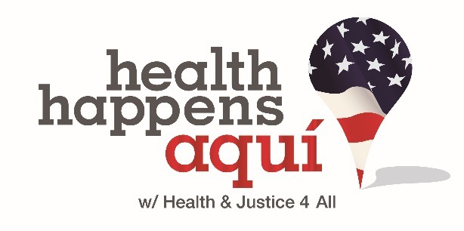

WEBSITE BOOT CAMP

Mark your calendar for Website Boot Camp! The training will be held in-person on **September 15 in Sacramento** and **September 29 in Los Angeles** (Meeting Rooms TBD). Please RSVP by Thursday, August 20th:

* Sacramento (insert EventBrite link)
* Los Angeles (insert EventBrite link)

This session is designed for all staff and consultants engaged in website content and/or overall digital strategy development AND implementation. This is a must-attend for staff/consultants to understand and use the new system for developing good content, posting to website and social media, and utilizing NationBuilder e-blasts.

If you have questions, please contact Amanda Bratcher at [ABratcher@CalEndow.org](mailto:ABratcher@CalEndow.org).

Thank you!

9:00 A.M. – 12:00 P.M. Please bring your laptop

1. THE NEW WORLD ORDER: THE SYSTEM FOR DEVELOPING CONTENT—HOW TO THINK STRATEGICALLY ABOUT DIGITAL ENGAGEMENT AND COMMUNICATIONS.
2. Why the content development pipeline is important and how it will make your life easier.
3. How to use the new system and everyone’s role in this process.
4. Best practices – What goes into good content? Questions to ask yourself as you prepare.
5. Submitting a new content request
6. INSPIRATION THROUGH TECHNOLOGY: INTRODUCTION TO WORD PRESS & NATIONBUILDER
7. Digital Engagement
   * + - 1. Virtuous cycle
         2. Connecting the dots and how The California Endowment campaigns relate
8. Word Press
   1. Templates
   2. Good content and compelling images
   3. Polls, blogs, action pages
9. NationBuilder
10. Action page types
11. Database management
12. Filtering and tagging
13. Final Questions/Comments & Closing