Practice M1: Introduction to DevOps
The lab environment has the following structure:
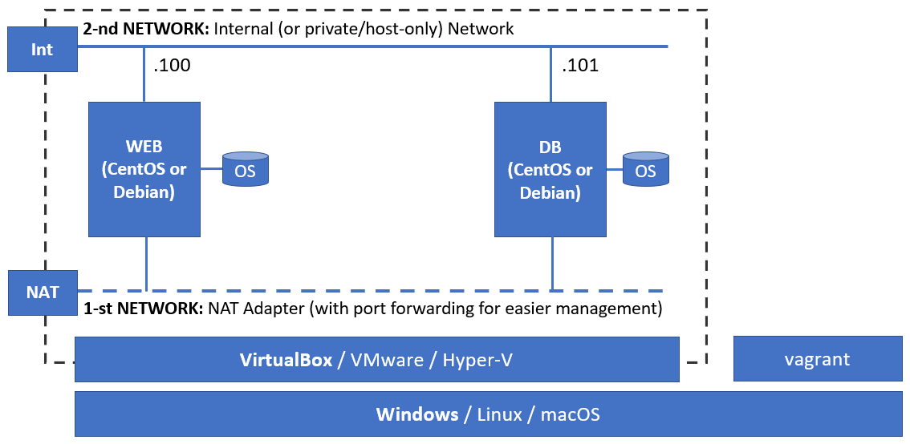
The following tasks are executed on different machines. It is stated clearly on which machine a task is being executed
VM templates can be downloaded from this URL: https://zahariev.pro/go/do1-templates
Do not hurry to download or install anything, wait until you reach the appropriate section

Part 1: Introduction
Nothing to do here, just talking/discussing

Part 2: Manual approach

Preparation
We must ensure that we have a working and supported hypervisor installed
VirtualBox is the preferred option as is it both free and well supported by Vagrant
Of course, other virtualization solutions like VMware Workstation and Hyper-V can do the job as well but will require some tweaks
Be sure to fill the Introduction Form (https://zahariev.pro/go/do1-form) and state at least your configuration – hardware, OS and virtualization solution. This will help to adapt the content to better fit the majority
Until the end of this practice, we will be working with VirtualBox
Please make sure that no other virtualization solutions are installed and active (this includes also Docker Desktop as it relies on an existing hypervisor)
If there are any, please uninstall them (or just go with them)
If you already have VirtualBox installed, skip the following section

Install VirtualBox (on a Windows host)
Navigate to the download page (https://www.virtualbox.org/wiki/Downloads) and download the latest version
Make sure that you have administrative access and double-click on the downloaded file to initiate the installation process
As you will see it is pretty straight-forward

Install VirtualBox (on a Red Hat-compatible host)
The steps are more or less the same no matter which Linux distribution is installed on the host
In any case, check the official documentation: https://www.virtualbox.org/wiki/Linux_Downloads
Open a terminal session
Download the repository configuration file
wget https://download.virtualbox.org/virtualbox/rpm/el/virtualbox.repo
Even though Fedora is part of the same family, for it the above should become
wget https://download.virtualbox.org/virtualbox/rpm/fedora/virtualbox.repo
So, as advised above, check the official documentation
Move it the appropriate target folder
sudo mv virtualbox.repo /etc/yum.repos.d/
Update currently installed packages
sudo dnf upgrade -y
Install any prerequisite packages that may be missing
sudo dnf install -y gcc make kernel-headers kernel-devel
Install the VirtualBox package
sudo dnf install -y VirtualBox-7.0
Add the current user to the appropriate user group
sudo usermod -a -G vboxusers $USER
Log-out and log-on again
Check that VirtualBox is correctly installed and working
Should you see any errors when trying to start a VM, you may need to run
sudo /sbin/vboxconfig
If the above end with an error, check the /var/log/vbox-setup.log file
Most probably you will have to install additional packages, for example
sudo dnf install elfutils-libelf-devel
And re-run the /sbin/vboxconfig command
The actual steps vary depending on the distribution in use and if the system is BIOS or UEFI-based

Application Deployment
Now, that we have the infrastructure set up, we can continue with the application deployment steps
Let’s imagine that we have to deploy a two-tier application with web-based (PHP) front-end and MariaDB/MySQL used for database
Following established practices, we will deploy the two components on two different machines (you can refer to the picture in the beginning of the document)

Import a template (on the host)
We will be using a template to save some time. Of course, should we want, we can start fresh and install the OS in the virtual machines manually
For the rest of the lab, we can use either one of the available templates – CentOS, Debian, or openSUSE
Let’s use the CentOS one (in fact, it is a CentOS Stream 9 template). Should you want to experiment with another one, be sure to adjust the steps
Start VirtualBox
Import centos-stream-9.ova as WEB machine
Import centos-stream-9.ova as DB machine
Set networking mode for the first (and only) network adapter to NAT *
Add a second network adapter ** to both virtual machines and set it to Internal Network mode. Make sure that the name of the internal network is the same for both machines
Start both machines
* For easier interaction you can set up a port forwarding rules to port 22 of both virtual machines. For example, for the WEB machine redirect 22 to 10001 on the host and for the DB machine redirect 22 to 10002 on the host
** Don’t forget to set static address on second network adapters and test the connectivity there. Use for example the 192.168.99.0/24 network

Install software (on WEB VM)
Log-on to the WEB machine with vagrant user and vagrant for password
Note: The root password is the same (vagrant)
Set the static IP address on the second network interface. For example, 192.168.99.100/24
Change the hostname to web by executing
sudo hostnamectl set-hostname web
Log-out and log-on again
Install Apache, PHP, Git, and other required/related packages
sudo dnf install -y httpd php php-mysqlnd git
Configure Apache to start automatically on boot and start it
sudo systemctl enable httpd
sudo systemctl start httpd
Check that we have connectivity both locally and remotely*
We can adjust the firewall in one of the following two ways
Stop and disable it
sudo systemctl stop firewalld
sudo systemctl disable firewalld
Or open the appropriate port or service
sudo firewall-cmd --add-service=http --permanent
sudo firewall-cmd --reload
We can check again
* Depending on the network mode of the virtual machines, you may need to set up a port forwarding rule. For example, port 80 on the VM to port 8080 on the host

Deploy the application (on WEB VM)
Go to the home folder of the vagrant user
Execute the following to clone the existing repository and get the application’s files locally
git clone https://github.com/shekeriev/bgapp
Copy all files from bgapp/web to /var/www/html
sudo cp -v bgapp/web/* /var/www/html/
Try to open the page on the host *
* Depending on the network mode of the virtual machines, you may need to set up a port forwarding rule. For example, port 80 on the VM to port 8080 on the host

Install software (on DB VM)
Log-on to DB machine with vagrant for user and vagrant for password
Note: The root password is the same (vagrant)
Set the static IP address on the second network interface. For example, 192.168.99.101/24
Change the hostname to db by executing
sudo hostnamectl set-hostname db
Log-out and log-on again
If using CentOS Stream 8, we may need to add the MariaDB repository (adjust version or selection) with:
curl -LsS https://downloads.mariadb.com/MariaDB/mariadb_repo_setup \
| sudo bash -s -- --mariadb-server-version=10.6 --skip-maxscale --skip-tools
Install MariaDB client and server components
sudo dnf install -y mariadb mariadb-server git
Enable and start the service
sudo systemctl enable mariadb
sudo systemctl start mariadb
Do some initial configuration *
sudo mysql_secure_installation
Note: Depending on the circumstances, the above command may have to become sudo mariadb-secure-installation

Configure database (on DB VM)
Go to home folder of the vagrant user
Execute the following to clone the existing repository and get the application’s files locally
git clone https://github.com/shekeriev/bgapp
Navigate to the db folder
Examine the SQL script
Execute the script against the database
mysql -u root -p < db_setup.sql
Log-on and check that the data is there
mysql -u root -p
use bulgaria;
select * from cities;
quit
Modify the firewall state in either of the following two ways
Disable it
sudo systemctl stop firewalld
sudo systemctl disable firewalld
Or open the appropriate port:
sudo firewall-cmd --add-port=3306/tcp --permanent
sudo firewall-cmd --reload

Configure and test the application (on WEB VM)
Check the config.php script if there is a need to change connection parameters
Open browser and check the final result. It should be working
In case of connectivity error execute the following on the web server to check where is the issue
curl http://localhost
php /var/www/html/index.php
Under RedHat-based distributions, we will see that in one of the attempts we can see the data and in the other – we cannot
This is caused by the SELinux suite, and we can tackle the issue by executing the following
sudo setsebool -P httpd_can_network_connect=1
Other option is to modify SELinux mode (/etc/sysconfig/selinux) to either permissive or disabled

Part 3: Vagrant

Preparation
In order to automate the process, we saw so far, we will need a helper tool
Vagrant is a good fit for this
To install it, we must navigate to here: https://www.vagrantup.com/downloads
Should you need an earlier version, you can check here: https://releases.hashicorp.com/vagrant/

Install Vagrant (on Windows host)
Make sure that you have administrative access and double-click on the downloaded file to initiate the installation process
As you will see it is pretty straight-forward

Install Vagrant (on Red Hat-compatible host)
Let us install the Vagrant tool which will help us automate our infrastructure creation and management to a good extent
The steps are more or less the same no matter which Linux distribution is installed on the host
First, we download the package locally
wget https://releases.hashicorp.com/vagrant/2.3.4/vagrant-2.3.4-1.x86_64.rpm
Then we install it
sudo rpm -ivh vagrant-2.3.4-1.x86_64.rpm
Then we check that it is working
vagrant version
We can add bash completion should we want it. Download a 3rd party completion file
wget https://github.com/hashicorp/vagrant/raw/master/contrib/bash/completion.sh -O vagrant-completion.sh
Move (install) the completion script (you may need to install the bash-completion package as well)
sudo mv vagrant-completion.sh /etc/bash_completion.d/

Create Vagrant box (on host)
We can create our own boxes or use ones already created by others
The basic steps to create a box of our own is to create a simple VM with minimal parameters:
- 1 CPU
- 1 GB RAM
- 16 GB HDD (Dynamic)
- No Audio
- 1 NIC in NAT mode (with a port forwarding rule SSH/TCP/2222/22)
Then we must install the OS (CentOS Stream 9 in our case) again with minimal (or what we find suitable) profile:
- Turn off the kdump utility
- Enable the network and set a hostname
- Set the appropriate time zone
- Select the OS profile – usually Minimal
- Add the vagrant user and set its password to vagrant
- Use the same password for the root user
For the purpose of the demo, we will reuse one of the available templates
Let’s use again CentOS. The template is called centos-stream-9.ova (it is in fact CentOS Stream 9)
Import a VM from the template to save some time (don’t forget the port forwarding rule)
Once, we have the machine up and running, we must log on as the root user and do some final adjustments
Make sure that there is SSH installed and running
Should we want, we can disable services like the firewall
Upgrade all installed packages
dnf upgrade
Add new packages if you see fit. For example, install at least these:
dnf install kernel-devel gcc make tar bzip2 wget elfutils-libelf-devel
Mount (Devices > Insert Guest Additions image) the VirtualBox Guest Additions media and install them
mount /dev/sr0 /mnt
/mnt/VBoxLinuxAdditions.run
Add the vagrant user to the vboxsf group
usermod -aG vboxsf vagrant
Set the GRUB waiting time to 0 (this will make our machine boot faster)
vi /etc/default/grub
grub2-mkconfig -o /boot/grub2/grub.cfg
Add the vagrant user to the sudoers list and allow it to sudo without entering password
echo "vagrant ALL=(ALL) NOPASSWD:ALL" | tee /etc/sudoers.d/vagrant
Close the session and open a new one as the vagrant user
Install the vagrant insecure key. First, create the target folder
mkdir -m 0700 -p /home/vagrant/.ssh
Download the key
wget --no-check-certificate \
https://raw.github.com/mitchellh/vagrant/master/keys/vagrant.pub \
-O /home/vagrant/.ssh/authorized_keys
Set the permissions of the key
chmod 0600 /home/vagrant/.ssh/authorized_keys
Clean up the DNF cache
sudo dnf clean all
Make sure that the hard disk is aligned
sudo dd if=/dev/zero of=/EMPTY bs=1M status=progress
sudo rm -f /EMPTY
Reboot the VM
sudo reboot
Do not forget to eject (Optical Drives > Remove disk from virtual drive) the additions media or any other media that may be still attached to the machine
Now, we are ready to build our box (execute next steps on the host and not in the VM)
Create a folder to host the box (on the host machine)
If we are on a Linux host, we can execute the following to create and enter the work folder
mkdir -p /home/$USER/Vagrant/centos && cd /home/$USER/Vagrant/centos
Once, we are inside the folder, we can start the box creation process
While the VM is still running, build the box with (replace <VM Name> with the name of the VM)
vagrant package --base <VM Name>
Let us test it
Add the box to the local catalog (replace <Box Name> with the name you want to use for your box)
vagrant box add <Box Name> package.box
Create a configuration based on the local box
vagrant init <Box Name>
Power on the machine
vagrant up
Connect to the machine
vagrant ssh
Explore what's inside the machine
Close the SSH session
exit
Turn off and delete the machine
vagrant destroy --force
Finally, we can publish our box to Vagrant Cloud
Navigate to https://app.vagrantup.com and login
Click on New Vagrant Box
Enter the details and click on Create box
Enter version and description and click Create version
Click on Add a provider
For provider set virtualbox and click on Continue to upload
Click on the Browse button and navigate to the box file
Once the upload is complete, click on the Update provider button
Click on the box name
Click on Release...
Click on Release version
Now, we can continue either with our own box or the cited in the next steps

First run of the box (on host)
Create a new work folder ~/do/m1/test
Go there and execute (replace <repo/box-name> with your repository and box name)
vagrant init <repo/box-name>
Instead of your repository and box, you can use for example, either shekeriev/centos-stream-9 or shekeriev/debian-11
Examine the created Vagrantfile
Power-on the machine
vagrant up
Start SSH session to the machine
vagrant ssh
Browse the machine by executing a few commands
Exit the session
exit
List all local machines
vagrant global-status
It should be listed indicating that it is in running state
List all boxes
vagrant box list
It should appear in the list together with any other boxes you may have
Destroy the machine
vagrant destroy --force

Application Deployment
For the next two tasks we will need the archive file available on the site of the current module
Download it and extract it somewhere

Automation Level 1 (on host)
Let’s assume that the files are extracted to a folder ~/do1/m1/
Navigate to the folder 3-1
Examine the Vagrantfile
Modify the settings if needed
Check the sub-folders
Execute
vagrant up
Open a browser and test the application
Destroy the machines
vagrant destroy --force

Alternative approach #1 (on host)
Let’s assume that the files are extracted to a folder ~/do/m1/
Navigate to the folder 3-2
Examine the Vagrantfile
Modify the settings if needed
Check the sub-folders
Execute
vagrant up
Open a browser and test the application
Destroy the machines
vagrant destroy --force

Alternative approach #2 (on host)
Can you think of another alternative approach?
For example, to use git clone within the Vagrantfile during the machine provision phase
Try to do it

