Practice M2: Introduction to Docker
For this practice we will use an infrastructure like this:
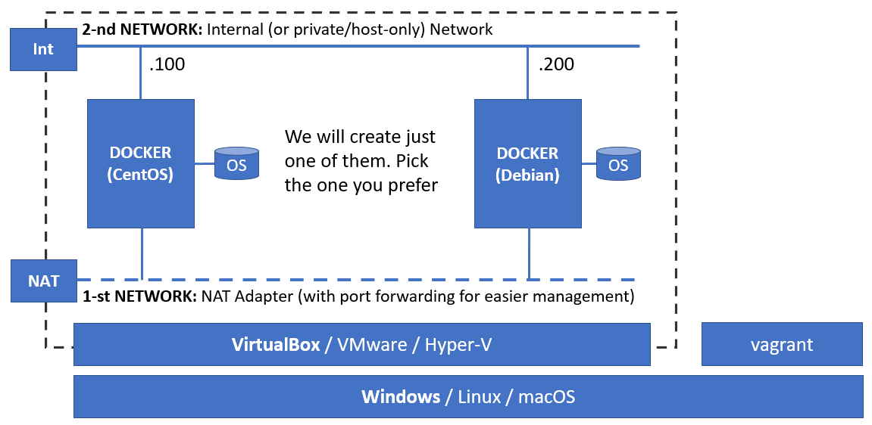
All exercises that follow assume that we are working in an environment with both VirtualBox and Vagrant installed
For the VM we will use a CentOS Stream 9 minimal based Vagrant box
Please note, that some commands end with this \ symbol. This is because the command is long and does not fit on one line. Written this way makes it more readable. When you type in such commands, you can omit the \ symbol and continue with the rest of the command

Part 1: Docker installation
References
https://docs.docker.com/engine/install/centos/
https://docs.docker.com/engine/install/linux-postinstall/
Commands
version, system info, container run

Preparation
Spin up either a CentOS Stream or Debian based virtual machine
You can do it either by importing a template or using Vagrant
Let us go with the second approach, as it is more manageable, and this is what we are aiming for
Open a terminal session and navigate to an empty folder of your choice
Invoke the initialization command to create an empty environment for CentOS Stream
vagrant init --minimal shekeriev/centos-stream-9
Or for Debian
vagrant init --minimal shekeriev/debian-11
Now open the Vagrant file with a text editor of your choice
If you are working in a graphical environment of Windows, Linux, or macOS, you can install the VSCode free editor by Microsoft and add one of available Vagrant plugins (for example the Vagrantfile Support by Marco Stazi or Vagrant by Baptist Benoist)
Now, that we are in, let us add one block, between the config.vm.box and end, to set some port forwarding and change the memory size
config.vm.network "forwarded_port", guest: 8080, host: 8080, auto_correct: true
config.vm.provider :virtualbox do |vb|
vb.customize ["modifyvm", :id, "--memory", "2048"]
end
Save and close the file
Return to the terminal session and start the environment
vagrant up
And then, once the machine is up and running, establish ssh session to it
vagrant ssh

Remove old installations
This is not directly applicable to our case, as we start fresh without existing Docker installation
Should you have old installation of Docker, it is recommended to remove it first

CentOS
Under CentOS and other Red Hat-based distributions we can execute this
sudo dnf remove docker docker-client docker-client-latest \
docker-common docker-latest docker-latest-logrotate \
docker-logrotate docker-selinux docker-engine-selinux docker-engine

Debian
Under Debian-based distributions we can execute this
sudo apt-get remove docker docker-engine docker.io containerd runc

Installation preparation
First, we must make sure that we have the appropriate repository registered

CentOS
Add the repository
sudo dnf config-manager \
--add-repo https://download.docker.com/linux/centos/docker-ce.repo

Debian
First, refresh package information and install the required packages
sudo apt-get update
sudo apt-get install ca-certificates curl gnupg lsb-release
Then add the repository key (change debian with ubuntu if working on Ubuntu)
curl -fsSL https://download.docker.com/linux/debian/gpg | sudo gpg --dearmor -o /usr/share/keyrings/docker-archive-keyring.gpg
Finally, add the repository (change debian with ubuntu if working on Ubuntu)
echo \
"deb [arch=$(dpkg --print-architecture) signed-by=/usr/share/keyrings/docker-archive-keyring.gpg] https://download.docker.com/linux/debian \
$(lsb_release -cs) stable" | sudo tee /etc/apt/sources.list.d/docker.list > /dev/null

Docker installation
Now, we are ready to install Docker itself

CentOS
To install Docker, execute the following:
sudo dnf install docker-ce docker-ce-cli containerd.io docker-compose-plugin
Let us start the docker daemon and check its status
sudo systemctl start docker
systemctl status docker

Debian
To install Docker, first we must update package information
sudo apt-get update
And then install the necessary packages
sudo apt-get install docker-ce docker-ce-cli containerd.io docker-compose-plugin
Finally, check that the service started successfully
systemctl status docker

Post installation test
If the service is working normally, we can receive more information about the installed versions and the current configuration with
sudo docker version
sudo docker system info
And let us start our very first container
sudo docker container run hello-world
Or this one:
sudo docker container run shekeriev/welcome-do:latest

Additional settings
To be able to work with docker without the need to use always sudo, we must add our user to the docker group
sudo usermod -aG docker $USER
To apply the change, we must log off and then log on back again
We can check by executing any of the previous docker commands, for example
docker container run hello-world
As a last step, we can mark the docker service for automatic start on boot (this is not necessary on Debian/Ubuntu as it is automatically done)
sudo systemctl enable docker
For more post-installation settings like remote connectivity, storage options, etc. visit the following address
https://docs.docker.com/engine/install/linux-postinstall/

Clean up
Close the session to the VM
And being in the folder where we started (where we have our minimal Vagrantfile), execute
vagrant destroy --force
This will stop and delete the virtual machine

Alternative way
Besides the way we saw, there are two other ways to install Docker
One of them is to download the archive and deal with everything manually
You can check more on this here: https://docs.docker.com/engine/install/binaries/
The other way is to use the Get Docker script
Is simple. Just download the script
curl -fsSL https://get.docker.com -o get-docker.sh
Should you want, you can do a dry run with
DRY_RUN=1 sh ./get-docker.sh
Or do the actual installation with
sudo sh get-docker.sh
That is, it. Of course, any post-installation actions are applicable here as well

Create a complete Vagrantfile
Let us try to write an all-in-one Vagrantfile that can be used to spin up a VM with docker installed and configured
Create a new folder and switch to it
Open a new Vagrantfile for editing

CentOS
You can copy and paste what we have in our first Vagrantfile and extend it or start clean
Any way, you should type the following text
Vagrant.configure("2") do |config|

config.vm.define "docker" do |docker|
docker.vm.box="shekeriev/centos-stream-9"
docker.vm.hostname = "docker.do1.lab"
docker.vm.network "private_network", ip: "192.168.99.100"
docker.vm.network "forwarded_port", guest: 8080, host: 8080, auto_correct: true
docker.vm.provision "shell", path: "docker-setup.sh"
docker.vm.provider :virtualbox do |vb|
vb.customize ["modifyvm", :id, "--memory", "2048"]
end
end

end
Save and close the file
Now create a new docker-setup.sh file
Type the following (these are the steps we did manually)
#!/bin/bash

echo "* Add hosts ..."
echo "192.168.99.100 docker.do1.lab docker" >> /etc/hosts

echo "* Add Docker repository ..."
dnf config-manager --add-repo https://download.docker.com/linux/centos/docker-ce.repo

echo "* Install Docker ..."
dnf install -y docker-ce docker-ce-cli containerd.io docker-compose-plugin

echo "* Enable and start Docker ..."
systemctl enable docker
systemctl start docker

echo "* Firewall - open port 8080 ..."
firewall-cmd --add-port=8080/tcp –permanent
firewall-cmd --reload

echo "* Add vagrant user to docker group ..."
usermod -aG docker vagrant
Save and close the file

Debian
You can copy and paste what we have in our first Vagrantfile and extend it or start clean
Any way, you should type the following text
Vagrant.configure("2") do |config|

config.vm.define "docker" do |docker|
docker.vm.box="shekeriev/debian-11"
docker.vm.hostname = "docker.do1.lab"
docker.vm.network "private_network", ip: "192.168.99.200"
docker.vm.network "forwarded_port", guest: 8080, host: 8080, auto_correct: true
docker.vm.provision "shell", path: "docker-setup.sh"
docker.vm.provider :virtualbox do |vb|
vb.customize ["modifyvm", :id, "--memory", "2048"]
end
end

end
Save and close the file
Now create a new docker-setup.sh file
Type the following (these are the steps we did manually)
#!/bin/bash

echo "* Add hosts ..."
echo "192.168.99.200 docker.do1.lab docker" >> /etc/hosts

echo "* Add any prerequisites ..."
apt-get update
apt-get install -y ca-certificates curl gnupg lsb-release

echo "* Add Docker repository and key ..."
curl -fsSL https://download.docker.com/linux/debian/gpg | gpg --dearmor -o /usr/share/keyrings/docker-archive-keyring.gpg
echo "deb [arch=$(dpkg --print-architecture) signed-by=/usr/share/keyrings/docker-archive-keyring.gpg] https://download.docker.com/linux/debian $(lsb_release -cs) stable" | tee /etc/apt/sources.list.d/docker.list > /dev/null

echo "* Install Docker ..."
apt-get update
apt-get install -y docker-ce docker-ce-cli containerd.io docker-compose-plugin

echo "* Add vagrant user to docker group ..."
usermod -aG docker vagrant
Save and close the file

Use the Vagrantfile
Give it a try with
vagrant up
If everything goes according to the plan, then as a result there should be a working docker machine
Once, done with the exploration, do not destroy the machine. We will be using it in the next part

Part 2: Working with images and containers
References
https://hub.docker.com/explore/
https://store.docker.com/
Commands
search, image pull, image ls, image rm, container run, container ls, container rm, container create, container start, container attach, container stop, container prune, container export, image import, image save, image load

Working with containers
We could search for all images that contain ubuntu in their name
docker search ubuntu
The first result in the list is with the biggest rating and it is marked as an official image
We can download it locally with
docker image pull ubuntu
In fact, the above command is equivalent to this one
docker image pull ubuntu:latest
As a result of the execution of either of the above two commands, we will have the latest version downloaded locally
Should we want a particular version, we can execute
docker image pull ubuntu:18.04
List with the available images can be obtained with the execution of the following command
docker image ls
Let us start a container out of the ubuntu:18.04 image
docker container run -it ubuntu:18.04
Once, we are in the container, we can execute the following sequence of commands (just the black portion)
root@35ac9218a880:/# ls
bin boot dev etc home lib lib64 media mnt opt proc root run sbin srv sys tmp usr var
root@35ac9218a880:/# ps ax
PID TTY STAT TIME COMMAND
1 pts/0 Ss 0:00 /bin/bash
15 pts/0 R+ 0:00 ps ax
root@35ac9218a880:/#
We can do the usual stuff. For example, install a package
Let’s do it by executing the following
apt-get update
apt-get install inetutils-ping
Now, we can ping, for example the address of softuni.bg
ping softuni.bg
It is working Press Ctrl+C to interrupt the ping command
Should we want to temporary exit the container without stopping it, we can do it by pressing and holding the Ctrl key, then pressing P and then Q and finally releasing the Ctrl key
Alternatively, we can press Ctrl+P and then Ctrl+Q
Now, we can ask for the list of all working containers
docker container ls
The result should look similar to
CONTAINER ID IMAGE COMMAND CREATED STATUS PORTS NAMES
35ac9218a880 ubuntu:18.04 "/bin/bash" 8 minutes ago Up 8 minutes cocky_fermat
Should we want to go back to the container, we can execute
docker container attach 35ac9218a880
Where the 35ac9218a880 sequence is the container ID (the first column of the docker container ls command)
In fact, we can use even shorter string if it is unique amongst the containers on the host
For example, we can use just 35 in this case
Alternatively, we can use the value from the last column - the name of the container (cocky_fermat)
We could terminate the container by executing the exit command
root@35ac9218a880:/# exit
If we ask now for the containers with
docker container ls
We won’s see it, as it not running anymore (we terminated the only process in the container)
In order to see the list of all containers including the stopped ones, we can execute
docker container ls -a
We can create a container with custom name and without starting it with
docker container create -it --name ubuntu-22 ubuntu /bin/bash
Then, we can start it by executing the following command
docker container start -ai ubuntu-22
Let us exit the container without stopping it. We can use the Ctrl+P and Ctrl+Q key combination
Then, we can stop it with
docker container stop ubuntu-22
Let’s start a few more containers but this time they will run in background or detached mode
Start the first one based on the Alpine image (it a tiny one) using this command
docker container run -d --name dummy1 alpine sleep 1d
Now, start the second but this time based on the Busybox image (even tinier) with
docker container run -d --name dummy2 busybox sleep 1d
Let’s check how tiny are those images and compare them to the Ubuntu based images
docker image ls
Wow, they are tiny indeed
Let’s see the list of running containers
docker container ls
Imagine that there were many running containers and we need a way to stop them all
We will need a way to extract just their IDs for example as a list and supply it to the stop command
A list of all running containers can be extracted with
docker container ls -q
Now, to combine this with the stop command, we can execute the following
docker container stop $(docker container ls -q)
What about the stopped containers? Can we remove them somehow? Yes, we can
Let’s ask for their list with
docker container ls -a
Particular stopped container or list of containers, we can remove with
docker container rm ubuntu-22
All stopped containers can be deleted with
docker container prune
Now, the list of the stopped containers should be empty
docker container ls -a
What about the images? How can we delete them?
Let’s check again their list with
docker image ls
We can remove one or more images with
docker image rm ubuntu
And check again
docker image ls
Yes, the image is gone

Archive and transfer containers
Let us start a container out of the Alpine (alpine) image
docker container run -it --name my-alpine alpine
Then, we can execute the following commands ls, echo, cat, and exit, as shown bellow
/ # ls
bin dev etc home lib media mnt proc root run sbin srv sys tmp usr var
/ # echo 'Hello from Alpine container!' > readme.txt
/ # cat readme.txt
Hello from Alpine container!
/ # ls
bin etc lib mnt readme.txt run srv tmp var
dev home media proc root sbin sys usr
/ # exit
Now the container is stopped. Check with
docker container ls -a
We can start it again with
docker container start -ai my-alpine
Check if the file is there
cat readme.txt
Stop the container again
exit
Now, we can save it as tar archive and then transfer it to another docker server and import it there
As we do not have another server, we will use our current
The export command is the following
docker container export -o my-alpine.tar my-alpine
Check the size of the resulting file
ls -lh
Now, check the current list of locally available images
docker image ls
The import process requires additional options because during the export the settings for CMD and ENV are lost
The actual import command may look like
docker image import my-alpine.tar --change "CMD /bin/sh" my-new-alpine
In fact, we are importing it as an image which later will be used to spin new container
Check again the list of locally available images
docker image ls
Now, we can start a container out of our new image and check if our custom file is there
docker container run -it my-new-alpine
/ # ls
bin etc lib mnt readme.txt run srv tmp var
dev home media proc root sbin sys usr
/ # cat readme.txt
Hello from Alpine container!
/ # exit

Archive and transfer images
We can archive images directly and move them between docker servers
Remember the Busybox image that we downloaded earlier?
Let’s archive it
docker image save -o busybox.tar busybox
In order to try the import from archive, first we must remove the existing image
docker image rm busybox
Confirm that the image is gone
docker image ls
And the import the image from the archive
docker image load -i busybox.tar
Now, confirm that we have the image, and we can use it
docker image ls
We can create and run a container out of it (we can even make the container disappear once stopped)
docker container run -it --rm busybox
Explore it and then execute the exit command to stop it
Check that the container is absent as promised
docker container ls -a
Yes, it is gone

Working with different registry
Okay, we saw that Docker Hub is the default registry (docker info)
But how we can change it at least temporary, just for a single container?
Check this address: https://hub.zahariev.pro/v2/_catalog
Two of the images here are suitable for test – alpine and k8s-environ
Should we want to see what tags are available for the k8s-environ image, we can execute
curl -X GET https://hub.zahariev.pro/v2/k8s-environ/tags/list
The first is just a local (for the registry) copy of the publicly available alpine image
Let’s try the second one
We must execute the following command
docker container run -d --name other -p 8080:80 hub.zahariev.pro/k8s-environ
So, we are prefixing the image with the registry, and this is enough
Check the list of local images
docker image ls
And then the containers
docker container ls
Open a browser tab and navigate to http://localhost:8080
The application is working
Remove the container
docker container rm --force other

Part 3: Creating images
Commands
image ls, container run, container ls, container commit, image build, image push, image history, container prune, image rm, login

Create image from container
Let us create and run a container out of the Ubuntu (ubuntu) image first
docker container run -it --name my-ubuntu ubuntu
Apply the Ctrl+P and Ctrl+Q combination to close the connection without terminating the container
We can check if the container is still running, but let us apply a filter this time
docker container ls -f name=my-ubuntu
The process of image creation out of a container (even a running one) is very simple
The actual command is this
docker container commit --author "SoftUni Student" my-ubuntu new-ubuntu
Let’s first check if the container is still running
docker container ls -f name=my-ubuntu
And then check if our new image is there
docker image ls new-ubuntu
Let us test if we can create and run a container based on it
This time we will launch the container with one additional option that will cause the container to be deleted automatically once stopped
docker container run -it --rm new-ubuntu
Yes, we can, and it is working. Now, close the session
root@fc0bc2b9b8ab:/# exit
If we check the list of stopped containers, we will not find it there as we used the --rm option again
docker container ls -a

Create image with heredoc
Have you heard about heredoc?
It is technique for building simple multi-line text documents on the fly
It can be used to create simple Docker images as well by creating the Dockerfile on the fly
Let us execute the following command
docker image build -t alp-htop - << EOF
FROM alpine
RUN apk --no-cache add htop
EOF
Do we have the new image listed?
docker image ls
Now, we can launch a container based on our new image
docker container run -it alp-htop
Check that we can use the added package
/ # htop
And then close the session
/ # exit

Create image from Dockerfile
We will create two identical from user point of view images using the Dockerfile technique
Let us create a folder nginx-1 and change to it
mkdir nginx-1 && cd nginx-1
Now, open an empty Dockerfile for editing (use nano if you like)
vi Dockerfile
Enter the following text
FROM ubuntu
LABEL maintainer="SoftUni Student"
RUN apt-get update
RUN apt-get install -y nginx
ENTRYPOINT ["/usr/sbin/nginx","-g","daemon off;"]
EXPOSE 80
Save and close the file
Next step is to generate or build the image
Image building is done with
docker image build -t nginx-1 .
Once the image is built, spin up a container based on it with
docker container run -d -p 8080:80 --name web-1 nginx-1
Now, we can open a browser on the host and navigate to http://localhost:8080
If all went according to plan, we must see output similar to this
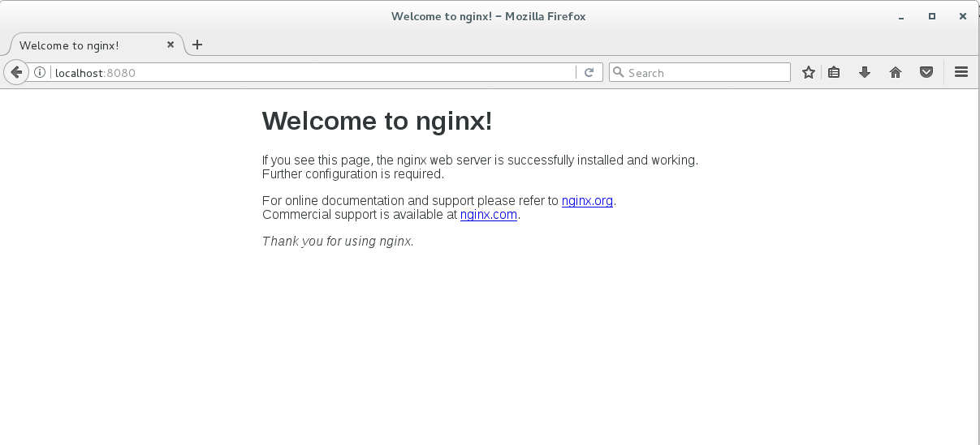
We can stop it with the following command
docker container stop web-1
Now, change to the upper folder
cd ..
Create another new folder and switch to it
mkdir nginx-2 && cd nginx-2
Open a new empty file for editing (use nano if you like)
vi Dockerfile
Enter the following text
FROM ubuntu
LABEL maintainer="SoftUni Student"
RUN apt-get update && apt-get install -y nginx
ENTRYPOINT ["/usr/sbin/nginx","-g","daemon off;"]
EXPOSE 80
Save and close the file
Build the new image with
docker image build -t nginx-2 .
Spin up a container out of the new image
docker container run -d -p 8080:80 --name web-2 nginx-2
If we open again a browser tab and visit http://localhost:8080 we will see the same result, as expected
Now stop it with the following command
docker container stop web-2
So, for us, the result is one and the same but for Docker this is not the case
Let us inspect the first image with
docker image history nginx-1
The output should be similar to
IMAGE CREATED CREATED BY SIZE COMMENT
b16421e0b876 3 minutes ago /bin/sh -c #(nop) EXPOSE 80 0B
3d5c566eb9a8 3 minutes ago /bin/sh -c #(nop) ENTRYPOINT ["/usr/sbin/ng… 0B
96a3afaaa16e 3 minutes ago /bin/sh -c apt-get install -y nginx 59.2MB
a96d134e620d 4 minutes ago /bin/sh -c apt-get update 33.7MB
92309843847a 4 minutes ago /bin/sh -c #(nop) LABEL maintainer=SoftUni … 0B
54c9d81cbb44 7 days ago /bin/sh -c #(nop) CMD ["bash"] 0B
<missing> 7 days ago /bin/sh -c #(nop) ADD file:3ccf747d646089ed7… 72.8MB
And then the second one
docker image history nginx-2
The output should be similar to
IMAGE CREATED CREATED BY SIZE COMMENT
335de904496b About a minute ago /bin/sh -c #(nop) EXPOSE 80 0B
ff29f1a69e9c About a minute ago /bin/sh -c #(nop) ENTRYPOINT ["/usr/sbin/ng… 0B
ec1107f8aad4 About a minute ago /bin/sh -c apt-get update && apt-get install… 92.8MB
92309843847a 4 minutes ago /bin/sh -c #(nop) LABEL maintainer=SoftUni … 0B
54c9d81cbb44 7 days ago /bin/sh -c #(nop) CMD ["bash"] 0B
<missing> 7 days ago /bin/sh -c #(nop) ADD file:3ccf747d646089ed7… 72.8MB
As it can be seen, both images have different number of layers (seven vs. six)
The difference is because of the different number of RUN commands in the two Dockerfiles
In any case, when we check their size
docker image ls
It is the same. So, can we go one step further? Sure, we can
Let’s go for a third run
Now, change to the upper folder
cd ..
Create another new folder and switch to it
mkdir nginx-3 && cd nginx-3
Open a new empty file for editing (use nano if you like)
vi Dockerfile
Enter the following text
FROM ubuntu
LABEL maintainer="SoftUni Student"
RUN apt-get update && apt-get install -y nginx && rm -rf /var/lib/apt/lists/*
ENTRYPOINT ["/usr/sbin/nginx","-g","daemon off;"]
EXPOSE 80
Save and close the file
Build the new image with
docker image build -t nginx-3 .
Spin up a container out of the new image
docker container run -d -p 8080:80 --name web-3 nginx-3
If we open again a browser tab and visit http://localhost:8080 we will see the same result, as expected
Now stop it with the following command
docker container stop web-3
Again, for us, the result is one and the same but for Docker this is not the case
Let us inspect this one as well
docker image history nginx-3
The output should be similar to
IMAGE CREATED CREATED BY SIZE COMMENT
f9e661a365e7 2 minutes ago /bin/sh -c #(nop) EXPOSE 80 0B
b85ce1089c69 2 minutes ago /bin/sh -c #(nop) ENTRYPOINT ["/usr/sbin/ng… 0B
0b5861ca838f 2 minutes ago /bin/sh -c apt-get update && apt-get install… 92.8MB
92309843847a 19 minutes ago /bin/sh -c #(nop) LABEL maintainer=SoftUni … 0B
54c9d81cbb44 7 days ago /bin/sh -c #(nop) CMD ["bash"] 0B
<missing> 7 days ago /bin/sh -c #(nop) ADD file:3ccf747d646089ed7… 72.8MB
Again, six layers as with the attempt no.2
Let’s check the size of the three images again
docker image ls nginx-*
Okay, we managed to save 30+ MB

Adding content during build
Now, change to the upper folder
cd ..
Create another new folder and switch to it
mkdir -p nginx-4/web && cd nginx-4
Create a custom index.html file
echo 'It works! :)' > web/index.html
Wait, where shall we copy this file (or the whole folder) in the image? Hm, let’s start again the last container (web-3)
docker container start web-3
Now, how can we enter? Perhaps, the attach command? Hm, no, it won’t work this time
We can execute a whole new process in the container with the following command
docker container exec -it web-3 bash
Check the configuration of the NGINX server with
cat /etc/nginx/nginx.conf
And then the file for the default web site
cat /etc/nginx/sites-enabled/default
Aha, the files are read from /var/www/html
So, we should place our content there
Close the session to the container
exit
Long way to check something simple. Is there another way?
Yes, there is. In fact, it is just a modification of what we did
Try this command
docker container exec -it web-3 cat /etc/nginx/sites-enabled/default
Okay, finally we can stop the container
docker container stop web-3
And continue with the building process
Now, open a new empty file for editing (use nano if you like)
vi Dockerfile
Enter the following text
FROM ubuntu
LABEL maintainer="SoftUni Student"
RUN apt-get update && apt-get install -y nginx && rm -rf /var/lib/apt/lists/*
COPY web/ /var/www/html
ENTRYPOINT ["/usr/sbin/nginx","-g","daemon off;"]
EXPOSE 80
Save and close the file
Build the new image with
docker image build -t nginx-4 .
Spin up a container out of the new image
docker container run -d -p 8080:80 --name web-4 nginx-4
If we open again a browser tab and visit http://localhost:8080 we will see a different result
Now stop it with the following command
docker container stop web-4

Publishing an image
Let’s assume that we are glad by what we accomplished so far, and we want to publish our latest image (nginx-4)
First, we must make sure that we have access to a registry
The easiest option is to register at Docker Hub here: https://hub.docker.com/
Then, we must login and authenticate our client to the registry
docker login
Enter the username and the password you used for Docker Hub
Now, tag the image appropriately
docker image tag nginx-4 <repository>/super-nginx:demo
Check that it appears in the list
docker image ls
Pay attention to their size an ID. They are in fact two names or records for the same image
Now, push it to the registry
docker image push <repository>/super-nginx:demo
Return to the browser and check that you see your newly published image
We can safely delete the local copy both for the original image (nginx-4) and the published one
docker image rm nginx-4
docker image rm <repository>/super-nginx:demo
Check that they are gone
docker image ls
Now, start a container out of the published image
docker container run -d -p 8080:80 <repository>/super-nginx:demo
If we open again a browser tab and visit http://localhost:8080 we will see it

ENTRYPOINT and CMD
Let us see how ENTRYPOINT and CMD work together
Return to the upper folder
cd ..
Create a new one
mkdir entry-cmd && cd entry-cmd
Open an empty Dockerfile for editing (or use nano if you like)
vi Dockerfile
Enter the following text
FROM busybox
LABEL description="ENTRYPOINT vs CMD demo" maintainer="SoftUni Student"
ENTRYPOINT ["ping", "-c", "4"]
CMD ["www.softuni.bg"]
Save and close the file
Build the image with
docker image build -t pinger .
Create and run a new container based on the image with
docker container run --name p1 pinger
And now run a second one but this time with modified command
docker container run --name p2 pinger tuionui.com
This way, by using both ETRYPOINT and CMD in their exec form, we got an image that when used for containers can be controlled by appending a parameter

ENTRYPOINT and CMD extended
We can go even further
Let’s first remove all stopped containers
docker container prune
Now, let’s create a pinger.sh bash script with the following content
#!/bin/bash
docker container run --rm pinger $1
Save and close the file
Then set its execute permissions
chmod +x pinger.sh
And test it without arguments
./pinger.sh
Now, test it with an argument
./pinger.sh abv.bg
It acts the same just the command is shorter
Let’s check the stopped containers
docker container ls -a
No traces of the last two executions
This way, we can create and use container-based utilities

Clean up
We can return our system to a clean state by removing all containers and images
First, we can stop all running containers
docker container stop $(docker container ls -q)
Then, we can remove all stopped containers
docker container prune
And finally, we can remove all images
docker image rm $(docker image ls -q)

