NYC Green Taxi – Data Pipeline

ETL
Created database green_taxi_trips
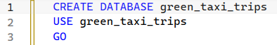
Create table raw_trips for raw data (before processing)
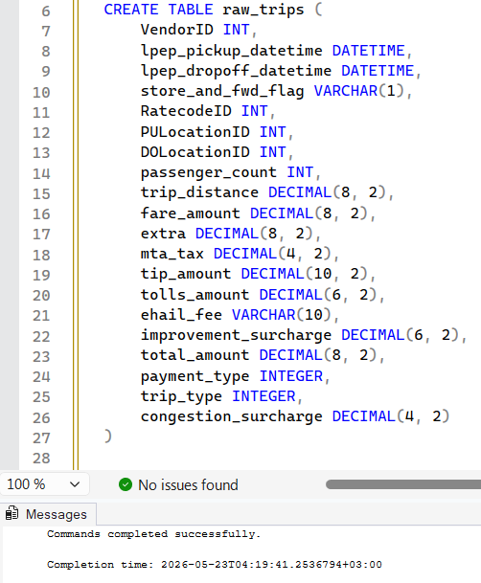
Inserted data from CSV to database table using BULK INSERT.
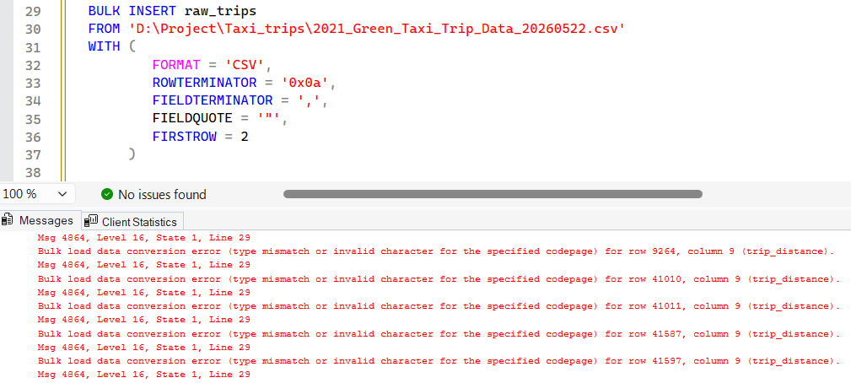
Some errors appeared. Checked rows specified in error messages – the reason is the presence of commas. These errors were actual for columns trip_distance, fare_amount, total_amount.
To fix the issue first assign type VARCHAR(10) to listed columns.
After successful import these columns will be cleaned and their types will be changed to DECIMAL.
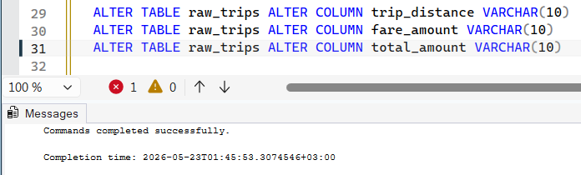
Now imported successfully
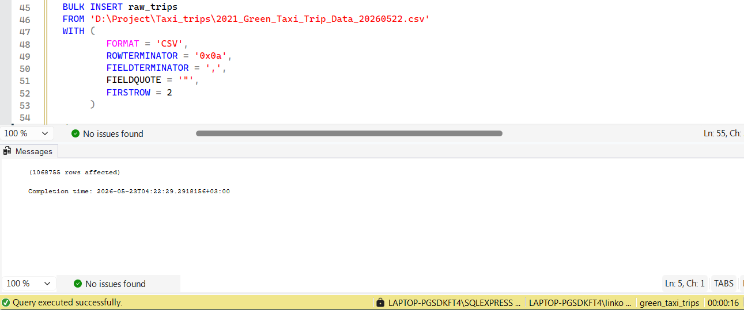
[Execution time = 16s]
It is expected that all columns with type DECIMAL have values in set [0-9.,-] (as it turned out commas are actual only for columns trip_distance, fare_amount, total_amount).
Created a stored procedure using dynamic SQL to check all specified columns for invalid characters at once.
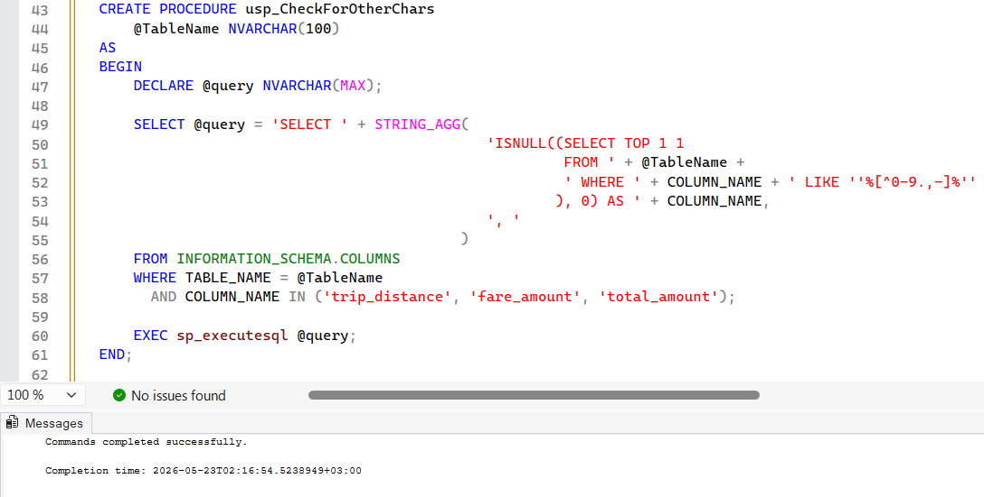
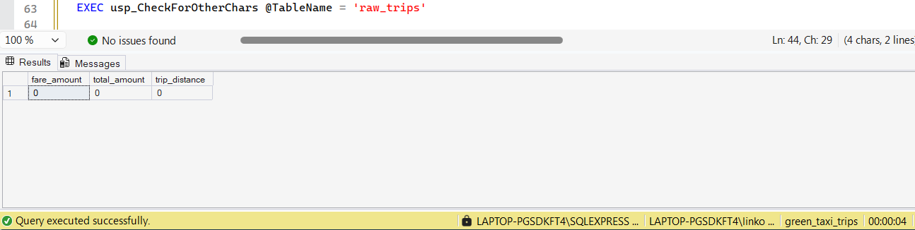
[Execution time = 4s]
Hypothesis confirmed, no other chars were detected.
Now, clean columns.
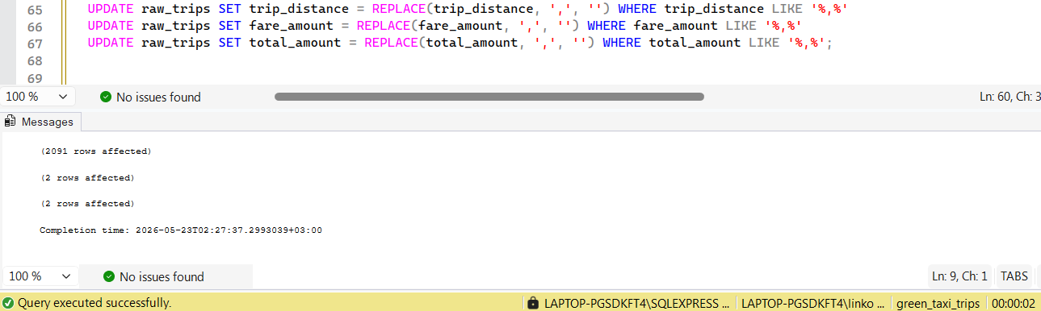
[Execution time = 2s]
Changed types to DECIMAL
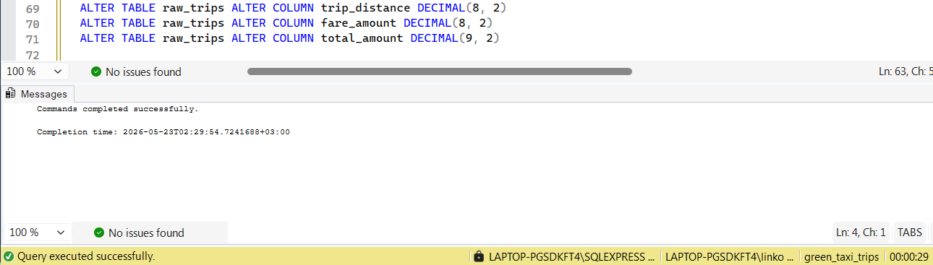
[Execution time = 29s]

Next, change store_and_fwd_flag from “N”/”Y” to “0”/“1”
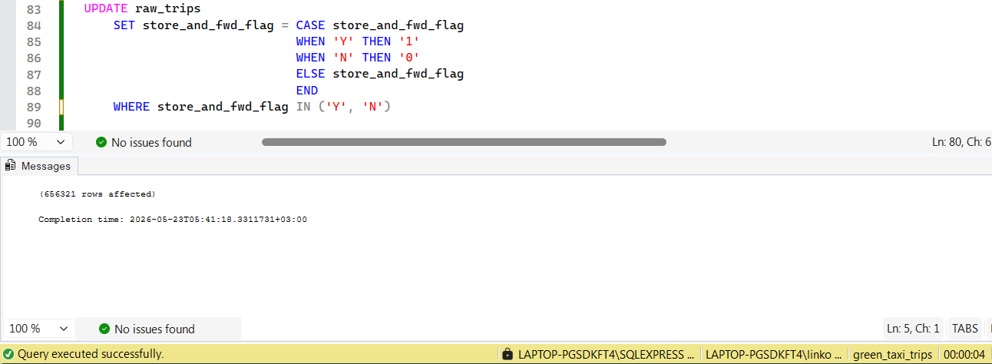
[Execution time = 4s]
and convert to BIT
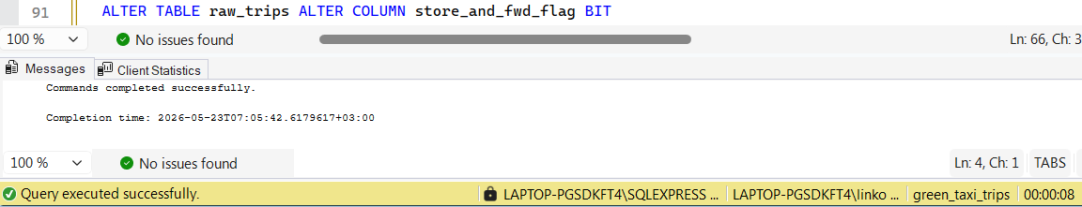
[Execution time = 8s]
Noticed that all values in column ehail_fee are NULL -> drop this column
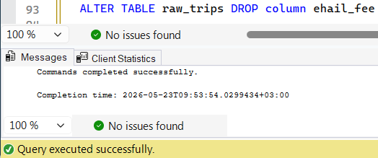
Next step is to standardize column names (snake_case)
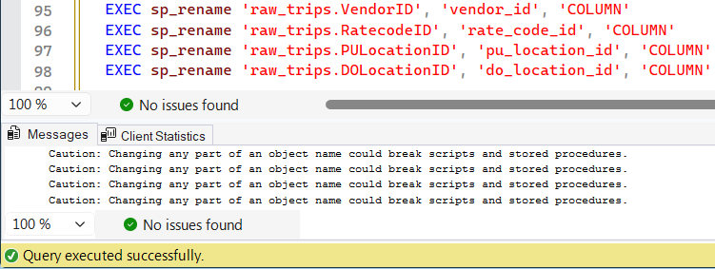

Columns payment_type and trip_type also should be renamed because they contain identifiers, not types.
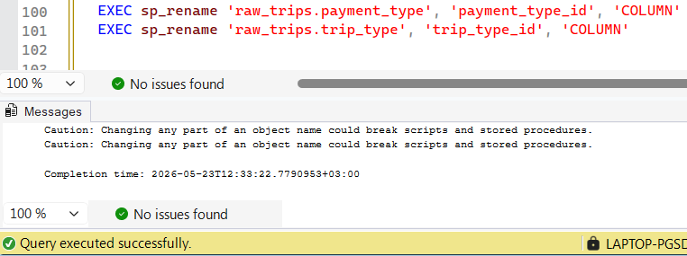
Next, I need to create a few new tables to store the decoded descriptions of the IDs mentioned in the dataset's data dictionary.
But before I need to create new column trip_id as PRIMARY KEY.
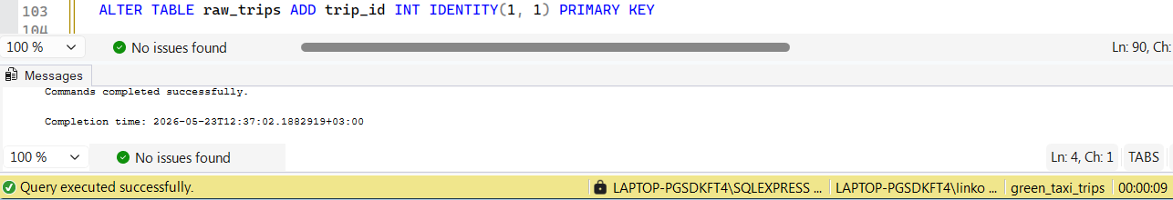
[Execution time = 9s]
And incremented by 1 to align with the reference table where IDs start from 1.
After cleaning it’s better to rename table from raw_trips -> trips
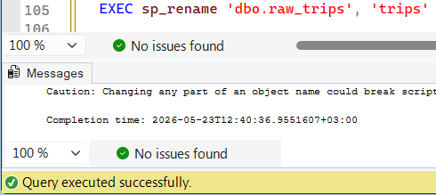

View final schema
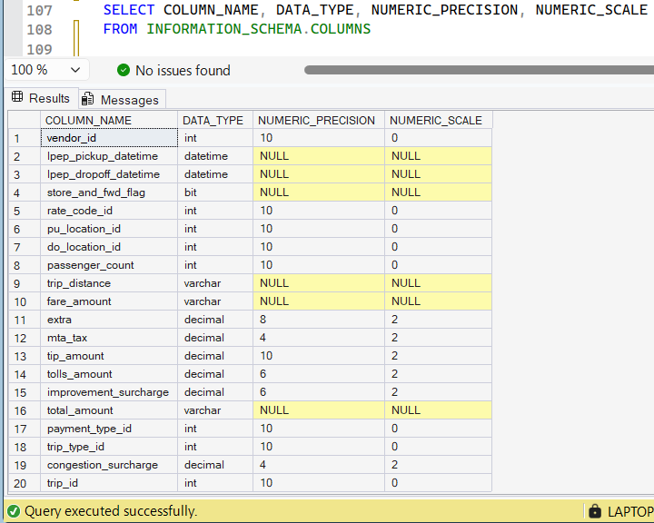
The next step is to create tables vendors, rate_codes, payment_types, trip_types and fill them with values from data dictionary
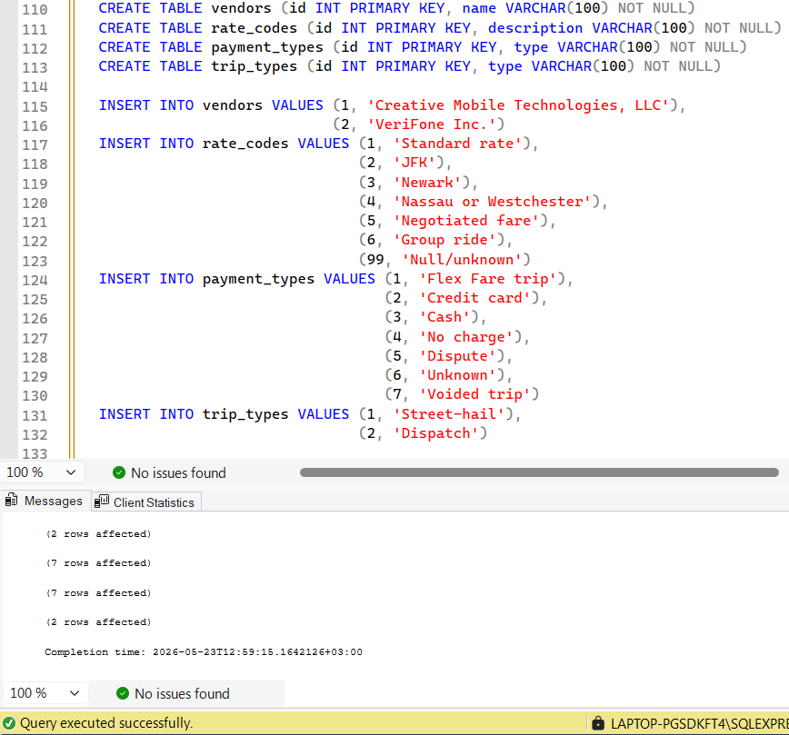
Before creating FOREIGN need check that columns vendor_id, rate_code_id, payment_type_id and trip_type_id in table trips don’t contain values that are not listed in tables vendors, rate_codes, payment_types and trip_types correspondingly.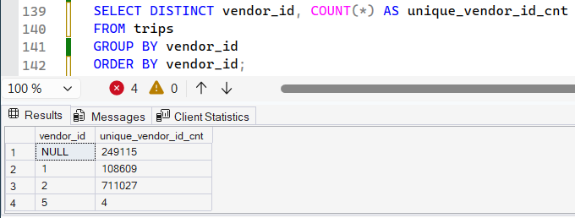
Value “5” in vendor_id not listed in vendors table -> it should be replaced with NULL.
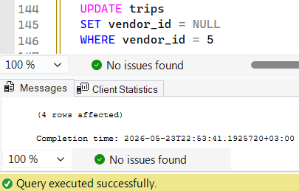
No issues found with other columns.
Create foreign keys
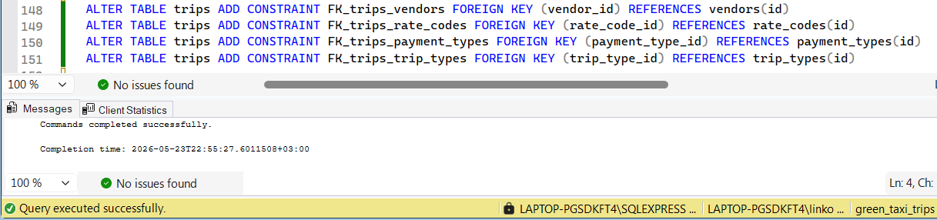

There are ~250,000 (25%) rows where columns vendor_id, passenger_count, store_and_fwd_flag, rate_code_id, payment_type_id, trip_type_id, congestion_surcharge simultaneously take NULL values.
TODO: in Power BI make a slicer for two modes: 1) all rows; 2) only rows where all values NOT NULL

