8.2

8.2.1



\[ <HeadEntity, Property, TailEntity> \]

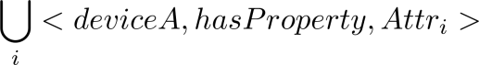

\bigcup\limits\_{i} <deviceA, hasProperty, Attr \_{i}>

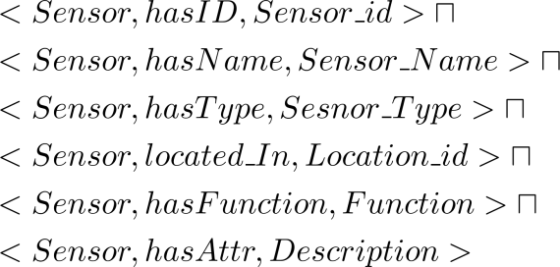

\begin{aligned}

& <Sensor, hasID, Sensor\\_id> \sqcap \\

& <Sensor, hasName, Sensor\\_Name> \sqcap \\

& <Sensor, hasType, Sesnor\\_Type> \sqcap\\

& <Sensor, located\\_In, Location\\_id> \sqcap\\

& <Sensor, hasFunction, Function> \sqcap \\

& <Sensor, hasAttr, Description>

\end{aligned}

8.2.2

wpsoffice

PE\_{i} := (Sensor\\_id, Object\\_id, Data, Timestamp)

8.2.3.1.1

wpsoffice

T =\{t\_{1}, t\_{2}, \dots, t\_{n}\}



\forall k \in (i, j) \ , \ s\_{k} = s\_{i} \ OR \ s\_{k} = s\_{j}

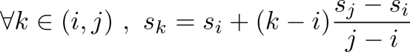

\forall k \in (i, j)\ , \ s\_{k} = s\_{i} + (k-i) \frac{s\_{j} - s\_{i}}{j-i}

8.2.3.1.2

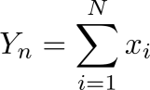

Y\_{n} = \sum\limits\_{i=1}^{N} x\_{i}

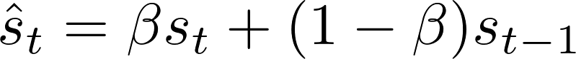

\hat{s}\_{t} = \beta s\_{t} + (1-\beta)s\_{t-1}

8.2.3.2.1

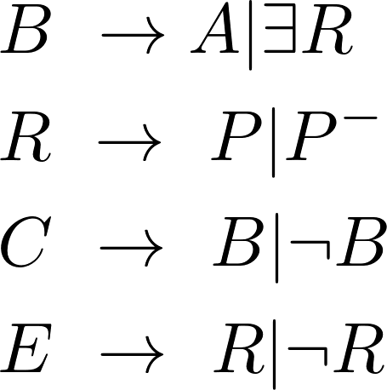

\begin{aligned}

& B \ \rightarrow \ A | \exists R \\

& R \ \rightarrow \ P | P^{-} \\

& C \ \rightarrow \ B| \neg B \\

& E \ \rightarrow \ R| \neg R

\end{aligned}

8.2.3.2.2

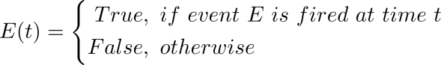

E(t)=\left\{

\begin{aligned}

True & , \ if \ event \ E \ is \ fired\ at\ time\ t\\

False & , \ otherwise

\end{aligned}

\right.

8.4.3

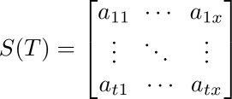

S(T) = \begin{bmatrix} a\_{11} \ & \cdots & \ a\_{1x} \\

\vdots \ & \ddots \ & \ \vdots\\

a\_{t1} \ & \ \cdots \ & \ a\_{tx} \end{bmatrix}

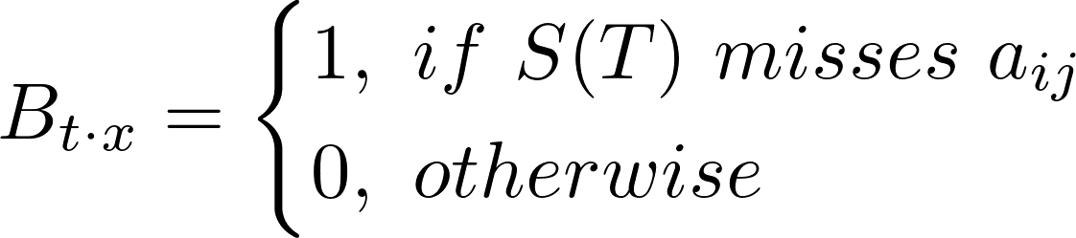

B\_{t \cdot x}=\left\{

\begin{aligned}

1 & , \ if \ S(T) \ misses \ a\_{ij} \\

0 & , \ otherwise

\end{aligned}

\right.

/private/var/folders/y7/_dxbgjfd16g8grhzs9syx0980000gn/T/com.kingsoft.wpsoffice.mac/wpsoffice.jyRfJrwpsoffice

\min\_{M} || \ M \ - \ S \ ||

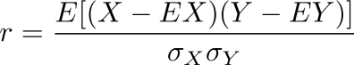

r = \frac{E[(X - EX)(Y - EY)]}{ \sigma\_{X} \sigma\_{Y} }



Y= s\_{0} + s\_{1}x\_{1} + s\_{2}x\_{2} + \dots + s\_{k}x\_{k}

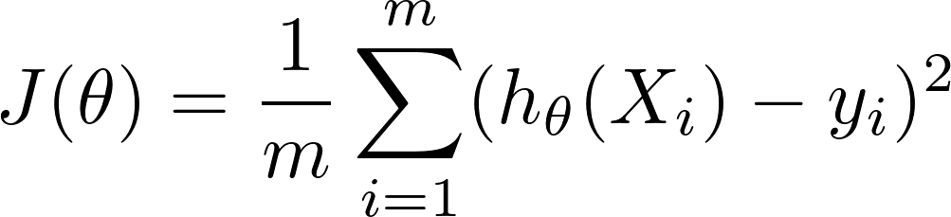

wpsoffice



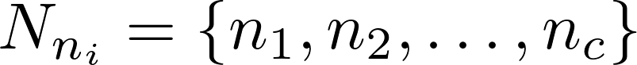

wpsoffice