【home-2】
1、题一
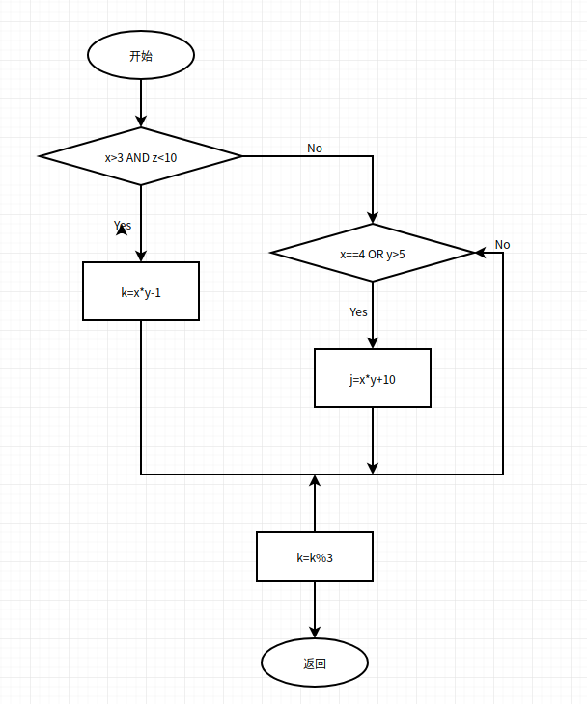
图1-程序流图
判定覆盖：
① x>3, z<10 T
②x<=3 或 z>=10 F
③ x==4 或y>5 T
④ x!=4, y<=5 F
①∧②③∧②④ 即acf∧abef∧abdf

[(4,1,1,0,0),(4.1.1.0.0)] ①acf
[(3,4,10,0,0),(3,6,10,28,0)] ②③abef
[(3,5,0,0,0),(3,5,0,0,0)] ②④abdf

条件组合覆盖：
T1 X>3 T2 Z<10
T3 X==4 T4 Y>5

① x>3, z<10 ⑤ x==4, y>5
② x>3, z>=10 ⑥ x==4, y<=5
③ x<=3, z<10 ⑦ x!=4, y>5
④ x<=3, z>=10 ⑧ x!=4, y<=5

合并后最小测试用例条件 ① ⑤ 、 ② ⑥、 ③ ⑦、 ④ ⑧

[(4,6,9,0,0),(4,6,9,0,2)] ① ⑤
[(4,5,10,0,0),(4,5,10,30,0)] ② ⑥
[(3,6,9,0,0),(3,6,9,28,0)] ③ ⑦
[(3,5,10,0,0),(3,5,10,0,0)] ④ ⑧

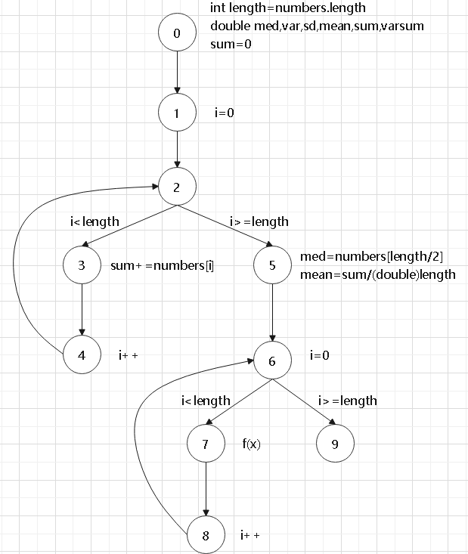
2、题二

图2-控制流图
点/边覆盖：
TR{0,1,2,3,4,5,6,7,8,9}
Path[0,1,2,3,4,5,6,7,8,9]

边对覆盖 :
TR{[0,1,2],[1,2,3],[1,2,5],[2,3,4],[2,5,6],[3,4,2],[4,2,3],[4,2,5],[5,6,7],[5,6,9],[6,7,8],[7,8,6],[8,6,7],[8,6,9]}
Path[0,1,2,3,4,2,5,6,7,8,6,9],[0,1,2,5,6,9],[0,1,2,3,4,2,3,4,2,5,6,7,8,6,7,8,6,9]

主路径覆盖：
TR{[2,3,4,2],[3,4,2,3],[4,2,3,4],[6,7,8,6],[7,8,6,7],[8,6,7,8],[0,1,2,3,5,6,9],[0,1,2,3,4],[7,8,6,9],[3,4,2,5,6,9],[3,4,2,5,6,7,8],[0,1,2,5,6,7,8]}
Path{[0,1,2,3,4,2,5,6,7,8,6,9],[0,1,2,3,4,2,5,6,9],[0,1,2,5,6,7,8,6,9],[0,1,2,5,6,9],[0,1,2,3,4,2,3,4,2,5,6,7,8,6,7,8,6,9]}

