Group 40: Nicole Lee Xue Ning 1003591, Phang Teng Fone 1003296, Gerald Lim Boon Hao 1003371

**Part 3**

**EN**

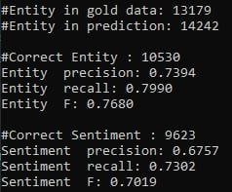

**SG**

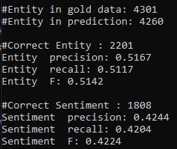

**CN**

