CSC738 Week 5 Lab: Regression, Forecasting and Challenges
Topic 3: Supervised Learning II · Step-by-step lab sheet

Before you start
- Open Google Colab (colab.research.google.com) and create a new notebook, or open Jupyter Notebook.
- For each step, type (or copy) the code into a new code cell and press Shift + Enter to run it.
- Run the steps in order: later steps use variables created in earlier steps.
- Compare your result with the expected output. Small differences in numbers are normal.
- Complete each Activity box, and keep your notebook: Parts 1 and 2 are templates for Assignments 1 and 2.
Three parts, matching the Week 5 lecture:
- Regression: baseline, linear and regularised models, non-linear regressors, metrics and residuals
- Time-series forecasting: a weekly dengue-style series, lag features, time-based validation and baselines
- Challenges: overfitting, data leakage and rare extreme values
All data is built into scikit-learn or generated in code. Cells marked Activity are for you to complete.

Part 1: Regression

1.1 Data and baseline
The diabetes dataset (built into scikit-learn): 442 patients, 10 numeric features, and a target measuring disease progression one year later.
Step 1: type and run this code in a new cell
import numpy as np, pandas as pd, matplotlib.pyplot as plt, warnings
warnings.filterwarnings("ignore")
from sklearn.datasets import load_diabetes
from sklearn.model_selection import train_test_split, KFold, cross_validate, GridSearchCV
from sklearn.pipeline import make_pipeline
from sklearn.preprocessing import StandardScaler
from sklearn.dummy import DummyRegressor

X, y = load_diabetes(return_X_y=True, as_frame=True)
X_train, X_test, y_train, y_test = train_test_split(X, y, test_size=0.2, random_state=42)
cv = KFold(5, shuffle=True, random_state=42)
SCORING = {"MAE": "neg_mean_absolute_error", "RMSE": "neg_root_mean_squared_error", "R2": "r2"}

def evaluate(model, X, y):
r = cross_validate(model, X, y, cv=cv, scoring=SCORING)
return {"MAE": -r["test_MAE"].mean(), "RMSE": -r["test_RMSE"].mean(), "R2": r["test_R2"].mean()}

print(X.shape, "| target range:", y.min(), "to", y.max())
pd.DataFrame([evaluate(DummyRegressor(strategy="mean"), X_train, y_train)], index=["Mean baseline"]).round(2)

Expected output (your numbers may differ slightly):
(442, 10) | target range: 25.0 to 346.0
MAE RMSE R2
Mean baseline 66.87 78.13 -0.03

The baseline always predicts the average target. Its R² is about 0 (or slightly negative): that is the score of a model that has learned nothing.

1.2 Linear, regularised and non-linear regressors
Step 2: type and run this code in a new cell
from sklearn.linear_model import LinearRegression, Ridge, Lasso
from sklearn.neighbors import KNeighborsRegressor
from sklearn.svm import SVR
from sklearn.ensemble import RandomForestRegressor, GradientBoostingRegressor

models = {
"Mean baseline": DummyRegressor(),
"Linear Regression": make_pipeline(StandardScaler(), LinearRegression()),
"Ridge (alpha=1)": make_pipeline(StandardScaler(), Ridge(alpha=1)),
"Lasso (alpha=1)": make_pipeline(StandardScaler(), Lasso(alpha=1)),
"KNN (k=10)": make_pipeline(StandardScaler(), KNeighborsRegressor(10)),
"SVR (RBF, C=100)": make_pipeline(StandardScaler(), SVR(C=100)),
"Random Forest": RandomForestRegressor(random_state=0),
"Gradient Boosting": GradientBoostingRegressor(random_state=0),
}
results = pd.DataFrame({name: evaluate(m, X_train, y_train) for name, m in models.items()}).T
results.round(2)

Expected output (your numbers may differ slightly):
MAE RMSE R2
Mean baseline 66.87 78.13 -0.03
Linear Regression 45.05 55.39 0.48
Ridge (alpha=1) 45.00 55.37 0.48
Lasso (alpha=1) 45.14 55.39 0.48
KNN (k=10) 48.12 59.53 0.40
SVR (RBF, C=100) 47.10 59.37 0.40
Random Forest 47.96 58.64 0.42
Gradient Boosting 49.52 61.04 0.37

On this small, noisy dataset the simple linear models do as well as the complex ones. More complex is not automatically better.
Activity 1. Tune alpha for Ridge with GridSearchCV over [0.01, 0.1, 1, 10, 100, 1000] (inside a pipeline with scaling, scoring "neg_mean_absolute_error"). Plot the cross-validated MAE against alpha. Where does the model start to underfit?
Your answer / code:

1.3 Lasso selects features
Step 3: type and run this code in a new cell
lasso = make_pipeline(StandardScaler(), Lasso(alpha=5)).fit(X_train, y_train)
coef = pd.Series(lasso[-1].coef_, index=X.columns).round(2)
print(coef.sort_values())
print("Features dropped (coefficient = 0):", list(coef[coef == 0].index))

Expected output (your numbers may differ slightly):
s3 -8.26
sex -2.51
s1 -0.00
age 0.00
s2 -0.00
s4 0.00
s6 0.00
bp 11.92
s5 18.66
bmi 25.85
dtype: float64
Features dropped (coefficient = 0): ['age', 's1', 's2', 's4', 's6']

1.4 Test once and analyse the residuals
Step 4: type and run this code in a new cell
from sklearn.metrics import mean_absolute_error, mean_squared_error, r2_score
final = make_pipeline(StandardScaler(), Ridge(alpha=1)).fit(X_train, y_train)
pred = final.predict(X_test)
print(f"Test MAE {mean_absolute_error(y_test, pred):.1f} | RMSE {mean_squared_error(y_test, pred) ** 0.5:.1f} | R² {r2_score(y_test, pred):.2f}")

res = y_test - pred
fig, ax = plt.subplots(1, 2, figsize=(11, 4))
ax[0].scatter(y_test, pred, s=15); ax[0].plot([25, 350], [25, 350], "k--"); ax[0].set(xlabel="Actual", ylabel="Predicted", title="Actual vs predicted")
ax[1].scatter(pred, res, s=15); ax[1].axhline(0, color="k", ls="--"); ax[1].set(xlabel="Predicted", ylabel="Residual (actual − predicted)", title="Residuals")
plt.tight_layout(); plt.show()

Expected output (your numbers may differ slightly):
Test MAE 42.8 | RMSE 53.8 | R² 0.45

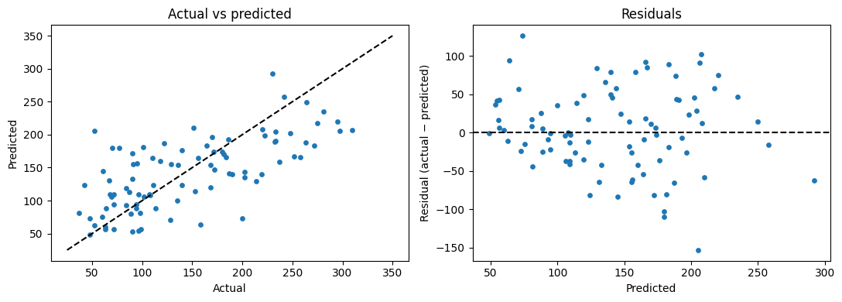
Activity 2. Look at the residual plot. Is there a clear pattern (curve or funnel), or random scatter? What does that tell you about the model?
Your answer / code:

Part 2: Time-series forecasting

2.1 A weekly dengue-style series
Five years of weekly cases, generated in code: a seasonal cycle, a slow trend, a rainfall effect two weeks later, and a few outbreak weeks.
Step 5: type and run this code in a new cell
rng = np.random.default_rng(1)
weeks = pd.date_range("2021-01-03", periods=260, freq="W")
w = np.arange(260)
rain = 150 + 80 * np.sin(2 * np.pi * (w - 8) / 52) + rng.normal(0, 25, 260)
cases = 80 + 0.15 * w + 35 * np.sin(2 * np.pi * (w - 12) / 52) + 0.25 * np.roll(rain - 150, 2) + rng.normal(0, 8, 260)
outbreaks = rng.choice(np.arange(60, 260), 8, replace=False); cases[outbreaks] += rng.uniform(60, 120, 8)
ts = pd.DataFrame({"cases": cases.round(), "rainfall": rain.round(1)}, index=weeks)
ts.cases.plot(figsize=(11, 3), title="Weekly cases (synthetic)"); plt.show()

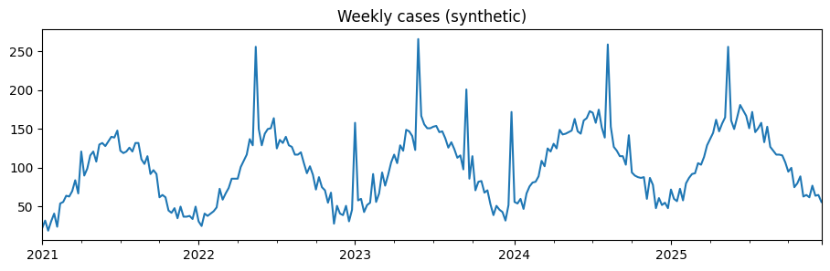

2.2 Features from the past only
Step 6: type and run this code in a new cell
df = ts.copy()
for lag in (1, 2, 52):
df[f"lag_{lag}"] = df.cases.shift(lag)
df["roll_mean_4"] = df.cases.shift(1).rolling(4).mean() # ends at last week
df["rain_lag_2"] = df.rainfall.shift(2) # rainfall two weeks ago is known
df["week_of_year"] = df.index.isocalendar().week.astype(int)
df = df.drop(columns="rainfall").dropna()
Xt, yt = df.drop(columns="cases"), df.cases
split = len(df) - 52 # last year = test set
Xt_tr, Xt_te, yt_tr, yt_te = Xt.iloc[:split], Xt.iloc[split:], yt.iloc[:split], yt.iloc[split:]
print("Train weeks:", len(Xt_tr), "| Test weeks:", len(Xt_te))
df.head(3)

Expected output (your numbers may differ slightly):
Train weeks: 156 | Test weeks: 52
cases lag_1 lag_2 lag_52 roll_mean_4 rain_lag_2 week_of_year
2022-01-02 31.0 50.0 34.0 22.0 39.75 83.2 52
2022-01-09 25.0 31.0 50.0 32.0 38.25 58.7 1
2022-01-16 41.0 25.0 31.0 19.0 35.00 102.5 2

2.3 Baselines, models and time-based tuning
Step 7: type and run this code in a new cell
from sklearn.model_selection import TimeSeriesSplit
def mape(a, p): return np.mean(np.abs(a - p) / np.abs(a)) * 100
def report(name, p):
return {"Model": name, "MAE": mean_absolute_error(yt_te, p), "RMSE": mean_squared_error(yt_te, p) ** 0.5,
"MAPE %": mape(yt_te, p), "R2": r2_score(yt_te, p)}

rows = [report("Naive (last week)", Xt_te.lag_1), report("Seasonal naive (52 weeks ago)", Xt_te.lag_52)]
lin = make_pipeline(StandardScaler(), LinearRegression()).fit(Xt_tr, yt_tr)
rows.append(report("Linear Regression", lin.predict(Xt_te)))
gb = GridSearchCV(GradientBoostingRegressor(random_state=0),
{"n_estimators": [100, 300], "learning_rate": [0.03, 0.1], "max_depth": [2, 3]},
cv=TimeSeriesSplit(5), scoring="neg_mean_absolute_error").fit(Xt_tr, yt_tr)
rows.append(report("Gradient Boosting (tuned)", gb.predict(Xt_te)))
print("Best GB settings:", gb.best_params_)
pd.DataFrame(rows).set_index("Model").round(2)

Expected output (your numbers may differ slightly):
Best GB settings: {'learning_rate': 0.03, 'max_depth': 3, 'n_estimators': 100}
MAE RMSE MAPE % R2
Model
Naive (last week) 14.44 22.56 12.71 0.73
Seasonal naive (52 weeks ago) 16.46 31.55 17.00 0.48
Linear Regression 11.86 20.14 11.28 0.79
Gradient Boosting (tuned) 14.73 24.72 14.99 0.68

Step 8: type and run this code in a new cell
plt.figure(figsize=(11, 3.5))
plt.plot(yt_te.index, yt_te, label="Actual", lw=2)
plt.plot(yt_te.index, lin.predict(Xt_te), label="Linear Regression")
plt.plot(yt_te.index, Xt_te.lag_1, label="Naive", alpha=.6, ls="--")
plt.legend(); plt.title("Last 52 weeks: actual vs forecast"); plt.show()

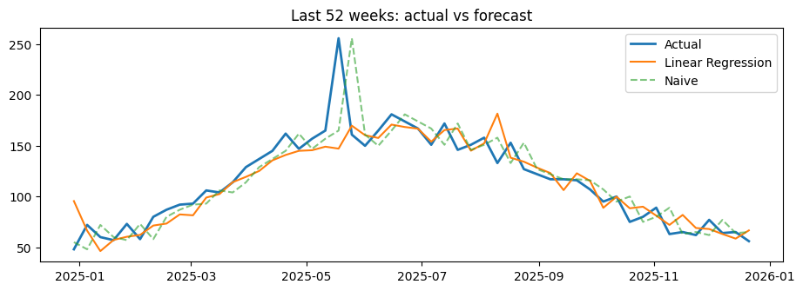
Linear Regression does well here because the trend continues upward. Tree-based models cannot predict beyond the range of values they saw in training, which hurts them when there is a trend.
Activity 3. Add a feature lag_3 and re-run 2.2 and 2.3. Does it help? Then remove rain_lag_2: how much does the error change, and what does that tell you about rainfall?
Your answer / code:

Part 3: Challenges

3.1 Overfitting with polynomial features
Step 9: type and run this code in a new cell
from sklearn.preprocessing import PolynomialFeatures
Xb = X_train[["bmi"]]
for deg in (1, 3, 10, 15):
m = make_pipeline(StandardScaler(), PolynomialFeatures(deg), LinearRegression())
r = cross_validate(m, Xb, y_train, cv=cv, scoring="neg_root_mean_squared_error", return_train_score=True)
print(f"degree {deg:2d}: train RMSE {-r['train_score'].mean():6.1f} | CV RMSE {-r['test_score'].mean():8.1f}")

Expected output (your numbers may differ slightly):
degree 1: train RMSE 62.0 | CV RMSE 62.5
degree 3: train RMSE 61.9 | CV RMSE 62.9
degree 10: train RMSE 60.8 | CV RMSE 170.2
degree 15: train RMSE 60.4 | CV RMSE 3410.7

Training error keeps falling as the degree grows, but cross-validated error rises sharply at high degrees: the curve is fitting noise.

3.2 Data leakage in time series
Step 10: type and run this code in a new cell
leaky = df.copy()
leaky["roll_mean_4"] = ts.cases.rolling(4).mean().loc[leaky.index] # forgot shift(1): includes this week
Xl = leaky.drop(columns="cases")
m_ok = make_pipeline(StandardScaler(), LinearRegression()).fit(Xt_tr, yt_tr)
m_leak = make_pipeline(StandardScaler(), LinearRegression()).fit(Xl.iloc[:split], yt_tr)
print(f"Correct features MAE: {mean_absolute_error(yt_te, m_ok.predict(Xt_te)):.1f}")
print(f"Leaky feature MAE: {mean_absolute_error(yt_te, m_leak.predict(Xl.iloc[split:])):.1f} (looks better, but impossible in real use)")

Xs_tr, Xs_te, ys_tr, ys_te = train_test_split(Xt, yt, test_size=52, random_state=0) # shuffled split
m_shuf = make_pipeline(StandardScaler(), LinearRegression()).fit(Xs_tr, ys_tr)
print(f"Shuffled split MAE: {mean_absolute_error(ys_te, m_shuf.predict(Xs_te)):.1f} (not a real forecast: trained on weeks after the ones it predicts)")

Expected output (your numbers may differ slightly):
Correct features MAE: 11.9
Leaky feature MAE: 7.9 (looks better, but impossible in real use)
Shuffled split MAE: 18.0 (not a real forecast: trained on weeks after the ones it predicts)

The leaky rolling mean contains the answer, so the error looks smaller. The shuffled split tests on random weeks from all five years while training on later weeks, so its number does not tell you how well you would forecast next year.

3.3 Rare extreme values: outbreak weeks
Step 11: type and run this code in a new cell
pred_te = pd.Series(lin.predict(Xt_te), index=Xt_te.index)
err = (yt_te - pred_te).abs()
is_outbreak = yt_te > yt_te.quantile(0.9)
print(f"MAE on normal weeks: {err[~is_outbreak].mean():.1f}")
print(f"MAE on the top 10% weeks: {err[is_outbreak].mean():.1f}")

Expected output (your numbers may differ slightly):
MAE on normal weeks: 10.3
MAE on the top 10% weeks: 26.2

One overall MAE hides how badly the model does on the weeks that matter most.
Activity 4. For health officers, which is worse: under-predicting an outbreak week or over-predicting a quiet week? Suggest one change to the model or the evaluation that reflects this.
Your answer / code:

Final activity: link to the assignments
- Assignment 1 (regression option): repeat Part 1 on your dataset: mean baseline, two models, cross-validated MAE, RMSE and R², then residuals.
- Assignment 2 (time-series option): repeat Part 2: features from the past only, time-based split, TimeSeriesSplit tuning, naive baselines and MAE/RMSE/MAPE.

