CSC738 Week 4 Lab: Classification Methods
Topic 3: Supervised Learning I · Step-by-step lab sheet

Before you start
- Open Google Colab (colab.research.google.com) and create a new notebook, or open Jupyter Notebook.
- For each step, type (or copy) the code into a new code cell and press Shift + Enter to run it.
- Run the steps in order: later steps use variables created in earlier steps.
- Compare your result with the expected output. Small differences in numbers are normal.
- Complete each Activity box, and keep your notebook: Sections 1, 3 and 5 are templates for Assignments 1 and 2.
You will follow the full classification workflow from the Week 4 lecture:
- Set a baseline
- Train five classifiers and see why scaling matters
- Compare them fairly with stratified cross-validation
- Try ensembles (Random Forest, Gradient Boosting)
- Tune hyperparameters with grid and random search
- Test the final model once
The dataset is the Breast Cancer Wisconsin dataset built into scikit-learn (569 tumours, 30 numeric features, malignant or benign), so nothing needs downloading. Cells marked Activity are for you to complete.

0. Setup and data
Step 1: type and run this code in a new cell
import numpy as np, pandas as pd, matplotlib.pyplot as plt, warnings
warnings.filterwarnings("ignore")
from sklearn.datasets import load_breast_cancer
from sklearn.model_selection import train_test_split, StratifiedKFold, cross_val_score, GridSearchCV, RandomizedSearchCV
from sklearn.pipeline import make_pipeline
from sklearn.preprocessing import StandardScaler

data = load_breast_cancer(as_frame=True)
X, y = data.data, data.target # target: 0 = malignant, 1 = benign
print(X.shape)
print(y.value_counts().rename({0: "malignant", 1: "benign"}))

X_train, X_test, y_train, y_test = train_test_split(X, y, test_size=0.2, stratify=y, random_state=42)
cv = StratifiedKFold(5, shuffle=True, random_state=42)
print("Train:", X_train.shape, "Test:", X_test.shape)

Expected output (your numbers may differ slightly):
(569, 30)
target
benign 357
malignant 212
Name: count, dtype: int64
Train: (455, 30) Test: (114, 30)

The test set is put aside now and used only once, in Section 6.

1. Baseline
Step 2: type and run this code in a new cell
from sklearn.dummy import DummyClassifier
base = DummyClassifier(strategy="most_frequent")
s = cross_val_score(base, X_train, y_train, cv=cv)
print(f"Majority-class baseline accuracy: {s.mean():.3f}")

Expected output (your numbers may differ slightly):
Majority-class baseline accuracy: 0.626

Any useful model must clearly beat this score.

2. Five classifiers: why scaling matters
Step 3: type and run this code in a new cell
from sklearn.linear_model import LogisticRegression
from sklearn.naive_bayes import GaussianNB
from sklearn.neighbors import KNeighborsClassifier
from sklearn.svm import SVC
from sklearn.tree import DecisionTreeClassifier

models = {
"Logistic Regression": LogisticRegression(max_iter=5000),
"Naive Bayes": GaussianNB(),
"KNN": KNeighborsClassifier(),
"SVM (RBF)": SVC(),
"Decision Tree": DecisionTreeClassifier(random_state=0),
}
rows = []
for name, m in models.items():
raw = cross_val_score(m, X_train, y_train, cv=cv).mean()
scaled = cross_val_score(make_pipeline(StandardScaler(), m), X_train, y_train, cv=cv).mean()
rows.append([name, round(raw, 3), round(scaled, 3)])
pd.DataFrame(rows, columns=["Model", "No scaling", "With scaling"])

Expected output (your numbers may differ slightly):
Model No scaling With scaling
0 Logistic Regression 0.945 0.978
1 Naive Bayes 0.941 0.934
2 KNN 0.941 0.963
3 SVM (RBF) 0.905 0.969
4 Decision Tree 0.923 0.923

SVM, Logistic Regression and KNN improve with scaling (SVM jumps from about 0.91 to 0.97) because they rely on distances or weighted sums, and the features here range from below 1 to over 1,000. Naive Bayes and the Decision Tree are almost unaffected.
Activity 1. Look at X.describe(). Which two features have the largest values? Explain in one sentence why they dominate KNN without scaling.
Your answer / code:

3. Fair comparison with cross-validation
Report the mean and the standard deviation, using macro F1 as well as accuracy.
Step 4: type and run this code in a new cell
results = []
for name, m in models.items():
pipe = make_pipeline(StandardScaler(), m)
acc = cross_val_score(pipe, X_train, y_train, cv=cv, scoring="accuracy")
f1 = cross_val_score(pipe, X_train, y_train, cv=cv, scoring="f1_macro")
results.append([name, f"{acc.mean():.3f} ± {acc.std():.3f}", f"{f1.mean():.3f} ± {f1.std():.3f}"])
pd.DataFrame(results, columns=["Model", "Accuracy", "Macro F1"])

Expected output (your numbers may differ slightly):
Model Accuracy Macro F1
0 Logistic Regression 0.978 ± 0.010 0.976 ± 0.011
1 Naive Bayes 0.934 ± 0.029 0.929 ± 0.031
2 KNN 0.963 ± 0.011 0.960 ± 0.012
3 SVM (RBF) 0.969 ± 0.015 0.967 ± 0.016
4 Decision Tree 0.923 ± 0.016 0.919 ± 0.016

When two models differ by less than their standard deviations, the difference may be due to chance.

4. Ensembles
Step 5: type and run this code in a new cell
from sklearn.ensemble import RandomForestClassifier, AdaBoostClassifier, GradientBoostingClassifier
ens = {
"Random Forest": RandomForestClassifier(random_state=0),
"AdaBoost": AdaBoostClassifier(random_state=0),
"Gradient Boosting": GradientBoostingClassifier(random_state=0),
}
for name, m in ens.items():
s = cross_val_score(m, X_train, y_train, cv=cv, scoring="f1_macro")
print(f"{name:18s} macro F1: {s.mean():.3f} ± {s.std():.3f}")

Expected output (your numbers may differ slightly):
Random Forest macro F1: 0.955 ± 0.013
AdaBoost macro F1: 0.962 ± 0.019
Gradient Boosting macro F1: 0.951 ± 0.014

Step 6: type and run this code in a new cell
rf = RandomForestClassifier(random_state=0).fit(X_train, y_train)
imp = pd.Series(rf.feature_importances_, index=X.columns).sort_values().tail(10)
imp.plot.barh(figsize=(7, 4), title="Random Forest: top 10 feature importances"); plt.tight_layout(); plt.show()

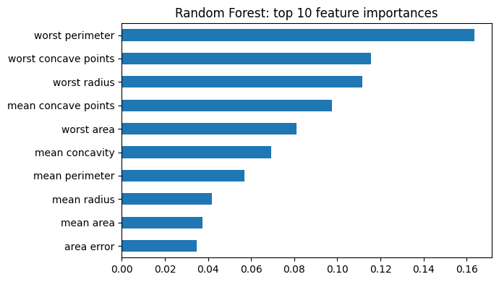
XGBoost is a separate library. To try it, run %pip install xgboost, then use from xgboost import XGBClassifier in the loop above.
Activity 2. Compare the best single model from Section 3 with the best ensemble. Is the ensemble clearly better, given the standard deviations?
Your answer / code:

5. Hyperparameter tuning
### 5.1 Grid search: SVM
Step 7: type and run this code in a new cell
svm_pipe = make_pipeline(StandardScaler(), SVC())
grid = {"svc__C": [0.1, 1, 10, 100], "svc__gamma": [0.001, 0.01, 0.1, 1]}
gs = GridSearchCV(svm_pipe, grid, cv=cv, scoring="f1_macro").fit(X_train, y_train)
print("Best settings:", gs.best_params_, "| CV macro F1:", round(gs.best_score_, 3))

heat = pd.DataFrame(gs.cv_results_)[["param_svc__C", "param_svc__gamma", "mean_test_score"]]
heat = heat.pivot(index="param_svc__C", columns="param_svc__gamma", values="mean_test_score")
plt.imshow(heat, cmap="viridis"); plt.colorbar(label="CV macro F1")
plt.xticks(range(4), heat.columns); plt.yticks(range(4), heat.index)
plt.xlabel("gamma"); plt.ylabel("C"); plt.title("Effect of C and gamma"); plt.show()

Expected output (your numbers may differ slightly):
Best settings: {'svc__C': 10, 'svc__gamma': 0.01} | CV macro F1: 0.974

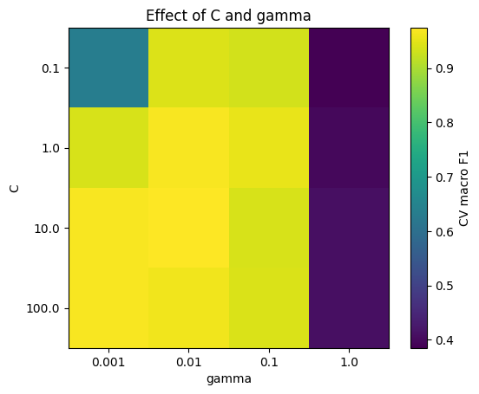
The heat map shows the effect of each hyperparameter, which Assignment 2 asks you to report: very large gamma overfits, very small C underfits.
### 5.2 Random search: Random Forest
Step 8: type and run this code in a new cell
dist = {"n_estimators": [100, 200, 300, 500], "max_depth": [None, 5, 10, 20],
"max_features": ["sqrt", "log2"], "min_samples_leaf": [1, 2, 5]}
rs = RandomizedSearchCV(RandomForestClassifier(random_state=0), dist, n_iter=15, cv=cv,
scoring="f1_macro", random_state=0).fit(X_train, y_train)
print("Best settings:", rs.best_params_, "| CV macro F1:", round(rs.best_score_, 3))

Expected output (your numbers may differ slightly):
Best settings: {'n_estimators': 300, 'min_samples_leaf': 1, 'max_features': 'sqrt', 'max_depth': None} | CV ma

Random search tried 15 of the 96 possible combinations. Activity 3. Tune KNN with GridSearchCV over n_neighbors = [1, 3, 5, 11, 21] and weights = ['uniform', 'distance'] (inside a pipeline with scaling). Plot score against n_neighbors. Where does it underfit and where does it overfit?

6. Test the final model once
Step 9: type and run this code in a new cell
from sklearn.metrics import classification_report, ConfusionMatrixDisplay
final = gs.best_estimator_ # or rs.best_estimator_, whichever was better in CV
y_pred = final.predict(X_test)
print(classification_report(y_test, y_pred, target_names=["malignant", "benign"]))
ConfusionMatrixDisplay.from_predictions(y_test, y_pred, display_labels=["malignant", "benign"])
plt.title("Final model on the test set"); plt.show()

Expected output (your numbers may differ slightly):
precision recall f1-score support

malignant 0.98 0.98 0.98 42
benign 0.99 0.99 0.99 72

accuracy 0.98 114
macro avg 0.98 0.98 0.98 114
weighted avg 0.98 0.98 0.98 114

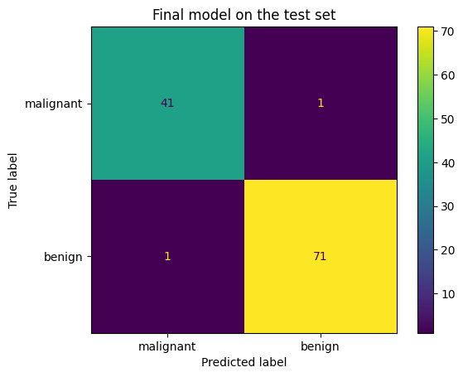
Activity 4. In this problem, which error is worse: predicting benign for a malignant tumour, or malignant for a benign one? Which metric would you report first, and why?
Your answer / code:

Final activity: link to the assignments
- Assignment 1: repeat Sections 1 and 3 on your own tabular dataset (two models plus baseline, default settings).
- Assignment 2: repeat Section 5 on your own dataset's features, tuning at least two hyperparameters and showing their effect as in the heat map.

