CompE 470L

Digital Systems

Lab 1: Pin Shift Register

Student: Tengiz Pataraia

16/10/2021

Contents

Task Description: 2

Solution: 2

Simulation: 3

Conclusion: 3

# Task Description:

user enters random numbers by using switches and by pressing key[0];

as soon as this random pattern contains consecutive numbers : x,y,z - you have to light up all four LEDs (after that, you can still accept new numbers or not, it matters not).

x,y,z are last three digits of my REDID (314)

# Solution:

I decided to solve this problem using shift registers. Every time the button is pressed, value of switches is written in r1, value of r1 is written to r2 and value of r2 is written to r3. After three presses we will have values stored in r1, r2 and r3.

On every clock cycle I check values in r1, r2 and r3. If they are equal to 314, then all LEDs are turned on, otherwise they are of.

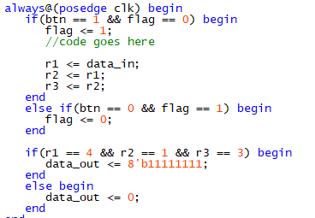

# Simulation:

Relying on my testbench, this is the simulation I got. First I write 3 in data_in and press button, then 1, and 4. As we can see number “move” through registers and when all of them have correct values LED register becomes 11111111, which means that LEDs will light up.

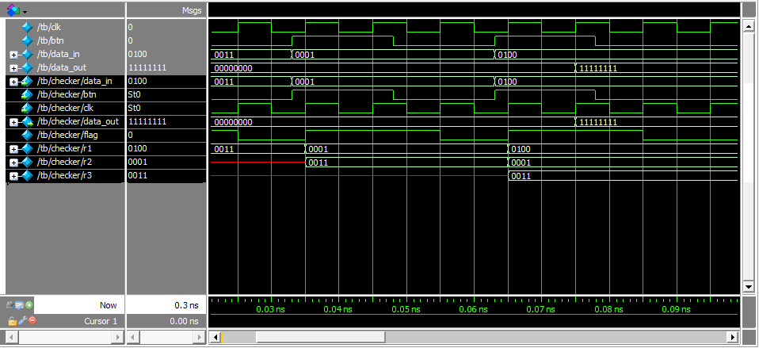

# Conclusion:

Everything works properly.