DESIGN DOCUMENT
System Design:

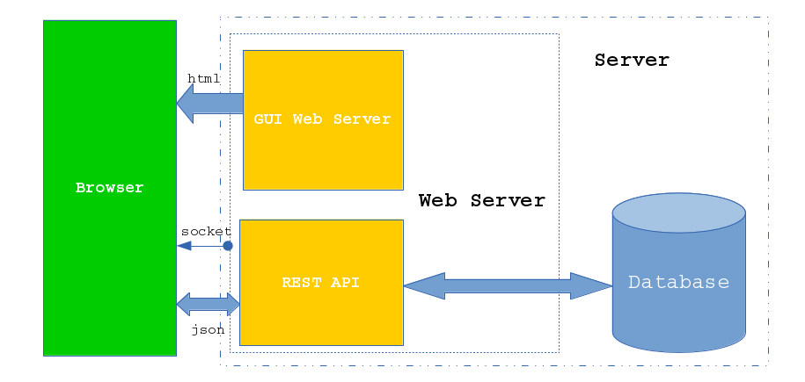
Programming Languages:
Javascript

Markup Languages:
HTML5

Design languages:
CSS

Databases:
MongoDB

Data-interchange formats:
JSON

Environments:
Node.js

Frameworks:
Express.js, Angular.js, Bootstrap, Mocha, Jasmine

libraries:
Mongoose, Socket.io, jQuery

API's:
Google Maps API V3

