BCSE497J - Project-I
CONTEXT-AWARE PERSONAL AI ASSISTANT USING LARGE LANGUAGE MODELS, DYNAMIC MODEL ROUTING, MEMORY, AND RETRIEVAL-AUGMENTED GENERATION (RAG)
23BAI0111 | NISCHAY N
23BAI0105 | TEJAS K M
23BCT0227 | TENIDHAR REDDY
Under the Supervision of
Prof. Mary Mekala A
School of Computer Science and Engineering (SCOPE)
B.Tech.
in
Computer Science and Engineering
School of Computer Science and Engineering

September 2026

ABSTRACT
Existing AI assistants such as ChatGPT, Claude, and Gemini require users to manually select a model and lose conversational context whenever they switch between them, since no single model is uniformly best across all task types. This project proposes a Context-Aware Personal AI Assistant built on three pillars: Dynamic Model Routing, Persistent Memory, and Retrieval-Augmented Generation (RAG). Following feedback at Review 1, the team studied Perplexity AI's production architecture in depth and found that it already ships all three pillars, which required refining the project's novelty claim. The revised contribution is not a bigger orchestration system, but a more transparent and measurable one: routing generalized beyond search to coding, writing, and multimodal tasks; a published, reproducible routing-scoring function in place of a black-box classifier; formally benchmarked memory instead of casual preference capture; and an open ablation study isolating each component's individual contribution — something not published even by Perplexity itself.
Since Review 1 the team has implemented all four variants on one shared pipeline in which routing, memory and retrieval are independent switches. Model A (routing only) combines an intent classifier (TF-IDF word and character n-grams with a calibrated Linear SVM, trained on 1,350 labelled queries across 5 task categories) with a published accuracy-cost-latency scoring function; it reaches 84.4% held-out accuracy on a leakage-free split, and routing beats an average fixed model by 0.083 points on the 0-1 routing score. Model B adds three-tier persistent memory (turns, session summaries, extracted user facts in SQLite with embedding recall), Model C adds retrieval-augmented generation with numbered, citable passages, and Model D combines all three. An ablation study on small open-weight models served locally through Ollama on an Apple M3 laptop with 8 GB RAM shows memory raising cross-session recall from 0% to 97% (30 questions) and retrieval raising accuracy on a closed-domain question set from 0% to 89% (36 questions), with the combined Model D reaching 97% recall and 89% RAG accuracy. A second, per-task benchmark of 50 automatically graded tasks shows the routed system answering 84% correctly, against 78% for the best single model, with 93.3% routing accuracy on 150 unseen prompts.
Keywords — Dynamic Model Routing, Large Language Models, Retrieval-Augmented Generation, Persistent Memory, Intent Classification, Ablation Study.

TABLE OF CONTENTS
Sl.No | Contents | Page No.
 | Abstract | i
1. | INTRODUCTION | 1
 | 1.1 Background | 1
 | 1.2 Motivation | 1
 | 1.3 Scope of the Project | 1
2. | PROJECT DESCRIPTION AND GOALS | 2
 | 2.1 Literature Review | 2
 | 2.2 Research Gap | 2
 | 2.3 Objectives | 3
 | 2.4 Problem Statement | 3
 | 2.5 Project Plan | 3
3. | TECHNICAL SPECIFICATION | 5
 | 3.1 Requirements | 5
 | 3.2 Feasibility Study | 5
 | 3.3 System Specification | 6
4. | DESIGN APPROACH AND DETAILS | 7
 | 4.1 System Architecture | 7
 | 4.2 Design | 8
5. | IMPLEMENTATION AND RESULTS | 11
 | 5.1 Implementation | 11
 | 5.2 Experimental Setup | 11
 | 5.3 Results | 12
 | 5.4 Prototype Demonstration | 16
 | 5.5 Discussion | 19
 | 5.6 Work Remaining Before the Final Review | 21
6. | REFERENCES | 22

1. INTRODUCTION
1.1 Background
Large language models (LLMs) such as GPT, Claude, Gemini, and search-tuned models like Perplexity's Sonar each have distinct strengths — one may excel at coding, another at long-form writing, another at real-time factual lookup. Today, using the best model for each task requires a person to manually judge the task and switch tools, losing conversational context and memory every time they do. A production system, Perplexity AI, already demonstrates that routing, memory, and retrieval can be combined at scale — but its routing logic is undisclosed, its memory is not formally benchmarked, and it is scoped to search-style question answering.
1.2 Motivation
The motivation for this project is twofold. First, no existing academic work combines dynamic model routing, persistent memory, and retrieval-augmented generation into a single evaluated system — each prior paper (RAG, ReAct, Toolformer, MemGPT, LongMem) addresses one piece in isolation. Second, while Perplexity proves this combination is commercially viable, it leaves open exactly the questions a rigorous engineering project can answer: which component contributes how much, whether routing generalizes past search, and whether a routing decision can be made transparent and reproducible rather than a black box.
1.3 Scope of the Project
This project's scope covers the design, implementation, and evaluation of a Context-Aware Personal AI Assistant across four components: (A) dynamic model routing driven by a trained intent classifier and a transparent scoring function; (B) persistent, benchmarked memory; (C) retrieval-augmented generation; and (D) their combination. At this stage all four variants are implemented on a single pipeline, an interactive Streamlit prototype exposes every routing, memory and retrieval decision, and the first full ablation study has been run. Remaining work before the Final Review is to strengthen the evaluation (larger benchmarks, measured rather than prior accuracy figures in the scoring table, and cloud-model runs) rather than to build new components.

2. PROJECT DESCRIPTION AND GOALS
2.1 Literature Review
Five academic works and one production system were reviewed to establish the state of the art in the three pillars this project builds on. Each academic paper contributes one piece — retrieval grounding, tool use, or memory — in isolation; Perplexity AI is the only known system to combine all three in production, and is therefore treated as the primary related work rather than only an evaluation baseline.
Paper | Objective | Methodology | Pros / Cons | Findings
Lewis et al., RAG (NeurIPS 2020) | Ground LLM outputs in retrieved documents | Dense passage retriever + seq2seq generator | + Cuts hallucination / – No routing or memory | RAG beats parametric-only models on factual QA
Yao et al., ReAct (ICLR 2023) | Interleave reasoning with tool-use actions | Alternates “thought”/“action” steps in-prompt | + Better multi-step tasks / – No persistent memory | Reasoning+acting beats reasoning-only or acting-only
Schick et al., Toolformer (NeurIPS 2023) | Teach an LLM when/how to call external tools | Self-supervised fine-tuning on API-call data | + Model-agnostic tool use / – No multi-LLM routing | Tool use lifts math/QA/lookup performance
Packer et al., MemGPT (2023) | OS-style memory hierarchy for long context | Virtual context paging between memory tiers | + Long-term memory / – No RAG or routing | Enables coherent chats beyond context limits
Wang et al., LongMem (NeurIPS 2023) | Decouple memory storage from a frozen LLM | Side network retrieves cached past activations | + Cheap memory scaling / – Single backbone, no routing | Beats standard LLMs on long-context recall
Perplexity AI — production architecture (2025–26) | Search-grounded Q&A combining all 3 pillars | Classifier→router across Sonar/GPT/Claude/Gemini + hybrid RAG | + Proves orchestration at scale / – Black-box routing, no ablation | All 3 pillars viable in production — but not measured or generalized

2.2 Research Gap
At Review 1, the team's claimed novelty was that “no existing system combines dynamic routing, persistent memory, and RAG.” Following the guide's feedback, the team studied Perplexity AI's published architecture in depth (Section 2.1, row 6) and found this claim no longer holds: Perplexity already ships model-agnostic routing across GPT, Claude, Gemini, and its own Sonar model, cross-session memory, and hybrid lexical-semantic RAG with inline citations.
What remains genuinely open, and forms this project's revised research gap, is: (1) routing generalized across task classes beyond search — coding, long-form writing, and multimodal tasks; (2) a transparent, published routing-scoring function, in contrast to Perplexity's undisclosed classifier weights; (3) a formally structured and benchmarked memory-retrieval system, rather than casual preference capture; and (4) an open, ablatable evaluation that isolates how much each component (routing / memory / RAG) individually contributes to overall system quality — a study neither prior academic work nor Perplexity has published.
2.3 Objectives
- Train an intent classifier reaching ≥90% held-out accuracy across 5 task categories. Status: Partially achieved. 84.4% accuracy (macro F1 0.844) on a group-aware split of 1,350 queries in which paraphrases of test queries never appear in training. The 97.0% reported at Review 2 used a random split that leaks paraphrases; the same random split on the current dataset reports 100.0%, so the leakage-free figure is the one reported.
- Design and publish a transparent routing-scoring function (Accuracy × Cost × Latency) that reproducibly selects a model per task. Status: Achieved. Every decision returns its per-model score breakdown; routing beats the average fixed model by 0.083 points.
- Implement a persistent, benchmarked memory module (Model B) and measure recall accuracy. Status: Achieved. 96.7% recall on 30 cross-session questions (baseline without memory: 0.0%).
- Implement a retrieval-augmented generation pipeline (Model C) and measure hallucination reduction against a no-retrieval baseline. Status: Achieved. Accuracy 0.0% → 88.9%; hallucination rate 52.8% → 8.3%.
- Conduct a full ablation study across Models A, B, C, and D, and publish the comparative results. Status: First full run complete (Chapter 5); to be repeated with larger benchmarks and cloud models before the Final Review.
2.4 Problem Statement
Users of AI assistants must manually choose a model per task and lose context when switching, while the one production system that automates this (Perplexity AI) does so with an undisclosed routing mechanism, unbenchmarked memory, and no published study isolating which architectural component drives its performance. This project addresses the problem of building and evaluating a context-aware assistant whose routing, memory, and retrieval components are individually measured, transparent, and generalizable beyond search-style tasks.
2.5 Project Plan
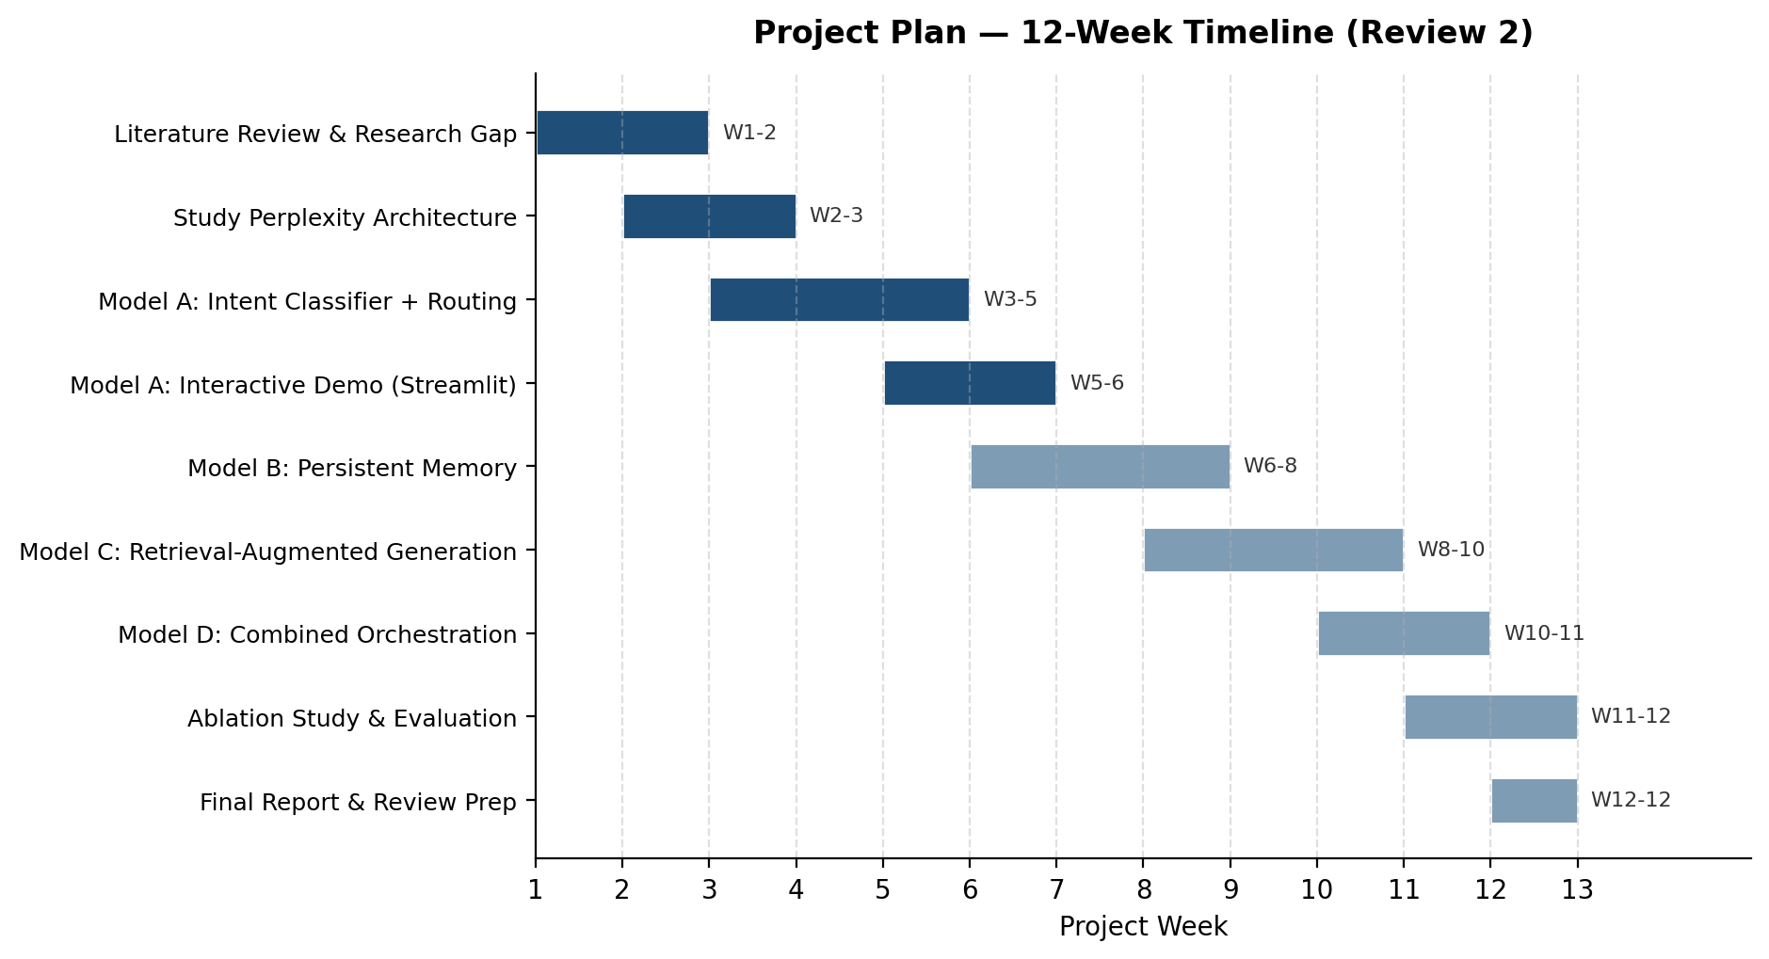
Fig. 1. Project Plan — 12-Week Gantt Chart

3. TECHNICAL SPECIFICATION
3.1 Requirements
3.1.1 Functional
- Classify each incoming query into a task-type intent (Coding / Long-form Writing / Search-Factual / General Reasoning / Multimodal).
- Route classified queries to the best-suited model using a transparent, published scoring function.
- Allow scoring weights (accuracy, cost, latency) to be configured and audited by the user.
- Retrieve relevant context passages to ground responses (Model C).
- Maintain persistent memory of user profile, extracted facts and session summaries across sessions (Model B).
- Generate responses constrained to retrieved context, with numbered citations.
- Provide an interactive interface to run queries and inspect routing decisions live.
3.1.2 Non-Functional
- Performance: classification and routing decisions should complete in well under one second on commodity hardware.
- Scalability: the routing and scoring configuration should extend to additional models or task categories without redesign.
- Reliability: the system should default gracefully (skip generation) if a downstream model API is unavailable.
- Usability: routing decisions and confidence scores should be visible and interpretable, not hidden.
- Maintainability: the intent dataset, scoring table, and generation logic are kept as separate, independently editable modules.
- Transparency: the scoring function and its weights must be inspectable and reproducible by any user.
3.2 Feasibility Study
3.2.1 Technical Feasibility
The project uses well-documented, freely available libraries (scikit-learn, pandas, NumPy, Streamlit, SQLite) and runs language models locally through Ollama, so no paid API or GPU is required. The intent classifier trains in seconds on a CPU, and every provider (local or cloud) sits behind one interface.
3.2.2 Economic Feasibility
Development cost is limited to engineering time and, optionally, LLM API usage for the generation step, which can be deferred or run against free-tier quotas during development. No specialized infrastructure investment is required at the current prototype stage.
3.2.3 Social Feasibility
The prototype is a research and learning tool at this stage, with no end-user deployment; ethical considerations around data privacy and model transparency are addressed directly by the project's core contribution — making routing decisions transparent and auditable rather than opaque.
3.3 System Specification
3.3.1 Hardware Specification
- Processor: any modern multi-core CPU; evaluation run on an Apple M3 laptop (no discrete GPU)
- Memory (RAM): 8 GB minimum (small 1–4B-parameter local models); 16 GB for 7–8B models
- Storage: about 10 GB for local model weights; under 500 MB for code, data and results
3.3.2 Software Specification
- Operating System: Windows / macOS / Linux (cross-platform)
- Programming Language: Python 3.10+
- Development Environment: Visual Studio Code
- Libraries and Frameworks: scikit-learn, pandas, NumPy, joblib, Streamlit, matplotlib, pytest; Ollama runtime; optional OpenAI / Anthropic / Gemini APIs
- Database: SQLite for persistent memory; pickled embedding index for retrieval; CSV / JSON datasets

4. DESIGN APPROACH AND DETAILS
4.1 System Architecture
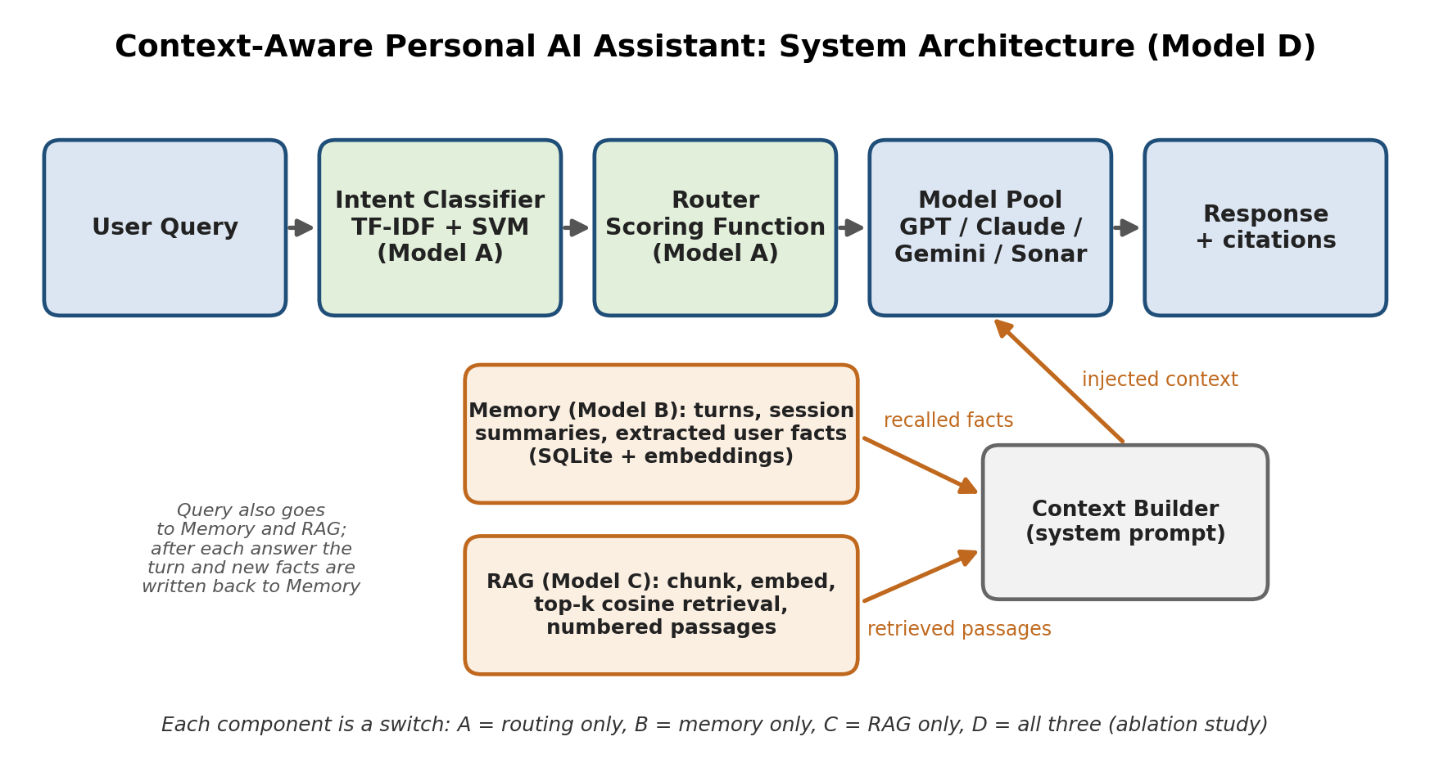
Fig. 2. System Architecture
A user query is tagged by the Intent Classifier and the Router applies the published scoring function, score = wₐ·Accuracy + wᴄ·(1 − Cost) + wₗ·(1 − Latency), to select a model from the pool. In parallel the Memory module recalls the most similar stored user facts and session summaries, and the Retriever returns the top-k document passages. The Context Builder injects both into the system prompt, the selected model generates a cited answer, and the turn is written back to memory. Routing, memory and retrieval are independent switches, which is what makes the ablation in Chapter 5 possible.
4.2 Design
4.2.1 Data Flow Diagram
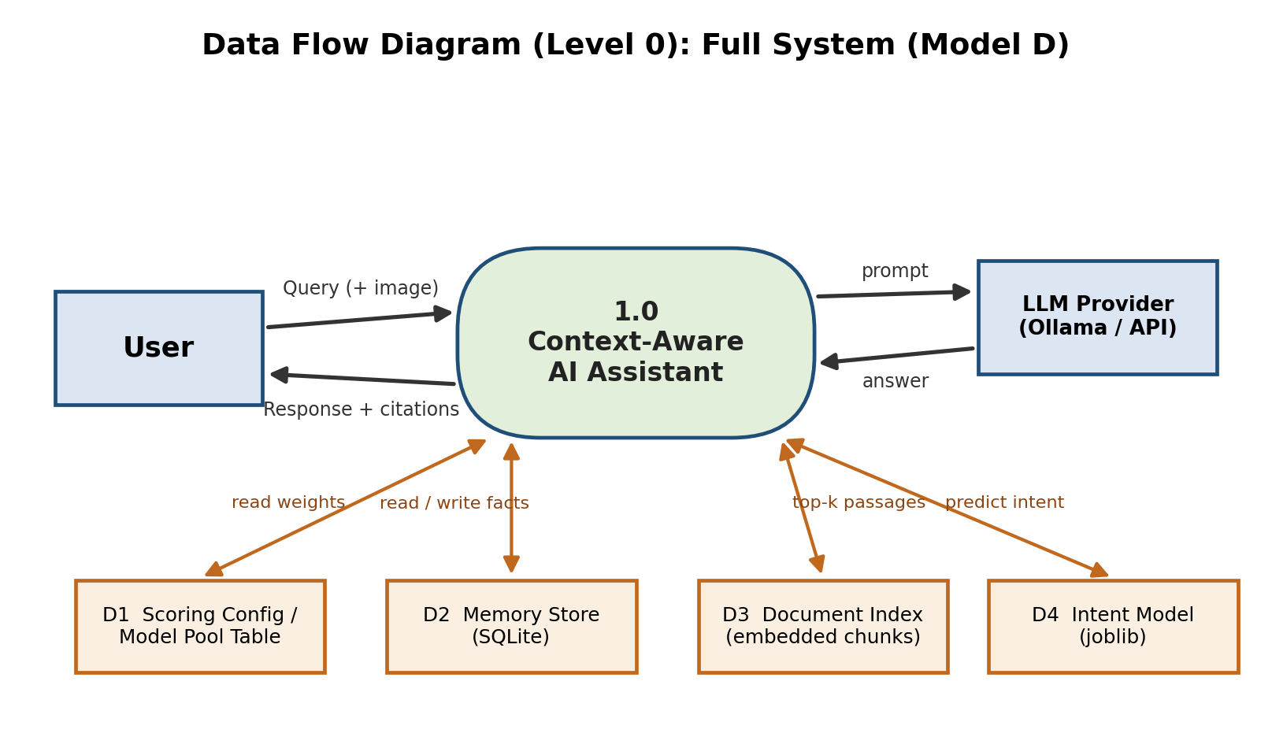
Fig. 3. Data Flow Diagram (Level 0) — Full System (Model D)
4.2.2 Use Case Diagram
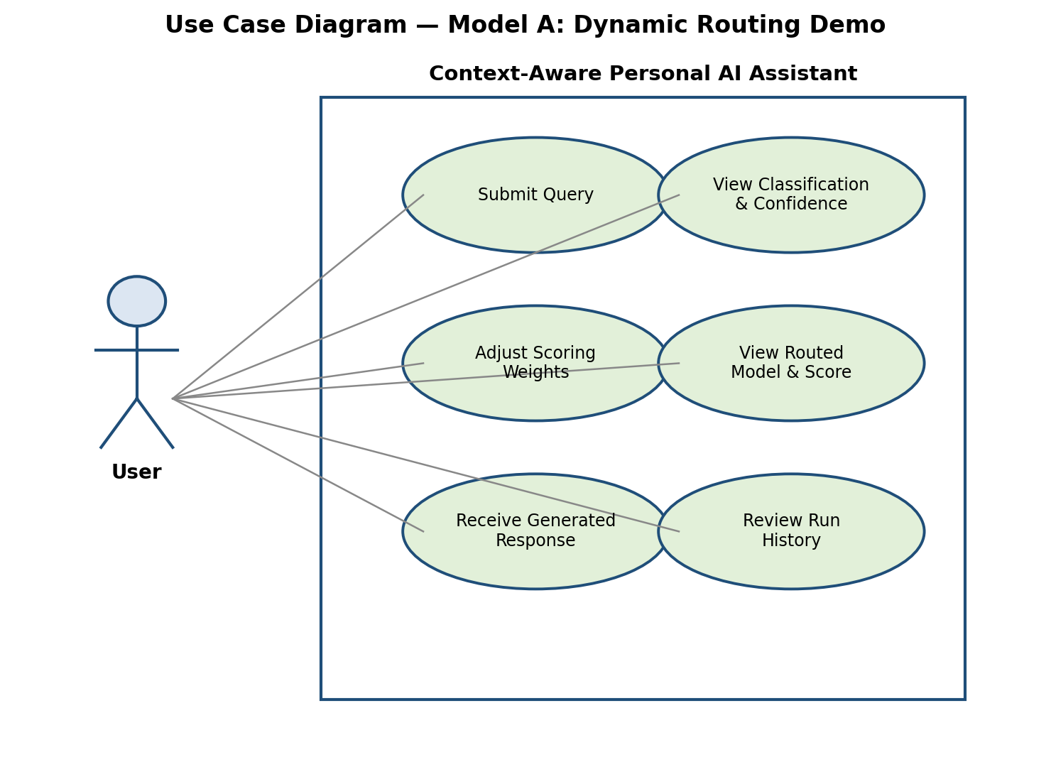
Fig. 4. Use Case Diagram — Prototype
4.2.3 Class Diagram
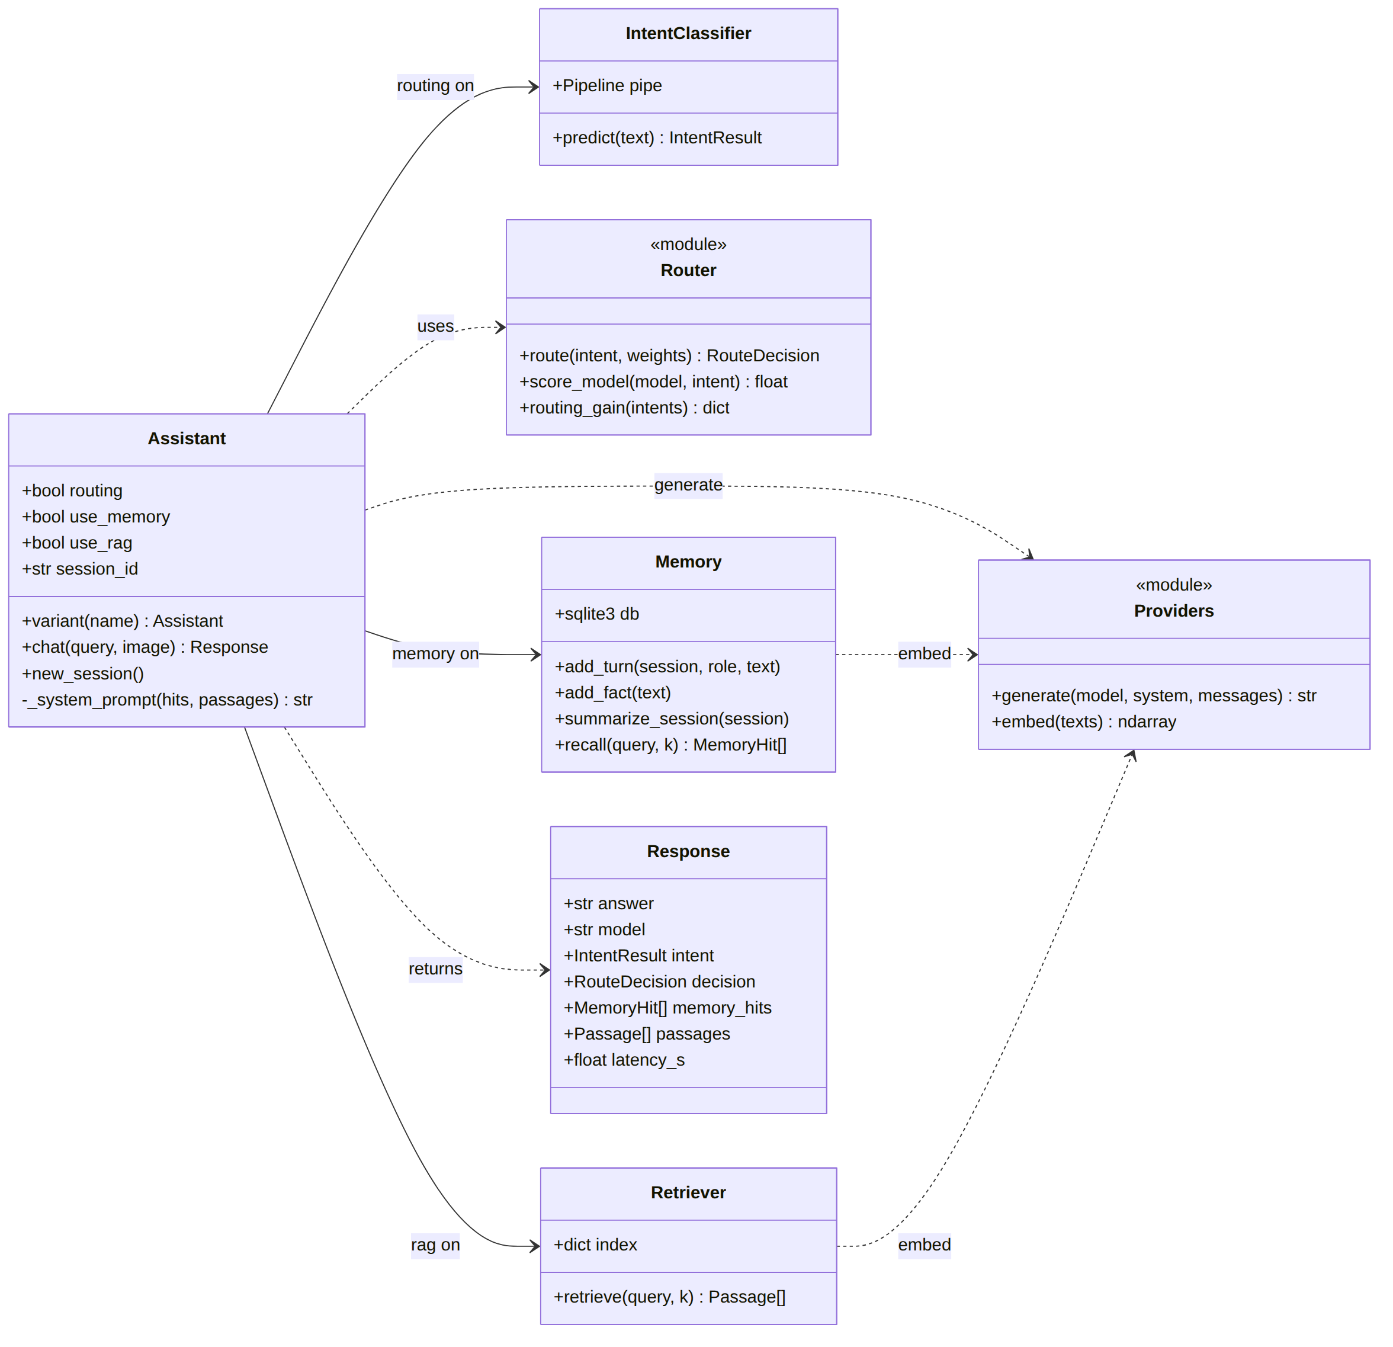
Fig. 5. Class Diagram — Core Modules
Assistant is the orchestrator; its three boolean flags select the ablation variant. IntentClassifier, Memory and Retriever are only instantiated when their switch is on. Router and Providers are stateless modules: the Router scores the model pool and Providers wraps generation and embedding for Ollama, OpenAI, Anthropic, Gemini or a deterministic mock used by the test-suite.
4.2.4 Sequence Diagram
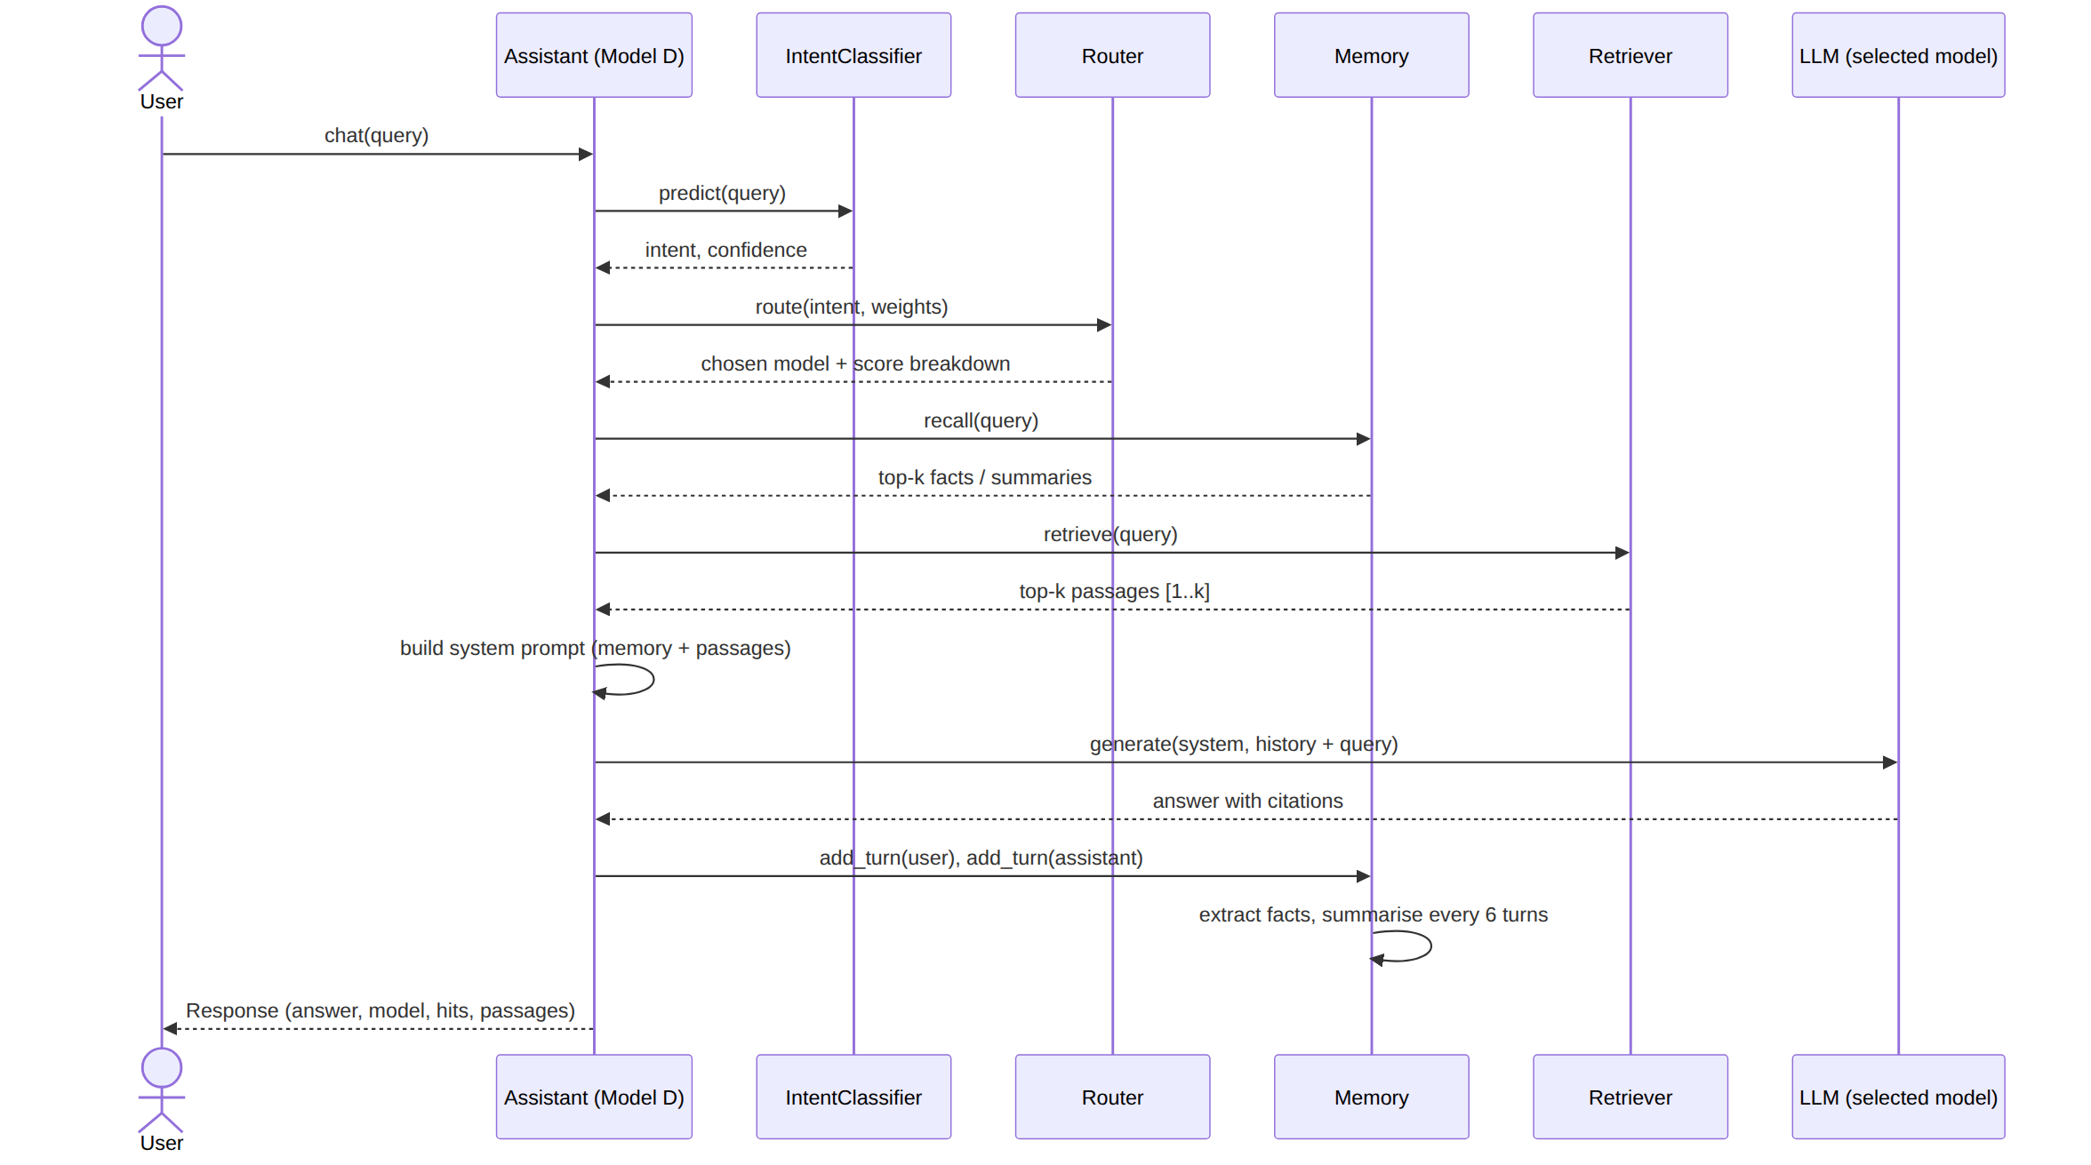
Fig. 6. Sequence Diagram — One Query Through Model D
For each query the assistant classifies intent, routes, recalls memory and retrieves passages before a single generation call; the turn is then stored and new first-person facts are extracted, with a session summary refreshed every six turns.

5. IMPLEMENTATION AND RESULTS
5.1 Implementation
The system is implemented in Python as a single package with one module per component. All variants share the same code path; a variant is defined only by which switches are on.
Module | File | Responsibility
Intent classifier | assistant/intent.py | TF-IDF (word 1-2, char 3-5 grams) + calibrated Linear SVM; 1,350 queries, 5 intents
Router | assistant/router.py | Published weighted score over accuracy, cost and latency; returns full breakdown
Memory | assistant/memory.py | SQLite: turns, session summaries, extracted user facts; cosine top-k recall
RAG | assistant/rag.py | 120-word chunks (30 overlap), embeddings, top-4 cosine retrieval, numbered passages
Providers | assistant/providers.py | Ollama / OpenAI / Anthropic / Gemini / mock generation and embeddings
Pipeline | assistant/pipeline.py | Assistant(routing, memory, rag) orchestrator; variants baseline, A, B, C, D
Evaluation | scripts/run_ablation.py | Runs every variant on all benchmarks; writes JSON, CSV and figures
Prototype | app.py | Streamlit chat with a live inspector for intent, scores, memory hits and passages

An offline test-suite (10 tests, deterministic mock model) checks classifier accuracy, routing determinism, weight sensitivity, fact extraction, cross-session recall, retrieval and the end-to-end Model D path.
5.2 Experimental Setup
To keep the study free and reproducible, each role in the model pool is played by a small open-weight model served locally by Ollama. The roles keep the names used in the design so the routing logic is unchanged; swapping in the commercial APIs is a configuration change.
Pool role | Local model used
GPT (coding) | qwen2.5-coder:3b
Claude (writing, reasoning) | llama3.2:3b
Gemini (multimodal) | moondream
Sonar (search) | llama3.2:1b
Embeddings | nomic-embed-text

Four benchmarks were used:
- Routing: intent accuracy on a group-aware held-out split (270 test queries, paraphrases of a test query never in training) and routing gain against each fixed model.
- Memory: a simulated user states 19+ personal facts across four sessions; a fresh session then asks 30 recall questions.
- RAG: 36 questions about a fictional company (six documents) whose facts no model can know from pre-training, so correct answers require retrieval. An answer is a hallucination when it is neither correct nor an explicit abstention.
- Per-task: 50 tasks (10 per task type), each phrased three ways, answered by every model and graded automatically (Section 5.3.4).
Non-routing variants always use the GPT-role model, so the baseline differs from Model A only by routing.
5.3 Results
5.3.1 Intent Classification
Intent | Precision | Recall | F1
Coding | 1.00 | 0.72 | 0.84
Multimodal | 0.89 | 1.00 | 0.94
Reasoning | 0.70 | 0.89 | 0.78
Search | 0.81 | 0.72 | 0.76
Writing | 0.91 | 0.89 | 0.90
Overall (accuracy / macro F1) |  | 0.844 | 0.844

Held-out accuracy is 84.4% on 270 unseen queries. A plain random split of the same data reports 100.0% because paraphrases of test queries leak into training; the Review 2 figure of 97.0% was affected by the same leakage and is superseded by the grouped figure.
5.3.2 Routing Gain
Always using | Routed score minus fixed score
GPT | +0.095
Claude | +0.103
Gemini | +0.060
Sonar | +0.075
Mean over fixed models | +0.083

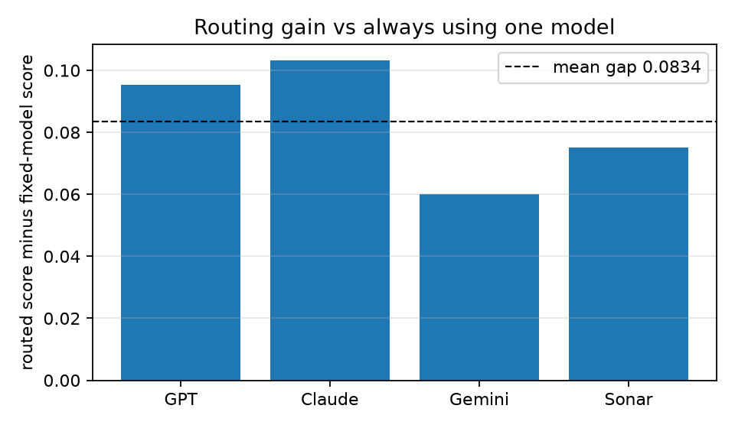
Fig. 7. Routing Gain Over Each Fixed Model
Routing never scores below any fixed model on this measure because it maximises the same score per query. The size of the gain depends on the accuracy, cost and latency priors in the model-pool table, so it is a property of the scoring function rather than of answer quality; Section 5.3.4 measures answer quality directly.
5.3.3 Ablation Study
Variant | Route | Mem | RAG | Memory recall | RAG accuracy | Hallucination | Citations
Baseline | – | – | – | 0.0% | 0.0% | 52.8% | 0.0%
Model A | ✓ | – | – | 0.0% | 0.0% | 13.9% | 0.0%
Model B | – | ✓ | – | 96.7% | 0.0% | 91.7% | 0.0%
Model C | – | – | ✓ | 0.0% | 88.9% | 8.3% | 13.9%
Model D | ✓ | ✓ | ✓ | 96.7% | 88.9% | 5.6% | 0.0%

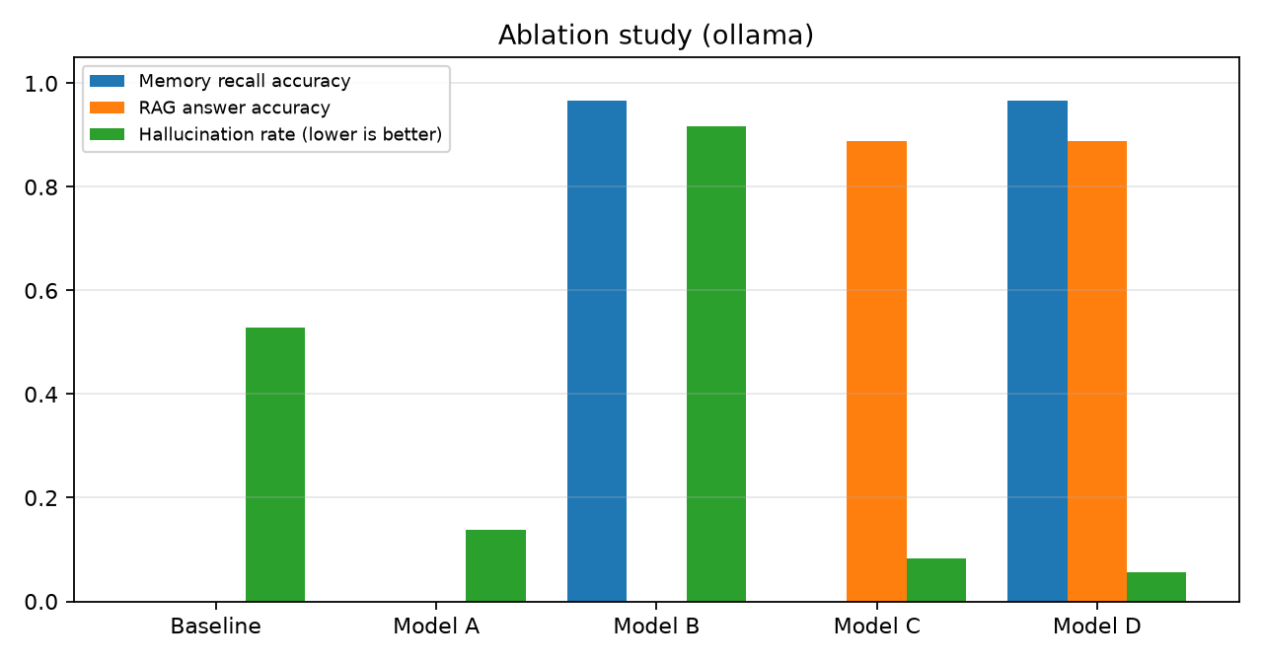
Fig. 8. Ablation Results Across Variants
5.3.4 Per-Task Benchmark: Routing and Answer Accuracy by Task Type
To test whether each kind of task reaches the right model and whether the answer is actually correct, a second benchmark of 50 tasks (10 per intent) was built. Every task is written three ways (direct, casual and verbose), giving 150 prompts for routing. The direct form of every task was answered by every model in the pool at temperature 0 and graded automatically: generated code is executed against unit tests, reasoning answers must match the exact number, factual answers must contain the fact, writing must satisfy explicit constraints (line counts, word limits, required words, valid JSON keys), and image questions use generated test images. Because routing only decides which model answers, the routed system's result on a task is the graded answer of the model it selects.
Prompt style | Intent accuracy
Direct | 100.0%
Casual | 82.0%
Verbose | 98.0%
All 150 prompts (text only) | 93.3%
All 150 prompts (image attached => multimodal) | 96.7%
Same route for all 3 phrasings of a task | 90.0%

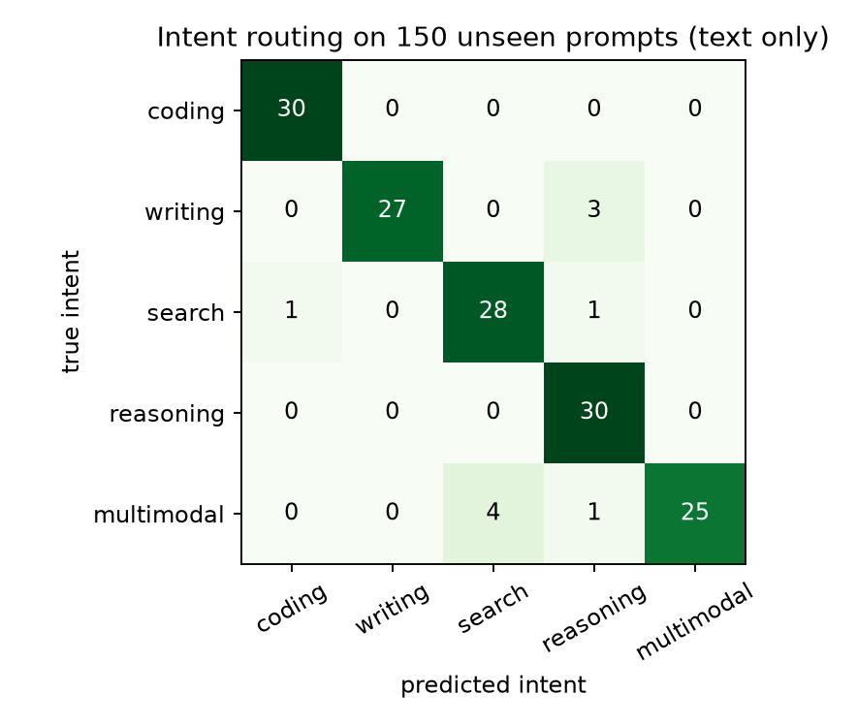
Fig. 9. Intent Confusion Matrix on 150 Unseen Prompts
Model | Coding | Writing | Search | Reason. | Multim. | Overall | Latency
GPT | 100% | 100% | 100% | 90% | 0% | 78% | 4.6s
Claude | 90% | 90% | 100% | 90% | 0% | 74% | 3.9s
Gemini | 80% | 60% | 60% | 0% | 50% | 50% | 3.3s
Sonar | 70% | 90% | 90% | 80% | 0% | 66% | 3.2s
Routed system | 100% | 90% | 90% | 90% | 50% | 84% | 4.3s

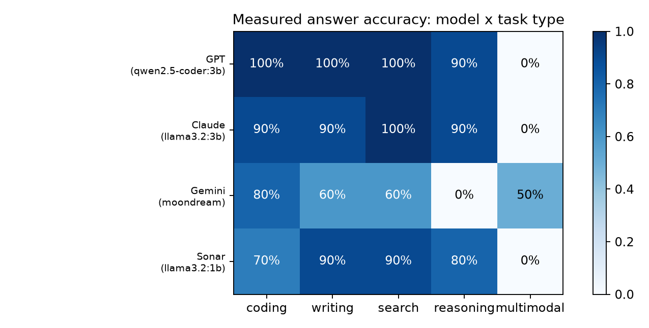
Fig. 10. Measured Answer Accuracy, Model × Task Type
System | Tasks correct
Routed (classifier + router) | 84.0%
Router with true intent | 84.0%
Router with measured priors | 82.0%
Best model per intent (hindsight) | 88.0%
Any model correct (upper bound) | 88.0%
Always GPT | 78.0%
Always Claude | 74.0%
Always Gemini | 50.0%
Always Sonar | 66.0%

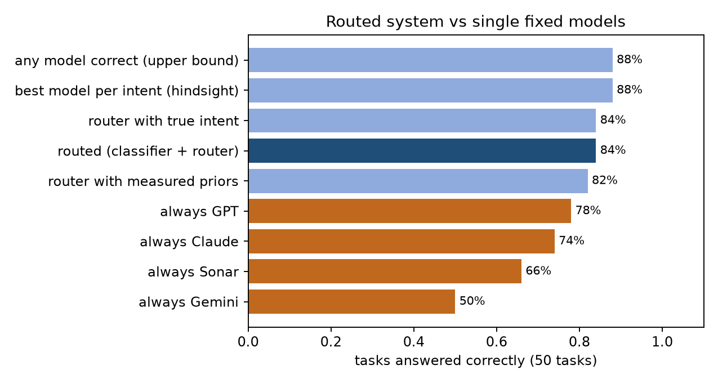
Fig. 11. Routed System vs Single Fixed Models
Task type | Model chosen with prior estimates | Model chosen with measured accuracy | Best in hindsight
Coding | GPT | GPT | GPT
Writing | Claude | Sonar | GPT
Search | Sonar | Sonar | Claude
Reasoning | Claude | Sonar | Claude
Multimodal | Gemini | Gemini | Gemini

- Routing beats every single model. The routed system answered 84% of the 50 tasks correctly, against 78% for the best fixed model (GPT role), 74% (Claude role), 66% (Sonar role) and 50% (Gemini role). The best possible choice of model per task type, known only in hindsight, reaches 88%, so routing captures most of the available gain.
- Classification is near perfect on clear prompts and weakest on casual ones. Intent accuracy is 100% on direct prompts, 98% on verbose prompts and 82% on casual, abbreviated prompts (for example “how many continents are there” was routed as reasoning). Across 150 prompts it is 93.3%, rising to 96.7% when an attached image forces the multimodal route.
- Misroutes were cheap in this pool. All five misroutes sent a writing or search prompt to a strong text model, which still answered correctly, so accuracy with predicted intent equals accuracy with the true intent (84%).
- Only the vision model can read images. The three text models rejected image input outright, so multimodal tasks depend entirely on the Gemini-role model (moondream), which read 5 of 10 test images correctly. The same model scored 0% on reasoning, which is exactly the kind of mismatch routing avoids.
- Measured priors trade accuracy for speed. Re-routing with the measured accuracies (and measured latency) sends writing and reasoning to the faster 1B Sonar-role model and scores 82%, two tasks below the prior-based router, while cutting average latency. Which is better depends on the accuracy weight, which the user controls.
5.4 Prototype Demonstration
The Streamlit prototype exposes every decision the pipeline makes: the predicted intent and its probabilities, the score of every model under the current weights, the memory items recalled and the passages retrieved, and the exact system prompt sent to the model. The screenshots below were captured from the running prototype on the local Ollama models.
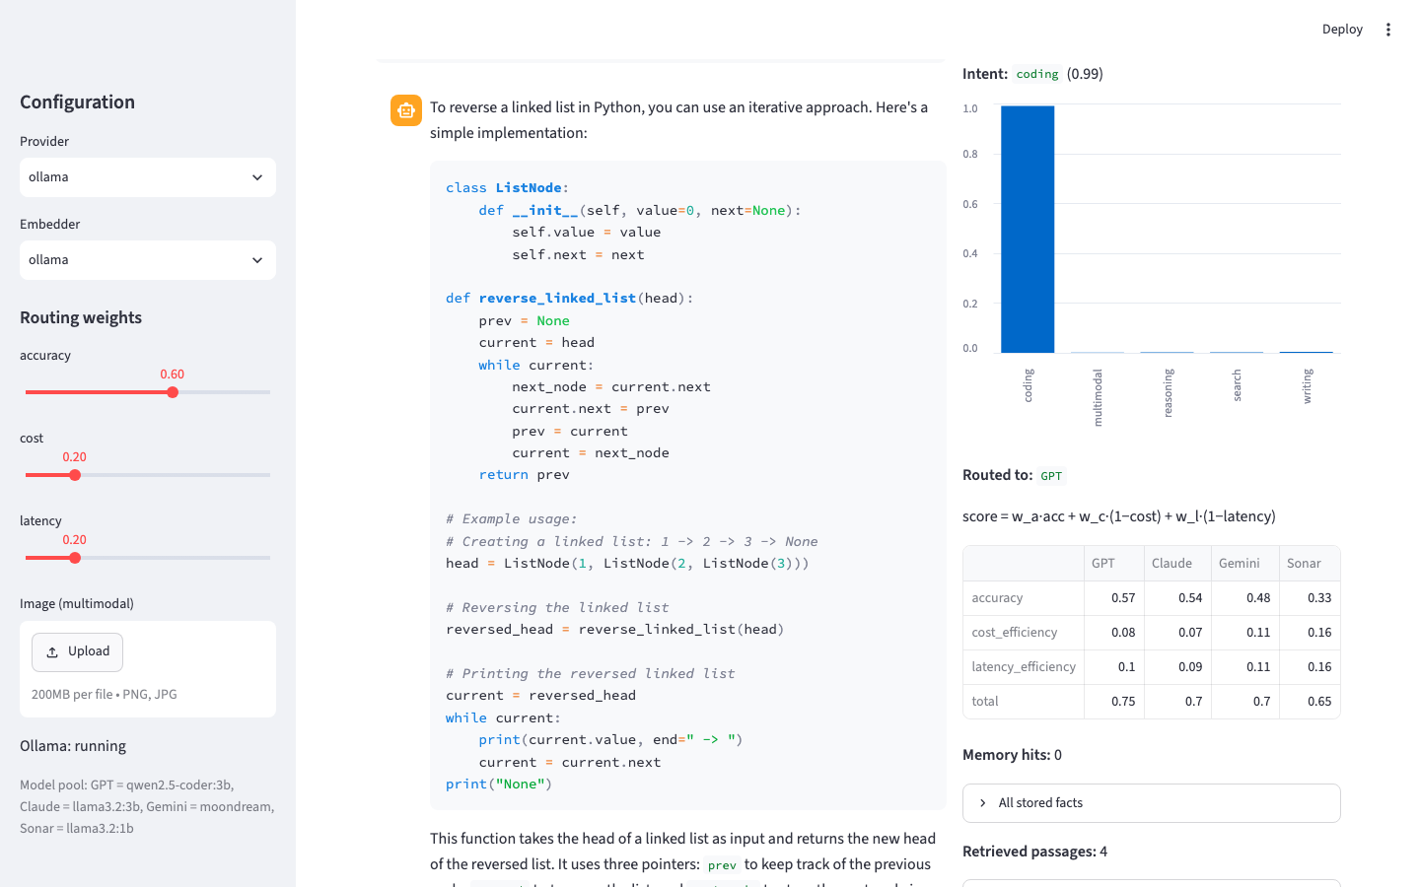
Fig. 12. Coding query (intent confidence 0.99) routed to the GPT-role model, with the per-model score breakdown
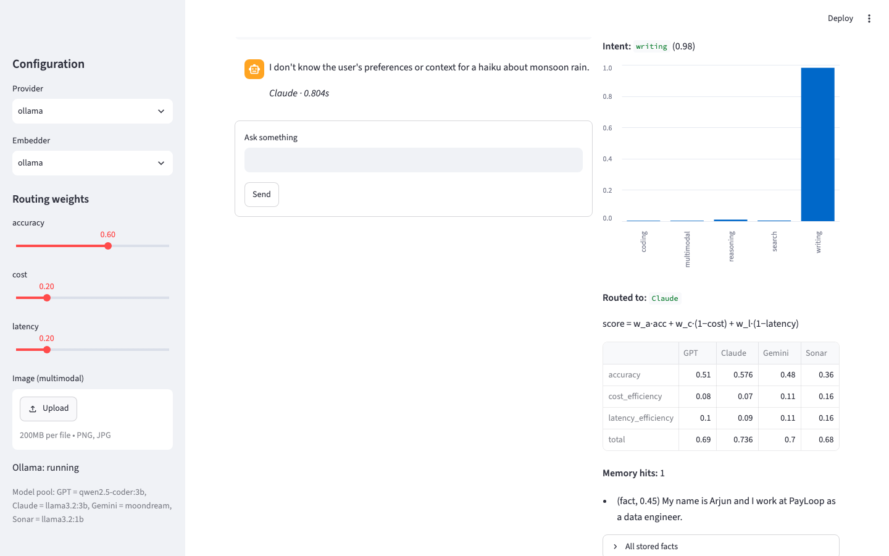
Fig. 13. Writing query routed to the Claude-role model under the default weights
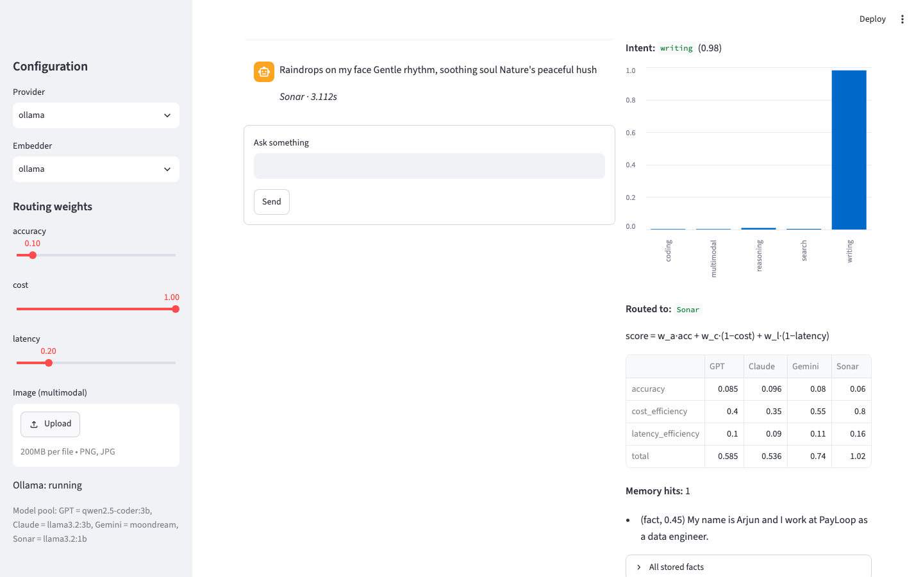
Fig. 14. The same writing query with the cost weight raised to 1.0: the router switches to the cheaper Sonar-role model
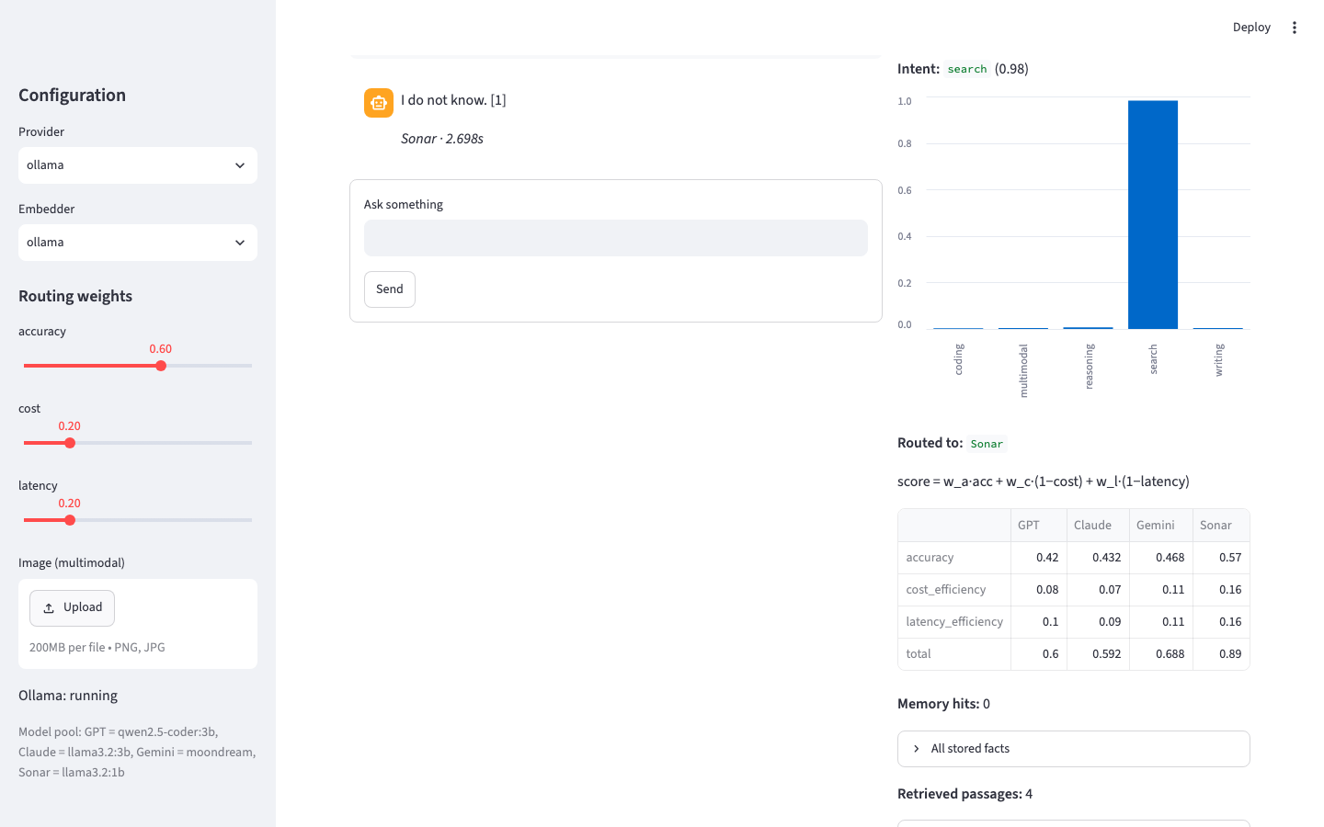
Fig. 15. Factual query routed to the Sonar-role model; the strict grounding prompt produces an abstention (see Section 5.5)
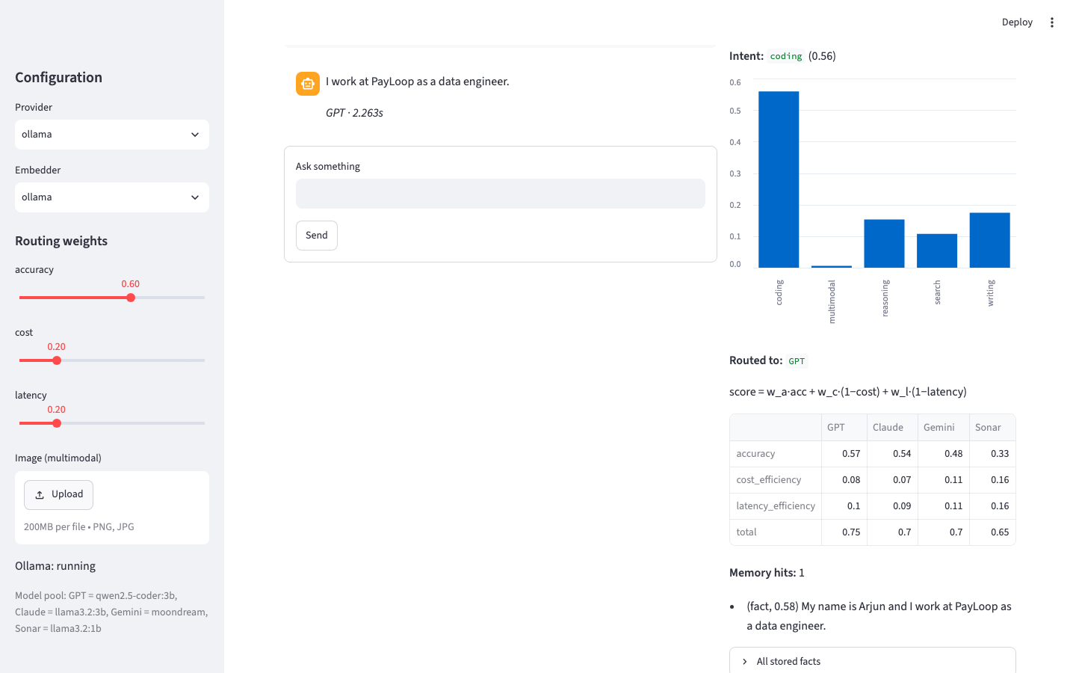
Fig. 16. A fact stated in an earlier session recalled in a new session
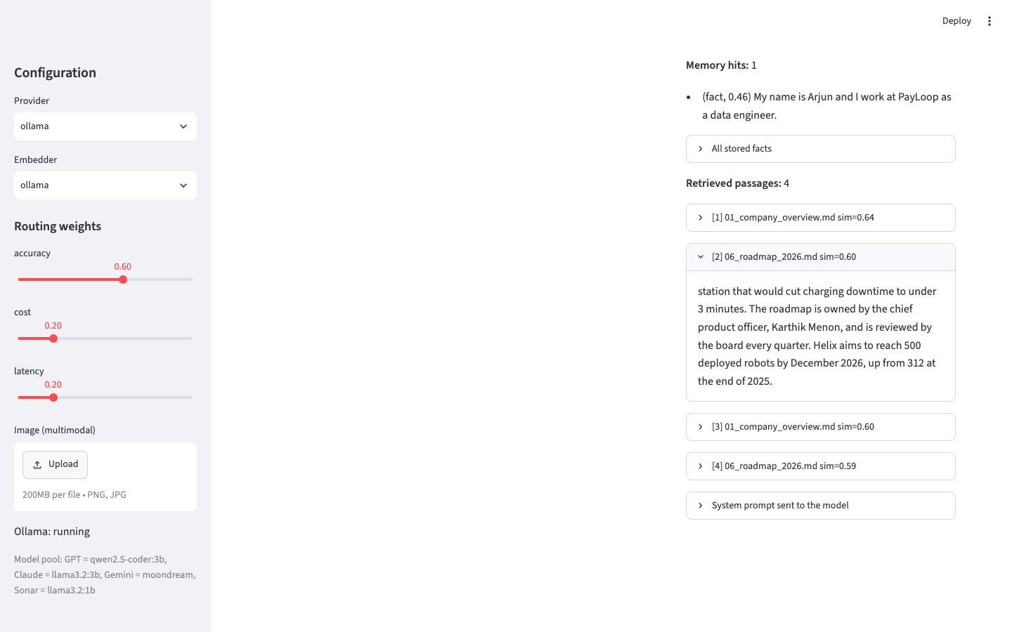
Fig. 17. Retrieved, numbered passages with similarity scores for a closed-domain question
5.5 Discussion
- Memory is the only source of cross-session recall. Variants without memory score 0.0% on recall; adding memory lifts it to 96.7% (Model B) and 96.7% (Model D).
- Retrieval drives factual accuracy and cuts hallucination. Without retrieval accuracy is 0.0% with a hallucination rate of 52.8%; with retrieval accuracy is 88.9% (Model C) and hallucination falls to 8.3%.
- Routing changes how a model fails. With no retrieval every variant scores 0% on the closed-domain questions, but the routed Model A abstains (86.1%) far more often than the fixed-model baseline, cutting hallucination from 52.8% to 13.9%. The search-role model it selects is more willing to say it does not know.
- Memory without retrieval increases hallucination on unknown facts (91.7% for Model B). Answers to earlier questions stay in the conversation history, and the model continues in the same confident style instead of abstaining. Memory is valuable for user facts but needs retrieval, or a stricter abstention prompt, beside it.
- The full system keeps both gains. Model D matches Model B on recall (96.7%) and Model C on RAG accuracy (88.9%) while lowering hallucination further (8.3% to 5.6%).
- Citations are rarely emitted (13.9% for Model C, 0.0% for Model D) even though answers are grounded: the 1-3B local models often ignore the instruction to cite [n]. This is expected to improve with larger or cloud models.
- Routing affects which model answers, not what context it sees, so its gain is measured separately in Section 5.3.2.
5.5.1 Positioning Against Perplexity AI
Perplexity AI is the closest production system. The table summarises where this project differs; it is not a head-to-head benchmark, since Perplexity uses live web search and far larger proprietary models.
Aspect | Perplexity AI | This project
Routing rule | Undisclosed classifier | Published weighted formula; weights adjustable by the user
Explanation of each decision | Not shown | Intent probabilities and every model's score, shown per query
Task scope | Search-style question answering | Coding, writing, reasoning, search and images, routed separately
Memory | Personalisation, not publicly benchmarked | Three-tier memory with a 30-question cross-session recall benchmark
Evidence of each component's value | No published ablation | Five-build ablation and a 50-task benchmark with every answer logged
Retrieval source | Live web | The user's own document collection (web search is future work)
Models and cost | Large commercial models, paid | Any provider; evaluated fully offline on free local models

Where Perplexity is stronger: live web retrieval, model scale and production reliability. Where this project contributes: it makes the routing decision inspectable and quantifies what routing, memory and retrieval each add, which no production system publishes.
- Over-grounding in the full system. Screenshots of Model D (Figs. 13 and 15) show a side effect of the strict grounding instruction: for general questions such as “What is the capital of Australia?” or a haiku request, retrieval still returns the closest Helix passages, and the prompt “answer only from the retrieved context” makes the model abstain. The planned fix is to inject passages and the grounding instruction only when retrieval similarity exceeds a threshold. The ablation numbers above were measured with the current behaviour and have not been adjusted.
Limitations: the benchmarks are small (tens of questions); correctness is judged by gold keywords rather than human rating, which occasionally marks a correct answer wrong (for example “No, you do not eat meat” fails the keyword “vegetarian”); the local models are far smaller than the commercial models they stand in for, and the routing priors are estimates. Each is addressed in the plan below.
5.6 Work Remaining Before the Final Review
- Gate retrieval on a similarity threshold so general questions are not forced into the document context.
- Improve intent classification on casual, short prompts (the weakest phrasing style) with more informal training data.
- Enlarge the memory and RAG benchmarks and add an LLM-judge or human rating alongside keyword matching.
- Repeat the ablation with the commercial APIs (GPT, Claude, Gemini) for comparison with the local run.
- Latency and cost measurements per variant; prepare the Scopus conference paper from these results.

6. REFERENCES
[1] P. Lewis et al., “Retrieval-Augmented Generation for Knowledge-Intensive NLP Tasks,” in Proc. NeurIPS, 2020, pp. 9459–9474.
[2] S. Yao et al., “ReAct: Synergizing Reasoning and Acting in Language Models,” in Proc. ICLR, 2023.
[3] T. Schick et al., “Toolformer: Language Models Can Teach Themselves to Use Tools,” in Proc. NeurIPS, 2023.
[4] C. Packer et al., “MemGPT: Towards LLMs as Operating Systems,” arXiv:2310.08560, 2023.
[5] W. Wang et al., “Augmenting Language Models with Long-Term Memory,” in Proc. NeurIPS, 2023.
[6] ByteByteGo, “How Perplexity Built an AI-Powered Search Engine,” ByteByteGo Newsletter, 2025–2026.
[7] Ollama, “Get up and running with large language models locally,” https://ollama.com, 2026.
[8] F. Pedregosa et al., “Scikit-learn: Machine Learning in Python,” J. Mach. Learn. Res., vol. 12, pp. 2825–2830, 2011.

