Part3: Node Internals

1. What is the Node.js Event Loop?
- The Event Loop is the system that lets Node.js run asynchronous code on a single thread.

- It keeps checking for finished tasks and runs their callbacks without blocking the main thread.

2. What is Libuv and What Role Does It Play in Node.js?
Libuv is a C library that powers Node’s async behavior.
It provides the event loop, the thread pool, and handles non-blocking I/O operations across different operating systems.

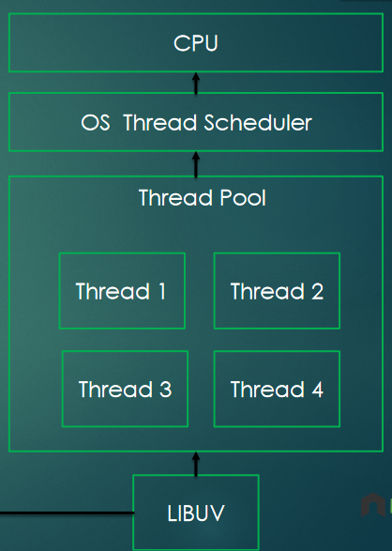

- How Does Node.js Handle Asynchronous Operations Under the Hood?

Node.js sends slow tasks (like file I/O, timers, network operations) to Libuv. Libuv uses the OS or a thread pool to finish the work, then returns the result through the event loop, which finally runs the callback.

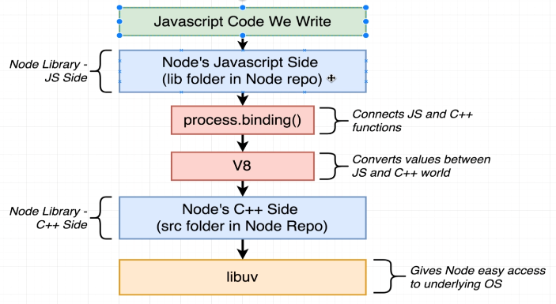

4. Difference Between Call Stack, Event Queue, and Event Loop

Call Stack: Runs synchronous code.

Event Queue: Stores callbacks waiting to run.

Event Loop: Moves callbacks from the queue to the stack when the stack is empty.

5. What is the Node.js Thread Pool and How to Set Its Size?
The thread pool is a set of background threads (default: 4) used for heavy tasks like fs, crypto, and compression.

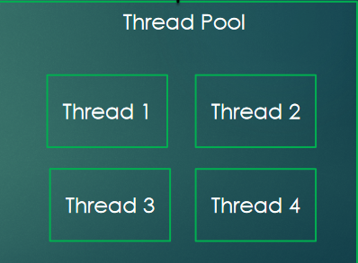

6. How Does Node.js Handle Blocking vs Non-Blocking Code?
.Blocking code stops the main thread until it finishes.
.Non-blocking code is offloaded to Libuv (event loop + thread pool), allowing the main thread to keep running other tasks.

