Deployment & Architecture Guide

# **1. Architecture Overview**

This document provides an overview of the retail store sample app deployed on AWS EKS using Kubernetes. The application consists of the following microservices deployed in separate pods:  
 - UI  
 - Catalog  
 - Carts  
 - Orders  
 - Checkout  
   
Each microservice uses its own dependencies like databases (MySQL, PostgreSQL), caches (Redis, DynamoDB), and message brokers (RabbitMQ). Helm and Helmfile were used to manage deployments and dependencies.

# CI/CD:

GitHub Actions automates IaC deployment and Helm chart releases.

Workflow verified in repository: project-bedrock-infra.

# 2. Accessing the Application

1. Port-forward the UI service: kubectl port-forward svc/ui 8080:80 -n default

2. Open in browser: http://127.0.0.1:8080

3. Screenshot:

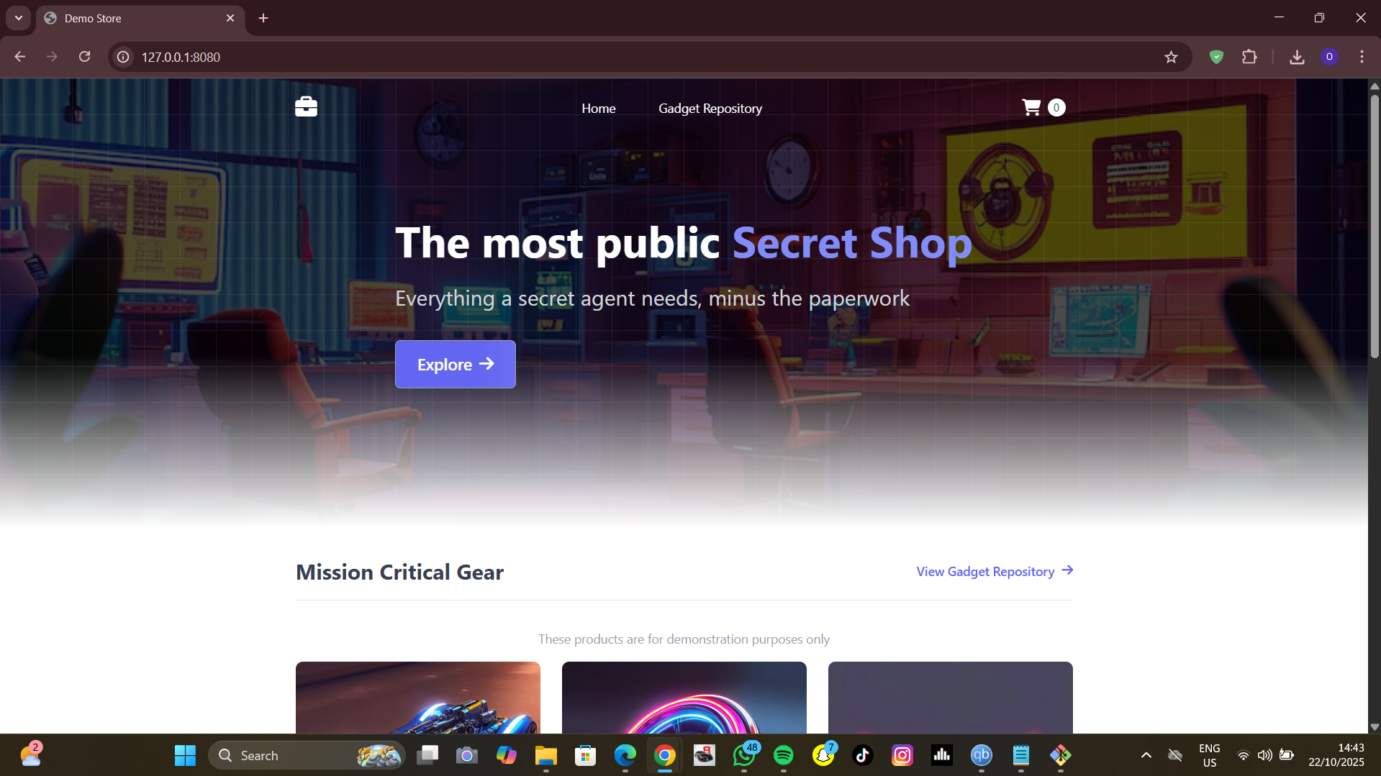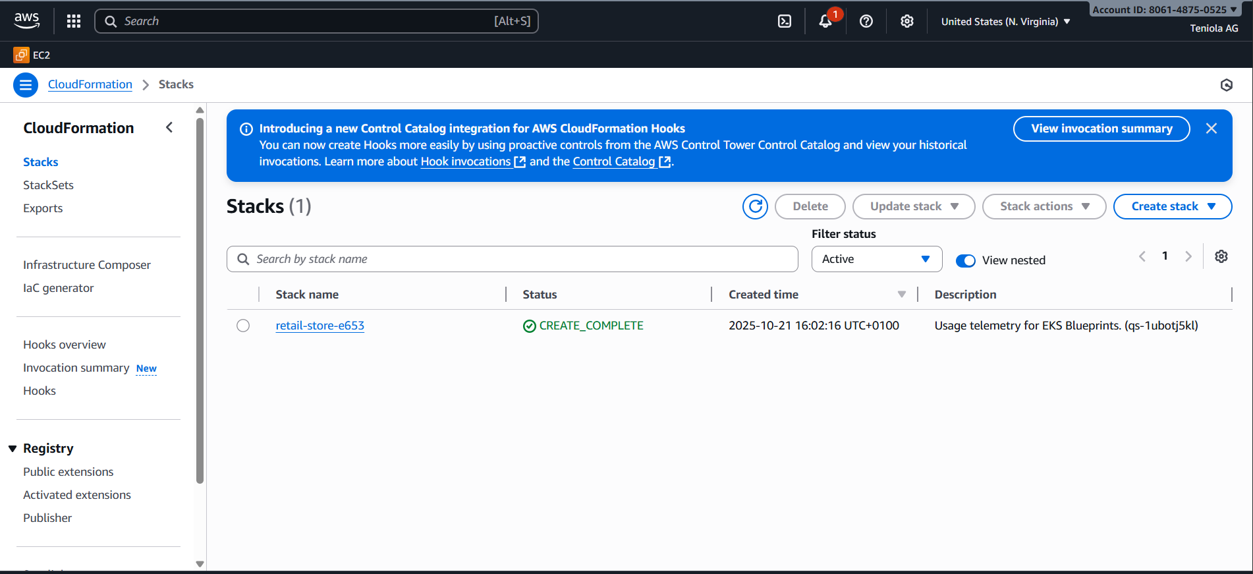

# 4. Verified Deployment

Pods running: (bash) kubectl get pods -n default

Services exposed: (bash) kubectl get svc -n default

Helm releases deployed: (bash) helm list -n default

Screenshots: 