**Unit Test document**

Default Desktop view -: Sorted card display

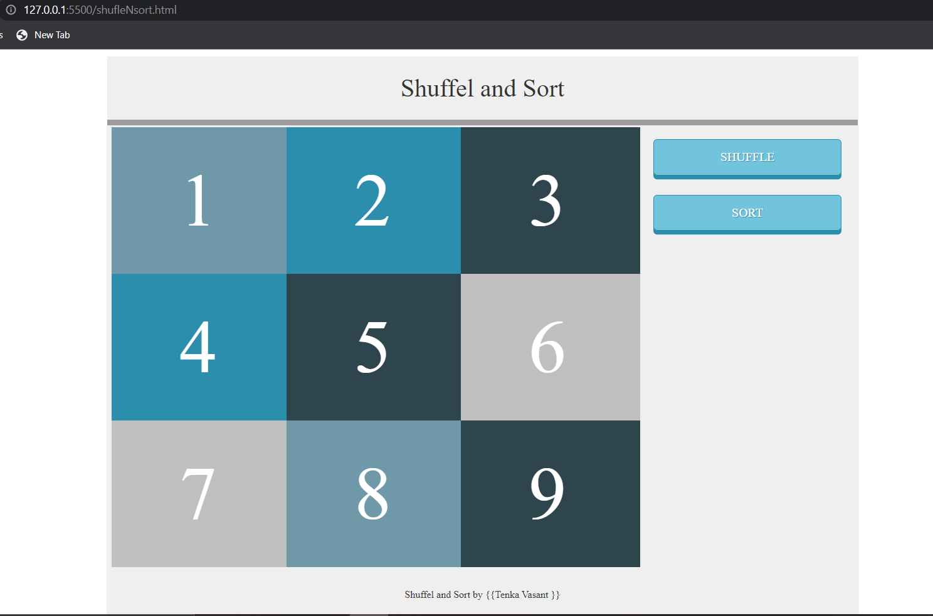

Step2 – onclick of Shuffle (shuffle card display)

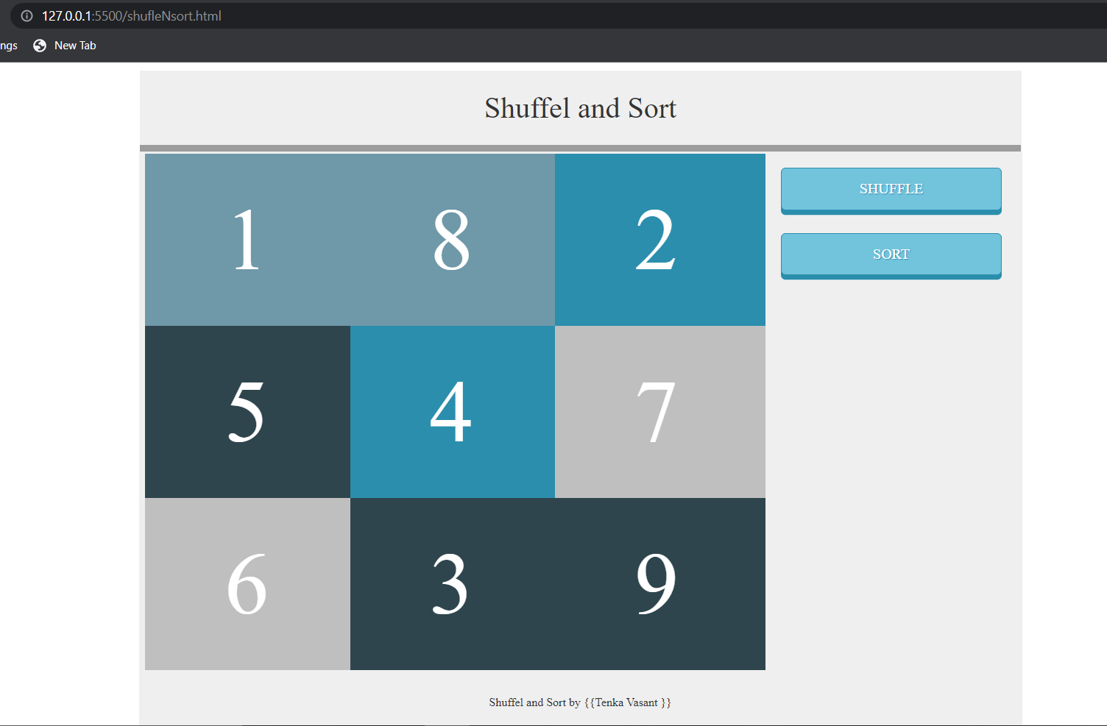

Step3 – onclick of sort (sorted card display)

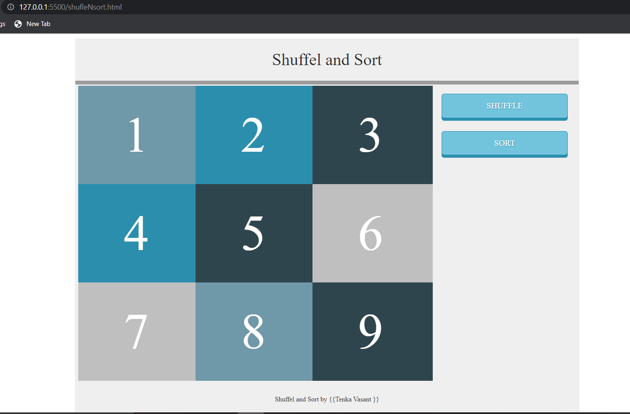

-=================================================================================

**Default Mobile view** -: Sorted card

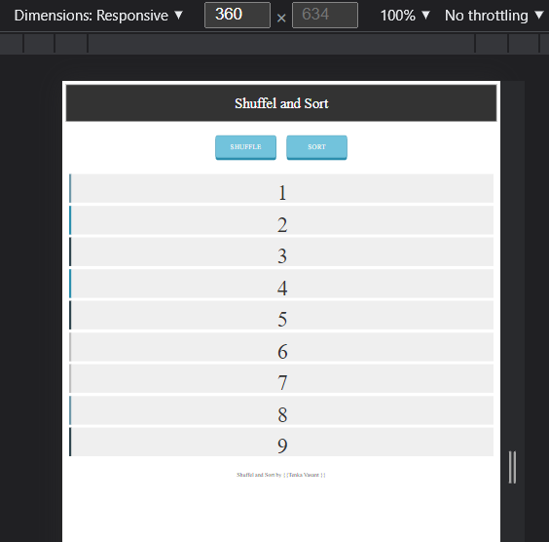

Step2 Mobile view– onclick of Shuffle (shuffle card display)

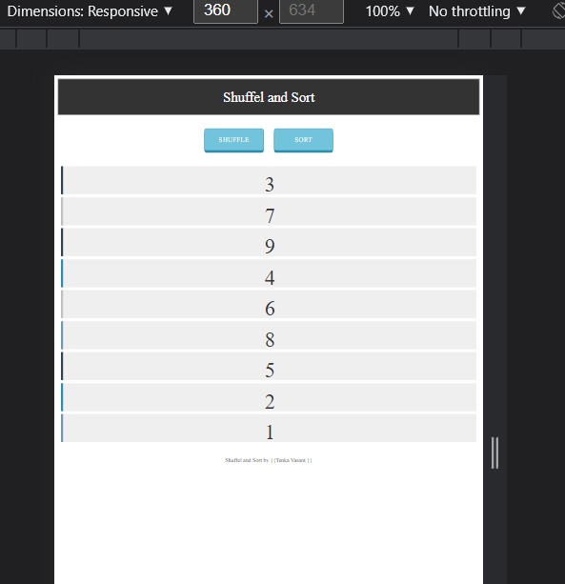

Step3 Mobile view – onclick of sort (sorted card display)

