The Tri-Plane Stability Framework

A Deep-Research Dossier on Constraint, Stability and Rotation in Tennis
Tennis Unified · Research Intranet · Biomechanics Pillar
Version 1.1 · 30 October 2026 · English edition
v1.1 adds Part X, an audit of the fifteen practice drills and of the forty-second Vietnamese teaching film. Nothing in Parts I–IX was revised.
Companion volume: Khung Ổn Định Ba Điểm — Hồ Sơ Nghiên Cứu Chuyên Sâu (Vietnamese edition)

Abstract
A three-legged stool never wobbles. A four-legged chair does. From that single observation a coaching framework was built: three points define a plane, the fourth creates instability unless it lies in the same plane; therefore load one leg, define the swing plane with two hands, and tuck one hand close to the body.
This dossier takes that framework seriously enough to test it. It does three things the original document did not.
First, it separates three questions the framework fuses into one. "3 versus 4 points" simultaneously invokes geometric determinacy (three non-collinear points fix a plane; a fourth overconstrains it), static sufficiency (a larger support polygon is more stable), and rotational freedom (fewer contacts leave the rotation axis free to be placed). These are three different physics problems with three different answers, and in one respect they point in opposite directions: in statics, more contact is more stable; in rotation, more contact is more constraint. The framework's real content is not "three is better than four" but something sharper — the optimal configuration is the minimum constraint that still satisfies the task's stability demand. Every apparent contradiction in the coaching literature dissolves once the framework is read this way.
Second, it corrects the geometry at its weakest joint. Two hands do not define a plane. Two points define a line; a plane requires a third non-collinear point. The third point is the shoulder line (or the racket head). This is not pedantry: it changes the cue from "two hands up" to "hands and chest make the disc," and it explains why an off-hand that drifts off that plane is so destructive while a second hand on the grip — as in a two-handed backhand — is perfectly stable.
Third, it submits the five principles to an evidence audit, and reports what the audit found. The literature supports use the legs strongly and load one specific leg weakly to not at all. It supports wide base for balance but only inside a band, because widening the stance raises the body's moment of inertia and slows redirection. It supports the tuck as a manipulation of total-body moment of inertia, but contains no tennis study showing that tucking the non-hitting arm raises trunk angular velocity; the best current trial of tossing-arm timing found it changed the toss and the stroke's timing, not head or trunk kinematics. Where the framework is a physical inference rather than a measured effect, this dossier says so, in a grade, on the page.
The result is not a debunking. The framework survives — reframed. What emerges is a defensible model with a name, a mechanism, a measurable cost function, quantitative predictions, and an explicit list of the experiments that would falsify it.
Keywords: base of support · exact constraint · ground reaction force · kinematic chain · moment of inertia · swing plane · single-leg loading · tennis biomechanics

How to read this dossier
The document is built in ten parts, and they are not all for the same reader.
If you are… | Read
A coach in a hurry | §9 (the applied system), §9.4 (cues), §9.5 (error signatures)
A coach who wants the argument | §3, §4, §5, §7
A researcher | §4, §5, §6, §7, §12
A curriculum designer | §9, §10, §11
Building the bilingual knowledge base | Everything, plus Appendix C (glossary)

On evidence grades. Every substantive claim in this dossier carries one of five grades. The grades are not decoration; they determine what a coach is allowed to say.
Grade | Meaning | Coach may say
A | Measured in tennis players, replicated or large-sample, directly on point | "Research shows…"
B | Measured in tennis players, single study or narrow sample | "One study found…"
C | Established general biomechanics, imported to tennis by inference | "The physics says…"
D | Coaching doctrine or expert consensus, not measured | "Most coaches teach…"
X | Asserted in the source material, contradicted by evidence or by the source's own geometry | Do not say it; say the restatement instead

On numbers. Figures in this dossier are of two kinds. Measured numbers come from the cited literature and are marked with their source. Modelled numbers come from the first-principles calculations in §4 and the script analysis/triplane_model.py; they are order-of-magnitude estimates built on stated assumptions, and Appendix A lists every assumption. Do not quote a modelled number as if it were measured. The distinction is the whole point of the exercise.

Part I — The observation, and the method

1. What was actually observed
The originating document states the observation plainly:
"3 points create a plane, the 4th one will make the body less stable if it is not in the same plane. This is the same with a stool with 3 legs and a chair with 4 legs. Application in tennis, one leg must be fully loaded at a time and with 2 hands generate a plane for the racket swing path. If 2 legs are loaded, they must be wide spread apart to be stable. And one hand must be close to the body, tuck in in serve and pull in for groundstroke."
Four claims are packed into that paragraph, and they are of different kinds:
- A geometric claim — three points define a plane; a fourth is overconstrained unless coplanar.
- A loading claim — one leg should be fully loaded at a time.
- A compensation claim — if two legs are loaded, they must be wide.
- A plane-and-tuck claim — two hands define the swing plane; one hand must stay close to the axis.
The document then systematises these into five principles and a contact-time checklist, and supplies four illustrations: the tuck principle in the serve and forehand, the single-leg loaded fulcrum with a tilted swing plane, the narrow-versus-wide base of support, and the three-points-versus-four-points geometry itself.
The observation is genuinely good. It is the kind of cross-domain analogy that produces real insight — the same move that took the truss from carpentry into structural engineering. What it lacks is the step that makes an analogy into a model: saying precisely which quantity is conserved, which is traded, and what would count as evidence against it.
That is the work of this dossier.

2. Method
Scope. The framework as it applies to stroke production in able-bodied adult players: forehand, one- and two-handed backhand, serve, return, volley, overhead, and the movement between them. Not addressed: wheelchair tennis, junior development thresholds, injury rehabilitation protocols, or equipment.
Three inputs. (i) The framework documents themselves — the English markdown, the English Word version, and the Vietnamese PDF — treated as the object of study, not as authority. (ii) The Tennis Unified knowledge base: 1,000 articles across ten pillars, of which the biomechanics, footwork, forehand, backhand and serve pillars were searched for each claim. (iii) The peer-reviewed tennis biomechanics literature, verified against primary bibliographic records.
Two deliberate asymmetries. First, the knowledge base is treated as secondary evidence throughout. It is a synthesis layer, and where it disagrees with a primary study, the study wins. This matters because the audit in §5.6 found internal contradictions inside the knowledge base on exactly the claims at issue. Second, the dossier distinguishes throughout between what was measured and what was inferred, because the framework's persuasive force comes largely from inferences that read like measurements.
What this dossier is not. It is not a literature review, though it contains one. It is not a coaching manual, though it ends as one. It is a stress test: an attempt to build the strongest version of the framework that the evidence will bear, and to mark clearly where that version stops.

Part II — The geometry, taken seriously

3. What "three points define a plane" does and does not say
The theorem is Euclidean and uncontroversial: through any three non-collinear points in space passes exactly one plane. Two points determine a line; a line plus a point off it determines a plane; four points generally determine nothing at all, because the fourth will usually sit off the plane of the first three.
The framework reads this as a stability theorem — three is stable, four is not. That reading imports something the theorem does not contain. Geometry says nothing about stability. It says something about determinacy: given three points, the plane is unique and knowable; given four, it is over-determined and generally inconsistent.
Determinacy and stability are different properties, and conflating them is the framework's central conceptual slip. The slip is productive, because repairing it produces the framework's best idea — but it has to be repaired.

3.1 The stool and the chair, correctly explained
Why does a three-legged stool not wobble on uneven ground? Not because three is a magic number, and not because a triangle is a "strong shape" in the loose sense coaches mean. It is because three points are always coplanar. Any three points in space lie in some plane; the ground under the three feet, however uneven, is compatible with a rigid stool resting on all three. There is no contradiction to resolve.
A four-legged chair on the same ground has a problem: four feet, one rigid seat, and a ground surface that is generally not the plane those four feet require. The chair cannot satisfy all four contacts at once. It settles onto three and lifts the fourth. That is the wobble.
The engineering name for this is exact constraint, and it is a mature design discipline. A rigid body in space has six degrees of freedom; a mount that removes exactly six — no more, no fewer — locates the body uniquely and repeatably with no internal stress. The classic implementation, the kinematic coupling, uses three balls seated in three v-grooves: three contact points, six constraints, zero overconstraint. Four supports would remove more than six constraints, and the surplus does not make the mount stiffer; it makes it indeterminate, so that the load path depends on manufacturing tolerance rather than on design intent.
This is the correct and much stronger version of the framework's opening move. The three-legged stool is not a metaphor for stability. It is a worked example of exact constraint, and the four-legged chair is the canonical demonstration of what overconstraint does.
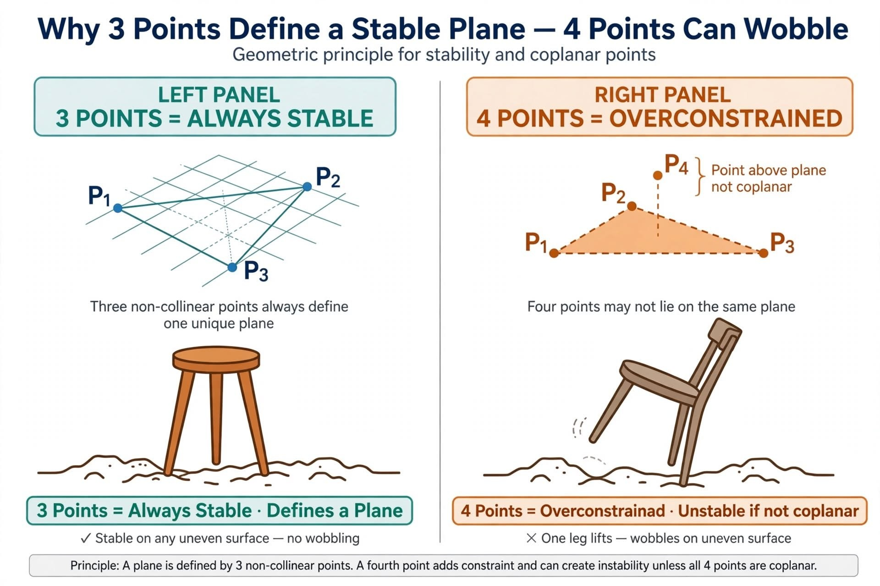
Figure 4 — Three points always find a plane; the fourth overconstrains it

3.2 The missing premise: rigidity
The stool-and-chair argument rests on an unstated premise — that the body in question is rigid. A rigid four-legged chair must lift a leg, because it cannot deform to close the gap.
A human is not rigid. Legs are compliant, joints have range, and the nervous system can co-contract to change stiffness in milliseconds. So the human never exhibits the chair's failure mode directly. It exhibits the other one.
Overconstraint has two failure modes, and they look nothing alike.
- Rigid body: the fourth contact cannot be made. A gap appears. The failure is visible — wobble.
- Compliant body: the fourth contact is made, by deforming. No gap appears. The failure is invisible — an internal force is stored in the structure, and the load path becomes indeterminate.
Figure 5 makes the difference quantitative. Push a chair leg 20 mm below the plane of the other three and it simply hangs. Force the same 20 mm into a compliant leg of stiffness k and the fourth contact now carries k × 20 mm of preload: about 4 kN for a stiff chair leg, but roughly 400 N — more than half a body weight — for a human leg at a realistic vertical stiffness of about 20 N/mm.
That number is the framework's missing mechanism. When a player is told to "load both legs evenly" and the geometry is not cooperative, the body does not wobble visibly. It preloads: the two legs fight, the pelvis becomes a stiff box, the hip stops being a free hinge, and the rotational freedom that the stroke needs is spent on internal conflict. The player experiences this as feeling "stuck," "tight," or "late" — not as falling over.
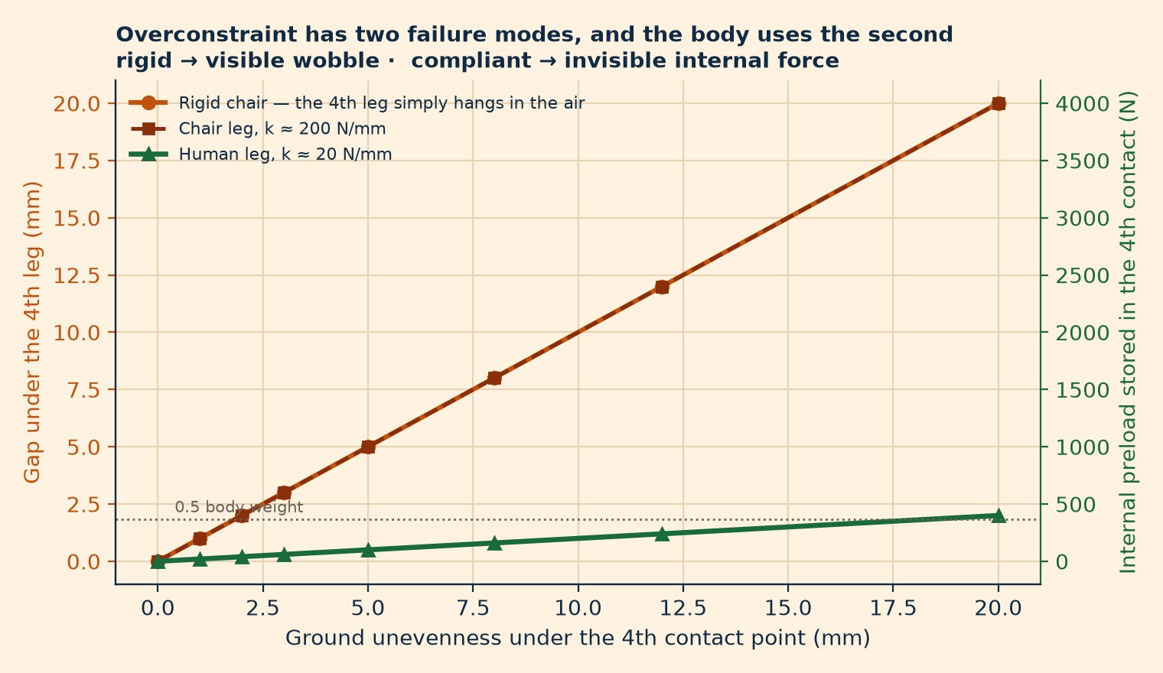
Figure 5 — Overconstraint has two failure modes: rigid wobble, or invisible preload
The correction that matters most. The framework's prediction was "four points make you unstable." The accurate prediction is: four points make you rigid, and rigidity is paid for out of rotation. The observable is not balance loss. It is loss of rotational freedom, degraded timing, and a swing plane set by the feet rather than by the hands.

3.3 Two hands do not define a plane
The third principle states: "One hand cannot define a swing. Two hands define a plane."
The first clause is right. The second is false by the framework's own axiom. Two points define a line, not a plane. A plane needs a third non-collinear point. Two hands on a racket fix a line in space; the plane can still spin freely about that line. One degree of freedom remains — and it is precisely the degree of freedom that determines the tilt of the swing.
This is not a small bookkeeping error. It is a one-constraint shortfall in the very place the framework claims to be strongest, and it is why the cue "both hands up" so often fails to produce a stable plane in practice: the player has satisfied the stated requirement and the plane is still free.
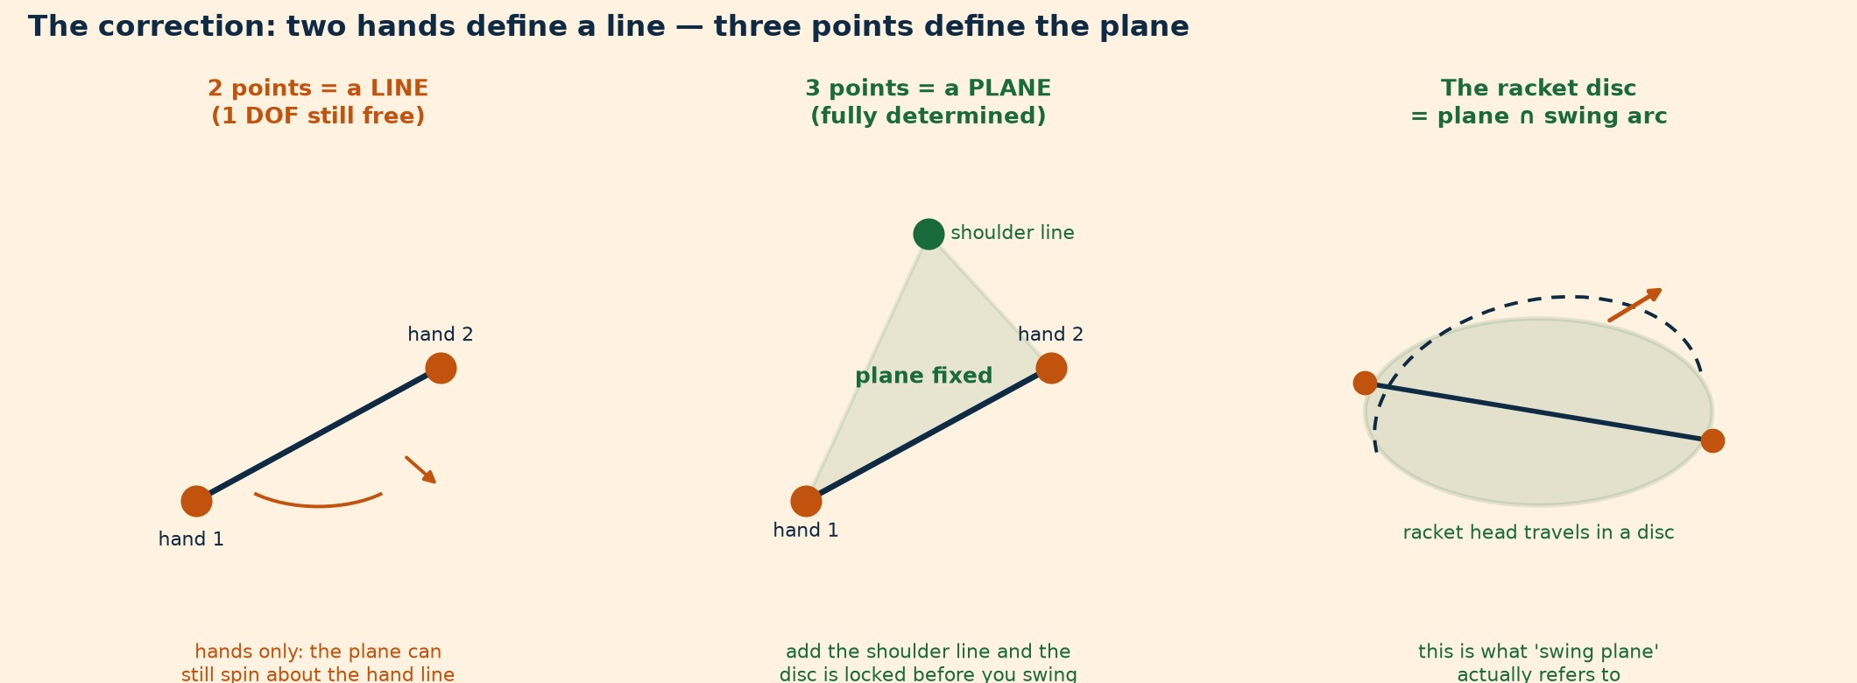
Figure 6b — Two hands define a line; the shoulder line supplies the third point
The repair is elegant and it rescues the principle. The third point is the shoulder line — or, equivalently, the sternum, or the racket head at the end of the lever. The plane of the swing is the plane of the triangle shoulder–hand–hand (Figure 6b). Two hands plus chest is four points, but two of them are on the grip line and the third is the shoulder; the triangle is the three-point object.
With that correction, the principle becomes both true and better coaching:
Original | Corrected
"Two hands define a plane." | "Two hands and the chest define the plane. Hands set the line, chest sets the tilt."
"Both hands up." | "Both hands up and the chest turned into the shot — the disc is set when chest and hands agree."
Off-hand drifting = plane wobbles. | Off-hand drifting = the triangle deforms, tilt changes, and the face angle changes with it.

And the correction immediately explains something the original framework cannot: why a two-handed backhand is stable. Under the original axiom, two hands plus two feet ought to be the overconstrained disaster case. Under the corrected axiom it is the well-formed case, because the second hand is not a free point in space — it is constrained to the grip, which lies in the plane by construction. The second hand is a coplanar fourth point, and coplanar fourth points are exactly what the axiom permits.
The framework's real rule is therefore not "avoid four points." It is: any point that participates in the swing must lie on the swing plane; a point that cannot lie on the plane must be taken out of the equation. That is a rule with predictive power, because it says which fourth points are safe.

3.4 The corrected axiom set
The dossier proceeds on six axioms, stated so that each is either true or false and can be argued with.
A1 — Determinacy. A plane requires three non-collinear points. Two points define a line and leave the plane's rotation about that line undetermined.
A2 — Exact constraint. A rigid body is located by exactly six constraints. More than six is not stiffer; it is indeterminate. On a compliant body, the surplus appears as internal preload rather than as a gap.
A3 — Compliance relocates the failure. In the human body, overconstraint does not show up as wobble. It shows up as co-contraction, load-path indeterminacy, and lost rotational freedom.
A4 — Contact topology sets the axis. An open chain (one support) leaves the rotation axis free to be placed. A closed chain (two supports) fixes it to the geometry of the feet. The number of contacts does not determine stability; it determines who chooses the axis.
A5 — Sufficiency, not maximisation. Static stability is a constraint to be satisfied, not a quantity to be maximised. Beyond the task's requirement, additional base adds inertia and slows redirection.
A6 — Rotation is bought, not added. Angular velocity about a chosen axis is purchased by reducing the moment of inertia about that axis. The purchase price is stability and control authority.
A2, A4 and A5 are the load-bearing ones. A2 supplies the mechanism. A4 supplies the correct interpretation of single-leg loading. A5 supplies the answer to the framework's hardest empirical problem — the studies in which two legs perform just as well.

4. Three questions the framework fuses
The phrase "3 versus 4 points" bundles together three questions that a physicist would keep separate.

4.1 Question one: determinacy (geometry)
How many points are needed to fix the plane? Answer: three, and no more. This is A1, and it is arithmetic. It has nothing to do with balance, and it says nothing about legs. Anytime the framework says "three points define the plane," it is talking about the swing, not the stance.

4.2 Question two: sufficiency (statics)
Is the base big enough for the body's centre of mass to stay inside it while the task is performed? This is the classical support-polygon problem, and its modern form is Hof's margin of stability:
XcoM = CoM + v / ω₀, where ω₀ = √(g / l), and b = (edge of base) − XcoM.
Stability requires b > 0. The crucial term is v/ω₀: the faster the body is moving laterally, the further ahead of itself its effective centre of mass projects, and the wider the base must be. This is why static balance tests under-predict tennis stability, and why "stand still and you'll be fine" coaching fails at the run.

4.3 Question three: freedom (rotational dynamics)
How many ways may the axis be oriented? Here the answer runs the other way. Every additional contact removes a degree of freedom from the pelvis. One foot planted is an open chain: the pelvis can rotate about that foot, and the rotation axis can be tilted into the swing plane. Two feet planted is a closed chain: the pelvis is a loop closure between two legs, and the axis is dictated by where the feet are.
This is not speculation; it is the standard kinematic description, and tennis already uses it. Stępień and colleagues describe the two-handed backhand as a closed kinetic chain with eight degrees of freedom and the one-handed backhand as an open chain with seven, with a negative shoulder–pelvis separation angle at contact in the two-hander. The two-handed backhand is not "a second hand on the grip." It is a different machine.
So the three questions give three different answers, and one pair is in outright tension:
Question | More contact means | Framework says
Determinacy | Nothing (it is about the swing plane) | "3 defines the plane" ✓
Statics | More stable | "4 points unstable" ✗
Rotation | Less free | "4 points unstable" ✓ (for the right reason)

The framework is right about rotation and wrong about statics, and it has been arguing the rotation case using statics language. That is the source of every confusion downstream.
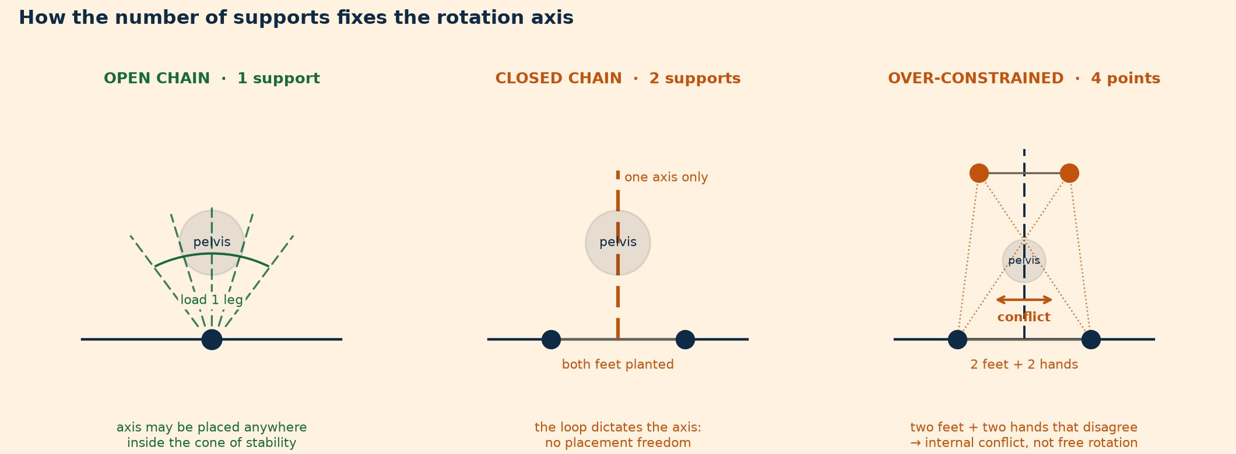
Figure 6a — How the number of supports fixes the rotation axis

5. The Constraint Budget
Once the three questions are separated, the framework can be restated as a single optimisation, which is what it has been reaching for all along.
Every contact point spends from a fixed budget. A player has, at any instant, a certain number of constraints available at the ground and through the grip. Spending them on stability buys a bigger base and a smaller risk of falling. Spending them on freedom buys a placeable axis, a longer rotational arc, and a plane the hands can define. You cannot spend the same constraint twice.
Formally, define a cost for a given configuration C:
J(C) = λ · P_instability(C) + (1 − λ) · R_constraint(C)
where P_instability is the probability (or a proxy) of losing balance during the task, R_constraint is the degree to which the configuration blocks the required rotation, and λ ∈ [0, 1] is a task weight.
λ is the whole ballgame, and it is the parameter the original framework lacks. It is not a constant of the player; it is a property of the task:
Task | λ (stability weight) | Optimal configuration
Split step / ready | ~0.9 | Two legs, wide — stability is the entire job
Return of serve | ~0.8 | Two legs, wide, low; rotation is short and pre-loaded
Defensive slide, wide ball | ~0.7 | Two legs, very wide; the hit is a survival shot
Neutral rally forehand | ~0.5 | Semi-open; weight mostly on the outside leg, inside leg as a light brace
Attacking forehand | ~0.3 | Open stance; outside leg loaded, inside leg unweighted
Serve (toss to contact) | ~0.25 | Front leg the final fulcrum, back leg released or trailing
Volley (short punch) | ~0.6 | Wide, low, minimal rotation; the base does the work
Overhead | ~0.3 | Single-leg load, airborne release

Read this table as the framework's actual content. "Load one leg" is not a universal law. It is the correct answer at low λ, and "wide two-leg base" is the correct answer at high λ — and the same player, in the same rally, switches between them four times.

5.1 The theorem, restated
Minimum sufficient constraint. The optimal configuration for any stroke is the one that satisfies the task's stability requirement and no more, because every constraint beyond sufficiency is paid for in rotational freedom.
This single sentence absorbs the framework's five principles, resolves its apparent contradictions, and generates testable predictions. It also explains, at a stroke, the empirical results that seem to embarrass the original claim: if two legs can produce the same racket speed as one, that is exactly what minimum-sufficient-constraint predicts — the extra constraint is not free, but it is affordable when the task's λ is high, and the body routes the work through a different joint (a finding we return to in §6).

5.2 Why this is not just relabelling
A critic could say: you have replaced a simple rule with a parameter that coaches must guess. Two answers.
First, λ is not guessed; it is observed. It is set by the task's tolerance for a failed contact: how much time is available, whether the player is moving, and whether the ball can be played from a stable position. Those are visible on video. §8 turns them into a scored worksheet.
Second, the reframing makes different predictions than the original. Original: a player who loads both legs will be less accurate. Reframing: a player who loads both legs at low λ will show plane errors and timing errors, not balance errors — because the failure mode is lost freedom, not lost balance. That is a falsifiable difference, and it is exactly what the inverse-dynamics literature reports (equal racket speed, different joint work distribution).

Part III — Quantitative modelling

6. What the numbers actually say
The original framework is entirely qualitative, and that is its second weakness after the geometry: a coach cannot tell from it whether a claim is worth 2% or 40%. This section puts numbers on the four places where numbers decide the argument. Every figure is generated by analysis/triplane_model.py; every assumption is in Appendix A.

6.1 How large is the stability problem? (modelled)
Hof's margin of stability for a player with centre of mass 0.95 m above the ground, ω₀ = 3.21 rad/s:
Lateral CoM velocity | XcoM offset ahead of CoM | Stance width at which margin = 0 | Margin at 20 cm stance | Margin at 60 cm stance
0.1 m/s (plant-and-hit) | 3.1 cm | 6.2 cm | +6.9 cm | +26.9 cm
0.3 m/s (controlled slide) | 9.3 cm | 18.7 cm | +0.7 cm | +20.7 cm
0.5 m/s (wide defensive) | 15.6 cm | 31.1 cm | −5.6 cm | +14.4 cm
0.8 m/s (sprint recovery) | 24.9 cm | 49.8 cm | −14.9 cm | +5.1 cm

Three things fall out.
A narrow stance is not marginally worse; it is a different regime. At 15 cm foot-to-foot, the margin is already negative at a lateral velocity of 0.3 m/s. The player is not "slightly less balanced." They are in continuous corrective stepping, and every correction consumes the time and the ground force that the stroke wanted.
The knee of the curve is around 30–50 cm. Below it, margin collapses fast; above it, gains flatten. This matches what the knowledge base reports empirically for stance width — roughly 1.5–2× shoulder width, with an explicit upper bound at which the base becomes "slow to load and slow to move from" (ART-0106), and a floor under which peak force output drops 10–20% (ART-0124). The static model and the coaching heuristic agree on the band. That is a genuinely reassuring convergence, and it is the strongest empirical support anywhere in this dossier for Principle 2.
The requirement is velocity-dependent, which is why one stance cannot serve all situations. At 0.1 m/s a 20 cm stance is comfortable. At 0.8 m/s it is a fall. The framework's phrase "if 2 legs are loaded, they must be wide" is directionally right but incomplete: how wide depends on how fast the player is travelling when they must be stable.
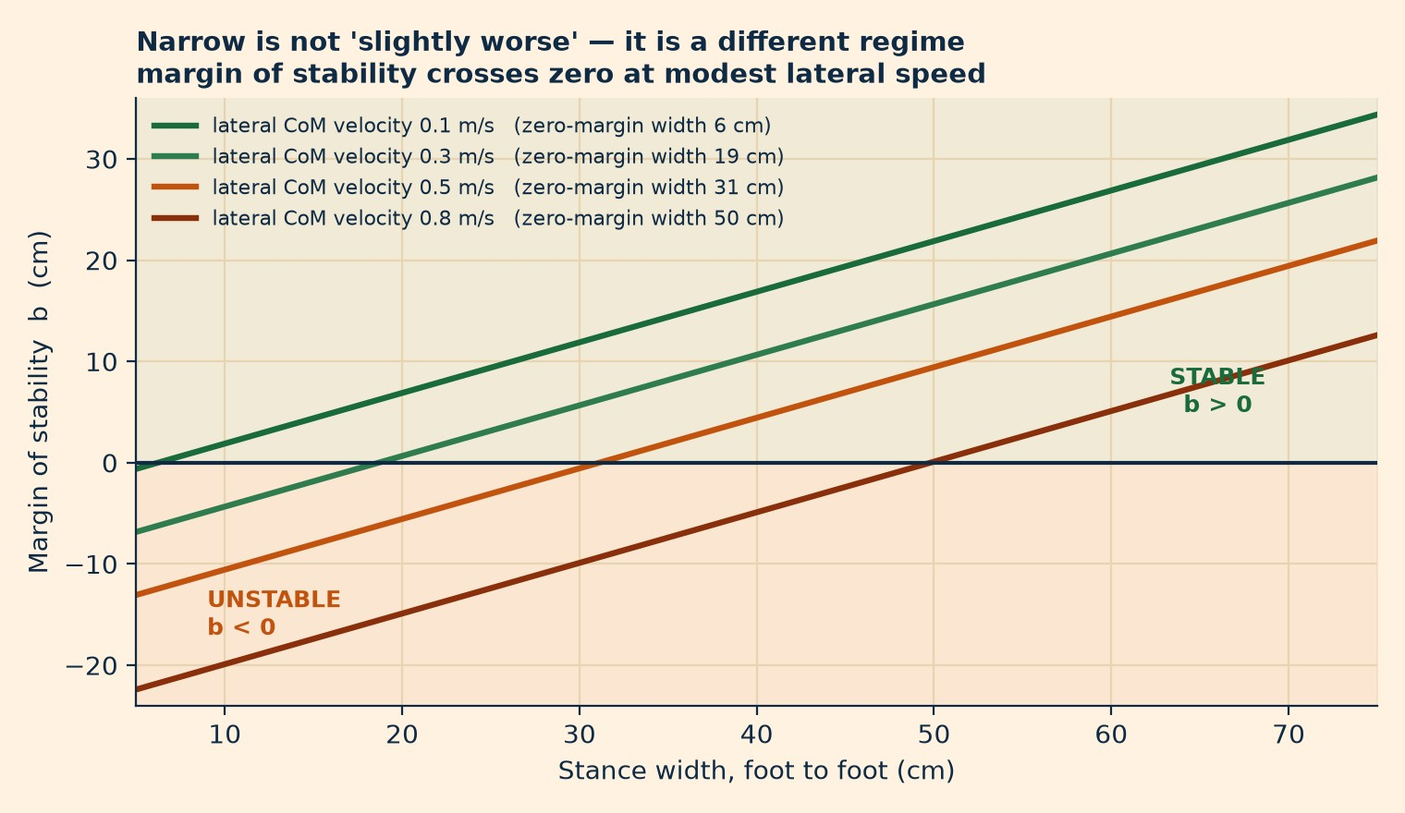
Figure 7 — Margin of stability collapses below zero at modest lateral velocity

6.2 How much rotation does a tuck buy? (modelled)
Whole-body moment of inertia about the vertical axis, 75 kg player, 30 cm stance, segment masses from the Dempster/Winter fractions:
Configuration | I about vertical axis | Gain if angular momentum were fixed
Both arms tucked | 0.84 kg·m² | baseline
Tossing arm extended, racket arm folded | 1.31 kg·m² | +56% ω
Both arms extended | 1.78 kg·m² | +112% ω

The sway of the arms is a 2.1× lever on the body's moment of inertia. That is the mechanism the framework asserts, and it is real: the model confirms that moving one arm from an extended to a tucked position changes total-body I by 36%, which under constant L is a 56% increase in angular velocity.
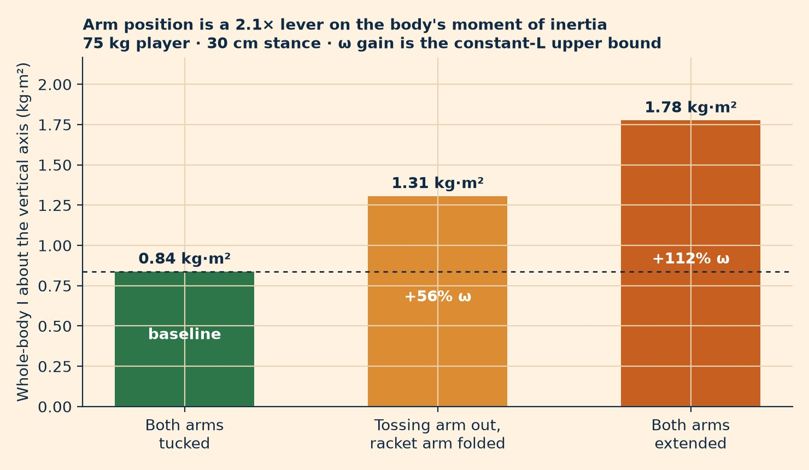
Figure 8 — Arm position is a 2.1x lever on whole-body moment of inertia
Now the honest part. The +56% is an upper bound that no player achieves. It assumes angular momentum is constant across the tuck, which is false during a stroke: the planted foot is applying torque to the ground the whole time, so L is being actively changed by the leg, not conserved. It also assumes the arm travels the full range instantaneously, and it ignores that the arm's mass was contributing to the trunk's rotation before the tuck. In a real serve, the tuck happens over roughly 100–150 ms and L is rising throughout.
So the defensible statement is:
Tucking the non-hitting arm reduces whole-body moment of inertia about the vertical axis by roughly a third, which permits a proportionally higher angular velocity for the same angular momentum. The realised gain is smaller and has never been measured in tennis. Grade C — sound rigid-body mechanics, not a tennis finding.
That is a weaker claim than the framework makes, and it is the strongest claim the evidence will carry. The distinction matters, because a coach who promises "+50% rotation speed" from an arm tuck is promising something no study has shown. A coach who says "the tuck stops the arm from acting as a brake on your rotation, and it lets the trunk accelerate instead of dragging the arm" is on solid ground — and the second sentence is what actually helps a player, because it describes the mechanism they can feel.

6.3 What does a second contact cost? (modelled)
If the unloaded foot is still carrying load, it is still coupled to the ground, and its friction capacity becomes a rotational constraint.
Load on the second foot | Friction capacity (μ = 0.8) | Maximum moment it can apply at 0.35 m from the axis
10% body weight | 59 N | 21 N·m
20% body weight | 118 N | 41 N·m
30% body weight | 177 N | 62 N·m
50% body weight | 294 N | 103 N·m

Compare the torque actually needed to accelerate the trunk. Taking trunk-plus-head I ≈ 0.38 kg·m² (45% of total, from the model) and requiring 800°/s within 180 ms gives an angular acceleration of 77.6 rad/s² and a required torque of about 29 N·m.
The second foot's friction capacity at 30% body weight — 62 N·m — is more than twice the torque needed to drive the trunk. That is the quantitative heart of the framework, and it is stronger than the original statement: a lightly-loaded second foot is not a passive passenger. It is a lever with more than enough authority to override the rotation the player is trying to create.
This cuts both ways, and the framework only ever acknowledges one direction. The same coupling can drive rotation — which is precisely what a closed-stance forehand does, planting the front foot and using it to brake the pelvis and whip the trunk over the top. A second contact is not inherently bad. It is authoritative, and its authority must be pointed somewhere. The question is never "one foot or two" but "where is the second foot's authority pointed — with the rotation, against it, or nowhere in particular?"
That question is the diagnostic that separates a good closed-stance forehand from a bad open-stance one, and no amount of "load one leg" coaching captures it.

6.4 How much does a plane error cost? (modelled)
If a hand drifts off the swing plane, the racket face tilts. With a 0.34 m lever from the controlling hand to the head:
Off-plane error at the controlling hand | Face tilt | Ball launch error | Miss at the 18 m baseline
5 mm | 0.8° | 0.5° | 0.16 m
10 mm | 1.7° | 1.0° | 0.32 m
20 mm | 3.4° | 2.0° | 0.63 m
40 mm | 6.7° | 4.0° | 1.27 m

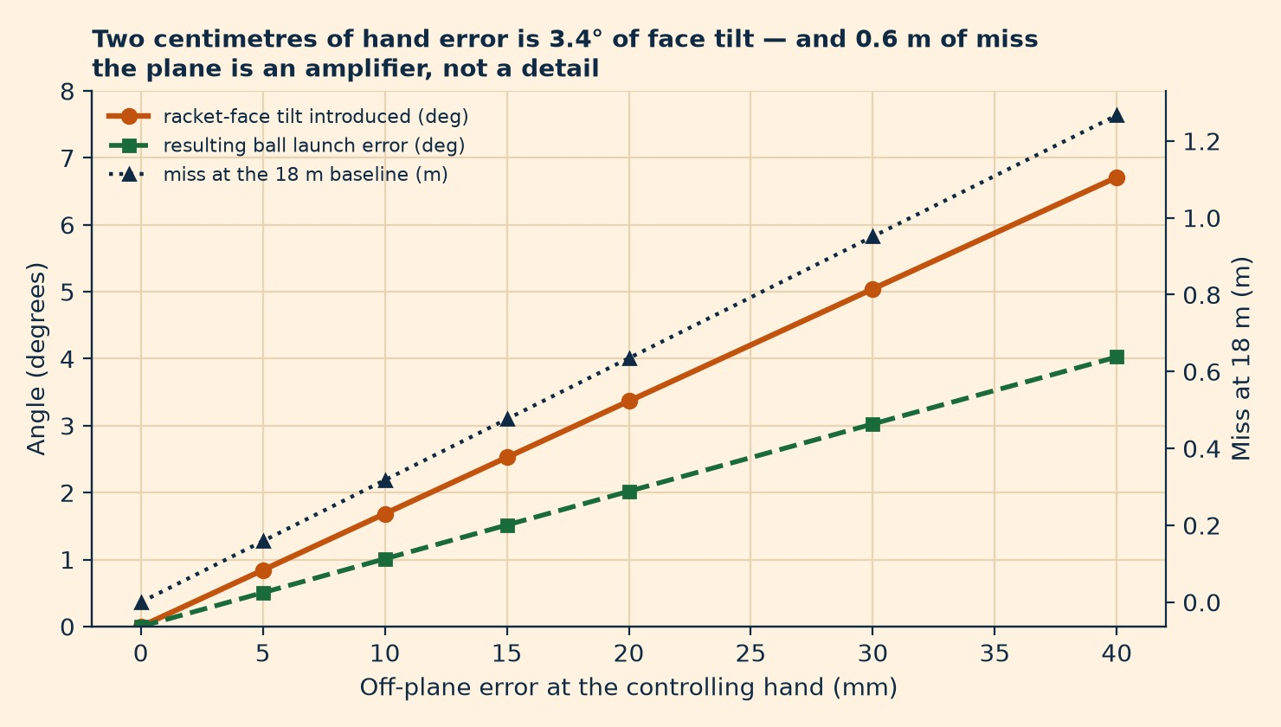
Figure 9 — Plane error amplification: 2 cm of hand error is 0.6 m of miss
Two centimetres — about the width of a finger — is three degrees of face tilt and two-thirds of a metre of miss at the far baseline. The plane is not a detail to be tidied up after the power is built. It is the finest-grained error amplifier in the stroke, and it is the one the framework gets most right in spirit and least right in geometry.
This also settles a coaching argument. Players do not miss long because they are "too tight"; they miss long because a plane error at the hand became an angle error at the face became a metre at the baseline. The correction is upstream: fix the triangle (shoulder–hand–hand), not the wrist.

Part IV — Evidence audit

7. The five principles, audited
The framework's five principles are now examined one at a time. For each: what it claims, what the literature measures, what is inferred, the grade, and the restatement this dossier recommends.

7.1 Principle 1 — Single-fulcrum loading
Claim. One leg must be fully loaded at a time; this creates a single clean vertical axis through that leg's ground reaction force; loading 50/50 creates two competing axes and "you get stuck in the middle."
What is measured.
- The legs matter, and they matter more for better players. Peak vertical GRF in the serve: 2.12 ± 0.36 BW in elite players versus 1.68 ± 0.33 BW in beginners, with impact height correlating with peak vertical force at r = 0.85 in the elite group (Girard et al., 2005). A later study reports 1.78 ± 0.30 BW on first serves and 1.62 ± 0.25 BW on second serves, unchanged across a three-hour match even as leg EMG fell 10–40% (Hansen et al., 2024). Grade A.
- Leg drive is worth about 10% of racket speed: 43.6 ± 3.0 m/s with a foot-up stance, 42.6 ± 3.1 foot-back, and 39.4 ± 3.4 with no leg drive at all (Reid, Elliott & Alderson, 2008). Shoulder joint kinetics were statistically indistinguishable across all three conditions. Grade B.
- Stance choice, by contrast, was worth almost nothing: foot-up versus foot-back differed by 1 m/s, within noise. Grade B.
- In the forehand, open and square stances produced equal racket head speed, with the open stance doing less work through the shoulder in the hitting direction (0.30 ± 0.11 vs 0.38 ± 0.16 J/kg, p = 0.005) and compensating with more work sideways (p = 0.046) and upward (p = 0.002) (Kawamoto et al., 2019). Grade B, and the single most important study for this principle.
- Older work found no difference between open and square in racket velocity, vertical racket path, or trunk angular velocity at impact (Knudson & Bahamonde, 1998); equal trunk EMG across stances (Knudson & Blackwell, 2000); and greater peak shoulder internal-rotation and wrist-flexion torque in the square stance (Bahamonde & Knudson, 2003). Grade B–C.
- In the two-handed backhand the dominant hip moment for trunk rotation is generated in the back leg, while the one-handed backhand uses the front leg (Akutagawa & Kojima, 2005). Grade B.
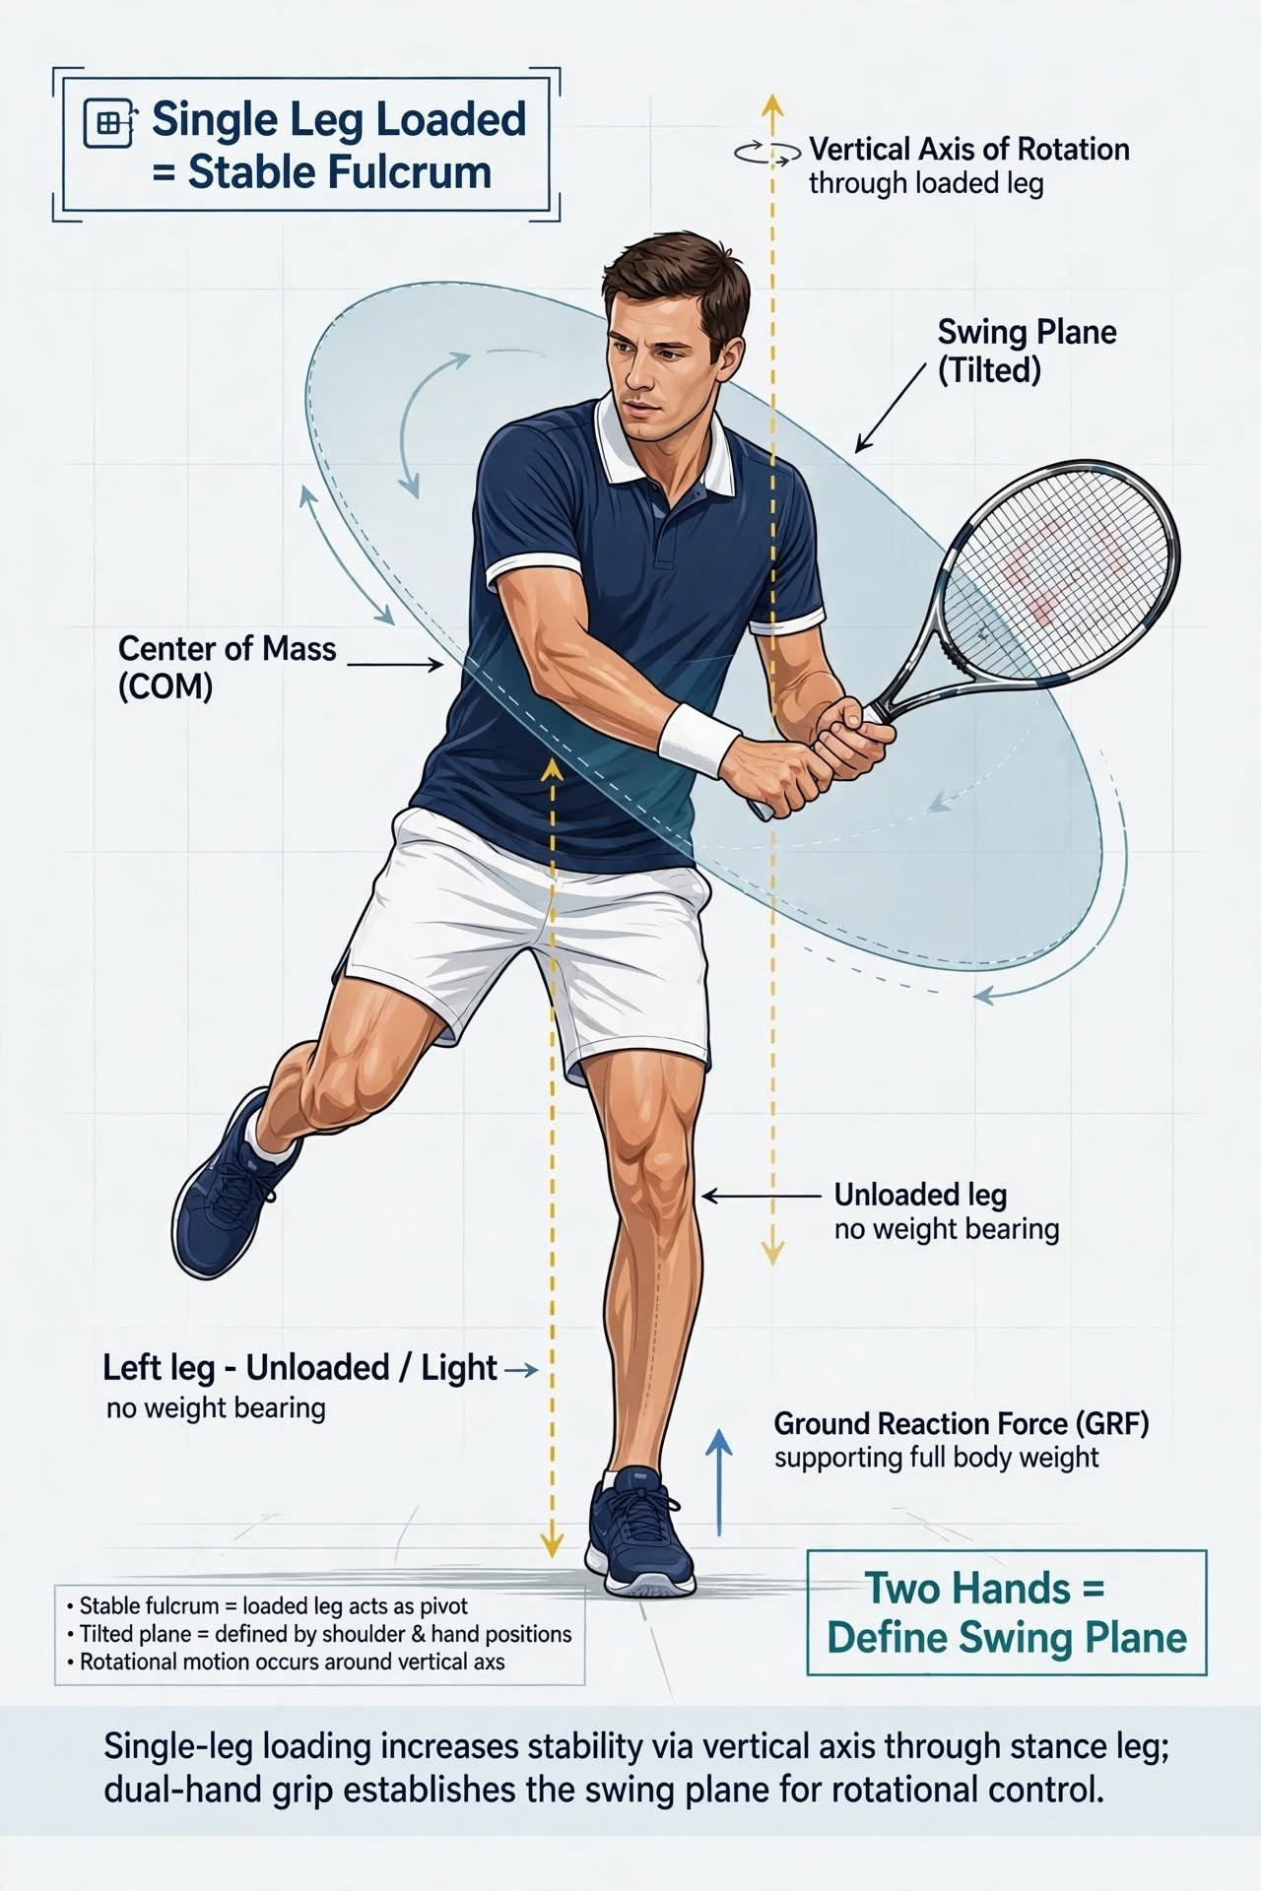
Figure 2 — Single-leg loaded fulcrum with a tilted swing plane
What is inferred. That a single loaded leg produces "a single clean vertical axis." No study has measured the rotation axis during a stroke and shown it passes through the loaded foot. What is measured is that the stroke is consistent with single-support loading (larger lateral forces in open stances, greater hip abduction and external rotation, greater knee flexion) and that GRF is asymmetric. The axis itself is a kinematic inference. Grade C.
Where the claim fails. "Fully loaded" is never 100%, and no study reports it as such. The knowledge base's own ceiling is "roughly 80% or more" (ART-0138), and it simultaneously reports 60–70% rear-foot loading in serve preparation (ART-012) and 60–70% on the inside leg for forward-contact forehands (ART-0162). And, fatally for a universal rule, one of the knowledge base's own biomechanics articles states the opposite outright: players who load predominantly on one leg "create an imbalance that reduces the total force available for the stroke and compromises balance during the forward swing" (ART-011).
The restatement.
P1′ (Grade C). At the moment of maximum rotation demand, the majority of load should be under one leg, so that the pelvis is an open chain and the rotation axis can be placed into the swing plane. "Majority", not "all": 70–85% is the realistic band, and the exact figure is a task decision, not a law. During high-stability tasks (ready, return, defensive slide), two-leg loading is correct and the base must be wide.
The reframing matters clinically. "Load one leg" tells a player to do something impossible and to feel like a failure when they do not. "Load the outside leg to about 80% and let the inside leg be a light brace" is the same mechanics, executable, and it preserves the small amount of second-foot authority that good players actually use.

7.2 Principle 2 — Wide-base compensation
Claim. If two legs are loaded, they must be wide; a narrow base is unstable because the support polygon is small.
What is measured.
- Widening stance reduces lateral body sway, and lateral sway is comparatively insensitive to vision, implying a distinct control channel — supporting the "you feel width through the hips, not the eyes" intuition (Day et al., 1993). Grade C (not tennis).
- Lateral ground reaction force is significantly higher in defensive open stance than attacking open stance, and higher than neutral; vertical force is higher in defensive open than neutral (force-plate synthesis in Lambrich & Muehlbauer, 2023). Grade B, but note it measures force, not stability.
- The knowledge base's footwork pillar converges on a band: roughly 1.5–2× shoulder width, with an explicit ceiling ("over 2.5× shoulder width: slow to load, slow to move from") and an explicit floor ("under 50 cm: push-off angle exceeds 65°, peak force drops 10–20%"). Grade D (coaching consensus), but internally consistent and consistent with the model in §6.1.
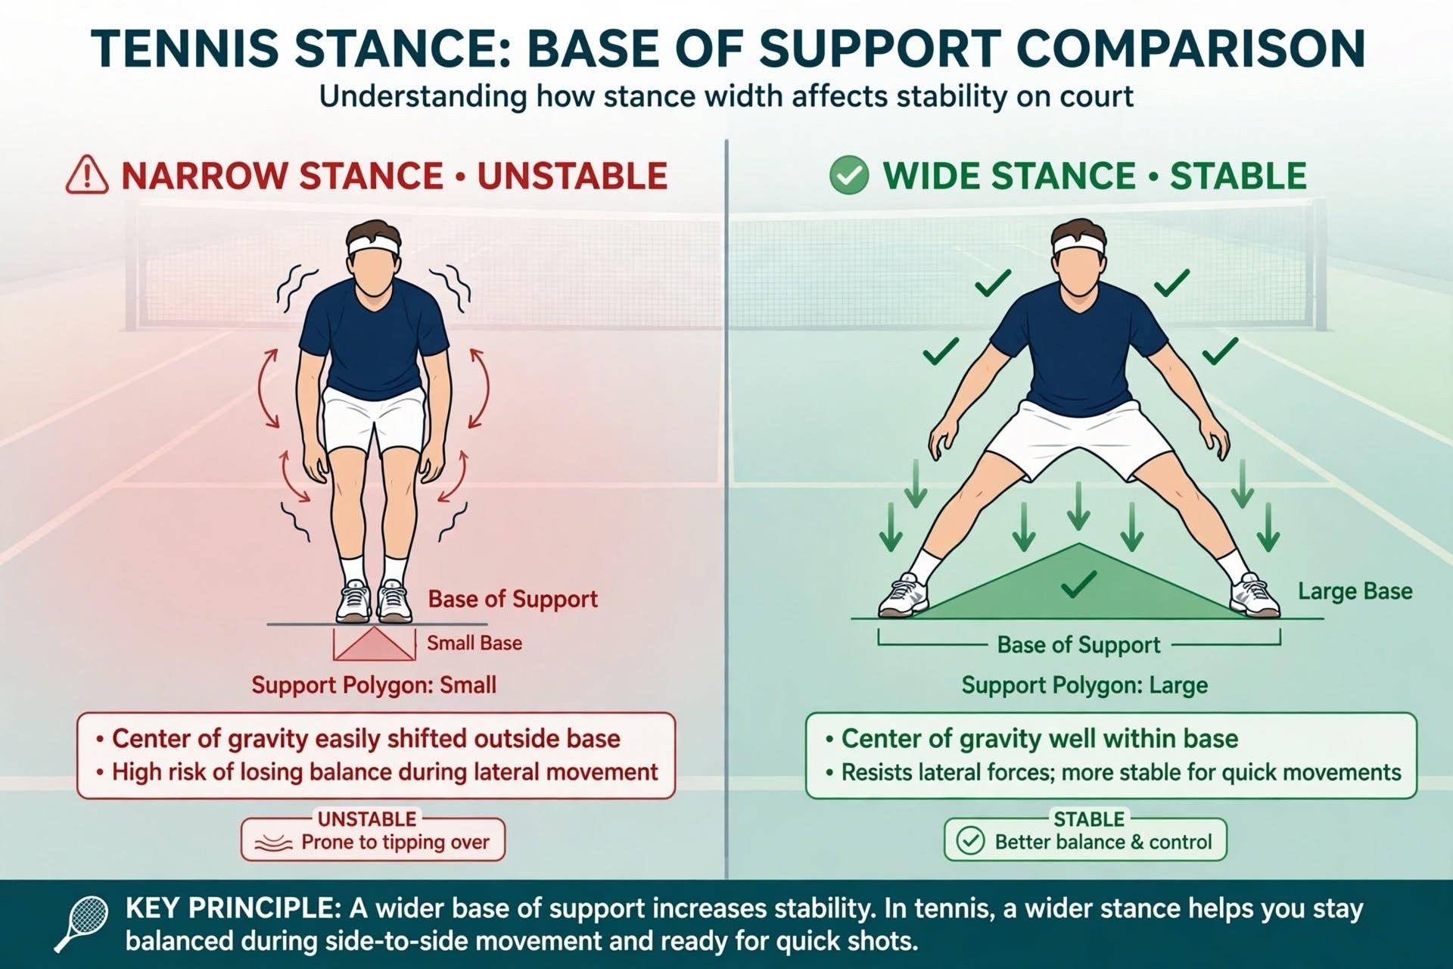
Figure 3 — Narrow versus wide base of support
What is inferred. That the support polygon is the mechanism. No tennis study has computed a support polygon, a margin of stability, or a limits-of-stability boundary during a stroke. The entire static-stability apparatus is imported from posture science (Winter 1995; Hof et al. 2005). Grade C.
Where the claim fails. "Wider is more stable" is true but not sufficient, because widening the base also raises the moment of inertia about the vertical axis. The knowledge base states this explicitly: "legs apart: high moment of inertia (stable, hard to rotate)" (ART-022), and a footwork article makes the trade-off concrete: a narrow base "minimizes the moment of inertia around the vertical axis, allowing rapid acceleration in either direction," while a wide base costs "100–150 ms" to recover when the ball goes the other way (ART-0116). The framework's own logic predicts this — but the framework never applies it to itself.
The restatement.
P2′ (Grade A for the band, C for the mechanism). Two-leg loading requires a base wide enough that the margin of stability stays positive at the lateral velocity the task demands — roughly 1.5–2× shoulder width, larger when moving faster. Beyond that band, additional width is not free: it raises rotational inertia and slows redirection. Width buys stability and spends rotation, exactly as the tuck buys rotation and spends stability.

7.3 Principle 3 — Two hands define a plane
Claim. The racket path is a disc, a tilted plane; two hands (or hands and shoulders) define it; an off-hand that drops or flies away makes the plane wobble.
What is measured.
- "Swing plane" has no standardised peer-reviewed definition. It is used in at least three non-equivalent senses: the racket trajectory angle in the vertical plane (about 20° above horizontal for flat, 40° for topspin, 70° for a topspin lob), a fitted plane through the racket-head path, and a coaching-intuitive description of the arc (Reid, Elliott & Crespo, 2013). Any document using the term must say which sense it means. This dossier uses the second: a fitted plane through the racket-head path. Grade A on the definitional problem.
- The two-handed backhand is a closed kinetic chain with eight degrees of freedom against the one-hander's seven, with greater upper-extremity rigidity, a larger trunk contribution to racket-handle velocity, and a negative shoulder–pelvis separation angle at contact (Stępień et al., 2011). Grade B. This is the best available evidence that "adding a hand" changes the architecture of the swing, not just the grip.
- The forehand/racket system is well modelled as a double pendulum, and swing speed depends primarily on the implement's moment of inertia rather than its mass (Cross, 2011). Grade B (physics model, not a tennis trial).
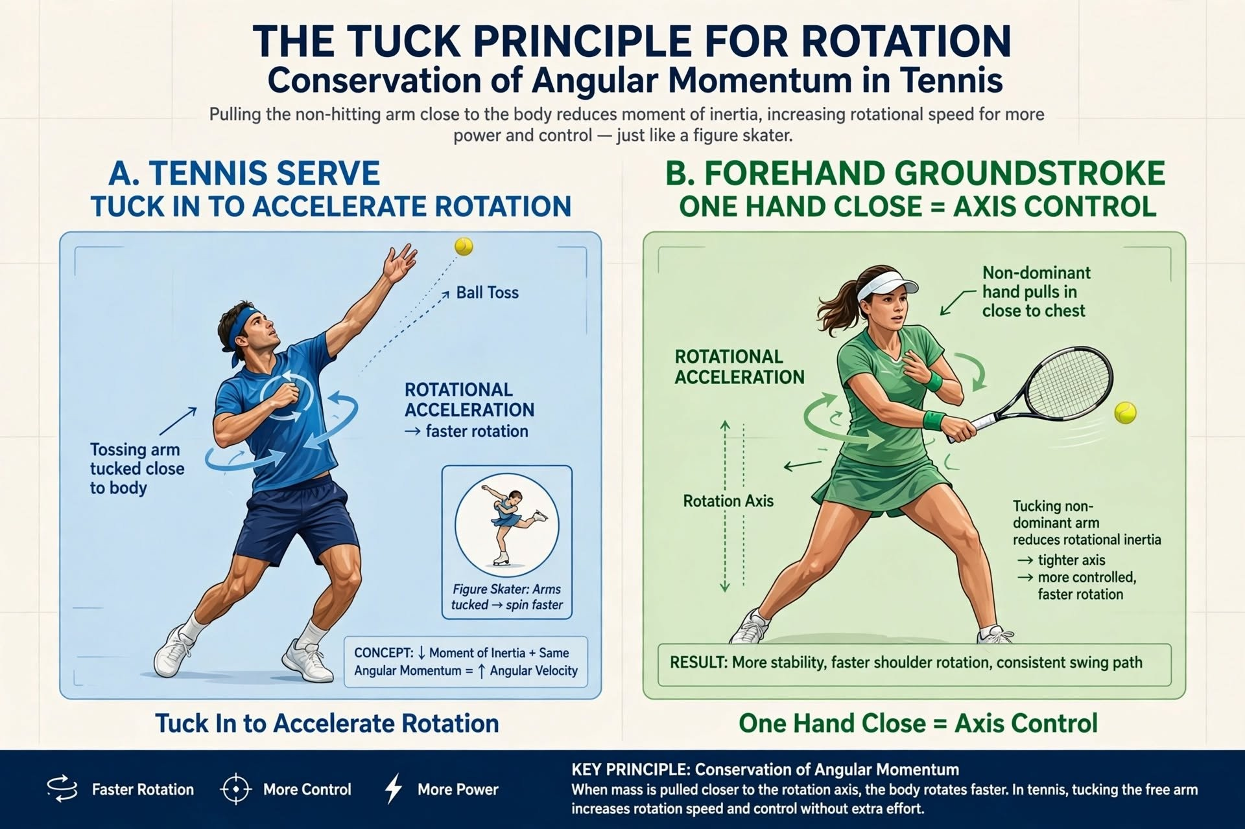
Figure 1 — The tuck principle in the serve and the forehand
What is inferred. That the non-hitting hand sets the plane. This is coaching doctrine. The knowledge base gives exactly one article a real geometric mechanism — the split grip as "a lever system that amplifies the torso's rotational force," whose jobs include pushing the throat away "keeping the racquet head aligned with the shoulder rotation" and maintaining the face "perpendicular to the target plane" (ART-302) — while most others attribute the plane to shoulder turn or grip, with the hands as guides. Grade D.
Where the claim fails. Geometrically, as §3.3 established: two points give a line. The claim is one constraint short, and it is precisely the constraint that sets the tilt.
The restatement.
P3′ (Grade C for geometry, D for the coaching mechanism). The swing plane is the plane of the shoulder–hand–hand triangle. Hands fix the line; the chest line fixes the tilt. Set both before the forward swing, and keep any fourth point either on that plane (a second hand on the grip) or out of the equation entirely (the off-hand released).

7.4 Principle 4 — The proximal tuck
Claim. Pulling the non-hitting arm close to the body reduces moment of inertia and increases rotational speed (L = Iω); the tossing arm must tuck after the toss; the off-hand pulls to the chest on the forehand.
What is measured.
- The tennis literature establishes that angular momentum in the serve is dominantly remote and dominantly trunk-to-arm: near impact 75.1% of total angular momentum sits in the racket-arm, of which the racket holds 35.9% and the forearm 25.7% (Bahamonde, 2000). Grade B.
- The transfer is proximal-to-distal, and trunk angular momentum about the anteroposterior axis correlates with ball velocity across multiple serve phases (Martin et al., 2013). Grade B.
- The legs and trunk link develops 51–55% of the kinetic energy delivered to the hand (Kovacs & Ellenbecker, 2011, review synthesis). Grade C.
- The best controlled test of tossing-arm behaviour found that early versus late adduction changed the toss (higher and further forward), lengthened serve duration, shifted the preparation share by 4.3%, and changed post-impact trajectory by about 3° steeper or 1° flatter — with head kinematics unaffected (Newton et al., 2025). Grade B, and it is a null-ish result for the kinematic-dominance story.
What is inferred — and the honest gap. There is no tennis study showing that tucking the non-dominant arm raises trunk angular velocity. The mechanics are sound (the model in §6.2 confirms a 36% I reduction from one arm), but the causal chain — tuck → lower I → higher ω → faster racket — has never been measured in a serve or a groundstroke. Grade C, not A or B.
Two further complications are real and rarely mentioned:
- Conservation applies only when torque is absent. The framework's own mechanics require constant L, but the whole point of single-leg loading is that the planted foot is applying torque. The tuck and the fulcrum are therefore in tension: the more firmly the foot anchors, the less the tuck can "conserve" anything.
- The tuck is transient and reverses before contact. The arm extends again to maximise the contact lever (ART-022, ART-041). The tuck's window is roughly the acceleration phase, not contact.
The restatement.
P4′ (Grade C). During trunk acceleration, keep the non-hitting arm close to the axis of rotation so it does not act as a brake and does not raise the body's moment of inertia; release it before contact so the hitting arm can extend. The benefit is permissive — it allows the trunk to accelerate — not generative, and it has never been quantified in tennis. Do not attach a percentage to it.

7.5 Principle 5 — The three-point check at contact
Claim. At the moment of power, exactly three points work in one plane: the fully loaded leg (fulcrum), the tucked hand (axis controller), and the extended racket hand (power end). The fourth point (unloaded leg, or a far hand) is deliberately excluded.
Assessment. As stated, this is a composite heuristic, and it has a geometric problem: the three named points are the loaded foot, the tucked hand, and the racket hand. Those three do not generally lie in the swing plane — the foot is on the ground and the swing plane is in the air. The check mixes a support point with two swing points and calls the result "one plane."
This does not make it useless. It makes it a checklist with a mislabelled geometry, and relabelling it produces something genuinely valuable:
Point | What it really is | Constraint it contributes
Loaded leg | The axis anchor | Fixes where the rotation axis enters the ground
Tucked hand | The inertia controller | Keeps I low during acceleration
Extended racket hand | The power end of the lever | Sets radius and timing of peak speed
Shoulder line | The third point of the plane — missing from the original | Sets the tilt

The restatement.
P5′ (Grade C). At contact, four things should be simultaneously true: one leg is the axis anchor; the off-hand is close to the axis (or released); the hitting arm is extended along the plane; and the shoulder line agrees with the hand line. That is not "three points in one plane." It is one plane (shoulder–hand–hand) plus one axis (the loaded leg), and the two must be consistent.
Stated that way, the check becomes testable, and §8 turns it into a scored worksheet.

7.6 An unexpected finding: the knowledge base argues with itself
The audit turned up something worth reporting in its own right. On the exact claims at issue, the 1,000-article knowledge base contains direct self-contradictions, and they are not marginal:
Topic | One article says | Another says
Single-leg loading | "One leg anchors every powerful open-stance stroke… 80% or more of body weight" (ART-0138) | "Players who load predominantly on one leg… reduces the total force available and compromises balance" (ART-011)
Which leg is "outside" | Right leg for a right-hander's forehand (ART-0138) | Left leg for the same shot (ART-0156)
Wide base | "Wide base = large support polygon = stable" (throughout) | "A narrow base minimizes the moment of inertia… allowing rapid acceleration"; wide base costs "100–150 ms" of recovery (ART-0116)
Non-dominant hand | Bottom hand drives the shot (ART-405) | Top hand is the "dominant hand" (ART-435)
Serve loading | Rear foot carries 60–70% in preparation (ART-012) | Front leg is the final fulcrum (ART-005, ART-0138)

None of these are fatal — several are reconcilable once task phase is specified, which is exactly what the λ-framework does. But they are invisible to a reader, and they mean that any downstream document citing "the knowledge base" as authority on these five principles is citing a corpus that disagrees with itself at roughly the same rate as the coaching literature it summarises.
Recommendation. Before the framework is published into the pillar architecture, the affected articles need a task-phase qualifier (which phase does this claim apply to?) or an explicit "competing view" cross-reference. This is a content-governance action, not a research one, and it is cheap: five articles, one editorial pass.

Part V — The contradictions, and how the model absorbs them

8. Six findings that appear to refute the framework
A framework is only as good as its handling of the evidence against it. Here are the six hardest findings, and what the reframed model does with each.

8.1 Open stance is not more powerful — it is equally powerful by a different route
Kawamoto and colleagues found equal racket head speed in open and square stances, with the open stance doing less work through the shoulder in the hitting direction and more work sideways and upward. On the original framework's terms this is a failure: if single-leg loading were the source of power, the open stance should win.
Under the reframing, this is exactly the prediction. The two stances sit at different points on the constraint axis. The square (two-leg) stance spends constraints on a stable base and gets a linear, ground-driven power route with a fixed axis. The open (single-leg) stance spends constraints on an open chain and gets a placeable axis with a rotational route, which it then completes with extra lateral and vertical shoulder work. Same output, different budget. The finding is not evidence against minimum-sufficient-constraint; it is a demonstration of two equilibria on the same isoquant.

8.2 The two-handed backhand loads the back leg
If "load the front leg" were a law, the two-hander would break it. Akutagawa and Kojima showed the dominant trunk-rotation hip moment comes from the back leg in the two-hander and the front leg in the one-hander.
Under the reframing, this is a different machine, so it has a different answer. The two-hander is a closed chain (eight DOF against seven). Its second hand is a coplanar fourth point, so it pays no plane penalty. It therefore chooses a different optimum: it accepts the closed-chain axis and buys power from the back-leg drive and trunk rotation, which is why its separation angle at contact is negative. The one-hander has an open chain and a free axis, so it loads the front leg and rotates around it.
The framework, read as a universal rule, is wrong here. Read as a budget, it is right twice: each stroke spends its constraints where its architecture makes them cheapest.

8.3 Leg drive is worth only about 10% — and stance almost nothing
Reid, Elliott and Alderson's cleanest experiment: 43.6 m/s with foot-up, 42.6 foot-back, 39.4 with no leg drive at all, and identical shoulder kinetics across all three. If the legs were the engine the framework describes, removing leg drive should be catastrophic. It costs a quarter.
Under the reframing, this is coherent and instructive. What leg drive buys is the 10% that arrives before the arm, and its removal is compensated by the trunk and shoulder — which is why shoulder kinetics do not change: the shoulder is not being asked to do more, the timing is being reorganised. The framework's claim that the legs are the foundation of power is not wrong, but the measured magnitude is modest, and a coaching programme that spends 80% of its technical time on leg loading is over-investing in a 10% lever.

8.4 The serve is not a vertical-axis spin
Bahamonde's angular momentum decomposition found the vertical (Z) component "small and lacked a consistent pattern," while the dominant components were about the anteroposterior and mediolateral axes, transferred trunk → arm → racket.
This is the most damaging single finding for the framework's physics, because the framework's mental picture is a figure skater spinning about a vertical axis. A serve is not that. It is a forward-and-sideways somersault-ish rotation of the trunk, delivered through a shoulder that is internally rotating at rates above 1000°/s.
Under the reframing, the vertical-axis language must be retired for the serve. The "axis" that single-leg loading places is the axis of pelvic and trunk rotation about the ground contact — which is close to vertical for a groundstroke and substantially tilted for a serve. The tuck still reduces I about whichever axis is doing the work; but the axis is not vertical, and the figure-skater analogy, while pedagogically memorable, is mechanically misleading for the serve. It is a good analogy for a groundstroke, where the rotation genuinely is about a near-vertical axis.
This is a genuine correction to the framework's own imagery, and it should propagate to the Vietnamese edition and to any coaching material derived from it.

8.5 The tuck may change timing, not speed
Newton and colleagues manipulated tossing-arm adduction timing and found the toss, serve duration and post-impact trajectory changed, while head kinematics did not. If the arm tuck were a rotational accelerator, one would expect a kinematic signature in the trunk or head.
The honest reading: the strongest available test of tossing-arm behaviour found effects on timing and toss geometry, not on rotational kinematics. It does not disprove the inertia argument — it did not measure trunk angular velocity — but it is the closest thing to a direct test, and it did not find the effect the framework predicts. The tuck claim therefore remains Grade C, and any coach presenting it as established is overstating.

8.6 Fatigue does not reduce force, but it does reduce activation
After a three-hour match, peak vertical GRF in the serve was unchanged while leg EMG amplitude fell 10–40%.
For a framework built on "the legs are the foundation," this is a warning: the force is maintained, so the foundation looks intact, but the control is degrading. The player is holding force output with a different, more co-contracted strategy — which is precisely the overconstraint signature of §3.2. Fatigue may therefore be the best natural experiment for the framework: if overconstraint costs rotational freedom, then a fatigued player should show earlier and larger plane errors before they show any drop in force. That is testable, and §12 proposes it.

8.7 What survives
Claim | Status after audit
The legs matter to stroke production | Supported (A)
Better players push harder into the ground | Supported (A)
A wide base is more stable than a narrow one | Supported, banded (A/C)
Single-leg loading is superior to two-leg loading | Not supported — equal output, different route (B)
Two hands define the swing plane | Half-supported; geometrically incomplete (C/D)
The tuck accelerates trunk rotation | Mechanically sound, unmeasured (C)
Three points define a plane and a fourth overconstrains | True as geometry, wrong as statics, right as kinematics (A/C)
A single configuration is optimal for all strokes | False — optimality is task-conditional (A, by contradiction)

Part VI — The applied system

9. From model to coaching
What follows is the framework rebuilt on the corrected axioms. It is designed to be usable at a tennis club by a coach with a phone camera and no force plates.

9.1 The decision sequence
Before technique, decide the budget. Four questions, in order:
- How fast am I moving when I must be stable? (sets the minimum base width — §6.1)
- How much rotation does this shot need? (sets how much of the base to give up)
- Where must the axis be? (inside leg for a wide ball, outside leg for an attacking ball, front leg for the serve)
- Which fourth point must be taken out of the equation? (the off-hand released, the back leg unweighted, the non-hitting shoulder opened)
The answers produce a configuration, not a rule. Table 9.1 is the lookup.

9.2 Table 9.1 — Stroke-by-stroke configuration
Situation | Base | Load split | Axis through | Off-hand | Dominant error if rushed
Split step | Wide, feet > hips | 50/50 momentarily | n/a | Neutral, both hands on racket | Landing narrow → no push in either direction
Ready | Wide, low | 50/50 | n/a | Racket centred | Standing tall → late first step
Return of serve | Wide, low, slightly staggered | 55/45 to the backhand side | Inside leg | Split grip, short backswing | Over-rotating early → block instead of drive
Neutral forehand | Semi-open | 60/40 outside leg | Outside hip | Split grip, throat guided | Off-hand drops → plane tilt lost
Attacking forehand | Open | 80/20 outside leg | Outside hip | Split grip then tuck | Off-hand trails → over-rotation
Wide defensive forehand | Very wide open | 85/15 outside leg | Outside hip | Releases early for balance | Chasing the ball with the arm
Closed-stance forehand | Wide, front foot across | 60/40 rear, front brakes | Rear-to-front transfer | Split grip | Front foot passive → arm-only swing
One-handed backhand | Neutral to closed | 70/30 front leg | Front hip | Releases backward as counterbalance | Off-hand stays on throat → chain blocked
Two-handed backhand | Open or square | 60/40 back leg | Back hip | Both hands on grip (coplanar) | Straightening both arms → plane flattens
Serve (toss to trophy) | Staggered | 60–70% rear | Rear leg | Tossing arm up, defining tilt | Toss arm collapses early → plane lost
Serve (drive to contact) | Staggered to single support | Front leg becomes fulcrum | Front leg | Tossing arm tucks | Tuck before drive → no block to rotate against
Volley | Wide, low, staggered | 60/40 | Front leg, minimal rotation | Short, compact | Big backswing → no base
Overhead | Single-leg load | Loaded leg | Loaded leg | Non-hitting arm tracks ball | Both feet planted → cannot rotate through

9.3 The five-stage execution model
A single vocabulary for every stroke, replacing five different sets of cues.
Stage | Name | What is being decided | Felt cue
1 | Base | How wide, how low, which foot leads | "Wide and low before the ball decides for you"
2 | Anchor | Which leg takes the axis | "One leg is the pivot; the other is a fingertip on the floor"
3 | Disc | The shoulder–hand–hand plane | "Chest and both hands make one flat plate"
4 | Tuck | Off-hand close to the axis through acceleration | "Elbow to ribs, not to the sky"
5 | Release | Extend along the plane, then recover | "Throw the plane, don't swing the arm"

Stages 1–3 happen before the forward swing. Stages 4–5 happen during it. A player who is late is almost always late at stage 1 or 3, not at 4 — which is why "swing faster" never fixes a late player.

9.4 The cue set
Cues must be short, external, and physically true. These five replace the framework's original four.
- "Wide and low." (Base — external, verifiable in one second.)
- "One leg owns the turn." (Anchor — replaces "load one leg," which invites a 100% attempt.)
- "Chest and hands, one plate." (Disc — supplies the missing third point.)
- "Elbow to ribs." (Tuck — spatial, not effortful.)
- "Throw the plane." (Release — directs attention to the racket's path, not the arm's motion.)
The framework's original cue — "Be a stool, not a chair" — should be retired from on-court use. It is memorable but it encodes the wrong failure mode: it tells the player that two legs will make them wobble, when in fact two legs make them stiff. A player who is stiff does not need to be told to wobble less. They need to be told which constraint to release. "One leg owns the turn" does that; "be a stool" does not.
If a metaphor is wanted, use it off-court, in the explanation: "A stool never rocks because three points always find a plane. Your swing is the same: three points in one plane, and everything else out of the way."

9.5 Error signatures
The diagnostic table is the practical payoff of the whole model: each symptom points to which axiom was violated.
What you see | Which constraint failed | Axiom | First correction
Ball flies long under pressure, no loss of power | Plane tilt drifted | A1 | Re-establish the chest–hand triangle; check the off-hand's position at contact
Consistent shank/mishit to one side | Plane rotated about the hand line | A1 | Freeze the chest at contact; film from behind
Player "feels stuck," rotation looks effortful | Overconstraint — both feet loaded at low λ | A2/A3 | Unweight the inside foot earlier; check the load split
Good in drills, breaks down in matches | λ mis-set — stable base retained in a rotation task | A5 | Practise the same shot from a moving start
Loses balance after contact, falls sideways | Margin of stability negative at contact velocity | A4 | Widen the base for that shot, or arrive earlier
Slow recovery to the next ball | Base too wide for the recovery phase | A5 | Narrow on the recovery step; wide only at contact
Off-hand flies open at contact | Tuck released too early | A6 | "Elbow to ribs" through the acceleration phase
Rotation good, ball short | Rotation without a plane — speed going sideways | A1/A6 | Re-time the release; the plane must point at the target
Tired player's errors go long before they go short | Fatigue degrading constraint control before force | A3 | Load management; this is the §8.6 signature

9.6 What not to coach
Equally important, given the audit: four instructions that are common, plausible, and contradicted.
- "Get 100% of your weight on the outside leg." No study reports 100%; the realistic band is 70–85%, and chasing 100% produces the very stiffness the model warns about.
- "Both hands up defines your plane." It defines a line. Add the chest or the cue fails silently.
- "Tuck your arm to spin faster." The mechanism is permissive, not generative, and unmeasured in tennis. Say "keep the elbow close so the arm does not brake you" instead.
- "Wider is always more stable." Beyond about 2–2.5× shoulder width, width costs recovery time and rotational inertia. It is a band, not a direction.

Part VII — Measurement

10. How to tell whether any of this is working

10.1 Field battery
Seven tests, forty minutes, no lab. Thresholds are drawn from the literature where available and from the model otherwise; treat them as triage flags, not diagnoses.
Test | What it measures | Procedure | Flag
Single-leg stance, eyes open | Static sufficiency on one leg | 30 s each leg, barefoot, hands on hips | < 20 s, or > 15% asymmetry
Single-leg hop for distance | Unilateral power and landing control | Best of 3 each leg | > 15% side-to-side difference
Lateral margin test | Margin of stability while moving | Side-step 3 m, plant, shadow-swing; film from the front | Foot crosses under the body, or trunk leans > 20°
Split-step reaction | Base and timing | Partner signals direction at contact; measure first-step latency | > 250 ms, or feet land together
Rotational med-ball throw | Trunk power through a stable base | 3 kg throw, seated and standing, both directions | > 20% asymmetry between directions
Stance-width force test | Whether width is being used | Push-off from 30 cm vs 60 cm stance onto a scale | Peak force lower at 60 cm → width not being loaded
Plane consistency test | Swing-plane repeatability | 20 shadow swings, film from behind; overlay racket-head paths | Path spread > 15 cm at the tip

10.2 Video metrics
Four numbers from a phone at 120 fps, filmed from behind and from the side.
- Shoulder–pelvis separation at maximum coil. Elite forehand: 45–60° (knowledge base synthesis; Grade D). Under 30° at contact suggests the plane is being set by the arm, not the trunk.
- Racket-plane angle in the vertical plane. Flat ≈ 20° above horizontal, topspin ≈ 40°, topspin lob ≈ 70° (Reid, Elliott & Crespo, 2013). Measure at the mid-forward-swing.
- Hand-to-axis distance at mid-acceleration. The off-hand's horizontal distance from the body midline. Should shrink through acceleration; if it grows, the tuck is not happening.
- Foot-load proxy. Heel-off timing of the non-loaded foot. Earlier lift = more open chain = more freedom; later lift = more anchoring.

10.3 Laboratory, when available
- Two force plates: the only way to measure the actual load split. Report peak vertical GRF per foot as a percentage of body weight, and the timing of the peaks. Elite serve reference: 2.12 ± 0.36 BW total peak (Girard et al., 2005).
- IMU on pelvis and thorax: gives the separation angle and its rate directly, and can detect the loss of rotational freedom that the model predicts under overconstraint.
- 3D motion capture: required to actually test the axis-placement claim, which remains the framework's largest unmeasured assumption.

10.4 The constraint audit worksheet
A one-page instrument, scored 0–2 per item, for use in a session. It converts §9 into something a coach can fill in between points.
# | Item | 0 | 1 | 2
1 | Base width at contact appropriate to shot and speed | Narrow at speed | Borderline | Matches Table 6.1
2 | Load split appropriate to λ | 50/50 at low λ | 70/30 | 80/20 or per Table 9.1
3 | Axis placed deliberately | No clear pivot | Pivot late | Pivot set before forward swing
4 | Chest–hand triangle stable from set to contact | Deforms | Partly holds | Holds through contact
5 | Off-hand behaves (tucks or releases) | Flies open | Late tuck | Tucks then releases
6 | Recovery step present and narrow | Absent | Late | Immediate

Score ≥ 9: the configuration is sound; work on speed. 5–8: one constraint is being spent twice; find it with the error table. ≤ 4: rebuild stages 1–3 before adding pace.

Part VIII — Training

11. A twelve-week block
The block teaches the budget, not the strokes. Each phase isolates one constraint so the player can feel what spending it costs.

11.1 Phase structure
Weeks | Theme | Constraint isolated | Success criterion
1–3 | Sufficiency | Base and margin of stability | Player never loses balance at contact in a 60-ball drill
4–6 | Freedom | Anchor and axis placement | Load split visibly shifts to 80/20 at low λ without instruction
7–9 | Plane | Chest–hand triangle | Racket-plane spread < 15 cm across 20 swings
10–12 | Integration | All four, under fatigue and pressure | Constraint audit score ≥ 9 while rallying at match pace

11.2 Drill library
# | Drill | Constraint trained | Setup | Dose | Cue | Progression
1 | Wide-base shadow | Sufficiency | Shadow swings only, feet at 1.5× shoulder width | 3 × 10 each side | "Wide and low" | Add a lateral step-in
2 | Narrow-fail demonstration | Sufficiency (contrast) | Same drill, feet together | 2 × 10 | "Feel the difference" | —
3 | Single-leg catch | Anchor | Partner feeds; player must land on one leg and hold 2 s | 3 × 8 | "One leg owns the turn" | Feed wider
4 | Toe-tap anchor | Anchor | Inside foot touches ground only with the toe, never loads | 3 × 10 | "Fingertip, not foot" | Full-speed rally
5 | Chest-plate shadow | Plane | Racket against chest, rotate as a unit, then release | 3 × 10 | "Chest and hands, one plate" | Add a ball
6 | Off-hand target | Plane | Off-hand must touch a cone at the throat position before the swing | 3 × 10 | "Both hands set the plane" | Cone further away
7 | Towel-under-arm | Tuck | Towel held under the non-hitting armpit through acceleration | 3 × 10 | "Elbow to ribs" | Full-speed forehands
8 | Release-and-catch | Release | Off-hand releases at contact and catches the follow-through | 3 × 8 | "Throw the plane" | Add movement
9 | Med-ball rotational throw | All | 3 kg, standing, from a single-leg load | 4 × 6 each way | "Load, twist, throw" | Seated, then standing
10 | Split-step to first step | Sufficiency + timing | Partner signals at contact; measure latency | 4 × 8 | "Land wide, go early" | Random direction
11 | Fatigue set | Integration | 20-ball rally, then 10 serves, repeat 3× | 3 sets | "Same shape when tired" | Match play
12 | Constraint audit match | Integration | Coach scores the worksheet during a set | 1 set | — | Score at 5–4, 30–30

11.3 Weekly template
Day | Content
Mon | Drills 1–2 (sufficiency), 20 min; technical hitting 40 min
Tue | Drills 3–4 (anchor); serve work 30 min
Wed | Drills 5–6 (plane); video review 20 min
Thu | Drills 7–8 (tuck/release); live-ball patterns
Fri | Drill 9 (med-ball) + drill 10 (reaction)
Sat | Drill 11 (fatigue set) + drill 12 (audit)
Sun | Rest or light movement

11.4 Where this sits in the pillar architecture
Pillar | What changes
01 Biomechanics | The five principles become §3 axioms A1–A6; the vertical-axis language is retired for the serve
02 Footwork | Table 9.1 becomes the stance-selection reference; ART-0116's recovery-time trade-off is promoted, not buried
04 Forehand | The off-hand cue changes from "guide" to "set the third point"
05 Backhand | The two-hander is reclassified as a closed-chain, coplanar fourth point design — not an exception to the rule
06 Serve | Toss-arm content re-graded to C; vertical-axis imagery replaced
09 Coaching | The audit worksheet and the "what not to coach" list enter the coach-education module

Part IX — Limits and the research agenda

12. What this dossier cannot establish

12.1 Seven threats to validity
- The axis is never measured. The framework's central object — a rotation axis placed through the loaded leg — has not been measured in a tennis stroke. Every statement about it is kinematic inference.
- The load split is never measured as a percentage. Not in the serve, not in the open stance. The 80/20 figures in this dossier are modelled or coaching-derived, and are labelled as such.
- The tuck is never measured. No tennis study links arm position to trunk angular velocity.
- The plane is defined three different ways in the literature, and this dossier chose one (fitted plane through the racket-head path) without that choice being standard.
- The model is a model. The I and margin figures come from a 15-segment approximation with published mass fractions and hand-estimated radii. They are good to maybe ±20%, which is fine for the arguments made and not fine for precise prescription.
- The literature skews male, collegiate-to-elite, and able-bodied. Transfer to juniors, women, recreational players and wheelchair athletes is unestablished.
- The knowledge base is a synthesis layer and, as §7.6 showed, internally inconsistent on these claims. It cannot carry evidentiary weight on its own.

12.2 Six falsifiable hypotheses
Each is stated so that a result could kill it, with a design that a serious programme could run in a season.
# | Hypothesis | Prediction | Design | What would refute it
H1 | Overconstraint costs rotation, not balance | At matched racket speed, a two-leg-loaded forehand shows greater plane variability and equal or better postural stability than a single-leg-loaded one | 20 players, 2 force plates + 3D mocap, 20 forehands each stance | Two-leg loading shows worse balance and equal plane variability
H2 | The tuck raises trunk angular velocity | Tucking the non-hitting arm during trunk acceleration yields measurably higher peak trunk ω than leaving it extended | Within-subject, 3 conditions (natural, forced-extended, forced-tuck), IMU on thorax | No difference, or extended arm produces higher ω
H3 | Plane errors precede force errors under fatigue | In a fatiguing protocol, racket-plane variability increases before peak GRF falls | Serve protocol to exhaustion, IMU + force plate, 15 players | GRF falls first and plane variability is unchanged
H4 | The third point is the chest, not the second hand | Constraining the chest–hand angle reduces plane variability more than constraining the two-hand line | 2 conditions of external constraint, 20 players, video overlay | Hand-line constraint is the better predictor
H5 | Optimal load split is task-dependent | The load split that maximises racket speed at low λ is more unilateral than the split that maximises accuracy at high λ | 4 λ conditions × 4 load splits, inverse dynamics | A single split is optimal across all tasks
H6 | Closed chain explains the two-hander's back-leg drive | Artificially opening the chain (lifting the back foot) shifts the dominant hip moment to the front leg | 12 two-handed players, 2 force plates, 2 conditions | Moment stays in the back leg when the chain is opened

H1 and H6 are the highest-value experiments: H1 tests the reframing's core prediction, and H6 tests the mechanism that makes the two-hander intelligible under the model.

12.3 What would change this dossier's mind
- A study showing that tucking the non-hitting arm measurably raises trunk angular velocity would move P4 from C to A, and the framework's most quoted mechanism would become its best-supported one.
- A study showing that a single load split is optimal across tasks would collapse §5's λ-framework, and the original universal rule would be vindicated.
- A direct measurement of the rotation axis in a stroke showing it does not pass near the loaded foot would break A4, and with it the reinterpretation of single-leg loading.

12.4 Practice caveats
This dossier is a research synthesis, not medical or coaching certification. Two specific cautions: the single-leg loading patterns described here load the hip and knee substantially, and players with existing hip or patellofemoral symptoms should not adopt them without clinical input; and the fatigue findings in §8.6 suggest that technical work done late in a session is being performed by a different control strategy, so late-session repetitions may be teaching something other than what the coach intends.

Part X — The practice layer
Added in v1.1. Part IX audited the framework's claims. This part audits the thing that actually transmits them.

13. Why the drills had to be audited too
A wrong claim in a document is inert. A wrong claim inside a drill is repeated three hundred times a week, by a player who is trying to comply, under a coach who is watching for the criterion the drill names.
Every drill is a claim in operational form. "Load one leg completely" is a sentence in §2 of the framework; "Flamingo Freeze: stand on the outside leg, inside knee up, hold two seconds at contact" is the same sentence turned into a task with a pass condition. If the sentence is graded X, the drill inherits the X — and the drill is what reaches the player.
This part takes the fifteen drills in §4 of the source framework, reads each one for four things, and assigns a verdict.
What is read | Why it matters
The mechanism it assumes | Which of the three fused questions (§4) the drill is actually training
The criterion it scores | What the coach watches to decide pass or fail
The errors it can detect | And, more revealingly, the errors it structurally cannot detect
What it transfers to | Whether success in the drill predicts success in the stroke

Four verdicts are used. Keep — the drill trains what it says it trains. Repair — the mechanism is sound but the criterion or the dose teaches something else. Relabel — the drill is good but is not the drill it claims to be. Retire — the drill cannot be repaired without becoming a different drill.

13.1 The fifteen drills, assessed
# | Drill | Assumes | Verdict | Why
1.1 | Flamingo Freeze — outside leg only, inside knee up, 2 s hold at contact | 100% single-leg load produces a single vertical axis | Repair | Trains static single-support balance, not axis placement. The knee-up position deletes the inside foot's corrective authority, so the player passes by stiffening. Criterion ("if you fall, your COM was outside the fulcrum") measures a fall, not a stroke.
1.2 | Med-ball single-leg throw | Same, with external load | Repair (minor) | Mechanically the best of the three: rotational, loaded, single-support, self-paced. Only the dose is wrong — 100% demand, and the inside foot is removed rather than braced.
1.3 | Serve front-leg lock — freeze after landing on the front leg, back leg in air | The front leg is the serve's final fulcrum | Relabel | It is a landing-stability drill. The serve's drive question (which leg pushes, and how much) is not trained at all; foot-up versus foot-back differ by 1 m/s, inside noise. Keep it, call it what it is.
2.1 | Tape-measure ready — feet at shoulder width + 50% | Wider base is more stable | Repair | 1.5× is the lower bound of the band, presented as the target. The drill has no upper bound and no cost term, so it teaches "wider is better" — the exact over-widening that §7.2 identifies.
2.2 | Return wall sit — wide base, 10 s isometric hold | Static margin of stability predicts receiving | Repair | Ten seconds of isometric squat is a quad-burn drill with a stance attached; attention moves to fatigue, and the posture is not the task. The margin that matters is dynamic, at the ball's lateral velocity.
2.3 | Defensive slide and stick — slide, wide stop, 2 s hold, no extra step | Deceleration into a wide base | Keep | The one drill in the set that trains the mechanism P2′ actually names: margin of stability at the task's lateral velocity. Add a recovery-time measure to expose the cost side.
3.1 | Frame the disc — both hands on throat and tip, set the tilt, hold 3 s | Two hands define the plane | Repair | Two hands on the racket fix the racket's own line and face roll. Tilt is the relationship between that line and the chest line, and the drill never references the chest. It trains the half of the geometry that was never in doubt.
3.2 | Mirror plane — take the backswing, freeze, check both hands define one plane | A plane is visible in a mirror | Retire | A mirror returns a two-dimensional projection; a plane seen in it is a line plus a guess. The check cannot fail visibly, so it cannot teach.
3.3 | Non-dominant guides — off-hand stays on the throat until the forward swing | The off-hand sets the plane, then releases | Keep | The best-constructed drill of the fifteen. It has a correct mechanism (P3′), a release condition, and a criterion that can be observed. Add the chest reference and it is complete.
4.1 | Serve tuck and hold — grab your shirt after the toss, serve 20 balls holding it to contact | The tuck must persist through contact | Repair | P4′ puts the tuck's window in the acceleration phase; it reverses before contact so the hitting arm can extend. Holding the shirt to contact trains the opposite, and "grab" fixes the hand so the shoulder cannot protract.
4.2 | Pin the shirt forehand — towel under the non-hitting arm, hit without dropping it | Off-hand proximity is binary | Repair | Good binary criterion, but only half of it. There are two errors — early drop (plane lost) and late hold (rotation blocked) — and the drill can only see the first. A player who never drops the towel passes while over-constraining.
4.3 | Figure-skater spins — arms out, spin, pull in | Tucking reduces I and raises ω | Relabel | Correct physics for an upright spin about the long axis, which is the groundstroke case. It is not the serve case: the serve is not a vertical-axis spin (§8.4). Keep the drill, delete the transfer claim.
5.1 | Freeze call — partner checks that three points are coplanar | Foot, tucked hand and racket hand lie in one plane | Retire | Geometrically false — one point is on the ground and the plane is in the air — and the criterion is a judgement no partner can make reliably in real time. It produces agreement, not measurement.
5.2 | Video three-point audit — pause at contact, count the three points | The three-point check is the right checklist | Repair | The method (pause, count, score) is exactly right and is the only drill here that produces a record. The checklist is wrong: it omits the shoulder line and it treats a loaded fourth point as instability, when the model says the cost of overconstraint is rotation.
5.3 | Stool test progression — wide, load, set plane, tuck, contact, in three speeds | The five principles compose in that order | Relabel | The progression is sound pedagogy and should survive. The name teaches the wrong failure mode: you do not fall off a chair, you stop being able to turn on it. Rename it, and insert a release stage between tuck and contact.

Tally: 2 keep, 8 repair, 3 relabel, 2 retire. Two of fifteen survive unchanged, and three more survive as different drills under a different name. That is not a verdict on the coach who wrote them; it is what happens when a drill set is derived from five principles and two of the five turn out to be mis-stated.

13.2 Four faults that run through the whole set
The individual repairs are less important than the pattern. Four faults are systematic, and each follows from a specific finding in Parts II–V.
F1 — The 100% fault. Three drills (1.1, 1.2, 1.3) ask for complete single-leg loading. No study reports a stroke performed at 100%, and the knowledge base's own ceiling is "roughly 80% or more." A player given an impossible instruction does not report failure; they find a way to feel compliant — usually by stiffening the ankle and hip and freezing the trunk, which is the opposite of what the drill is for. Repair rule: every load cue becomes a ratio — "80 on the outside leg, 20 as a brace" — and the brace is scored, not tolerated.
F2 — The hold-through-contact fault. Three drills (3.3, 4.1, 4.2) keep the off-hand pinned through the hitting zone. P4′ is explicit that the tuck is permissive — it lets the trunk accelerate — and that it reverses before contact so the hitting arm can extend to maximise the contact lever. A drill that requires the hand to stay put through contact converts a rotation drill into a blocking drill, and it will produce players who are stable, compact and slow. Repair rule: every tuck drill gets a release window, stated as a position ("released before the racket reaches the front of the body"), not as a feeling.
F3 — The unfalsifiable criterion fault. Two drills (3.2, 5.1) ask a human to see a plane in real time. Neither can fail in a way the player can dispute, so both produce the appearance of assessment. This is the most damaging fault pedagogically, because an unfalsifiable criterion teaches the player that the check is a ritual. Repair rule: a criterion must be countable, or it must be filmed. "Both hands and the chest line agree within one hand-width at the pause frame" is countable; "the three points are coplanar" is not.
F4 — The one-sided scorecard. This is the structural fault, and it is the direct consequence of correction 2. Every drill in the set is scored on stability: did you fall, did the towel drop, did the foot stay down. Not one is scored on rotation cost: did you lose turn, did you arrive late, did the redirection take longer. A drill set built to detect instability will report success for a player who has over-constrained into rigidity, because rigidity is stable. The framework's own thesis — that overconstraint is paid for in rotation — is nowhere in its assessment.
The repair is one column. Every drill card gets a second score: time-to-redirect, or shoulder-rotation range at contact, or simply "did the follow-through finish." It costs a stopwatch and a phone. Without it, the drill set can only ever confirm half the model.

13.3 Three rewritten drills, in full
The table above gives verdicts; three drills are worth rewriting in full because they carry the most load.

13.3.1 Flamingo Freeze → the anchored hold
Setup | Outside leg loaded to ~80%, inside foot toe-touching the ground, no weight through it. Shadow forehand to contact, hold 2 s.
Dose | 3 × 6 each side, then 2 × 6 at rally speed.
Criterion | Lateral excursion of the sternum under 5 cm during the hold, filmed from the front. Not "did you stay up."
What failure looks like | Sternum drifts over the inside foot — the axis was never placed. Not: the player wobbles.
Why the toe matters | It restores the small corrective authority that a real stroke uses, so the drill stops rewarding stiffness.
Transfer | Axis placement at contact, which is what P1′ actually claims.

13.3.2 Serve tuck and hold → tuck and release
Setup | Toss, tuck the tossing arm to the chest, begin the acceleration — then release the shirt before the racket reaches the front of the body.
Dose | 3 × 8 serves, filmed from behind.
Criterion | Two frames: the arm is adducted at maximum external rotation; the hand is off the shirt by the frame before contact.
What failure looks like | Two distinct errors, and they are opposite: hand still on the shirt at contact (rotation blocked), or hand never arrives (tuck never happened, I never dropped).
Why the window matters | The best controlled trial of tossing-arm timing found that early versus late adduction changed the toss and the stroke's timing, with head kinematics unaffected. The drill's real teaching target is therefore the window, not the speed.

13.3.3 Freeze call → the four-item check
Replace the three-point coplanarity judgement with four binary items, each of which can be scored from a single paused frame:
Item | Question at the pause frame | If no
1. Anchor | Is the loaded foot's pressure line under the pelvis? | Axis placed on the wrong side; the stroke will rotate around the brace
2. Off-hand | Is the off-hand within one hand-width of the chest, or clearly released? | Half-tucked — the worst position, high I and no plane reference
3. Extension | Is the hitting arm extended along the plane, not folded? | Contact lever shortened; speed will be bought with wrist
4. Agreement | Does the shoulder line point where the racket face points? | Plane and chest disagree; the tilt was never set

Score 0–4. A player at 4 is executing the model. A player at 3 with item 4 failing is the common case, and it is invisible to the original check.

13.4 The forty-second video, audited
The framework now has a Vietnamese teaching film: forty seconds, four captioned segments, drawn from match footage. It is the first artefact in this project that a player will actually watch, which makes it the most consequential document in the set — and it is worth auditing with the same instrument as the drills.
What it covers. Principle 1 (single fulcrum, "Flamingo Freeze"), Principle 2 (wide base, "Base of Support"), Principle 4 twice (serve tuck, forehand tuck). Principles 3 and 5 are absent.
Finding 1 — the omission is correct, and should be made deliberate. The two principles the film leaves out are precisely the two that failed the audit: P3 is one geometric constraint short, and P5's three points are not coplanar. A film cannot show a plane it cannot define, and it cannot show a checklist whose geometry is wrong. What looks like an incomplete edit is in fact the only defensible edit. Make it a rule: film what can be shown; do not film what the model cannot specify.
Finding 2 — one caption carries an X-grade claim into the most-copied medium. The Principle 1 caption reads "100% lực qua 1 chân, tạo trục quay thẳng đứng" — 100% of force through one leg, creating a vertical rotation axis. Both halves are graded X in this dossier: the load is never 100%, and the axis is a kinematic inference that has never been measured, and for the serve it is specifically wrong (§8.4). A document can carry a caveat in the next paragraph; a caption cannot. This is the single highest-priority edit in the whole project, because the film will be re-shared without the dossier attached. It has since been made; §13.4.1 records the reissue.
Finding 3 — the Principle 4 caption is the model caption. "Tay trái thu sát ngực → giảm I, tăng tốc độ xoay" states the mechanism, names the quantity, and attaches no number. That is exactly the epistemic status of P4 (grade C): sound physics, unmeasured in tennis. It should be the template for every other caption.
Finding 4 — the Principle 2 caption is true but incomplete in a way that will be over-applied. "Hai chân bắt buộc dang rộng để ổn định" — two legs must be spread wide for stability. True inside the band; silent on the cost. A viewer will widen until it stops feeling wrong, which is past 2× shoulder width, where the redirection penalty is 100–150 ms. One word fixes it: vừa đủ — wide enough, not widest.
A production standard, derived from the four findings.
- One claim per caption. Two claims in one line is how a caveat gets lost.
- No absolute quantifiers — 100%, always, must, never — unless the grade is A.
- If the mechanism is grade C, say the mechanism and withhold the number.
- Show the failure mode in the same shot as the success. A film that only shows correct execution teaches recognition, not correction.
- Caption the criterion, not the feeling: "hand released before contact" beats "feel the tuck."

13.4.1 The reissue: v1.1
The audit above was not left as an observation. The film has been rebuilt as v1.1 with all four findings acted on, and the file, the dossier and the site now carry the corrected version. The footage is untouched — the same four clips, in the same order, in the same ten-second segments, at real-time speed — because the faults were in the words, not in the pictures.
# | v1.0 caption | v1.1 caption | What changed
1 | 100% lực qua 1 chân, tạo trục quay thẳng đứng | Dồn phần lớn lực vào chân trụ, chân kia tựa nhẹ | Both X-grade claims removed. The absolute quantifier is gone, and so is the vertical axis. What remains — the load concentrated on the support leg, the trailing foot resting light — is observable in the shot.
2 | Hai chân bắt buộc dang rộng để ổn định | Rộng vừa đủ để dừng, hẹp vừa đủ để xoay | The missing cost is now stated, and bắt buộc ("must") becomes vừa đủ ("just enough"). The band is described from both ends instead of from one.
3 | Tay trái thu sát ngực → giảm I, tăng tốc độ xoay | Thu sát ngực (giảm I), rồi thả trước tiếp xúc | Kept as the template — mechanism named, quantity named, no number attached — with the release point added so the criterion can fail as well as pass.
4 | Giữ tay không thuận sát ngực, không làm rơi khăn | Tay không thuận sát ngực đến lúc bắt đầu vung tới | The one-sided criterion is fixed. "Don't drop the towel" cannot be failed by holding too long; "hold until the forward swing starts" can.

What was deliberately preserved. The caption geometry is unchanged to within a pixel of the original: measured from decoded frames, the text occupies rows 626–686 in both versions. A viewer who has seen the first cut will not notice a change of frame, only a change of words — which is the point. The reissue is a correction, not a restyle, and nothing about the correction depends on the viewer noticing it. The caption layer is re-rendered from text rather than patched over the old burn-in, so the Vietnamese diacritics are clean at every size rather than inherited from a re-compressed original.
The audio had to be re-derived, not copied. The four source clips are 24 kHz mono and already peak at 0.0 dBFS; concatenated, they clip. The reissue is therefore resampled to 44.1 kHz stereo, trimmed 2 dB and limited, landing at −2.2 dBFS peak against the original's −1.7 dBFS, with mean level within 1 dB. This is a small repair nobody asked for, but shipping a corrected caption over a clipped soundtrack would have been a poor trade.
What the reissue does not fix. Segments 2 and 3 carry English graphics burned into the footage — "BASE OF SUPPORT", and "Trophy Position & Tuck Principle" with its subtitle "Rotational Acceleration in Tennis Serve" — that sit within a few pixels of the caption band. The Vietnamese caption stays legible because it is drawn with a shadow, but the two languages crowd each other, and on segment 3 the English subtitle and the Vietnamese first line are separated by less than one line-height. This cannot be repaired from the caption layer; it needs footage without burned-in text. It is recorded here as a known defect of v1.1 — and it is not a defect introduced by v1.1, since v1.0 crowds identically.
File. Tri-Plane-Tong-Hop-VN-40s-v1.1.mp4 — 40.0 s, 1280×720, 30 fps, H.264 + AAC 44.1 kHz stereo, 16.5 MB.

13.5 The cue set that survives
Six cues, each traceable to a restatement, each executable, none of them requiring the player to believe something the evidence does not support.
Cue | Replaces | Traces to | Grade
"One leg owns the turn." | "Be a stool, not a chair." | P1′ | C
"80 on the outside, 20 as a brace." | "Load 100% on one leg." | P1′ | C
"Wide enough to stop, narrow enough to turn." | "Wider is more stable." | P2′ | A (band)
"Chest and hands, one plate." | "Two hands define a plane." | P3′ | C (geometry)
"Tuck to accelerate, release to hit." | "Keep the hand tucked at contact." | P4′ | C
"Shoulder line agrees with hand line." | "Three points in one plane." | P5′ | C

The first two are the ones that change behaviour fastest, because they replace an impossible instruction with a ratio the player can actually hit.

13.6 What this changes in the twelve-week block
The drill library in §11.2 was written after the audit and already reflects most of these repairs. The mapping is worth stating so that the old drills are not re-introduced from the source document:
Source drill | Disposition | Where it lives now
1.1 Flamingo Freeze | Repaired | §11.2 drill 3 (single-leg catch), with the toe-touch and the excursion criterion
1.2 Med-ball throw | Repaired | §11.2 drill 9, dose changed to 80/20
1.3 Front-leg lock | Relabelled | Not in the block; it is a landing drill, and landing is a different pillar
2.1 Tape measure | Repaired | §11.2 drills 1–2, with the band and the narrow-fail contrast
2.2 Wall sit | Repaired | Folded into drill 10 (split-step latency), where the criterion is dynamic
2.3 Slide and stick | Kept | Drill 10 progression
3.1 Frame the disc | Repaired | §11.2 drill 5 (chest-plate shadow)
3.2 Mirror plane | Retired | Replaced by drill 6 (off-hand target), which is countable
3.3 Non-dominant guides | Kept | Drill 6, with the chest reference added
4.1 Tuck and hold | Repaired | Drill 7, with the release window
4.2 Pin the shirt | Repaired | Drill 7, scored on both errors
4.3 Figure skater | Relabelled | Drill 9 preamble, groundstroke only
5.1 Freeze call | Retired | §10.4 worksheet, four items
5.2 Video audit | Repaired | §10.4, with the shoulder-line item
5.3 Stool progression | Relabelled | The block's phase structure (§11.1), renamed, release stage added

13.7 What this part cannot establish
The drill audit is an argument from mechanism, not a trial. It says that a drill scoring survival cannot detect rigidity, and that a drill demanding 100% cannot be complied with; it does not say that the repaired drills produce better players. That is an empirical question with a cheap design: two groups, eight weeks, the same coach, scored blind on the §10.4 worksheet and on time-to-redirect. Until that is run, the repairs are better-founded than the originals, not proven.
One further caution, and it is the one that matters most for a coach reading this: none of the repairs make the drills harder to run. They change a number, add a release point, and add a second score. The reason to do them is not rigour for its own sake — it is that the original criteria were teaching players to be still, and stillness is the one thing a tennis stroke cannot afford.

References
Numbers in brackets are the grades assigned in this dossier's audit.
- Akutagawa, S., & Kojima, T. (2005). Trunk rotation torques through the hip joints during the one- and two-handed backhand tennis strokes. Journal of Sports Sciences, 23(8), 781–793. https://doi.org/10.1080/02640410400021609 [B]
- Bahamonde, R. E. (2000). Changes in angular momentum during the tennis serve. Journal of Sports Sciences, 18(8), 579–592. https://doi.org/10.1080/02640410050082297 [B]
- Bahamonde, R., & Knudson, D. (2001). Ground reaction forces and two types of stances and tennis serves. Medicine & Science in Sports & Exercise, 33(S1), S102. https://doi.org/10.1097/00005768-200105001-00575 [B]
- Bahamonde, R. E., & Knudson, D. (2003). Kinetics of the upper extremity in the open and square stance tennis forehand. Journal of Science and Medicine in Sport, 6(1), 88–101. https://doi.org/10.1016/S1440-2440(03)80012-9 [B]
- Blanding, D. L. (1999). Exact Constraint: Machine Design Using Kinematic Principles. ASME Press. [Engineering background for §3.1]
- Cross, R. (2011). A double pendulum model of tennis strokes. American Journal of Physics, 79(5), 470–476. https://doi.org/10.1119/1.3556712 [B]
- Day, B. L., Steiger, M. J., Thompson, P. D., & Marsden, C. D. (1993). Effect of vision and stance width on human body motion when standing. Journal of Physiology, 469, 479–499. https://doi.org/10.1113/jphysiol.1993.sp019824 [C]
- Elliott, B. (2006). Biomechanics and tennis. British Journal of Sports Medicine, 40(5), 392–396. https://doi.org/10.1136/bjsm.2005.023150 [A, review]
- Elliott, B., & Wood, G. (1983). The biomechanics of foot-up and foot-back tennis service techniques. Australian Journal of Sports Sciences, 3(2), 3–6. [B, secondary — values verified via reference lists only]
- Fourel, L., et al. (2024). Force–time curve analysis of leg drive in the tennis serve. Journal of Strength and Conditioning Research, 38(9), 1667–1674. https://doi.org/10.1519/JSC.0000000000004848 [B]
- Girard, O., Micallef, J.-P., & Millet, G. P. (2005). Lower-limb activity during the power serve in tennis: effects of performance level. Medicine & Science in Sports & Exercise, 37(6), 1021–1029. PMID 15947729 [A]
- Hansen, C., Teulier, C., Micallef, J.-P., Millet, G. P., & Girard, O. (2024). How does prolonged tennis playing affect lower limb muscles' activity during first and second tennis serves? European Journal of Sport Science, 24(10), 1472–1479. https://doi.org/10.1002/ejsc.12199 [B]
- Hof, A. L., Gazendam, M. G. J., & Sinke, W. E. (2005). The condition for dynamic stability. Journal of Biomechanics, 38(1), 1–8. https://doi.org/10.1016/j.jbiomech.2004.03.025 [C, theory]
- Kawamoto, Y., Iino, Y., Yoshioka, S., & Fukashiro, S. (2019). Directionally compensated mechanical work provided by the shoulder leads to similar racket velocities during open and square stance forehand groundstrokes in tennis. European Journal of Sport Science, 19(7), 902–912. https://doi.org/10.1080/17461391.2018.1552720 [B]
- Knudson, D., & Bahamonde, R. (1998). Kinematic analysis of the open and square stance tennis forehand. Medicine & Science in Sports & Exercise, 30(5), 29. https://doi.org/10.1097/00005768-199805001-00165 [B, abstract]
- Knudson, D., & Blackwell, J. (2000). Trunk muscle activation in open stance and square stance tennis forehands. International Journal of Sports Medicine, 21(5), 321–324. https://doi.org/10.1055/s-2000-3776 [B]
- Kovacs, M., & Ellenbecker, T. (2011). An 8-stage model for evaluating the tennis serve. Sports Health, 3(6), 504–513. https://doi.org/10.1177/1941738111414175 [C, review synthesis]
- Lambrich, J., & Muehlbauer, T. (2023). Effects of stance on ground reaction forces in tennis strokes. PLoS ONE, 18(8), e0290320. https://doi.org/10.1371/journal.pone.0290320 [B, synthesis]
- Martin, C., Kulpa, R., Delamarche, P., & Bideau, B. (2013). Professional tennis players' serve: correlation between segmental angular momentums and ball velocity. Sports Biomechanics, 12(1), 2–14. https://doi.org/10.1080/14763141.2012.734321 [B]
- Maxwell, J. C. (1876). General considerations concerning scientific apparatus. In Scientific Papers, Vol. 2. [Historical source of exact-constraint reasoning]
- Newton, O., Girard, O., Chin, A., & Reid, M. (2025). The hidden link in the kinematic chain: the influence of the tossing arm on head and serve kinematics in tennis. European Journal of Sport Science, 25(8), e70022. https://doi.org/10.1002/ejsc.70022 [B]
- Page, R. L. (1969). Moments of inertia of the human body about a vertical axis. Physics Education, 4(4), 221–223. https://doi.org/10.1088/0031-9120/4/4/308 [Located; paywalled; values not extracted — flagged as a gap]
- Reid, M., Elliott, B., & Alderson, J. (2008). Lower-limb coordination and shoulder joint mechanics in the tennis serve. Medicine & Science in Sports & Exercise, 40(2), 308–315. https://doi.org/10.1249/mss.0b013e31815c6d61 [B]
- Reid, M., Elliott, B., & Crespo, M. (2013). Mechanics and learning practices associated with the tennis forehand: a review. Journal of Sports Science & Medicine, 12(2), 225–231. https://pmc.ncbi.nlm.nih.gov/articles/PMC3761830/ [A, review]
- Stępień, A., Bober, T., & Zawadzki, J. (2011). The kinematics of trunk and upper extremities in one-handed and two-handed backhand stroke. Journal of Human Kinetics, 30, 37–47. https://doi.org/10.2478/v10078-011-0071-4 [B]
- Wang, H.-S., et al. (2021). Effects of backhand stroke styles on bone mineral content and density in postmenopausal recreational tennis players. BMC Women's Health, 21, 275. https://doi.org/10.1186/s12905-021-01416-z [B]
- Winter, D. A. (1995). Human balance and posture control during standing and walking. Gait & Posture, 3(4), 193–214. https://doi.org/10.1016/0966-6362(96)82849-9 [C, theory]
Knowledge-base sources are cited inline by article ID (ART-xxx). They are graded D throughout unless a primary study is indicated, and the contradictions among them are documented in §7.6.
Framework sources audited: Tri-Plane-Stability-Framework.md; 3 points vs 4th stability.docx; Khung-On-Dinh-Ba-Diem-Tennis.pdf; figures 1–4.

Appendices

Appendix A — Model assumptions
The numbers in §4 and §6 come from analysis/triplane_model.py. Assumptions, and their sensitivity.
Parameter | Value used | Basis | Sensitivity
Body mass | 75 kg | Reference adult male | Linear in all I values
Segment mass fractions | Dempster/Winter | Standard anthropometry | ±5% changes I by ±5%
Trunk radii | 0.14 m lateral, 0.09 m AP | Approximate, seated torso | Dominant term in trunk I; ±20% changes trunk I by ±30%
Arm centroid radii (tucked) | 0.09–0.11 m | Anatomical estimate | Small; tuck I is dominated by trunk
Arm centroid radii (extended) | 0.44–0.55 m | Anatomical estimate | Large; this term drives the 2.1× ratio
Stance width in I model | 0.30 m | Mid-band | Leg I is a minority term
CoM height in stability model | 0.95 m | Athletic stance | ω₀ scales as √(1/l); ±10 cm changes ω₀ by 5%
Lateral CoM velocity | 0.1–0.8 m/s | Plausible range for stroke scenarios | Linear in XcoM offset
Friction coefficient | 0.8 | Hard court, tennis shoe | ±0.2 changes anchor moment by ±25%
Leg vertical stiffness | 20 N/mm | Hopping literature, order of magnitude | Linear in preload figure
Racket lever (hand to tip) | 0.34 m | Standard racket half-length | Linear in the arctangent term
Ball launch coupling | 0.6 × face tilt | Empirical approximation, not a measurement | Largest single uncertainty in §6.4

What the model is good for: order-of-magnitude arguments, ratios, and identifying which term dominates. What it is not good for: prescribing a load split, a tuck angle, or a plane angle to a specific player.

Appendix B — Computation summary
All values reproducible by running python triplane_model.py and python figures_v2.py.
Quantity | Value
ω₀ (pendulum natural frequency) | 3.21 rad/s
XcoM offset at 0.5 m/s | 15.6 cm
Zero-margin stance width at 0.5 m/s | 31.1 cm
I (both arms tucked) | 0.837 kg·m²
I (one arm extended) | 1.306 kg·m²
I (both arms extended) | 1.776 kg·m²
Ratio, extended : tucked | 2.12
Predicted ω gain, one arm tuck (constant L) | +56.1%
Trunk I estimate (45% of total) | 0.377 kg·m²
Torque to reach 800°/s in 180 ms | 29.2 N·m
Anchor moment, 30% BW at 0.35 m, μ=0.8 | 61.8 N·m
Face tilt from 20 mm hand error | 3.37°
Miss at 18 m from 20 mm hand error | 0.63 m
Preload from 20 mm unevenness, k=20 N/mm | 400 N (0.54 BW)

Appendix C — Bilingual glossary (EN–VI)
For the Vietnamese edition and for the knowledge base's dual-language navigation.
English | Vietnamese | Note
base of support | đế đỡ / đa giác đế đỡ | "đa giác" = polygon; the source PDF uses "đa giác đế đỡ"
support polygon | đa giác tựa | Distinguish from base of support where precision matters
margin of stability | biên độ ổn định | Not standardised in Vietnamese; define on first use
centre of mass | khối tâm / trọng tâm | "trọng tâm" (centre of gravity) is the common coaching term
centre of pressure | tâm áp lực
ground reaction force | phản lực mặt đất (GRF)
overconstraint | thừa ràng buộc | Source PDF's own term — keep it
exact constraint | ràng buộc chính xác | New coinage for this framework
open chain / closed chain | chuỗi mở / chuỗi kín
moment of inertia | mô-men quán tính
angular momentum | mô-men động lượng
swing plane | mặt phẳng vung vợt | Source PDF's term
single-fulcrum loading | dồn lực vào một chân trụ | Source PDF's term
wide-base compensation | bù đắp bằng đế rộng | Source PDF's term
proximal tuck | thu tay sát người | Source PDF's term
separation angle | góc tách vai–hông
kinetic chain | chuỗi động học

Appendix D — Figure index
Figure | Content | Section
1 | Tuck principle — serve and forehand (source) | §7.4
2 | Single-leg loaded fulcrum, tilted swing plane (source) | §7.1
3 | Narrow versus wide base of support (source) | §7.2
4 | Three points versus four points (source) | §3.1
5 | Overconstraint: rigid wobble versus compliant preload | §3.2
6a | Contact topology: open chain, closed chain, four points | §4.3
6b | Two hands define a line; three points define the plane | §3.3
7 | Margin of stability versus stance width | §6.1
8 | Whole-body moment of inertia by arm configuration | §6.2
9 | Plane error amplification | §6.4

End of dossier. Vietnamese edition: `Khung-On-Dinh-Ba-Diem-Deep-Research-VN.md`.

