Field verification methods – measuring distance between observed and forecast features

The Displacement and Amplitude score DAS (Keil and Craig, 2009)

Measuring distance between observed and forecast features is not only an intuitive error measure for many users, but also avoids the double-counting penalty where a feature displaced in space is scored worse than either a complete miss or a false alarm since it is penalized as both at once. The Displacement and Amplitude Score DAS is based on an optical flow algorithm that defines a vector field that deforms, or morphs, one image to match another. In DAS distance and amplitude errors are combined to produce a single measure. The optical flow method does not require identification and matching of discrete objects, which is often subjective and sensitive to many parameters in the algorithms.

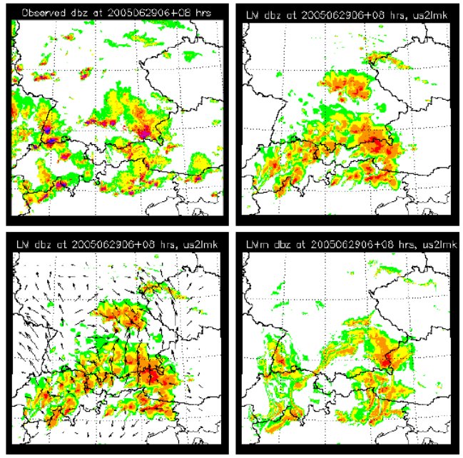
Observed radar reflectivity (top left), forecast one (top right), forecast superimposed with displacement vector field matching the forecast onto the observation (bottom left), and morphed forecast (bottom right). The two components of DAS in forecast space comprise the mean displacement vector length and the root mean square error of morphed forecast and observation (bottom right – top left).

Keil, C. and G. C. Craig (2009): A displacement and amplitude score employing an optical flow technique. Weather and Forecasting, 24, 1297-1308.

