Why when a model resolution is improved do the forecasts often verify worse ?

Martin Goeber & Clive Wilson, Met Office

The apparently worse performance of more realistic-looking and more detailed forecasts compared to smoother, less realistic forecasts is considered from an number of viewpoints. The classic "double penalty" explanation is considered first in both a continuous error measure (RMS) frame and then in a categorical error frame. Finally we caution against relying on RMS alone as one may "hedge" to reduce this by smoothing forecasts (or using lower resolution models) which have unrealistic forecast variance.

Double Penalty (continuous case)

The normal explanation of why higher resolution models can verify worse than smoother lower resolution models is because of the double penalty. At it's simplest this arises when an observed small scale feature is more realistically forecast but is misplaced. The higher resolution model is penalised twice; once for missing the actual feature and again for forecasting it where it isn't. For example, consider a step feature (ie a rain area) of amplitude 1 (a). (It is assumed to be at least 4 grid points wide so that a model may potentially resolve it.) The higher resolution model forecasts the correct amplitude but located at the adjacent area (b), whereas the lower resolution model forecasts a constant of k (0k 1) for both areas (c). The RMS error is lower for the coarser model, even though it has not the correct amplitude or variance unlike the higher resolution forecast.

1
a
1
b
k
c

 | High resolution (b) | Low resolution (c)
Forecast amplitude | (0,1) | k=0 | k=½ | k=1
Error (absolute) | 2*1 | 1 | 2*½ | 1
RMSE | 1 | 1/2 | ½ | 1/2
Forecast variance | ¼ | 0 | 0 | 0
Correlation with observed | -1 | 0 | 0 | 0

Another way of saying this is that if a feature is misplaced by order of its size or more then the double penalty will apply in full. This is especially true of narrow features such as rainbands or convective squall lines etc. However from a value point of view the higher resolution forecast is potentially more useful in that it at least has the correct intensity albeit without the accurate location.

Consider now a less severe misplacement, with a fraction f in common with the "observed" feature. The double penalty contribution to the absolute error is now 2*(1-f)/2, the RMS error is (1-f) and the correlation with the observed is 2f-1. If the common fraction is greater than 3/4 the higher resolution forecasts will have a lower RMS error than the minimum RMS error of a constant low resolution forecast (of 1/2 everywhere). In wave terms this is a phase error of π/4 or less. See below for a discussion of the double penalty in categorical verification.
1
f

A (slightly) more realistic case

The step feature example above illustrates the essential double penalty argument but is rather artificial for continuous fields. A somewhat more realistic idealisation is a long wave cosine representing a larger synoptic scale feature with a short wave pulse superposition, representing a frontal band say. Three forecasts are considered: only the long wave feature is predicted (low resolution model), a completely accurate forecast of the amplitudes of both wave-lengths but displaced (high resolution model) and a forecast in which only the short wave feature is displaced. 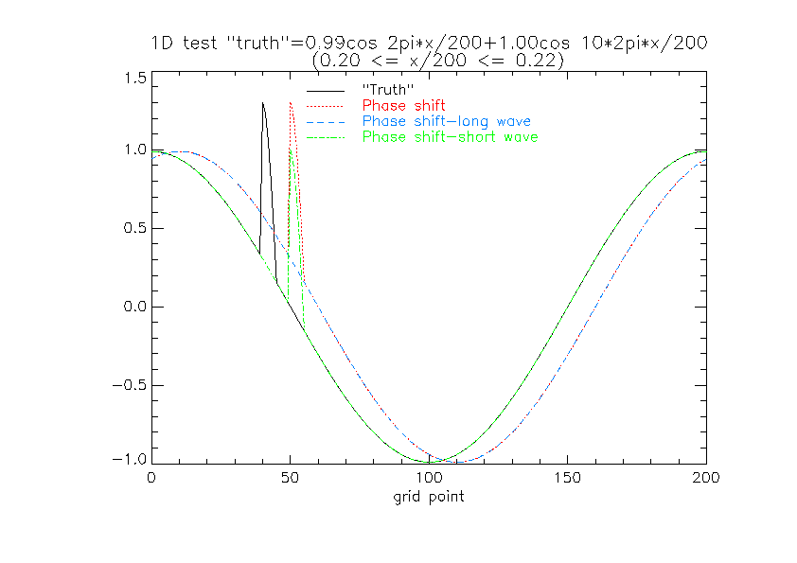 The double penalty affects both the high-resolution forecasts, whereas only a single penalty (in addition to the long wave phase error) applies to the (displaced) long wave forecast.

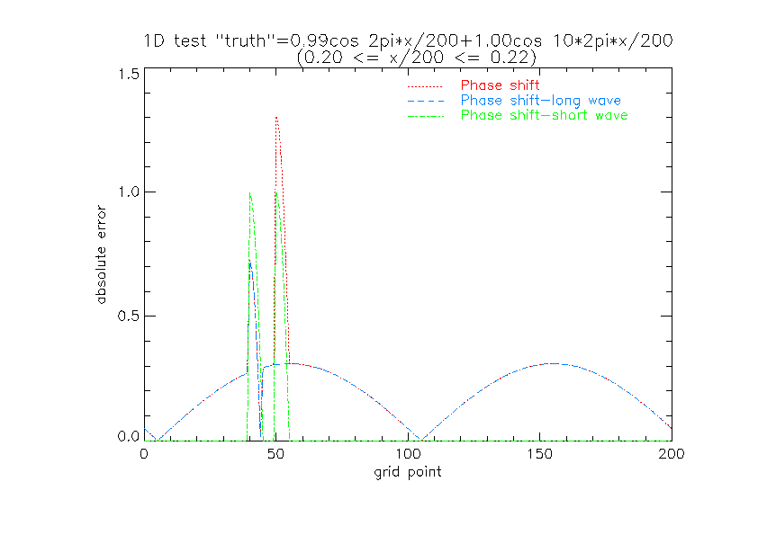

The RMS errors for displacements greater than ~1/5 short wavelength are smaller for the low resolution "model" than for the two forecasts which have the short wave feature. It is only for small positional errors that these have smaller rms errors and larger correlation with the "truth".
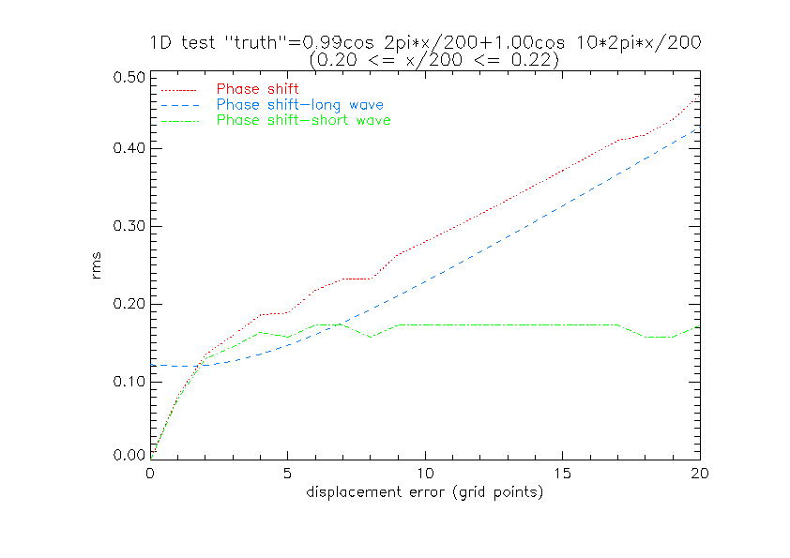This shows that higher resolution models which have the capability of retaining and forecasting sharper and smaller scale features can verify worse (in a pointwise sense) than coarser models which are less well able to resolve such features. If the cause of the phase displacement is a general positional error of the larger scale 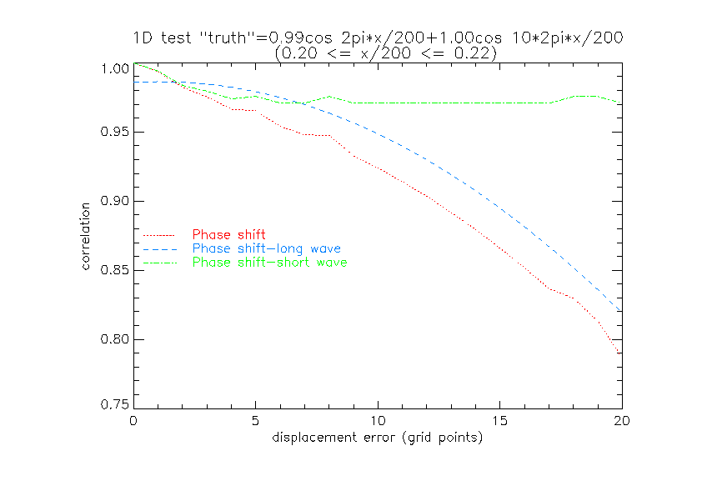structures ( eg a cyclone track/speed error due to an inadequate initial analysis) which also translates the smaller scale feature, the higher resolution model will be rather unjustly judged inaccurate. On the other hand, the better resolution model potentially may have smaller phase errors at larger scales and a better-resolved initial analysis with smaller location errors so that the double penalty is less influential on the overall RMS error. It may also have higher correlation than the smoother low resolution model.
An alternative to the tradition RMS error , especially when assessing rainfall features is to use some sort of coherent pattern based scheme, decomposing the error into amplitude, displacement and structural error ( eg Hoffmann et al , 1995, Ebert and McBride, 2000).

Double penalty (categorical case)

When models resolve ever smaller scales, e.g. mesoscale precipitation variability instead of 'big blobs of rain', the risk of a double penalty rises as will be illustrated with an extreme example in the following.

Fig. a) shows the observed rain in a grid box (e.g. upscaled gauge obs or radar), fig. b) a forecast from a high resolution model and fig. c) could be a low resolution model forecast or a high resolution forecast which is very smooth (i.e. spreads the rain over a large area, i.e. 4 grid boxes). Note that the total area rainfall is the same in all cases (otherwise the interpretation would be even more complex).
a)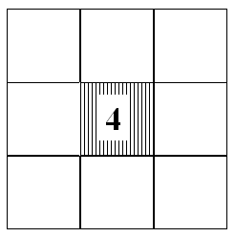 b) 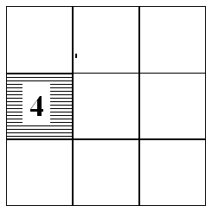
c)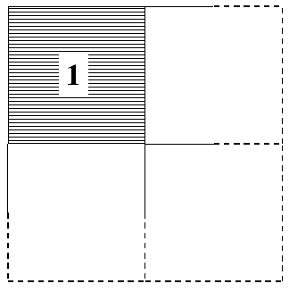

Now, the double penalty means that forecast b) is penalised twice for not getting the rain at exactly the right place (miss) and producing rain at just the wrong place (false alarm), whereas forecast c) makes one hit and is only once penalised for issuing false alarms (albeit 3 of them). Various measures for this extreme example are summarised in the table below.

measure | Case b)  threshold 1mm (4mm) | Case c)  threshold 1mm (4mm)
# hits | 0 (0) | 1 (0)
# false alarms | 1 (1) | 3 (0)
# misses | 1 (1) | 0 (1)
# correct rejections | 7 (7) | 5 (8)
Frequency bias | 1 (1) | 4 (0)
Hit rate | 0 | 1 (0)
False alarm rate | 0.125 (0.125) | 0.375 (0)
ETS | -0.06 (-0.06) | 0.16 (0)

This shows that there is not simply a double penalty but that case b) and c) have different advantages and disadvantages. Most clearly, case c) seems to have higher skill according to hit rate and ETS and false alarm rate for the 4mm threshold, but less accuracy according to the false alarm rate for the lower threshold. On the other hand, case c) has a terrible bias in both cases and additionally the bias switches orientation from lower to higher threshold. Thus it is clear that one has to look at more than one measure, indeed at least at two independent ones because the 2*2 contingency table has 2 degrees of freedom when the observations are given.

So, what is better? It depends.

From a model development point of view case b) is probably better since the frequency distribution of rain of the forecast is perfect and thus the energetics of the model could be more 'healthy' as in case c) where there is much too much light rain and no heavy rain. This might have all sorts of causes (too much cloud, weak widespread ascent, too much diffusion, etc.) and lead to all sorts of effects (too widespread latent heat release, widespread wet soil, etc.).

From a customer point of view it depends again, for instance some customers might complain in case c) to have no indication of heavy rain at all, whereas they might be reasonably happy with case b) if they put up with small placement errors. More importantly, it depends on the cost/loss ratio of the specific customer. If the loss is high for a customer who misses an event case c) is better for light rain, if the costs are high for a customer who experiences a false alarm case b) is better for light rain but case c) is better for heavy rain.

There is another statistical argument in favour of case b) which is that this model has just missed the event spatially in this weather situation, but it has the potential to develop heavy rain and might thus hit in another situation, whereas the model in case c) might never be able to produce heavy rain and thus will always miss heavy events

Why considering RMS error alone may be misleading (or how to "cheat" with smoother forecasts )

The changes to RMS errors in going from a very smooth model to a model with a more realistic variability can be better understood by using the mean square error (MSE) and decomposing as in Murphy and Epstein (1989). Here we compare a forecast f against a reference r (either a model analysis or observation) using the MSE (E'2):
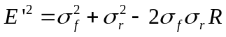
where the RMS error (E') is defined by:
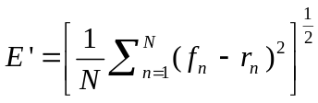

and the second and third terms are the forecast and analysed (reference) variances, and the final term is the covariance of forecast and analysed (reference) fields. This covariance term has been written as the product of forecast and analysed standard deviations and the correlation coefficient R between forecast and analysis fields (note: this is not the anomaly correlation, but the standard spearman correlation).
This expression does not include the bias or mean error. This can be added to the above expression to give us the total MSE for a forecast:
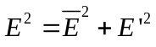
The statistical averaging operator above can be either over a spatial domain (e.g. NH, SH) at a given time, at a point but measured over the time domain, or both spatially and temporally averaged.
For a perfect forecasting system we require that the forecast variance equals the analysed/observed variance and the bias is zero. The correlation/ covariance term measures the phase error in the forecast patterns irrespective of the errors in forecast amplitude. If we neglect the bias then the error variance (random component) has a simple geometric interpretation shown below (taken from Taylor (2001), p. 7184).
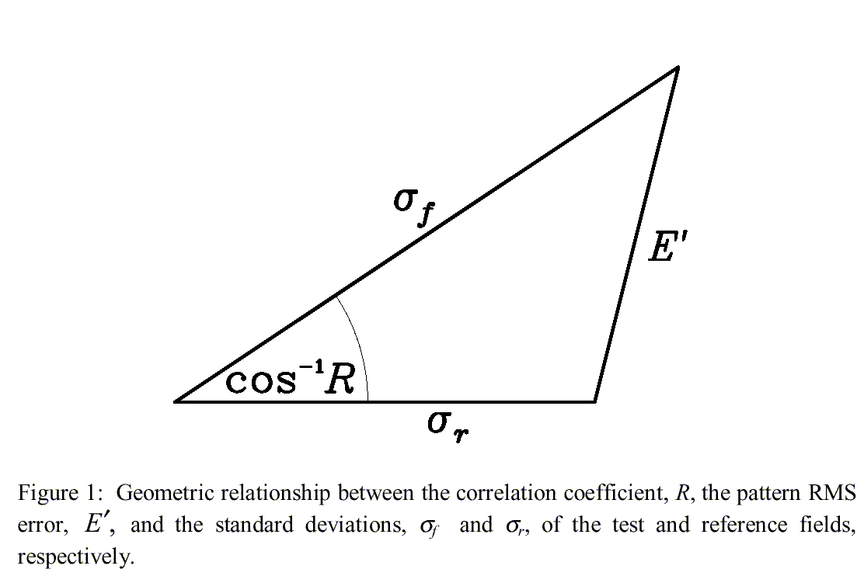

We can decrease the RMS error (E') by:

- Reducing the forecast standard deviation so that it equals the analysed (reference) standard deviation (line 1 in figure below).
- Increasing the correlation coefficient (R) (i.e. decreasing cos⁻¹R)

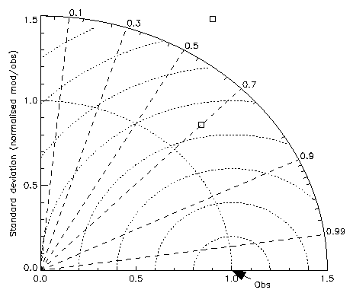
R=const.
E'=const
1
2
Figure 1: 'Taylor'-diagram (2001) showing lines of constant correlation, arcs of constant E' and arcs of constant standard deviation. Case 1 has same correlation R as forecasted, but observed standard deviation; case 2 has minimum E' .
However a simple examination of the diagram shows that a minimum in RMSE (for a given R) is actually achieved by a line 2 (see above) which is the perpendicular from the line of constant correlation to the analysed standard deviation. For this scenario the forecast standard deviation is less than the analysed standard deviation. The RMS error can in fact be reduced for the range of forecast standard deviations between the intersections of lines 1 and 2 with forecast s.deviation line. This is the process of "hedging" where we can improve our score, RMS error in this case, by smoothing our forecast. If we continue to reduce the forecast standard deviation beyond that given by line 2 we see that the RMS error increases again. It is also interesting that for large correlations (small angles cos-1R), the scope for hedging is much reduced as lines 1 and 2 become very close together.
Mathematically, the above discussion can be summarised by minimising E' with respect to the forecasted standard deviation:

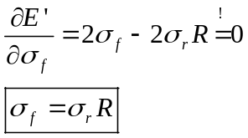

Thus, if one looks solely at the RMS error, then the optimal strategy is to reduce the variability of the forecast relative to the observations by
(1-R)*100%.

Acknowledgements
We wish to thank Sean Milton and Ian Culverwell for many helpful discussions and contributions.

Recommendations

- Investigate a multi-dimensional problem with many (independent!) measures: double penalty is a problem for the "one eyed".
- Start verification and comparison of models at a common, coarser scale (e.g. 4 times grid size of the coarsest model), and be aware of the double penalty when going down to higher resolution.
- Verify the frequency distribution of values in a larger area (e.g. a catchment), i.e. for instance the median or the 95% quintile.
- Verify rain areas according to their amplitude, displacement and shape error (Ebert and McBride, 2000).
- Be clear about the goal of the forecast and specifically about the cost/loss ratio of the customer. A smoother model might pay in the short run, but it might lead to a flawed development (energetics etc.) of the model in the long run. As a compromise, build ‘physically’ the best model and hedge the output during post-processing towards customer desires.

References:

Ebert, E.E. and J.L. McBride, 2000: Verification of precipitation in weather systems: Determination of systematic errors. J. Hydrology,
239, 179-202.

Hoffman, R.N., Z. Liu, J.-F. Louis, and C. Grassoti, 1995: Distortion Representation of Forecast Errors. Mon.Wea.Rev., 123, 2758-2770.

Murphy, A.H. and Epstein, E.S., 1989: Skill scores and correlation coefficients in model verification. Mon.Wea.Rev., 117, 572-581.

Taylor, K.E., 2001: Summarizing multiple aspects of model performance in a single diagram. J. Geophys.Res., D7, 106, 7183-7192.

