1.
db["ListingsAndReviews"].find({
beds: { $gte: 4 },
"address.country": "Portugal",
price: { $lt: 75 }
})
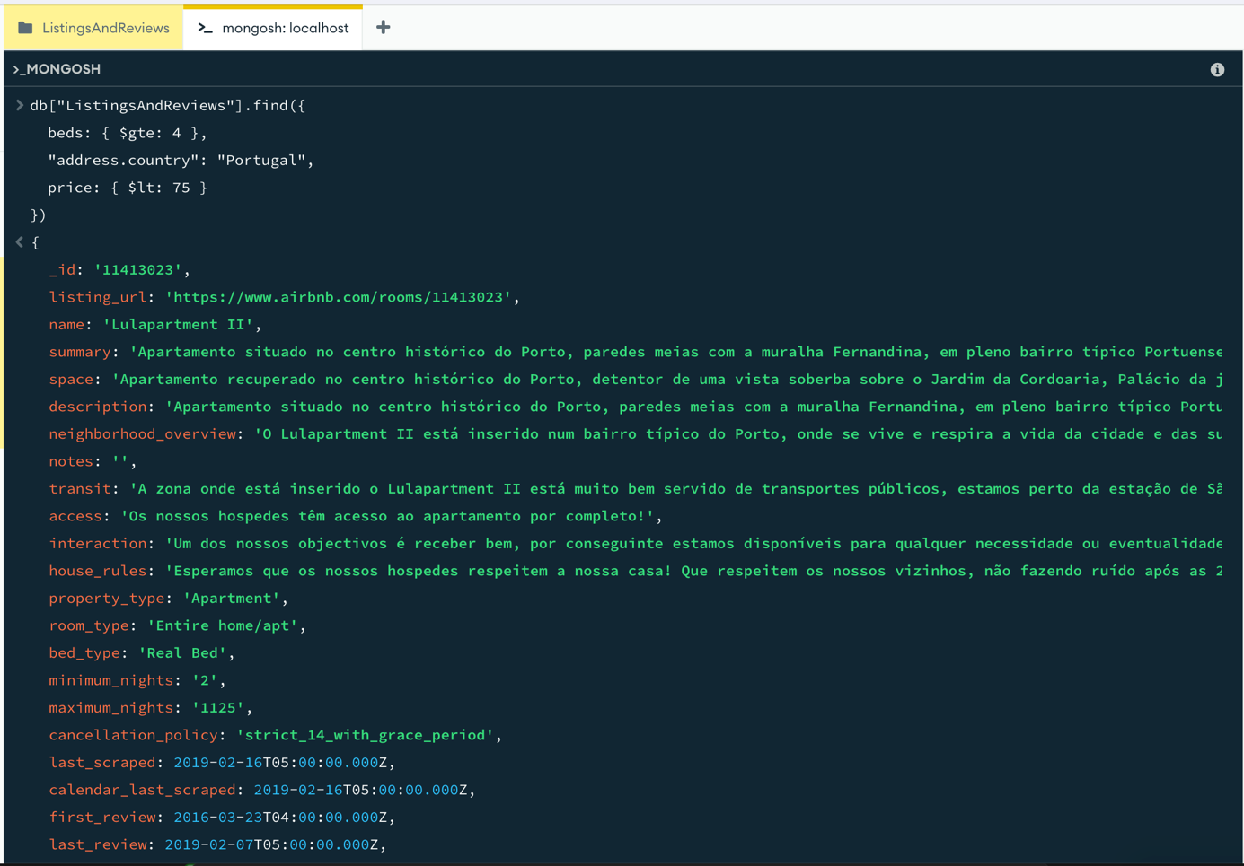
2.
db["ListingsAndReviews"].find(
{ "review_scores.review_scores_cleanliness": { $gte: 9 } },
{ name: 1, summary: 1, "address.country": 1, price: 1, _id: 0 }
).sort({ price: 1 })
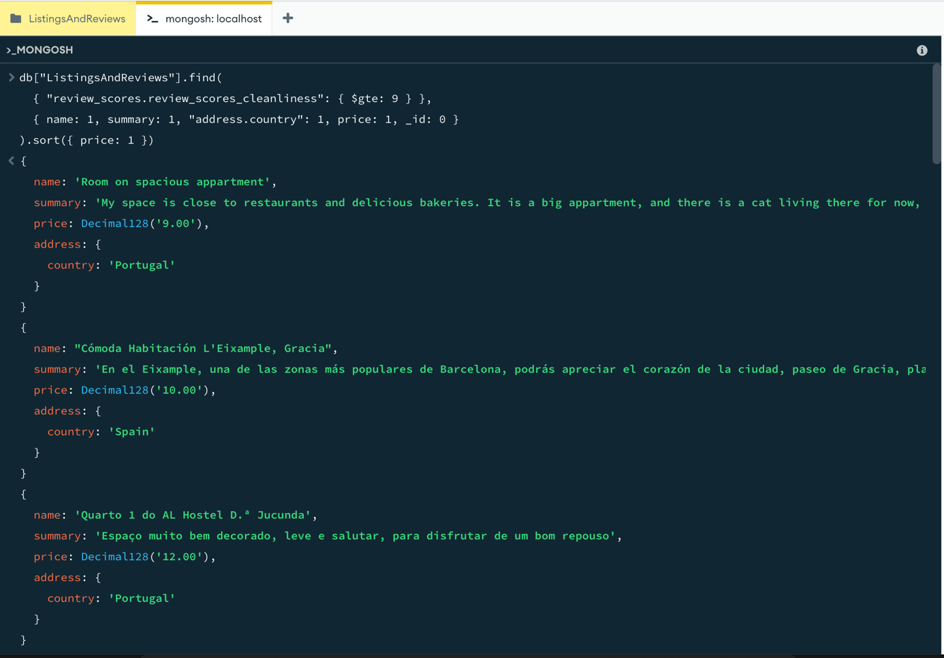

3.
db["ListingsAndReviews"].updateOne(
{ description: /mountain view/i },
{ $set: { price: 90 } })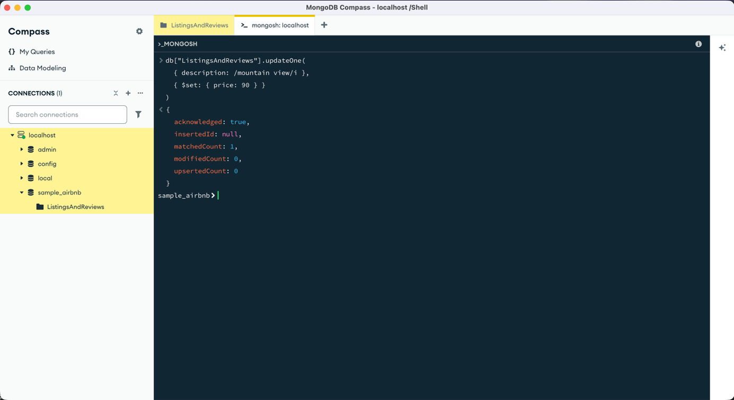
4.
db["ListingsAndReviews"].updateMany(
{ country: "Turkey" },
{ $set: { isactive: false } }
)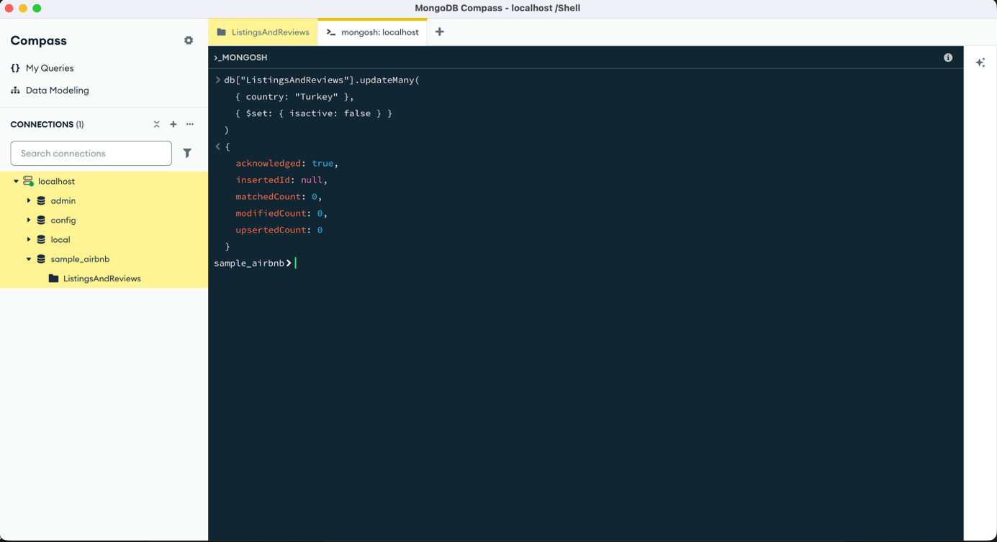
5.
db.AirBnB.deleteMany(
{ review_scores_rating: { $lt: 21 } }
)