# 6.3 卷积神经网络识别fashion-MNIST

import numpy as np

import pandas as pd

import matplotlib.pyplot as plt

import time

import copy

import torch

from torch import nn

import torch.nn.functional as F

import torch.optim as optim

import torchvision

import torch.utils.data as Data

from torchvision import transforms

import hiddenlayer as hl

from torchvision.datasets import FashionMNIST

from sklearn.metrics import accuracy_score, confusion_matrix

import seaborn as sns

train_data = FashionMNIST(

root="./deep Learning/FashionMNIST", # 数据的路径

train=True, # 只使用训练数据集

# 将数据转化为torch使用的张量,取汁范围为［0，1］

transform=transforms.ToTensor(),

download=True # 因为数据已经下载过，所以这里不再下载

)

# 定义一个数据加载器

train_loader = Data.DataLoader(

dataset=train_data, # 使用的数据集

batch_size=64, # 批处理样本大小

shuffle=True, # 每次迭代前打乱数据

num_workers=0, # 使用两个进程

)

print('train_loader的batch数量为：', len(train_loader))

# train_loader的batch数量为： 938

# 可视化训练数据集的一个batch的样本来查看图像内容

for step, (b_x, b_y) in enumerate(train_loader):

if step > 0:

break

# 输出训练图像的尺寸和标签的尺寸，都是torch格式的数据

print(b_x.shape)

print(b_y.shape)

# torch.Size([64, 1, 28, 28])

# torch.Size([64])

# 显示一个batch的图像

batch_x = b_x.squeeze().numpy()

batch_y = b_y.numpy()

class_label = train_data.classes

class_label[0] = 'T-shirt'

plt.figure(figsize=(12, 5))

for ii in np.arange(len(batch_y)):

plt.subplot(4, 16, ii + 1)

plt.imshow(batch_x[ii], cmap='gray')

plt.title(class_label[batch_y[ii]], fontsize=9)

plt.axis('off')

plt.subplots_adjust(wspace=0.05)

plt.show() # 课本缺了一行show

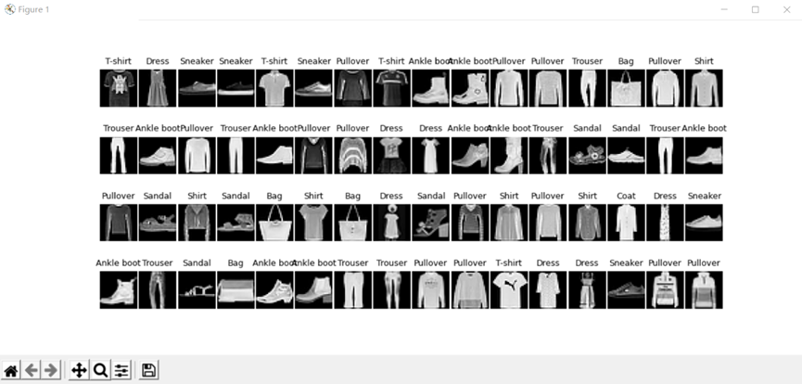

test_data = FashionMNIST(root="./deep Learning/FashionMNIST", train=False)

test_data_x = test_data.data.type(torch.FloatTensor) / 255.0

test_data_x = torch.unsqueeze(test_data_x, dim=1)

test_data_y = test_data.targets

print(test_data_x.shape)

print(test_data_y.shape)

# torch.Size([10000, 1, 28, 28])

# torch.Size([10000])

class MyConvNet(nn.Module):

def __init__(self):

super(MyConvNet, self).__init__()

self.conv1 = nn.Sequential(

nn.Conv2d(

in_channels=1,

out_channels=16,

kernel_size=3,

stride=1,

padding=1

),

nn.ReLU(),

nn.AvgPool2d(

kernel_size=2,

stride=2,

),

)

self.conv2 = nn.Sequential(

nn.Conv2d(16, 32, 3, 1, 0),

nn.ReLU(),

nn.AvgPool2d(2, 2)

)

self.classifier = nn.Sequential(

nn.Linear(32 * 6 * 6, 256),

# nn.Linear(32*7*7,128),

nn.ReLU(),

nn.Linear(256, 128),

nn.ReLU(),

nn.Linear(128, 10)

)

def forward(self, x):

x = self.conv1(x)

x = self.conv2(x)

x = x.view(x.size(0), -1) # 展开卷积层

output = self.classifier(x)

return output

myconvnet = MyConvNet()

print(myconvnet)

# MyConvNet(

# (conv1): Sequential(

# (0): Conv2d(1, 16, kernel_size=(3, 3), stride=(1, 1), padding=(1, 1))

# (1): ReLU()

# (2): AvgPool2d(kernel_size=2, stride=2, padding=0)

# )

# (conv2): Sequential(

# (0): Conv2d(16, 32, kernel_size=(3, 3), stride=(1, 1))

# (1): ReLU()

# (2): AvgPool2d(kernel_size=2, stride=2, padding=0)

# )

# (classifier): Sequential(

# (0): Linear(in_features=1152, out_features=256, bias=True)

# (1): ReLU()

# (2): Linear(in_features=256, out_features=128, bias=True)

# (3): ReLU()

# (4): Linear(in_features=128, out_features=10, bias=True)

# )

# )

def train_model(model, traindataloader, train_rate, criterion, optimizer, num_epochs):

batch_num = len(traindataloader)

train_batch_num = round(train_rate * batch_num)

best_model_wts = copy.deepcopy(model.state_dict())

best_acc = 0.0

train_loss_all = []

train_acc_all = []

val_loss_all = []

val_acc_all = []

since = time.time()

for epoch in range(num_epochs):

print('Epoch {}/{}'.format(epoch, num_epochs - 1))

print('-' * 10)

train_loss = 0.0

train_corrects = 0

train_num = 0

val_loss = 0

val_corrects = 0

val_num = 0

for step, (b_x, b_y) in enumerate(traindataloader):

if step < train_batch_num:

model.train()

output = model(b_x)

pre_lab = torch.argmax(output, 1)

loss = criterion(output, b_y)

optimizer.zero_grad()

loss.backward()

optimizer.step()

train_loss += loss.item() * b_x.size(0)

train_corrects += torch.sum(pre_lab == b_y.data)

train_num += b_x.size(0)

else:

model.eval()

output = model(b_x)

pre_lab = torch.argmax(output, 1)

loss = criterion(output, b_y)

val_loss += loss.item() * b_x.size(0)

val_corrects += torch.sum(pre_lab == b_y.data)

val_num += b_x.size(0)

train_loss_all.append(train_loss / train_num)

train_acc_all.append(train_corrects.double().item() / train_num)

val_loss_all.append(val_loss / val_num)

val_acc_all.append(val_corrects.double().item() / val_num)

print('{} Train Loss: {:.4f}, Train Acc: {:.4f},'.format(epoch, train_loss_all[-1], train_acc_all[-1]))

print('{} Val Loss: {:.4f} , Val Acc: {:.4f}'.format(epoch, val_loss_all[-1], val_acc_all[-1]))

if val_acc_all[-1] > best_acc:

best_acc = val_acc_all[-1]

best_model_wts = copy.deepcopy(model.state_dict())

print('save model')

time_use = time.time() - since

print('Train and val complete in {:.0f}m {:.0f}s'.format(time_use // 60, time_use % 60))

model.load_state_dict(best_model_wts)

train_process = pd.DataFrame(data={'epoch': range(num_epochs),

'train_loss': train_loss_all, 'train_acc': train_acc_all,

'val_loss': val_loss_all, 'val_acc': val_acc_all})

return model, train_process

criterion = nn.CrossEntropyLoss()

optimizer = optim.Adam(myconvnet.parameters(), lr=0.0003)

myconvnet, train_process = train_model(myconvnet, train_loader, 0.8, criterion, optimizer, num_epochs=25)

plt.figure(figsize=(12, 4))

# 绘制损失曲线

plt.subplot(1, 2, 1)

plt.plot(train_process['epoch'], train_process['train_loss'], 'ro-', label='Train loss')

plt.plot(train_process['epoch'], train_process['val_loss'], 'bs-', label='Val loss')

plt.legend()

plt.xlabel('Epoch')

plt.ylabel('Loss')

# 绘制准确率曲线

plt.subplot(1, 2, 2)

plt.plot(train_process['epoch'], train_process['train_acc'], 'ro-', label='Train accuracy')

plt.plot(train_process['epoch'], train_process['val_acc'], 'bs-', label='Val accuracy')

plt.xlabel('Epoch')

plt.ylabel('Accuracy')

plt.legend()

# 显示图表

plt.tight_layout() # 可选，用于调整子图布局

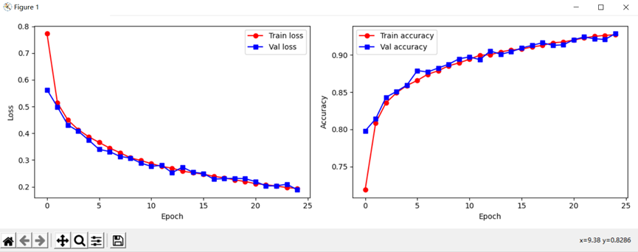plt.show()

# plt.figure(figsize=(12, 4))

# plt.subplot(1, 2, 1)

# plt.plot(train_process.epoch, train_process.train_loss_all, 'ro-', label='Train loss')

# plt.plot(train_process.epoch, train_process.val_loss_all, 'bs-', label='Val loss')

# plt.legend()

# plt.xlabel('epoch')

# plt.ylabel('Loss')

# plt.subplot(1, 2, 2)

# plt.plot(train_process.epoch, train_process.train_acc_all, 'ro-', label='Train acc')

# plt.plot(train_process.epoch, train_process.val_acc_all, 'bs-', label='Val acc')

# plt.xlabel('epoch')

# plt.ylabel('acc')

# plt.legend()

# plt.show()

myconvnet.eval()

output = myconvnet(test_data_x)

pre_lab = torch.argmax(output, 1)

acc = accuracy_score(test_data_y, pre_lab)

print('在测试集的精度', acc)

conf_mat = confusion_matrix(test_data_y, pre_lab)

df_cm = pd.DataFrame(conf_mat, index=class_label, columns=class_label)

heatmap = sns.heatmap(df_cm, annot=True, fmt='d', cmap='YlGnBu')

heatmap.yaxis.set_ticklabels(heatmap.yaxis.get_ticklabels(), rotation=0, ha='right')

heatmap.xaxis.set_ticklabels(heatmap.xaxis.get_ticklabels(), rotation=45, ha='right')

plt.ylabel('True label')

plt.xlabel('Predicted label')

plt.show()

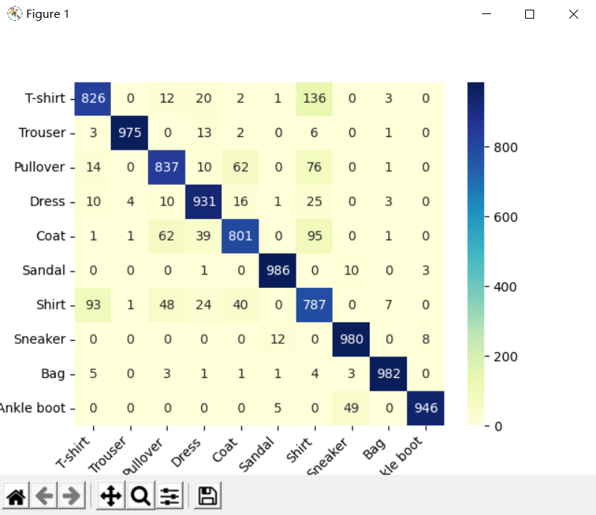

# Epoch 24/24

# ----------

# 24 Train Loss: 0.1940, Train Acc: 0.9273,

# 24 Val Loss: 0.1891 , Val Acc: 0.9288

# save model

# Train and val complete in 28m 33s

# 在测试集的精度 0.9051

# Traceback (most recent call last):

# File "D:\pythoncode\learn\a\deep_learning6.3.py", line 208, in <module>

# plt.plot(train_process.epoch, train_process.train_loss_all, 'ro-', label='train_loss')

# File "D:\anaconda3\envs\deeplearning\lib\site-packages\pandas\core\generic.py", line 5141, in __getattr__

# return object.__getattribute__(self, name)

# AttributeError: 'DataFrame' object has no attribute 'train_loss_all'

# plt.plot(train_process.epoch, train_process.train_loss_all, 'ro-', label='Train loss')

# plt.plot(train_process.epoch, train_process.val_loss_all, 'bs-', label='Val loss')

# 把上面的代码换成下面的这种，不知道课本当时为什么这么写。。。

# plt.plot(train_process['epoch'], train_process['train_acc'], 'ro-', label='Train accuracy')

# plt.plot(train_process['epoch'], train_process['val_acc'], 'bs-', label='Val accuracy')

# 6.3.4 空洞卷积神经网络的搭建

import numpy as np

import pandas as pd

import matplotlib.pyplot as plt

import time

import copy

from sklearn.metrics import accuracy_score, confusion_matrix

import seaborn as sns

import torch

from torch import nn

import torch.nn.functional as F

import torch.optim as optim

import torchvision

import torch.utils.data as Data

from torchvision import transforms

import hiddenlayer as hl

from torchvision.datasets import FashionMNIST

from sklearn.metrics import accuracy_score

train_data = FashionMNIST(

root="./deep Learning/FashionMNIST", # 数据的路径

train=True, # 只使用训练数据集

# 将数据转化为torch使用的张量,取汁范围为［0，1］

transform=transforms.ToTensor(),

download=True # 因为数据已经下载过，所以这里不再下载

)

test_data = FashionMNIST(root="./deep Learning/FashionMNIST", train=False)

test_data_x = test_data.data.type(torch.FloatTensor) / 255.0

test_data_x = torch.unsqueeze(test_data_x, dim=1)

test_data_y = test_data.targets

class_label = train_data.classes

class_label[0] = 'T-shirt'

train_loader = Data.DataLoader(

dataset=train_data, # 使用的数据集

batch_size=64, # 批处理样本大小

shuffle=True, # 每次迭代前打乱数据

num_workers=0, # 使用两个进程

)

class MyConvdilaNet(nn.Module):

def __init__(self):

super(MyConvdilaNet, self).__init__()

self.conv1 = nn.Sequential(

nn.Conv2d(

in_channels=1,

out_channels=16,

kernel_size=3,

stride=1,

padding=1,

dilation=2

),

nn.ReLU(),

nn.AvgPool2d(

kernel_size=2,

stride=2,

),

)

self.conv2 = nn.Sequential(

nn.Conv2d(16, 32, 3, 1, 0, dilation=2),

nn.ReLU(),

nn.AvgPool2d(2, 2)

)

self.classifier = nn.Sequential(

nn.Linear(32 * 4 * 4, 256),

# nn.Linear(32*7*7,128),

nn.ReLU(),

nn.Linear(256, 128),

nn.ReLU(),

nn.Linear(128, 10)

)

def forward(self, x):

x = self.conv1(x)

x = self.conv2(x)

x = x.view(x.size(0), -1) # 展开卷积层

output = self.classifier(x)

return output

def train_model(model, traindataloader, train_rate, criterion, optimizer, num_epochs):

batch_num = len(traindataloader)

train_batch_num = round(train_rate * batch_num)

best_model_wts = copy.deepcopy(model.state_dict())

best_acc = 0.0

train_loss_all = []

train_acc_all = []

val_loss_all = []

val_acc_all = []

since = time.time()

for epoch in range(num_epochs):

print('Epoch {}/{}'.format(epoch, num_epochs - 1))

print('-' * 10)

train_loss = 0.0

train_corrects = 0

train_num = 0

val_loss = 0

val_corrects = 0

val_num = 0

for step, (b_x, b_y) in enumerate(traindataloader):

if step < train_batch_num:

model.train()

output = model(b_x)

pre_lab = torch.argmax(output, 1)

loss = criterion(output, b_y)

optimizer.zero_grad()

loss.backward()

optimizer.step()

train_loss += loss.item() * b_x.size(0)

train_corrects += torch.sum(pre_lab == b_y.data)

train_num += b_x.size(0)

else:

model.eval()

output = model(b_x)

pre_lab = torch.argmax(output, 1)

loss = criterion(output, b_y)

val_loss += loss.item() * b_x.size(0)

val_corrects += torch.sum(pre_lab == b_y.data)

val_num += b_x.size(0)

train_loss_all.append(train_loss / train_num)

train_acc_all.append(train_corrects.double().item() / train_num)

val_loss_all.append(val_loss / val_num)

val_acc_all.append(val_corrects.double().item() / val_num)

print('{} Train Loss: {:.4f}, Train Acc: {:.4f},'.format(epoch, train_loss_all[-1], train_acc_all[-1]))

print('{} Val Loss: {:.4f} , Val Acc: {:.4f}'.format(epoch, val_loss_all[-1], val_acc_all[-1]))

if val_acc_all[-1] > best_acc:

best_acc = val_acc_all[-1]

best_model_wts = copy.deepcopy(model.state_dict())

print('save model')

time_use = time.time() - since

print('Train and val complete in {:.0f}m {:.0f}s'.format(time_use // 60, time_use % 60))

model.load_state_dict(best_model_wts)

train_process = pd.DataFrame(data={'epoch': range(num_epochs),

'train_loss': train_loss_all, 'train_acc': train_acc_all,

'val_loss': val_loss_all, 'val_acc': val_acc_all})

return model, train_process

myconvdilanet = MyConvdilaNet()

print(myconvdilanet)

criterion = nn.CrossEntropyLoss()

optimizer = optim.Adam(myconvdilanet.parameters(), lr=0.0003)

myconvdilanet, train_process = train_model(myconvdilanet, train_loader, 0.8, criterion, optimizer, num_epochs=25)

plt.figure(figsize=(12, 4))

# 绘制损失曲线

plt.subplot(1, 2, 1)

plt.plot(train_process['epoch'], train_process['train_loss'], 'ro-', label='Train loss')

plt.plot(train_process['epoch'], train_process['val_loss'], 'bs-', label='Val loss')

plt.legend()

plt.xlabel('Epoch')

plt.ylabel('Loss')

# 绘制准确率曲线

plt.subplot(1, 2, 2)

plt.plot(train_process['epoch'], train_process['train_acc'], 'ro-', label='Train accuracy')

plt.plot(train_process['epoch'], train_process['val_acc'], 'bs-', label='Val accuracy')

plt.xlabel('Epoch')

plt.ylabel('Accuracy')

plt.legend()

# 显示图表

plt.tight_layout() # 可选，用于调整子图布局

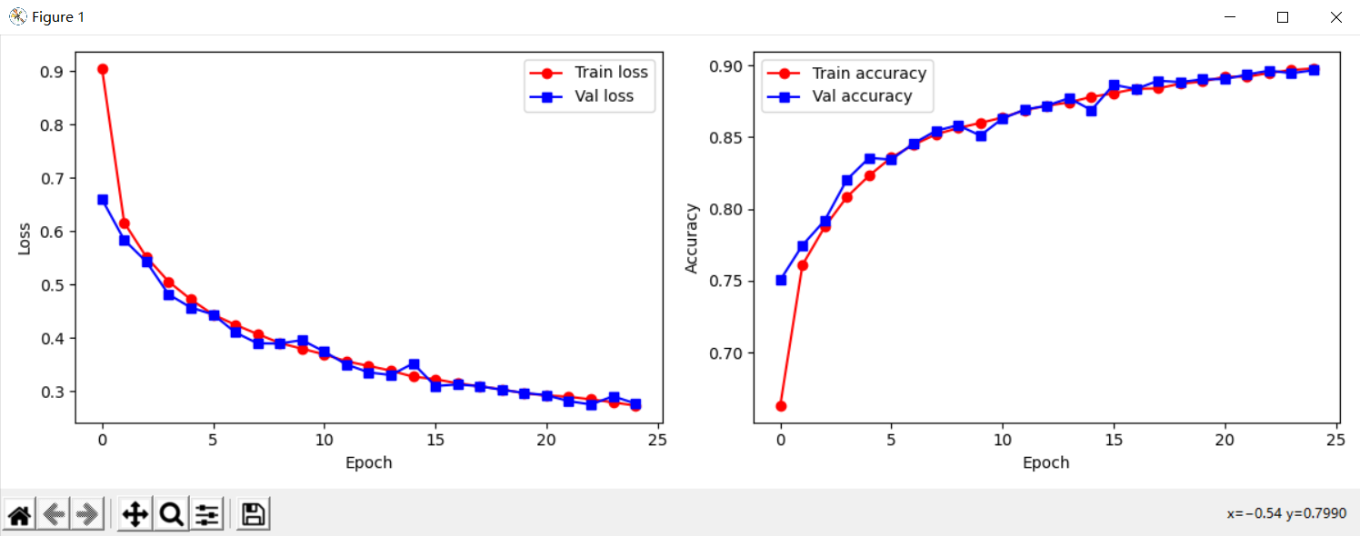plt.show()

myconvdilanet.eval()

output = myconvdilanet(test_data_x)

pre_lab = torch.argmax(output, 1)

acc = accuracy_score(test_data_y, pre_lab)

print('在测试集的精度', acc)

conf_mat = confusion_matrix(test_data_y, pre_lab)

df_cm = pd.DataFrame(conf_mat, index=class_label, columns=class_label)

heatmap = sns.heatmap(df_cm, annot=True, fmt='d', cmap='YlGnBu')

heatmap.yaxis.set_ticklabels(heatmap.yaxis.get_ticklabels(), rotation=0, ha='right')

heatmap.xaxis.set_ticklabels(heatmap.xaxis.get_ticklabels(), rotation=45, ha='right')

plt.ylabel('True label')

plt.xlabel('Predicted label')

plt.show()

# Epoch 24/24

# ----------

# 24 Train Loss: 0.2729, Train Acc: 0.8980,

# 24 Val Loss: 0.2767 , Val Acc: 0.8967

# save model

# Train and val complete in 21m 49s

# 在测试集的精度 0.8826

