# 8.3 基于卷积自编码的图像去噪

import numpy as np

import pandas as pd

import matplotlib.pyplot as plt

from mpl_toolkits.mplot3d import Axes3D

import hiddenlayer as hl

from sklearn.model_selection import train_test_split

from skimage.util import random_noise

from skimage.measure import compare_psnr

import torch

from torch import nn

import torch.nn.functional as F

import torch.utils.data as Data

import torch.optim as optim

from torchvision import transforms

from torchvision.datasets import STL10

from torchvision.utils import make_grid

from tqdm import tqdm

device = torch.device("cuda" if torch.cuda.is_available() else "cpu") # device的定义

print("使用设备：", device)

# 定义一个将bin文件处理为图像数据的函数

def read_image(data_path):

with open(data_path, 'rb') as f:

data1 = np.fromfile(f, dtype=np.uint8)

# 图像[数量，通道，宽，高]

images = np.reshape(data1, (-1, 3, 96, 96))

# 图像转化为RGB的形式，方便使用matplotlib进行可视化

images = np.transpose(images, (0, 3, 2, 1))

# 输出的图像取值在0～1之间

return images / 255.0

# 读取训练数据集,5000张96*96*3的图像

data_path = "deep Learning/STL10/train_X.bin"

images = read_image(data_path)

print("images.shape:", images.shape)

# images.shape: (5000, 96, 96, 3)

# 为数据添加高斯噪声

def gaussian_noise(images, sigma):

"""sigma:噪声标准差"""

sigma2 = sigma ** 2 / (255 ** 2) # 噪声方差

images_noisy = np.zeros_like(images)

for ii in range(images.shape[0]):

image = images[ii]

# 使用skimage库中的random_noise函数添加噪声

noise_im = random_noise(image, mode="gaussian", var=sigma2, clip=True)

images_noisy[ii] = noise_im

return images_noisy

images_noise = gaussian_noise(images, 30)

print("images_noise:", images_noise.min(), "~", images_noise.max())

# images_noise: 0.0 ~ 1.0

# 可视化其中的部分图像

# 不带噪声的图像

plt.figure(figsize=(8, 4))

for ii in np.arange(32):

plt.subplot(4, 8, ii + 1)

plt.imshow(images[ii, ...])

plt.axis("off")

plt.show()

# 带噪声的图像

plt.figure(figsize=(8, 4))

for ii in np.arange(32):

plt.subplot(4, 8, ii + 1)

plt.imshow(images_noise[ii, ...])

plt.axis("off")

plt.show()

# 数据准备为Pytorch可用的形式

# 转化为［样本，通道，高，宽］的数据形式

data_Y = np.transpose(images, (0, 3, 2, 1))

data_X = np.transpose(images_noise, (0, 3, 2, 1))

# 将数据集切分为训练集和验证集

X_train, X_val, y_train, y_val = train_test_split(

data_X, data_Y, test_size=0.2, random_state=123)

# 将图像数据转化为向量数据

X_train = torch.tensor(X_train, dtype=torch.float32)

y_train = torch.tensor(y_train, dtype=torch.float32)

X_val = torch.tensor(X_val, dtype=torch.float32)

y_val = torch.tensor(y_val, dtype=torch.float32)

# 将X和Y转化为数据集合

train_data = Data.TensorDataset(X_train, y_train)

val_data = Data.TensorDataset(X_val, y_val)

print("X_train.shape:", X_train.shape)

print("y_train.shape:", y_train.shape)

print("X_val.shape:", X_val.shape)

print("y_val.shape:", y_val.shape)

# X_train.shape: torch.Size([4000, 3, 96, 96])

# y_train.shape: torch.Size([4000, 3, 96, 96])

# X_val.shape: torch.Size([1000, 3, 96, 96])

# y_val.shape: torch.Size([1000, 3, 96, 96])

# 定义一个数据加载器

train_loader = Data.DataLoader(

dataset=train_data, # 使用的数据集

batch_size=32, # 批处理样本大小

shuffle=True, # 每次迭代前打乱数据

num_workers=0, # 使用4个进程

)

# 定义一个数据加载器

val_loader = Data.DataLoader(

dataset=val_data, # 使用的数据集

batch_size=32, # 批处理样本大小

shuffle=True, # 每次迭代前打乱数据

num_workers=0, # 使用4个进程

)

for step, (b_x, b_y) in enumerate(train_loader):

if step > 0:

break

# 输出训练图像的尺寸和标签的尺寸

print(b_x.shape)

print(b_y.shape)

# torch.Size([32, 3, 96, 96])

# torch.Size([32, 3, 96, 96])

class DenoiseAutoEncoder(nn.Module):

def __init__(self):

super(DenoiseAutoEncoder, self).__init__()

# 定义Encoder

self.Encoder = nn.Sequential(

nn.Conv2d(in_channels=3, out_channels=64,

kernel_size=3, stride=1, padding=1), # [,64,96,96]

nn.ReLU(),

nn.BatchNorm2d(64),

nn.Conv2d(64, 64, 3, 1, 1), # [,64,96,96]

nn.ReLU(),

nn.BatchNorm2d(64),

nn.Conv2d(64, 64, 3, 1, 1), # [,64,96,96]

nn.ReLU(),

nn.MaxPool2d(2, 2), # [,64,48,48]

nn.BatchNorm2d(64),

nn.Conv2d(64, 128, 3, 1, 1), # [,128,48,48]

nn.ReLU(),

nn.BatchNorm2d(128),

nn.Conv2d(128, 128, 3, 1, 1), # [,128,48,48]

nn.ReLU(),

nn.BatchNorm2d(128),

nn.Conv2d(128, 256, 3, 1, 1), # [,256,48,48]

nn.ReLU(),

nn.MaxPool2d(2, 2), # [,256,24,24]

nn.BatchNorm2d(256),

)

# 定义Decoder

self.Decoder = nn.Sequential(

nn.ConvTranspose2d(256, 128, 3, 1, 1), # [,128,24,24]

nn.ReLU(),

nn.BatchNorm2d(128),

nn.ConvTranspose2d(128, 128, 3, 2, 1, 1), # [,128,48,48]

nn.ReLU(),

nn.BatchNorm2d(128),

nn.ConvTranspose2d(128, 64, 3, 1, 1), # [,64,48,48]

nn.ReLU(),

nn.BatchNorm2d(64),

nn.ConvTranspose2d(64, 32, 3, 1, 1), # [,32,48,48]

nn.ReLU(),

nn.BatchNorm2d(32),

nn.ConvTranspose2d(32, 32, 3, 1, 1), # [,32,48,48]

nn.ConvTranspose2d(32, 16, 3, 2, 1, 1), # [,16,96,96]

nn.ReLU(),

nn.BatchNorm2d(16),

nn.ConvTranspose2d(16, 3, 3, 1, 1), # [,3,96,96]

nn.Sigmoid(),

)

# 定义网络的向前传播路径

def forward(self, x):

encoder = self.Encoder(x)

decoder = self.Decoder(encoder)

return encoder, decoder

# 输出网络结构

DAEmodel = DenoiseAutoEncoder().to(device)

print(DAEmodel)

# DenoiseAutoEncoder(

# (Encoder): Sequential(

# (0): Conv2d(3, 64, kernel_size=(3, 3), stride=(1, 1), padding=(1, 1))

# (1): ReLU()

# (2): BatchNorm2d(64, eps=1e-05, momentum=0.1, affine=True, track_running_stats=True)

# (3): Conv2d(64, 64, kernel_size=(3, 3), stride=(1, 1), padding=(1, 1))

# (4): ReLU()

# (5): BatchNorm2d(64, eps=1e-05, momentum=0.1, affine=True, track_running_stats=True)

# (6): Conv2d(64, 64, kernel_size=(3, 3), stride=(1, 1), padding=(1, 1))

# (7): ReLU()

# (8): MaxPool2d(kernel_size=2, stride=2, padding=0, dilation=1, ceil_mode=False)

# (9): BatchNorm2d(64, eps=1e-05, momentum=0.1, affine=True, track_running_stats=True)

# (10): Conv2d(64, 128, kernel_size=(3, 3), stride=(1, 1), padding=(1, 1))

# (11): ReLU()

# (12): BatchNorm2d(128, eps=1e-05, momentum=0.1, affine=True, track_running_stats=True)

# (13): Conv2d(128, 128, kernel_size=(3, 3), stride=(1, 1), padding=(1, 1))

# (14): ReLU()

# (15): BatchNorm2d(128, eps=1e-05, momentum=0.1, affine=True, track_running_stats=True)

# (16): Conv2d(128, 256, kernel_size=(3, 3), stride=(1, 1), padding=(1, 1))

# (17): ReLU()

# (18): MaxPool2d(kernel_size=2, stride=2, padding=0, dilation=1, ceil_mode=False)

# (19): BatchNorm2d(256, eps=1e-05, momentum=0.1, affine=True, track_running_stats=True)

# )

# (Decoder): Sequential(

# (0): ConvTranspose2d(256, 128, kernel_size=(3, 3), stride=(1, 1), padding=(1, 1))

# (1): ReLU()

# (2): BatchNorm2d(128, eps=1e-05, momentum=0.1, affine=True, track_running_stats=True)

# (3): ConvTranspose2d(128, 128, kernel_size=(3, 3), stride=(2, 2), padding=(1, 1), output_padding=(1, 1))

# (4): ReLU()

# (5): BatchNorm2d(128, eps=1e-05, momentum=0.1, affine=True, track_running_stats=True)

# (6): ConvTranspose2d(128, 64, kernel_size=(3, 3), stride=(1, 1), padding=(1, 1))

# (7): ReLU()

# (8): BatchNorm2d(64, eps=1e-05, momentum=0.1, affine=True, track_running_stats=True)

# (9): ConvTranspose2d(64, 32, kernel_size=(3, 3), stride=(1, 1), padding=(1, 1))

# (10): ReLU()

# (11): BatchNorm2d(32, eps=1e-05, momentum=0.1, affine=True, track_running_stats=True)

# (12): ConvTranspose2d(32, 32, kernel_size=(3, 3), stride=(1, 1), padding=(1, 1))

# (13): ConvTranspose2d(32, 16, kernel_size=(3, 3), stride=(2, 2), padding=(1, 1), output_padding=(1, 1))

# (14): ReLU()

# (15): BatchNorm2d(16, eps=1e-05, momentum=0.1, affine=True, track_running_stats=True)

# (16): ConvTranspose2d(16, 3, kernel_size=(3, 3), stride=(1, 1), padding=(1, 1))

# (17): Sigmoid()

# )

# )

# 定义优化器

LR = 0.0003

optimizer = torch.optim.Adam(DAEmodel.parameters(), lr=LR)

loss_func = nn.MSELoss().to(device) # 损失函数

# 记录训练过程的指标

history1 = hl.History()

# 使用Canvas进行可视化

canvas1 = hl.Canvas()

train_num = 0

val_num = 0

# 对模型进行迭代训练,对所有的数据训练EPOCH轮

for epoch in range(10):

train_loss_epoch = 0

val_loss_epoch = 0

# 对训练数据的迭代器进行迭代计算

for step, (b_x, b_y) in enumerate(tqdm(train_loader)):

b_x, b_y = b_x.to(device), b_y.to(device)

DAEmodel.train()

# 使用每个batch进行训练模型

_, output = DAEmodel(b_x) # CNN在训练batch上的输出

loss = loss_func(output, b_y) # 平方根误差

optimizer.zero_grad() # 每个迭代步的梯度初始化为0

loss.backward() # 损失的后向传播，计算梯度

optimizer.step() # 使用梯度进行优化

train_loss_epoch += loss.item() * b_x.size(0)

train_num = train_num + b_x.size(0)

# 使用每个batch进行验证模型

for step, (b_x, b_y) in enumerate(tqdm(val_loader)):

b_x, b_y = b_x.to(device), b_y.to(device)

DAEmodel.eval()

_, output = DAEmodel(b_x) # CNN在训练batch上的输出

loss = loss_func(output, b_y) # 平方根误差

val_loss_epoch += loss.item() * b_x.size(0)

val_num = val_num + b_x.size(0)

# 计算一个epoch的损失

train_loss = train_loss_epoch / train_num

val_loss = val_loss_epoch / val_num

# 保存每个epoch上的输出loss

history1.log(epoch, train_loss=train_loss,

val_loss=val_loss)

# 可视网络训练的过程

with canvas1:

canvas1.draw_plot([history1["train_loss"], history1["val_loss"]])

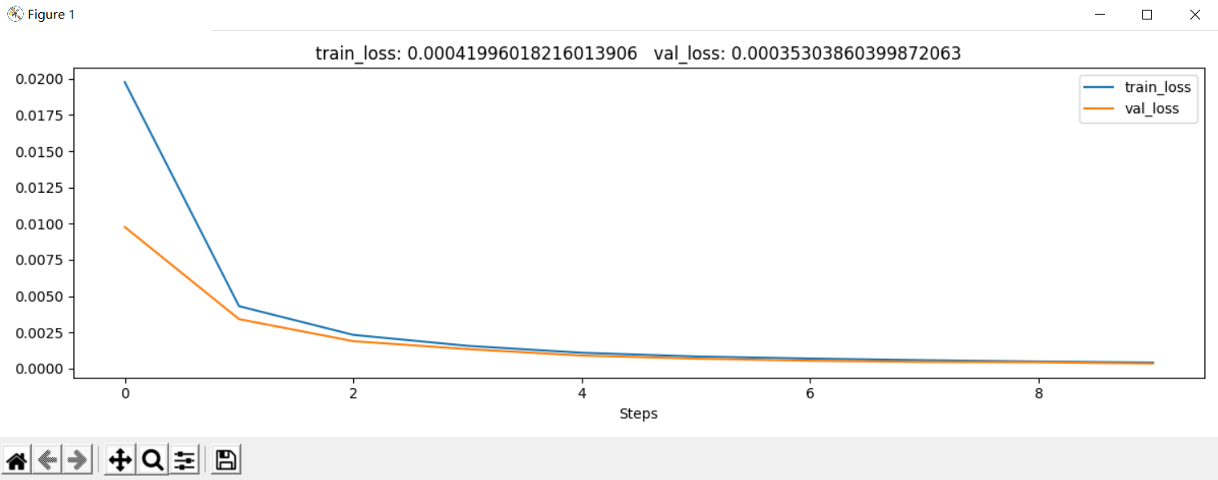

# 输入

imageindex = 1

im = X_val[imageindex, ...]

im = im.unsqueeze(0)

im = im.cpu()

imnose = np.transpose(im.data.numpy(), (0, 3, 2, 1))

imnose = imnose[0, ...]

# 去噪

DAEmodel.eval()

DAEmodel.cpu()

with torch.no_grad():

_, output = DAEmodel(im)

im_cpu = im.cpu()

output_cpu = output.cpu()

# 将张量转换为 NumPy 数组

imnose = np.transpose(im_cpu.data.numpy(), (0, 3, 2, 1))

imnose = imnose[0, ...]

imde = np.transpose(output_cpu.data.numpy(), (0, 3, 2, 1))

imde = imde[0, ...]

# 获取原始图像

im = y_val[imageindex, ...]

imor = im.unsqueeze(0)

imor = imor.to(device) # 确保原始图像也在 GPU 上

imor_cpu = imor.cpu()

imor = np.transpose(imor_cpu.data.numpy(), (0, 3, 2, 1))

imor = imor[0, ...]

# 计算去噪后的 PSNR

print("加噪后的 PSNR:", compare_psnr(imor, imnose), "dB")

print("去噪后的 PSNR:", compare_psnr(imor, imde), "dB")

# 加噪后的 PSNR: 19.467736211368948 dB

# 去噪后的 PSNR: 25.285308385089348 dB

# 将图像可视化

plt.figure(figsize=(12, 4))

plt.subplot(1, 3, 1)

plt.imshow(imor)

plt.axis("off")

plt.title("Origin image")

plt.subplot(1, 3, 2)

plt.imshow(imnose)

plt.axis("off")

plt.title("Noise image $\sigma$=30")

plt.subplot(1, 3, 3)

plt.imshow(imde)

plt.axis("off")

plt.title("Deoise image")

plt.show()

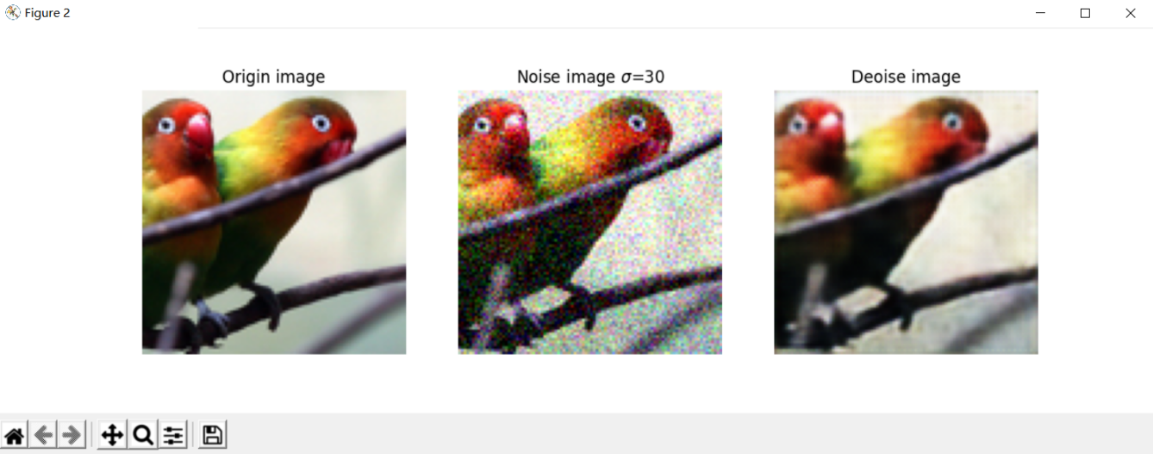

# 计算模型对整个验证集去噪后的PSNR提升量的均值

PSNR_val = []

DAEmodel.eval()

for ii in range(X_val.shape[0]):

imageindex = ii

# 输入

im = X_val[imageindex, ...]

im = im.unsqueeze(0)

imnose = np.transpose(im.data.numpy(), (0, 3, 2, 1))

imnose = imnose[0, ...]

# 去噪

_, output = DAEmodel(im)

imde = np.transpose(output.data.numpy(), (0, 3, 2, 1))

imde = imde[0, ...]

# 输出

im = y_val[imageindex, ...]

imor = im.unsqueeze(0)

imor = np.transpose(imor.data.numpy(), (0, 3, 2, 1))

imor = imor[0, ...]

# 计算去噪后的PSNR

PSNR_val.append(compare_psnr(imor, imde) - compare_psnr(imor, imnose))

print("PSNR的平均提升量为:", np.mean(PSNR_val), "dB")

# PSNR的平均提升量为: 5.824640007434276 dB