# 6.5 卷积神经网络进行情感分类

# 导入本章所需要的模块

import matplotlib.pyplot as plt

import numpy as np

import os

import pandas as pd

import string

import torch

import torch.nn.functional as F

import torch.optim as optim

from torch import nn

from torchtext import data

from torchtext.vocab import Vectors

import re

import time

import copy

def load_text_data(path):

text_data = []

label = []

for dset in ['pos', 'neg']:

path_dset = os.path.join(path, dset) # dset : dataset

path_list = os.listdir(path_dset)

for fname in path_list: # fname : filename

if fname.endswith('.txt'):

filename = os.path.join(path_dset, fname)

with open(filename) as f:

text_data.append(f.read())

if dset == 'pos ':

label.append(1)

else:

label.append(0)

return np.array(text_data), np.array(label)

df1 = pd.read_csv('train_imdb.csv')

df2 = pd.read_csv('test_imdb.csv')

# 提取"text"字段的内容并转换为Numpy数组

text_data = df1['text'].values

train_text = np.array(text_data)

train_label = df1['label'].values

text_data = df2['text'].values

test_text = np.array(text_data)

test_label = df2['label'].values

print(len(train_text), len(train_label))

print(len(test_text), len(test_label))

# 25000 25000

# 25000 25000

def text_preprocess(text_data):

text_pre = []

for text1 in text_data:

text1 = re.sub('<br /><br />', ' ', text1)

text1 = text1.lower()

text1 = re.sub('\d+', '', text1)

text1 = text1.translate(str.maketrans("", "", string.punctuation.replace("'", "")))

text1 = text1.strip()

text_pre.append(text1)

return np.array(text_pre)

train_text_pre = text_preprocess(train_text)

test_text_pre = text_preprocess(test_text)

from nltk.tokenize import word_tokenize

import numpy as np

import re

# nltk.download('punkt') # 下载punkt tokenizer

def stop_stem_word(datalist, stop_words):

datalist_pre = []

for text in datalist:

text_words = word_tokenize(text)

text_words = [word for word in text_words if word not in stop_words]

text_words = [word for word in text_words if len(re.findall("'", word)) == 0]

datalist_pre.append(text_words)

return np.array(datalist_pre)

from nltk.corpus import stopwords

# nltk.download('stopwords')

stop_words = stopwords.words('english')

stop_words = set(stop_words)

train_text_pre2 = stop_stem_word(train_text_pre, stop_words)

test_text_pre2 = stop_stem_word(test_text_pre, stop_words)

print(train_text_pre[1])

# 篇章级语料

# i am curious yellow is a risible and pretentious steaming pile it doesn't matter what

print("=" * 10)

print(train_text_pre2[1])

# 去除停用词，按照空格切分成一个个的单词

# ['curious', 'yellow', 'risible', 'pretentious', 'steaming', 'pile', 'matter', 'one', 'political'

# 装上NLTK的stopwords

# Traceback (most recent call last):

# File "D:\pythoncode\learn\a\deep_learning6.5.py", line 94, in <module>

# stop_words = stopwords.words('english')

# NameError: name 'stopwords' is not defined

texts = [" ".join(words) for words in train_text_pre2]

traindatasave = pd.DataFrame({"text": texts, "label": train_label})

texts = [" ".join(words) for words in test_text_pre2]

testdatasave = pd.DataFrame({"text": texts, "label": test_label})

traindatasave.to_csv("imdb_train.csv", index=False)

testdatasave.to_csv("imdb_test.csv", index=False)

traindata = pd.DataFrame({"train_text": train_text, "train_word": train_text_pre2, "train_label": train_label})

train_word_num = [len(text) for text in train_text_pre2]

traindata["train_word_num"] = train_word_num

plt.figure(figsize=(8, 5))

_ = plt.hist(train_word_num, bins=100)

plt.xlabel("word number")

plt.ylabel("Freq")

plt.show()

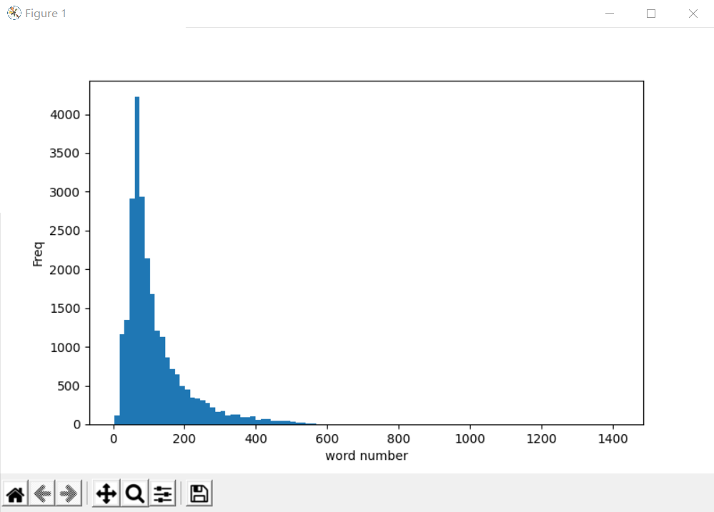

from wordcloud import WordCloud

plt.figure(figsize=(16, 10))

for ii in np.unique(train_label):

text = np.array(traindata.train_word[traindata.train_label == ii])

text = ' '.join(np.concatenate(text))

plt.subplot(1, 2, ii + 1)

wordcod = WordCloud(font_path='simhei.ttf', margin=5, width=1800, height=1000, max_words=500, min_font_size=5,

background_color='white',

max_font_size=250)

wordcod.generate_from_text(text)

plt.imshow(wordcod)

plt.axis("off")

if ii == 1:

plt.title("Positive")

else:

plt.title("Negative")

plt.subplots_adjust(wspace=0.05)

plt.show()

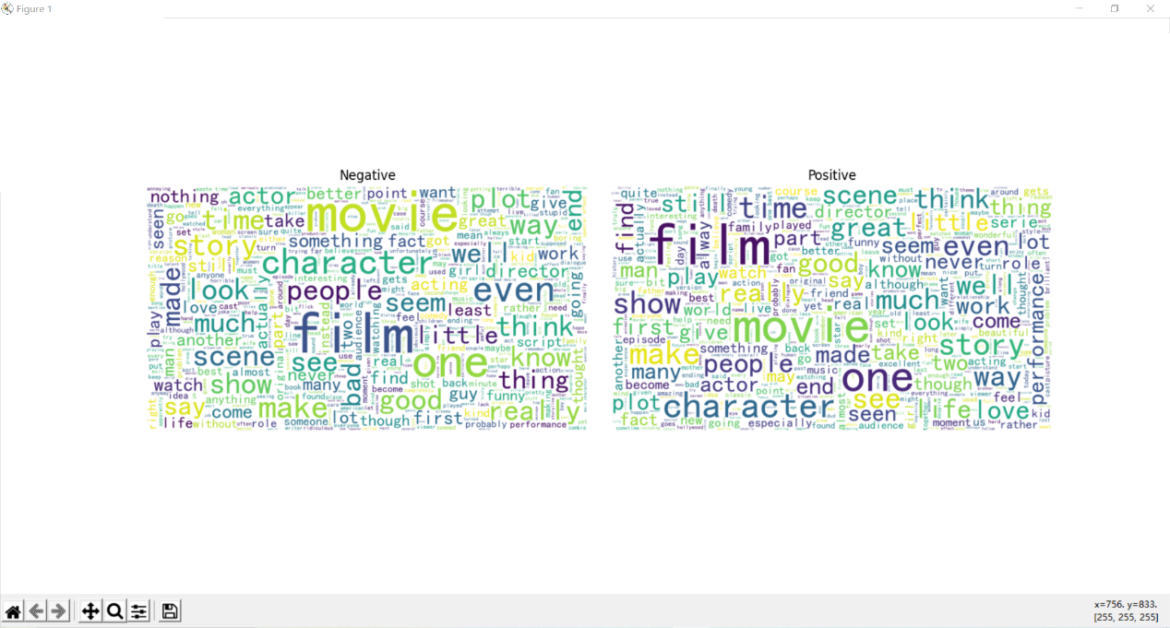

# 课本代码导入模块没有给出代码导致，导入包即可

# Traceback (most recent call last):

# File "D:\pythoncode\learn\a\deep_learning6.5.py", line 140, in <module>

# wordcod = WordCloud(margin=5, width=1800, height=1000, max_words=500, min_font_size=5, max_font_size=250)

# NameError: name 'WordCloud' is not defined

# 字体报错 TrueType字体 TrueTypefonts .ttf文件 经过测试，字体路径是找到的，不然会报cannot open resource，

# wordcloud装了最新版1.9.2，降版本pip install wordcloud == 1.8.0 成功解决

# Traceback (most recent call last):

# File "D:\pythoncode\learn\a\deep_learning6.5.py", line 142, in <module>

# wordcod.generate_from_text(text)

# File "D:\anaconda3\envs\deeplearning\lib\site-packages\wordcloud\wordcloud.py", line 621, in generate_from_text

# self.generate_from_frequencies(words)

# File "D:\anaconda3\envs\deeplearning\lib\site-packages\wordcloud\wordcloud.py", line 508, in generate_from_frequencies

# box_size = draw.textbbox((0, 0), word, font=transposed_font, anchor="lt")

# File "D:\anaconda3\envs\deeplearning\lib\site-packages\PIL\ImageDraw.py", line 651, in textbbox

# raise ValueError("Only supported for TrueType fonts")

# ValueError: Only supported for TrueType fonts

#

# 进程已结束,退出代码1

mytokenize = lambda x: x.split()

# tokenize='basic_english'

TEXT = data.Field(sequential=True, tokenize=mytokenize,

include_lengths=True, use_vocab=True,

batch_first=True, fix_length=200)

LABEL = data.Field(sequential=False, use_vocab=False,

pad_token=None, unk_token=None)

# 对所要读取的数据集的列进行处理

train_test_fields = [ # 踩坑，注意这里是按照顺序索引的，比如，它不会按照列名找到”label“，而是按照第一个就是TEXT

("text", TEXT),

("label", LABEL)

]

traindata, testdata = data.TabularDataset.splits(

path='./',

format='csv',

train='imdb_train.csv', fields=train_test_fields,

test='imdb_test.csv', skip_header=True

)

# 打印数据集大小

print(len(traindata), len(testdata))

# 25000 25000

# ex0 = traindata.examples[0]

# print('ex0.label', ex0.label)

# print('ex0.text', ex0.text)

train_data, val_data = traindata.split(split_ratio=0.7)

print(len(train_data), len(val_data))

# 17500 7500

vec = Vectors("glove.6B.100d.txt")

# 使用训练集构建单词表，导入预先训练的词嵌入

TEXT.build_vocab(train_data, max_size=20000, vectors=vec)

LABEL.build_vocab(train_data)

# 训练集、验证集和测试集定义为迭代器

print(TEXT.vocab.freqs.most_common(n=10))

# [('movie', 30061), ('film', 27361), ('one', 18244), ('like', 13721), ('good', 10390), ('would', 9348), ('even', 8852), ('time', 8475), ('really', 8274), ('story', 8239)]

print("词典的词数:", len(TEXT.vocab.itos))

# 词典的词数: 20002

print("前10个单词：", TEXT.vocab.itos[0:10])

# 前10个单词： ['<unk>', '<pad>', 'movie', 'film', 'one', 'like', 'good', 'would', 'even', 'time']

print("类别标签情况：", LABEL.vocab.freqs)

# 类别标签情况： Counter({'0': 8795, '1': 8705})

BATCH_SIZE = 32

train_iter = data.BucketIterator(train_data, batch_size=BATCH_SIZE)

val_iter = data.BucketIterator(val_data, batch_size=BATCH_SIZE)

test_iter = data.BucketIterator(testdata, batch_size=BATCH_SIZE)

for step, batch in enumerate(train_iter):

if step > 0:

break

print("数据的类别标签", batch.label)

print("数据的尺寸", batch.text[0].shape)

print("数据样本数", batch.text[1])

# 数据的类别标签 tensor([1, 1, 1, 0, 1, 0, 1, 1, 0, 1, 0, 0, 1, 1, 1, 1, 0, 0, 1, 0, 1, 0, 1, 1,

# 1, 0, 1, 1, 1, 0, 0, 0])

# 数据的尺寸 torch.Size([32, 200])

# 数据样本数 tensor([ 55, 30, 96, 68, 129, 100, 33, 200, 156, 49, 39, 200, 200, 21,

# 165, 152, 62, 101, 33, 110, 68, 105, 31, 111, 107, 58, 109, 76,

# 101, 200, 68, 64])

class CNN_Text(nn.Module):

def __init__(self, vocab_size, embedding_dim, n_filters, filter_sizes, output_dim, dropout, pad_idx):

super().__init__()

self.embedding = nn.Embedding(vocab_size, embedding_dim, padding_idx=pad_idx)

self.convs = nn.ModuleList([

nn.Conv2d(in_channels=1, out_channels=n_filters,

kernel_size=(fs, embedding_dim)) for fs in filter_sizes])

self.fc = nn.Linear(len(filter_sizes) * n_filters, output_dim)

self.dropout = nn.Dropout(dropout)

def forward(self, text):

embedded = self.embedding(text)

embedded = embedded.unsqueeze(1)

conved = [F.relu(conv(embedded)).squeeze(3) for conv in self.convs]

pooled = [F.max_pool1d(conv, conv.shape[2]).squeeze(2) for conv in conved]

cat = self.dropout(torch.cat(pooled, dim=1))

return self.fc(cat)

INPUT_DIM = len(TEXT.vocab)

EMBEDDING_DIM = 100

N_FILTERS = 100

FILTER_SIZES = [3, 4, 5]

OUTPUT_DIM = 1

DROPOUT = 0.5

PAD_IDX = TEXT.vocab.stoi[TEXT.pad_token]

model = CNN_Text(INPUT_DIM, EMBEDDING_DIM, N_FILTERS, FILTER_SIZES, OUTPUT_DIM, DROPOUT, PAD_IDX)

print(model)

pretrained_embeddings = TEXT.vocab.vectors

model.embedding.weight.data.copy_(pretrained_embeddings)

UNK_IDX = TEXT.vocab.stoi[TEXT.unk_token]

model.embedding.weight.data[UNK_IDX] = torch.zeros(EMBEDDING_DIM)

model.embedding.weight.data[PAD_IDX] = torch.zeros(EMBEDDING_DIM)

optimizer = optim.Adam(model.parameters())

criterion = nn.BCEWithLogitsLoss()

#

def train_epoch(model, iterator, optimizer, criterion):

epoch_loss = 0

epoch_acc = 0

train_corrects = 0

train_num = 0

model.train()

for batch in iterator:

optimizer.zero_grad()

pre = model(batch.text[0]).squeeze(1)

loss = criterion(pre, batch.label.type(torch.FloatTensor))

pre_lab = torch.round(torch.sigmoid(pre))

train_corrects += torch.sum(torch.tensor(pre_lab.long() == batch.label)) # 括号内转为torch.tensor

train_num += len(batch.label)

loss.backward()

optimizer.step()

epoch_loss += loss.item()

epoch_loss = epoch_loss / train_num

epoch_acc = train_corrects.double().item() / train_num

return epoch_loss, epoch_acc

def evaluate(model, iterator, criterion):

epoch_loss = 0

epoch_acc = 0

train_corrects = 0

train_num = 0

model.eval()

with torch.no_grad():

for batch in iterator:

pre = model(batch.text[0]).squeeze(1)

loss = criterion(pre, batch.label.type(torch.FloatTensor))

pre_lab = torch.round(torch.sigmoid(pre))

train_corrects += torch.sum(torch.tensor(pre_lab.long() == batch.label))

train_num += len(batch.label)

epoch_loss += loss.item()

epoch_loss = epoch_loss / train_num

epoch_acc = train_corrects.double().item() / train_num

return epoch_loss, epoch_acc

EPOCHS = 10

best_val_loss = float('inf')

best_acc = float(0)

for epoch in range(EPOCHS):

start_time = time.time()

train_loss, train_acc = train_epoch(model, train_iter, optimizer, criterion)

val_loss, val_acc = evaluate(model, val_iter, criterion)

end_time = time.time()

print("Epoch:", epoch + 1, "|", "Epoch time", end_time - start_time, "s")

print("Train Loss:", train_loss, "|", "Train Acc:", train_acc)

print("Val. Loss:", val_loss, "|", "Val. Acc:", val_acc)

if (val_loss < best_val_loss) & (val_acc > best_acc):

best_model_wts = copy.deepcopy(model.state_dict())

best_val_loss = val_loss

best_acc = val_acc

model.load_state_dict(best_model_wts)

test_loss, test_acc = evaluate(model, test_iter, criterion)

print("在测试集上的预测精度", test_acc)

# Epoch: 1 | Epoch time 62.18106269836426 s

# Train Loss: 0.014305785978691919 | Train Acc: 0.7802857142857142

# Val. Loss: 0.010499856820702553 | Val. Acc: 0.8602666666666666

# Epoch: 2 | Epoch time 64.33356475830078 s

# Train Loss: 0.008702067593591553 | Train Acc: 0.8852

# Val. Loss: 0.0092372254550457 | Val. Acc: 0.878

# Epoch: 3 | Epoch time 63.778724908828735 s

# Train Loss: 0.005293139319973332 | Train Acc: 0.9350857142857143

# Val. Loss: 0.009738493733604749 | Val. Acc: 0.8790666666666667

# Epoch: 4 | Epoch time 64.7396559715271 s

# Train Loss: 0.0028063043298731955 | Train Acc: 0.9686857142857143

# Val. Loss: 0.011253245748331149 | Val. Acc: 0.8785333333333334

# Epoch: 5 | Epoch time 66.96816277503967 s

# Train Loss: 0.0014695384308296654 | Train Acc: 0.9862857142857143

# Val. Loss: 0.013079128769785165 | Val. Acc: 0.8745333333333334

# Epoch: 6 | Epoch time 66.8894910812378 s

# Train Loss: 0.0007409520095946001 | Train Acc: 0.9937142857142857

# Val. Loss: 0.015568103588372469 | Val. Acc: 0.8732

# Epoch: 7 | Epoch time 64.34104418754578 s

# Train Loss: 0.0005200898583279923 | Train Acc: 0.9951428571428571

# Val. Loss: 0.017476340961021682 | Val. Acc: 0.8736

# Epoch: 8 | Epoch time 67.11497616767883 s

# Train Loss: 0.0003756954844608637 | Train Acc: 0.9958857142857143

# Val. Loss: 0.02083487620341281 | Val. Acc: 0.8597333333333333

# Epoch: 9 | Epoch time 65.55319833755493 s

# Train Loss: 0.00022720735681110195 | Train Acc: 0.9985142857142857

# Val. Loss: 0.021132646035403012 | Val. Acc: 0.8742666666666666

# Epoch: 10 | Epoch time 78.16548037528992 s

# Train Loss: 0.00020813046585618786 | Train Acc: 0.9982857142857143

# Val. Loss: 0.023343770688772202 | Val. Acc: 0.8709333333333333

# 在测试集上的预测精度 0.85108

#

# 进程已结束,退出代码0