Q!. Use – Superstore_Canada.xls and format your numbers exactly likeshown in screenshot below

Ans.

<https://public.tableau.com/views/assignment2q1/Sheet1?:language=en-US&publish=yes&:display_count=n&:origin=viz_share_link>

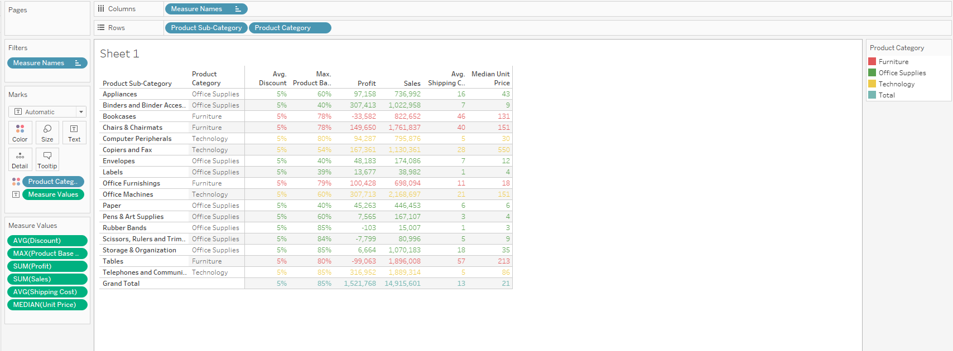

Q2. Use – Superstore_Canada.xls and format your numbers exactly like

shown in screenshot below

Ans,

<https://public.tableau.com/views/assignment2q2/Sheet2?:language=en-US&publish=yes&:display_count=n&:origin=viz_share_link>

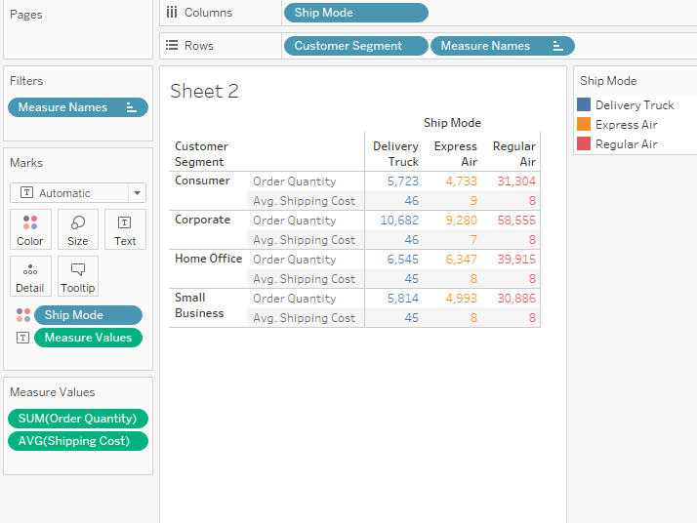

Q3. Import – Superstore_Canada.xls (Sheet – Orders) and answer the

following questions:

Worksheet url : <https://public.tableau.com/views/assignment2q3/Sheet3?:language=en-US&publish=yes&:display_count=n&:origin=viz_share_link>

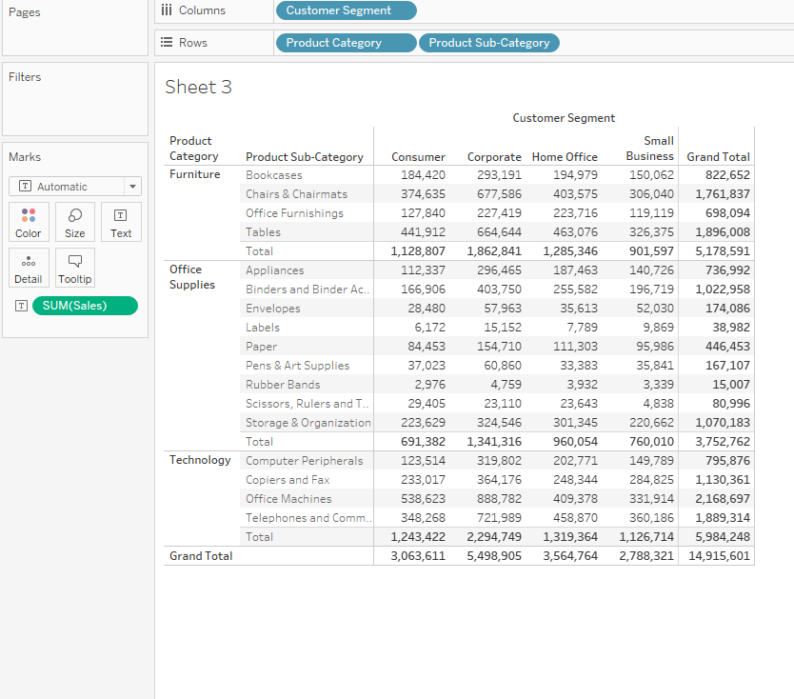

1. What is the total sales of the store?

Ans. 14,915,601

1. What is the total sales of product category = “Furniture”?

Ans. 5,178,591

C. What is the total sales of product category = “Furniture” sold to Customer

Segment = “Corporate”?

Ans. 1,862,841

D. Set the default number format of Discount to percentage with 2 decimal

places.

<https://public.tableau.com/views/assignment2q4/Sheet4?:language=en-US&publish=yes&:display_count=n&:origin=viz_share_link>

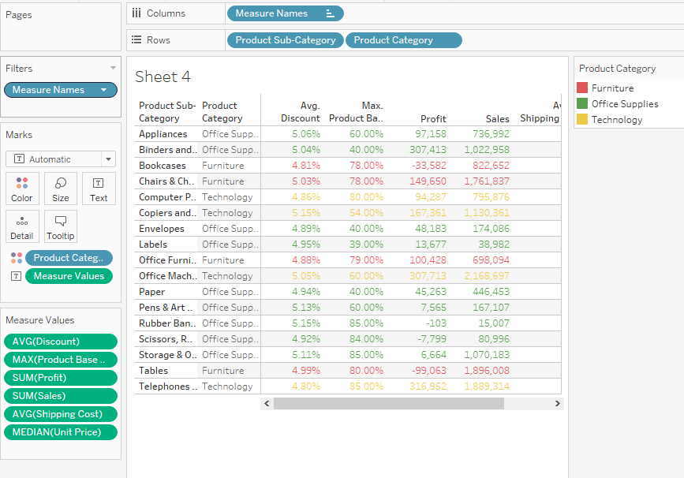

E. Find average discount on each order priority. Which order priority has

highest average discount?

Ans. Low at 5.04%

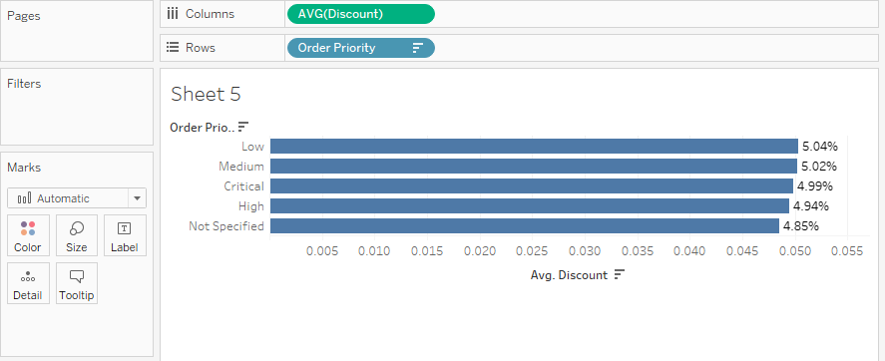

Q4. Import – Superstore_Canada.csv and answer the following questions:

Worksheet URl : <https://public.tableau.com/views/assignment2q5/Sheet6?:language=en-US&publish=yes&:display_count=n&:origin=viz_share_link>

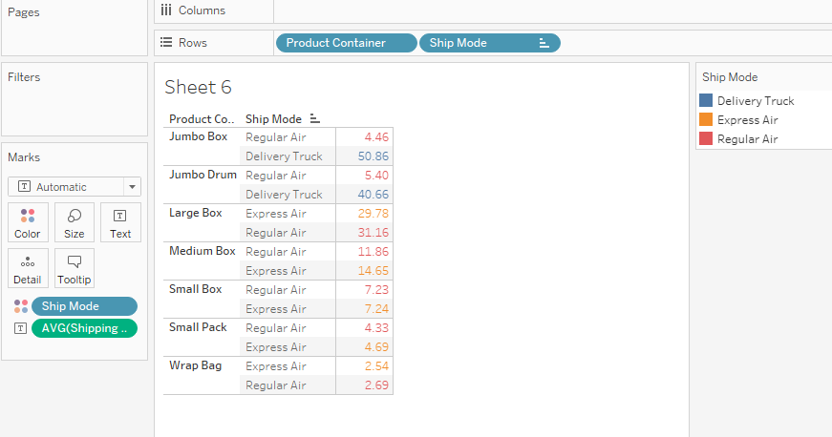

A. For Product Container = “Large Box” which Ship Mode has lowest

average shipping cost?

Ans. Express Air

B. For Product Container = “Medium Box” which Ship Mode has lowest

average shipping cost?

Ans. Regular Air

1. Which Ship Mode uses only “Jumbo” sized Product Containers?

Ans. Delivery Truck

D. Which Ship Mode doesn’t entertain “Jumbo” sized Product Containers?

Ans, Express Air