Q1 Out of all the products shipped in year 2010 which was the largest selling products (in

terms of Sales) ?

Ans Bretford CR8500 Series Meeting Room Furniture

<https://public.tableau.com/views/assignment3q1_16494412682200/Sheet7?:language=en-US&publish=yes&:display_count=n&:origin=viz_share_link>

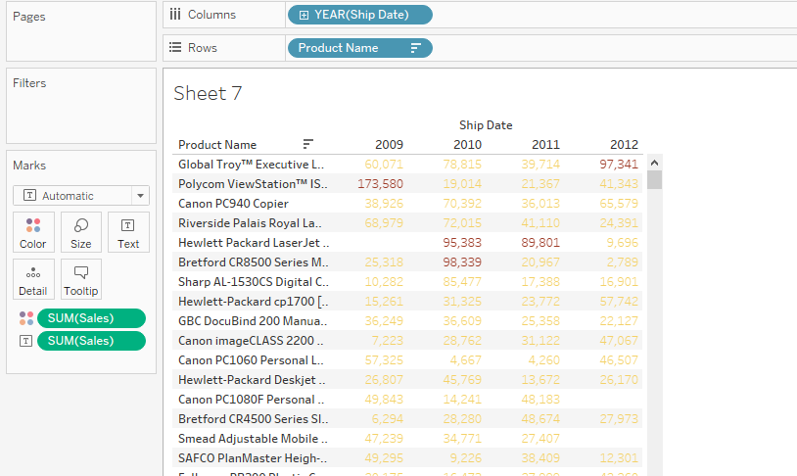

Q2. Of all the products shipped in June 2009 which had the highest quantity?

• Ans Avery494

<https://public.tableau.com/views/assignment3q2_16494413619840/Sheet9?:language=en-US&publish=yes&:display_count=n&:origin=viz_share_link>

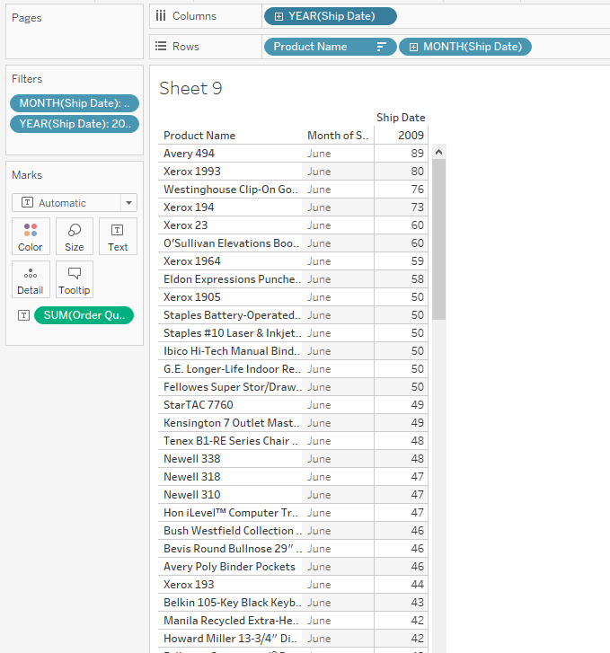

Q3 As per the order date what was the total profit generated by Product Category = “

Office Supplies “ between 1st Aug 2010 to Aug 2012 ?

• Ans – 242,081

<https://public.tableau.com/views/assignment3q3_16494415105790/Sheet8?:language=en-US&publish=yes&:display_count=n&:origin=viz_share_link>

