PAPER TEMPLATE FOR TENOR

|  |  |  |
| --- | --- | --- |
| First Author | Second Author | Third Author |
| Affiliation  City, Country  author1@adomainorg | Affiliation  City, Country  author2@adomain.org | Affiliation  City, Country  author3@adomain.org |

ABSTRACT

The abstract should be placed at the top left column on the first page. Please write about 150-200 words that specifically highlight the purpose of your work, its context, and provide a brief synopsis of your results. Abstract should be one single paragraph and not contain equations, special characters or specific format instructions (bullet lists, URLs, etc.) Do not use citations or footnotes in the abstract. As all first paragraphs, the abstract should not be indented.

INTRODUCTION

This template includes all the information about formatting manuscripts for the TENOR conference. Please use either LaTeX (strongly encouraged) or MS Word templates when preparing your submission. Please follow these guidelines to give the final proceedings a uniform look. **Use *only* the predefined “TENOR” styles provided in this template should make it easier.** If you have any questions, please contact the conference organizers.

PAGE size AND FORMAT

The proceedings will be formatted as portrait A4-size paper (21.0cm x 29.7cm). All material on each page should fit within a rectangle of 17.2 cm x 25.2 cm, centered on the page, beginning 2.0 cm from the top of the page and ending with 2.5cm from the bottom. The left and right margins should be 1.9 cm. The text should be in two 8.2 cm columns with a 0.8 cm gutter. All text must be in a two-column format, and justified.

The maximum allowed length is 10 pages. We encourage a paper length of 6-8 pages.

Copyright notice

Do not move the copyright notice from his original position (at the exact bottom of the first column). Font is Times New Roman Italics, size 7. Line spacing 1,5. Fill in the year and authors First and Last Name. If more than two authors, use *et al* so that the notice is no more than 4 or 5 lines.

Copyright: © XXXX First author, Second Author et al. This is an open-access article distributed under the terms of the [Creative Commons Attribution 3.0 Unported](http://creativecommons.org/licenses/by/3.0/) License, which permits unrestricted use, distribution, and reproduction in any medium, provided the original author and source are credited.

Typeset Text

Normal or Body Text

Please use a 10pt Times font. Sans-serif or non-proportional fonts can be used only for special purposes, such as distinguishing source code from text.

The first paragraph in each section should not be indented, but all other paragraphs should be (0,25cm). Line should be single spaced. Avoid orphan lines, and **do not break columns manually** (leave the text down to the bottom of the columns). Do not leave blank lines or space between paragraphs. Use non-breakable space to avoid line breaks just before figure, numbers, references, etc.

Use “curly quotes”, *italics* but avoid other formatting effects if possible. URL text color must remain black.

Title and Authors

The title is 14pt Times, bold, UPPER CASE, centered. Authors’ names formatted as a table, each centered, Times 10pt, bold. Affiliation Times 10pt. Email address Courier New, 10pt. The lead author’s name is to be listed first (left-most), and the co-authors’ names after. If the addresses for all authors are the same, include the address only once, centered. If the authors have different addresses, put the addresses, evenly spaced, under each authors’ name. Adjust blank space below authors manually if needed.

Lists

Below is the preferred format for bullet and numbered list.

* One item (note the bullet symbol used •).
* Another item spreading over several lines (beware of indentation and spacing).
* Sub-lists are discouraged but authors are free to choose the symbol for it.

1. A numbered item
2. Another numbered item spreading on several lines of text.

Page Numbering, Headers and Footers

Do not include headers, footers or page numbers in your submission. These will be added electronically at a later stage, when the publications are assembled.

headings

First level headings are in Times 10pt bold, UPPER CASE, centered with 12pt before and 6pt after spacing. For a section header immediately followed by a subsection header, the space should be merged. **The predefined “TENOR” styles include adequate value for spacing.**

Sections and subsection headings should be numbered and resented as defined in the TENOR styles.

Second Level Headings

Second level headings are in Times 10pt bold, flush left, 12pt before and 6pt after spacing. The first letter of each significant word is capitalized.

Third-Level Headings

Third level headings are in Times 10pt italic, flush left, 12pt before and 6pt after spacing. The first letter of each significant word is capitalized.

Additional Notes on Section Headings:

* Using more than three levels of headings is strongly discouraged.
* Do not use a numbered subheading when there is just one of them (e.g. no 1.1 without 1.2)

Footnotes

Indicate footnotes with a number in the text.[1] Use 8pt type for footnotes. Place the footnotes at the bottom of the page on which they appear. Precede the footnote with a 0.5pt horizontal rule. Note: footnote number after punctuation refers to a whole phrase or statement,[2] while before punctuation[3], it refers to the preceding word or group of words.

Floats and equations

Equations

Equations of importance, or to which you refer later, should be placed on separated lines and numbered. The number should be on the right side, in parentheses.

 (1)

Refer to equations like so: As (1) shows, I do not completely trust Special Relativity.

Figures, Tables, and Captions

All artwork must be centered, neat, clean, and legible. All lines should be very dark for purposes of reproduction and artwork should not be hand-drawn. The proceedings will be distributed in electronic form only, therefore color figures are allowed. However, you may want to check that your figures are understandable even if they are printed in black-and-white. Vectorial figures are preferred. In order to optimize readability, the font size of text within a figure should be at least identical to footnote font size (8pt). If bitmap figures are used, please make sure that the resolution is enough for print quality.

Figure and tables are numbered consecutively. Place tables/figures in text as close to the reference as possible, and preferably at the top of the page. Inline insertion of figures is preferred. Beware of the overall text and columns formatting when placing figures, in order to avoid blank space at the bottom of columns. Figures and tables may extend across both columns to a maximum width of 17.2cm.

Numbers and captions of figures and tables always appear below the figure/table. Figure and table captions must follow the model below, with 10pt Times font, bold face for figure/table label and number, and a small spat of 3pt before and after. Captions must be justified on the whole column width if composed of several lines, of centered in case of a single line.

**All figures and tables must be referred to in the main text body**, for example: see Figure 1 and Table 1 (*not* Fig. 1, or figure 1).

|  |  |
| --- | --- |
| String value | Numeric value |
| Hello TENOR | 2019 |

Table 1. Table captions placed below the table.

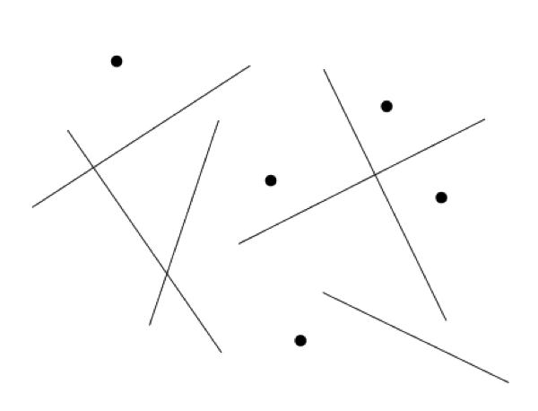

Figure 1. Figure captions should be placed below the figure, exactly like this. Justified, column-wide when more than one line).

Citations

All bibliographical references should be listed at the end, inside a numbered, first-level heading section titled REFERENCES.

References must be numbered **in order of appearance**. Reference numbers should appear within square brackets, such as in [1] or [1, 2, 3]. Do not list references that do not appear in the text. Use references preferably for bibliographic items. Prefer footnotes to cite URLs.[4]

The reference format follows standard IEEE (see examples below). The references section must be balanced between the columns.

CONCLUSIONS

Please submit full-length papers. Submission is fully electronic and automated through the [conference submission system](https://easychair.org/conferences/?conf=tenor2015) (see call for papers). Do not send papers directly by e-mail.

Acknowledgments

At the end of the Conclusions, acknowledgements to people, projects, funding agencies, etc. can be included after the heading “Acknowledgments” (similar to second-level heading, with no numbering).

# REFERENCES

1. A. Someone, B. Someone, and C. Someone, “The Title of the Conference Paper,” in *Proceedings of the International Conference on New Tools for Music Notation and Representation (TENOR’16)*, Paris, 2016, pp.213-218.
2. X. Someone and Y. Someone, *The Title of the Book*. Springer-Verlag, 2004.
3. A. Someone and B. Someone, “The Title of a Journal Paper,” *Journal New Music Research*, vol. 111, no. 22, 2009, pp. 111–222.
4. A. Author, “Title of a Book Chapter”, in X. Editor1, Y. Editor2 (Eds.), *Title of the Book*, publisher, 2018.
5. X. Author. This is the title of an online text reference. [Online] Available: http://the-address.org

1. This is a footnote.
2. Like this.
3. Like this.
4. My URL: http://tenor-conference.org/