Detailed installation instruction for Cisco UCCX Full Screen Wallboard 2.1
Copyright © 2009 by Antoni Sawicki <tenox@tenox.tc>

- Enable MS-SQL hybrid / mixed authentication mode.
This is required if the UCCX server and wallboard machine are not part of a domain. By all means this is supported by Cisco.

- Login to the UCCX server and open up SQL Server Enterprise Manager.
- Expand SQL Server Group and right click on a server, then select Properties.
- Navigate to Security tab.
- Select Authentication -> SQL Server and Windows

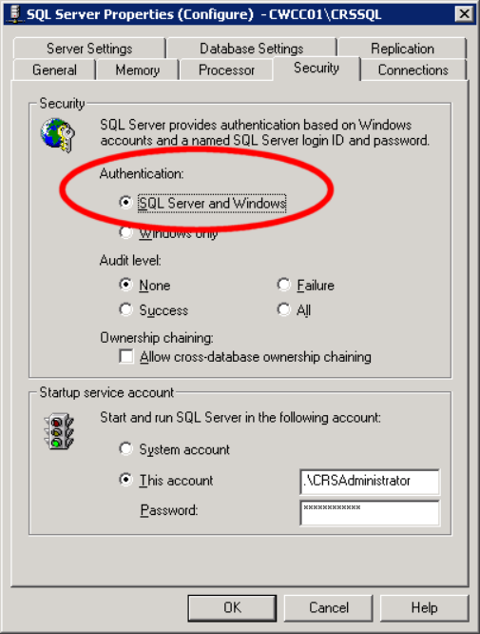

- Fix authentication in the reporting tool.
This is only required if you’re using historical reporting tool and change the authentication mode above.

  - Find and open up the hrcConfig.ini file by default located in
C:\Program Files\Cisco UCCX Histrocal Reports
  - Find all references to AUTH variables in different sections
  - Change value to 1 so it is AUTH=1

see the screenshot bellow:

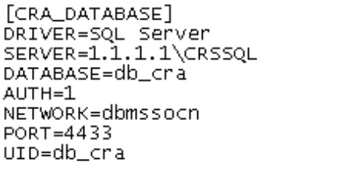

- Create wallboard user / login in the SQL Database.

Likely chance is you will have a wallboard user already configured in the system. Make sure you know the password and the role is set to db_wallboard_read. I created my user manually:

  - Go to Databases->Database->Users and click on add new user
  - Put the username and make sure the rules are set to public and db_wallboard_read like here:
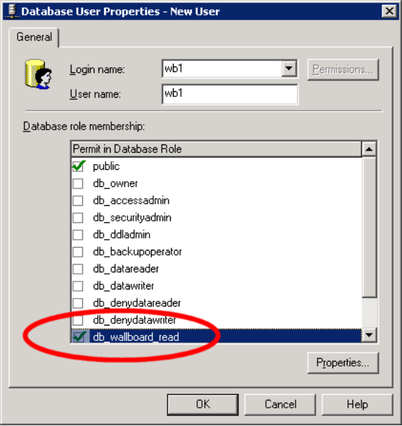
  - Create new login with the same name and select SQL Server Authentication
Make sure to select SQL Authentication and Default database like bellow:
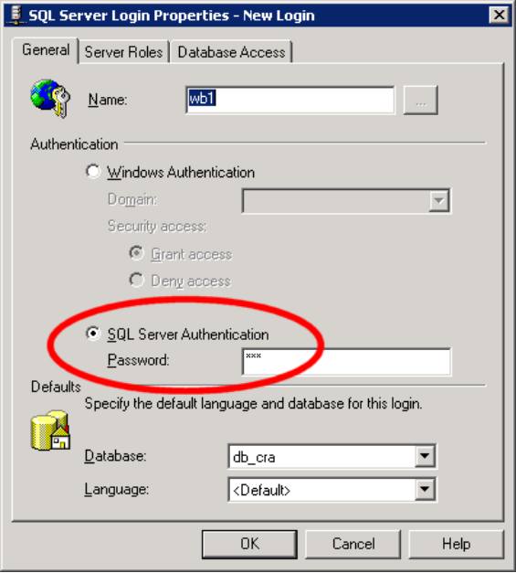
  - Make sure you set it to access right database and have the right roles
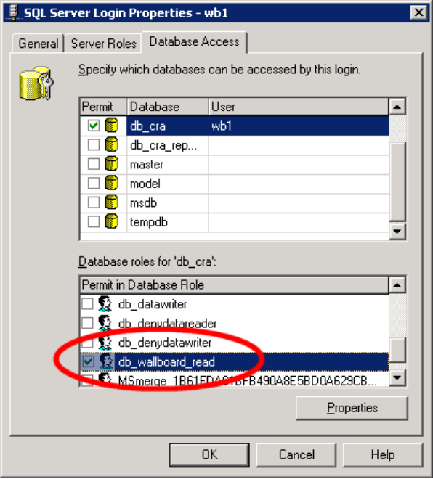

- Enable Real Time Snapshot in UCCX.

  - Go to the UCCX configuration page
  - Navigate to Tools Menu and then to Real Time Snapshot Config
  - Tick Data Writing Enable
  - Set Data Writing Interval to 5
  - Tick in Cisco Unified CCX CSQs Summary and System
  - Leave Wallboard Server Name empty

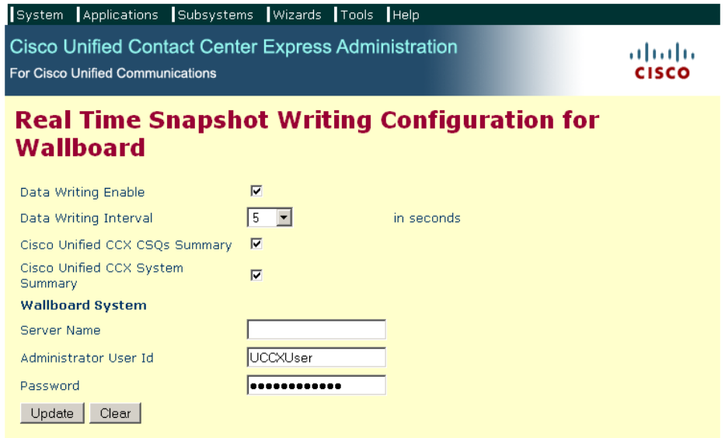

- Create ODBC source.

This needs to be done on every machine hosting the Wallboard application that will be connecting over network to the UCCX server.

  - Go to Start->Settings->Control Panel->Administrative Tools->Data Sources (ODBC)
  - In User DSN or System DSN click Add
  - Scroll down and choose SQL Server driver
  - For name choose what you’ll put in the wallboard.cfg eg “wb”
  - In Server put the ip address of your UCCX server

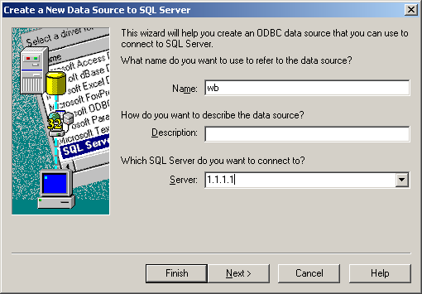

  - Select With SQL Server authentication option
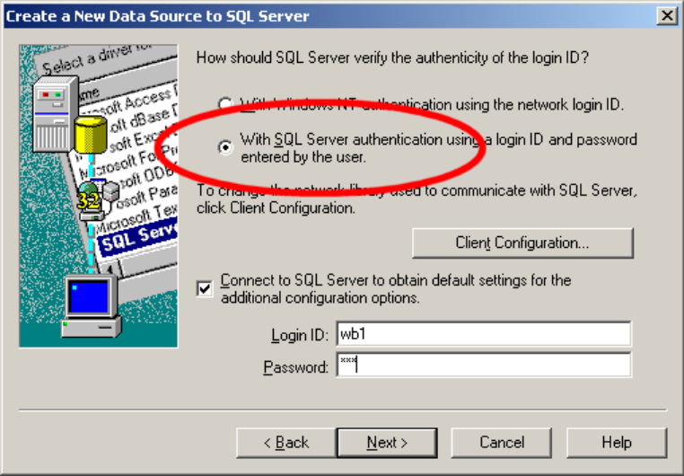

  - Click on Client Configuration…
  - Make sure TCP/IP is selected and right IP address and port present
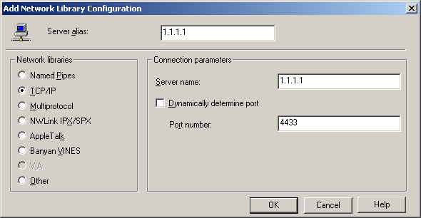

  - Put the SQL server login and password you’ve created
  - Obtain the rest configuration from the server automatically and leave everything at default.
  - No harm testing the connection either.

- Configure wallboard.cfg to the values you have configured in previous steps

odbc_dns1=wb
odbc_username=wb1
odbc_password=wb1

Configure rest of the file to your desired settings.

queue_name= you can get from UCCX configuration page under
Subsystems -> RmCm -> Contact Service Queues

You have to click on the desired queue and copy the name from the Contact Service Queue Name field and paste to queue_name= in wallboard.cfg

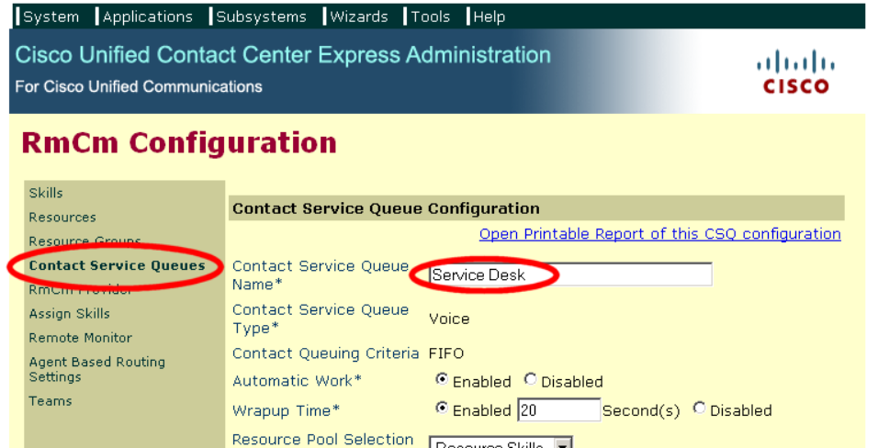

queue_name=Service Desk

- Run the wallboard.exe

Make sure it’s set to auto start, time is synchronised on the machine and all the usual settings. Desktop icon cleanup agent and other tool tips also come in a way quite often.

