

**ADDIS ABABA UNIVERISITY**

**ADDIS ABABA INSTITUTE OF TECHNOLOGY**

**CENTER OF INFORMATION TECHNOLOGY AND SCIENTIFIC COMPUTING**

**DEPARTMENT OF INFORMATION TECHNOLOGY**

**Title of the Project**

Project Proposal

**PREPARED BY:** -

**ADVISORS**:

**Date:**

**ACKNOWLEDGMENT**

**TABLE OF CONTENTS**

**ACRONYMS** v

**ABSTRACT** vi

**1.** **INTRODUCTION** 1

**1.1** **Background of Tikur Anbesa Hospital** 1

**1.2** **The Existing System** 1

**1.3** **Statement of the Problem** 2

**1.4** **Objective of the Project** 3

**1.4.1** **General Objective** 3

**1.4.2** **Specific Objective** 3

**1.5** **Proposed System** 3

**1.6** **Feasibility Study** 4

**1.6.1.** **Economic Feasibility** 4

**1.6.1.1.** **Developmental cost** 4

**1.6.1.2.** **Operational Cost** 4

**1.6.2.** **Technical Feasibility** 5

**1.6.3.** **Schedule Feasibility** 5

**1.7** **Scope**  5

**1.8** **Methodology** 6

**1.9** **Project Management plan** 7

**1.9.1.** **Time Management plan** 7

**1.9.2.** **Quality Management Plan** 8

**1.9.3.** **Communication Management Plan** 8

**APPENDIX** ix

**REFERENCE** x

**LIST OF TABLES**

**Gant Chart 7**

# **ACRONYMS**

# **ABSTRACT**

# **INTRODUCTION**

## **Background**

This section Provide essential information like

* What the motivation for this project is (e.g. to fill a gap in the product portfolio)
* Who the customer is
* What the project will deliver. Is it a new product or an extension of an existing one?
* What it will cost
* How long it will take
* Which organizations are involved
* Which other projects depend on the project result
* Which other projects contribute with their results

## **The Existing System**

*[Identify what type of methods and techniques are currently used to do the job which leads to view the gap and creating a problem the you are initiated to solve]*

## **Statement of the Problem**

Identify the needs or problems to be addressed. Include the target population and any statistical information that you may have. Ideas for information to include here are:

• Length of time needs/problems have existed

• Whether problem has ever been addressed before, and what the outcome was

• Impact of problem to target population

• Impact of problem to surrounding populations

|  |  |
| --- | --- |
| Element | Description |
| The problem of ... | Describe the problem |
| Affects ... | Identify stakeholders affected by the problem |
| And results in ... | Describe the impact of this problem on stakeholders and business activity |
| Benefits of a solution ... | Indicate the proposed solution and list a few key benefits |

## **Objective of the Project**

*[Identify changes desired to be seen upon completion of effort.]*

### **General Objective**

### **Specific Objective**

## **Proposed System**

*[Identify and describe what the solution of the problem you are targeting briefly]*

## **Feasibility Study**

## **Economic Feasibility**

### **Developmental cost**

### **Operational Cost**

## **Technical Feasibility**

## **Schedule Feasibility**

## **Scope**

*Clarify what the project will (and will not) deliver, in order to avoid future shifts in the level of ambition.*

## **Methodology**

Describe what you will do during the upcoming months that you spend on the project. This requires real thinking ahead. This section needs to answer the big question: “HOW DO YOU PLAN TO SOLVE THE PROBLEM?”. In the previous semesters students were saying they will use “waterflow” or X methodology. Yes! Waterflow is a methodology and it defines the next steps as requirements, design, implementation and testing. But name-dropping a **generic** methodology doesn’t mean it is going to work for you. You need to tell us the **specifics** of a methodology.

We need you to really think about how you plan to define the requirements. Are you going to interview people? If so, who and when? How many people do you need to interview or distribute questioners for until you clearly have the picture of the problem that you are working with. You need to convince us that in the coming *X* weeks you are going to have a clearly defined requirement by following this **clearly** defined methodology.

The same goes for design. Answer questions such as: When and how am I going to define the project’s constraints? Does it need to be easy to use? Is performance what is expected of me? It is maintainability that I worry about? Do I need to review and compare some alternate design strategies? How do you plan to make sure that your constraints (what ever they are) are reflected in your project? [MAIN POINT: Review your software engineering’s design lectures and convince us that you are going to do your project design well. Show us that you know what you are getting into. BUT DON’T DO THE DESIGN JUST YET.]

The “Implementation methodology” also needs to be defined. What are the tools that you plan to use to solve change your design to implementation? Do you plan to review alternate implementations? Are you planning to use any libraries or frameworks? … *Convince* your audience that you know how you plan to implement your project.

Testing is also important. How do you plan to test the product? Are you planning to use actual customers to test if it really makes their life easier? How do you plan to assess success of the product? Do I need system testing, or user testing, or integration testing? Why do I use them? How do I plan to do them? Reviewing your software engineering lectures course notes may help.

## **Project Management plan**

## **Time Management plan**

Figure 1

Describe the entire project schedule using gant chart and additional tabular description if necessary

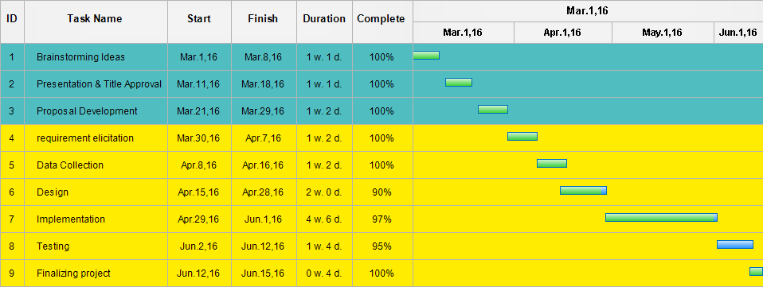

1. **Quality Management Plan**

*[Describe the potential risks related to the software quality. Provide the project management plan to enable quality. Describe the salient, planned testing considerations.]*

*[OPTIONAL CONTENT: Include any analysis plan for usability and acceptance testing.]*

1. **Communication Management Plan**

*State the principles for reporting and distributing information within the project for the different groups of internal and external stakeholders. Include, for example, how often the reporting will take place, the type of reports or information, the type of media in which it is presented, and the type of meetings that will take place.*

1. *Internal communication and reporting: ensure that all information is available to those who need it.  
   – Plan project meetings, how often they take place, and who will participate  
   – Define how project information will made available to the internal stakeholders (e.g. project library)  
   – Define how and how often sub-projects and sub-contractors report to the project manager  
   – Define who participates milestone meetings  
   – Define how events will be communicated*
2. *External communication and reporting:  
   – Define what information will be provided to which stakeholders  
   – Define how and how often information will be provided to which stakeholders often (e.g. project report)   
   – Plan regular meetings with external stakeholders (e.g. SteCo meetings)*

***Example****:*

| **Type of Communication** | **Method / Tool** | **Frequency/Schedule** | **Information** | **Participants / Responsibles** |
| --- | --- | --- | --- | --- |
| **Internal Communication:** | | | | |
| Project Meetings | Teleconference | Weekly and on event | Project status, problems, risks, changed requirements | Project Mgr Project Team |
| Sharing of project data | Shared Project Server | When available | All project documentation and reports | Project Mgr(s)  Project Team Members |
|  |  |  |  |  |
| Milestone Meetings | Teleconference | Before milestones | Project status (progess) | Project Mgr Sub-project Mgr |
| Final Project Meeting | Teleconference | M6 | Wrap-up  Experiences | Project Mgr Project Team |
| **External Communication and Reporting:** | | | | |
| Project Report | Excel sheet | Monthly | Project status - progress - forecast - risks | Project Manager Sub-Project Managers |
| SteCo Meetings | Teleconference | Monthly |  | Project Manager, SteCo |
|  |  |  |  |  |

# **APPENDIX**

# **REFERENCE**

<Insert here any document referred to in the proposal. An example might be articles or Web sites that you consulted during the literature search. >