Group 1:

Task : Identify the shapes and lines from a flowchart image and return the shape name and coordinates

Team :

Example:

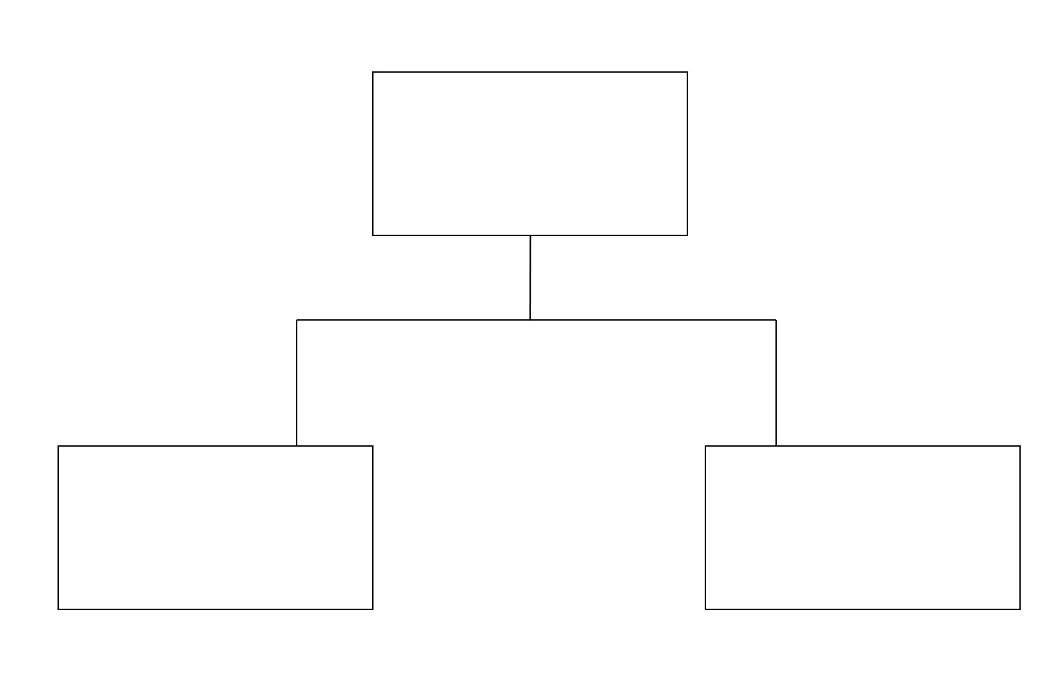

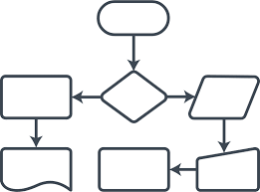

Group 2 :

Task : Flowchart image to text

Give input as flowchart image and the expected output is the textual explanation what the flow is all about.

Example :

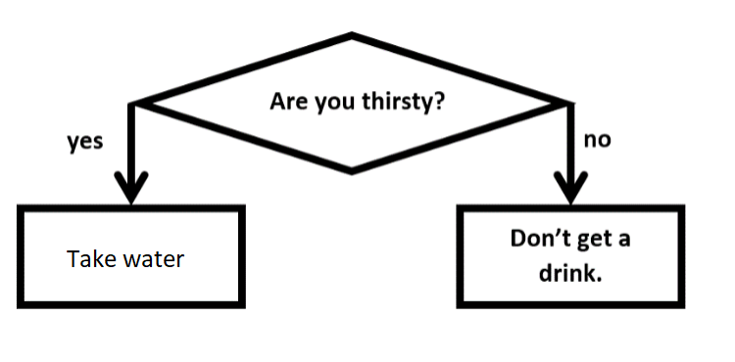

"If Are you thirsty? is Yes then Take water and if Are you thirsty? is no then Don't get a drink."

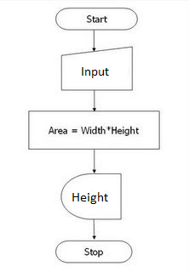

"Start is connected with Input which is then connected with Area = Width\*Height which is further connected with Height which is finally connected with Stop."

Team: