TT-QuietBox® 2

(Blackhole®)

User Guide

Revision 1.0
September 11, 2026
Note: the most recent version of this user guide may be online. Please visit docs.tenstorrent.com

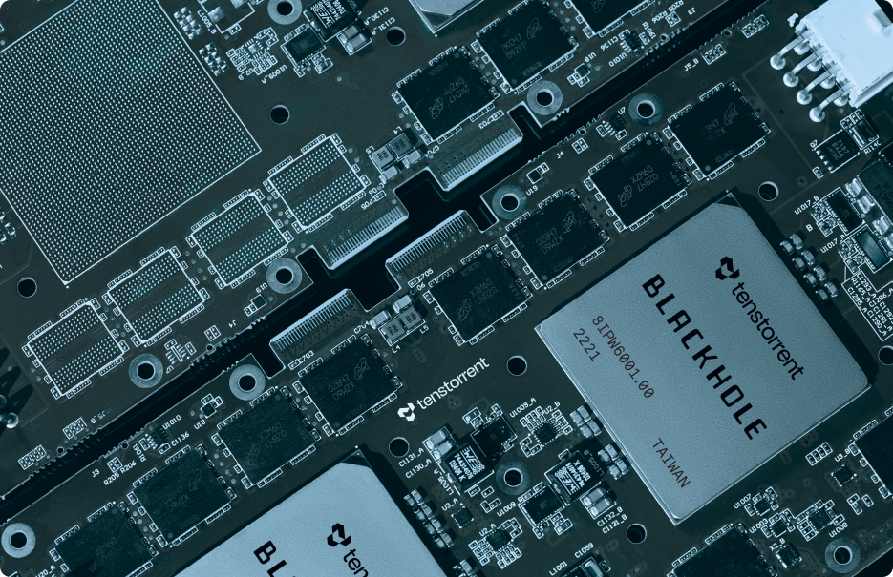

© 2026 Tenstorrent Holdings Inc. and its subsidiaries.

The information contained herein is for informational purposes only and is subject to change without notice. While every precaution has been taken in the preparation of this document, it may contain technical inaccuracies, omissions and typographical errors, and Tenstorrent is under no obligation to update or otherwise correct this information. Tenstorrent, Inc. makes no representations or warranties with respect to the accuracy or completeness of the contents of this document, and assumes no liability of any kind, including the implied warranties of noninfringement, merchantability or fitness for particular purposes, with respect to the operation or use of Tenstorrent products described herein. No license, including implied or arising by estoppel, to any intellectual property rights is granted by this document. Terms and limitations applicable to the purchase or use of Tenstorrent products are as set forth in a signed agreement between the parties or in the Tenstorrent Standard Terms and Conditions of Sale.

Trademarks

A list of Tenstorrent's trademarks can be found at https://tenstorrent.com/trademarks. Other product names and links to external sites used in this publication are for identification purposes only and may be trademarks of their respective companies.

*Links to third party sites are provided for convenience and unless explicitly stated, Tenstorrent is not responsible for the contents of such linked sites and no endorsement is implied.

Table of Contents
Specifications 4
Package Contents 4
TT-QuietBox 2 System Specifications 4
Blackhole p300c Card Specifications 6
Internal Topology 6
Supported Models 7
Power and Operating Conditions 7
System Overview 8
System Rear View 9
Important Safety Warnings 10
Electrical Safety 10
Electrostatic Discharge Safety 10
Other Notices to Users 10
Hardware and Software Setup 12
Before You Begin 12
Required Tools 12
Step 1: Unbox the Workstation 13
Step 2: Set Up the Hardware 18
Step 3. First-Time Log In 19
Step 4. Change Default Password 20
Step 5. Setup and Confirm Internet Connection 20
Step 6. Update System Software 20
Step 7: Verify System Recognition of Blackhole Cards 21
Step 8: Get Access to Model Weights 21
Step 9: Launch TT-Studio 22
What to do Next 23
Need Additional Support? 23
Compliance and Legal 24
Compliance 24
United States of America 24
Canada 25
English 25
Français 25
United Kingdom 25
Europe - CE Marking 25
South Korea (한국) 26

Specifications
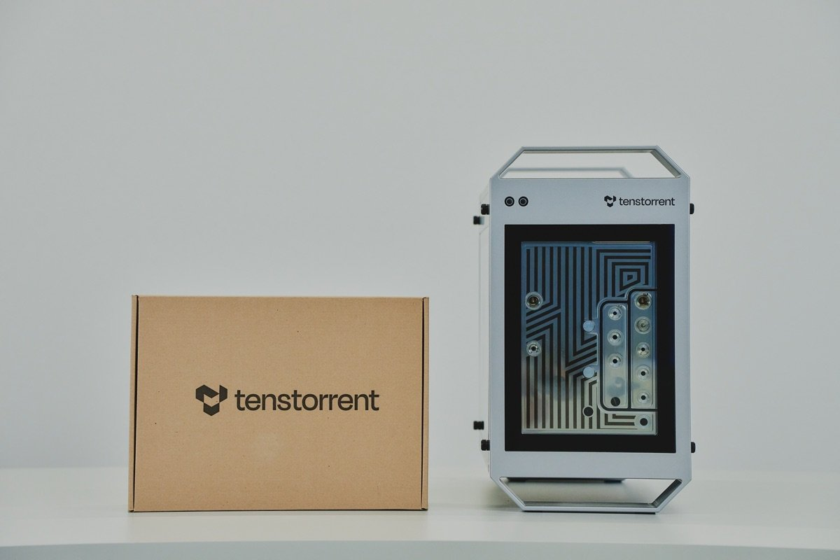
This document provides detailed technical specifications for the TT-QuietBox® 2 (Blackhole®) workstation. It lists package contents, hardware components, physical dimensions, and operating requirements.

Package Contents
The Tenstorrent TT-QuietBox 2 (Blackhole) system package includes the following items:
- 1x TT-QuietBox 2 (Blackhole) workstation
- 1x Power Supply Cord (C19 to country-specific wall outlet)
- 1x eMeet Luna Plus speakerphone

TT-QuietBox 2 System Specifications
Specification | Details
Model | TW-04003
Operating System | Ubuntu 24.04
CPU | Ryzen 7 9700X 65W Granite Ridge 3.8GHz
Motherboard | ASRock B850M-C, mATX
Memory | 256 GB (4x64 GB) DDR5-5600 UDIMM, CL46 (4 slots, 0 free)
Storage | 4TB - WD Blue SN5000 NVMe™ SSD  Hyper M.2 (PCIe Gen4x4)  WDS400T4B0E-00BKY0
Tenstorrent Processors | 2x Blackhole p300c cards (4 Blackhole chips)
Rear I/O Panel | 1x HDMI Port  1x USB 3.2 Gen 2 Type-A Port  1x USB 3.2 Gen 2 Type-C Port (non-video)  2x USB 3.2 Gen 1 Ports  4x USB 2.0 Ports  1 x BIOS Flashback Button  HD Audio Jacks: Line in / Front Speaker / Microphone
Network Controller | Gigabit LAN 10/100/1000 Mb/s Base T  Realtek 8111H
Wireless and Networking | Wi-Fi 6 (802.11a/b/g/n/ax), Dual-Band (2.4 GHz / 5 GHz), Bluetooth 5.3
RF Output Power | • Bluetooth (2.4 GHz): 13 dBm  • Wi-Fi 2.4 GHz: 23 dBm  • Wi-Fi 5 GHz (5.15–5.35 GHz): 23 dBm  • Wi-Fi 5 GHz (5.47–5.725 GHz): 22 dBm  • Wi-Fi 5 GHz (5.725–5.825 GHz): 23 dBm  • Wi-Fi 6 (5.825–5.925 GHz): 24 dBm
Power Supply | 1600W Cooler Master V Platinum 1600 V2
Idle Power | 750W
Sound Pressure | 38 dBA (under max operating load)
System Dimensions | Height: 15.6” (39.5 cm) Width: 9.1” (23.1 cm) Depth: 17.8” (45.2 cm) (including handles and feet)
System Weight | 20 kg (44 lbs) +/- 1.5 lbs
Shipping Box Dimensions | Height: 20.7” (52.5 cm) Width: 14.4” (36.7 cm) Depth: 25.0” (63.5 cm)
Shipping Box Weight | 23.2 kg (52 lbs)

Blackhole p300c Card Specifications
The TT-QuietBox 2 is powered by two p300c cards, for a total of four Blackhole chips. The table below describes the combined specifications of the two cards for your reference. Please note the p300c card is not sold separately outside of the TT-QuietBox 2. If you are interested in a Blackhole card to add to your existing system, check out our available cards (https://www.tenstorrent.com/cards).
Specification | Two p300c Cards
SKU | TC-03007 + TC-03007
Tensix Cores | 240 + 240
AI Clock | 1.35 GHz
Static Random Access Memory [SRAM] | 360MB + 360MB (1.5MB per Tensix core)
Dynamic Random Access Memory [DRAM] | 128GB (64GB + 64GB) GDDR6
Memory Bandwidth | 2,048 GB/s total (1,024 GB/s per card); 512 GB/s per Blackhole ASIC (8 channels × 32 bits per channel at 16 Gb/s)
Ethernet Bandwidth  (Between any Two ASICs) | 800Gbps
Total Ethernet Bandwidth  (Between p300c Cards per Topology) | 1.6Tbps (800Gbps + 800Gbps)
Total Board Power | Up to 1100W (550W + 550W)
Cooling | Liquid + Forced air
Dimensions (WxDxH)  (per p300c Card) | 12.10” x 0.86” x 4.44” (30.7 x 2.17 x 11.27 cm)

Note: Memory bandwidth references Blackhole ASIC to GDDR6 and is GB/s (Giga bytes per second). Ethernet bandwidth references ASIC-to-ASIC or card-to-card and is Gbps (Giga bits per second)

Internal Topology
The workstation's two p300c cards are connected internally with a Samtec ARP6 series High Performance cable. The below topology is pre-installed inside the QuietBox 2 by Tenstorrent and is outlined here for your reference.
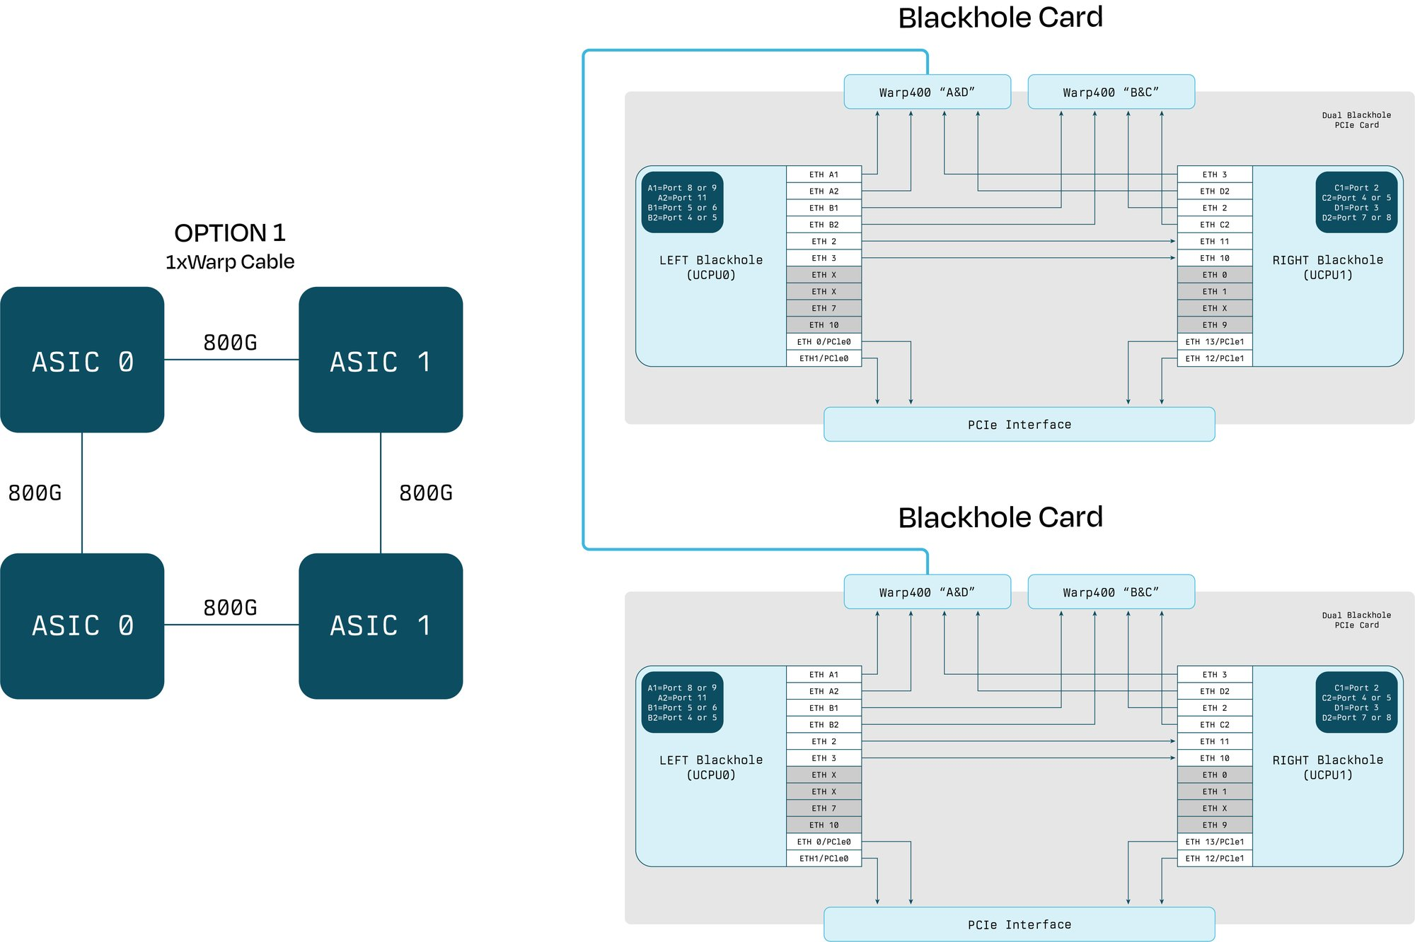

Supported Models
For the most up-to-date list of models supported by TT-QuietBox 2, check the Developer Hub (https://tenstorrent.com/developers).

Power and Operating Conditions
Topic | Specification
Maximum Power Draw | 1300W
Operating Temperature | 50°F to 95°F (10°C to 35°C)
Operating Relative Humidity | 10% to 90% (non-condensing)
Non-Operating Temperature | -4°F to 140°F (-20°C to 60°C)
Non-Operating Relative Humidity | 5% to 95% (non-condensing)

The TT-QuietBox 2 can draw up to 1300W. To prevent overloading the power circuit or tripping your electrical panel, avoid sharing the circuit with other high-power devices, or connect it to a dedicated circuit. This is especially relevant to users in 120V countries, such as the USA, Canada, and Japan.

System Overview
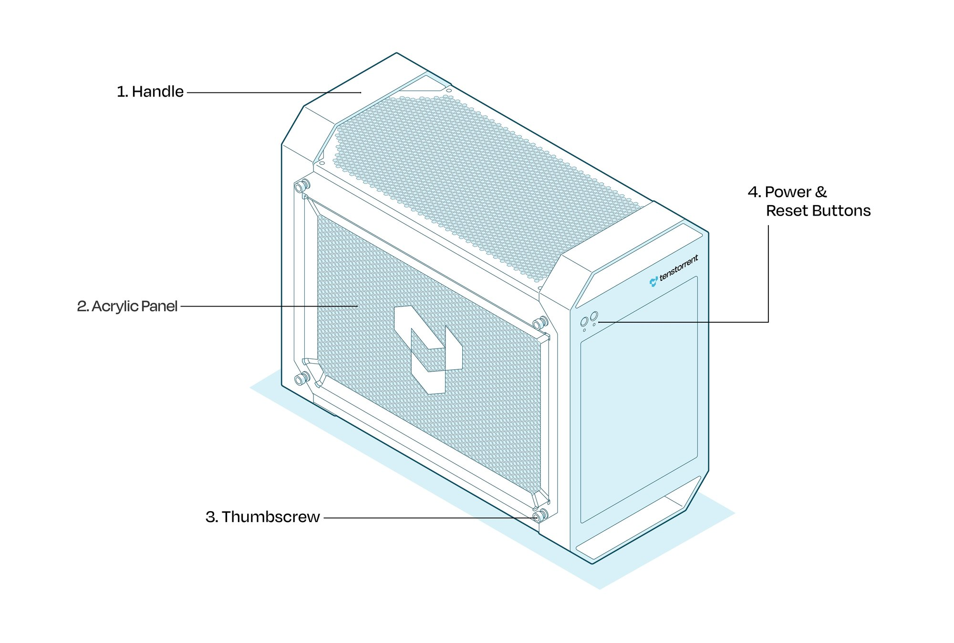
No | Item | Description
1 | Handle | Used to aid in lifting the workstation
2 | Acrylic Panel | Showcases internal Accelerator cards
3 | Thumbscrew | Enables toolless access to the interior*
4 | Power Button | Powers the workstation on/off
5 | Reset Button | Resets the workstation

*This workstation is designed for adult use only. Ensure the TT-QuietBox 2 is located where children cannot access or tamper with it. Keep the workstation secure when not in use.

System Rear View
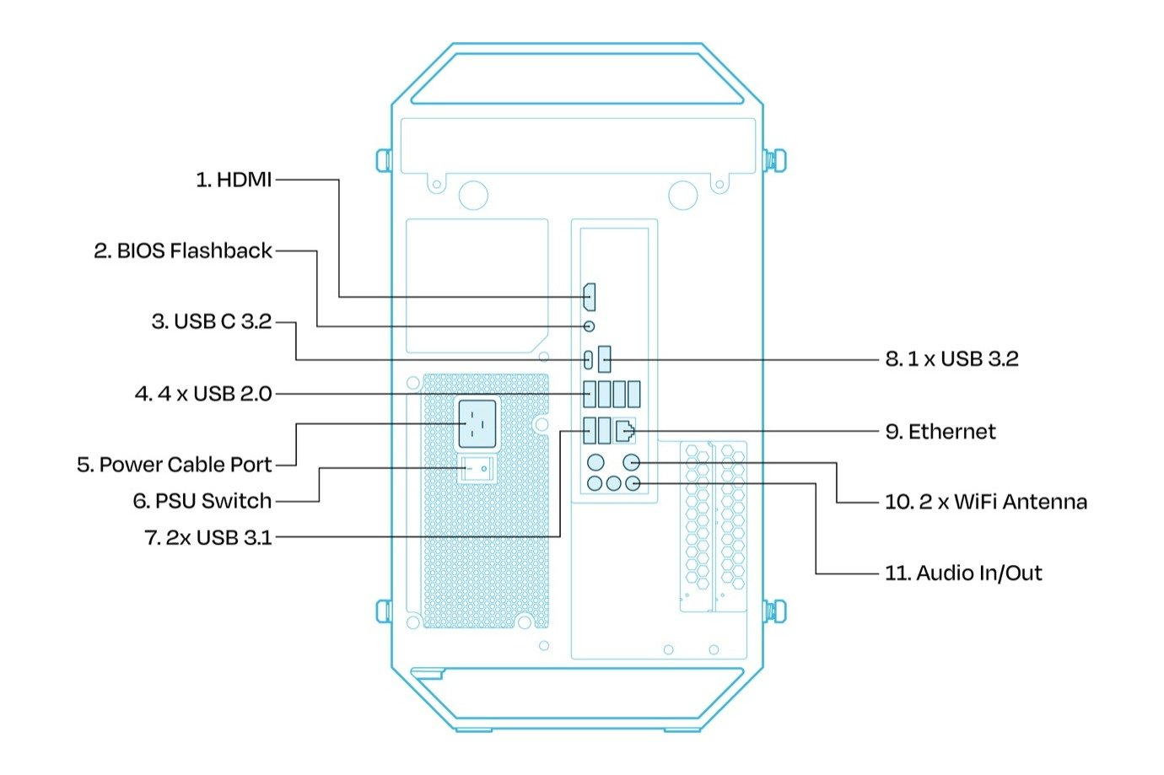
Number | Item
1 | 1x HDMI Port
2 | 1 x BIOS Flashback Button
3 | 1x USB 3.2 Gen 2 Type-A Port
4 | 4x USB 2.0 Type-A Ports
5 | Power Cable Port
6 | On/Off Power Supply Unit Switch
7 | 1x USB 3.2 Gen 2 Type-C Port (non-video)
8 | 2x USB 3.2 Gen 1 Type-A Ports
9 | 1x RJ45 Gigabit LAN Port (10/100/1000 Mbps, Realtek 8111H)
10 | 2x WiFi Antenna
11 | HD Audio Jacks: Line in / Front Speaker / Microphone

Important Safety Warnings

⚠ Caution: Hot Surface
The interior of the workstation can become extremely hot when running. Do not touch any interior components of the workstation without turning the power off, letting the PSU fully drain, and allowing interior components to cool.

Electrical Safety

⚠ Danger
Failure to follow these electrical safety instructions may result in electric shock, fire, or damage to the workstation.
- Do not share the workstation's electrical outlet with other high-power devices. Do not use household surge strips, extension cords, or multi-outlet power taps.
- Use only the provided C19 power cable, and ensure it is plugged into a properly grounded outlet. Do not bypass the grounding pin. Using a non-Tenstorrent approved power cable may result in equipment damage, electric shock, or fire hazard.
- If the circuit becomes overloaded and if the breaker trips, immediately disconnect and remove the power cord. Tenstorrent recommends a qualified electrician inspect and verify the circuit’s capacity before resuming setup.
- Never attempt to reset or bypass a tripped breaker without first confirming the circuit integrity; failure to do so may result in overheating, voltage drop, or irreversible damage.

Electrostatic Discharge Safety

Important
Electrostatic discharge (ESD) can permanently damage Tensix cores, memory modules, or other components. Handle with care and always follow ESD-safe practices. Before opening the TT-QuietBox 2 workstation or handling the internal components, you must discharge static electricity to avoid damaging ESD sensitive hardware.
- Touch an exposed metal surface, such as a grounded rack, chassis, or power supply casing, before and during internal handling.
- Ideally, wear an ESD wrist strap connected to a verified ground point.
- Avoid working on carpeted floors or in low-humidity environments where static buildup is more likely.
- Do not touch any processor, memory module, connector, or printed circuit board (PCB) circuitry unless absolutely necessary, and only after properly discharging.

Other Notices to Users
- This equipment has been tested and found to comply with the limits for a Class B digital device, pursuant to part 15 of the FCC Rules. These limits are designed to provide reasonable protection against harmful interference in a residential installation.
- This equipment generates, uses and can radiate radio frequency energy and, if not installed and used in accordance with the instructions, may cause harmful interference to radio communications. However, there is no guarantee that interference will not occur in a particular installation.
- Changes or modifications to this workstation which are not expressly approved by Tenstorrent may void the user's authority to operate it. Tenstorrent cannot accept responsibility for any failure to satisfy any Safety, EMC or regulatory requirements that result from non-approved modification of the product, including the fitting of non-Tenstorrent cards, cables, or any other hardware or software modification which may affect compliance. To avoid damage and personal injury, only use Tenstorrent approved components with this device.
- Do not use the TT-QuietBox 2 in a way that it was not designed to be used.

Hardware and Software Setup
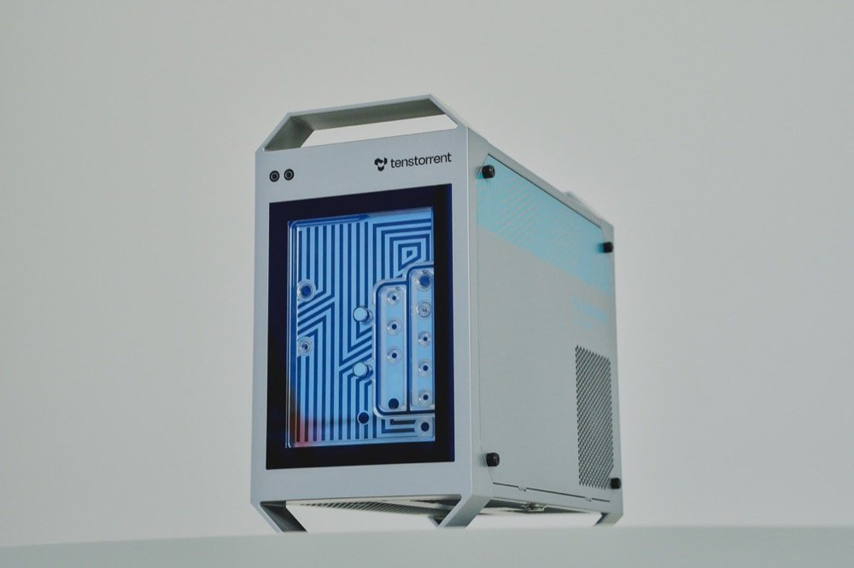
This guide shows users how to safely unbox, setup hardware, and install software on a TT-QuietBox® 2 (Blackhole®) workstation.

Before You Begin
- Choose a stable area for the TT-QuietBox 2 where it will not need to be moved regularly. To ensure proper airflow intake, allow for 10 inches (25 cm) of clearance around the body of the workstation. Do not place items on top of the workstation, as this can block the heat exhaust.
- The Power Supply Unit (PSU) on the TT-QuietBox 2 may draw up to 1300W of power while running high-load models like image generation. In 120V regions (North America, South America, Japan, Taiwan), a standard residential 15A circuit supports a maximum continuous load of 1440W. If you are in one of these regions, avoid plugging the workstation into the same power circuit as other high-power devices. We recommend connecting the TT-QuietBox 2 to a dedicated circuit whenever possible.
- Review the safety warnings .
- Inspect your package for signs of damage. Do not proceed with unboxing or installation if you suspect shipping damage to the system. Contact Tenstorrent support by raising a support request. (https://tenstorrent.atlassian.net/servicedesk/customer/portal/1) Our team will review your request and provide assistance.

Required Tools
Ensure you have everything you need to get started.
The Tenstorrent TT-QuietBox 2 (Blackhole) (TW-04003) package includes the following items:
- 1x TT-QuietBox 2 (Blackhole) workstation
- 1x Power Supply Cord (C19)
- 1x eMeet Luna Plus speakerphone
For setup, you will also need your own:
- Keyboard
- Mouse
- HDMI cable + monitor
Note: Only use certified HDMI cables with the TT-QuietBox 2. Using non-certified HDMI cables may result in device damage, or non-compliant video operation.

Step 1: Unbox the Workstation
- Position the box in your prepared unboxing area, ensuring ample space to work around it.
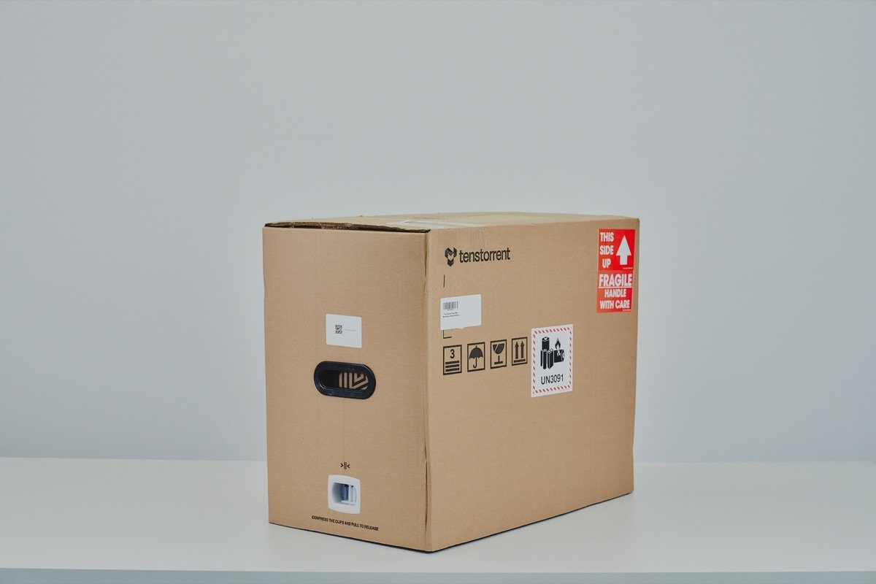
- Remove the white side clips near the bottom of the packaging. Squeeze the tabs on the clip and pull to release.
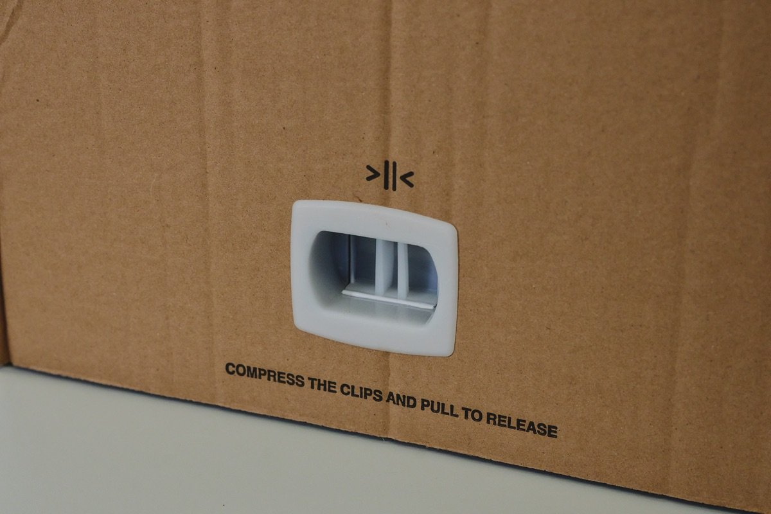
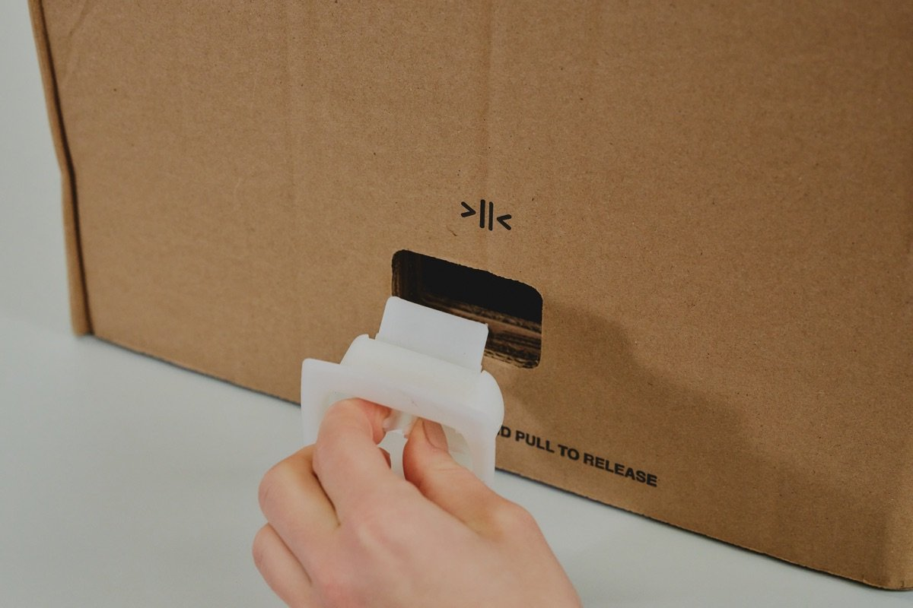
- Lift box lid, remove accessories box and styrofoam, then remove internal cardboard case.
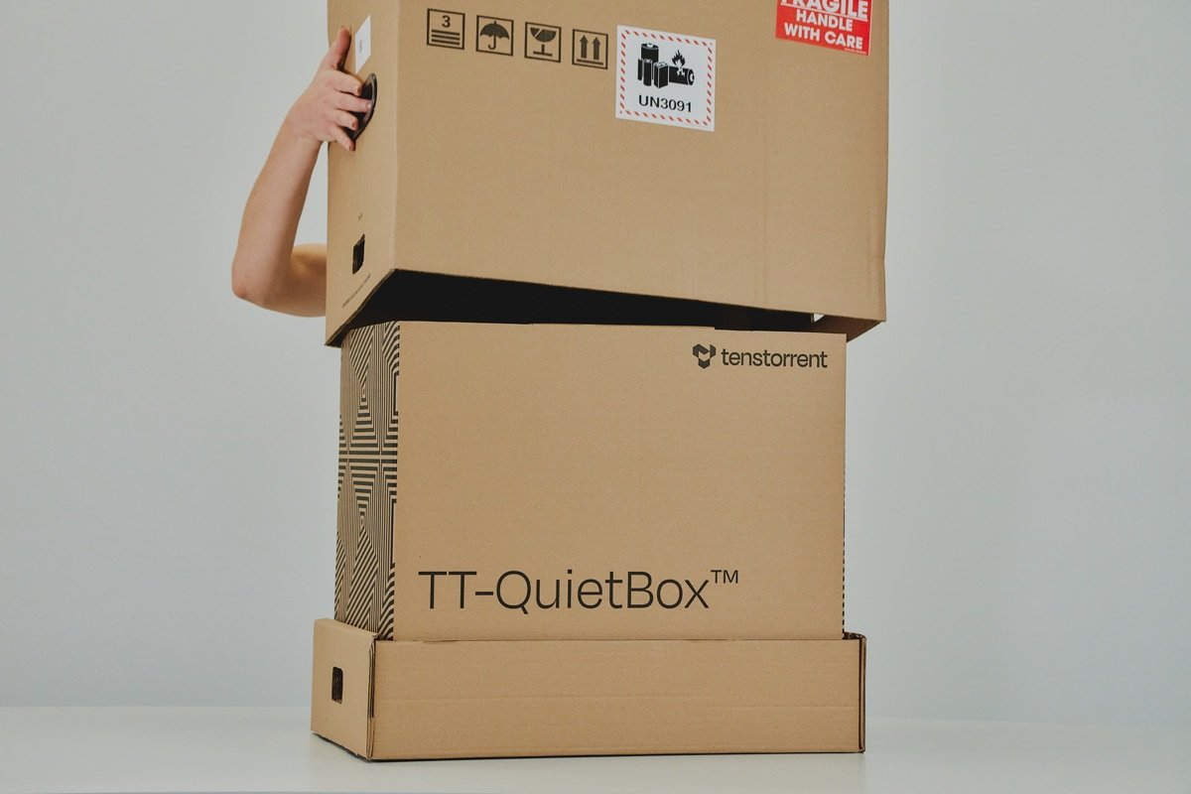
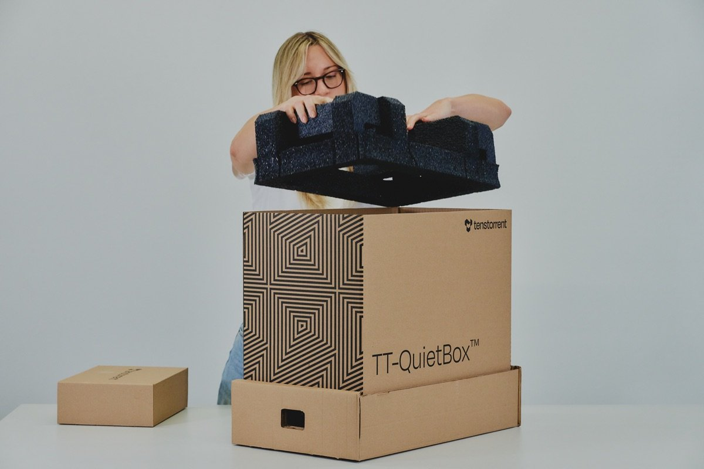
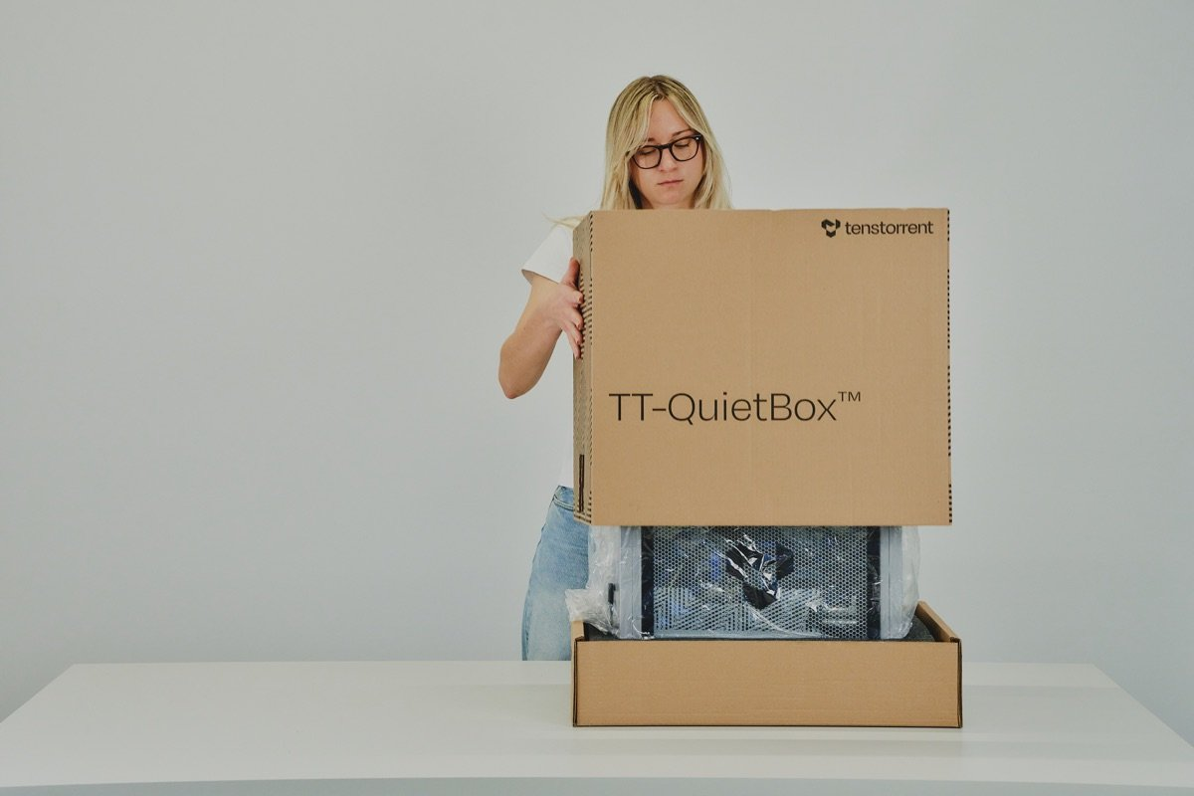
- Lift the TT-QuietBox 2 out of the package using the handles.
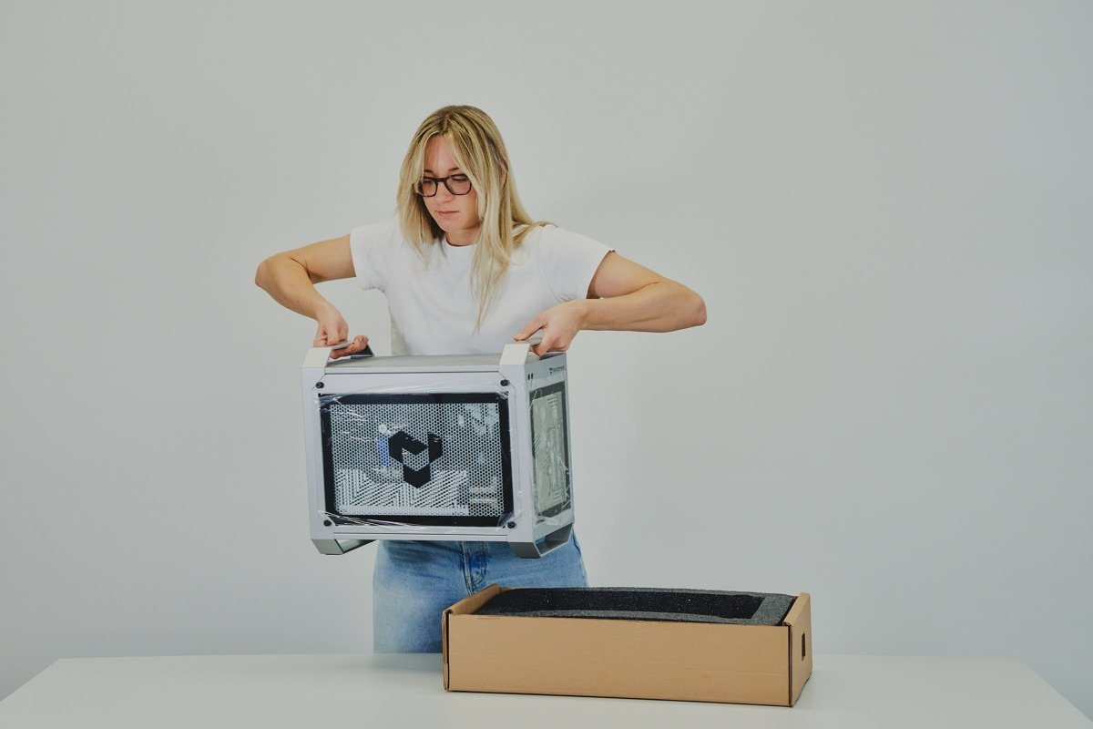
- Remove protective wrapping on all sides.
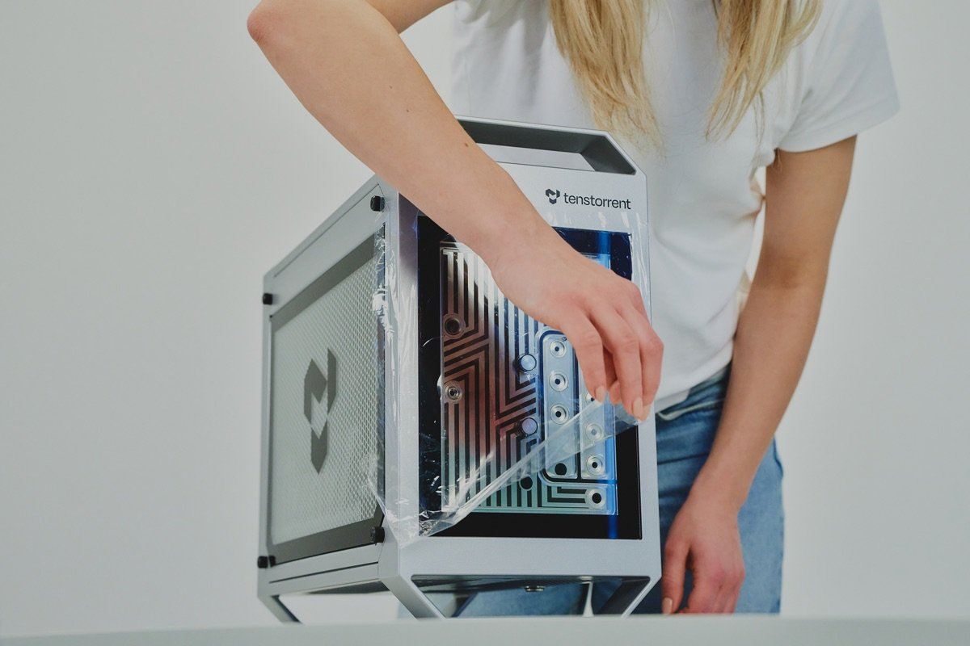
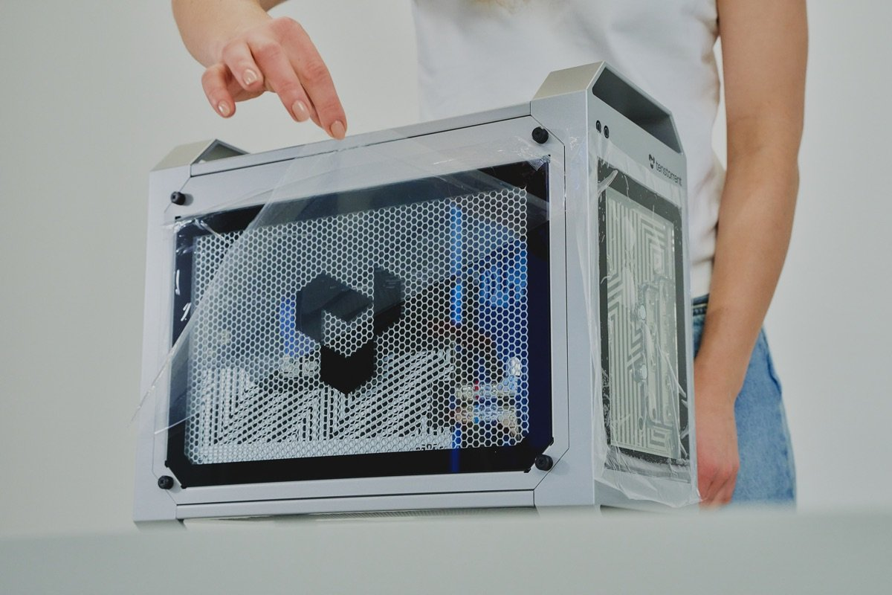

Step 2: Set Up the Hardware

- Connect the power cable. Connect the provided C19 power cable to the workstation and then to a dedicated power outlet. See the Electrical Safety section for the full list of power requirements.
- Connect peripherals. Connect the HDMI monitor, keyboard, and mouse to the back of the workstation. (Please note: video is not supported through the USB-C port). For internet connections, we recommend Ethernet over WiFi for faster downloading of models.
- Confirm WiFi antenna are installed. Two WiFi antenna come pre-installed on your TT-QuietBox 2. If needed, turn the antenna clockwise until they are securely connected, and ensure they are pointed upwards. You may need to adjust the direction of the antenna for stronger WiFi signal. However, for faster downloads, we recommend connecting your workstation directly to Ethernet.
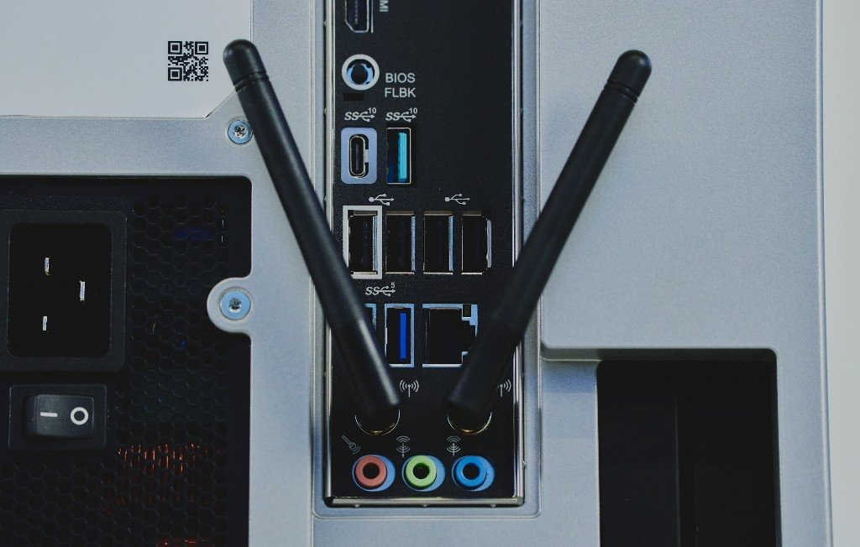
- Power on the workstation. On the back of the workstation, flip the switch on the PSU to the "ON" position.
- On the front of the workstation, press the power button to turn the system on.
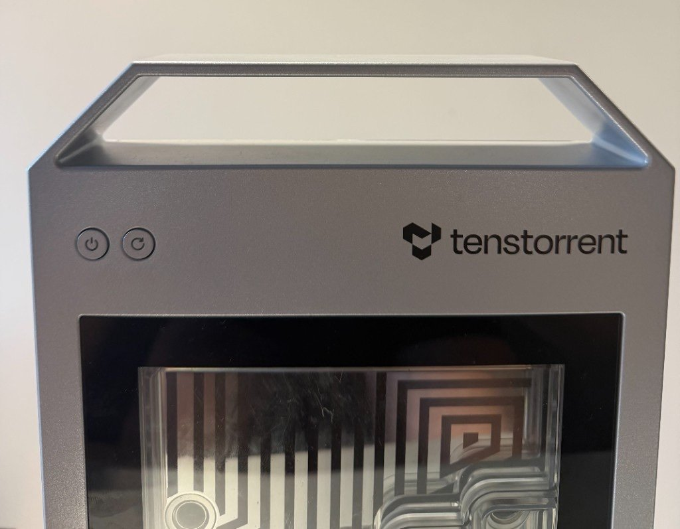

Step 3. First-Time Log In
Once your system is booted up, the login prompt will appear.
Enter the default password: ttuser

Step 4. Change Default Password
After logging in, open a Terminal window by pressing Ctrl+Alt+T and follow these steps to change your password from the public default:
- Run command: passwd
- Enter current password: ttuser
- Enter new password of your choosing and hit enter to confirm the change.

Step 5. Setup and Confirm Internet Connection
TT-QuietBox 2 can be connected to the internet via WiFi or Ethernet cable. For faster model downloads, we recommend a direct Ethernet connection.
If you have not done so already during hardware setup, connect your Ethernet cable to the standard RJ45 port on the back of the workstation. Then, verify your internet connection by clicking on the status icons in the upper right corner of the screen. Confirm the internet connection reads "Wired."
If you would prefer to set up a WiFi connection, on your monitor, click on the status icons in the top right corner of the screen. Then, click on "Wi-Fi" (it may say "not connected" or "off"). Select your WiFi network from the drop-down list, enter the password, and click "Connect."

Note:
Network bandwidth is significantly better over wired Ethernet than WiFi, which makes it the better choice for downloading large open-source AI models.

Step 6. Update System Software
TT-QuietBox 2 comes pre-installed with the Ubuntu operating system (24.04).
Step 1: Upon logging in, a Ubuntu Software Updater may offer a prompt that new software has been issued since the latest release. If this prompt appears, click “Install Now” to download the latest Ubuntu updates.
Step 2: To ensure you have the latest system package updates, open a Terminal window by pressing Ctrl+Alt+T and run:
sudo apt update && sudo apt upgrade -y
Step 3: Install the latest Tenstorrent firmware and system software, which will then trigger a system reboot:
/bin/bash -c "$(curl -fsSL https://tenstorrent.ai/install.sh)"
After the system reboots, log in with ttuser and continue to the next step.

Step 7: Verify System Recognition of Blackhole Cards
To verify all cards are up and running in your TT-QuietBox, launch TT-SMI. This is Tenstorrent's simple command line utility that displays devices, device telemetry and other system information.
- In the terminal your shell prompt should read: (.tenstorrent-venv) ttuser@tt-quietbox:~$
- Run command tt-smi
- Under the “Device Information” pane, you should see an output which lists four recognized accelerators. See the screenshot below for reference.
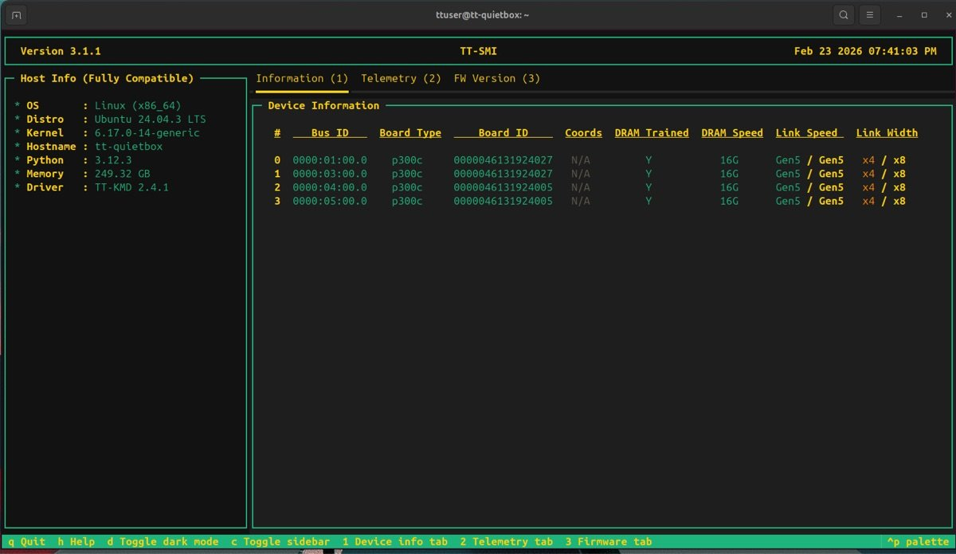

Important
If .tenstorrent-venv is not active, or you don’t see all four accelerators listed in the Device Information pane of TT-SMI, please visit the troubleshooting page. (./support-bh-2.md)

- Once all cards have been verified, close TT-SMI by pressing Q on your keyboard.

Note:
Setting up your TT-QuietBox 2 for more than one person? Follow these steps to set up another user on your TT-QuietBox 2 .

Step 8: Get Access to Model Weights
TT-QuietBox 2 comes pre-installed with TT-Studio (https://docs.tenstorrent.com/tt-studio/), Tenstorrent's simple web interface for running AI models.
For the most up-to-date list of models supported by TT-QuietBox 2, check the Developer Hub (https://tenstorrent.com/developers).
TT-Studio uses the Hugging Face API to manage open-source AI model weights and configuration files. Hugging Face is a free, open source community for collaborating on AI models and applications. Hugging Face access tokens are the unique security keys that allow weights from AI models to be downloaded to your machine. Read more about how user access tokens work in the Hugging Face documentation (https://huggingface.co/docs/hub/en/security-tokens#how-to-manage-user-access-tokens).

Note:
For Qwen3-32B (https://huggingface.co/Qwen/Qwen3-32B), the model weights come pre-downloaded onto your TT-QuietBox 2. However, you will still require an access token from Hugging Face to use the model.

To get access to model weights on Hugging Face, follow these steps:
- Open a new browser window and navigate to huggingface.co (https://huggingface.co).
- Create or log in to your Hugging Face account.
- Create your access token at huggingface.co/settings/tokens (https://huggingface.co/settings/tokens). Copy and securely store the access token as it is only displayed once and will be needed in the next step.
- Some of the models in TT-Studio (Llama-3.1-8B-Instruct (https://huggingface.co/meta-llama/Llama-3.1-8B-Instruct) and Llama-3.3-70B-Instruct (https://huggingface.co/meta-llama/Llama-3.3-70B-Instruct)) require access to be granted by the model developer via the Hugging Face website. For these models, click Request Access and read and sign any required community license agreements.

Step 9: Launch TT-Studio
- Open a terminal window and pull the latest from the TT-Studio github repo:
cd ~/.local/lib/tt-studio
git pull
- When the process is complete, run this command in Terminal to open TT-Studio:
tt-studio
- When prompted, paste in your HuggingFace access token from the previous step.
- Choose to install dependencies with Docker by entering "Y". It may take a few minutes to build the docker containers. When prompted, enter your sudo password (this is the same password you use to log in to your workstation). Administrative access is required to set up TT-Inference-Server, the engine which runs AI models on Tenstorrent hardware.
- The TT-Studio web app will now launch in your default web browser.
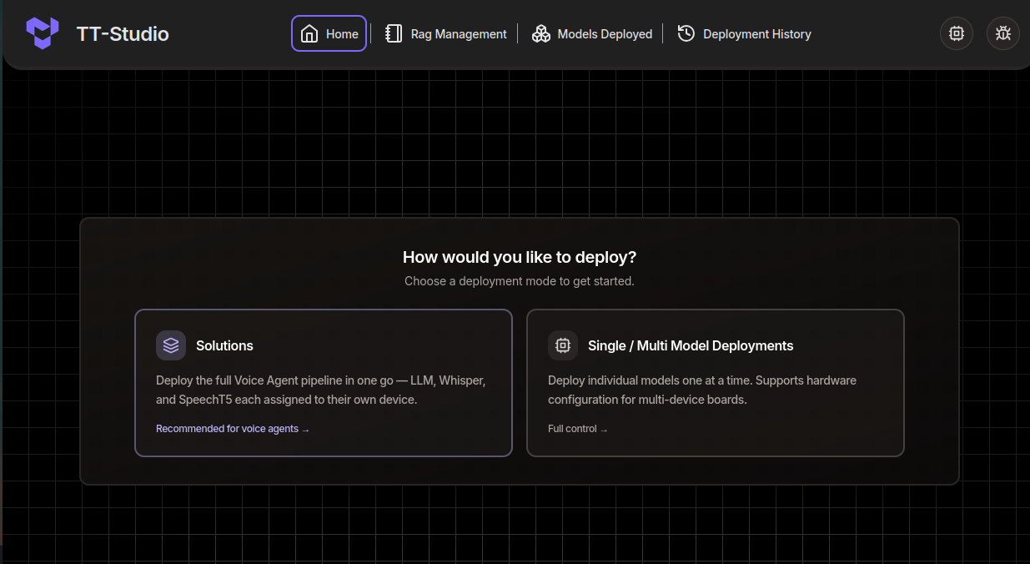
- To get a model running as quickly as possible, select "Single / Multi Model Deployments" and then choose "Qwen3-32B" from the Select Model dropdown. Click "next" and "Deploy".
- Once the model is ready, click "Chat" or "API" to interact with the model in realtime.

Note:
Qwen3-32B comes pre-loaded on your TT-QuietBox 2. Downloading other models can take anywhere from a few minutes to a few hours, depending on the size of the model you’ve selected and the speed of your internet connection.

What to do Next

Need Additional Support?
If you encounter any issues, or have a question that isn't covered in this guide, please raise a support request. (https://tenstorrent.atlassian.net/servicedesk/customer/portal/1) Our team will review your request and provide assistance.

Compliance and Legal
This document provides regulatory compliance information for the Tenstorrent TT-QuietBox® 2 (Blackhole®) workstation (model TW-04003). It outlines the standards and regulations with which this device complies in various regions, assisting users in understanding compliance requirements for proper installation and operation.

Compliance
The TT-QuietBox® 2 (Blackhole®) complies with requirements of:
- USA CFR Title 47, FCC Part 15, Subpart B, Class B
- Innovation, Science and Economic Development Canada (ISED)
- EUROPE - CE Marking
- UK Electromagnetic Compatibility Regulations 2016 (S.I, 2016/1091)

United States of America
This device complies with part 15 of the FCC Rules. Operation is subject to the following two conditions:
- This device may not cause harmful interference.
- This device must accept any interference received, including interference that may cause undesired operation.
This equipment has been tested and found to comply with the limits for a Class B digital device, pursuant to Part 15 of the FCC Rules. These limits are designed to provide reasonable protection against harmful interference in a residential installation. This equipment generates, uses, and can radiate radio frequency energy and, if not installed and used in accordance with the instructions, may cause harmful interference to radio communications. However, there is no guarantee that interference will not occur in a particular installation.
If this equipment does cause harmful interference to radio or television reception, which can be determined by turning the equipment off and on, the user is encouraged to try to correct the interference by one or more of the following measures:
- Reorient or relocate the receiving antenna.
- Increase the separation between the equipment and receiver.
- Connect the equipment into an outlet on a circuit different from that to which the receiver is connected.
- Consult the dealer or an experienced radio/TV technician for help.
FCC Warning: The FCC requires that you be notified that any changes or modifications to this device not expressly approved by the manufacturer could void the user’s authority to operate the equipment.

Canada

English
The TT-QuietBox® 2 (Blackhole®) has been tested to comply with the Interference Causing Equipment Standard, ICES-003 Issue 7, CAN ICES-003(B)/NMB-003(B)
This device complies with Innovation, Science and Economic Development Canada (ISED) license-exempt RSS Standard(s). Operation is subject to the following two conditions: (1) this device may not cause interference, and (2) this device must accept any interference, including interference that may cause undesired operation of the device.

Français
Le présent appareil est conforme aux CNR D’Innovation, Sciences et Développement économique Canada applicables aux appareils radio exempts de licence. L’exploitation est autorisée aux deux conditions suivantes : (1) l’appareil ne doit pas produire de brouillage, et (2) l’utilisateur de l’appareil doit accepter tout brouillage radioélectrique subi, même si le brouillage est susceptible d’en compromettre le fonctionnement.

United Kingdom
The TT-QuietBox® 2 (Blackhole®) complies with the following UK Regulations.
Electromagnetic Compatibility Regulations 2016 (S.I, 2016/1091)
Restrictions of the Use of Certain Hazardous Substances in Electrical and Electronic Equipment Regulations 2012 (S.I.2012/3032)

Europe - CE Marking
The TT-QuietBox® 2 (Blackhole®) bears the CE mark in compliance with the following EU Directives.
EMC Directive 2014/30/EU
RoHS, Directive 2011/65/EU

South Korea (한국)
이 기기는 가정용(B급) 전자파적합기기로서 주로 가정에서 사용하는 것을 목적으로 하며, 모든 지역에서 사용할 수 있습니다.

