tt-dfd
Introduction 3
tt-dfd 4
Core Logic Analyzer 5
CLA High Level Overview 5
Event 5
Trigger on User Defined Function 7
Action 8
Clock Halt Action 9
Custom Actions 9
Event-Action Pair (EAP) 9
Sequential Linking of EAPs 11
CLA Registers 13
CLA Programming Support 16
Debug Mux 16
Structure 16
Lane Mapping 17
Operating Modes 17
Programming 17
Debug Signal Trace 17
Debug Signal Trace Data 18
Frames 18
DST Packets 18
Debug Signal Trace Hardware 20
DST Trace Generator 20
Packetizer 21
Instruction Trace 22
Trace Encoder 22
HART2TE Interface 23
Encoder Build Time Parameter 24
Trace Generator Packets 24
Trace Network Interface (TNIF) 24
Trace Network 25
Trace Hops 25
Building a trace network 25
Trace Grant 26
Trace Funnel 27
Trace Sink SRAM 27
Programming Guide 27
Instruction Trace 27
Debug Signal Trace 27
Programming Sequence 30
Integration 31
Parameters 31
Ports 33

Introduction
Post Silicon debug requires observability, design control for experimenting and data capture at the point of failure. Traditional data capture methods, such as scan and array dumps, only allow for capturing the design state when the failure is observed at system level, losing all transitional data.
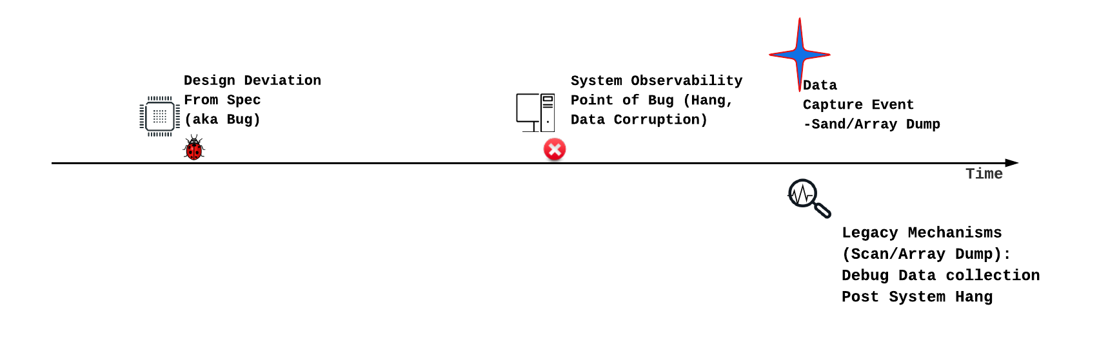
Current RISC-V debug specifications, which include debug module and instruction trace, can track design transitions. However, visibility is confined to architectural components and frequently necessitates a functional core. Effective debugging requires the tracing of micro-architectural events, initiated by trace capture events that occur as close as possible to the point of design deviation. The specific debug scenario dictates the definition of these trigger events. Debugging can be significantly accelerated if these trigger events can also modify design behavior, thereby facilitating debug experiments.
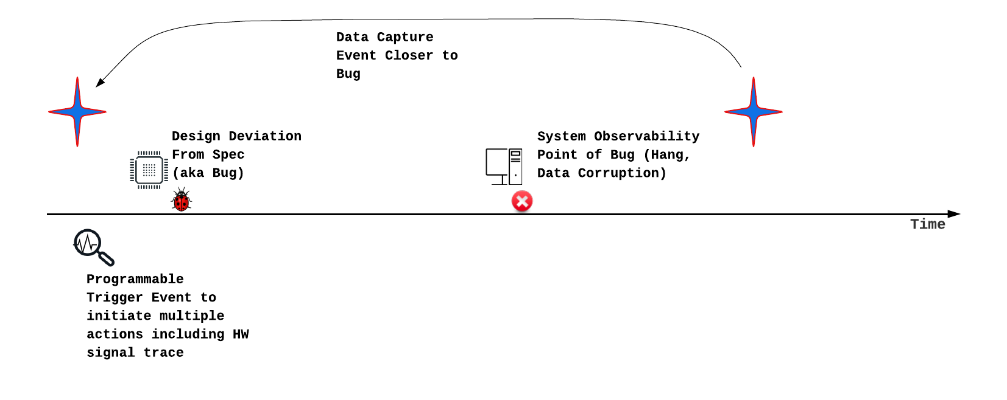
Subsequent chapters detail Core Logic Analyzer and Debug Signal Trace design elements, which are designed to achieve this objective. Beyond Debug, Core Logic Analyzer can also be used for performance analysis, hardware bug workarounds and generating reactive stimuli. These Design for Debug (DfD) blocks are provided as open-source collateral, known as tt-dfd. The tt-dfd package also incorporates RISC-V defined Instruction Trace, based on N-Trace.

This document details the component of tt-dfd and integration steps.

tt-dfd
Tenstorrent offers tt-dfd as customizable IP to meet the Dfd requirements of SOC/Chiplet designs. A detailed block diagram is provided. Tenstorrent is open-sourcing the tt-dfd IP to promote the development of the post-silicon debug software and hardware ecosystem, including standardization. The IP is available for download at https://github.com/tenstorrent/tt-dfd.

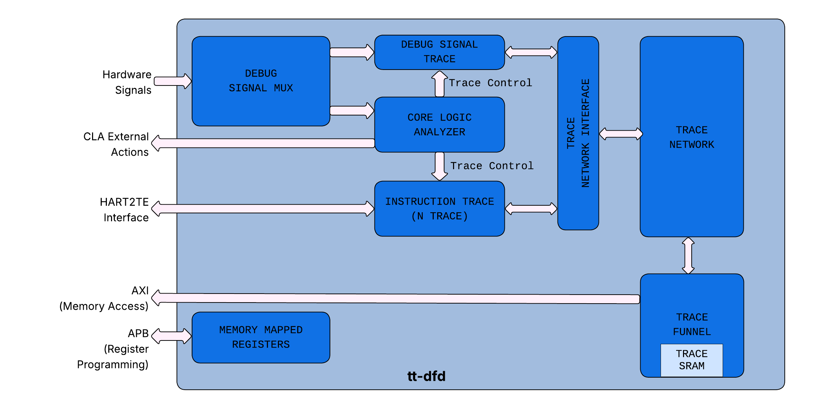

The tt-dfd IP implements the following:
- Core Logic Analyzer: This component observes hardware signals and initiates actions when specific, programmable conditions (triggers) are met. Actions include starting or stopping the instruction and debug signal traces.
- Instruction Trace: This feature traces retired program counters (PCs) to analyze software execution, which is also useful for debugging purposes.
- Debug Signal Trace (DST): DST allows users to trace selected hardware signals, storing them either on-chip or in memory for later analysis, primarily for hardware debugging.
- Trace Network Interface (TNIF): TNIF allows arbitrates and interfaces DST and Instruction Trace blocks to Trace Network.
- Trace Network & Funnel: This on-chip network is responsible for transferring data from the Instruction Trace and Debug Signal Trace modules to either on-chip SRAM or main memory.
- Debug Signal Mux: The Debug Signal Mux is a programmable multiplexer designed to assemble the debug bus out of fixed-width lanes. The debug bus width and lane width are configurable at build itme. Its output is subsequently utilized by the CLA and DST.

Core Logic Analyzer
The Core Logic Analyzer (CLA) offers capabilities for observing hardware signals, establishing user-defined triggers based on these signals, and executing actions when triggers are met. Beyond its primary debugging function, the CLA can be expanded to include performance monitoring, generating reactive stimuli based on runtime feedback, and implementing workarounds. For the initial silicon version of the IP, debugging will be the most prominent use. Other usage models are expected to provide return on investment over several silicon generations.

CLA High Level Overview
The CLA offers three key features:
- Debug Bus: The CLA features a configurable debug bus, which is a dedicated set of hardware signals for observation. It can be configured with a width of 64 or 128 bits each with 8 or 16 bit lanes, giving four possible configurations. To observe more signals than the bus can carry at once, a programmable mux tree (the Debug Signal Mux) precedes the CLA input.
- Event-Action Pairs: CLA allows users to take “actions” when a set of events meet user defined functions. Subsequent sections details on each of the element of event-action pairs
- Nodes: CLA supports the concept of nodes to allow sequential execution of “Event-Action Pairs”. This allows users to program conditions like Event-A followed by Event-B.

Event
The Core Logic Analyzer (CLA) enables users to program events based on the status of debug signals and internal CLA state elements, such as counters. These events are evaluated within a single cycle. The table below lists the CLA supported events.

Event Select | Name | Description
0x0 | Disable | Event not active.
0x1 | Always On | The event is active all the time. Useful for default actions.
0x2 | Match1 (positive filter) | Match Debug Signals with a given mask and value.  +ve Filter: Debug Signals & Mask == Match Value  -ve Filter: Debug Signals & Mask! = Match Value.  Use case example: Detect a state-machine to transition out of a given state.
0x3 | No Match1 (negative filter
0x4 | Match2 (positive filter))
0x5 | No Match2 (negative filter)
0x6 | Edge Detect Set 0 | For Debug Signals listed in c_dbg_signal_edge_detect_cfg[signal0_select] and look for a transition. The nature of transition ( pos-edge or neg-edge) is selected by c_dbg_signal_edge_detect_cfg[pos_edge_signal0]
0x7 | Edge Detect Set 1 | For Debug Signals listed in c_dbg_signal_edge_detect_cfg[signal1_select] and look for a transition. The nature of transition ( pos-edge or neg-edge) is selected by c_dbg_signal_edge_detect_cfg[pos_edge_signal1]
0x8 | Transition | Look for transition of Debug Signals from Value A (with Mask A) to Value B (with Mask B). Useful for tracking state machine transitions.
0x9 | Cross Trigger In 1 | Cross Trigger Input from adjacent CLA. Cross triggers are daisy chained (to minimize wiring)
0xa | Cross Trigger In 2
0xb | 1s Count | Trigger if sum of all unmasked bits of debug bus equals a value (useful for one-hot rules)
0xc | Debug Signals Change | Any change in Debug Signals.
0xd-0xe | Future Use | Future Use
0xf | Core time match | Input time value matches (greater than or equal to the programmed value) with the programmed value in CLA Time match register. To deassert this event, write 0 to the time match value MMR.
0x10 | CLA Counter0 Target Match | CLA Counter0 == Counter Target
0x11 | CLA Counter0 Target Overflow | CLA Counter0 > Counter Target
0x12 | CLA Counter0 Below Target | CLA Counter0 < Counter Target
0x13 | CLA Counter1 Target Match | CLA Counter1 == Counter Target
0x14 | CLA Counter1 Target Overflow | CLA Counter1 > Counter Target
0x15 | CLA Counter1 Below Target | CLA Counter1 < Counter Target
0x16 | CLA Counter2 Target Match | CLA Counter2 == Counter Target
0x17 | CLA Counter2 Target Overflow | CLA Counter2 > Counter Target
0x18 | CLA Counter2 Below Target | CLA Counter2 < Counter Target
0x19 | CLA Counter3 Target Match | CLA Counter3 == Counter Target
0x1A | CLA Counter3 Target Overflow | CLA Counter3 > Counter Target
0x1B | CLA Counter3 Below Target | CLA Counter3 < Counter Target
0x1C | Match3 (positive filter) | Match Debug Signals with a given mask and value.  +ve Filter: Debug Signals & Mask == Match Value  -ve Filter: Debug Signals & Mask! = Match Value.  Use case example: Detect a state-machine to transition out of a given state.
0x1D | No Match3 (negative filter)
0x1E | Match4 (positive filter)
0x1F | No Match4(negative filter)
0x20 | LFSR | Current low-order bit of the pseudo-random event source. Active only while that source is running
0x21 | Compare0 Below | Compare Debug Signals with a given value and mask. Four events  1. Below target  2. Below target or match  3. Above target  4. Above target or match
0x22 | Compare0 Below or Match
0x23 | Compare0 Above
0x24 | Compare0 Above or Match
0x25 | Compare1 Below
0x26 | Compare1 Below or Match
0x27 | Compare1 Above
0x28 | Compare1 Above or Match
0x29 | Compare2 Below
0x2A | Compare2 Below or Match
0x2B | Compare2 Above
0x2C | Compare2 Above or Match
0x2D | Compare3 Below
0x2E | Compare3 Below or Match
0x2F | Compare3 Above
0x30 | Compare3 Above or Match
0x31-0x3F | Future Use | Future Use

Trigger on User Defined Function
Each Event-Action Pair selects up to three events and combines them with a 2-bit Logical Operation field: 00 = OR of Event0 and Event1, 01 = AND of Event0 and Event1, 11 = NOR of Event0 and Event1, and 10 = User Defined Function. With 10 selected, all three events are combined through an 8-entry lookup table (the UDF field) indexed by {Event2, Event1, Event0}, which lets any Boolean function of the three events be expressed. A trigger is created when the selected relation returns true, and the EAP's actions are then executed.

Action
Actions are steps taken by Core Logic Analyzer when a trigger is fired. The purpose of actions can broadly be defined into local and global actions. Local actions are implemented within Core Logic Analyzer. Global actions are implemented outside of CLA. The components of Debug Signal Trace implement actions related to trace. The table below lists the CLA supported actions.

Select  # | Name | Scope | Description
0x0 | Null | -
0x1 | Clock Halt | Global | See Clock Halt Section.
0x2 | Debug Interrupt | Global | This action asserts o/p pin external_action_debug_interrupt_out which is routed as an interrupt to the core.
0x3 | Reserved
0x4 | Start Trace | Global | Action to start trace indicated by o/p pin: external_cla_action_trace_start
0x5 | Stop Trace | Global | Action to start trace indicated by o/p pin: external_cla_action_trace_stop
0x6 | Trace Pulse | Global | Action to trace for a single cycle (when trigger fires). Indicated by o/p pin:  external_cla_action_trace_pulse
0x7 | Cross Trigger Out 1 | Global | Trigger to other CLAs. Triggers are daisy chained to minimize wiring.
0x8 | Cross Trigger Out 2 | Global
0x9 | Reserved
0x10 | Incr. CLA Counter0 by 1 | Local | Increment the CLA counter0.
0x11 | Clear CLA Counter0 | Local | Clear the CLA counter0.
0x12 | Auto Incr CLA Counter0 | Local | Increment CLA counter0 for every CLA clock.
0x13 | Stop Auto Incr Counter0 | Local | Stop auto increment of CLA counter0.
0x14 | Incr. CLA Counter1 by 1 | Local | Increment the CLA counter1.
0x15 | Clear CLA Counter1 | Local | Clear the CLA counter1.
0x16 | Auto Incr CLA Counter1 | Local | Increment CLA counter1 for every CLA clock.
0x17 | Stop Auto Incr Counter1 | Local | Stop auto increment of CLA counter1.
0x18 | Incr. CLA Counter2 by 1 | Local | Increment the CLA counter2.
0x19 | Clear CLA Counter2 | Local | Clear the CLA counter2.
0x1A | Auto Incr CLA Counter2 | Local | Increment CLA Counter2 for every CLA clock.
0x1B | Stop Auto Incr Counter2 | Local | Stop auto increment of CLA Counter2.
0x1C | Incr. CLA Counter3 by 1 | Local | Increment the CLA counter3.
0x1D | Clear CLA Counter3 | Local | Clear the CLA counter3.
0x1E | Auto Incr CLA Counter3 | Local | Increment CLA Counter3 for every CLA clock.
0x1F | Stop Auto Incr Counter3 | Local | Stop auto increment of CLA Counter0.

Clock Halt Action
A clock halt action effectively freezes the design when predefined trigger conditions are met. If these conditions involve monitoring internal microarchitectural states, halting the clock and then performing a scan allows for the capture of the design's state very close to the point of interest.
Local clock gating is faster than global clock halt (like PLL shutdown).

The Clock Halt action activates both the external_action_halt_clock_out signal for global clock gating and the external_action_halt_clock_local_out signal for local clock halting. Users have the ability to enable or disable these functions using the CDbgClaCtrlStatus[DisableLocalClockHalt] & CDbgClaCtrlStatus[DisableGlobalClockHalt] settings, respectively.

Custom Actions
In addition to the standard actions, CLA offers "customer actions," which are defined & implemented by users. A 16-bit wide output bus from the CLA - external_action_custom - allows external (non-CLA) logic to implement the desired actions. When the trigger conditions are met, the user can program specific custom actions.

Event-Action Pair (EAP)

Each action is linked to a particular event using an "event-action" pair register. The EAP register layout is as below. It broadly contains - events, User Defined Function, Actions, Custom Actions and Destination Node.

Field | Description | Comments
Event 0 | Select an event.
Event 1 | Select an event
Event 2 | Select an event
Logical Operation | Logical operation using Event0 and Event1.  00 : OR  01 : AND  10: UDF Result  11 : NOR
User Defined Function | 8-bit lookup table to implement a function w/ 3 events | Relation to be satisfied among Event0, Event1and Event 2 to activate the actions
Action 1 | Select an Action
Action 0 | Select an Action
Action 2 | Select an Action
Action 3 | Select an Action
Destination Node | Select “Destination Node” | See “Linking of EAPs”
CustomAction1 | Select bit position for custom action | Select the bit position of the custom action bus to be set when the result of Logical Operation (see above) of events is TRUE.
CustomAction1 Enable | Enable custom action 1
CustomAction0 | Select bit position for custom action | Select the bit position of the custom action bus to be set when the result of Logical Operation (see above) of events is TRUE.
CustomAction0 Enable | Enable custom action 0

Note on UDP:
Here is a reference example of UDP. Assume you want to implement a logical operation of (Event2 && Event1) || Event0 .
Here is the truth table for the same:
Event2 | Event1 | Event0 | (Event2 && Event1)  || Event0 . | UDP Entry
0 | 0 | 0 | 0 | UDP[0] (LSB)
0 | 0 | 1 | 1 | UDP[1]
0 | 1 | 0 | 0 | UDP[2]
0 | 1 | 1 | 1 | UDP[3]
1 | 0 | 0 | 0 | UDP[4]
1 | 0 | 1 | 1 | UDP[5]
1 | 1 | 0 | 1 | UDP[6]
1 | 1 | 1 | 1 | UDP[7] (MSB)
In the UDP field program a value of 8’b11101010 (8’hEA)

Pictorial representation of EAP.
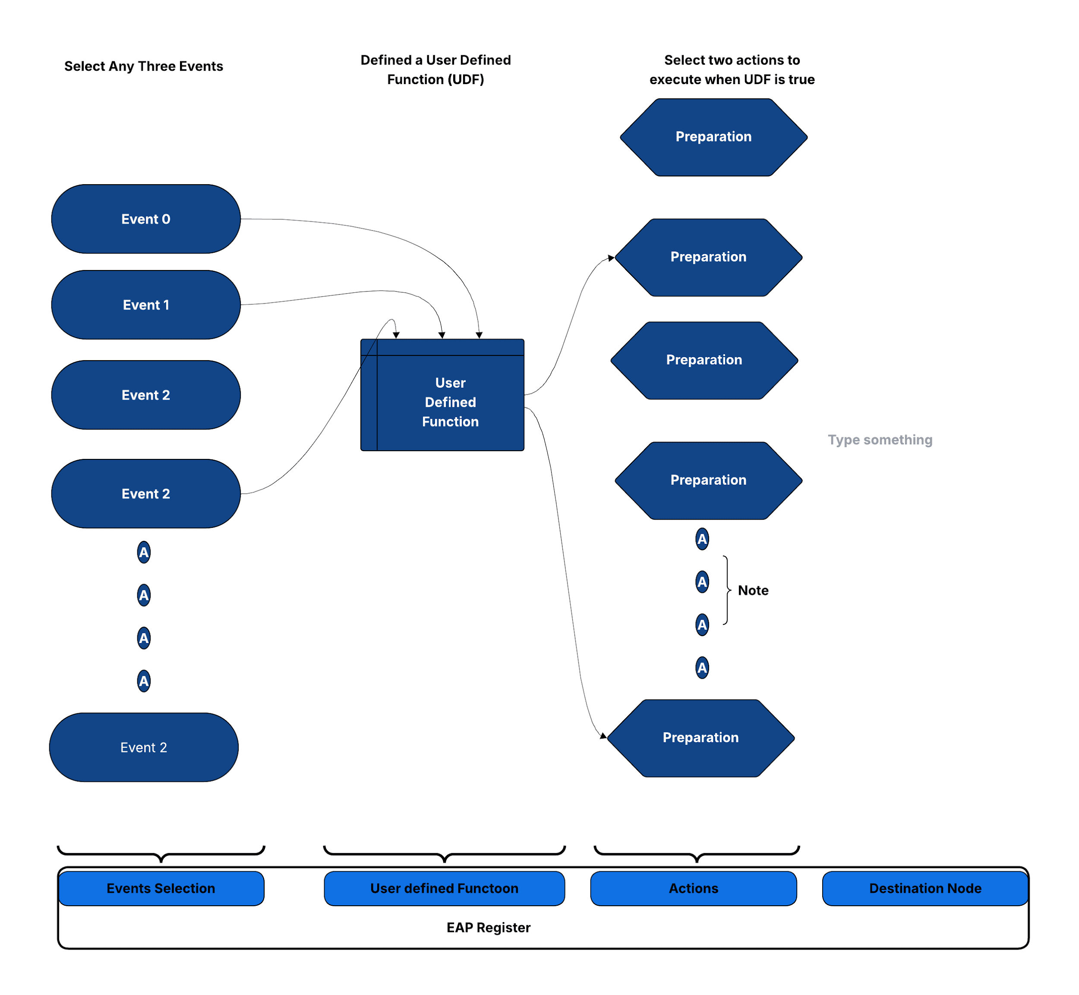

Sequential Linking of EAPs
Debugging often necessitates observing a series of events over multiple cycles, as single-cycle events alone are usually inadequate. For example, imagine a design is stalled, waiting for a timer interrupt after executing a Wait For Interrupt (WFI) instruction. To debug such situations effectively, it's essential to first monitor Debug Signals for a WFI opcode match, and then subsequently monitor the debug signals for a Timer Interrupt match. In other words we want to have two different trigger matches in sequence.
To facilitate sequential triggers, CLA utilizes the concept of nodes. The CLA implements four nodes and each node comprises of for EAPs (Event Action Processors). Each EAP can be programmed with a "destination node." With this mechanism, CLA can switch from any one node to another node using the destination node.
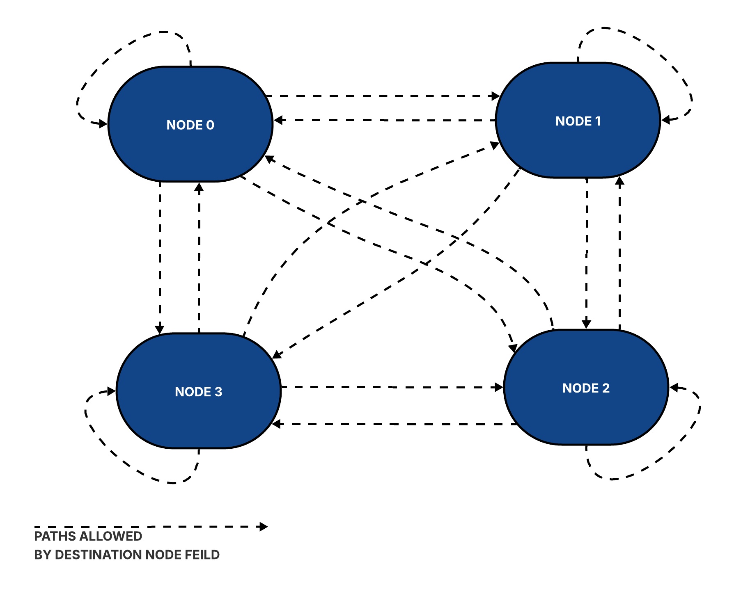

At any given time, only one node, referred to as the current node, and its associated 4 EAPs are active. An EAP can initiate a switch from the current node to its destination node based on its pre-programmed conditions. Upon reset, Node0 is designated as the current node. Once the EAP events within Node0 are met, the CLA transitions to the EAP's destination node, along with the execution of specified actions. With the transition, the EAPs of destination nodes are activated.

To illustrate the linking, let us continue with the example of debugging a hang with design stuck waiting for a timer interrupt for WFI exit. Let us say that a timer interrupt is programmed to occur within X clocks of WFI. If the interrupt is not received within this timeframe, CLA should be programmed to freeze the design (using clock stop action), and its state should be captured (e.g., using a Scan). Here is pseudo-code CLA programming for such a debug case, using nodes.

CLA Counter 0 Target is set to TIMEOUT
Set “Clr. CLA Counter0” in the CLA Ctrl & Status
#Start a CLA Counter on WFI Retire….and switch to Node 1
Node0 EAP0
Event0 :Debug Bus Mask0 & Match0 == WFI Indication
Event1 & Event2 :Always ON
UDF :AND of Event1, Event2 and Event3
Action0 :AutoIncr CLA Counter0
Dest. Node :Node1
#Clear the Counter on Interrupt and switch-back to Node1 (back to default state)
#If (Counter0 ==TIMEOUT), Freeze the clock and Switch to Node2
Node1 EAP0
Event0 :Debug Bus Mask1 & Match1 == Interrupt Indication
Event1 & Event2 :Always ON
UDF :AND of Event1, Event2 and Event3
Action0 :Clear CLA Counter0
Dest. Node :Node0
Node1 EAP1
Event0 :CLA Counter0 == TIMEOUT
Event1 & Event2 :Always ON
UDF :AND of Event1, Event2 and Event3
Action0 :Clock Halt (for Subsequent Scan Dump)
Dest. Node :Node2

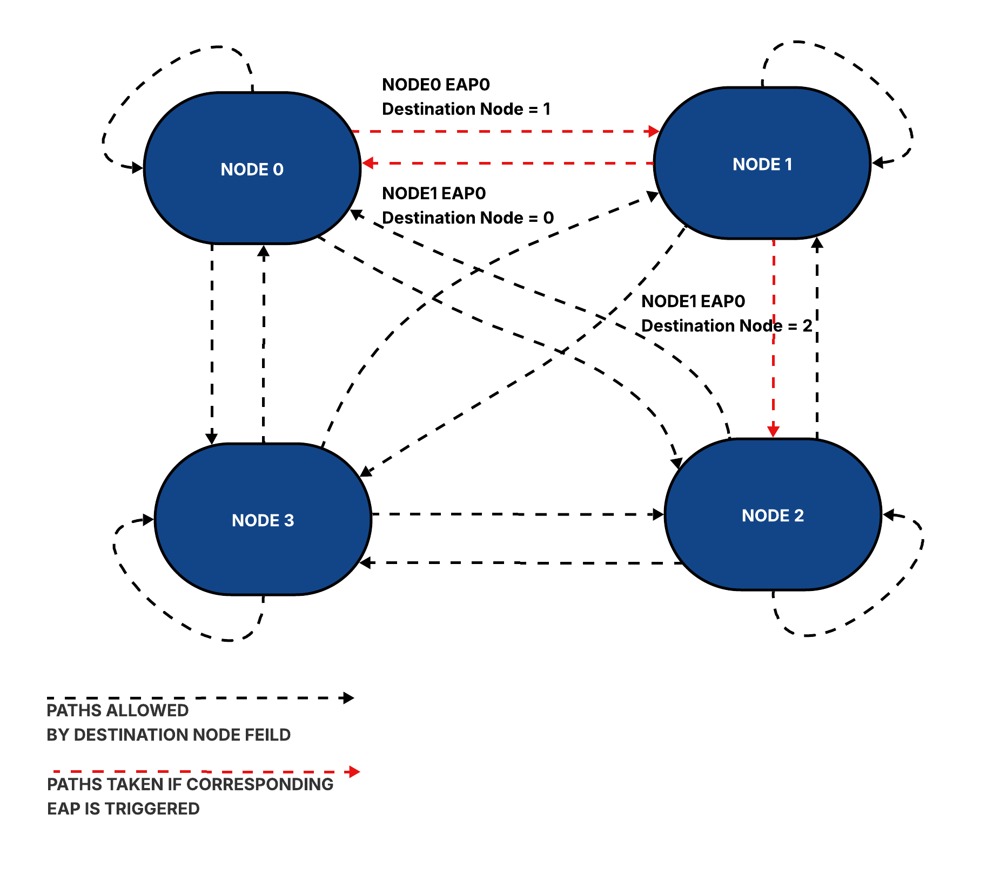
Note: In scenarios where multiple EAPs are triggered simultaneously, the CLA prioritiz
es and switches to the destination node associated with the lowest-numbered EAP. If no EAP events are triggered, the CLA remains in its current node. Users also have the option to configure the CLA to remain in the current node even when an event is triggered.

CLA Registers

The CLA registers are implemented within a 4KiB window with each CLA getting its own register window. The organization of these MMR spaces is discussed in the MMRs chapter.

Following is the table of CLA registers. Please refer to CR Registers.html for register fields.
Register | Description
Counter Config Registers:  CDbgClaCounter<0,1,2,3>Cfg | Configuration for CLA counters used for counting cycles after an event match, and trigger an action on match.
EAP Registers:  CDbgNode0Eap<0,1,2,3>  CDbgNode1Eap<0,1,2,3>  CDbgNode2Eap<0,1,2,3>  CDbgNode3Eap<0,1,2,3> | Action(s) are tied to events(s) using "event-action pairing" registers. CLA supports 4, Each Node has 4 EAPs.
Debug Signal Mask & Match Registers:  CDbgSignalMask<0,1,2,3>  CDbgSignalMatch<0,1,2,3> | CLA Supports 4 sets of Debug Signal Mask and Match. These are used to define debug bus match event. Match event is triggered when debug_bus & mask = match.
Edge Detect:  CDbgSignalEdgeDetectCfg | Register to configure debug bus for edge triggers.
EAP Status:  CDbgEapStatus | Register to indicate if EAP Pair was activated. Use the corresponding w2c register to reset the status. There are 2 bits for each EAP. The bit corresponds to action-0 and action-1 of the EAP. The register is used by SW to know if an action was taken (ex: NMI ISR needs to know which of the EAP triggered the NMI)
CLA Control/Status:  CDbgClaCtrlStatus | Ctrl/Status register to Enable EAP after EAP programming is complete, and read the current node.
Transition Event Registers:  CDbgTransitionMask  CDbgTransitionFromValue  CDbgTransitionToValue | 3 registers to configure "transition event".  TransitionMask register is to select the debug signals of interest for transition events. The transition event is triggered on transition from CDbgTransitionFromValue to CDbgTransitionToValue. This register specifies Value A.
One Count Event:  CDbgOnesCountMask  CDbgOnesCountValue | 2 registers to configure "ones count" event.  CDbgOnesCountMask register is to select the debug signals of interest using a mask. Event triggered when the sum of the unmasked selected signals match the value specified in this register.
Debug Bus Change Event:  CDbgAnyChange | This register is used to trigger an event when the debug bus changes value. The register value is used to select the subset of the debug signals.
Debug Bus Snapshot:  CDbgSignalSnapshotNode0Eap<0,1,2,3>  CDbgSignalSnapshotNode1Eap<0,1,2,3>  CDbgSignalSnapshotNode2Eap<0,1,2,3>  CDbgSignalSnapshotNode3Eap<0,1,2,3> | When the UDF of a EAP returns true, CLA captures the current value of the debug bus in this register. Since we have 16 EAPs, we have 16 “Snapshot” registers, one per EAP.
TimeMatch Event:  CDbgClaTimeMatch | If the value in the register is greater than or equal to the to time register value of the core (core timer is an input to CLA), CLA generates a time match event. Needs to be non zero for the time match event signal to trigger. To stop the event trigger write 0s to this register.
CDbgSignalDelayMuxSel | CLA supports up to 16 lanes in the debug bus. Each lane is 8-bit wide. This register can be used to add 0-3 additional clock delays on each lane before CLA samples the lane.
CDbgClaTimestamp | The 64-bit timestamp of the instance, exposed as TimestampUpper (63:8) and TimestampLower (7:0). Hardware-updated, so a read taken while the instance runs returns a moving value and a software write racing a hardware update is not guaranteed to win. Also exported from the block for correlation with trace.
CDbgClaTimestampConfig | Resync arms a one-shot reload of the timestamp from CDbgClaTimestampSync; TsCapture arms a timestamp capture; DebugMarker is driven continuously on the debug-marker output and is never updated by hardware, so software can tag a window of trace at any time.
CDbgClaTimestampSync | Value loaded into the timestamp counter. The load is a one-shot: write this register, then set Resync, and the next rising edge of cross trigger input 1 performs the load. Hardware clears Resync on completion, so Resync reading 0 is the completion indication. Programming the same sync value in several CLA instances and issuing one cross-trigger pulse aligns them all to a common time value. Available only in the free-running-counter timestamp scheme.
CDbgClaTimestampOffset | Constant displacement this instance holds from a shared reference timestamp. Used only in the reference-tracking timestamp scheme, where software does not write the timestamp itself.
CDbgTimestampCapture | Read-only. With TsCapture set, the next rising edge of cross trigger input 1 writes the upper timestamp bits here, low byte written as 0. Available only in the reference-tracking scheme. Not double buffered.
CDbgCompare<0,1,2,3> CDbgCompare<0,1,2,3>Mask | Four comparison units. Each compares the masked debug bus numerically against its programmed value and provides four events: below, below-or-match, above, above-or-match. In a 128-bit build each value and mask is a Lo/Hi pair.
CDbgLfsr / CDbgLfsrMask | A 63-bit linear-feedback shift register used as a pseudo-random event source for stimulus generation and sampling-based experiments. Lfsr holds the software-seeded state, Mask selects the feedback taps. The source runs only while LfsrActive and EnableEap are both set and exposes the low-order bit of its state as an event. Because the state advances every clock, software needing a stable read must clear LfsrActive first.
CDbgMuxSelLo / CDbgMuxSelHi | Programming interface for the Debug Signal Mux; see the Debug Mux chapter.
CDbgClaXtriggerTimestretch | Multiple CLAs can “talk” to each other using cross triggers. The value in this register extends pulse duration to detect the cross trigger..

CLA Programming Support

To ease CLA programming, a CLA Compiler is part of an open source package. CLA compiler compiles an abstract description of a CLA program into csr register values. This makes programming the CLA easier and less error-prone, since you do not need to manually calculate mux selects, match, or mask CSRs.
Please refer to https://github.com/tenstorrent/tt-dfd/tree/main/scripts/cla_compiler for more details.

Debug Mux
The Debug Signal Mux (DBM) exists because the number of signals of debug interest greatly exceeds the number that can be sampled at once. The DBM selects among input lanes of a fixed lane width to form the output lanes of the same width that make up the debug bus.

Structure
Lane width is a build-time choice of 8 or 16 bits and applies to input and output lanes alike. The number of output lanes is the debug bus width divided by the lane width: four for a 64-bit bus on 16-bit lanes, eight for a 64-bit bus on 8-bit lanes or a 128-bit bus on 16-bit lanes, and sixteen for a 128-bit bus on 8-bit lanes. The number of input lanes is a separate build-time parameter and must be at least the output lane count. The maximum number of input lanes is a function of the select width and the number of output lanes. We use 6-bit mux selects (field width in the MMR) giving us a total of 2⁶ selections. Accounting for static lanes (see next section), the maximum number of input lanes is:
2⁶ -1 + NUM_OUTPUT_LANES

(NUM_OUTPUT_LANES = DEBUG_SIGNAL_WIDTH/LANE_WIDTH)

Lane Mapping
The first N input lanes, where N is the output lane count, are statically mapped to the correspondingly numbered output lanes and are selected by a mux select value of 0 - the default, which reproduces a straight-through debug bus. A non-zero select value n on an output lane connects it to upper input lane (N + n - 1). Any upper input lane can therefore be routed to any output lane, while a static input lane appears only on its own output lane. Select values addressing an input lane beyond the configured input lane count have no mapping and must not be programmed.

Operating Modes
A design normally contains several DBMs. Each is given a unique ID at instantiation and the DBM control registers are broadcast to all of them: only the DBM whose ID matches the DbmId field latches the controls, which keeps the register cost independent of the number of DBMs. DbmMode selects one of four modes: 0 - off, input and output disconnected; 1 - normal debug mode, output driven per the mux select fields; 2 - ID output mode, output equal to the DBM ID; 3 - toggle ID output mode, output alternating every cycle between the DBM ID and its complement. Modes 2 and 3 need no lane programming and are used to prove that the ID decode and the observation path are alive.

Programming
CDbgMuxSelLo holds one 6-bit mux select field per output lane for lanes 0 to 7, together with the DbmId, DbmMode, FineGrainTime and Valid fields. CDbgMuxSelHi holds the selects for output lanes 8 to 15 and is required only in a build whose derived output lane count is 16.

Debug Signal Trace
Debug Signal Trace (DST) enhances traditional post-silicon hardware debug data collection by providing improved visibility into design states. Unlike conventional methods (scan and array dump) that capture a single snapshot at the point of failure, DST traces a selected set of design signals over multiple cycles leading up to the failure. This trace data can be stored in on-chip memory (SRAM) or off-chip system memory.
The post-processing of this stored trace data not only aids in debug visibility but also enables the creation of post-silicon coverage points. DST data is timestamped, allowing for correlation with instruction trace data, thereby extending its utility to software performance analysis.
To facilitate adoption and ease of use, DST's control register definition mirrors that of the RISC-V Trace Control Interface, a standard familiar to the RISC-V debug community. DST minimizes memory storage requirements through signal compression. It leverages existing triggers from the RISC-V Debug Specification and also incorporates user-configurable triggers based on a select set of design signals.

Debug Signal Trace Data
DST Trace Data is generated when input debug bus signals change. The compression applied is selected by software in trDstControl.trDstFormat: XOR compression only, XOR plus "Variable Length Transmission" (VLT) compression (the reset default), or no compression at all. In VLT mode only the bytes that changed are transmitted, with Byte Enables in the packet header indicating their positions; the term "variable length" indicates that the number of bytes transmitted varies with the debug bus activity. With compression disabled, every packet is a header followed by the unmodified debug bus.

Frames
Both Debug Signal Trace and N-Trace instruction data produce variable-length packets. The trace generator must arbitrate with the Trace Sink (SRAM/SMEM) for transfer size allocation due to this variability. Implementing a configurable, fixed transfer size simplifies this arbitration. Aligning the transfer size to the maximum memory or on-chip bus transfer boundary further allows software to minimize penalties from unaligned access and optimize memory bandwidth. To achieve a configurable fixed transfer size, the Tt-dfd hardware packs packets into frames before transmitting them to the trace sink. Tt-dfd also incorporates "filler packets" for both instruction and debug signal traces to generate a complete frame upon "trace flush.".

DST Packets
DST packets are of two types- Trace Data Packets and Trace Support Packets. Trace Data Packets are used for transmitting debug signals. Trace Support Packets provide additional data to assist with debugging and decoding, such as timestamps. Future definitions can be added to Trace Support Packets as needed.

Trace Data Packet
Packet Format
Header1 (Byte-1) | Header0 (Byte-0)
Byte Enables  (8 bits) | Pkt Type (1’b0) | Src Id  (4 bits) | Pkt Loss  (1 bit) | Trace Info  (2 bits)
Payload0 (Byte -3 - ..[9]) | Payload0 (Byte -2)
Payload: Variable size,  May go up to 8 bytes | Payload: Variable size,  May go up to 8 bytes

For 128-bit debug bus, the payload may go up to 16 bytes. An additional Header2 is added at Byte-2 to provide the byte enables for the 8 additional payload bytes.

Header Decode for Trace Data Packet
Name | Bits | Meaning
Packet Type | Hdr0[7] | 1’b0: Trace Data Packet. Use this table for decoding Trace Packet.
Source ID | Hdr0[6:3] | Source ID. Can support up to 16 sources.
Packet Loss | Hdr0[2] | Set to 1 if prior packet(s) were lost. Packets can be lost due to trace network bandwidth constraints.
Trace Info | Hdr0[1:0] | 2’b01: Trace Start  2’b10: Trace Stop  2’b11: Trace Sync (periodic sync w/ all BE-s set to 1 and all debug bus bytes transmitted, irrespective of byte lane content. This resets the SW decoding logic. Useful to recover from losses.
Byte Enables | Hdr1[7:0] | Hdr1[7:0] for a 64-bit debug bus; Hdr1[7:0] and Hdr2[7:0] for a 128-bit debug bus. Each bit indicates whether the corresponding byte lane of the debug bus is changing and is transmitted; there is one Byte Enable bit per byte lane. The number of bytes in the payload equals the number of Byte Enables set to 1. The total length of the packet is the payload length plus the header length, which is 2 bytes for a 64-bit debug bus and 3 bytes for a 128-bit debug bus. A packet with all Byte Enables set to 0 is legal and is used to flush the pipeline. The packet emitted when tracing stops and the pipeline is flushed is always a full-width packet, so its declared length matches that of a normal VLT packet in every configuration.

Trace Support Packet
Packet Format
Header1 (Byte-1) |  | Header0 (Byte-0)
Support Form  (4 bits) | Support Info  (4 bits) | Pkt Type (1’b1) | Src Id  (4 bits) | Pkt Loss  (1 bit) | Header Extended  (1 bit) | Null Packet (1bit)
Payload0 (Byte -3 - ..[9]) |  | Payload0 (Byte -2)
Payload: Variable size,  May go up to 8 bytes |  | Payload: Variable size,  May go up to 8 bytes
Header Decode for Trace Support Packet
Name | Bits | Meaning
Packet Type | Hdr0[7] | 1’b1: Trace Support Packet. Use this table for decoding Trace Packet.
Source ID | Hdr0[6:3] | Source ID. Can support up to 16 sources.
Packet Loss | Hdr0[2] | Set to 1 if prior packet(s) were lost.
Header Extended | Hdr0[1] | If set to 1, next byte is header, else data
Null Packet | Hdr0[0] | If set to 1, this is a null packet. Used to fill frames.
Support Form, | Hdr1[7:4] | 4’b0000: Time Stamp.  Use of other fields:  Support Info: Not Used  Payload: 64-bit timestamp counter  4’b0001: Trace Info Update  Use of other fields:  Support Specific Info: Not Used  Payload: None
Support Info | Hdr1[3:0] | 4’b0001: Trace Start, 4’b0010: Trace Stop

Debug Signal Trace Hardware
Debug Signal has two high level blocks - DST Trace Generator and Packetizer. DST Trace Generator takes incoming debug bus and trace control signals, and compresses the packet to generate “VLT Packets” (details in next section). The Packetizer (reused for Instruction Trace as well) interfaces the Trace Generator with Trace Network.
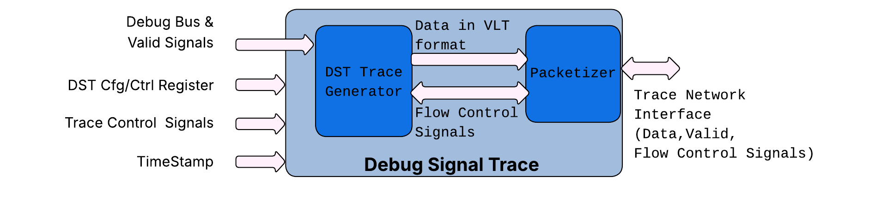

DST Trace Generator
The DST trace generator converts incoming debug signals, timestamps and generates a compressed data stream called “VLT” packets. Details on different VLT packet formats are listed in the DST Packets section. The DST produces traces based on configuration registers and trace control signals (start, stop, and flush).

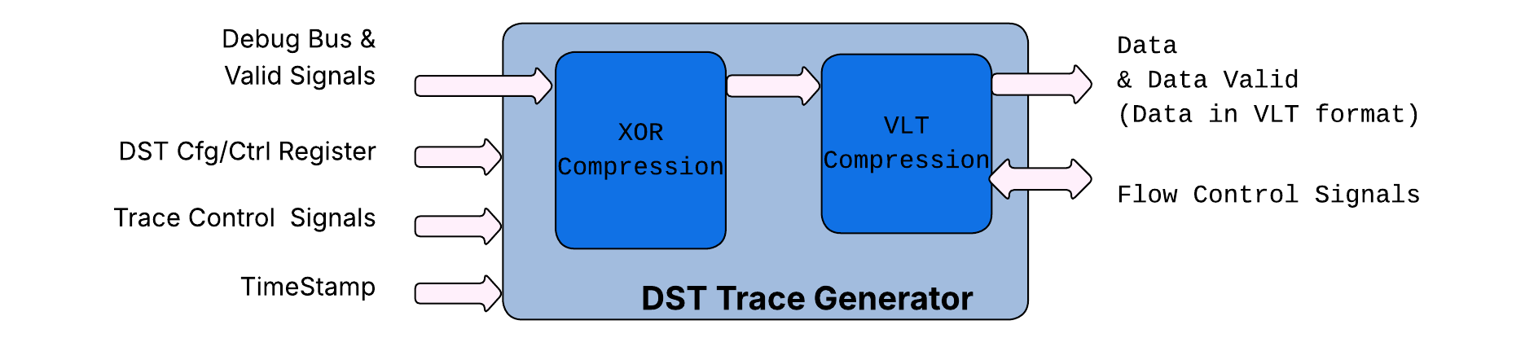
The DST Trace Generator can apply two compression stages, XOR compression and Variable Length Transmission (VLT) compression, and software selects which of them are active through trDstControl.trDstFormat (bits 26:24). Bit 0 of the field enables XOR compression and bit 1 enables VLT compression. The supported values are 0 (no compression - every packet is a header followed by the unmodified debug bus), 1 (XOR only) and 3 (XOR plus VLT, the reset default). Value 2 is not a supported encoding and must not be programmed.XOR compression transmits data only when incoming data changes. However, this method is less effective for debug buses that monitor multiple, often uncorrelated hardware signals. For instance, if signals A, B, and C (part of a debug bus) each change on consecutive clock cycles (e.g., A on cycle 0, B on cycle 1, C on cycle 2), and this pattern repeats, XOR compression provides minimal benefit. VLT offers an improvement over XOR. Instead of tracking data changes across the entire width of the debug bus, VLT monitors changes at the byte-lane level. Only the changed bytes are transmitted, with Byte Enables indicating their positions. The "variable length" aspect refers to the fact that the number of transmitted bytes varies according to the debug bus input.
XOR Compression is implemented by dfd_xor_compression & VLT compression by dfd_vlt_packet_compression.
Details on different VLT packet formats and compression schemes are listed in the chapter DST Packets.

Packetizer

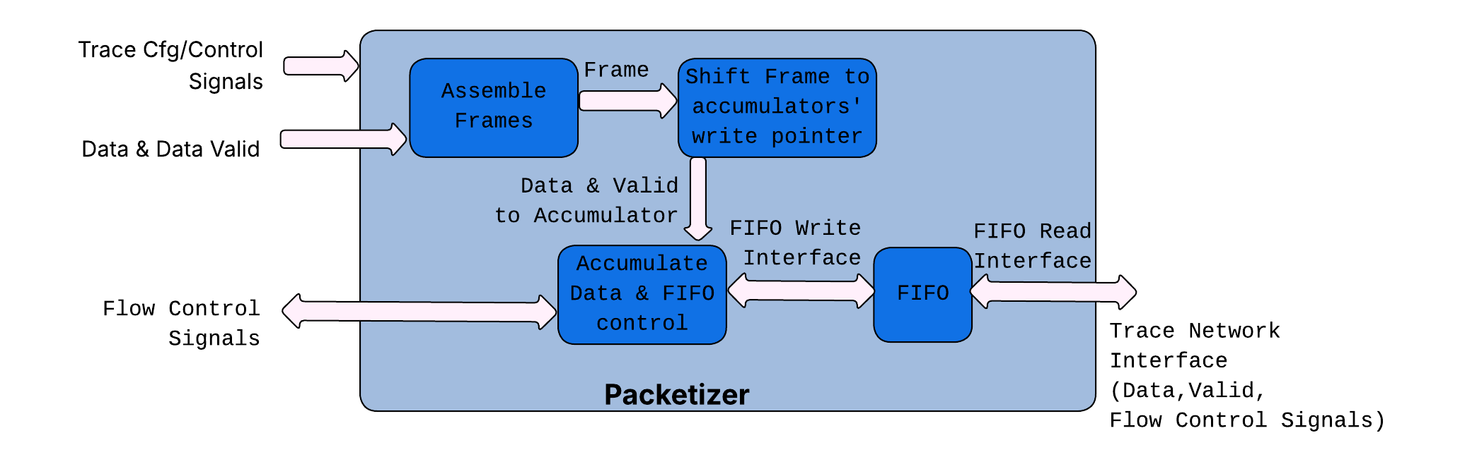
The Packetizer transforms variable-length packets into a continuous data stream, which is then sent to a FIFO. It only accepts a packet if there is enough space to accommodate it. If a packet is not accepted, it is dropped and the packet loss bit is set in the header of the next packet to indicate this. This FIFO's read port serves as the interface to the trace network. The Packetizer comprises four primary blocks:
- dfd_frame_filler: Responsible for assembling incoming packets into frames.
- dfd_cross_connect: Shifts frames to align with the valid data currently held in the accumulator.
- dfd_accumulator: Accumulates and assembles data, then transfers it for writing to the FIFO.
- generic_FIFOMN: A FIFO used for buffering data and interfacing with the trace network.

Instruction Trace
Instruction tracing enables tracking program flow through program counters. It utilizes the N-Trace format, as detailed in the RISC-V N-Trace (Nexus-based Trace) Spec.
The Instruction Trace comprises a Trace Encoder and a Packetizer. The Trace Encoder interfaces with the Core via the HART2TE Interface, generating N-Trace Packets for the Packetizer. These n-Trace packets are then transmitted by the Packetizer to the Trace Sink over the TNIF interface. Further details about the Packetizer can be found in the dedicated section: Packetizer.

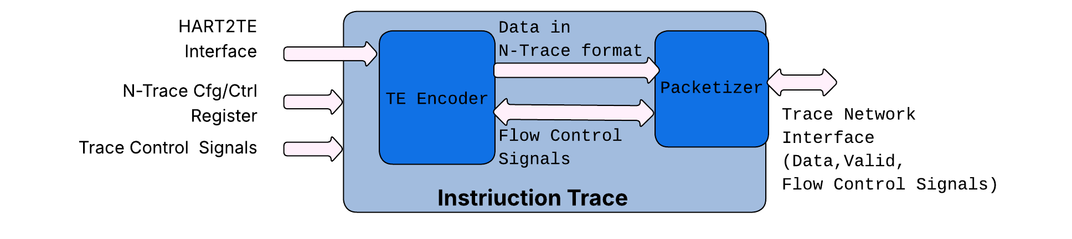

Trace Encoder
The trace encoder block creates an instruction trace, which includes history generation, according to the N-trace packet specification. The trace encoder (TE) processes a maximum of two branches per cycle and operates in two distinct modes. In lossless (throttle) mode, the TE asserts the backpressure signal to the core (when Trtecontrol.Trteinststallena == 1) to prevent FIFO overflow in the encoder. The core must stop instruction retire when backpressure is asserted. Conversely, in loss mode, the TE signals a packet loss using an N-Trace error message if an overflow occurs.
The following figure describes the overview of the interface from hart to the Trace Encoder block:
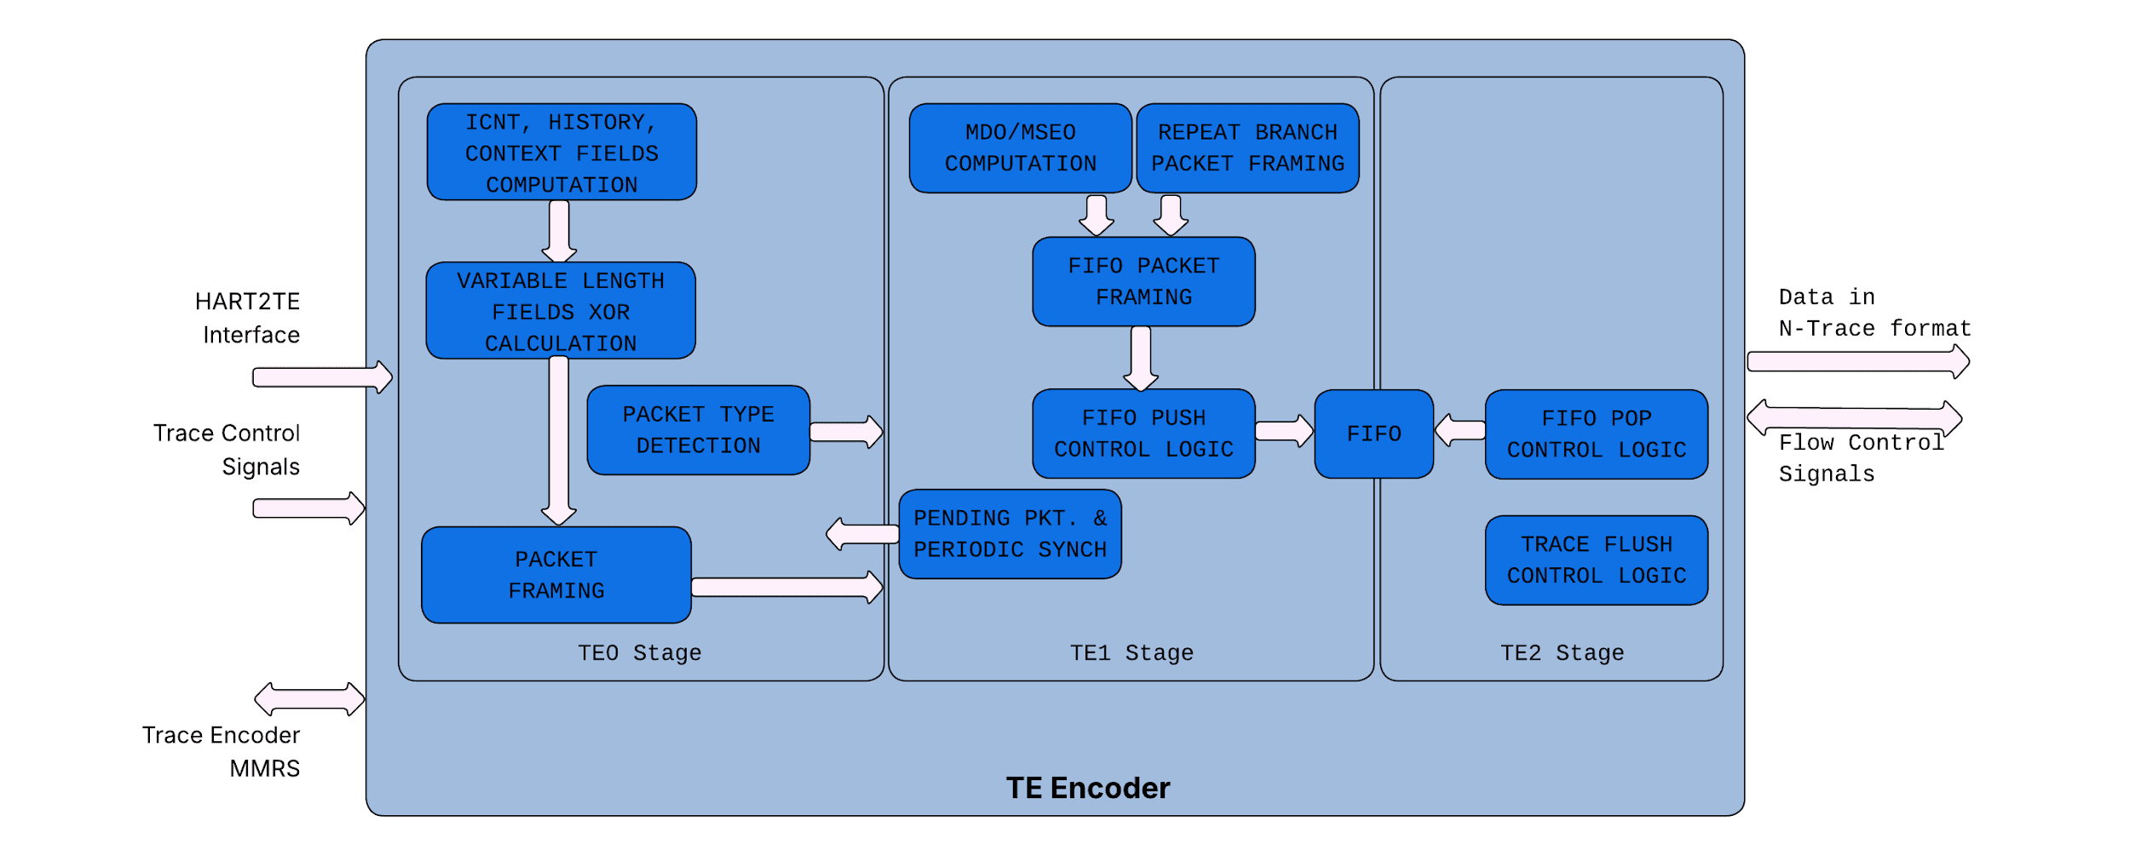

HART2TE Interface
When the Core executes a jump to a PC that is not aligned with the current instruction's boundary, it sends a "block" to the Trace Encoder. This action commonly occurs during interrupt, exception, or branch instructions. The core communicates details of the block using HART2TE Interface as listed below (This is borrowed from HART2TE interface as listed in RISCV Debug Spec).
List of Trace Encode signals exposed at tt-dfd top level.
Core to TE | Description
IRetire | Number of halfwords represented by instructions retired in this block
IType | Termination type of the block
IAddr | The address of the 1st instruction retired in the block
ILastSize | The size of the last retired instruction in the block.  0: Compressed  1: Uncompressed
Priv | Privilege level for all instruction in all the block(s)
Context | Context for all the instructions in the block
Tval | The associated trap values
Tstamp | Time generated by core

TE to Core | Description
Active | Indicates state of Trace Cfg register Trtecontrol.Trteactive.
StallModeEn | Indicates state of Trace Cfg register Trtecontrol.Trteinststallena.
StartStop | Start Trace.  (Trtecontrol.Trteenable & Trtecontrol.Trteactive ==1).
Backpressure | Backpressure to core to avoid packet loss due to TE Encoder FIFO overflow.

Encoder Build Time Parameter
Trace Encoder has following configurable parameters:
Parameter | Description | Default Value
IRETIRE_WIDTH | Width of the retired-instruction count carried on the hart-to-TE interface | 5
PC_WIDTH | Program-counter width; the address field carries bits PC_WIDTH-1 down to 1 | 64
CONTEXT_WIDTH | Width of the hart context input reported in Ownership messages | 32
TVAL_WIDTH | Width of the trap-value input reported in the VendorDefined message | 64
TSTAMP_WIDTH | Width of the timestamp input | 64

Trace Generator Packets
The following packets are supported by the trace encoder:
Packet | Comments
Ownership Packet | Sent on context and privilege change
ProgTraceSync | Start of the trace
Error | Supported when stalling is disabled
ResourceFull | For both HIST and ICNT bits
IndirectBranchHist(Sync) | HTM mode supported
RepeatBranch | HRepeat is enabled and cannot be disabled.
ProgTraceCorrelation | Trace stop
VendorDefined | Used for xcause and xtval reporting

Trace Network Interface (TNIF)
The Trace network manages and grants requests from various blocks. Blocks, like a RISC-V core can produce both instruction trace and debug signal trace. The trace network interface locally arbitrates between these two sources before transmitting the trace information.
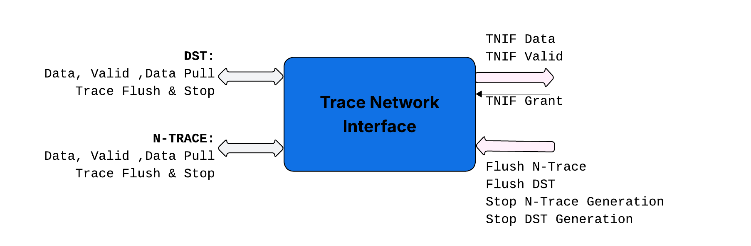
Flush signals force intermediate buffers between the trace generator and sink to empty out. Stop signals, enable the trace sink to apply back-pressure, preventing the generator from producing more data and thus avoiding overflow.

Trace Network
The trace network facilitates the transfer of packets from trace generators to the trace sink. These packets are then stored in trace SRAM or System Memory. The trace network itself consists of multiple trace hops, each with pre-defined build-time parameters for adding repeater flops, which helps in minimizing routing timing constraints.

Trace Hops
Trace Hop consolidates trace traffic from upstream Trace hops and the closest trace generator. This combined traffic is forwarded downstream to the trace funnel. Trace Hop includes parameters (NUM_REPEATER_STAGES) that allow for the addition of repeater flop stages downstream, which helps to alleviate routing constraints.
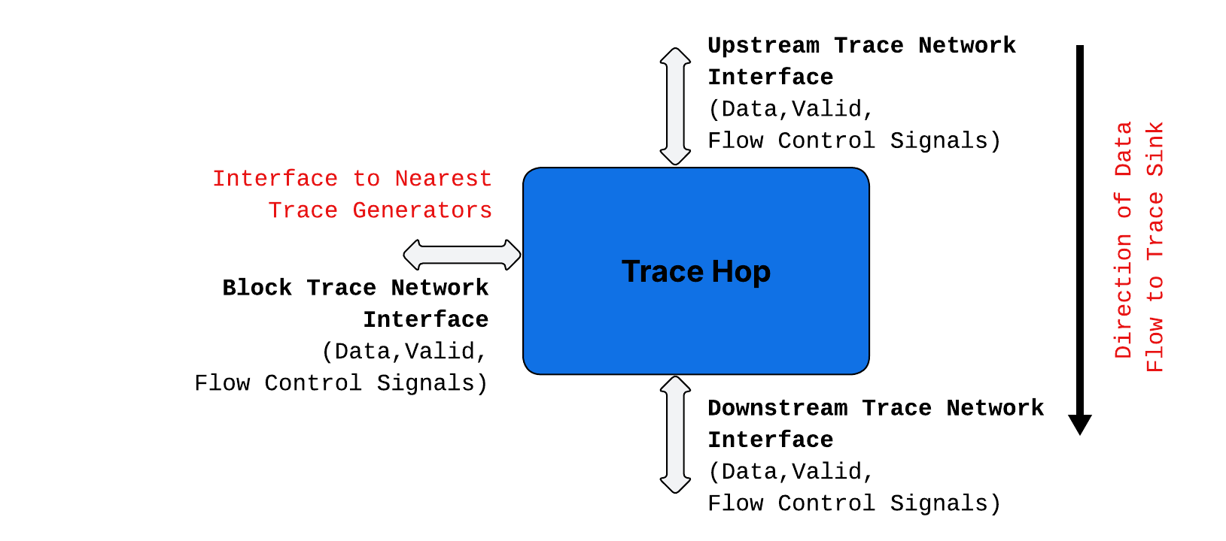

Building a trace network
The Trace Sink accommodates two trace network interface channels, North and South, configurable at build time. Each channel carries up to four trace-generating blocks, so a full network serves up to eight blocks, each of which can present both an instruction-trace and a debug-signal-trace source. A single-block configuration is a first-class topology in which all trace flows on the North channel and the South branch is absent by design rather than stubbed out - in the network, in the funnel and in the funnel's south-side enabled-source reporting. For odd block counts greater than one, the North path carries one more block than the South. The funnel's enabled-source fields are sized for a ceiling of eight instruction-trace and eight debug-signal-trace sources independently of the configured block count.
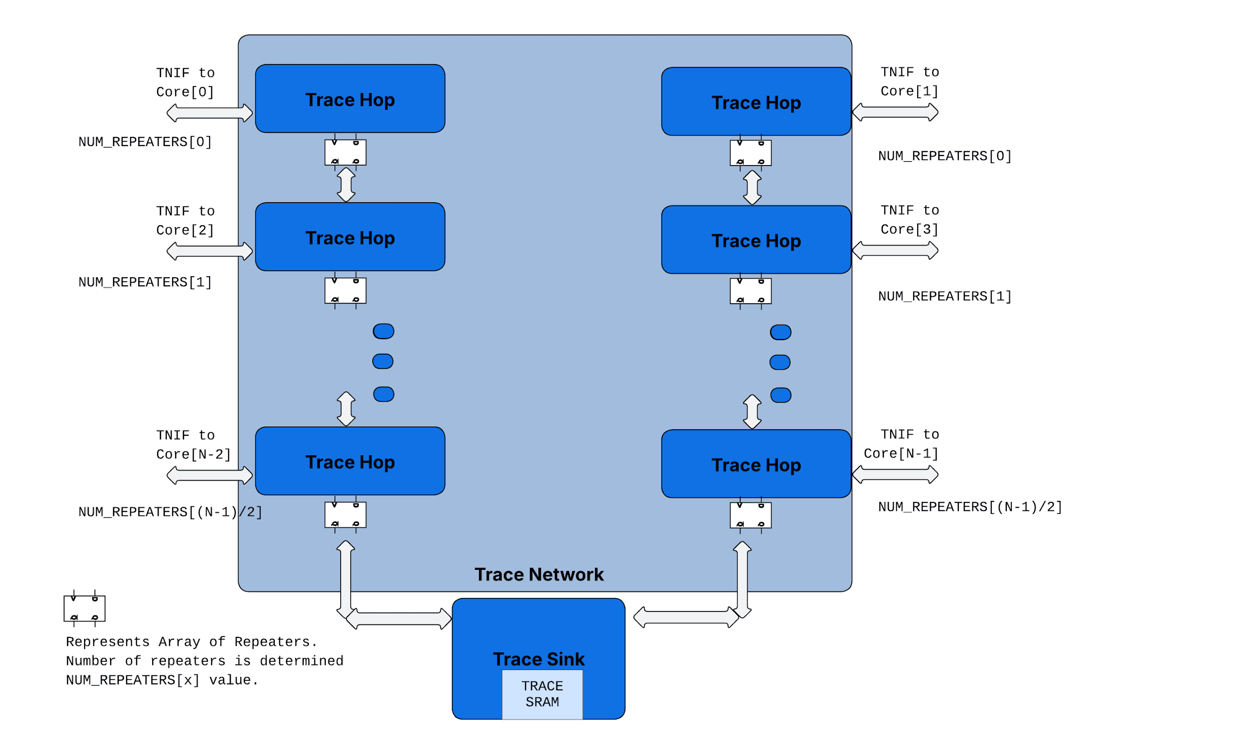

Trace Grant
Data is “pulled” from the Block (Trace Generator) on "Trace Grant." This grant is generated locally at each trace hop, utilizing time-slots and back pressure signals from the funnel. At each hop, a grant is provided to the connected block based on pre-defined time slots.

If a channel has N/2 enabled blocks, each block receives one grant every N/2 clock cycle. The grant delivery is synchronized across all blocks on the channel, with a delay parameter adjusted according to the physical layout and the number of repeaters.

Because the grant period is a direct function of the number of enabled sources, the membership of that set must not change while the channel is carrying trace. Tracing must be stopped and the disabled sources map must be set to 0 before it is programmed with a valid map.

Trace Funnel
The trace funnel consolidates trace traffic from two channels, directing it to the trace sink. It features a Trace RAM for "SRAM Mode" storage. In "SMEM Mode," the trace funnel utilizes an AXI interface to transfer trace data to system memory.

Trace Sink SRAM
The trace sink SRAM size is selected at build time as 8, 16, 32 or 64 KiB, with a default of 16 KiB. It is always organised as eight 64-bit-wide macrocell instances with a width of 64. This organization allows the macros to be split between DST and N-Trace and used as two virtual SRAMs when both sources are active, and it enables further banking schemes that allow reads from one bank while another is being written.

Programming Guide

Instruction Trace
N-Trace Encoder, and components of Trace Funnel use control and data flow as described in RISC-V Trace Control Interface Specification.

Debug Signal Trace
The RISC-V Trace Control Specification, originally designed for instruction trace, also governs the programming sequence for Trace components for Debug Signal Trace. The registers defined in the Trace Control Interface Specification are duplicated for Debug Signal Trace (DST). The table below details the registers reused by the DST implementation from the Trace Control Specification. Standardizing register definitions for the Debug Signal Trace extension, as per the Trace Control Specification, allows for reuse of SW stack across instruction trace and debug signal trace.

Three implementation properties differ from the specification and must be honoured by software:

• trDstControl.trDstActive, the sink's RAM Active bit and trFunnelControl.trFunnelActive are each the functional clock enable of their domain. A domain is clock-gated until its own Active bit is written, so Active must be set, and read back, before any other programming of that domain takes effect. Register windows remain accessible while Active is 0, so configuration written beforehand is retained.
• Writing Active to 0 does not clear the corresponding Enable field. Software must clear Enable explicitly, and before clearing Active, rather than treating Active = 0 as a reset of the component.
• A control-register write is an ordinary per-field write; it does not restore the other fields of that register to their defaults. Software must write every field it depends on explicitly, which matters because several fields do not reset to 0, among them trDstControl.trDstFormat (reset 3) and trDstImpl.trDstVendorFrameLength (reset 1).

Trace Control Registers |  | Name and Fields of equivalent registers for DST
Name | Fields | Name | Fields
trTeControl |  | trDstControl
 | trTeActive |  | trDstActive
 | trTeEnable |  | trDstEnable
 | trTeInstTracing |  | trDstInstTracing
 | trTeEmpty |  | trDstEmpty
 | trTeInstMode
 | trTeContext
 | trTeInstTriggerEnable |  | trDstInstTriggerEnable
 | trTeInstStallOrOverflow
 | trTeInstStallEna
 | trTeInhibitSrc
 | trTeSyncMode |  | trDstSyncMode
 | trTeSyncMax |  | trDstSyncMax
 | trTeFormat |  | trDstFormat
trTeImpl |  | trDstImpl
 | trTeVerMajor |  | trDstVerMajor
 | trTeVerMinor |  | trDstVerMinor
 | trTeCompType |  | trDstCompType
 | trTeProtocolMajor |  | trDstProtocolMajor
 | trTeProtocolMinor |  | trDstProtocolMinor
 | trTeVendorFields |  | trDstVendorFields
trTeInstFeatures |  | trDstInstFeatures
 | trTeInstNoAddrDiff
 | trTeInstNoTrapAddr
 | trTeInstEnRepeatedHistory
 | trTeSrcID |  | trDstSrcID
 | trTeSrcBits |  | trDstSrcBits
trRamControl |  | trDstRamControl
 | trRamActive |  | trDstRamActive
 | trRamEnable |  | trDstRamEnable
 | trRamEmpty |  | trDstRamEmpty
 | trRamMode |  | trDstRamMode
 | trRamStopOnWrap |  | trDstRamStopOnWrap
trRamImpl |  | trDstRamImpl
 | trRamVerMajor |  | trDstRamVerMajor
 | trRamVerMinor |  | trDstRamVerMinor
 | trRamCompType |  | trDstRamCompType
 | trRamHasSRAM |  | trDstRamHasSRAM
 | trRamHasSMEM |  | trDstRamHasSMEM
 | trRamVendorFrameLength |  | trDstRamVendorFrameLength
trRamStartLow |  | trDstRamStartLow
 | trRamStartLow |  | trDstRamStartLow
trRamStartHigh |  | trDstRamStartHigh
 | trRamStartHigh |  | trDstRamStartHigh
trRamLimitLow |  | trDstRamLimitLow
 | trRamLimitLow |  | trDstRamLimitLow
trRamLimitHigh |  | trDstRamLimitHigh
 | trRamLimitHigh |  | trDstRamLimitHigh
trRamWPLow |  | trDstRamWPLow
 | trRamWrap |  | trDstRamWrap
 | trRamWPLow |  | trDstRamWPLow
trRamWPHigh |  | trDstRamWPHigh
 | trRamWPHigh |  | trDstRamWPHigh
trRamRPLow |  | trDstRamRPLow
 | trRamRPLow |  | trDstRamRPLow
trRamRPHigh |  | trDstRamRPHigh
 | trRamRPHigh |  | trDstRamRPHigh
trRamData |  | trDstRamData
 | trRamData |  | trDstRamData
trFunnelControl
 | trFunnelActive
 | trFunnelEnable
 | trFunnelEmpty
trFunnelImpl
trFunnelDisInput
 | TrFunnelDisInput [7:0] |  | trFunnelDisInput[15:8]

Programming Sequence
The programming guide follows trace control spec. It is summarized here for completeness.

Enabling Trace
- Release all needed components from reset by setting tr??Active = 1 (Set tr??Active and read back the same)
- RAM Sink Configuration
- Program the RAM Mode config (RMW)
- Discovery of trRamStart and trRamLimit (Incase of SRAM mode)
- Program the required trRamStart/Limit (Both the modes, RMW)
- Program StoponWrap or Overflow condition
- Clear the trRamWpLow and trRamWpHigh, trRamRpLow/High (Read back 0’s)
- Enable RAM (trRamEnable, RMW)
- Funnel Configuration
  - Ensure Funnel disinput is 0
- Program the Funnel disinput (If needed to disable few cores for funnel)
- Enable Funnel (trFunnelEnable)
- Trace Encoder
- Program Periodic Sync, Stall/Error configs etc, (RMW)
- Program Vendorfields (Frame length – If needed)
- Set Enable and InstrTracing (RMW)

Trace Stop and Reading out Trace Data
- Trace Encoder
- Clear Enable bit (RMW)
- Wait for trTeEmpty to be High
- Funnel
- Clear Enable bit (RMW)
- Wait for trFunnelEmpty to be High
- Sink
- Clear RamEnable bit (RMW)
- Wait for trRamEmpty to be High
- Start the trace RAM reads (in case of SRAM mode)
- In case of SMEM mode, empty is set when all AXI writes are done
- SRAM RAM Reading
  - StoponWrap Mode
- Poll for trRamEnable to check for StopOnWrap (Later version)
- Read WpLow, RpLow
- Read Ramdata till WpLow == RpLow
- Overflow Mode (WpLow.Wrap is set)
- Read from WpLow till LimitLow
- Read from StartLow to WpLow

Integration

This section lists the ports and parameters in the dfd IP to facilitate integration.

Parameters
Name | Description | Default value | Valid values
NUM_CLA_INST | Number of CLA instances | 8 | 1-8
NUM_DST_INST | Number of DST instances | 8 | 1-8
NUM_NTRACE_INST | Number of Ntrace instances | 8 | 1-8
DEBUGMARKER_WIDTH |  | 8 | 1-8
TRC_SIZE_IN_KB | Size of the trace sink | 32 | 1,2,4,8,16,32
TSEL_CONFIGURABLE |  | 0 | 0
TRC_RAM_INDEX | Depth of trace sink | 512 | 512,256,128,64,32,16
SINK_CELL | Trace sink cell enum | mem_rf_rw1_r0_w0_512x64_s
MMR_BASE_ADDRESS | Base address for dfd MMR space | 0
MMR_ADDR_WIDTH | Address width used for MMR space | 17
MMR_DATA_WIDTH | Data width used for MMR space | 32 | 32
MMR_AXI_ID_WIDTH | AXI ID width in MMR access path (only in AXI variant) | 4
MMR_AXI_USER_WIDTH | AXI user width in MMR access path (only in AXI variant) | 8
DEBUG_SIGNAL_WIDTH | Width of debug bus | 64 | 64,128
LANE_WIDTH | Lane width in debug bus | 8 | 8,16
NUM_INPUT_LANES | Number of input lanes | 8 | >=NUM_OUTPUT_LANES
CONTEXT_WIDTH | Width of the hart context input reported in Ownership messages | 32
IRETIRE_WIDTH | Width of the retired-instruction count carried on the hart-to-TE interface | 5
PC_WIDTH | Program-counter width; the address field carries bits PC_WIDTH-1 down to 1 | 64
TVAL_WIDTH | Width of the trap-value input reported in the VendorDefined message | 64
TRC_AXI_ADDR_WIDTH | Address with used for trace AXI master | 52
TRC_AXI_ID_WIDTH | ID width used for trace AXI master | 4
TRC_AXI_USER_WIDTH | User width used for trace AXI master | 8
TRC_AXI_DATA_WIDTH | DATA width used for trace AXI master | 512
TRC_BASE_ADDRESS | Base address for trace | 0
TSTAMP_WIDTH | Timestamp width | 64
TIMESTAMP_SYNC_SCHEME |  | 0 | 0,1
OCTS_TS_OUTPUT | Supply OCTS timestamp to DST | 0 | 0,1

Ports

Port Name | direction | Type | Description
i_clk | input | logic | Clock
i_rst_n | input | logic | Synchronous reset
i_mem_tsel_settings | input | logic [10:0] | Memory cell configuration
i_debug_bus_signals | input | logic [NUM_CLA_INST-1:0][NUM_INPUT_LANES-1:0][LANE_WIDTH-1:0] | Debug Bus signals
i_cla_time_tick | input | logic [NUM_CLA_INST-1:0] | Time increment pulse
i_cla_xtrigger | input | logic [NUM_CLA_INST-1:0][XTRIGGER_WIDTH-1:0] | Cross trigger in
o_cla_xtrigger | output | logic [NUM_CLA_INST-1:0][XTRIGGER_WIDTH-1:0] | Cross trigger out
o_cla_debug_marker | output | logic [NUM_CLA_INST-1:0][DEBUGMARKER_WIDTH-1:0] | CLA debug marker
o_cla_external_action_halt_clock_out | output | logic [NUM_CLA_INST-1:0] | Global clock halt
o_cla_external_action_halt_clock_local_out | output | logic [NUM_CLA_INST-1:0] | Local clock halt
o_cla_external_action_debug_interrupt_out | output | logic [NUM_CLA_INST-1:0] | Debug interrupt
o_cla_external_action_toggle_gpio_out | output | logic [NUM_CLA_INST-1:0] | GPIO toggle
o_cla_external_action_custom | output | logic [NUM_CLA_INST-1:0][CLA_NUMBER_OF_CUSTOM_ACTIONS-1:0] | Custom action bus
i_timestamp | input | logic [NUM_CLA_INST-1:0][63:0] | Timestamp for DST
i_octs_timestamp | input | logic [NUM_CLA_INST-1:0][63:0] | OCTS timestamp input
i_ref_timestamp | input | logic [NUM_CLA_INST-1:0][55:0] | Reference timestamp used by TIMESTAMP_SYNC_SCHEME=1
i_cla_ext_posedge | input | logic [NUM_CLA_INST-1:0] | Detects posedge in connected signal
o_debug_mux_sel | output | DbgMuxSelMmr_s [NUM_CLA_INST-1:0] | External Debug Mux programming interface
i_ntr_hart_te_iretire | input | [NUM_NTRACE_INST-1:0][NUM_BLOCKS_NTR_WRAPPER-1:0][IRETIRE_WIDTH-1:0] | Per-block retire count for the cycle
i_ntr_hart_te_itype | input | [NUM_NTRACE_INST-1:0][NUM_BLOCKS_NTR_WRAPPER-1:0][ITYPE_WIDTH_NTR_WRAPPER-1:0] | Per-block retire type
i_ntr_hart_te_iaddr | input | [NUM_NTRACE_INST-1:0][NUM_BLOCKS_NTR_WRAPPER-1:0][PC_WIDTH-1:1] | Per-block address of the retired instruction
i_ntr_hart_te_ilastsize | input | [NUM_NTRACE_INST-1:0][NUM_BLOCKS_NTR_WRAPPER-1:0] | Per-block size indicator of the last instruction retired in the cycle
i_ntr_hart_te_tstamp | input | [NUM_NTRACE_INST-1:0][TSTAMP_WIDTH-1:0] | Timestamp of the retire cycle for each N-Trace instance
i_ntr_hart_te_priv | input | logic [NUM_NTRACE_INST-1:0][2:0] | Current hart privilege mode
i_ntr_hart_te_context | input | logic [NUM_NTRACE_INST-1:0][CONTEXT_WIDTH-1:0] | Hart context value reported in the context field of trace packets
i_ntr_hart_te_tval | input | logic [NUM_NTRACE_INST-1:0][TVAL_WIDTH-1:0] | Trap value (tval) of the retiring exception
i_ntr_hart_te_error | input | logic [NUM_NTRACE_INST-1:0] | Error indication from the hart
o_ntr_tr_active | output | logic [NUM_NTRACE_INST-1:0] | Encoder active status per N-Trace instance
o_ntr_tr_stall_mode_en | output | logic [NUM_NTRACE_INST-1:0] | Mirrors the trTeInstStallEna control bit
o_ntr_tr_start_stop | output | logic [NUM_NTRACE_INST-1:0] | Instruction-trace start/stop state sent to the core
o_ntr_tr_start_backpressure | output | logic [NUM_NTRACE_INST-1:0] | Backpressure request to the hart
i_sdtrig_control | input | logic [MAX_DST_NTR_INST_NTR_WRAPPER-1:0][1:0] | Trace control from the debug trigger module
i_vid_map | input | logic [NUM_CORES_TRACE_WRAPPER-1:0][NUM_CORES_WIDTH_TRACE_WRAPPER-1:0] | Per-core virtual-ID map used by the trace funnel to tag trace sources
m_trc_axi_* aw/w/ar request signals | output | flattened AXI4 signals | AXI4 master write-address; write-data and read-address channels the trace sink uses to write trace data to memory
m_trc_axi_* b/r response and ready signals | input | flattened AXI4 signals | AXI4 master write-response and read-data channels plus ready signals returned by the memory system to the trace sink
i_jtag_mmr_req_addr | input | logic [MMR_ADDR_WIDTH-1:0] | Address of a JTAG MMR access
i_jtag_mmr_req_data | input | logic [MMR_DATA_WIDTH-1:0] | Write data of a JTAG MMR access
i_jtag_mmr_req_vld | input | logic | JTAG MMR request valid
i_jtag_mmr_req_we | input | logic | JTAG MMR write enable: 1 for a write; 0 for a read
o_jtag_mmr_rsp_data | output | logic [MMR_DATA_WIDTH-1:0] | Read data returned for a JTAG MMR access
o_jtag_mmr_rsp_vld | output | logic | JTAG MMR response valid
paddr | input | logic [MMR_ADDR_WIDTH-1:0] (17b) | APB address of the MMR access
psel | input | logic | APB select for the MMR interface
penable | input | logic | APB enable; marking the access phase of a transfer
pstrb | input | logic [MMR_PSTRB_WIDTH_MMRS-1:0] | APB write byte strobes
pwrite | input | logic | APB direction
pwdata | input | logic [MMR_DATA_WIDTH-1:0] | APB write data
pready | output | logic | APB ready
prdata | output | logic [MMR_DATA_WIDTH-1:0] | APB read data
pslverr | output | logic | APB slave error response for the transfer
i_critical_signal_hold | input | logic | While high, the warm-reset override keeps the critical state of the MMR blocks from being reset
i_test_icg_en | input | logic | DFT test enable for the integrated clock gates

