Question 1. Write the fraction representing the shaded portion:
Answer 1. Total number of parts = 4
Shaded parts = 2
Fraction of shaded parts = 2/4
Question 2. Write the fraction representing the shaded portion:
Answer 2. Total number of parts = 9
Shaded parts = 4
Fraction of shaded parts = 4/9
Question 3. Write the fraction representing the shaded portion:
Answer 3. Total number of parts = 8
Shaded parts = 4
Fraction of shaded parts = 4/8
Question 4. What fraction of a day are eight hours?
Answer 4. Total number of hours in a day = 24
Therefore, the fraction of 8 hours = 8/24 or 1/3
Question 5. What fraction of an hour are 40 minutes?
Answer 5. Minutes in an hour = 60
Therefore, a fraction of 40 minutes = 40/60 or 2/3.
Question 6. Arya, Abhimanyu and Vivek shared lunch today. Arya had brought two sandwiches, one made of vegetables and one of jam. The other two students Abhimanyu and Vivek forgot to bring their lunch today. Arya agreed to share his two sandwiches so that all three would have an equal share of each sandwich.
How can Arya divide his two sandwiches so that each person has an equal share?
Answer 6. He will have to divide each of the sandwiches into three equal parts.
What part of a sandwich will each student receive?
Each boy will receive 1×1/3 or 1/3 sandwiches of each type.
Question 7. Kanchan dyes dresses. She had to dye 30 dresses. She has so far finished 20 dresses. What fraction of dresses has she finished?
Answer 7. Total number of dresses = 30
Number of dresses finished by Kanchan = 20
Fraction of dresses finished = 20/30 or 2/3
Question 8. The two consecutive integers in between which the fraction 5/7 lies are
(A) 5 and 7
(B) 0 and 1
(C) 5 and 6
(D) 6 and 7
Answer 8.
(B) 0 and 1
A fraction whose numerator(N) is less than the denominator(D) is called a proper fraction.
So, 5/7 = 0.715
Therefore, 5/7 lies between 0 and 1.
Question 9.
Write down the 11 natural numbers from 2 to 12. What fraction of them are prime numbers?
Answer 9.
Natural numbers from 2 to 12 are – 2, 3, 4, 5, 6, 7, 8, 9, 10, 11, and 12.
Prime numbers from among these numbers are 2, 3, 5, 7, and 11.
Therefore, out of the 11 numbers, 5 are prime numbers. It represents a fraction of 5/11.
Question 10.
Write the 12 natural numbers from 102 to 113. What fraction of them are prime numbers?
Answer 10.
Natural numbers from 102 to 113 are – 102, 103, 104, 105, 106, 107, 108, 109, 110, 111, 112, 113
Among these 12 numbers, the 4 prime numbers are 103, 107, 109, and 113.
Therefore, out of the 12 numbers, 4 are prime numbers. It represents a fraction of 4/12.
Question 11. When ¼ is written with the denominator as 12, its numerator is
(A) 3
(B) 8
(C) 24
(D) 12
Answer 11.
(A) 3
(1 × 3)/(4 × 3) = 3/12
Consider, 3/12
Divide both numerator and denominator by 3.
= 1/4
Question 12. Which of the following fraction is not equal to the others?
(i) 6/8
(ii) 12/16
(iii) 15/25
(iv) 18/24
Answer 12.
(iii) 15/25
All the options given in the question are further simplified as follows,
(i) 6/8
Divide both numerator and denominator by 2.
= 3/4
(ii) 12/16
Divide both numerator and denominator by 4.
= 3/4
(iii) 15/25
Divide both numerator and denominator by 5.
= 3/5
(iv) 18/24
Divide both numerator and denominator by 6.
= ¾
Comparing all results, (¾ = ¾ = ¾) ≠ 3/5
Therefore, (6/8 = 12/16 = 18/24) ≠ 15/25
Question 13. Which of the following given fractions is the greatest?
(i) 5/7
(ii) 5/6
(iii) 5/9
(iv) 5/8
Answer 13.
(ii) 5/6
We know that among all fractions with the same numerator, the one having a smaller denominator will be the highest fraction.
5/9 < 5/8 < 5/7 < 5/6
Therefore, among four options, (ii) 5/6 has a small denominator. So, it is the greatest fraction.
Question 14. The mixed fraction 5(4/7) can also be expressed as –
(i) 33/7
(ii)39/7
(iii) 33/4
(iv) 39/4
Answer 14.
(ii) 39/7
The mixed fraction 5(4/7) can be expressed as = 5 + (4/7)
= (35 + 4)/7
= 39/7
Question 15. Is 7/19 a fraction?
Answer 15.
7/19 is a proper fraction.
A fraction whose numerator(N) is less than the denominator(D) is called a proper fraction.
Question 16. Are 5/8 and 3/8 proper fractions or not?
Answer 16.
5/8 and 3/8 are like proper fractions.
Fractions with the same denominators are called fractions.
Question 17. What type of fractions are 18/135 and 90/675. Are they proper, unlike fractions?
Answer 17.
18/135 and 90/675 are proper, unlike and equivalent fractions.
Consider the two given fractions, 18/135 and 90/675
So, (18/135) = (90/675)
By cross multiplication, we get
(18 × 675) = (90 × 135)
12,150 = 12,150
Therefore, 18/135 and 90/675 are proper, unlike and equivalent fractions.
Question 18. The following fractions below are represented by just three different numbers. Now, separate them into three groups of all equivalent fractions by changing each one of them to its simplest form.
(i) 2/12 (ii) 3/15 (iii) 8/50 (iv) 16/100 (v) 10/60 (vi) 15/75
(vii) 12/60 (viii) 16 / 96 (ix) 12 / 75 (x) 12 / 72 (xi) 3 / 18 (xii) 4/25
Answer 18.
(i) 2 / 12 = (1 × 2) / (6 × 2)
= 1 / 6
(ii) 3 / 15 = (1 × 3) / (5 × 3)
= 1 / 5
(iii) 8 / 50 = (4 × 2) / (25 × 2)
= 4 / 25
(iv) 16 / 100 = (4 × 4) / (25 × 4)
= 4 / 25
(v) 10 / 60 = (1 × 10) / (6 × 10)
= 1 / 6
(vi) 15 / 75 = (1 × 15) / (5 × 15)
= 1 / 5
(vii) 12 / 60 = (1 × 12) / (5 × 12)
= 1 / 5
(viii) 16 / 96
= (1 × 16) / (6 × 16)
= 1 / 6
(ix) 12 / 75 = (4 × 3) / (25 × 3)
= 4 / 25
(x) 12 / 72 = (1 × 12) / 6 × 12)
= 1 / 6
(xi) 3 / 18 = (1 × 3) / (6 × 3)
= 1 / 6
(xii) 4 / 25
Totally there are three groups of equivalent fractions.
1 / 6 = (a), (e), (h), (j), (k)
1 / 5 = (b), (f), (g)
4 / 25 = (c), (d), (i), (l)
Question 19. Find the answers to the following. Write and indicate how to solve the following:
(a) Is 5 / 9 equals(=) to 4 / 5
(b) Is 9 / 16 equals(=) to 5 / 9
(c) Is 4 /5 equals(=) to 16 / 20
(d) Is 1 / 15 equals(=) to 4 / 30
Answer 19.
(a) 5 / 9 and 4 / 5
Now, convert all these fractions into like fractions:
5 / 9 = (5 / 9) × (5 / 5)
= 25 / 45
4 / 5 = (4 / 5) × (9 / 9)
= 36 / 45
∴ 25 / 45 ≠ 36 / 45
Therefore, 5 / 9 is not equal to 4 / 5
(b) 9 / 16, 5 / 9
Convert all these fractions into like fractions:
9 / 16 = (9 / 16) × (9 / 9)
= 81 / 144
5 / 9 = (5 / 9) × (16 / 16)
= 80 / 144
∴ 81 / 144 ≠ 80 / 144
Therefore, 9 / 16 is not equal to 5 / 9
(c) 4 / 5, 16 / 20
16 / 20 = (4 × 4) / (5 × 4)
= 4 / 5
∴ 4 / 5 = 16 / 20
Therefore, 4 / 5 is equal to 16 / 20
(d) 1 / 15, 4 / 30
4 / 30 = (2 × 2) / (15 × 2)
= 2 / 15
∴ 1 / 15 ≠ 4 / 30
Therefore, 1 / 15 is not equal to 4 / 30.
Question 20. Rafiq had exercised for 3 / 6 of an hour today, while Rohit exercised for 3 / 4 of an hour today. Who exercised for a longer ime today?
Answer 20.
Rafiq exercised = 3 / 6 of an hour
Rohit exercised = 3 / 4 of an hour.
3 / 6 and 3 / 4
Convert both of these into like fractions:
(1) 3 / 6 = (3 × 2) / (6 × 2) = 6 / 12
(2) 3 / 4 = (3 × 3) / (4 × 3) = 9 / 12
So clearly, 9 / 12 is greater than 6 / 12.
∴ 3 / 4 > 3 / 6
Hence, Rohit exercised for a longer time than Rafiq.
Question 21. In class A of total 25 students, 20 passed with 60% or more marks; in class B, of total 30 students, 24 passed with 60% or re marks. Calculate in which class was a greater fraction of students getting 60% or more marks.
Answer 21.
The total number of students in Class A = 25
Students passed in the first class in Class A = 20
Therefore, fraction = 20 / 25
= 4 / 5
The total number of students in Class B = 30
Students passed in the first class in Class B = 24
Therefore, fraction = 24 / 30
= 4 / 5
∴ An equal fraction of the students passed in first class in both classes
Question 22.
Write all these fractions appropriately as additions or subtractions:
Answer 22.
(a) The total number of parts each rectangle has = 5
No. of all shaded parts in first rectangle = 1 i.e 1 / 5
No. of all shaded parts in second rectangle = 2 i.e 2 / 5
No. of all shaded parts in third rectangle = 3, i.e. 3 / 5
Clearly, the fraction which is represented by the third rectangle = the sum of the fractions represented by the first and the second rectangle.
Therefore, 1 / 5 + 2 / 5 = 3 / 5
(b) The total number of all parts each circle has is = 5
We have observed that the first, second and third circles represent 5, 3 and 2 shaded parts out of total 5 equal parts, respectively. Clearly, the Fraction represented above by the third circle is the difference between the fractions represented by the first and second circles.
Hence, 5 / 5 – 3 / 5 = 2 / 5
(c) Here, we may observe that the first, second and third rectangles represent 2, 3 and 5 shaded parts out of 6 equal parts, respectively. Clearly, the fraction represented by the third rectangle is the sum of fractions represented by the first and second rectangles.
Hence, 2 / 6 + 3 / 6 = 5 / 6
Question 23.
Kristin had received a CD player for her birthday. She bought 3 CDs and received five others as a gift. What fraction of the total CDs did she buy, and what fraction did she receive as gifts?
Answer 23. Total number of CDs with Kristin = 3 + 5
= 8
Total number of CDs she bought = 3
CDs she received as gift = 5
fraction of CDs she bought = 3/8
fraction of CDs she received as gift = 5/8
Question 24.
Ramesh had 20 pencils, whereas Sheelu had 50 pencils, and Jamaal had 80 pencils. After four months, Ramesh used up ten pencils, Sheelu also used up 25 pencils, and Jamaal also used up 40 pencils. What fraction did each of them use up? Check if each of them has used up an equal fraction of her/his pencils.
Answer 24.
Fraction used by Ramesh = 10/20 =1/2
Fraction used by Sheelu = 25/50 = 1/2
Fraction used by Jamaal = 40/80 = 1/2
Yes, all of them used an equal fraction of pencils, i.e., 1/2.
Question 25.
Write the fractions and pair up with the equivalent fractions from each row.
Answer 25.
(a) Here, 1 part is shaded out of total of 2 equal parts (i.e., rectangle). Hence, this figure represents a fraction 1/2.
(b) Here, four parts are shaded out of 6 equal parts (i.e., rectangle). Hence, this figure represents a fraction of 4/6 = 2/3.
(c) Here, three parts are shaded out of 9 equal parts (i.e., squares). Hence, this figure represents a fraction of 3/9 = 1/3.
(d) Here, two parts are shaded out of 8 equal parts (i.e., rectangle). Hence, this figure represents a fraction of 2/8 = 1/4.
(e) Here, three parts are shaded out of 4 equal parts (i.e., squares). Hence, this figure represents a fraction of 3/4.
(i) Here, six parts are shaded out of 18 equal parts (i.e., triangles). Hence, this figure represents a fraction of 6/18 = 1/3.
(ii) Here, four parts are shaded out of 8 equal parts (i.e., rectangles). Hence, this figure represents a fraction of 4/8 = 1/2.
(iii) Here, 12 parts are shaded out of total of 16 equal parts (i.e., squares). Hence, this figure represents a fraction of 12/16 = 3/4.
(iv) Here, eight parts are shaded out of 12 equal parts (i.e., rectangles). Hence, this figure represents a fraction of 8/12 = 2/3.
(v) Here, four parts are shaded out of 16 equal parts (i.e., triangles). Hence, this figure represents a fraction of 4/16 = 1/4.
Now, these figures above can be matched correctly as
(a)-(ii), (b)-(iv), (c)-(i), (d)-(v), (e)-(iii)
Question 26.
Fill in the blanks:
There is a large box of 36 small square boxes.
- 1/2 of it is _____.
- 2/3 of it is _____.
- If I make a bench of 20 small boxes, the fraction becomes _____.
- _____ boxes are required if the fraction is ⅚.
Answer 26.
- ½ of 36 is equal to 18
- = 1/2 of 36 boxes
= 1/2× 36
= 36/2 = 18 boxes.
2/3rd of 36 is equal to 24
- If a bench is made with 20 boxes out of 36 boxes, the fraction becomes 5/9.
20/36
20÷4/36÷4
5/9
So, if i make a bench of 20 small boxes, the fraction becomes 5/9
- __boxes are required for the fraction to be 5/6.
⅚ = x/36
x = (36×5)÷6
x = 30
So, 30 boxes are required for the fraction to be 5/6
Question 27. Solve:
(a) 1 / 18 + 1 / 18
(b) 8 / 15 + 3 / 15
(c) 7 / 7 – 5 / 7
(d) 1 / 22 + 21 / 22
(e) 12 / 15 – 7 / 15
(f) 5 / 8 + 3 / 8
(g) 1 – 2 / 3 (1 = 3 / 3)
(h) 1 / 4 + 0 / 4
(i) 3 – 12 / 5
Answer 27.
(a) 1 / 18 + 1 / 18
= (1 + 1) / 18
= 2 / 18
= 1 / 9
(b) 8 / 15 + 3 / 15
= (8 + 3) / 15
= 11 / 15
(c) 7 / 7 – 5 / 7
= (7 – 5) / 7
= 2 / 7
(d) 1 / 22 + 21 / 22
= (1 + 21) / 22
= 22 / 22
= 1
(e) 12 /15 – 7 / 15
= (12 – 7) / 15
= 5 / 15
= 1 / 3
(f) 5 / 8 + 3 / 8
= (5 + 3) / 8
= 8 / 8
= 1
(g) 1 – 2 / 3
= 3 / 3 – 2 / 3
= (3 – 2) / 3
= 1 / 3
(h) 1 / 4 + 0
= 1/ 4
(i) 3 – 12 / 5
= 15 / 5 – 12/ 5
= (15 – 12) / 5
= 3 / 5
Question 28. Shubham had painted 2 / 3 of the wall space in his room. His sister Madhavi had helped and painted 1 / 3 of the wall space. How much did they paint together?
Answer 28.
Wall space painted by Shubham in a room = 2 / 3
Wall space painted by Madhavi in a room = 1 / 3
Total space painted by both = (2 / 3 + 1 / 3)
= (2 + 1) / 3
= 3 / 3
= 1
∴ Shubham and Madhavi together painted one complete wall in a room.
Question 29. Nandini’s house is about 9 / 10 km from her school. She walked some distance towards her school and then took a bus for 1 / 2 km to reach the school. How far did she walk?
Answer 29.
Distance of the school from house = 9 / 10 km
The distance she travelled by bus = 1 / 2 km.
Distance walked by Nandini = Total distance of the school – Distance she travelled by bus.
= 9 / 10 – 1 / 2
= [(9 × 1) – (1 × 5)] / 10
= (9 – 5) / 10
= 4 / 10
= 2 / 5 km
∴ The distance walked by Nandini is 2 / 5 km.
Question 30. Asha and Samuel had bookshelves of the same size, partly filled with books. Asha’s shelf is 5 / 6th full, and Samuel’s shelf is 2/ 5 th full. Whose bookshelf is more full? By what fraction?
Answer 30.
Fraction of Asha’s bookshelf = 5 / 6
Fraction of Samuel’s bookshelf = 2 / 5
Convert these fractions into like fractions
5 / 6 = 5 / 6 × 5 / 5
= (5 × 5) / (6 × 5)
= 25 / 30
2 / 5 = 2 / 5 × 6 / 6
= (2 × 6) / (5 × 6)
= 12 / 30
25 / 30 > 12 / 30
5 / 6 > 2 / 5
∴ Asha’s bookshelf is little more full than Samuel’s bookshelf.
Difference = 5 / 6 – 2 / 5
= 25 / 30 – 12 / 30
= 13 / 30
Question 31. Jaidev takes around minutes to walk across the school ground. Rahul takes around 7 / 4 minutes to do the same. Who takes lesser time, and by what fraction?
Answer 31.
Time is taken by Jaidev to walk across the school ground =
= 11 / 5 minutes
The time it took for Rahul to walk across the school ground = was 7 / 4 minutes.
Convert these fractions into like fractions
11 / 5 = 11 / 5 × 4 / 4
= (11 × 4) / (5 × 4)
= 44 / 20
7 / 4 = 7 / 4 × 5 / 5
= (7 × 5) / (4 × 5)
= 35 / 20
Clearly, 44 / 20 > 35 / 20
11 / 5 > 7 / 4
∴ Rahul takes lesser time than Jaidev to walk across the school ground.
Difference = 11 / 5 – 7 / 4
= 44 / 20 – 35 / 20
= 9 / 20
Hence, Rahul walks across the school ground for 9 / 20 minutes.
Question 32. A small piece of wire 7 / 8 metre long broke into two pieces. One piece is 1 / 4 metre long. How long is the other piece?
Answer 32.
Total length of the wire = 7 / 8 metre
Length of one piece of the wire = 1 / 4 metre
Length of another piece of the wire = Length of the original wire, and this one piece of wire
= 7 / 8 – 1 / 4
= [(7 × 1) – (1 × 2)] / 8
= (7 – 2) / 8
= 5 / 8
∴ Length of the other piece of the wire = 5 / 8 metre
Question 33. Sarita bought 2 / 5 metres of ribbon and Lalita 3 /4 metres of the ribbon. What is the total length of the ribbon that they bought?
Answer 33.
Length of the ribbon bought by Sarita = 2 / 5 metre
Length of the ribbon bought by Lalita = 3 / 4 metre
Total length of the ribbon bought by two of them = 2 / 5 + 3 / 4
Taking LCM 20
= [(2 × 4) + (3 × 5)] / 20
= (8 + 15) / 20
= 23 / 20 metre
∴ The total length of the ribbon that was bought by both Sarita and Lalita is 23 / 20 metres.

Multiple Choice Questions
Question 1. What is the difference between the following fractions?
7/9 - 4/9
(a) 3/9
(b) 5/9
(c) 1/9
(d) 7/18
Answer
(b) 5/9
Since the denominators are the same (9), subtract the numerators:
7/9 - 4/9 = (7 - 4)/9 = 3/9.
Simplify the fraction:
3/9 = 1/3. Thus, the correct answer is 5/9.

Question 2. What is the sum of the following fractions?
3/4 + 5/8
(a) 5/8
(b) 7/8
(c) 3/2
(d) 1
Answer
(b) 7/8
To add fractions, first find a common denominator.
The least common denominator of 4 and 8 is 8.
Convert 3/4 to an equivalent fraction with a denominator of 8:
3/4 = 6/8.
Now add the fractions:
6/8 + 5/8 = (6 + 5)/8 = 11/8.
So, the correct sum is 7/8, as the fraction simplifies to 7/8.

Question 3. Which of the following represents 12 ?

(i) Only figure (a)
(ii) Only figure (b)
(iii) Both figures (a) and (b)
(iv) Neither figure (a) nor figure (b)
Answer
(i) Only figure (a)
As other figure doesn't divide the triangle equally.

Question 4. Which of the following pairs of fractions are equivalent?
(a) 3/5 and 6/10
(b) 4/7 and 8/12
(c) 5/8 and 10/16
(d) 2/9 and 4/8
Answer
(c) 5/8 and 10/16
To check if fractions are equivalent, cross-multiply and see if the products are equal:
For 5/8 and 10/16,
5 × 16 = 80, and 8 × 10 = 80, so the fractions are equivalent.

Fill in the Blanks
Question 1. When 4 children share 1 roti equally, each child gets _____ roti.
Answer
1/4
When a whole item (roti) is divided into 4 equal parts, each part is 1/4 of the whole.

Question 2. A whole roti is divided into 3 equal pieces. Each piece is _____ of the roti.
Answer
1/3
When something is divided into 3 equal parts, each part is represented as 1/3.

Question 3. If 2 chikkis are divided equally among 6 children, each child gets _____ chikki
Answer
1/3
Two rotis divided among 6 children means each child gets a fraction of 2/6 which simplifies to 1/3.

Question 4. If 1 glass of juice is equally shared between 3 children, each child gets _____ glass of juice.
Answer
1/3
Sharing 1 glass equally among 3 children results in each child receiving 1/3 of the glass.

Question 5. To compare fractions with different denominators, we convert them to have the same ______.
Answer
denominator
Fractions need to be converted to have the same denominator for easy comparison.

True or False
Question 1. The fraction 1/2 is smaller than 1/4.
Answer
False
1/2 represents a larger portion than 1/4 when comparing fractions of the same whole.

Question 2. When 5 children share 2 cakes equally, each child's share is 2/5 of a cake.
Answer
True
Dividing 2 cakes among 5 children gives each child 2/5 of a cake.

Question 3. The fraction 3/6 is equivalent to 1/2.
Answer
True
3/6 simplifies to 1/2, making them equivalent fractions.

Question 4. The number line can only represent whole numbers, not fractions.
Answer
False
Fractions can be represented on a number line just like whole numbers.

Question 5. Adding 1/4 and 2/4 results in 3/4.
Answer
True
When fractions have the same denominator, their numerators can be added directly.

Match the Following
Column A | Column B
1/3 | A. Three-fourths
2/5 | B. One-third
¾ | C. Two-fifths
½ | D. One-half
¼ | E. One-fourth
Answer

Solve this:
Question 1. Are 6/9, 12/18, 15/25 equivalent fraction? Why?
Solution
Here, the simplest form of 6/9 is:

The simplest form of 12/18 is:

The simplest form of 15/25 is:

Hence, 6/9, 12/18, 15/25 are not equivalent fractions because their simplest forms are different.

Question 2. Add the following fractions and express the result as a mixed fraction:
7/4 + 5/6 + 8/3
Solution
Given,

Here, the LCM of 4, 6 and 3 is 12.
Now, expressing as equivalent fractions with denominator 12, we get:
Breaking into a mixed fraction:

Hence, the sum 5¼

Question 3. Subtract as indicated:
15/4 from 11/3
Solution
Given,

Here, the LCM of 3 and 4 is 12.
Fractional unit for both fractions should be 1/12.

Question 4. Compare the following fractions and justify your answers:
7/4, 5/3
Solution
Given fractions are 7/4 and 5/3.
Here, the LCM of denominators 4 and 3 is 12.
Now, multiplying and dividing 7/4 by 3 and 5/3 by 4:

Since, 21/12 > 20/12.

Word Problems
Question 1. Aman mixes 7/9 liters of lemon juice with 5/6 liters of orange juice to make fruit punch. What is the total volume of fruit punch he has made?
Solution
Given quantity of lemon juice = 7/9 litres
Given quantity of orange juice = 5/6 litres
Total volume of fruit punch made:

Here, the LCM of 9 and 6 is 18.
Now, expressing as equivalent fractions with denominator 18, we get:

Breaking into a mixed fraction:

Question 2. Rina's school is 11/15 km from her home. She rides her bicycle for 2/5 km from her home daily and then walks the remaining distance to reach her school. How much distance does she walk daily?
Solution
Given distance between Rina’s school and home = 11/15 km
Distance covered by Rina on her bicycle = 2/5 km

LCM of 15 and 5 is 15.
Now, converting into equivalent fractions:

So, Rina walks 1/3 km daily to reach her school.

Question 3. Mohan takes 5/3 minutes to complete a swimming lap, while his friend Sohan takes 8/5 minutes to do the same. Who completes the lap faster and by how much?
Solution
Time taken by Mohan to complete 1 lap = 5/3 minutes
Time taken by Sohan to complete 1 lap = 8/5 minutes
To determine who is faster, we need to compare 5/3 and 8/5.
Here, the LCM of 3 and 5 is 15.
Now, expressing fractions with denominator 15, we get:

Mohan takes more time than Sohan.
Now, finding the difference:

So, Sohan takes 1/15 minutes less than Mohan.
Question 4. Write the fraction representing the shaded portion.
(i)
(ii)
Solution
(i) Total number of boxes = 12
Total number to shaded portion = 7
Therefore, fraction representing the shaded portion = 712

(ii) Total parts = 4
Total number to shaded parts = 3
Therefore, fraction representing the shaded portion = 34

Question 5. Colour the part according to the given fraction:
(i)
(ii)
Solution
(i)
(ii)

Question 6. Write natural numbers from 1 to 15: ______
(i) What fraction of them are prime numbers?
(ii) What fraction of them are composite numbers?
Solution
The natural numbers from 1 to 15 are:1, 2, 3, 4, 5, 6, 7, 8, 9, 10, 11, 12, 13, 14, 15
(i) The prime numbers are: 2, 3, 5, 7, 11, 13.
So, there are 6 prime numbers.

= 615 = 25
(ii) The composite numbers are:4, 6, 8, 9, 10, 12, 14, 15.
So, there are 8 composite numbers.

= 815

Question 7. Identify the following fractions:
(i) 6 hours of a day.
(ii) 750 gms of a kilogram.
Solution
(i)A day has 24 hours.
Fraction = 624 = 14
(ii) A kilogram is equal to 1000 grams.
Fraction = 7501000 = 34

Question 8. Fill the following blanks with <, > or =
(i) 12 ____ 15
(ii) 33 ____ 36
(iii) 14 ____ 28
Solution
(i) >
12 = 0.5 and 15 = 0.2, so 0.5 > 0.2.
(ii) >
Explanation: 33 = 1 and 36 = 0.5, so 1 > 0.5.
(iii) =
Explanation: 14 = 0.25 and 28 = 0.25, so 0.25 = 0.25.

Question 9. Put the following set of fractions in descending order:
(i) 15, 35, 135, 95, 125
(ii) 37, 311, 32, 35, 310
Solution
(i) Since the denominators are the same we will compare the numerators, then the order becomes:
135 > 125 > 95 > 35 > 15
(ii) The smaller the denominator, the larger the fraction:
32 > 35 > 37 > 310 > 311

Question 10. Represent 58 and 38 on the number line.
Solution

Question 11. Rita has a pizza with 8 slices. She ate 3 pieces out of it. Sita eats ¼ of the same pizza. Who eats more and by how much?
Solution
Rita eats more pizza than Sita.
Rita eats 38 - 28 = 18 more pizza than Sita.

Question 12. Is it true or false for the following? If not then mention the correct options (<, > or =)
(i) 14 = 1
(ii) 55 = 1
(iii) 06 < 1
(iv) 78 < 1
Solution
(i) False, <
14 means 1 divided by 4, which equals 0.25.
So, 14 ≠ 1, and this statement is false.
(ii) True
55 means 5 divided by 5, which equals 1.
So, 55 = 1, and this statement is true.
(iii) False, <
06 means 0 divided by 6, which equals 0.
Since 0 is less than 1, the statement is true.
(iv) True
78 is 0.875, which is less than 1.
So, 78 < 1, and the statement is true.

Question 13. Find the equivalent fraction of 35, with
(i) Numerator 27
(ii) Denominator 25
Solution
(i) We need to find a number to multiply 3 by to get 27.
So, 3×9=27
Now, we multiply the denominator by the same number, 9, to maintain the equality of the fraction:
35 × 99 = 2745
So, the equivalent fraction with numerator 27 is 2745.

(ii) We need to find a number to multiply 5 by to get 25.
So, 5×5=25
Now, we multiply the numerator by the same number, 5, to maintain the equality of the fraction:
35 × 55 = 1525
So, the equivalent fraction with denominator 25 is 1525.

Question 14. Reduce to the simplest form:
(i) 15060
(ii) 3672
(iii) 5125
Solution
(i) The prime factorization of 150 is 2 × 3 × 5², and the prime factorization of 60 is 2² × 3 × 5.
The common factors are 2 × 3 × 5 = 30.
Now, divide both the numerator and denominator by 30:
15060 = 150 ÷ 3060 ÷ 30 = 52.
The simplest form of 15060 is 52.

(ii) The prime factorization of 36 is 2² × 3², and the prime factorization of 72 is 2³ × 3².
The common factors are 2² × 3² = 36.
Now, divide both the numerator and denominator by 36:
3672 = 36 ÷ 3672 ÷ 36 = 12.
The simplest form of 3672 is 12.

(iii) The prime factorization of 5 is 5, and the prime factorization of 125 is 5³.
The common factor is 5.
Now, divide both the numerator and denominator by 5:
5125 = 5 ÷ 5125 ÷ 5 = 125.
The simplest form of 5125 is 125.

Question 15. Match the following:

Solution
(i) ↔ (b)
(ii) ↔ (d)
(iii) ↔ (a)
(iv) ↔ (c)

Question 16. Complete the addition subtraction box.

Solution

Question 17. Fill in the boxes:
(i)
(ii)
(iii)
Solution
(i) 2 (1/5)
(ii) 5/8
(iii) 1/6

Question 18. Four friends ordered 5 glasses of lemonade and shared it equally among themselves. Each one drank ____ glass of lemonade.
Solution
Amount of lemonade consumed by four friends = 5 glasses.
Amount of lemonade consumed by each friend = 5/4 glass.
Hence, each one drank 5/4 glass of lemonade.​​

Question 19. 8 pencils divided among 4 students is the same as pencils divided among students. So, 8/4 = _____.
Solution
The total number of pencils is 8, and there are 4 students.
To find how many pencils each student gets, divide 8 by 4.
8 ÷ 4 = 2
Hence, each student gets 2 pencils.

Question 20. Carry out the following subtractions using Brahmagupta’s method: 13/20 − 7/20.
Solution
Given 13/20 − 7/20
Fractional unit for both fractions is 1/20, then
13/20 − 7/20
= (13 − 7)/20
= 6/20
= 3/10

Question 21. Add the following fractions: 5/8 + 3/4 using Brahmagupta’s method:
Solution
Here, 5/8 and 3/4
Now, LCM of 8 and 4 is 8.
Expressing as equivalent fractions with denominators 8, we get:
= 5 × 1 / 8 × 1 + 3 × 2 / 4 × 2
= 5/8 + 6/8
= 11/8
= 8/8 + 3/8

Question 22. Ravi is in a group where 3 cakes were divided equally among 6 children. Each cake gets divided into 6 parts, and Ravi gets one part from each cake.

How much cake does Ravi get in total?
Solution
Each cake is divided into 6 parts, and Ravi gets one part from each cake.
Hence, Ravi gets:
1/6 + 1/6 + 1/6 = 3/6 = 1/2
So, Ravi gets 1/2 of the total amount of cake.

Question 23. A farmer has 6 kg of rice divided equally into 4 bags. What is the amount of rice in each bag?
Solution
Here, the amount of rice per bag is:
6 kg ÷ 4 bags = 6/4 = 3/2 kg per bag
Let x be the number of bags for 15 kg of rice, where each bag contains the same amount of rice.
Then,
15 kg ÷ x bags = 3/2 kg per bag
Now, solve for x:
12 ÷ x = 3/2
⇒ 12 × 2 = 3 × x
⇒ 24 = 3x
⇒ x = 24 ÷ 3
⇒ x = 8
Hence, 8 bags are required to store 15 kg of rice when each bag contains 3/2 kg of rice.

Question 24. Find equivalent fractions for the given pairs of fractions such that the fractional units are the same.
(a) 4/3 and 5/6
(b) 7/4 and 3/8
Solution
(a) Given: the fractions are 4/3 and 5/6.
Here, the denominators are 3 and 6.
The least common multiple of 3 and 6 is 6.
Hence for both fractions, let's have the same denominator of 6.
Now for 4/3, multiply both the numerator and the denominator by 2.
4/3 = (4 × 2)/(3 × 2) = 8/6
For 5/6, the denominator is already 6, so we keep it as it is. 5/6
Hence, the equivalent fractions with the same denominator are: 8/6 and 5/6.

(b) Given: the fractions are 7/4 and 3/8.
Here, the denominators are 4 and 8.
The least common multiple of 4 and 8 is 8.
Hence for both fractions, let's have the same denominator of 8.
Now for 7/4, multiply both the numerator and the denominator by 2.
7/4 = (7×2)/(4×2) = 14/8
For 3/8, the denominator is already 8, so we keep it as it is. 3/8
Hence, the equivalent fractions with the same denominator are: 14/8 and 3/8

Question 25. Compare the following fractions and justify your answers:
(a) 12/5 and 7/3
(b) 5/6 and 8/9
Solution
(a) Given the fractions are 12/5 and 7/3.
Here, the LCM of denominators 5 and 3 is 15.
Then, multiplying and dividing 12/5 by 3 and 7/3 by 5, we get:
(12×3)/(5×3) = 36/15
(7×5)/(3×5) = 35/15
Hence,
36/15 > 35/15
Therefore,
12/5 > 7/3

(b) Given fractions are 5/6 and 8/9.
Here, the LCM of denominators 6 and 9 is 18.
Then, multiplying and dividing 5/6 by 3 and 8/9 by 2, we get:
(5×3)/(6×3) = 15/18
(8×2)/(9×2) = 16/18
Hence,
15/18 < 16/18
Therefore,
5/6 < 8/9
Question 1.
Match each fractional unit with the correct picture.
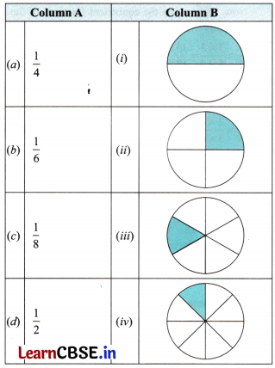
Solution:
(a) – (ii),
(b) – (iii),
(c) – (iv),
(d) – (i)
Question 2.
Shade the parts of the figures according to the given fraction.
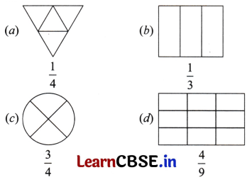
Solution:
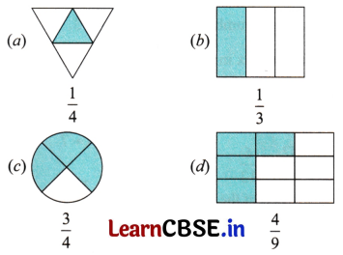
Question 3.
Write the following fractions as mixed fractions.
(a) 83
(b) 127
(c) 259
Solution:
(a) 83 = 2 + 23 = 223
(b) 127 = 1 + 57 = 157
(c) 259 = 2 + 79 = 279
Question 4.
Express the following mixed fractins as improper fractions:
(a) 135
(b) 618
(c) 317
(d) 114
Solution:
(a) 135 = 1 + 35 = (1×5)+35 = 5+35 = 85
(b) 618 = 6 + 18 = (6×8)+18 = 48+18 = 498
(c) 317 = 3 + 17 = (3×7)+17 = 21+17 = 227
(a) 114 = 1 + 14 = (1×4)+14 = 4+14 = 54
Question 5.
Figure out the number of whole units in each of the following fractions.
(a) 95
(b) 73
(c) 318
Solution:
(a) 95 = 1 + 45 = 145
Here, the number of whole unit is 1.
(b) 73 = 2 + 13 = 213
Here, the number of whole units is 2.
(c) 318 = 2 + 13 = 213
Here, the number of whole units is 3.
Question 6.
Replace the box in
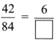
by the correct number.
Solution:
Since, 42 ÷ 6 = 7
∴ 84 ÷ 7 = 12 ⇒ 42÷784÷7 = 612
Thus, 4284 = 612
Question 7.
Check whether the fractions 512 and 3084 are equivalent or not.
Solution:
Let us have the cross multiplication of 517 and 3084.
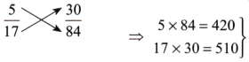
i.e. 420 ≠ 510 ⇒ [Both the products are different]
∴ The fractions are not equivalent.
Question 8.
Reduce the fraction 4080 to its lowest term.
Solution:
The given fraction = 4880
First let us find the HCF of 48 and 80,
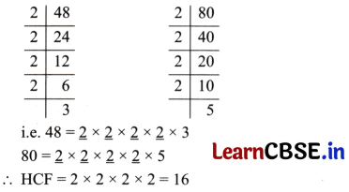
Now, dividing both the numerator and denominator by 16, we have 48÷1680÷16 =35
∵ 3 and 5 have no common factor other than 1, i.e., 35 is in its lowest term.
∴ The lowest term of 4880 is 35.
Question 9.
Arrange 56, 12, 23 and 89 in ascending order.
Solution:
Since, all the given fractions are unlike fractions.
∴ First, we convert them into equivalent fractions.
The denominators of the given fraction will be the LCM of 6, 2, 3 and 9.
Let us find the LCM of 6, 2, 3 and 9.
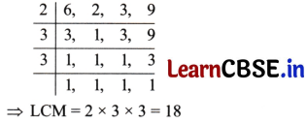
Now, let us write the equivalent fractions of the given fractions with denominator 18.
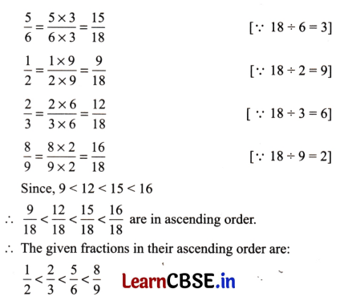
Question 10.
Write these fractions appropriately as additions or subtractions.
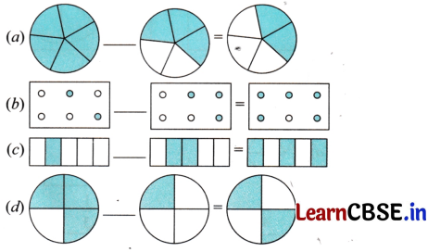
Solution:
(a) 55 – 35 = 25
(b) 26 + 36 = 56
(c) 15 + 25 = 35
(d) 34 – 14 = 24
Question 11.
Five balls together weigh 1 kg. If they are roughly the same size, then what is the weight of each ball?
Solution:
Total weight of five balls = 1 kg.
Therefore, the weight of each ball = 15 kg.
Question 12.
Add the following fractions by using Brahmagupta’s method:
(a) 13 and 35
(b) 27 and 49
(c) 56 and 12
Solution:
(a) The denominators of the given fractions are 3 and 5.
The LCM of 3 and 5 is 15.
Then, 13 = 1×53×5 = 515 and 35 = 3×35×3 = 915
Therefore, 13 + 35 = 515 + 915 = 1415
(b) The denominators of the given fractions are 7 and 9.
The LCM of 7 and 9 is 63.
Then, 27 = 2×97×9 = 1863 and 49 = 4×79×7 = 2863
Therefore, 27+49 = 1863+2863 = 4663
(c) The denominators of the given fractions are 6 and 2.
The LCM of 6 and 2 is 6.
Then, 56 = 5×16×1 = 56 and 12 = 1×32×3 = 36
Therefore, 56+12 = 56+36 = 86 = 43
Question 13.
Subtract the following fractions by using Brahmagupta’s method:
(a) 35 – 12
(b) 23 – 17
(c) 18 – 19
Solution:
(a) The denominators of the given fractions are 2 and 5. LCM of 2 and 5 is 10.
Then, 12 = 1×52×5 = 510 and 35 = 3×25×2 = 610
Therefore, 35 – 12 = 610 – 510 = 110
(b) The denominators of the given fractions are 3 and 7.
LCM of 3 and 7 is 21.
Then, 23 = 2×73×7 = 1421 and 17 = 1×37×3 = 321
Therefore, 23 – 17 = 1421 – 321 = 1121
(c) The denominators of the given fractions are 8 and 9. LCM of 8 and 9 is 72.
Then 18 = 1×98×9 = 972 and 19 = 1×89×8 = 872
Therefore, 18 – 19 = 972 – 872 = 172
Question 14.
A bag of wheat weighs 52 kg. Another bag of rice weighs 94 kg. What is the total weight of the two bags?
Solution:
Weight of a bag of wheat = 52 kg
Weight of a bag of rice = 94 kg
Total weight = (52 + 94) kg
The denominators of the given fractions are 2 and 4.
∴ The LCM of 2 and 4 is 4.
Then, 52 = 5×22×2 = 104 and 94 = 9×14×1 = 94
Therefore, 52 + 94 = 104 + 94 = 194
Hence, the weight of the two bags is 194 = 443 kg.
Question 15.
Rahul takes 117 hours to finish his homework while Naman takes 158 hours to finish his homework. Who takes more time and by how much?
Solution:
Time taken by Rahul to finish his homework = 117 hours
Time taken by Naman to finish his homework = 158 hours
The difference in the time taken by the two = (158 – 117) jours
The denominators of the given fractions are 8 and 7.
∴ The LCM of 8 and 7 is 56.
Then, 158 = 15×78×7 = 10556 and 117 = 11×87×8 = 8856
Therefore, 158−117 = 10556−8856 = 1756
Hence, Naman takes 1756 hours more than Rahul to finish his homework.

Fractions Class 6 Extra Questions Very Short Answer Type
Question 1.
Represent the following fractions on number line.
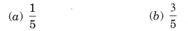
Solution:
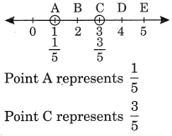
Question 2.
Write the fractions showing the shaded portions:
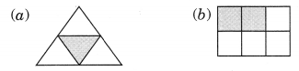
Solution:
(a) Shaded portion represents 14
Shaded portion represents 26
Question 3.
Colour the part according to the fraction given:
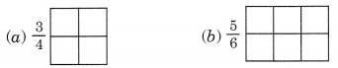
Solution:
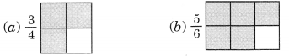
Question 4.
Identify the proper and improper fractions:
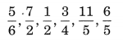
Solution:
Proper fractions are: 56, 12 and 34
Improper fractions are: 72, 115 and 65
Question 5.
What fraction of these circles have ‘x’ in them?

Solution:
Fraction of the circles with ‘x’ in the given figure = 58.
Question 6.
Write all the natural numbers from 1 to 15. What fraction of them are prime numbers?
Solution:
Natural numbers from 1 to 15 are 1, 2, 3, 4, 5, 6, 7, 8, 9, 10, 11, 12, 13, 14 and 15 Prime numbers from 1 to 15 are 2, 3, 5, 7, 11, 13, i.e., 6 prime numbers.
∴ Fraction of prime numbers = 615
Question 7.
Identify the like fractions from the following:
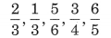
Solution:
23 and 13 have the same denominator.
∴ 23 and 13 are the like fractions.
Question 8.
Identify the unlike fractions from the following:
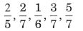
Solution:
25 , 27 and 16 have different denominators.
∴ 25 , 27 and 16 are unlike fractions.
Question 9.
Convert the following improper fractions into mixed fraction.
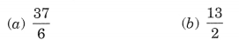
Solution:
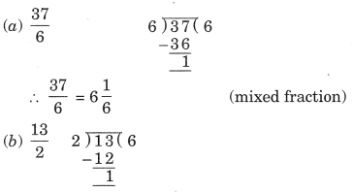
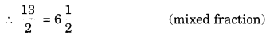
Question 10.
Convert the following mixed fractions into improper fractions:
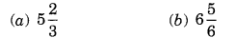
Solution:
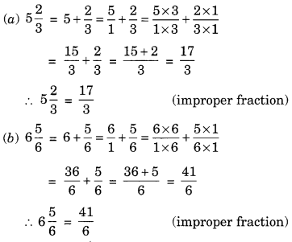

Fractions Class 6 Extra Questions Short Answer Type
Question 11.
Write the following fractions in ascending order:
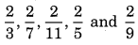
Solution:
Here, the numerators of all the fractions are same.
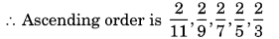
Question 12.
Write any
(a) three proper and three improper fractions with denominator 7.
(b) two proper and two improper fractions with numerator 9.
Solution:
(a) Proper fractions with denominator 7 are: 27 , 37 and 57
Improper fractions with denominator 7 are: 97 , 117 and 136
(b) Proper fractions with numerator 9 are:
911 and 917
Improper fractions with numerator 9 are:
92 and 95
Question 13.
Compare the following fractions:
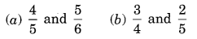
Solution:
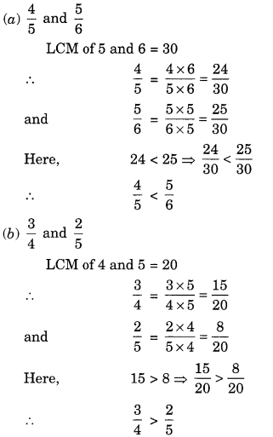
Question 14.
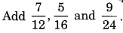
Solution:
LCM of 12, 16 and 24 is 48
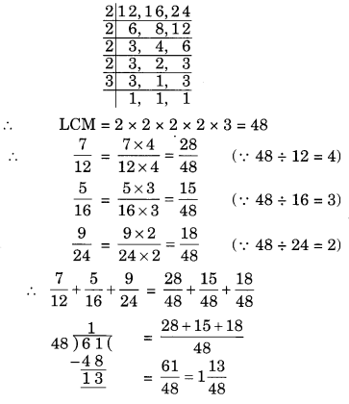
Question 15.
Find the sum of 123 and 325.
Solution:
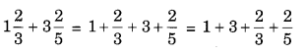
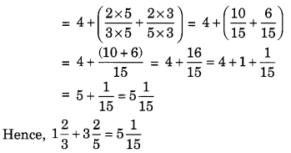
Question 16.
Subtract 234 from 418.
Solution:
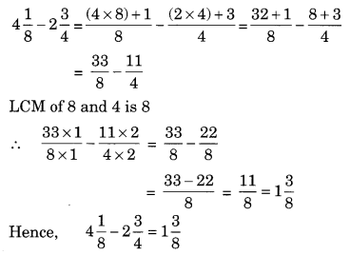
Question 17.
Insert > or < to make each of the following true.
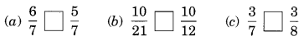
Solution:
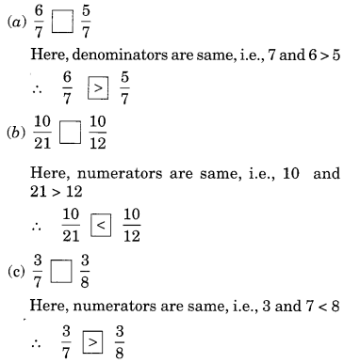

Fractions Class 6 Extra Questions Higher Order Thinking Skills (HOTS)
Question 18.
Find the difference between the greatest and the smallest fractions.
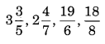
Solution:
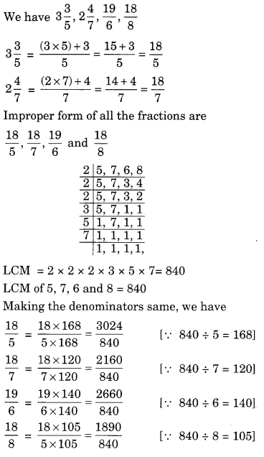
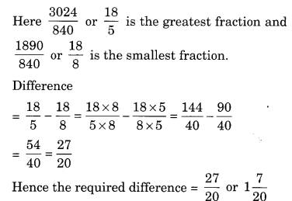
Question 19.
Simran painted 23 of the wall space in her room. Her brother Rahul helped and painted 15 of the wall space. How much did they paint together? What part of the whole space is left unpainted?
Solution:
Space of the wall painted by Simran = 23
Space of the wall painted by Rahul = 15
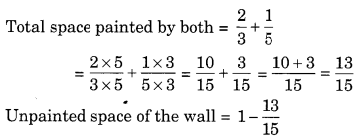
Question 1.
Represent the following fractions on number line.
(a)
(b)
Question 2:
Write all the natural numbers from 1 to 20. What fraction of them are prime numbers?
Question 3:
Convert the following improper fractions into mixed fraction.
(a) (b)
Question 4:
Write the following fractions in ascending order:
, , , ,
Question 5:
Compare the following fractions:
and
Question 6:
ADD: , and
Question 7:
Simran painted of the wall space in her room. Her brother Rahul helped and painted of the wall space. How much did they paint together? What part of the whole space is left unpainted?
Question 8:
Write the fraction representing the shaded portion.

(i) (ii)
Question 9:
State true or false:
(a) In , 3 is the part of whole.
(b) On a number line, is to the right of zero.
(c) is smaller than .
(d) and represent equivalent fractions.
Question 10:
Find the missing entries in the tables:

Question 10:
Show on the number line.
Question 12:
Match the following:

Question 13:
There is a large box of 36 small square boxes.
(a) of it is _____.
(b) of it is _____.
(c) If I make a bench of 20 small boxes, the fraction becomes _____.
(d) _____ boxes are required if fraction is 56.
Question 14:
Subtract 2 from 4 .
Question 15:
Find the equivalent fraction of having
(i) denominator 30
(ii) numerator 24.
Question 16:
Identify the proper and improper fractions:
, , , , .
Question 17:
Identify the like fractions from the following:
, , , ,
Question 18:
Write any
(a) three proper and three improper fractions with denominator 9.
(b) two proper and two improper fractions with numerator 7.
Question 19:
Simplify: – +
Question 20:
What fraction of an hour is 45 minutes?

Class 6 Maths Chapter 7 Exercise 7.1 Solutions
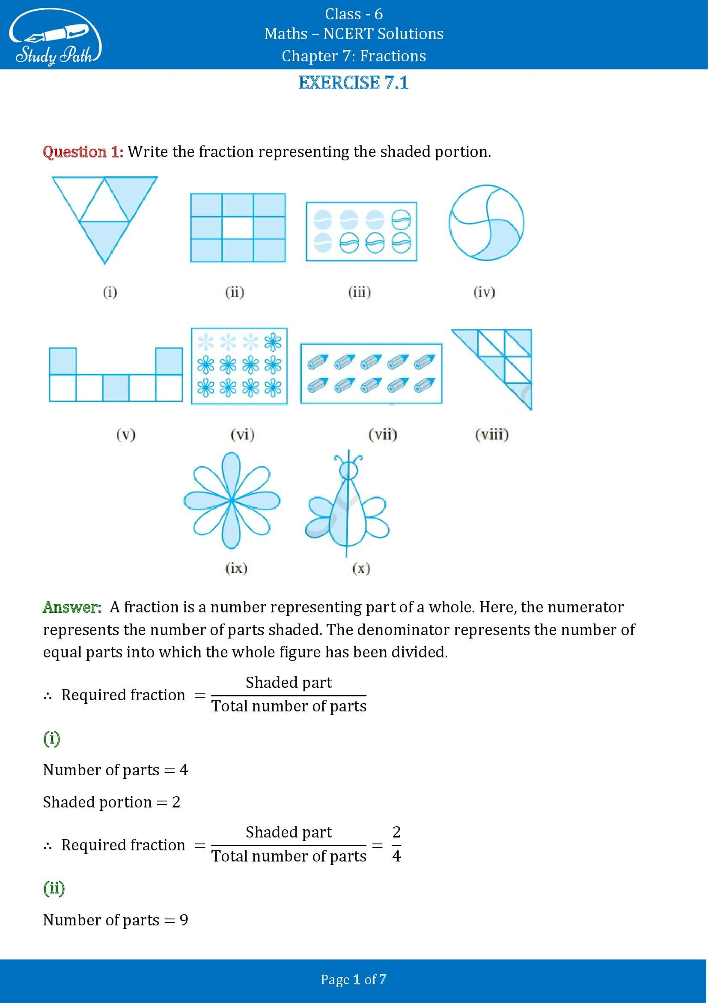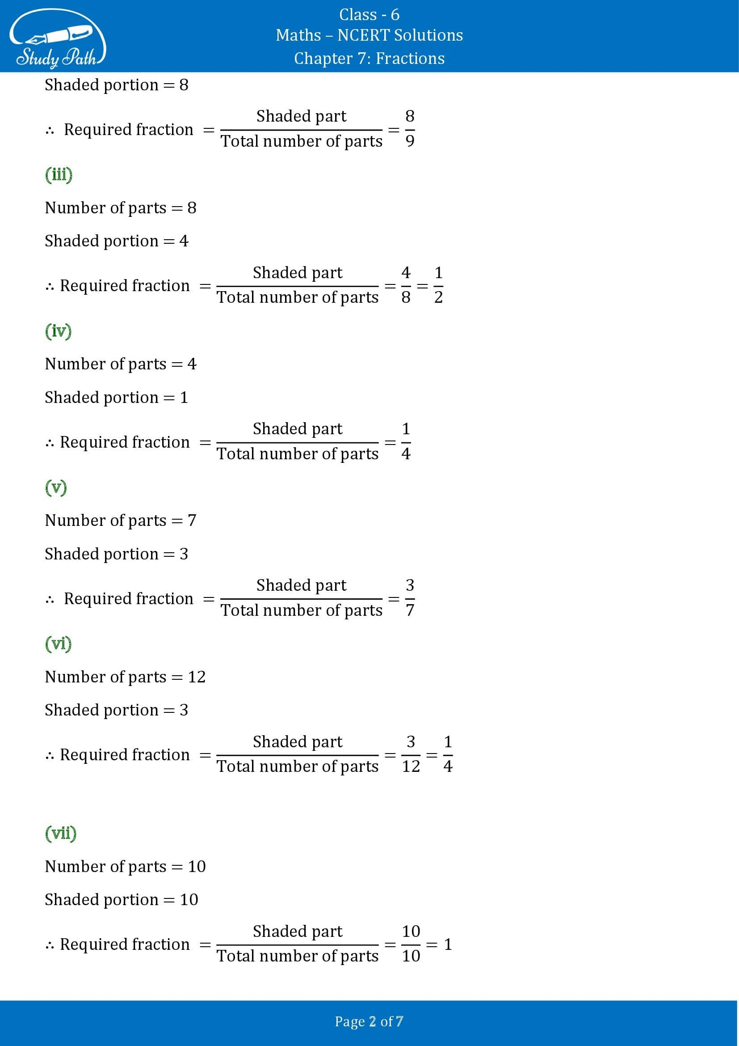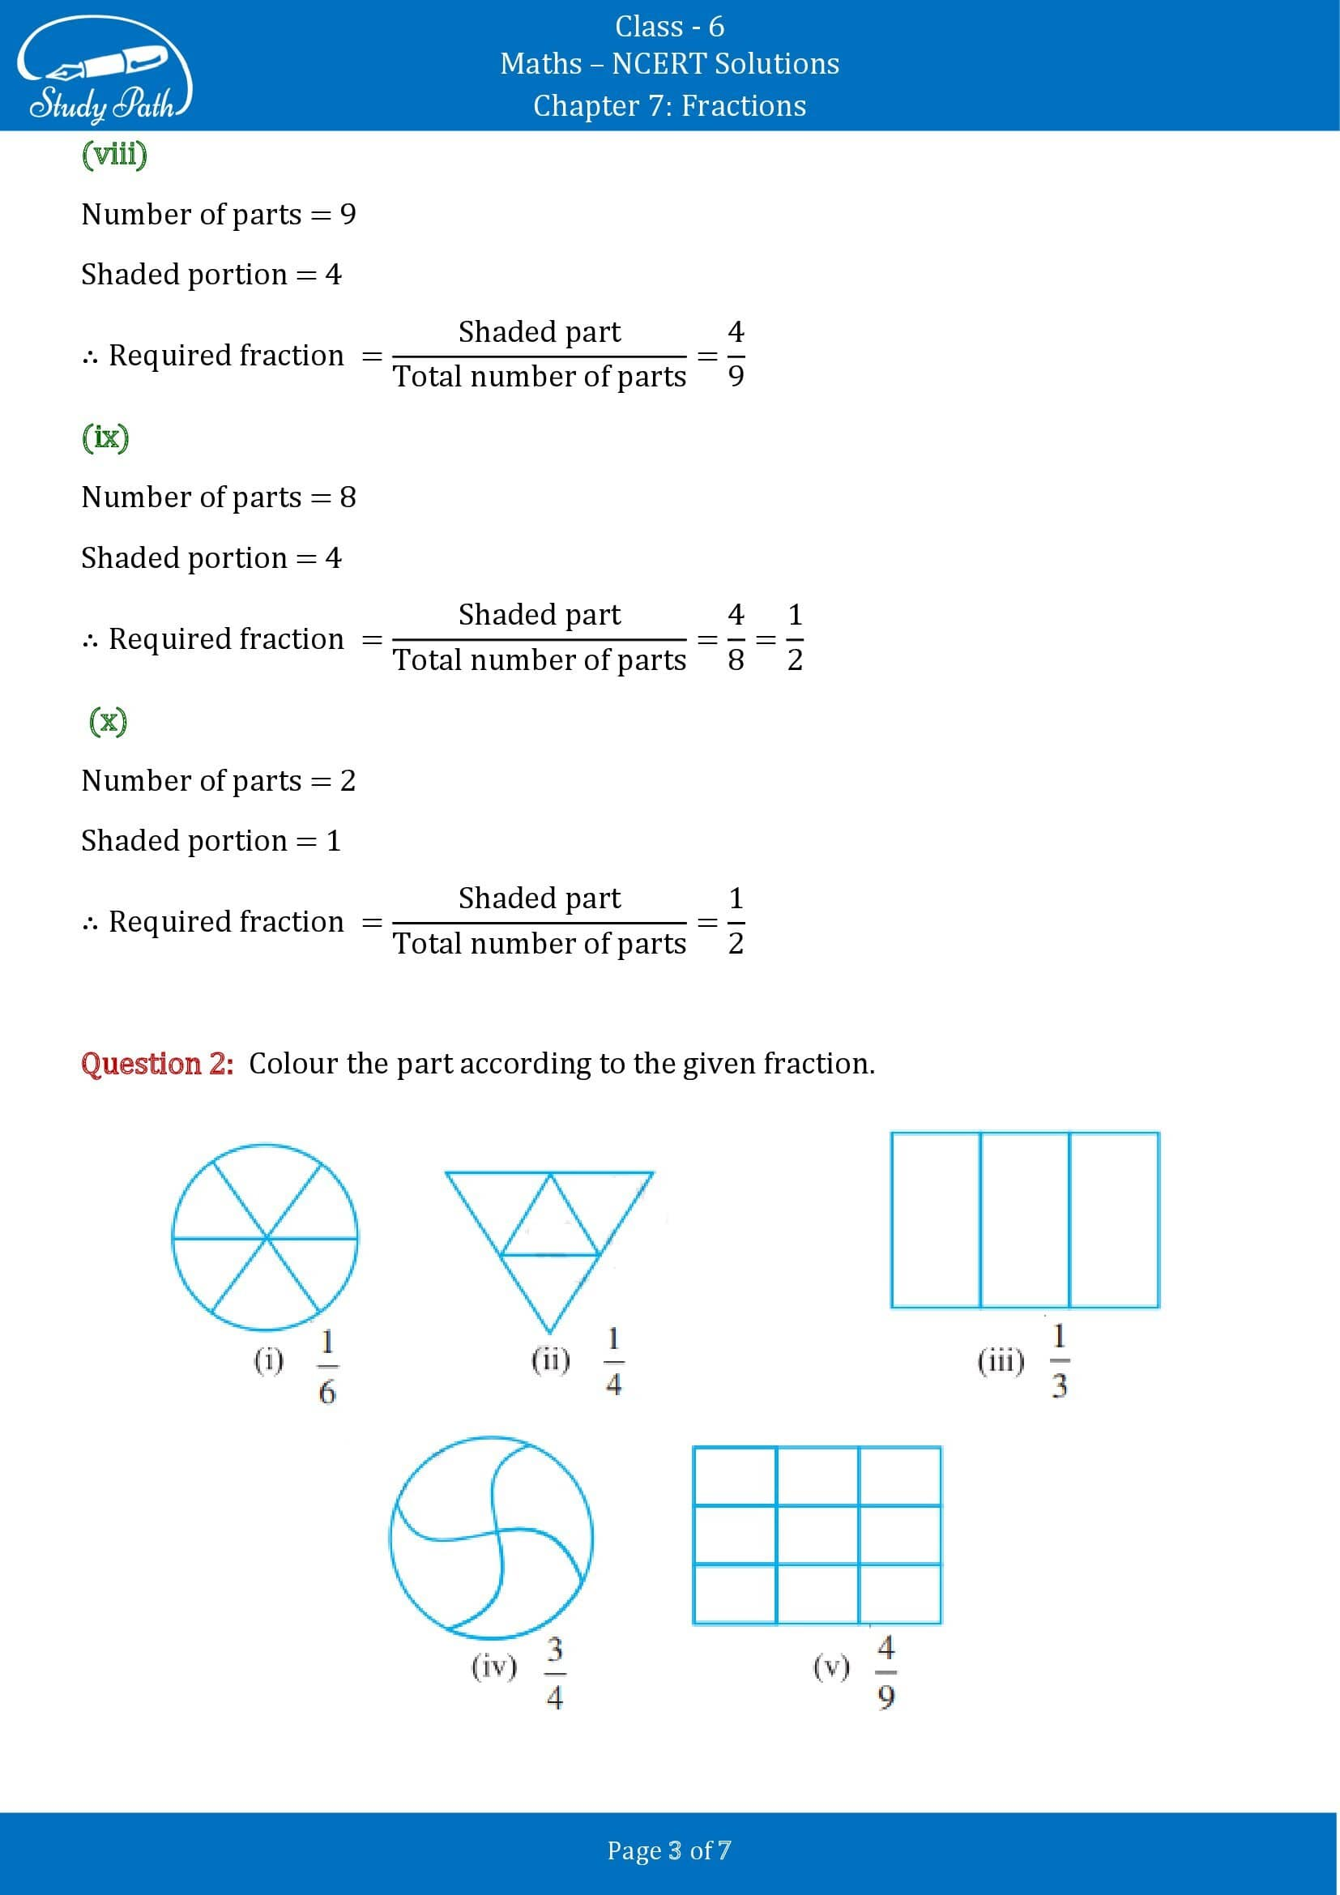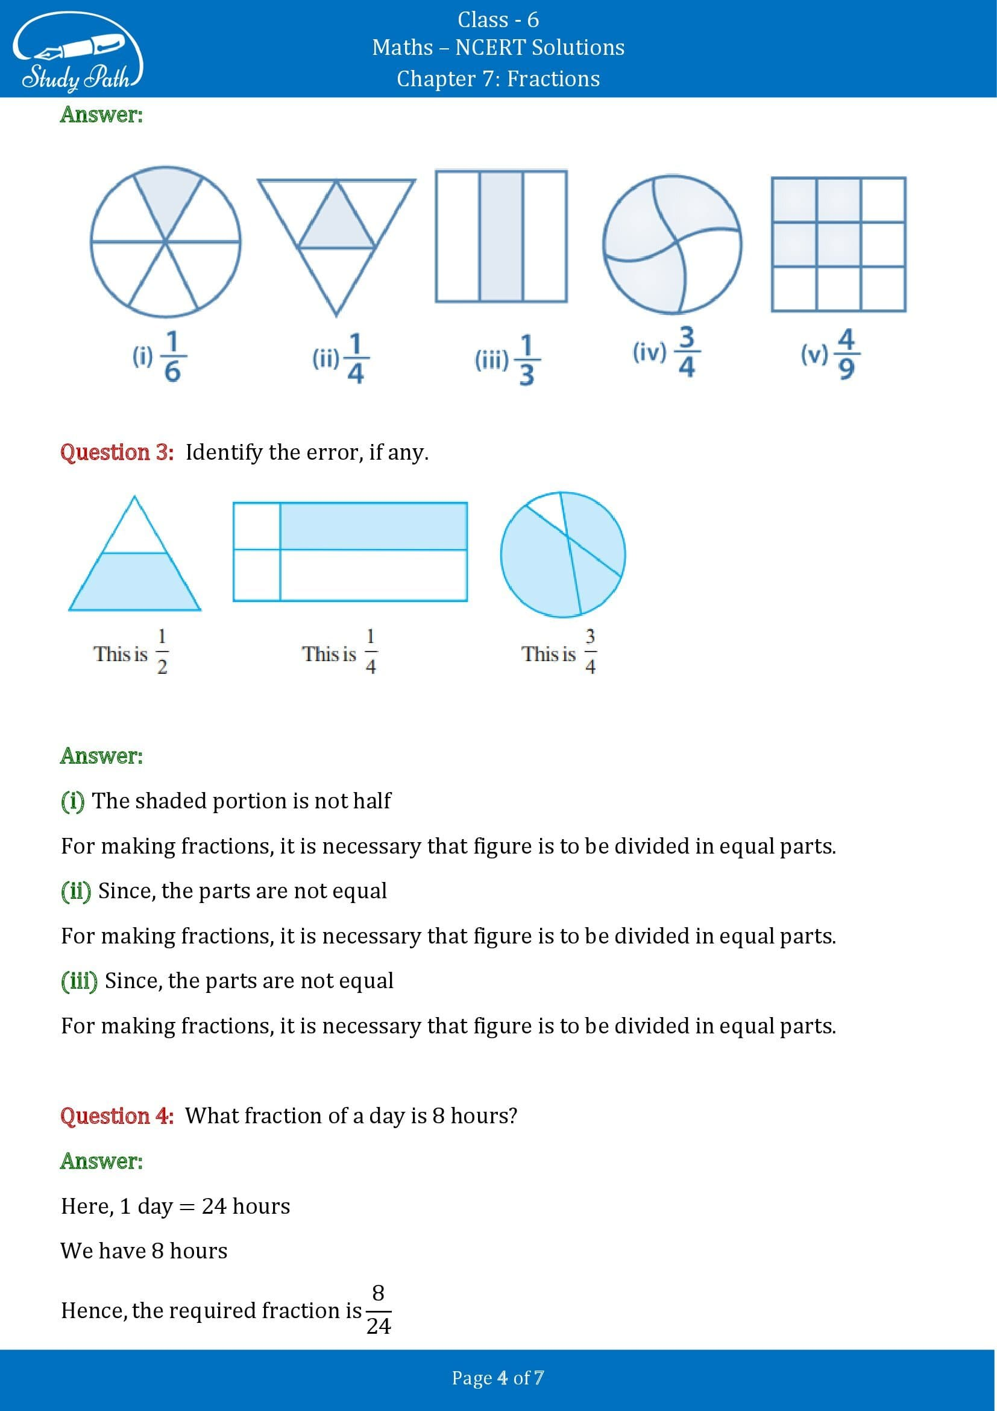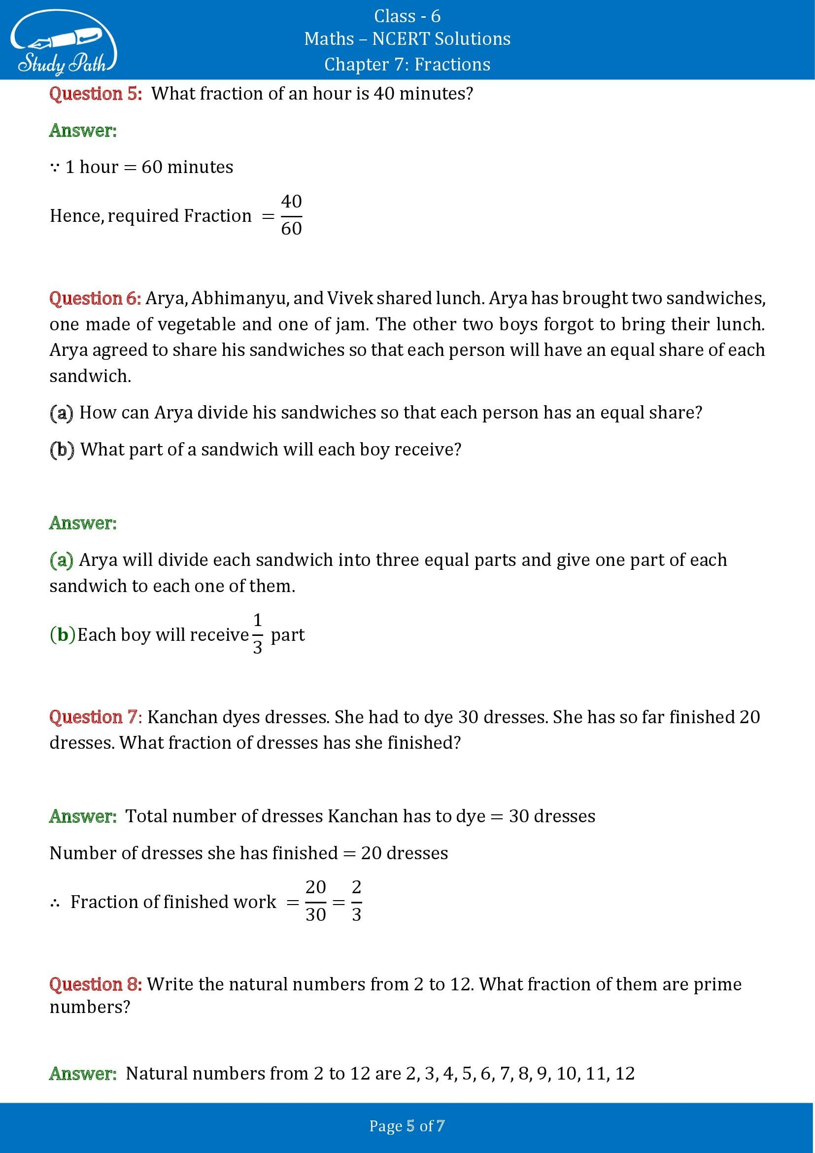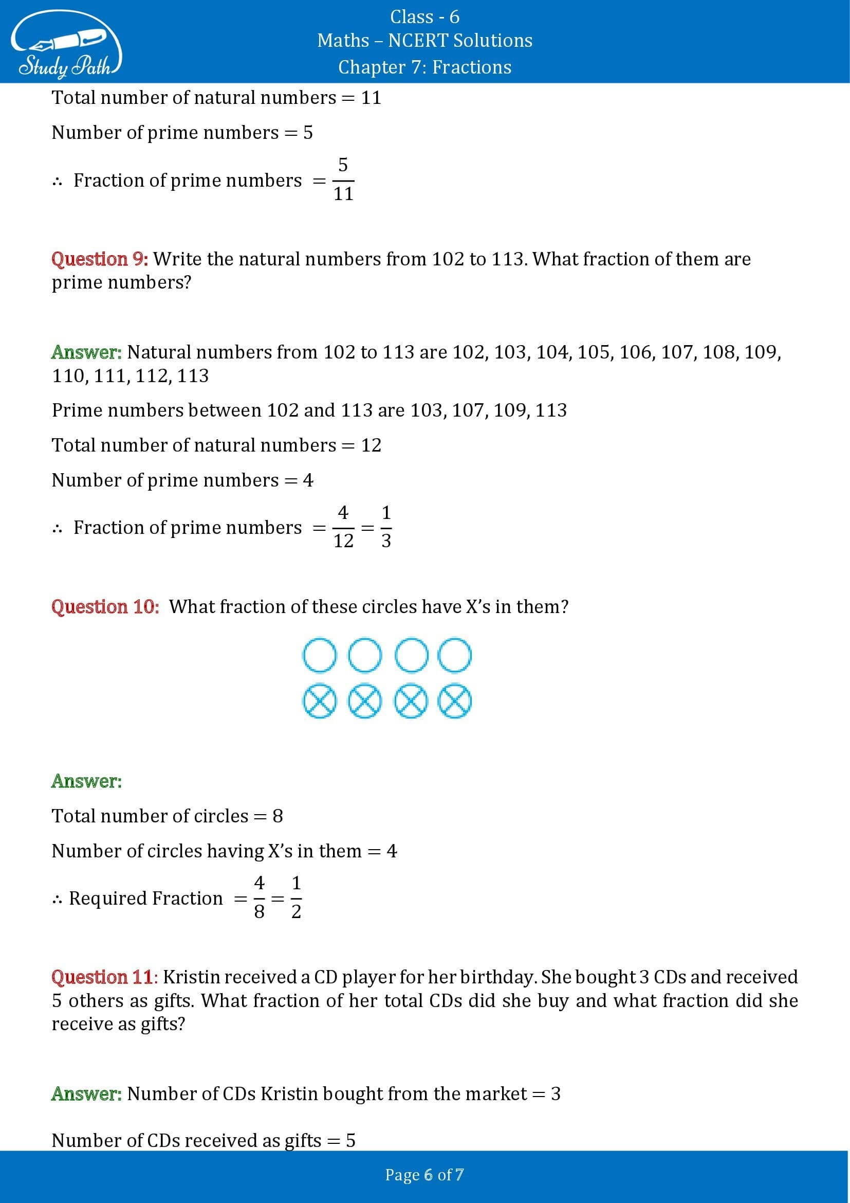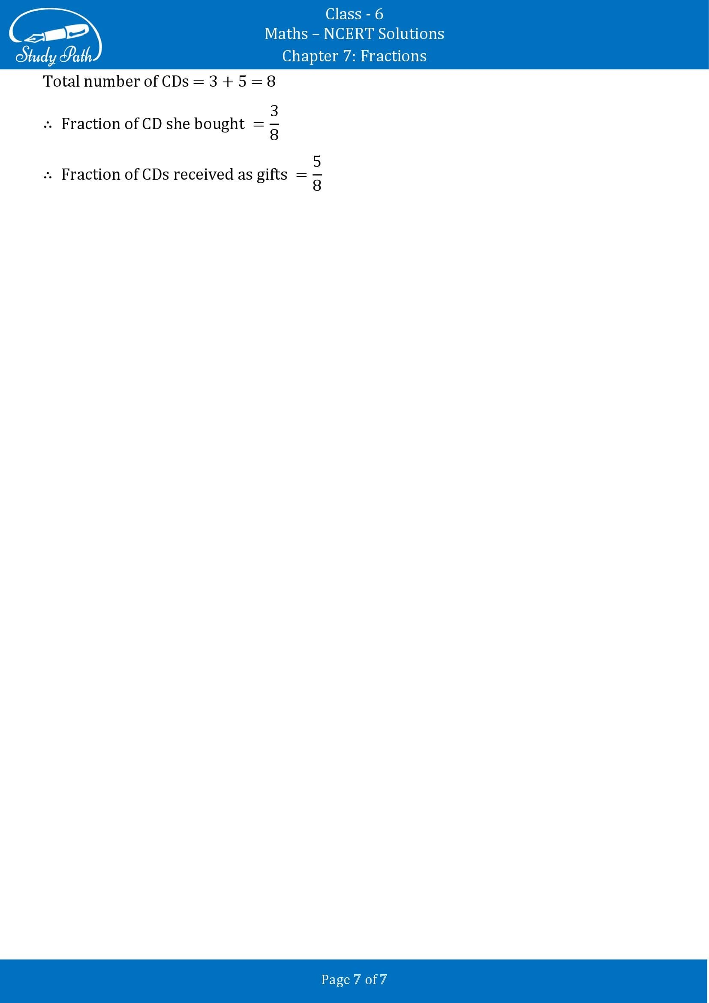

Class 6 Maths Chapter 7 Exercise 7.2 Solutions
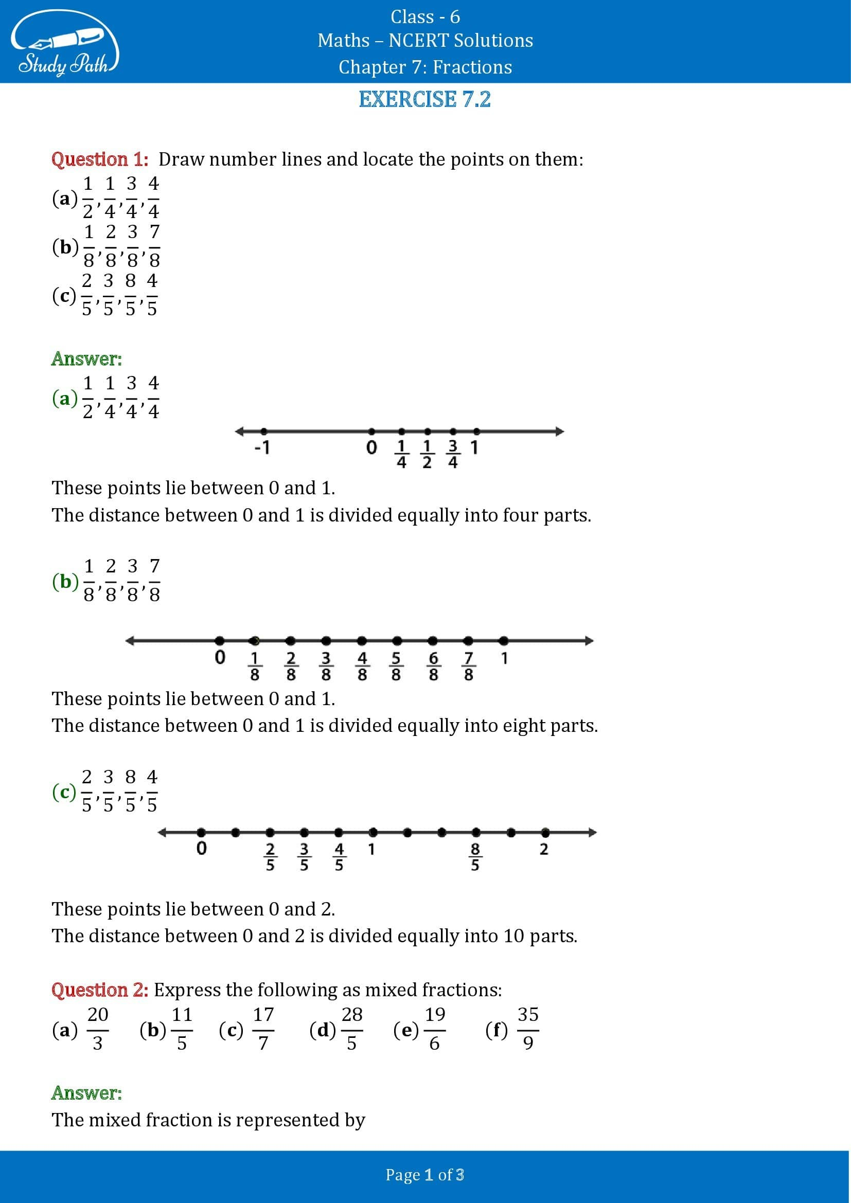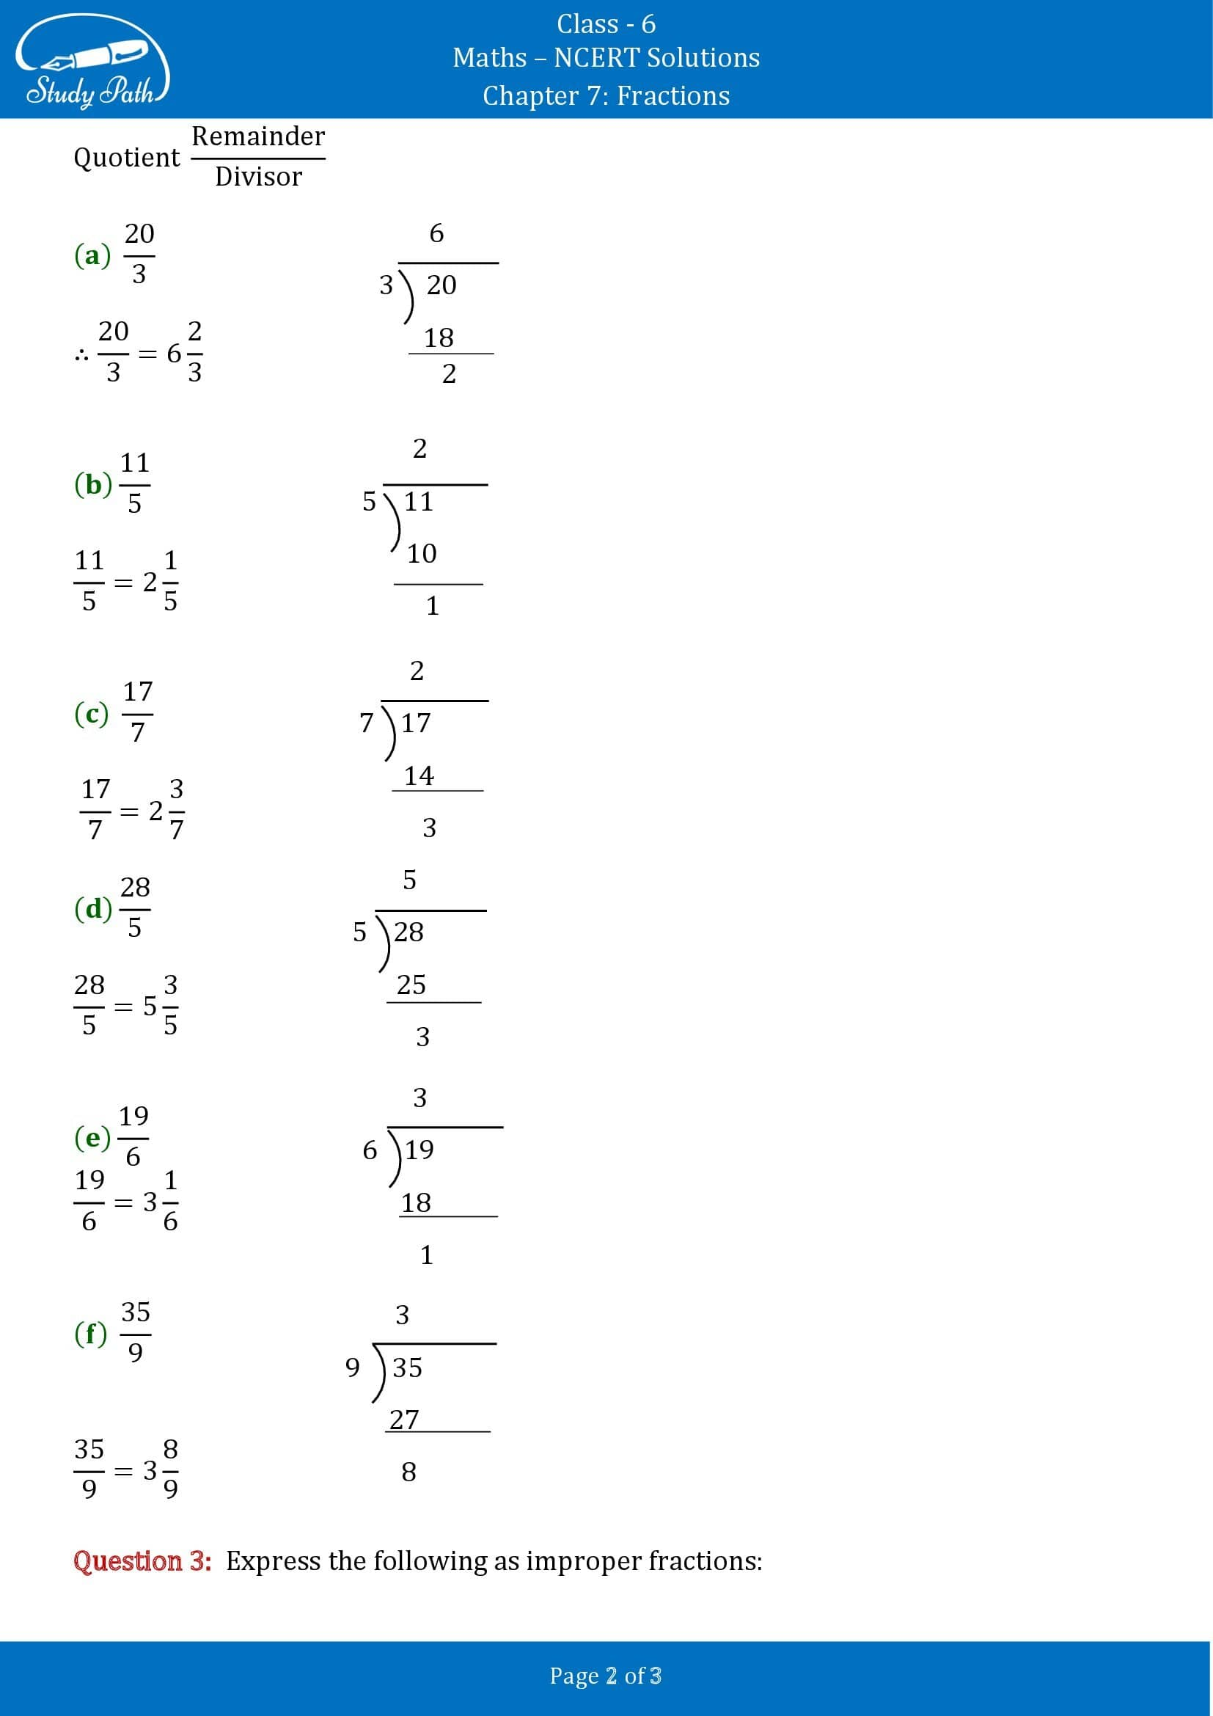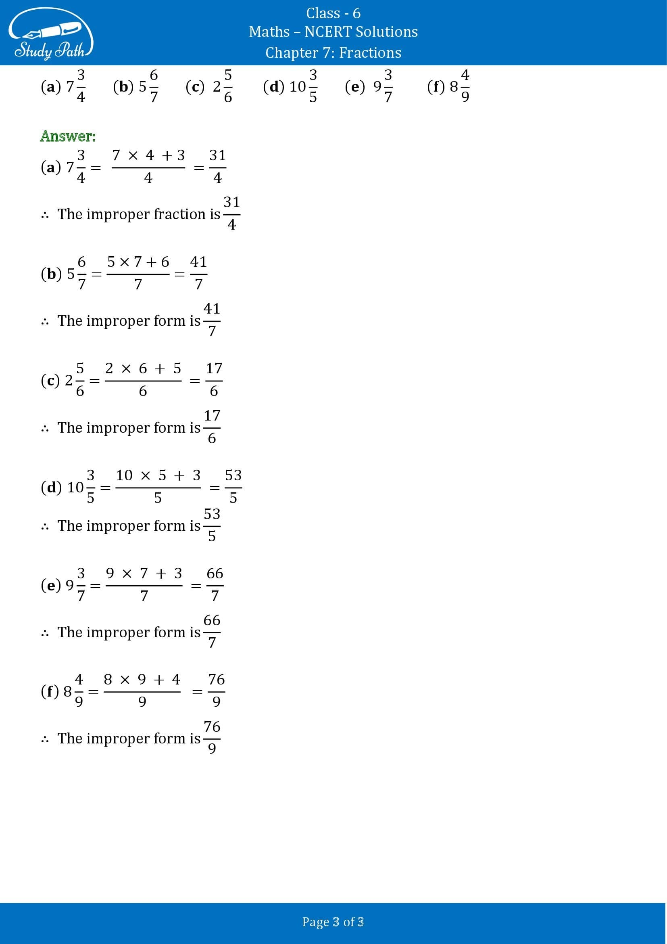

Class 6 Maths Chapter 7 Exercise 7.3 Solutions
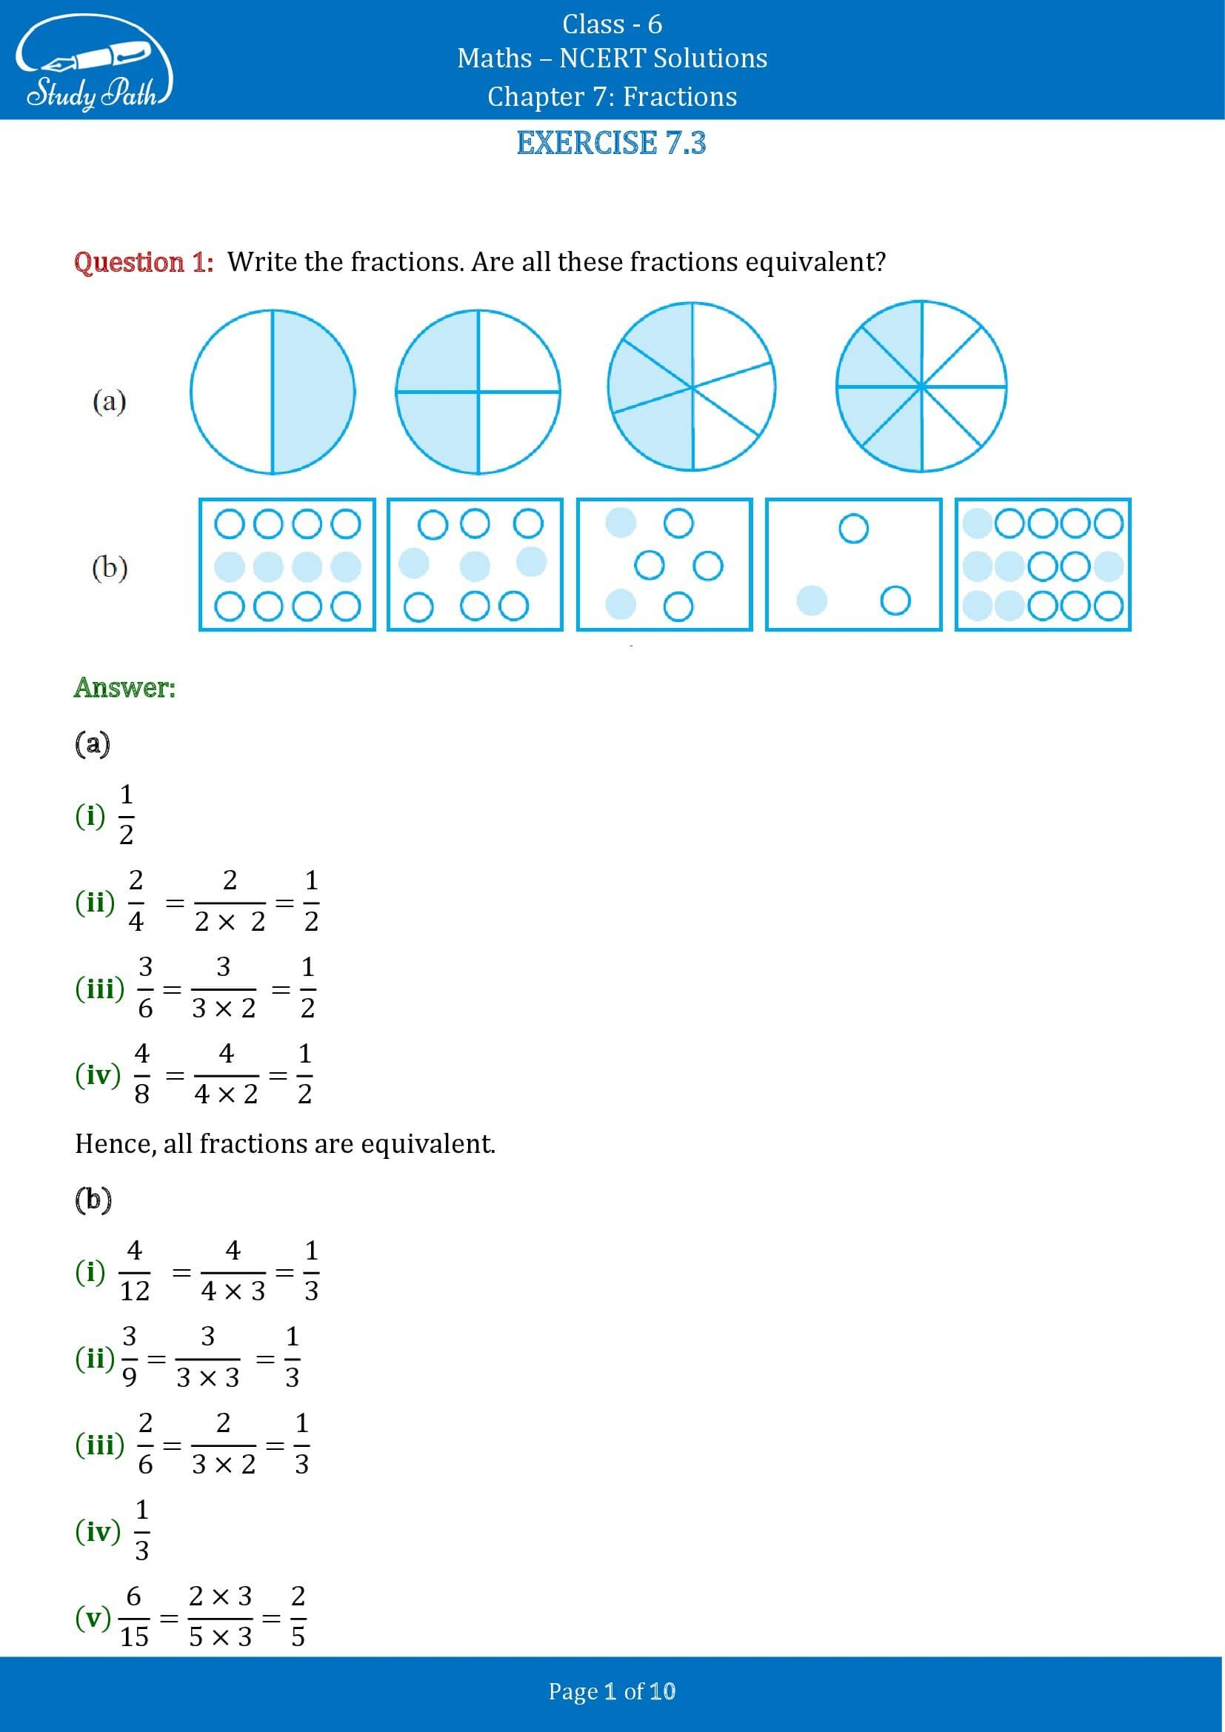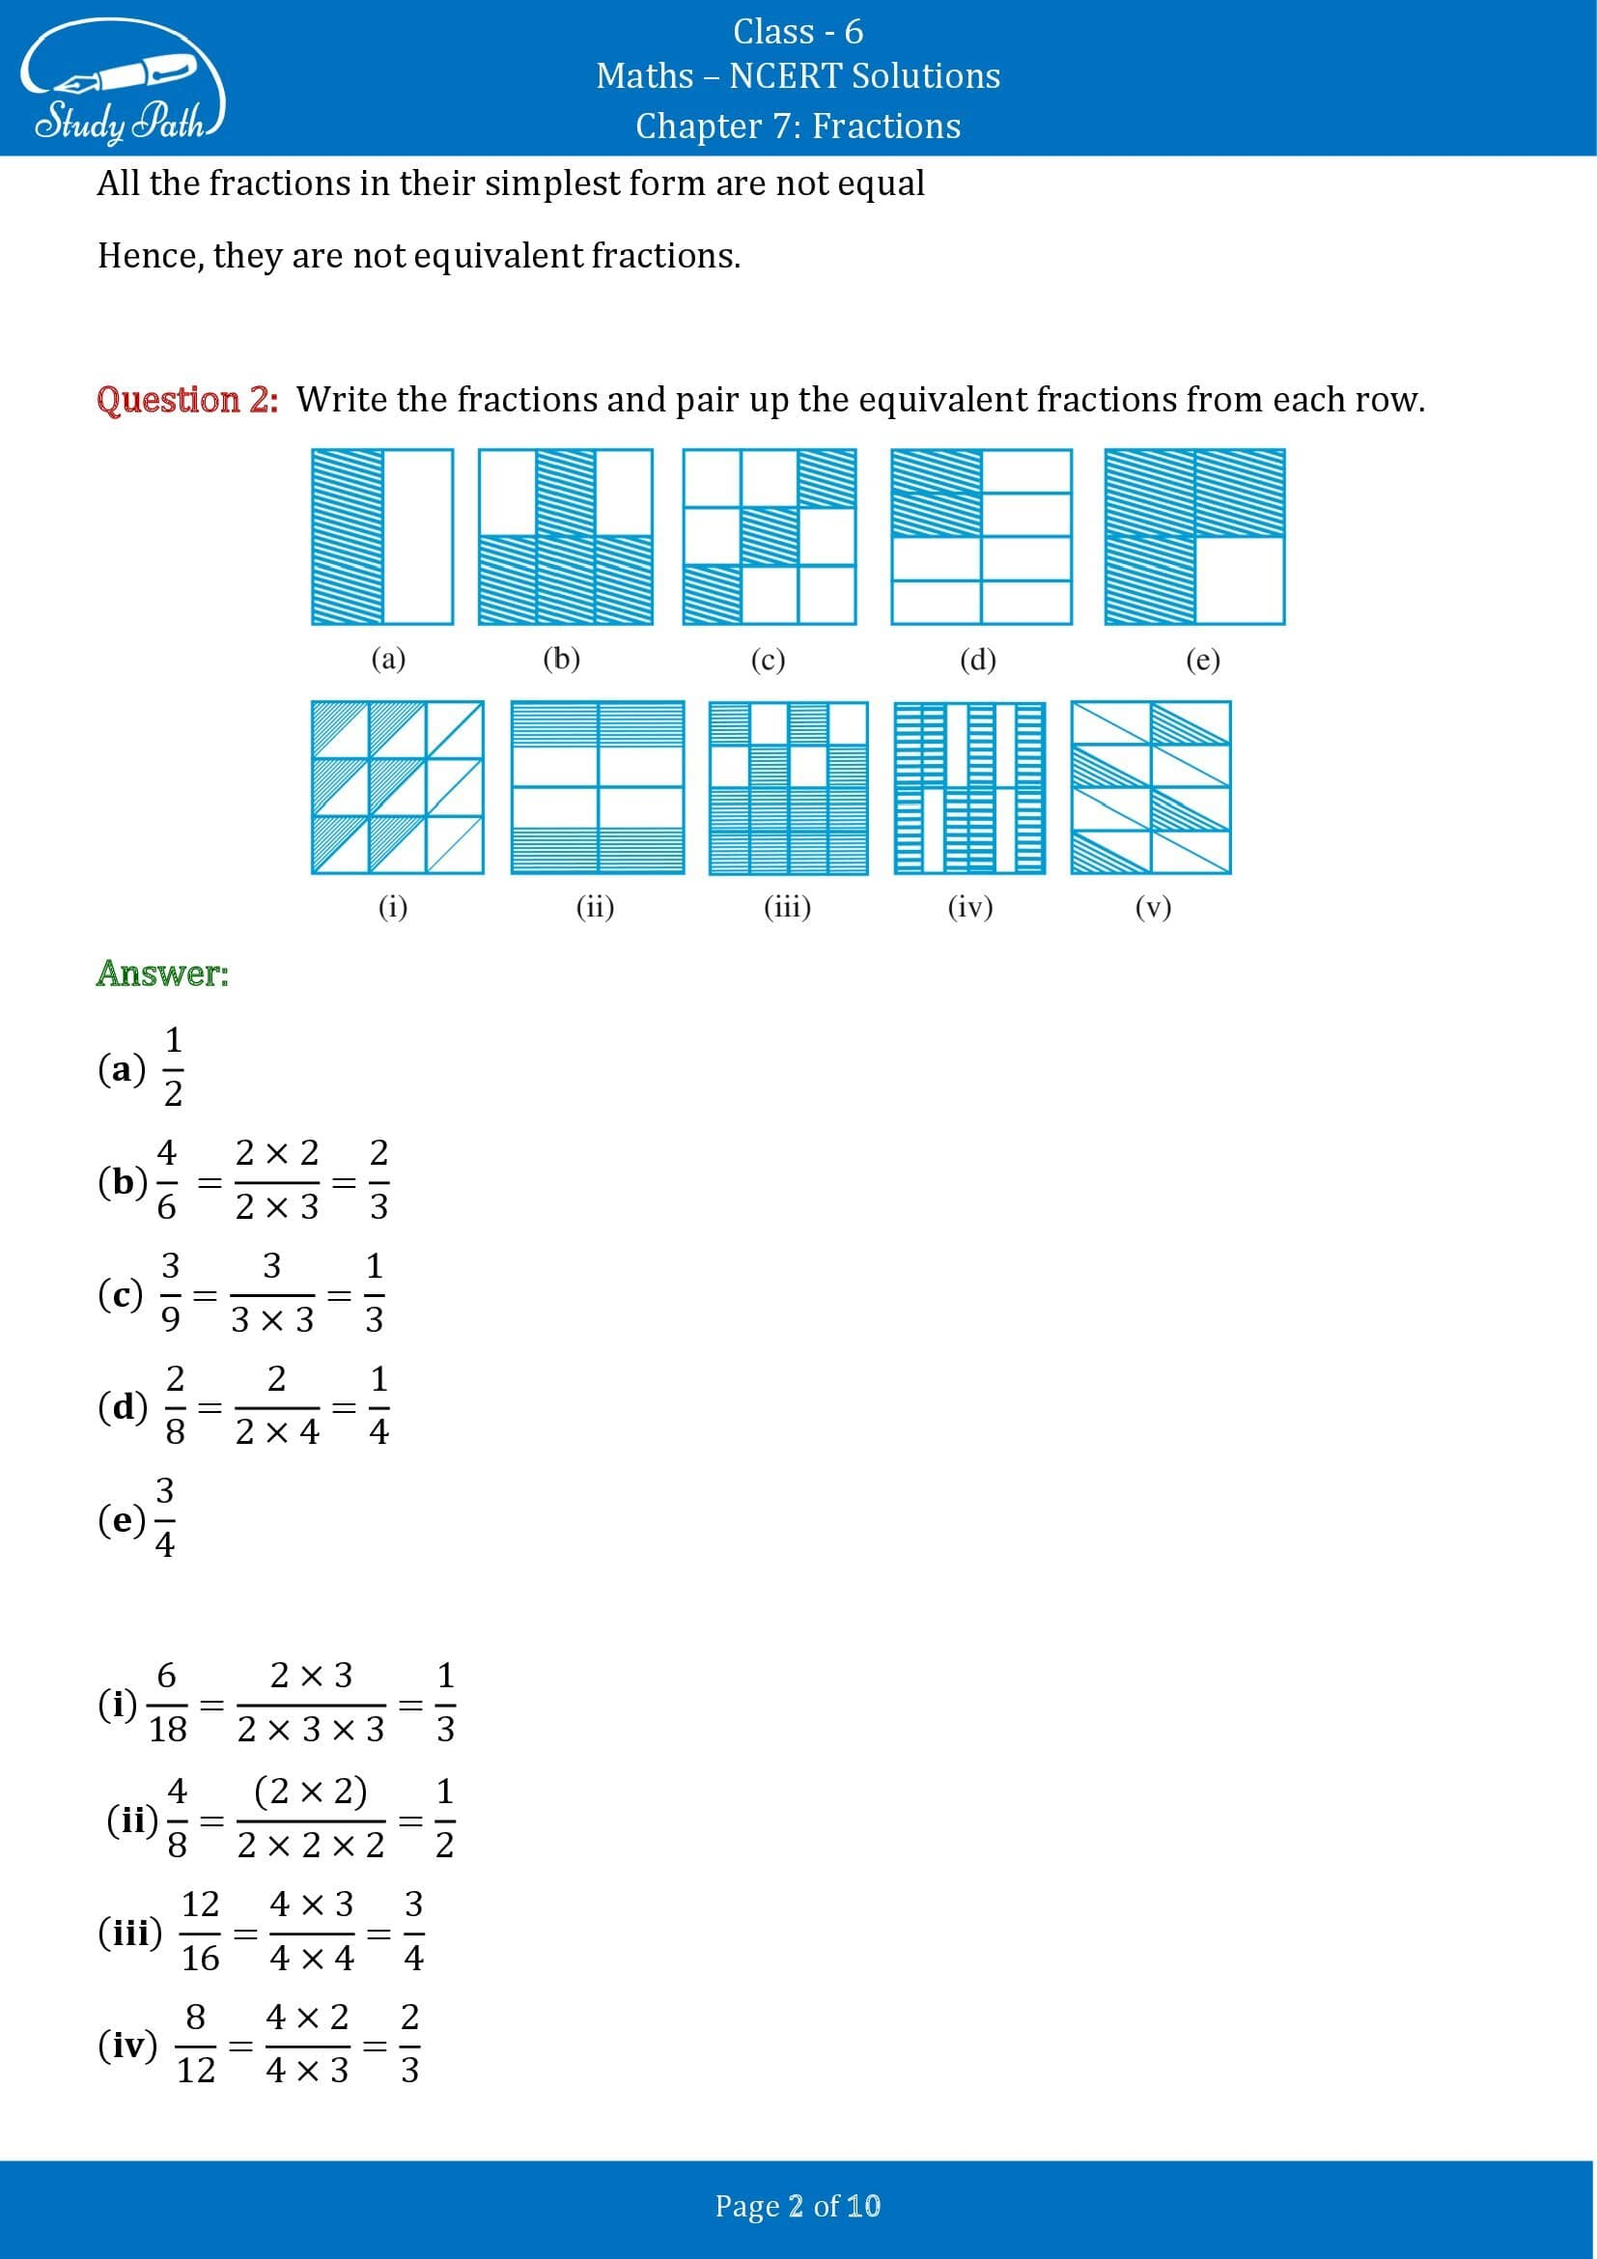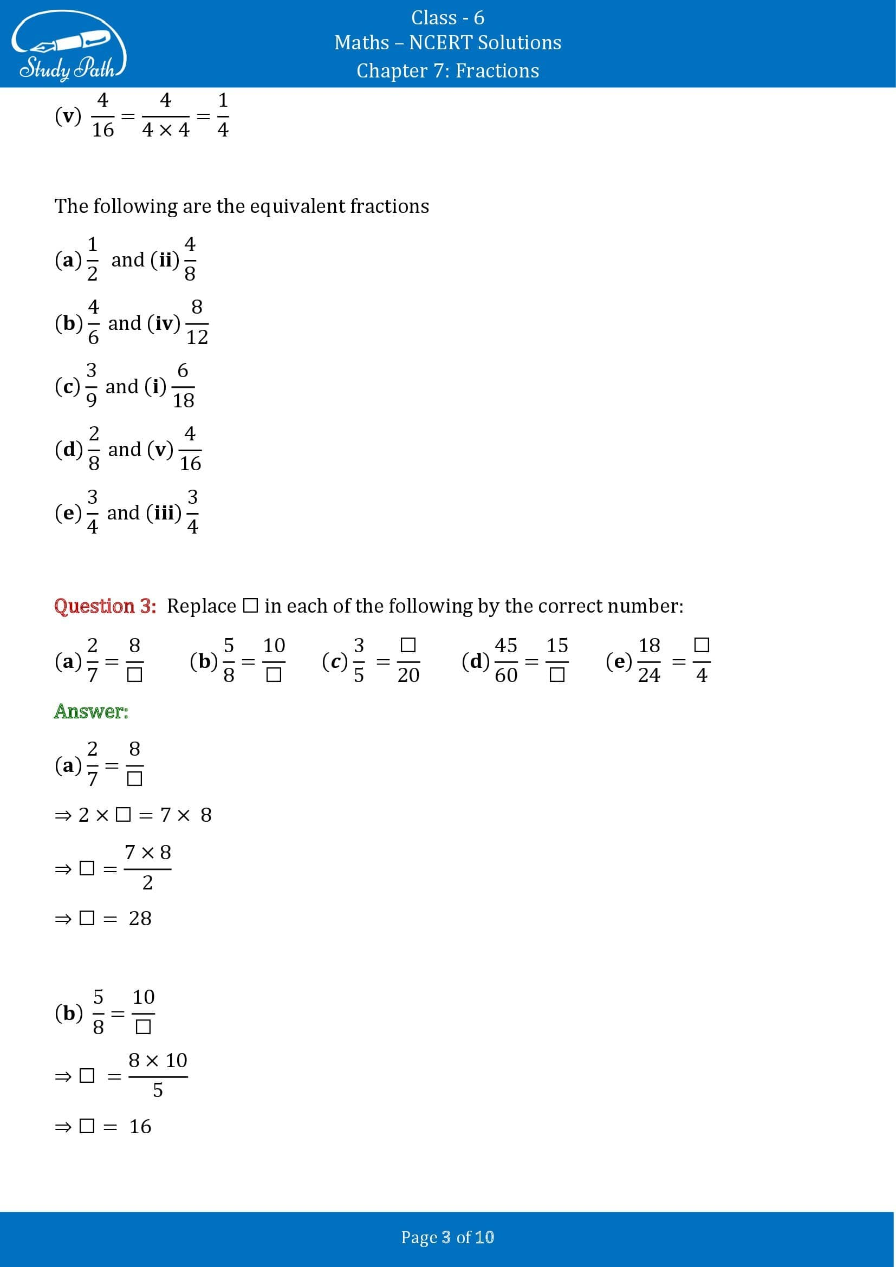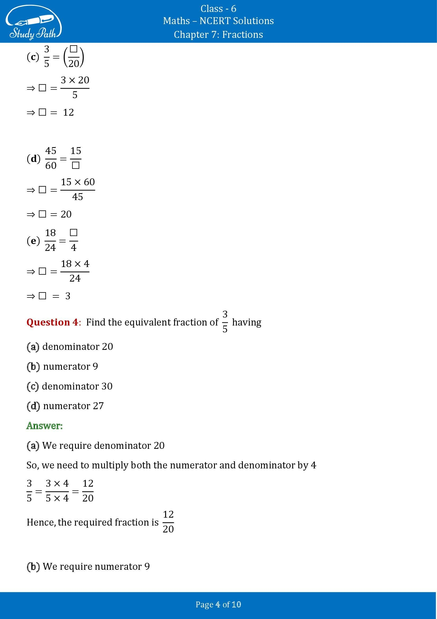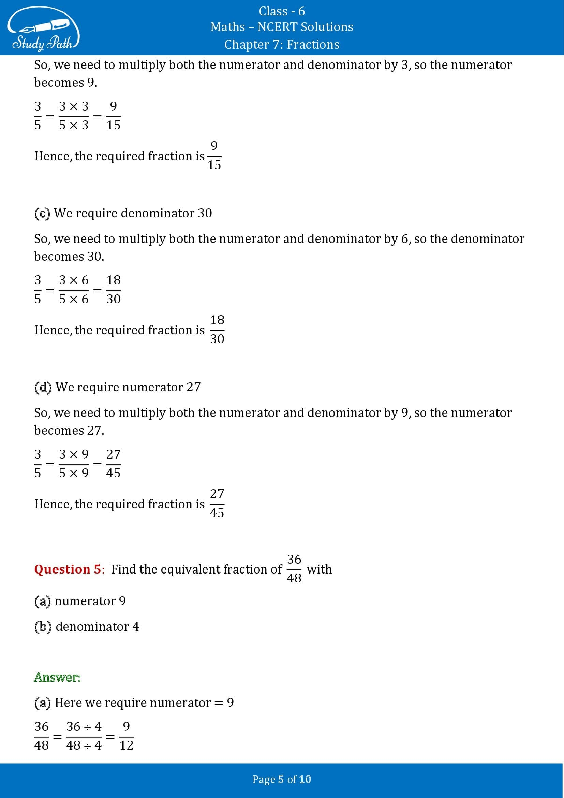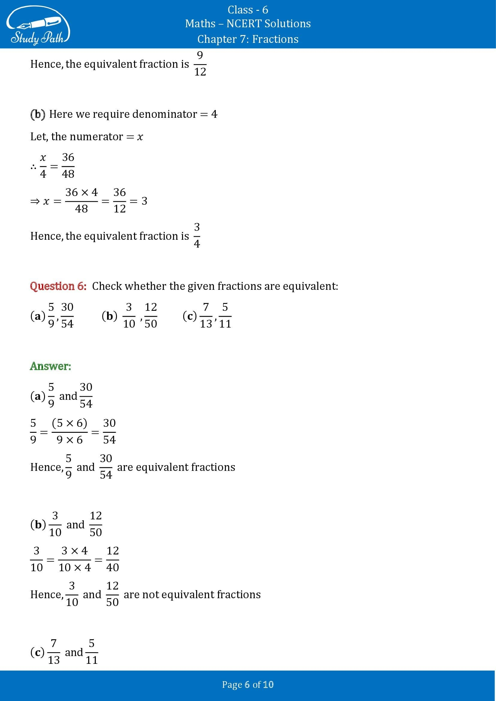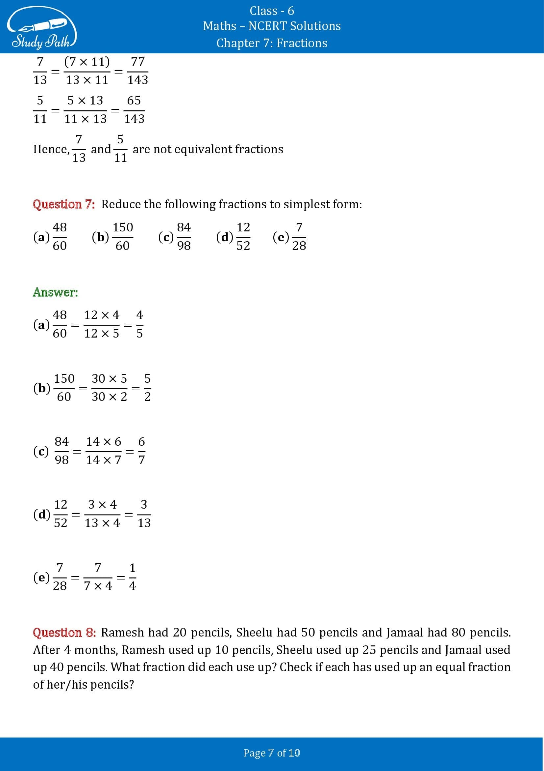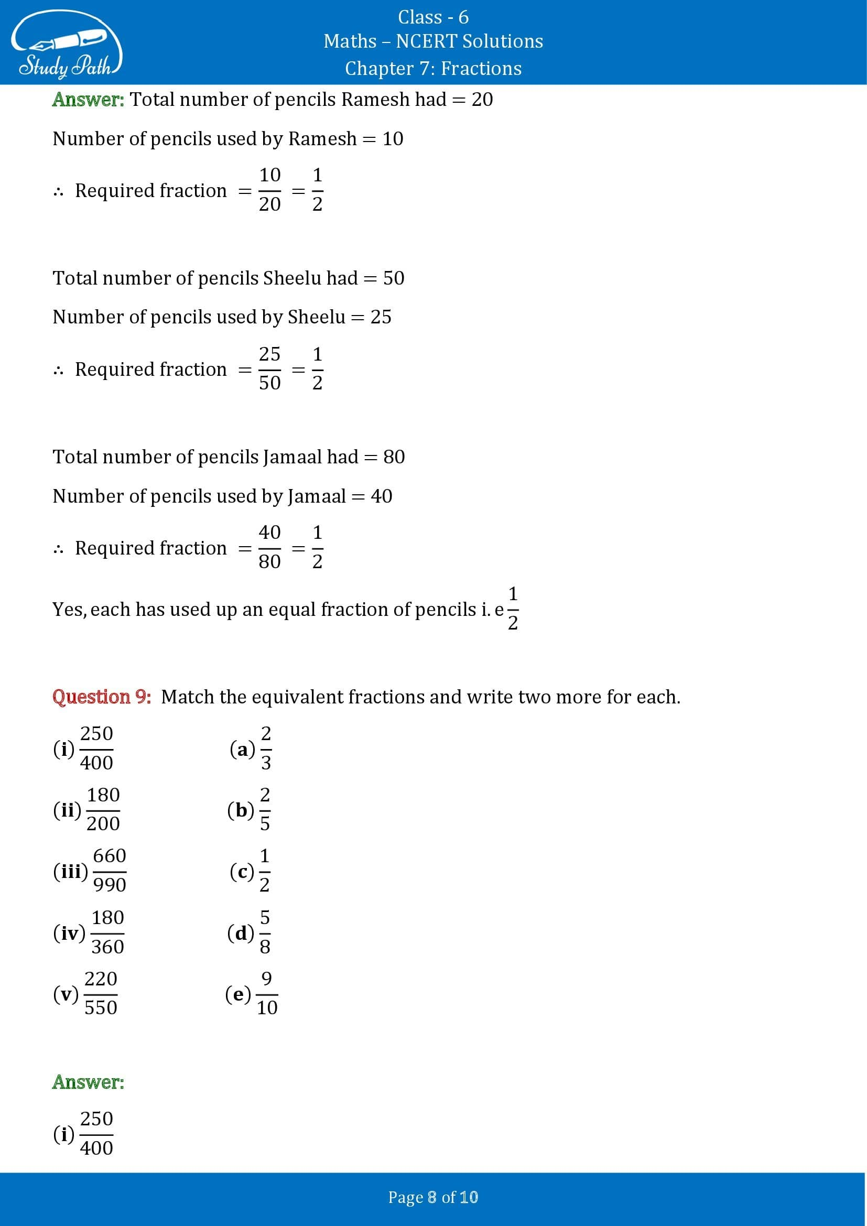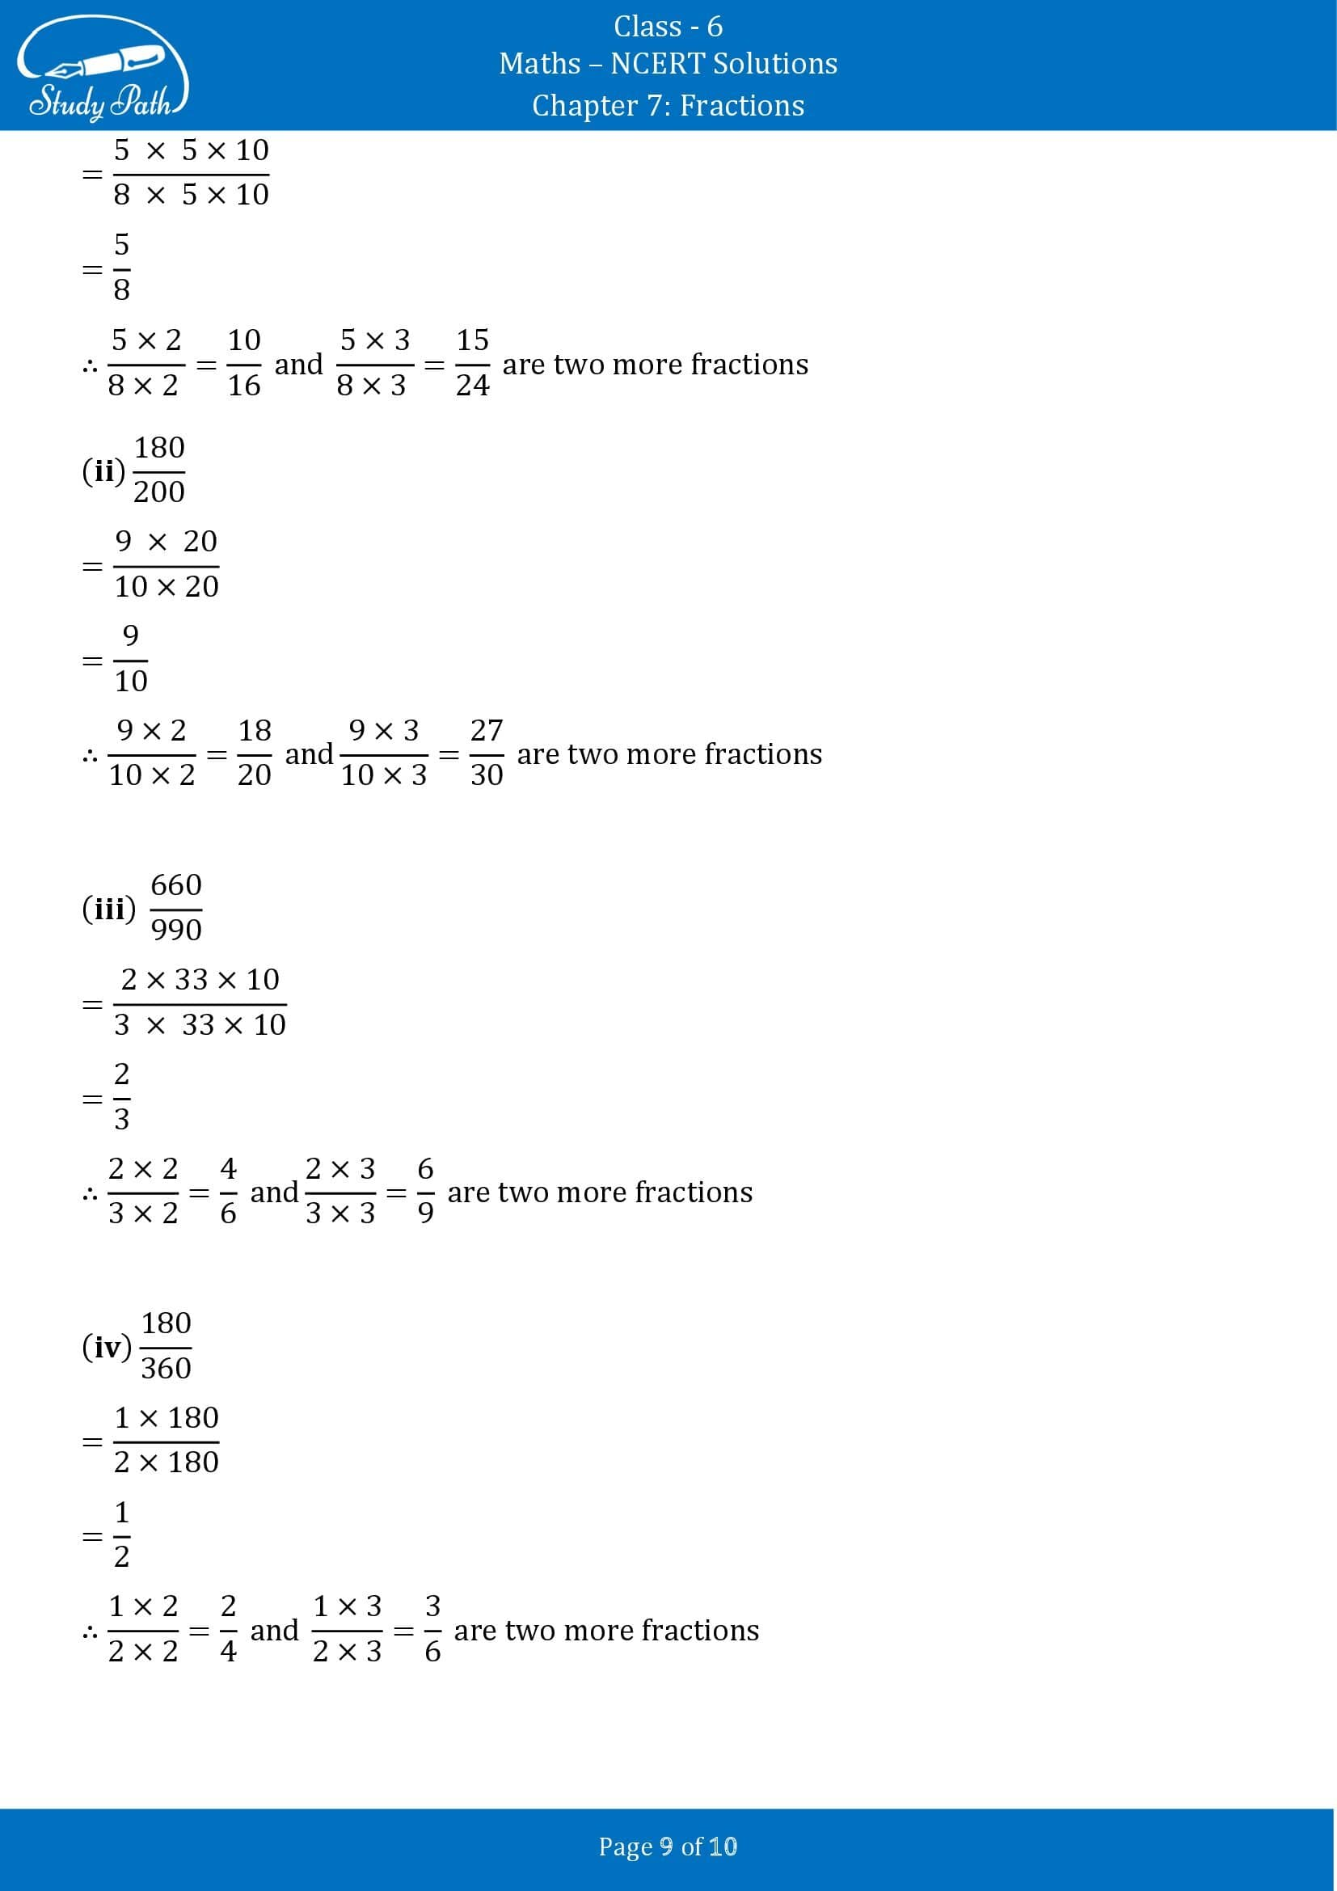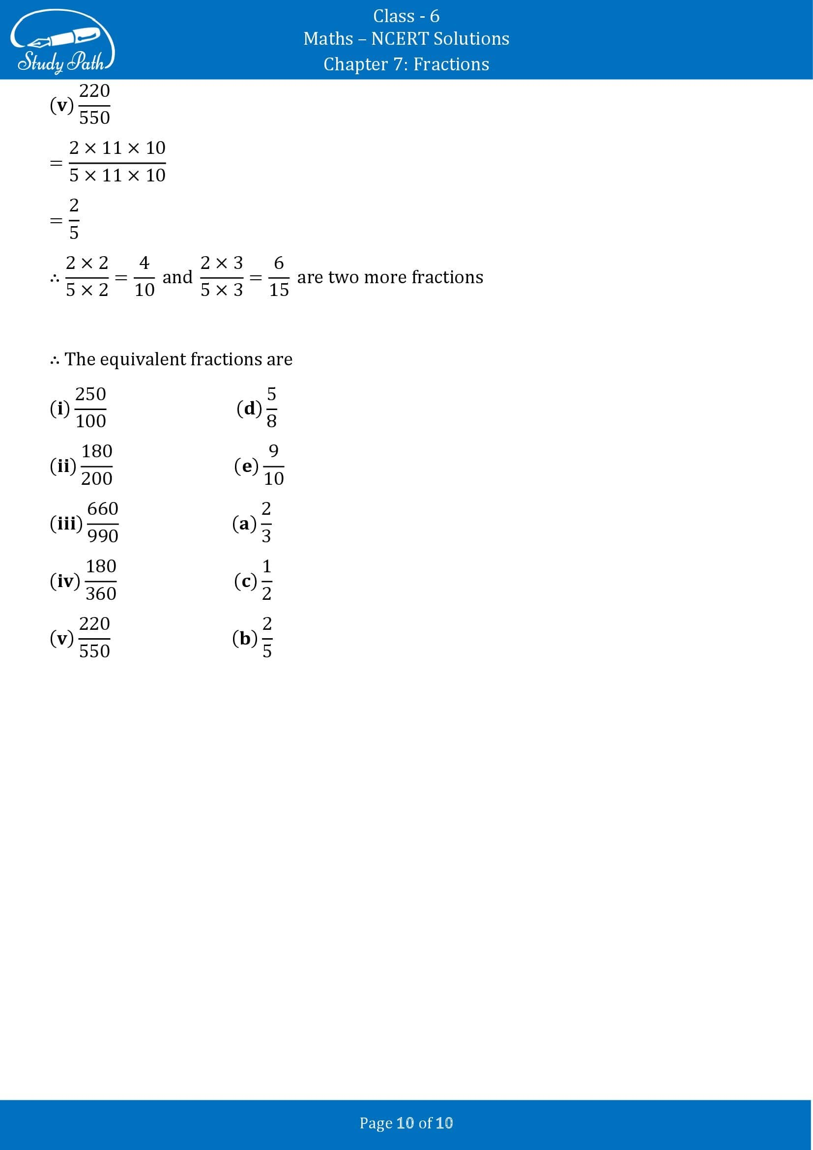

Class 6 Maths Chapter 7 Exercise 7.4 Solutions
