RAMCO VIDYA MANDIR SR. SEC. SCHOOL, THAMARAIKULAM
Subject: Biology
MT- 3
CLASS : 11-A | TIME :
EXAM NO : | MARKS : 61

SECTION – Section A SECTION (8 MARKS)

1. Which of the following is the most abundant protein in the animal world?
(a) Insulin
(b) Collagen
(c) Trypsin
(d) Haemoglobin
2. The respiratory rhythm centre is located in which part of the brain?
(a) Cerebrum
(b) Cerebellum
(c) Medulla oblongata
(d) Hypothalamus
3. What is the activation energy of a reaction in presence of carbonic anhydrase enzyme compared to uncatalysed reaction?
(a) 10 times lower
(b) 100 times lower
(c) 10 million times lower
(d) 1000 times lower
4. During inspiration, the intra-pulmonary pressure becomes:
(a) Equal to atmospheric pressure
(b) Higher than atmospheric pressure
(c) Lower than atmospheric pressure
(d) Double the atmospheric pressure
5. Which type of neuron has one axon and one dendrite?
(a) Multipolar
(b) Bipolar
(c) Unipolar
(d) Apolar
6. Chitin, a complex polysaccharide, is found in:
(a) Plant cell walls
(b) Bacterial cell walls
(c) Exoskeleton of arthropods
(d) Human connective tissue
7. Assertion (A): Enzymes are highly specific in their action.
Reason (R): The active site of an enzyme has a specific shape that fits only particular substrates.
(a) Both A and R are true and R is the correct explanation of A
(b) Both A and R are true but R is not the correct explanation of A
(c) A is true but R is false
(d) A is false but R is true
8. Assertion (A): The myelin sheath increases the speed of nerve impulse conduction.
Reason (R): Myelin sheath prevents the leakage of ions across the axonal membrane.
(a) Both A and R are true and R is the correct explanation of A
(b) Both A and R are true but R is not the correct explanation of A
(c) A is true but R is false
(d) A is false but R is true
SECTION – Section B SECTION (6 MARKS)

9. Define zwitterion and give an example.
OR
What are prosthetic groups? How do they differ from co-enzymes?
10. If a person's tidal volume is 500 mL and breathing rate is 14 breaths per minute, calculate the total volume of air breathed in one hour.
11. Name the chemical neurotransmitters involved in synaptic transmission and state where they are stored.
SECTION – Section C SECTION (12 MARKS)

12. Explain the role of pH and temperature in enzyme activity with suitable examples.
OR
Describe the classification of enzymes based on the type of reactions they catalyse. Give one example for each class.
13. Based on the given diagram of protein structure levels, identify and explain the different levels of protein organization shown.
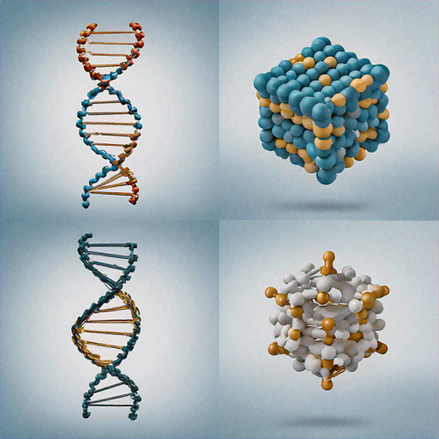
14. Describe the mechanism of generation of action potential in a neuron.
15. Explain the factors affecting the rate of diffusion of gases across the alveolar membrane.
SECTION – Section D SECTION (4 MARKS)

- Read the passage:
A 45-year-old factory worker in a cement grinding unit was experiencing severe breathing difficulties. His medical examination revealed that prolonged exposure to cement dust had caused inflammation and fibrosis in his lungs. The doctor explained that the defense mechanisms of his respiratory system, including the mucus-secreting cells and cilia in the trachea and bronchi, were overwhelmed by the constant dust exposure. His vital capacity was measured at 3000 mL compared to the normal 4800 mL. The partial pressure of oxygen in his blood was found to be lower than normal, affecting the oxygen-haemoglobin dissociation curve. The doctor advised him to use protective masks and prescribed medications to reduce inflammation.
16. (a) What is vital capacity and why was the patient's vital capacity reduced? (2 marks)
(b) How does fibrosis affect the gaseous exchange in alveoli? (1 mark)
(c) What preventive measure should workers in dusty environments take? (1 mark)
SECTION – Section E SECTION (5 MARKS)

17. Describe the transport of oxygen and carbon dioxide in blood. Explain the role of haemoglobin and factors affecting oxygen-haemoglobin dissociation curve.
OR
Explain the structure of a neuron with a well-labeled diagram. Describe how nerve impulse is transmitted across a chemical synapse.

