RAMCO VIDYA MANDIR SR. SEC. SCHOOL, THAMARAIKULAM
Subject: Biology
MT- 3
CLASS : 11-B | TIME :
EXAM NO : | MARKS : 61

SECTION – Section A SECTION (8 MARKS)

1. In which type of placentation, the ovary becomes two-chambered due to the formation of a false septum?
(a) Marginal
(b) Axile
(c) Parietal
(d) Free central
2. The region of root responsible for water and mineral absorption is:
(a) Root cap
(b) Region of meristematic activity
(c) Region of elongation
(d) Region of maturation with root hairs
3. Which organelle is known as the 'power house' of the cell?
(a) Golgi apparatus
(b) Mitochondria
(c) Chloroplast
(d) Endoplasmic reticulum
4. The type of ribosomes found in prokaryotic cells is:
(a) 80S
(b) 70S
(c) 60S
(d) 50S
5. In frogs, the exchange of gases in water occurs through:
(a) Lungs only
(b) Buccal cavity
(c) Skin
(d) Nostrils
6. The cotyledon in monocotyledonous seeds is called:
(a) Tegmen
(b) Scutellum
(c) Aleurone layer
(d) Coleoptile
7. Assertion (A): The cell wall is present in plant cells but absent in animal cells.
Reason (R): Cell wall provides mechanical support and protection to plant cells.
(a) Both A and R are true and R is the correct explanation of A
(b) Both A and R are true but R is not the correct explanation of A
(c) A is true but R is false
(d) A is false but R is true
8. Assertion (A): Chromoplasts are responsible for photosynthesis in plants.
Reason (R): Chromoplasts contain carotenoid pigments like carotene and xanthophyll.
(a) Both A and R are true and R is the correct explanation of A
(b) Both A and R are true but R is not the correct explanation of A
(c) A is true but R is false
(d) A is false but R is true
SECTION – Section B SECTION (6 MARKS)

9. Define mesosome and state its functions in prokaryotic cells.
OR
What are plasmodesmata? How do they help in cell-to-cell communication?
10. A plant cell has 46 chromosomes with approximately 2 meters of DNA. If this DNA is equally distributed among all chromosomes, calculate the average length of DNA per chromosome in millimeters.
11. Differentiate between rough endoplasmic reticulum (RER) and smooth endoplasmic reticulum (SER) based on their structure and function.
SECTION – Section C SECTION (12 MARKS)

12. Explain the different types of aestivation found in flowers with suitable examples.
OR
Describe the structure and functions of mitochondria. Why are they called 'power houses' of the cell?
13. Study the given diagram of a flower and answer:
(a) Identify the type of flower based on ovary position
(b) Name two examples of plants showing this arrangement
(c) What is the position of ovary called in such flowers?
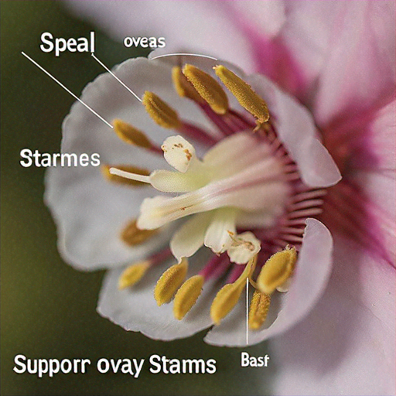
14. Describe the male reproductive system of frog with special reference to the connection between testes and kidneys.
15. Explain the fluid mosaic model of plasma membrane. What role does cholesterol play in the membrane structure?
SECTION – Section D SECTION (4 MARKS)

- Read the passage:
A biology student was observing different plant cells under an electron microscope. She noticed that plant cells from green leaves contained numerous lens-shaped organelles about 5-10 micrometers in length. These organelles had a double membrane structure with the inner membrane forming stacks of flattened sacs. The stacks resembled piles of coins and were connected by tubular structures. The student also observed that these organelles contained their own circular DNA molecules and 70S ribosomes, similar to those found in prokaryotes. Interestingly, cells from potato tubers had similar shaped organelles but they lacked the green pigment and instead stored starch. The student realized these organelles could divide by fission, independent of cell division.
16. (a) Identify the organelles observed in green leaf cells. (1 mark)
(b) What are the coin-like stacks called and what is their function? (1 mark)
(c) Name the type of plastids found in potato tuber cells and state their function. (1 mark)
(d) Why do these organelles have 70S ribosomes instead of 80S ribosomes found in the cytoplasm? (1 mark)
SECTION – Section E SECTION (5 MARKS)

17. Describe the different types of placentation found in flowering plants with suitable diagrams and examples.
OR
Explain the structure of a eukaryotic nucleus. Discuss the role of nuclear pores and nucleolus in cellular functions.

