RAMCO VIDYA MANDIR SR. SEC. SCHOOL, THAMARAIKULAM
Subject: Chemistry
MT- 3
CLASS : 11-A | TIME :
EXAM NO : | MARKS : 66

SECTION – Section A SECTION (8 MARKS)

1. For a reaction at equilibrium, if the volume of the container is suddenly decreased, which of the following will be true for a reaction where Δn < 0?
(a) Equilibrium shifts to the left
(b) Equilibrium shifts to the right
(c) No change in equilibrium position
(d) Kc value changes
2. The lattice enthalpy of NaCl is +788 kJ/mol and hydration enthalpy is -784 kJ/mol. The enthalpy of solution will be:
(a) -1572 kJ/mol
(b) +1572 kJ/mol
(c) +4 kJ/mol
(d) -4 kJ/mol
3. For the reaction N2O4(g) ⇌ 2NO2(g), if Kc = 4.64 × 10^-3 at 25°C, the unit of Kc is:
(a) mol/L
(b) L/mol
(c) mol²/L²
(d) No unit
4. Which of the following represents the correct relationship between Cp and Cv for an ideal gas?
(a) Cp + Cv = R
(b) Cp - Cv = R
(c) Cp × Cv = R
(d) Cp/Cv = R
5. The equilibrium constant for a reverse reaction is 0.01. The equilibrium constant for the forward reaction will be:
(a) 0.01
(b) 1.00
(c) 10
(d) 100
6. In bomb calorimeter, the heat measured corresponds to:
(a) ΔH at constant pressure
(b) ΔU at constant volume
(c) ΔG at constant temperature
(d) ΔS at constant pressure
7. Assertion: Addition of an inert gas at constant volume does not affect the equilibrium position.
Reason: Inert gas does not change the partial pressures of reactants and products.
(a) Both assertion and reason are true, and reason is the correct explanation
(b) Both assertion and reason are true, but reason is not the correct explanation
(c) Assertion is true but reason is false
(d) Assertion is false but reason is true
8. Assertion: For an isolated system, ΔU = 0.
Reason: In an isolated system, there is no exchange of energy or matter with surroundings.
(a) Both assertion and reason are true, and reason is the correct explanation
(b) Both assertion and reason are true, but reason is not the correct explanation
(c) Assertion is true but reason is false
(d) Assertion is false but reason is true
SECTION – Section B SECTION (6 MARKS)

9. (a) Define heterogeneous equilibrium with an example.
OR
(b) What is meant by standard enthalpy of sublimation? Give its significance.
10. Calculate the value of Kp for the reaction 2NOCl(g) ⇌ 2NO(g) + Cl2(g) at 500K, if Kc = 1.8 × 10^-2. (R = 0.0831 bar L mol^-1 K^-1)
11. State Le Chatelier's principle. How does it help in predicting the effect of temperature on an exothermic reaction?
SECTION – Section C SECTION (12 MARKS)

12. (a) Derive the relationship between ΔH and ΔU for a gaseous reaction. Under what conditions are they equal?
OR
(b) Explain why the equilibrium constant expression for heterogeneous equilibria does not include concentrations of pure solids and liquids.
13. The following diagram shows the effect of temperature on the equilibrium:
2NO2(g) ⇌ N2O4(g); ΔH = -57.2 kJ/mol
Explain the color changes observed in the three test tubes based on Le Chatelier's principle.
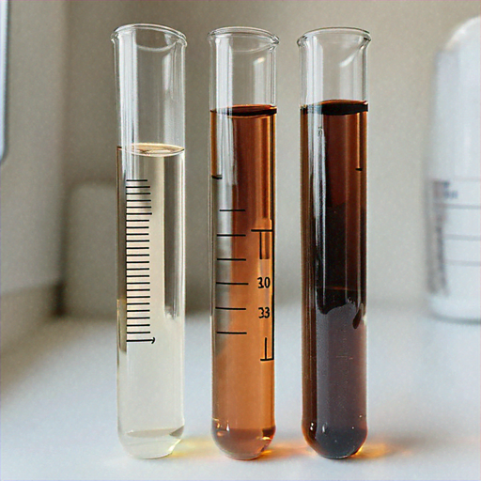
14. For the reaction H2(g) + I2(g) ⇌ 2HI(g), the equilibrium constant Kc = 57.0 at 700K. If at a given time [H2] = 0.10M, [I2] = 0.20M and [HI] = 0.40M, determine whether the system is at equilibrium. If not, in which direction will the reaction proceed?
15. Explain the Born-Haber cycle for the formation of NaCl(s). Calculate the lattice enthalpy if: Sublimation energy of Na = 108.4 kJ/mol, Ionization energy of Na = 496 kJ/mol, Bond dissociation energy of Cl2 = 242 kJ/mol, Electron gain enthalpy of Cl = -348.6 kJ/mol, Formation enthalpy of NaCl = -411.2 kJ/mol
SECTION – Section D SECTION (4 MARKS)

- Read the passage:
In industrial processes, the optimization of reaction conditions is crucial for maximum yield. The Haber process for ammonia synthesis is a classic example: N2(g) + 3H2(g) ⇌ 2NH3(g); ΔH = -92.38 kJ/mol. This exothermic reaction involves a decrease in volume (4 moles of gas forming 2 moles). According to Le Chatelier's principle, low temperature favors product formation due to the exothermic nature, while high pressure favors it due to volume decrease. However, at low temperatures, the reaction rate becomes impractically slow. Therefore, a compromise temperature of about 450°C is used along with high pressure (200-300 atm) and an iron catalyst. The catalyst increases the rate without affecting the equilibrium position. The unreacted gases are recycled to improve overall yield. This optimization demonstrates how thermodynamic and kinetic factors must be balanced in industrial chemistry.
16. (a) Why is a compromise temperature of 450°C used in the Haber process instead of a lower temperature? (1 mark)
(b) How does high pressure favor ammonia formation in this reaction? (1 mark)
(c) What is the role of the iron catalyst in this process? (1 mark)
(d) Calculate Kp if Kc = 3.55 × 10^2 at 500K. (R = 0.0831 bar L mol^-1 K^-1) (1 mark)
SECTION – Section E SECTION (5 MARKS)

17. (a) (i) State and explain Hess's law of constant heat summation with a suitable example. (2 marks)
(ii) The combustion of 1g of graphite produces 20.7 kJ of heat. Calculate the molar enthalpy of combustion of graphite. (Atomic mass of C = 12g/mol) (1 mark)
(iii) Differentiate between extensive and intensive properties with two examples each. (2 marks)
OR
(b) (i) Derive the expression for the equilibrium constant Kc for the general reaction: aA + bB ⇌ cC + dD (2 marks)
(ii) For the reaction PCl5(g) ⇌ PCl3(g) + Cl2(g), Kc = 1.8 at a certain temperature. If 3 mol/L of PCl5 is taken initially, calculate the equilibrium concentrations of all species. (2 marks)
(iii) How does the addition of a catalyst affect the equilibrium constant and the time to reach equilibrium? (1 mark)

