RAMCO VIDYA MANDIR SR. SEC. SCHOOL, THAMARAIKULAM
Subject: ECONOMICS
MT- 3
CLASS : 11-C | TIME :
EXAM NO : | MARKS : 49

SECTION – Multiple Choice Questions SECTION (9 MARKS)

1. In a perfectly competitive market, when the market price falls below the minimum average variable cost in the short run, a profit-maximizing firm will:
A) a) Continue producing at the same level | B) b) Increase production to cover losses
C) c) Produce zero output and shut down | D) d) Produce where MC equals AVC

2. If the demand curve shifts rightward and the supply curve shifts leftward simultaneously in a perfectly competitive market, the equilibrium:
A) a) Price will definitely increase, quantity effect is ambiguous | B) b) Quantity will definitely increase, price effect is ambiguous
C) c) Both price and quantity will increase | D) d) Price will increase, quantity will decrease

3. The break-even point for a firm in perfect competition occurs where:
A) a) Total revenue equals total variable cost | B) b) Price equals minimum average cost
C) c) Marginal revenue equals zero | D) d) Total cost equals zero

4. In perfect competition, a firm's supply curve in the long run is the rising portion of the _____ curve from and above the minimum _____.
5. When a unit tax is imposed on a perfectly competitive firm, its supply curve shifts to the _____ by the amount of the tax.
6. Match the following market situations with their outcomes:
A. Price ceiling below equilibrium - 1. Excess supply
B. Price floor above equilibrium - 2. Normal profit for all firms
C. Free entry and exit - 3. Excess demand
D. Technological progress - 4. Rightward shift in supply
7. Identify the odd one out regarding conditions for profit maximization in perfect competition:
A) a) Price equals marginal cost | B) b) Marginal cost curve must be rising
C) c) Price must exceed average fixed cost | D) d) Price must be greater than or equal to AVC in short run

8. At which output level will the profit-maximizing firm produce?
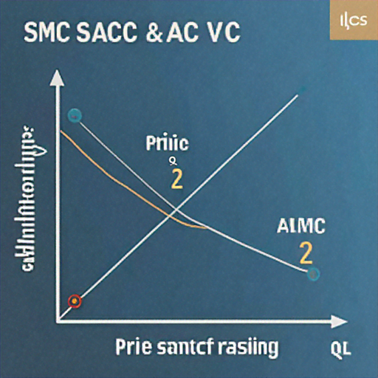
A) a) q1 | B) b) q2
C) c) Between q1 and q2 | D) d) Zero output

9. Assertion (A): In a perfectly competitive labour market, the firm employs labour up to the point where wage equals the value of marginal product of labour.
Reason (R): The marginal revenue product of labour equals price times marginal product in perfect competition.
A) a) Both A and R are true and R is the correct explanation of A | B) b) Both A and R are true but R is not the correct explanation of A
C) c) A is true but R is false | D) d) A is false but R is true

SECTION – Short to Medium Answer Questions SECTION (6 MARKS)

10. A wheat farmer operates in a perfectly competitive market. When the market price is Rs 25 per kg, the farmer's average variable cost is Rs 20 and average total cost is Rs 30. Should the farmer continue production in the short run? Explain your reasoning with appropriate calculations.
11. Explain how the imposition of a price floor in the agricultural market leads to government intervention. What are the economic consequences of maintaining a price floor above the equilibrium price?
12. In a perfectly competitive market with free entry and exit, why does a rightward shift in demand not affect the equilibrium price in the long run? Illustrate your answer with a suitable diagram.
SECTION – Short Detailed Answer Questions SECTION (12 MARKS)

13. A firm in perfect competition has the following cost structure: Fixed Cost = Rs 100, and the variable cost schedule is: Output (units): 0, 1, 2, 3, 4, 5; Total Variable Cost (Rs): 0, 40, 70, 95, 130, 180. If the market price is Rs 45, determine the profit-maximizing output level and calculate the firm's profit or loss.
14. Consider a labour market where the demand curve for labour is given by w = 100 - 2L and the supply curve is w = 20 + L, where w is the wage rate and L is labour hours. Calculate the equilibrium wage rate and employment level. What happens if the government imposes a minimum wage of Rs 50?
15. Explain the three conditions that must hold for a profit-maximizing firm to produce positive output in the short run under perfect competition. Why might a firm continue to produce even when incurring losses?
16. A perfectly competitive market has 50 identical firms. Each firm's supply curve is given by: qs = 2p - 10 for p ≥ 5, and qs = 0 for p < 5. If market demand is qD = 500 - 10p, find the equilibrium price and quantity. How many units does each firm produce at equilibrium?
SECTION – Detailed Answer Questions SECTION (12 MARKS)

17. Analyze the impact of technological progress on a perfectly competitive firm's supply curve and market equilibrium. Discuss how this affects: (a) the firm's marginal cost curve, (b) the market supply curve, (c) equilibrium price and quantity with fixed number of firms, and (d) long-run equilibrium with free entry and exit. Use appropriate diagrams to support your analysis.
18. Compare and contrast the short-run and long-run supply curves of a perfectly competitive firm. In your answer, explain: (a) the derivation of each supply curve, (b) the role of fixed and variable costs, (c) the shut-down points in each case, and (d) why the long-run supply curve is more elastic than the short-run supply curve. Include relevant diagrams.
19. A perfectly competitive market for rice has the following characteristics: Market demand: qD = 1000 - 2p; Individual firm's cost function: TC = 50 + 10q + q². (a) Derive the individual firm's supply curve. (b) If there are 20 identical firms in the market, find the market equilibrium. (c) Calculate each firm's profit at equilibrium. (d) Explain what will happen in the long run if free entry and exit are allowed.

