RAMCO VIDYA MANDIR SR. SEC. SCHOOL, THAMARAIKULAM
Subject: Maths
Periodic Test - 2
CLASS : 9 | TIME :
EXAM NO : | MARKS : 44

SECTION – Multiple Choice Questions SECTION (10 MARKS)

1. In a parallelogram PQRS, if ∠P = 75°, then ∠R equals:
A) a) 75° | B) b) 105°
C) c) 85° | D) d) 95°

2. If the diagonals of a quadrilateral bisect each other at right angles and are equal, then it is a:
A) a) Rectangle | B) b) Rhombus
C) c) Square | D) d) Parallelogram

3. In triangle XYZ, if XY = XZ = 8.5 cm and ∠Y = 65°, then ∠Z equals:
A) a) 65° | B) b) 50°
C) c) 55° | D) d) 60°

4. The curved surface area of a cone with radius 14 cm and slant height 15 cm is:
A) a) 660 cm² | B) b) 550 cm²
C) c) 440 cm² | D) d) 770 cm²

5. In the given triangle, if E and F are mid-points of sides AB and AC respectively, and BC = 12 cm, then EF equals:
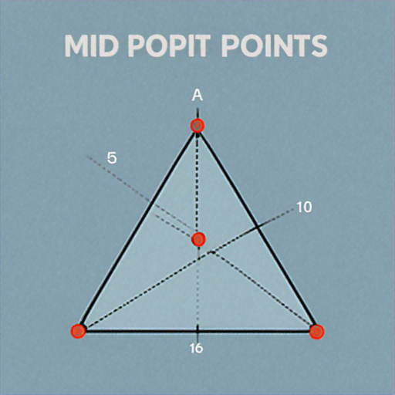
A) a) 4 cm | B) b) 6 cm
C) c) 8 cm | D) d) 10 cm

6. Two triangles are congruent by RHS rule if:
A) a) Two sides and any angle are equal | B) b) Hypotenuse and one side are equal
C) c) All angles are equal | D) d) Two angles and one side are equal

7. The volume of a hemisphere with radius 7 cm is:
A) a) 718.67 cm³ | B) b) 359.33 cm³
C) c) 1436 cm³ | D) d) 512.5 cm³

8. In the given quadrilateral ABCD, diagonals AC and BD intersect at O. If OA = 4 cm, OC = 4 cm, OB = 3 cm, OD = 3 cm, then ABCD is a:
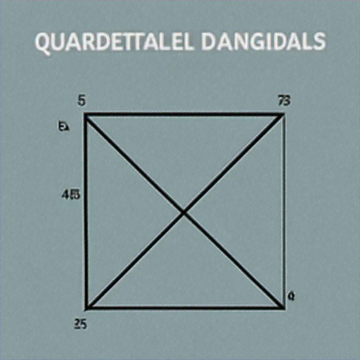
A) a) Rectangle | B) b) Square
C) c) Parallelogram | D) d) Trapezium

9. The total surface area of a cone with radius 3 cm and height 4 cm is:
A) a) 75.43 cm² | B) b) 65.97 cm²
C) c) 47.12 cm² | D) d) 56.55 cm²

10. In an equilateral triangle, each angle measures:
A) a) 45° | B) b) 60°
C) c) 90° | D) d) 30°

SECTION – Short Answer Questions - Set 1 SECTION (6 MARKS)

11. In a rhombus KLMN, prove that the diagonals KM and LN are perpendicular to each other.
12. A conical vessel has base radius 5 cm and height 12 cm. Find its curved surface area.
13. In triangle PQR, if PQ = PR and ∠Q = 48°, find ∠P.
14. The mid-points of sides of a triangle are joined to form another triangle. If the perimeter of the original triangle is 36 cm, find the perimeter of the new triangle.
SECTION – Short Answer Questions - Set 2 SECTION (6 MARKS)

15. ABCD is a trapezium with AB || DC. E and F are mid-points of AD and BC respectively. Prove that EF || AB and EF = (AB + DC)/2.
16. A metallic sphere of radius 6 cm is melted and recast into a cone of height 18 cm. Find the radius of the base of the cone.
17. In triangles ABC and PQR, AB = PQ, BC = QR and ∠B = ∠Q. Prove that the triangles are congruent and state the congruence rule used.
SECTION – Long Answer Questions SECTION (10 MARKS)

18. PQRS is a parallelogram. L and M are points on PQ and SR respectively such that PL = MR. Prove that: (i) LM and QS bisect each other (ii) PLMR is a parallelogram
19. In the given figure, triangles ABC and DEF have AB = 7 cm, BC = 9 cm, AC = 8 cm, DE = 7 cm, EF = 9 cm, DF = 8 cm. Prove that the triangles are congruent. Also find the correspondence between vertices and state the congruence rule used.
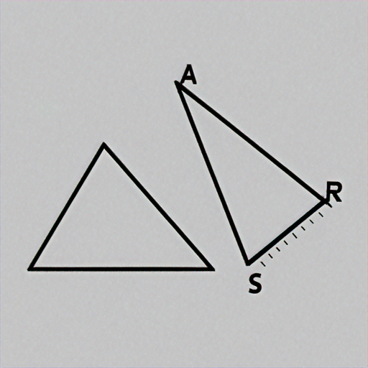
20. A tent is in the shape of a right circular cone. The radius of the base is 12 m and the height is 16 m. Find: (i) The slant height of the tent (ii) The cost of canvas required to make the tent at ₹85 per m² (iii) The volume of air inside the tent
SECTION – Case Based Questions SECTION (8 MARKS)

21. Case Study 1: A company manufactures ice cream cones. Each cone has a radius of 2.8 cm at the top and height 11.2 cm. The company wants to maximize the amount of ice cream that can be filled in each cone.
(a) Calculate the volume of one ice cream cone. (1 mark)
(b) If the company produces 1000 cones per day, what is the total volume of ice cream needed? (1 mark)
(c) Find the curved surface area of one cone if it needs to be covered with chocolate coating. (2 marks)
22. Case Study 2: A landscape designer is creating a garden with geometric patterns. The design includes a triangular section ABC where AB = AC = 15 m, and a quadrilateral section PQRS where all sides are equal.
(a) If ∠BAC = 40° in the triangular section, find ∠ABC. (1 mark)
(b) What type of quadrilateral is PQRS if all its sides are equal? (1 mark)
(c) If the diagonals of PQRS bisect each other at right angles, prove that PQRS is a rhombus. (2 marks)
