RAMCO VIDYA MANDIR SR. SEC. SCHOOL, THAMARAIKULAM
Subject: SocialScience
Periodic Test - 2
CLASS : 9 | TIME :
EXAM NO : | MARKS : 50

SECTION – Multiple Choice Questions SECTION (10 MARKS)

1. The Spartacist uprising in Germany was inspired by which revolution?
a) French Revolution
b) American Revolution
c) Bolshevik Revolution
d) Industrial Revolution
2. According to the National Population Policy 2000, what is the target for infant mortality rate?
a) Below 40 per 1000 live births
b) Below 30 per 1000 live births
c) Below 50 per 1000 live births
d) Below 20 per 1000 live births
3. The _______ Commission was appointed in 1979 to identify socially and educationally backward classes in India.
4. The Nazi propaganda film that created hatred for Jews was called _______.
5. Match the following:
A. Antyodaya Anna Yojana - i. 1975
B. Integrated Child Development Services - ii. 2000
C. National Food Security Act - iii. 2013
D. Targeted Public Distribution System - iv. 1997
6. Match the following Nazi terms with their actual meanings:
A. Final Solution - i. Deporting to gas chambers
B. Evacuation - ii. Mass killing of Jews
C. Disinfection areas - iii. Gas chambers
D. Special treatment - iv. Mass killings
7. This card represents which component of India's food security system?
a) Buffer Stock
b) Public Distribution System
c) Minimum Support Price
d) Food Corporation of India
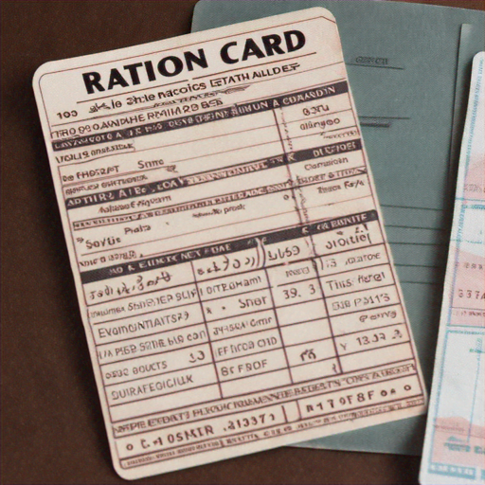
8. Identify the odd one out regarding population determinants:
a) Birth rate
b) Death rate
c) Migration
d) Literacy rate
9. Assertion (A): The President of India exercises nominal powers.
Reason (R): The President acts on the advice of the Council of Ministers.
a) Both A and R are true and R is the correct explanation of A
b) Both A and R are true but R is not the correct explanation of A
c) A is true but R is false
d) A is false but R is true
10. Consider the statements about Fundamental Rights:
I. They are enforceable by law
II. They can be suspended during national emergency
III. Right to property is a Fundamental Right
IV. They are mentioned in Part III of the Constitution
Which statements are correct?
a) I, II and IV
b) II, III and IV
c) I, III and IV
d) All of the above
SECTION – Answer in a sentence SECTION (4 MARKS)

11. What was the significance of Article 48 in the Weimar Constitution?
12. Define dependency ratio in the context of population studies.
13. What is the role of Cabinet Secretariat in Indian administration?
SECTION – Short answer questions SECTION (9 MARKS)

14. Explain how the economic crisis of 1923 contributed to political radicalization in Germany.
15. Analyze the impact of internal migration on urban and rural population composition in India.
16. Describe the process through which the Mandal Commission recommendations were implemented.
17. Explain the significance of Public Interest Litigation in protecting Fundamental Rights.
SECTION – Detailed answer questions SECTION (10 MARKS)

18. Analyze the Nazi ideology of racial hierarchy and explain how it was implemented through various policies and institutions in Germany between 1933-1945.
19. Evaluate the effectiveness of India's food security system, discussing both the Public Distribution System and Buffer Stock mechanism, along with their challenges.
20. Critically examine the relationship between the political executive and permanent executive in India, with specific reference to their roles in policy formulation and implementation.
SECTION – Case based question SECTION (4 MARKS)

- Read the passage:
The Bengal Famine of 1943 remains one of the most devastating food crises in Indian history, claiming approximately three million lives. Despite adequate rice production of 76 lakh tonnes that year, the famine occurred due to multiple factors including wartime policies, hoarding, and distribution failures. The British colonial government's decision to divert food supplies for military purposes and restrict inter-provincial grain movement exacerbated the crisis. Agricultural laborers, fishermen, and transport workers were the worst affected as rice prices skyrocketed beyond their purchasing power. This tragedy highlighted how food insecurity isn't merely about production shortfalls but involves complex issues of accessibility and affordability. The famine's lessons influenced independent India's food security policies, leading to the establishment of the Public Distribution System and the Food Corporation of India. These institutions were designed to prevent such catastrophes by ensuring food availability even during crises, maintaining buffer stocks, and providing subsidized food to vulnerable populations through a network of fair price shops.
21a. What were the main occupational groups affected by the Bengal Famine?
21b. Despite adequate rice production, why did the famine occur?
21c. How did the Bengal Famine influence India's post-independence food policies?
21d. What does this case reveal about the relationship between food production and food security?
SECTION – Map based question SECTION (3 MARKS)

22a. Mark any two states with population density below 250 persons per square kilometer.
22b. Identify the state with the highest food grain production as per recent data.
22c. Label any one state where cooperative societies run more than 90% of fair price shops.

