RAMCO VIDYA MANDIR SR. SEC. SCHOOL, THAMARAIKULAM
Subject: SocialScience
Periodic Test - 2
CLASS : 8 | TIME :
EXAM NO : | MARKS : 50

SECTION – Multiple Choice Questions SECTION (10 MARKS)

1. Which type of farming involves cultivating single crops like tea, coffee, or rubber on large estates?
a) Subsistence farming
b) Plantation agriculture
c) Shifting cultivation
d) Nomadic herding
2. According to the 2011 census, what percentage of India's population are Muslims?
a) 10.2%
b) 12.5%
c) 14.2%
d) 16.8%
3. The Employment of Manual Scavengers and Construction of Dry Latrines (Prohibition) Act was passed in _______.
4. Around _______ per cent of India's population is Adivasi.
5. Match the following:
A. Jhumming - 1. Mexico
B. Milpa - 2. Brazil
C. Roca - 3. Malaysia
D. Ladang - 4. North-East India
6. Match the following crops with their requirements:
A. Rice - 1. 210 frost-free days
B. Cotton - 2. High temperature and humidity
C. Coffee - 3. Cool climate
D. Tea - 4. Warm and wet climate
7. This image represents which type of agricultural practice commonly found in hilly regions?
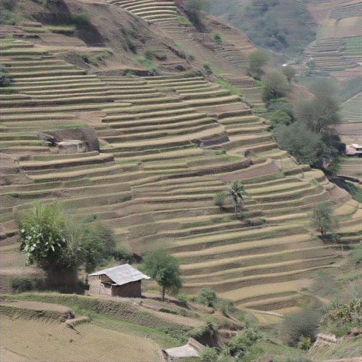
8. Identify the odd one out:
a) Scheduled Castes
b) Scheduled Tribes
c) Manual Scavengers
d) Zamindars
9. Assertion (A): The Scheduled Tribes and Other Traditional Forest Dwellers Act, 2006 recognizes forest rights of Adivasis.
Reason (R): Adivasis have been historically displaced from their forest lands.
a) Both A and R are true and R is the correct explanation of A
b) Both A and R are true but R is not the correct explanation of A
c) A is true but R is false
d) A is false but R is true
10. Which statement about marginalisation is INCORRECT?
a) It affects only economic aspects of life
b) It leads to exclusion from mainstream society
c) It can affect multiple communities simultaneously
d) It involves denial of resources and opportunities
SECTION – Answer in a sentence SECTION (4 MARKS)

11. Define 'Golden Fibre' and name the countries that are leading producers of this crop.
12. What does Article 17 of the Indian Constitution state about untouchability?
13. What is the main difference between intensive subsistence agriculture and commercial farming?
SECTION – Short answer questions SECTION (9 MARKS)

14. Explain how the displacement of Adivasis from their forest lands affects their economic and social life.
15. Describe the working conditions of manual scavengers and the laws enacted for their protection.
16. Compare the agricultural practices of a typical Indian farm with that of a farm in the USA.
17. How does the reservation policy work as a tool for promoting social justice in India?
SECTION – Detailed answer questions SECTION (10 MARKS)

18. Analyze the various factors that have led to the marginalisation of Adivasi communities in India and discuss the constitutional safeguards provided to protect their rights.
19. Explain the different types of farming practices prevalent in India and discuss how agricultural development can be achieved to ensure food security.
20. Discuss the significance of the Scheduled Castes and Scheduled Tribes (Prevention of Atrocities) Act, 1989, with reference to Rathnam's case study and explain how marginalised communities use laws to confront discrimination.
SECTION – Case based question SECTION (4 MARKS)

- Read the passage:
Munna Lal, a farmer from Adilabad village in Uttar Pradesh, owns 1.5 hectares of land where he practices intensive subsistence farming. He grows wheat and rice as main crops and pulses as secondary crops, achieving two harvests annually due to fertile soil. He purchases high-yielding variety seeds from the market every alternate year and rents a tractor for ploughing, though some neighbors still use bullocks. For irrigation, he rents a nearby tubewell. Besides crops, Munna Lal keeps two buffaloes and some hens, selling milk to the local cooperative store. He is a member of the agricultural cooperative society that provides him credit for seeds and implements. His biggest challenge is the lack of storage facilities, forcing him to sell produce even when market prices are unfavorable. Despite government initiatives to develop storage infrastructure, small farmers like Munna Lal continue to face difficulties in getting fair prices for their produce.
21a. What type of farming does Munna Lal practice on his land?
21b. Name two modern agricultural inputs that Munna Lal uses for farming.
21c. How does the cooperative society help farmers like Munna Lal?
21d. What is the main marketing challenge faced by Munna Lal?
SECTION – Map based question SECTION (3 MARKS)

22a. Mark any one state with high Adivasi population in central India.
22b. Identify and mark Assam - a major tea producing state.
22c. Locate and label any one state where commercial grain farming is practiced.

