Lab1 -

OutPut:

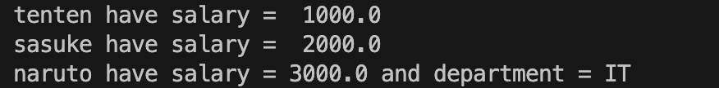

Lab2 –

Output

