Short Questions to Analyzing the NYC Subway Dataset
Analyzing the NYC Subway Dataset
Short Questions
Overview

(Updated per comments by reviewer Andre Ribeiro, and thanks to him!).

This project consists of two parts. In Part 1 of the project, you should have completed the questions in Problem Sets 2, 3, 4, and 5 in the Introduction to Data Science course.
This document addresses part 2 of the project. Please use this document as a template and answer the following questions to explain your reasoning and conclusion behind your work in the problem sets. You will attach a document with your answers to these questions as part of your final project submission.

Section 1. Statistical Test
1.1 Which statistical test did you use to analyze the NYC subway data? Mann-Whitney U test
Did you use a one-tail or a two-tail P value? What is the null hypothesis? What is your p-critical value? Two-tailed. Null hypothesis is that the means are equal, ridership is the same on rainy and dry days. P-critical = .05.
1.2 Why is this statistical test applicable to the dataset? In particular, consider the assumptions that the test is making about the distribution of ridership in the two samples. Test is not making any assumptions about the probability distribution of the ridership in the samples.
1.3 What results did you get from this statistical test? These should include the following numerical values: p-values, as well as the means for each of the two samples under test.
P=.02499, no-rain mean 1090.28, with-rain mean 1105.45
1.4 What is the significance and interpretation of these results? The ridership on days with no rain is significantly different than on days with rain.

Section 2. Linear Regression
2.1 What approach did you use to compute the coefficients theta and produce prediction for ENTRIESn_hourly in your regression model:
- Gradient descent (as implemented in exercise 3.5)
- OLS using Statsmodels
- Or something different?
3. OLS using scipy.stats, and statsmodels
2.2 What features (input variables) did you use in your model? Did you use any dummy variables as part of your features? Time-of-day (Hour), no dummy variables.
2.3 Why did you select these features in your model? We are looking for specific reasons that lead you to believe that the selected features will contribute to the predictive power of your model.
- Your reasons might be based on intuition. For example, response for fog might be: “I decided to use fog because I thought that when it is very foggy outside people might decide to use the subway more often.”
- Your reasons might also be based on data exploration and experimentation, for example: “I used feature X because as soon as I included it in my model, it drastically improved my R2 value.”
It seemed pretty obvious that ridership would vary by time-of-day – people ride the subway much more in the daytime than at night. I tried adding rain and weekend variables but did not get significantly better R2.
2.4 What are the coefficients (or weights) of the non-dummy features in your linear regression model? The coefficient is 134.9291.
2.5 What is your model’s R2 (coefficients of determination) value? R2 = 0.294
2.6 What does this R2 value mean for the goodness of fit for your regression model?
An R2 of 0.294 indicates that the model doesn't provide precise predictions of the ridership.
Do you think this linear model to predict ridership is appropriate for this dataset, given this R2 value?
It's not clear to me if the overall goal is to predict ridership at individual stations (UNITs), or for the system as a whole. If the former, then UNIT should be a variable in the model. If the latter, then data should be aggregated over the UNITs. In either case, much better predictions could be made (e.g. R2 = 0.86 for the system as a whole, just based on time-of-day).

Section 3. Visualization
Please include two visualizations that show the relationships between two or more variables in the NYC subway data.
Remember to add appropriate titles and axes labels to your plots. Also, please add a short description below each figure commenting on the key insights depicted in the figure.
3.1 One visualization should contain two histograms: one of ENTRIESn_hourly for rainy days and one of ENTRIESn_hourly for non-rainy days.
- You can combine the two histograms in a single plot or you can use two separate plots.
- If you decide to use to two separate plots for the two histograms, please ensure that the x-axis limits for both of the plots are identical. It is much easier to compare the two in that case.
- For the histograms, you should have intervals representing the volume of ridership (value of ENTRIESn_hourly) on the x-axis and the frequency of occurrence on the y-axis. For example, each interval (along the x-axis), the height of the bar for this interval will represent the number of records (rows in our data) that have ENTRIESn_hourly that falls in this interval.
- Remember to increase the number of bins in the histogram (by having larger number of bars). The default bin width is not sufficient to capture the variability in the two samples.

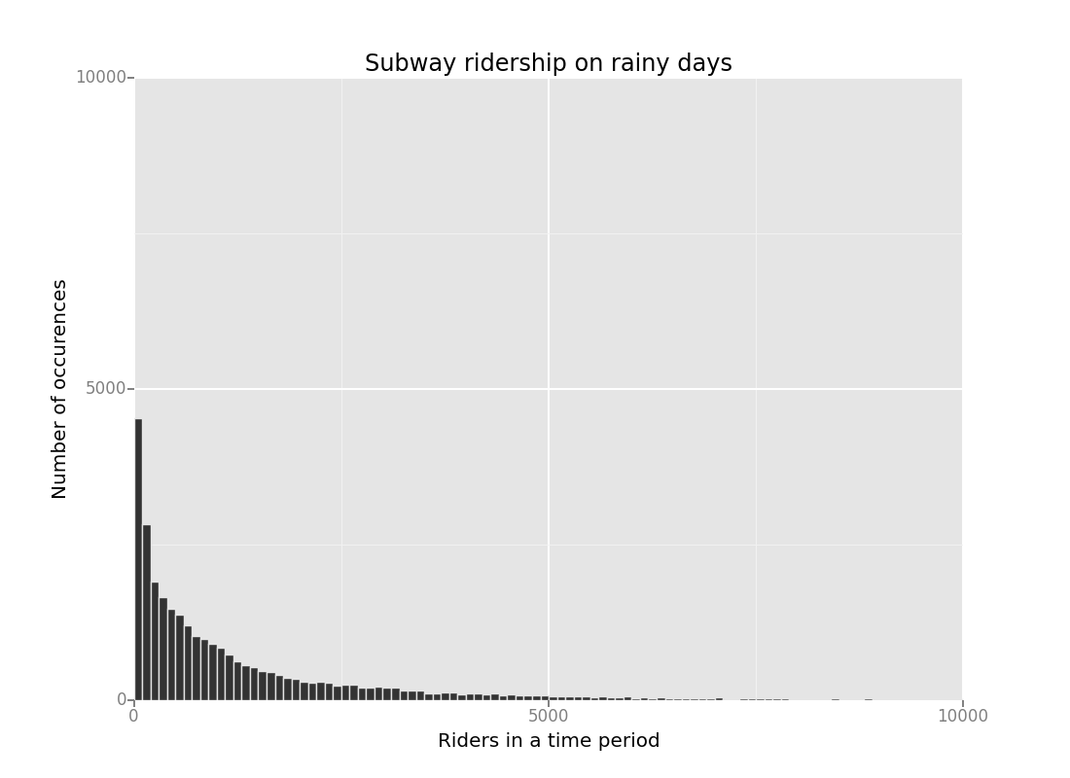
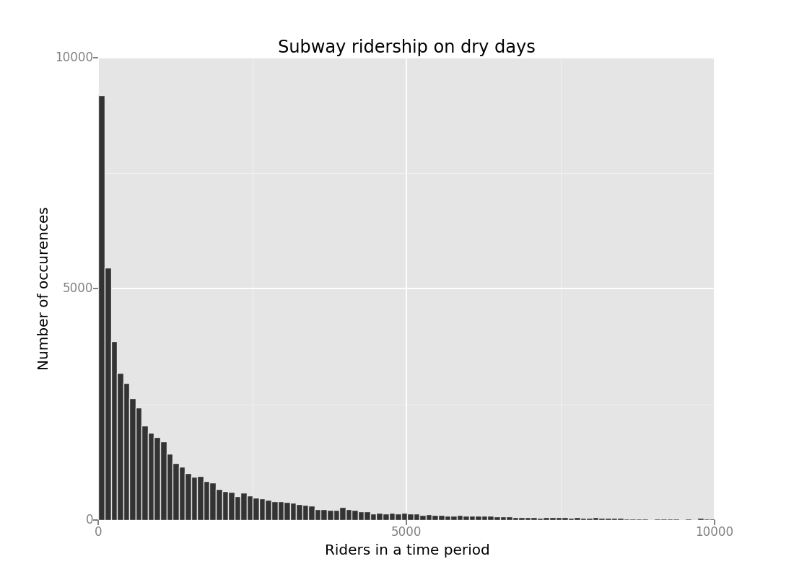

Same data, combined into one chart:
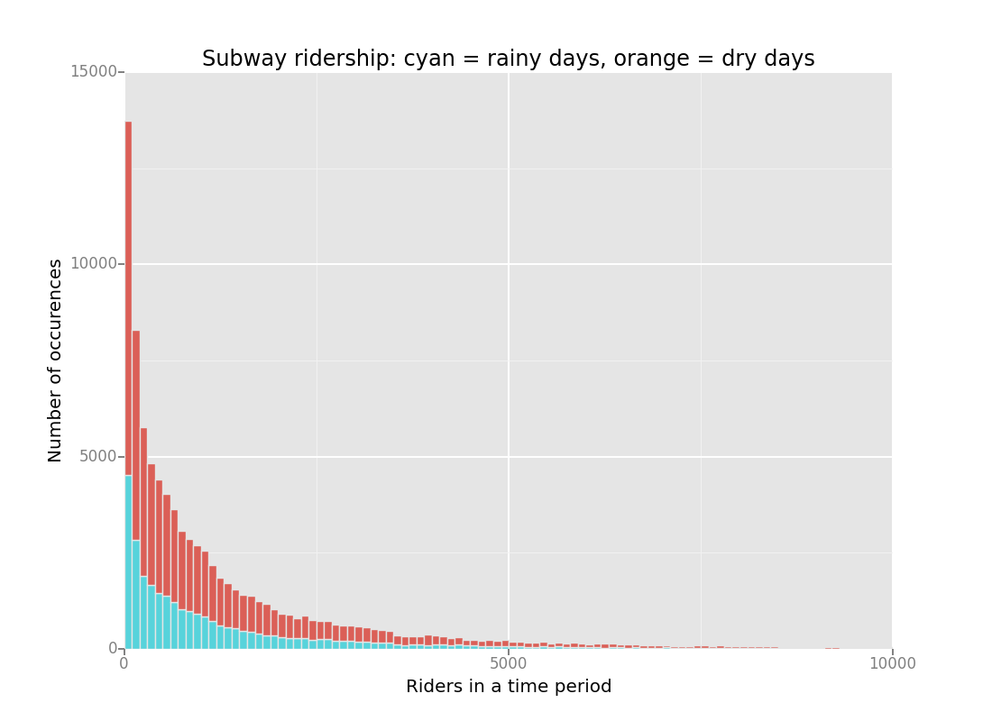

3.2 One visualization can be more freeform. You should feel free to implement something that we discussed in class (e.g., scatter plots, line plots) or attempt to implement something more advanced if you'd like. Some suggestions are:
- Ridership by time-of-day
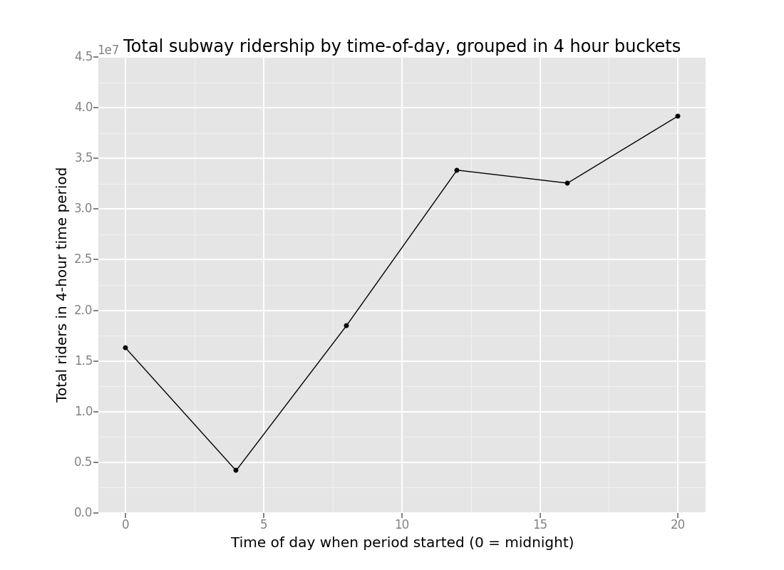
- Ridership by day-of-week

Section 4. Conclusion
Please address the following questions in detail. Your answers should be 1-2 paragraphs long.
4.1 From your analysis and interpretation of the data, do more people ride
the NYC subway when it is raining or when it is not raining? Slightly more people ride the NYC subway when is is raining, but difference is barely significant, using p=.025 for a one-tail test.
4.2 What analyses lead you to this conclusion? You should use results from both your statistical
tests and your linear regression to support your analysis. Per the Mann-Whitney test, there is a barely significant difference between when it is raining or not raining. When using a linear regression, adding the rain/no-rain variable added very little (e.g. .006) to the regression R2.

Section 5. Reflection
Please address the following questions in detail. Your answers should be 1-2 paragraphs long.
5.1 Please discuss potential shortcomings of the methods of your analysis, including:
- Dataset,
When the raw data was processed to calculate the “ENTRIESn_hourly” values, information was “thrown away”. The time difference between consecutive entries for a given UNIT should have been calculated and saved as a column in the data. The time difference varies from seconds to hours, so the “ENTRIESn_hourly” values were less consistent. Dividing the “ENTRIESn_hourly” by the time difference, e.g. creating “ENTRIES_per_hour” would give values that are more comparable, and more predictable.
- Analysis, such as the linear regression model or statistical test. It would be helpful to have more context on the requirement for the predictions, which would drive the form of the analysis. For example:
- If the goal is to determine station staffing, then a UNIT level model would be useful.
- If the goal is to predict system cash flow, then a model not including UNIT would be useful.
- If the goal is just to satisfy casual curiosity, then an overall model (not including UNIT) might be useful.

I used a simple linear regression model for the time-of-day analysis. Since the time-of-day is cyclical, another approach would be to add cyclical terms, e.g. sine/cosine to the model.
5.2 (Optional) Do you have any other insight about the dataset that you would like to share with us? I also noted the time difference between samples was smaller during peak periods, exaggerating the impact noted above. In effect, “noise” was added to the values.

