Business Central — Tentixo Playbook
Version: 1.0 Status: Active Created: 2026-05-26 Updated: 2026-06-04 Scope: BC knowledge capture — architecture, operations, bookkeeping, client status
Living document. Captures what Chris has learned about BC from Morre, current client setups, and conventions to follow when working with Claude Code on BC-related tasks.

1. Context
Me: Chris Mansson, Client Director at Tentixo (Stockholm-based boutique Nordic cybersecurity + ERP advisory firm).
Co-founder & technical lead: Lars Mårelius (“Morre”). He’s the deep BC operator and architect. He teaches Socratically — drills the architecture before the UI — and is strongly opinionated about doing things the “right” way the first time rather than patching later.
My BC level: Learning. Strong on commercial/strategic framing, conceptually solid on architecture, weak on UI muscle memory and edge cases.
Active BC engagements: - Tinky Minds Lab AB — first practical setup. 18,000 SEK Heat Map engagement (incl. 2 workshops). Used as a real-world exercise to learn the full customer→project→invoice flow in Tentixo’s sandbox. - Formpipe — newly signed BC-support contract. Spinning up a new Microsoft tenant in October 2026. Engagement scope: optimise finance operations and evaluate which third-party integrations (TimeLog, Younium, Rillion, etc.) can be replaced by BC-native functionality. - Lasernet — ongoing BC governance programme (separate engagement, less active for me personally).

2. How Morre teaches (working conventions)
When I’m getting help on BC tasks, default to these patterns — they match how Morre frames things:
- Architecture before UI. Always orient on which layer of the hierarchy you’re touching (see §3) before walking through buttons and field names.
- Think before you do. For each step, name the decision being made and surface trade-offs explicitly rather than picking the obvious default silently.
- Posting groups are the magic. Most “how do I make BC do X” answers route through posting group setup, not workflow customisation.
- Pricing belongs in price lists, not items. Item Unit Price should usually be 0 (or a reference catalogue price). Customer-specific or project-specific prices override via price lists.
- Resources = “we sell you”. Employees = “you work for us”. Separate records, both needed for people-driven engagements.
- Service-type Items, not Inventory. Inventory type triggers stock tracking, negative inventory traps, valuation noise — wrong for consulting.
- Transaction-based, not database-based. BC’s strength vs systems like TimeLog: posted entries stay in the ledger. Reversals create audit trail. Avoid any pattern that suggests “just edit the value.”

3. Core architectural model

3.1 The layered hierarchy
Every layer depends on the one below. Get a lower layer wrong → everything above breaks.
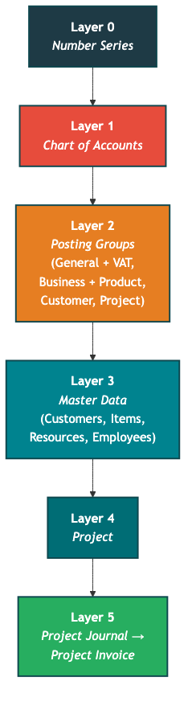
Diagram 1
Five “people” registers in BC — the same person can appear in multiple registers, each serving a different purpose:
Register | Purpose | Used by
Employee | “You work for us” — payroll, HR | Payroll, employment records
Resource | “We sell you” — billable rates | Project Journal lines, time sheets
Contact | CRM — relationships, interactions | Person Responsible on Project card
User | System login — controls who can post | Project Manager, posting restrictions
Customer/Vendor | Business entity | Invoicing, AP/AR
Person Responsible on the project card pulls from Contacts. Project Manager pulls from Users (or Employee/Resource — check which register the field draws from).

3.2 GVH framework (Goods / Virtual / Human)
Tentixo’s chart of accounts is organised around three sales categories. The CoA’s intent is to expose cost structure, not just categorise the deliverable.
Range | Type | Cost driver | Examples
30xx | Goods | Physical, shipping | Hardware resale
31xx | Virtual | Low marginal, self-serve | Licenses, electronic services
32xx | Human | Employees, HR | Consulting, advisory
Litmus test: if we remove humans, can we still deliver? If no → Human, regardless of pricing model. Heat Map is Human (Consulting) — fixed price doesn’t override delivery reality.
CoA intent = cost structure, not product type. A Virtual item (e.g., a fixed-price package) can land on a Human/Consulting account (32xx) if it’s human-bound — because the chart of accounts exposes what costs the company carries (employees, HR, shipping), not what the deliverable looks like. This is the conversation you need to have with every client and they never have time for.
VAT subcategory — Electronic Service: Within Virtual, there’s a VAT-significant distinction. A license downloaded from a website = electronic service (specific VAT rules for cross-border EU). Same license shipped on a CD-ROM = still Virtual, but not electronic service. Reactive support can be electronic service if minimal human involvement; heavy support is just “service.” The VAT Prod. Posting Group handles this (separate rows in the VAT Posting Setup for SERVICE vs ELECTRONIC SERVICE).

3.3 BC module map
(diagram: ai/docs/BC_CentralParts-chris.png)
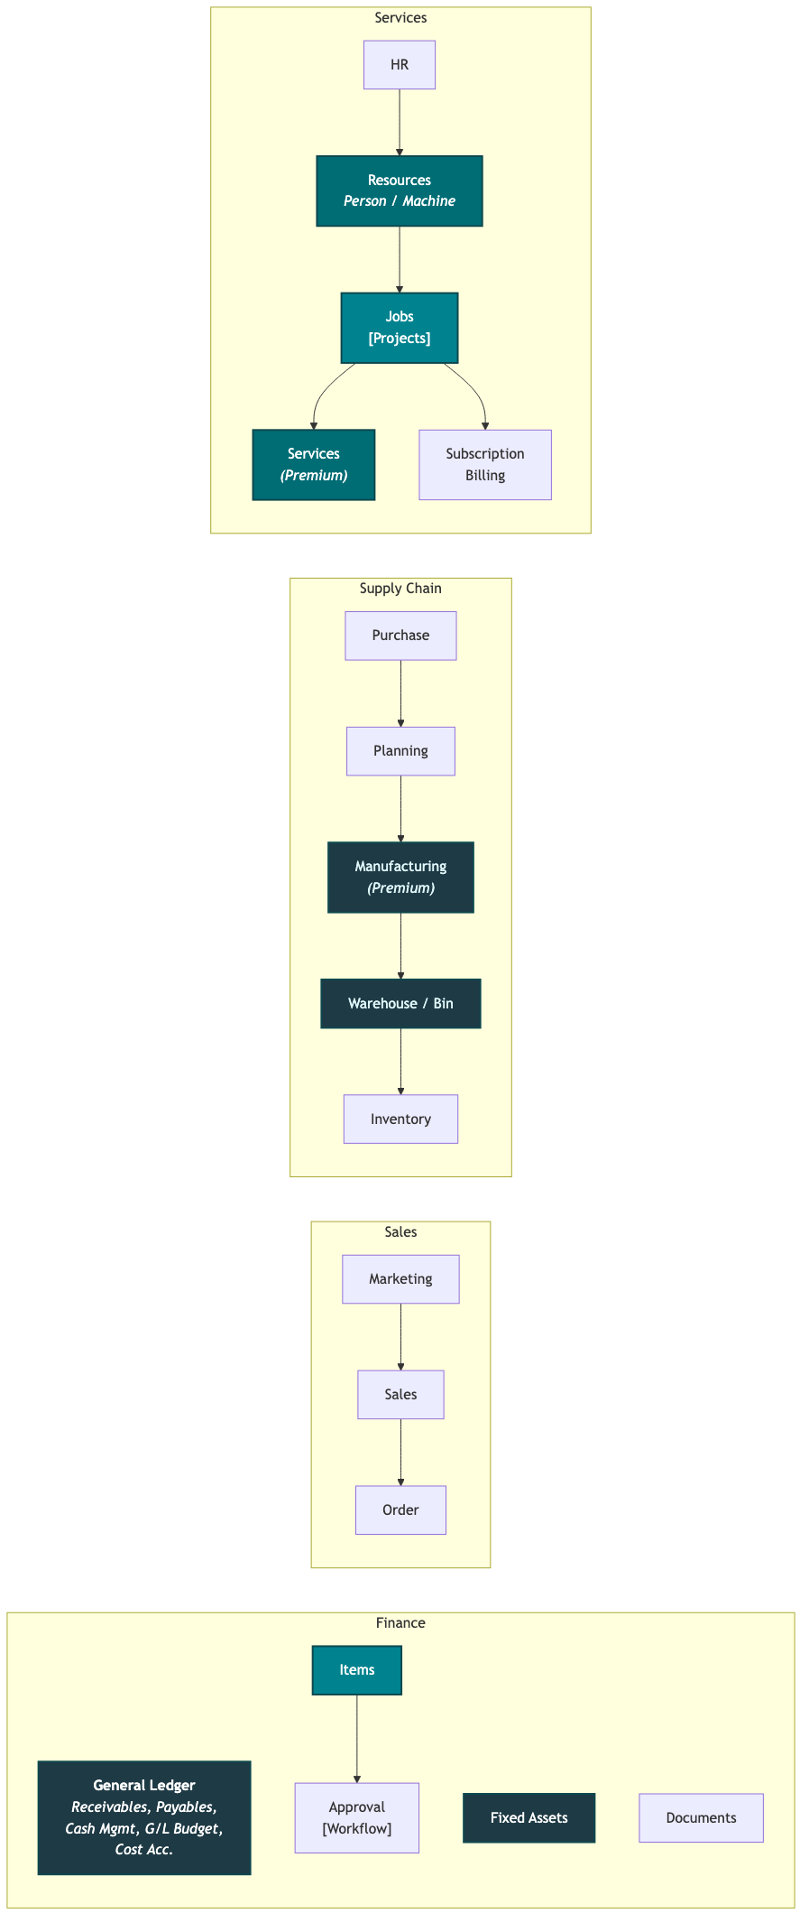
Diagram 2
Document lifecycle:
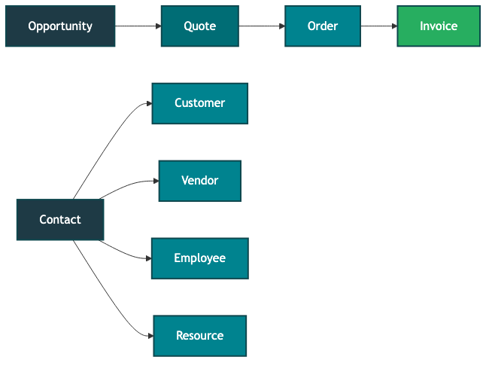
Diagram 3
Contact is the root of “people”: Contact → branches into Customer, Vendor, Employee, Resource. A single contact can spawn multiple entity types.

3.4 The WHO × WHAT posting matrix
BC’s core elegance — and the lens Morre uses to evaluate every implementation:
- Business Posting Group on the Customer = WHO we sell to (EXT, NATIONAL, INTERCO)
- Product Posting Group on the Item/Resource = WHAT we sell (CONSULTING1/2/3, SERVICES, GOODS)
- General Posting Setup = the matrix that maps every (WHO, WHAT) combination to a specific G/L revenue account
- Same logic for VAT: VAT Bus × VAT Prod → correct moms rate + accounts
Companies that skip this either duplicate items (e.g., “Heat Map - Sweden” vs “Heat Map - Norway”) or fall into dimension overload (Formpipe’s pre-acquisition mistake).

3.5 Posting flow — how journal entries reach the ledger
(diagram: ai/docs/BC-Posting-chris.png)
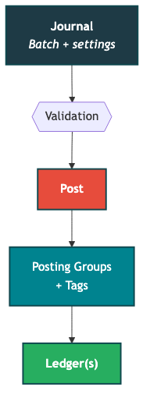
Diagram 4
G/L Account posting in detail (e.g., document GJ1234):
- General Journal entry in a batch
- Post triggers the posting engine
- Engine reads Gen Posting Type (Purchase / Sale / Settlement) and the four posting groups:
Posting Group | Question it answers
Gen Business | Whom? (who are we doing business with)
Gen Product | What? (what are we selling/buying)
VAT Business | Who + Where? (jurisdiction of counterparty)
VAT Product | What + Level? (what type, at what VAT rate)
- “All Five or None!” — Gen Posting Type + all four posting groups must be set together, or none at all. You can’t partially specify.
- Output: document number → General Ledger (CoA) entry on the resolved account (e.g., 3010), and VAT% matched by Biz+Prod → VAT Entries ledger.

3.6 Document posting — invoices and fixed assets
(diagram: ai/docs/BC-Posting-from-document-chhris.png)
Fixed Asset Vendor Invoice posting — more complex, touches more ledgers:
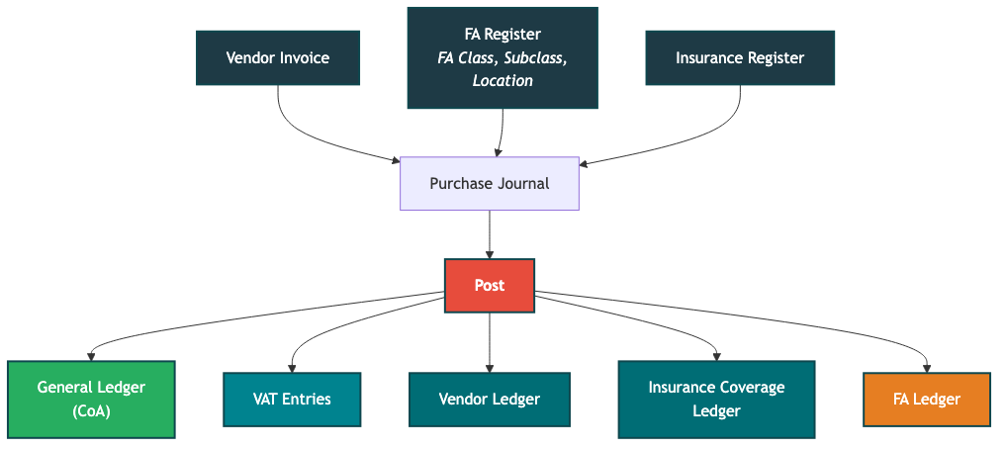
Diagram 5
- Prerequisites: FA Card must exist (FA Class, FA Subclass, FA Location). Insurance Card if the asset is covered.
- Tags: Posting Type, Document Type, FA Posting Type, Depr. Book Code
- Posting Groups: Gen Business, Gen Product, VAT Business, VAT Product, Vendor, FA
Vendor Invoice Payment registration:
- Purchase Journal (with Bank Account as balancing account) → Post → “Apply Payment to Invoice” on the Vendor Ledger
- Posting Groups: Vendor + Bank Account → writes to General Ledger + Bank Account Ledger

3.7 Project module ERD
(diagram: ai/docs/BC-Project-ERD-Chris.png)
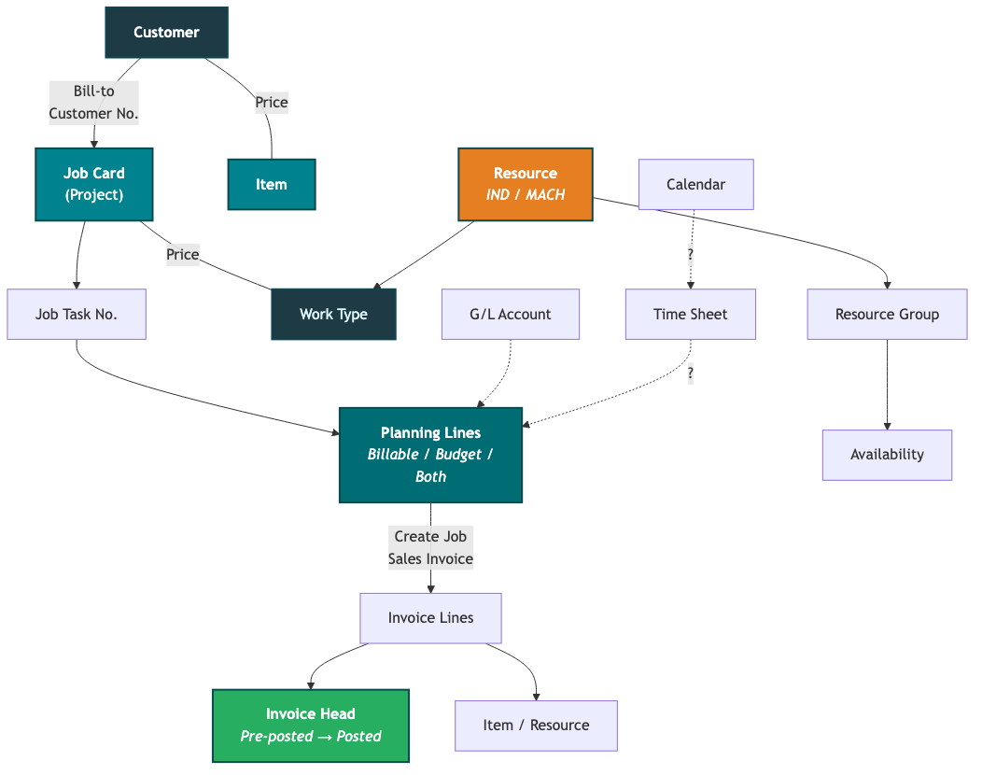
Diagram 6
- Planning Lines are the journal entries: Billable, Budget, or Both Billable and Budget
- “Create Job Sales Invoice” pulls Planning Lines → Invoice Lines → Invoice Head
- G/L Account can also appear on Planning Lines (for non-item, non-resource costs)
- Time Sheet and Calendar connections shown with “?” — integration points that may or may not be enabled

3.8 VAT Business Posting Groups — geographic model
(diagram: ai/docs/BC-VAT-pg-Chris.png)
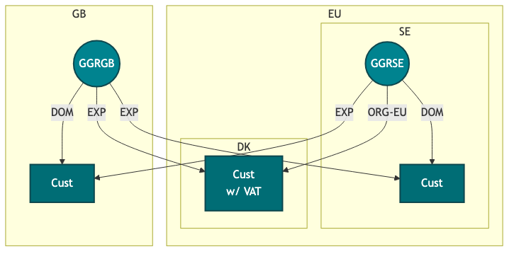
Diagram 7
- Each country has its own GGR (effectively the VAT Bus. Posting Group for that entity)
- DOM = domestic (same country), EXP = export (cross-border), ORG-EU = EU organisation (intra-community VAT rules)
- DK customer “with VAT” shows that some jurisdictions require VAT registration on the customer card
- This is why the WHO × WHAT matrix is so powerful — same item, different customer country, correct VAT treatment automatically

3.9 Warehouse module
(diagram: ai/docs/BC-Warehous-ERD-Chris.png)
Not directly relevant for consulting/services, but important for Goods-type engagements and Formpipe’s product lines.
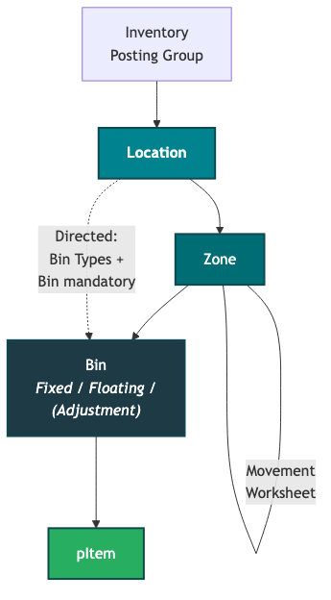
Diagram 8
Inbound flow: Purchase Order → Receipt (Released) → Put-Away (Released)
Outbound flow: Sales Order (Released) → Pick (Register) → Shipment (Post) → Invoice
If Bin is not mandatory: just “Recording” (simplified tracking without bin-level precision).

3.10 Why Project (not direct Sales Invoice) for “messy” engagements
Project model wins over direct invoicing when: - Engagement is evolving, not a one-off transaction - Mixed billing (fixed-price + hours + travel + future licenses) in one container - Need analytical granularity per sub-element preserved through to invoicing - Want budget vs actual and margin reporting
Keep recurring/subscription billing outside the project — keeps project P&L clean.

4. Operational playbook — the 8-step flow
Morre’s prescribed order for setting up a new consulting engagement. Order matters because of layer dependencies.
Diagram 9

Step 1 — Customer
Field | Tentixo convention (domestic SE B2B)
Gen. Bus. Posting Group | EXT
VAT Bus. Posting Group | EXT
Customer Posting Group | DOMESTIC
Country/Region Code | SE
Registration No. | org.nr (e.g. 5566778899)
VAT Registration No. | SE + org.nr + 01
Payment Terms | 30D
Registration No. is on General FastTab (newer BC) or Invoicing FastTab (older). Don’t confuse with VAT Registration No.

Step 2 — Contact
Creating a Customer auto-creates a company-type Contact card. Open it and add person contacts (decision-maker, billing/AP, technical lead).
Watch for duplicate contacts if the same company is both customer and vendor (Idonex pattern). Merge via Contact → Actions → Merge.

Step 3 — Item (Service-type)
Field | Value
Type | Service
Base Unit of Measure | PCS
Gen. Prod. Posting Group | CONSULTING1 (Human-bound delivery)
VAT Prod. Posting Group | VAT25
Inventory Posting Group | blank
Unit Price | 0 (override via price list)

Step 4 — Resource (the “we sell you” side)
Field | Value
Type | Person
Base Unit of Measure | HOUR
Unit Cost | 560 (my internal cost rate)
Unit Price | 1400 (default sell rate — override per client/project)
Gen. Prod. Posting Group | CONSULTING1
VAT Prod. Posting Group | VAT25
Trap: Unit Cost and Unit Price sit next to each other. Don’t change Unit Cost when you mean Unit Price (Morre caught me on this).

Step 5 — Employee (the “you work for us” side)
Parallel record to Resource. Where the Resource card links via Employee No., populate it. Payroll-side setup is a separate workstream.

Step 6 — Project
Field | Value
Bill-to Customer No. | the customer
Project Posting Group | a consulting-aligned group with WIP account configured
Status | Open
Person Responsible | the lead consultant
Project Tasks: start with one posting-type task (e.g., 1000 Heat Map). Add sub-tasks only when engagement splits (retainer + project work, or pre-study/execution/post). Don’t pre-optimise.
WIP method must match project type. If a T&M project has WIP method set to “Fixed Price” (or vice versa), the WIP postings hit the wrong chart-of-accounts entries. Check WIP Method on the project card before any WIP calculation.

Step 7 — Project Journal
Journal batch hygiene: Before posting, check which batch you’re in (top of the journal page). Batches let multiple people work in the same journal simultaneously without collisions. There’s a dedicated API batch with its own number series — never post manually to it. Use the DEFAULT batch for manual work.
Two line types for fixed-price engagements:
Line 1 (revenue capture):
Type=Item, No.=HM-LITE, Project Task=1000, Qty=1,
Unit Price=18000 (override), Line Type=Billable
Line 2 (cost capture):
Type=Resource, No.=CHRIS, Project Task=1000, Qty=16,
Line Type=Non-Billable
For T&M instead: Resource lines are Billable, no Item line needed.
Posting date shortcuts: Type T + Tab for today’s date. For prior months, type the short date directly (e.g., 0430 for April 30).
Unit Price vs Unit Price (LCY): If the project is in a foreign currency, set the price in Unit Price. Unit Price (LCY) is the local-currency equivalent and auto-calculates. For SEK projects, they’re the same — but edit Unit Price, not the LCY field.
Late hours: Post old hours to the correct past month (posting date = when the work happened). BC’s invoicing picks up anything uninvoiced regardless of date, so late-reported hours get captured automatically on the next invoice run.
Post the journal (F9).

Step 8 — Create Project Invoice
Two ways to create the invoice: 1. Global: Search → “Create Project Sales Invoice” → OK. Takes all uninvoiced billable lines across projects. 2. Per task line: From the project task, Manage → Line → Documents → Create Sales Invoice. Invoices just that task — useful when you want to bill pre-study separately from execution.
The draft Sales Invoice is linked to the project. Project-linked lines are locked — you can’t change quantities or prices on them. You can add extra lines (e.g., comments, one-off charges), but those additions won’t be tracked in the project.
Work Description field (under “Show more” on the invoice header): Text that appears above the line items on the printed invoice. Use it for engagement descriptions, period references, etc.
Review header/lines/Statistics (F7), then Post & Send.
Invoice structure (useful for API work): An invoice is just Head + Lines. The “head” contains everything that visually appears in the header and footer of the printed invoice — customer, payment terms, dates, addresses. Lines are the billable items.
After posting, the project ledger marks those lines as “invoiced” (a dot/boolean). BC will never invoice the same line twice — this is the core safety net for automation.
After posting, open Project Statistics for budget vs actual, billable vs non-billable, cost vs revenue, margin.

5. Bookkeeping fundamentals
From Morre session, June 2026

5.1 Double-entry: always zero
Every transaction has a plus and a matching minus — the books must always net to zero. This is “double-entry Italian bookkeeping.” Start every transaction by thinking about the bank: did money come in, go out, or stay?
The sign convention (counterintuitive until you internalise it):
Account type | Sign | Why
Bank (assets, 1000s) | + | You have money — makes sense
Liabilities (2000s) | − | You owe money — balances the asset
Revenue (3000s) | − | A sale puts + in the bank, so the revenue entry must be −
Costs (4000s+) | + | Paying salary takes − from the bank, so the cost entry is +
Example — share capital: Shareholders invest 100,000. Bank = +100,000, Share Capital = −100,000 (you owe it back). Net = zero.
Example — salary: Pay 10,000 salary. Cost = +10,000, Bank = −10,000. Net = zero.
Example — sale with VAT: Sell 80,000 + 20% VAT = 100,000 collected. Bank = +100,000, Revenue = −80,000, VAT liability (2640) = −20,000. Net = zero.

5.2 Chart of accounts — the number logic
Range | Type | Sign | What lives here
1000s | Assets | + | Bank (1930), fixed assets, receivables
2000s | Liabilities | − | Loans, VAT payable (2640), share capital
3000s | Revenue | − | Sales income
4000s | Cost of goods sold | + | Costs directly tied to a sale (mirror of 3000s)
5000s–7000s | Operating costs | + | Salaries, depreciation, rent, etc.
The 3000/4000 mirror: Revenue account 3011 (goods revenue) pairs with 4011 (purchase of goods). Same structure — one digit apart. This is deliberate.
GVH in the 3000s (Tentixo/Formpipe convention): - 30xx — Goods - 31xx — Services (virtual, low-marginal) - 32xx — Human (consulting) - 33xx — Odd sales (one-offs you want separated from core revenue)
Tree rule: The chart of accounts is a tree (each account has one parent). If you use granular child accounts, you must not also post to the parent — they overlap. Pick one level. (Formpipe violated this with manual bookings — led to confusion.)

5.3 Cost vs. investment — fixed assets
Buying something expensive (a building, equipment) is not a cost — it’s converting one asset form (cash) to another (fixed asset). Both stay on the balance sheet:
- Bank (1930) = −1,000,000 (cash out)
- Fixed Asset (e.g., buildings) = +1,000,000 (value in)
Net effect on income statement: zero. You looped within the balance sheet.

5.4 Depreciation and appreciation
Depreciation: The asset wears down. Each year, move value from the balance sheet to the income statement: - Fixed Asset = −10,000 (value decreases) - Depreciation cost (e.g., 7821) = +10,000 (cost recognized)
Appreciation: A repair increases the asset’s value beyond what was there: - Bank = −20,000 (paid for repair) - Fixed Asset = +20,000 (value increases) - Appreciation account (7xxx) = −20,000 (effectively profit — you created value)

5.5 Revenue recognition — when did it happen?
Critical distinction (Swedish terms are more precise than English here):
Swedish | English | What it means
Inbetalning | Payment in | Cash hits the bank (balance sheet event)
Intäkt | Revenue | The earning event — when you can say “I earned this” (income statement event)
These are different events at different times. Getting paid in advance ≠ earning the revenue. Invoicing in June for May work → revenue belongs in May, not June. The income statement cares about when the value was delivered, not when cash moved.

5.6 Work in progress (WIP) and recognized revenue
IFRS requires showing revenue you know you’ll earn (signed contracts, partially completed projects) — otherwise the company looks undervalued.
The mechanism: Book revenue as − (income statement) and a matching + on a “fake bank account” (a WIP/recognized receivable on the balance sheet). When the real invoice goes out, cancel both entries and replace with the real sale + real receivable.
BC-specific flow: Project module handles this. Mark project as X% complete → press a button → BC books the WIP entries. When you create the actual invoice, the WIP entries get reversed automatically.
BC “shipped not invoiced”: Goods shipped but not yet invoiced sit on a specific account — this is the “fake money” that represents revenue earned but not yet billed.

5.7 Pre-booked revenue from signed orders (the Formpipe/HubSpot pattern)
When a firm order is signed (e.g., 12-month contract), BC books forward-looking revenue: 1. Signed order creates 12 monthly sales orders in BC 2. Each month, order → invoice, which cancels the pre-booking and replaces it with a real entry 3. Revenue moves from “recognized/pre-booked” to “actual” one month at a time

5.8 Incoterms — when risk transfers
For physical goods, the revenue event depends on Incoterms (international trade terms, ~200 years old): - Ex Works: risk transfers when buyer picks up the package outside your warehouse - Alongside Ship: risk transfers at the crane — quay side vs. ship side determines whose insurance pays
The point: there must be zero ambiguity about when the sale happened. Bookkeeping follows the risk transfer, not the payment.

6. Common gotchas (lessons learned the hard way)
- Wrong tenant: Tentixo company vs Cronus demo. Check top-right tenant selector before anything else.
- Inventory item type for services: triggers negative inventory + valuation drama. Always Service for what we sell.
- Unit Cost vs Unit Price on the Resource card: adjacent fields, easy to confuse. Cost = what I cost the firm; Price = what the firm sells me for.
- Hard-coded prices in items: don’t. Use price lists. Items at 0 (or reference price), overrides on the project/invoice line.
- Project Journal columns scrolled off-screen: Project Journal lines have ~20 columns; only the leftmost fit. Personalize the layout (gear icon → Personalize) and pull Quantity, Unit Price, Line Type into view. Hide irrelevant ones (Location Code).
- Job vs Project terminology: Microsoft renamed Jobs → Projects in BC 2023 wave 1. Older sandboxes/extensions may still say “Job Journal”. Same functionality.
- VAT lookup populates address on one line: cut/paste into separate fields.
- Country/Region = SE is mandatory for VAT validation.
- Finalize WIP before closing a project: If a project is at 90% WIP and you close it without running the final WIP calculation, the cancelling entries don’t fire — you’re left with orphaned WIP postings and manual cleanup. Always run WIP to 100% (or final state) before changing project status to closed.
- Don’t mix parent and child accounts in the CoA: Post to either the summary account or its children, never both. Formpipe did this with manual bookings and it obscured what was what.
- Cancelling entry on the wrong account type: In the Formpipe/Sikri carve-out, a correction for a prepaid contract (2171) was accidentally booked to a post-pay account (1470). Automated code correctly treated it as post-pay, producing a ~500,000 SEK discrepancy. Then a manual fix compounded the error (minus instead of plus — doubling the mistake). Lesson: the account you post to determines how code and reports interpret the entry. A “small” misposting cascades.

7. Tentixo posting group conventions (sandbox state)
Group type | Codes in use
Gen. Bus. Posting Group | EXT, NATIONAL, INTERCO
VAT Bus. Posting Group | EXT, NATIONAL
Customer Posting Group | DOMESTIC (1511 AR), INTERCO (1565 AR)
Gen. Prod. Posting Group | CONSULTING1 (employees), CONSULTING2 (sub-consultants), CONSULTING3 (training, cost-only), SERVICES, GOODS
VAT Prod. Posting Group | VAT25, VAT12, VAT6, VAT0
Project Posting Group | (consulting-aligned, with WIP account)
CONSULTING tiers: - CONSULTING1 — employees (highest margin) - CONSULTING2 — sub-consultants (e.g., Jeff) - CONSULTING3 — consultants in training (cost only, not sold)

8. Terminology cheat sheet (EN ↔ SV)
English | Swedish | Notes
Chart of Accounts | Kontoplan | BAS-kontoplan is the Swedish standard
Posting Group | Bokföringsmall | Often kept in English
General Posting Setup | Allmän bokföringsinställning | The WHO×WHAT matrix
Customer Posting Group | Kundbokföringsmall | Drives AR account
Item | Artikel | Service-type for consulting
Resource | Resurs | Type=Person for consultants
Project (was: Job) | Projekt | Renamed BC 2023 wave 1
Project Journal | Projektjournal | Where hours/items hit the project
Project Ledger | Projektreskontra | The transaction record
WIP | PIA (Pågående arbete) | Work in progress
Registration No. | Organisationsnummer | Bolagsverket ID
VAT Registration No. | Momsregistreringsnummer | SE + org.nr + 01
ORG Scheme | Identifierarschema | Peppol e-invoicing identifier code
EORI | EORI | EU customs ID — services don’t need it
T&M | Löpande räkning | Modern usage often just “T&M”
Retainer | Retainer-avtal | Modern Swedish
Double-entry bookkeeping | Dubbel bokföring | Italian origin — every entry needs a balancing counter-entry
Balance sheet | Balansräkning | Assets (1000s) and liabilities (2000s) — must net to zero
Income statement | Resultaträkning | Revenue (3000s) and costs (4000s+) — profit and loss
Revenue (the event) | Intäkt | When you earned it — not when cash arrived
Payment in | Inbetalning | When cash actually hits the bank
Depreciation | Avskrivning | Annual write-down of fixed asset value
Appreciation | Uppskrivning | Increase in asset value (e.g., renovation)
Fixed asset | Anläggningstillgång | Long-lived asset on balance sheet, not expensed immediately
Recognized revenue | Upparbetad intäkt | Revenue booked before invoicing (WIP / IFRS requirement)
Shipped not invoiced | Levererat ej fakturerat | Goods/services delivered but invoice not yet sent
Incoterms | Incoterms | International trade terms defining when risk transfers
Prepaid | Förskottsbetald | Payment received before service delivered (liability until earned)
Electronic service | Elektronisk tjänst | VAT subcategory of Virtual — self-serve, no human involvement
Journal batch | Journalgrupp | Envelope for journal entries; separate batches for API vs manual
Base Unit of Measure | Basenhet | International code matters for e-invoicing (EA = each, not PCS)

9. Useful shortcuts
Shortcut | What
Alt+Q | Tell Me search (find any page/action)
F7 | Statistics on current document
F9 | Post
T + Tab (in date field) | Today’s date
Gear icon → Personalize | Customise column layout per page (per user, safe to change)
Right-click column header | Hide / re-order columns
Renumber Document Numbers | Action in journals to fix numbering gaps after batch work

10. Active client status

Tinky Minds Lab AB
- Engagement: Heat Map project (incl. 2 workshops), agreed 18,000 SEK ex moms
- Customer card: created in Tentixo sandbox. VAT validated, address populated (had to cut/paste from one-line VAT lookup). Country/Region SE set.
- Contact card: auto-created from customer. Person contacts to be added.
- Item: HM-LITE, Service type, CONSULTING1, VAT25, Unit Price = 0 (override on invoice)
- Resource: Chris (Person, HOUR, CONSULTING1, VAT25, cost 560, price 1400)
- Employee: Chris — record exists, linked to Resource
- Project: linked to Tinky, one task (ITSEC). Person Responsible = Chris (from Contacts). WIP method = Sales Value.
- Status: First invoice posted (May 27, 2026). Item line: 1× HM-LITE @ 18,000 SEK. Posted to ledger, visible in posted sales invoices.
- Open question: keep as catalogue SKU (HM-LITE with override pricing) or as one-off custom item? Morre says keep same item, override price via price lists — don’t lock pricing into the item.

Formpipe — TimeLog discovery
- Engagement: BC-support contract, optimise finance ops for October 2026 new tenant cutover
- Tactical approach (Morre): “We get the freedom, we interview people, set it up the way we want, then show them the granularity they can gain.” Don’t argue the architectural layer with the client — know it, implement it, demonstrate the value. Get CFO-level buy-in for structural changes; don’t try to push bottom-up.
- Discovery meeting 27 May 2026: Therese Baly (Project Controller, Finance)
- Key findings:
  - No TimeLog ↔ BC integration. Manual PDF + Teams chat + Finance re-keys into BC. TimeLog may have had a BC integration partially configured but never completed.
  - No customer key mapping. Names diverge; no org.nr linkage. Greenfield mapping needed. Morre needs a two-column table (TimeLog customer ID ↔ BC customer No.) for automation.
  - ~100% T&M in TimeLog. Licenses via Younium (separate). Fixed-price hacked as T&M @ 1000 SEK/h avg.
  - Excel-based retainer reservation tracking is the highest-risk manual process. Retainers are pre-invoiced; overages billed the following month.
  - Internal/non-billable projects invisible to Finance (live only in TimeLog). Key question: do they have non-invoiceable lines (e.g., project entertainment costs)?
  - Late hour reporting is a real issue — need to understand how often hours arrive months late and how that affects invoicing.
  - Denmark is the political blocker (runs payroll in TimeLog). Sweden wants out.
  - Therese is change-receptive. Already worked with Gustav Kinnander (“Gurra”) on a near-shipped BC time-reporting solution.
  - TimeLog has project management features (Gantt, milestones, task planning) beyond just time reporting — someone may depend on these.
- What Morre needs for API automation: How hours map to invoice lines (the “fakturaunderlag”), contract types (T&M vs fixed, pre-pay vs post-pay), and whether there’s a super-user who plans all projects in TimeLog.
- Next steps:
  - Follow-up with Therese for sample fakturaunderlag PDFs
  - Excavate the Gurra-Therese BC solution that almost shipped
  - Decide whether to talk to Finance (hand-keying team) and STG BI/reporting team
  - Decide DK scope (carve out or address)
  - Get customer ID mapping table (or determine it doesn’t exist yet)

11. Open questions / things to learn next
- Project Posting Groups in depth — WIP completion methods, when each fires, how to avoid the “close without final WIP” trap (partially covered in §5.6 — need hands-on practice)
- Recurring billing in BC (Younium replacement question) — what BC offers natively
- Multi-entity / intercompany — relevant for Formpipe SE/DK split
- BC + Power BI as single source of truth (Therese explicitly asked for this)
- Graph API / Business Central API patterns for automation (Python tooling Morre and I are building)
- Sales Price Lists in detail — customer-specific, project-specific, resource-specific overrides
- Time Sheet feature — when to enable on Resource cards, approval flow setup
- Dimensions strategy — when to use vs. when posting groups are sufficient (avoid Formpipe’s dimension overload)
- Revenue recognition timing for physical goods — Incoterms + BC’s handling of shipped-not-invoiced (Morre flagged he needs to research this further)
- Prepaid vs. post-pay account handling in carve-out scenarios — the 2171/1470 distinction and how to keep automated code safe

12. Using this file with Claude Code
- Keep as ai/reports/business-central-playbook.md. Source material (.docx, .png) lives in ai/docs/.
- Update the “Active client status” and “Open questions” sections as engagements evolve.
- When Morre walks me through a new BC area, append a section here before the knowledge fades.
- Treat the conventions in §2 as standing instructions — if Claude Code suggests a pattern that conflicts (e.g., hardcoded item prices, Inventory-type for services), push back.

Version History
Version | Date | Changes
1.0 | 2026-06-04 | Consolidated from three Morre sessions + six architecture diagrams. Applied TXO look and feel.

